COMPUTATIONAL ASSIGNMENT

NAME-PRIYANKA JALAN ROLL.NO-190649

REDLICH-KWONG EQUATION OF STATE-

The Redlich–Kwong equation of state is an empirical, algebraic equation that relates temperature, pressure, and volume of gases, and is generally more accurate than the van der Waals equation and the ideal gas equation at temperatures above the critical temperature.

It was formulated by Otto Redlich and Joseph Neng Shun Kwong in 1949. It showed that a two-parameter, cubic equation of state could well reflect reality in many situations, standing alongside the much more complicated Beattie–Bridgeman model and Benedict–Webb–Rubin equation that were used at the time.

The Redlich–Kwong equation is formulated as:

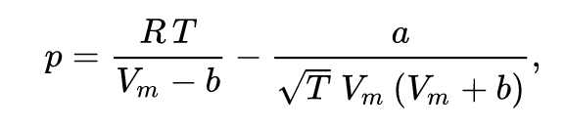

Where

* p is the gas pressure
* R is the gas constant,
* T is temperature,
* Vm is the molar volume (V/n),
* a is a constant that corrects for attractive potential of molecules, and
* b is a constant that corrects for volume.

The constants are different depending on which gas is being analysed. The constants can be calculated from the critical point data of the gas as follows-

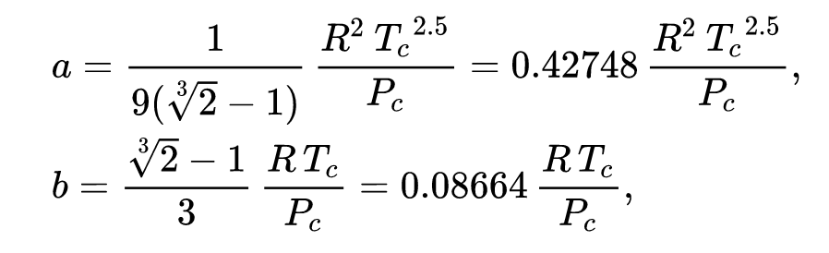

ETHYLENE GLYCOL-

The critical point data of ethylene glycol is given as follows-

Critical Temperature (Tc)- 719.7 K

Critical Pressure (Pc)- 77 bar

Critical Volume (Vc)- 191 cm3/mol

The above data have been taken from the following book-

Introduction to Chemical Engineering Thermodynamics by J.M. Smith, Hendrick Van Ness, Michael Abbott, Mark Swihart 8th edition.

MATLAB CODE-

%% ETHYLENE GLYCOL CRITICAL POINT DATA AND CONSTANTS-

Tc=719.7;

Pc=77;

Vc=191;

R=83.14;

a=0.42748\*R\*R\*power(Tc,2.5)/Pc;

b=0.08664\*R\*Tc/Pc;

%% P-V DIADRAM FOR REDLICH KWONG EQUATION OF STATE

figure

i=1;

for T=500:10:900

x=linspace(1,2000,500);

y=zeros(500,1);

for i=1:500

y(i,1)=R\*T/(x(i)-b)-a/(sqrt(T)\*x(i)\*(x(i)+b));

end

plot(x,y);

ylim([-40 120]);

hold on;

end

title('Redlich Kwong equation of state');

xlabel('Volume(V)(cm3/mol)');

ylabel('Pressure(P)(bar)');

xlim([0 2000]);

hold off;

%% DOME SHAPED CURVE BY EQUATING THE FUGACITY COEFFICIENTS

pp=zeros(800,1);

vv=zeros(800,1);

it=1;

for T=[500:5:800 716:1:719 718.01:0.01:718.99]

% assume a value of Psat initially=30bar

Psat=30;

tol=0.0001;

itr=1;

err=1;

while itr<200

% compute roots of Redlich Kwong

a1=Psat;

b1=-1\*R\*T;

c1=a/sqrt(T)-Psat\*b\*b-R\*T\*b;

d1=-1\*a/(sqrt(T))\*b;

p=[a1 b1 c1 d1];

r=roots(p);

vl=min(r);% Volume of the liquid phase

vg=max(r);% Volume of the gaseous phase

if(~isreal(vl)||(~isreal(vg)))

Psat=Psat+0.5;

itr=itr+1;

continue;

end

z1=Psat\*vl/(R\*T);

z2=Psat\*vg/(R\*T);

% log(Fugacity coefficient) for liquid phase

f1=(z1-1)-log(z1)-log(1-b/vl)-(a/(sqrt(T)\*b\*R\*T))\*log(1+b/vl);

% log(Fugacity coefficient) for vapor phase

f2=(z2-1)-log(z2)-log(1-b/vg)-(a/(sqrt(T)\*b\*R\*T))\*log(1+b/vg);

% iterating till the difference of log(fugacity) of the two phases

% is below the tolerance value

err=abs(f2-f1);

if err>tol&&f1>f2

Psat=Psat+0.1;

elseif err>tol&&f2>f1

Psat=Psat-0.1;

else

break;

end

itr=itr+1;

end

if(isreal(vl)&&isreal(vg) )

plot(vl,Psat,'r\*');

plot(vg,Psat,'r\*');

pp(it)=Psat;

vv(it)=vl;

it=it+1;

pp(it)=Psat;

vv(it)=vg;

it=it+1;

end

hold on;

end

%% SATURATION DOME CURVE

figure

pp=pp(1:it-1,1);

vv=vv(1:it-1,1);

[vv, sortIndex] = sort(vv);

pp = pp(sortIndex);

cs = csape(vv,pp);

fnplt(cs,2);

title('Saturation dome curve');

xlabel('Volume(V)(cm3/mol)');

ylabel('Pressure(P)(bar)');

hold on;

% find the critical point by interpolating using spline

[~,ii] = findpeaks(pp);

F = griddedInterpolant(vv,pp,'spline');

xmaxs = arrayfun(@(xx)fminsearch(@(x)-F(x),xx),vv(ii));

plot(xmaxs(1),F(xmaxs(1)),'r+');

hold off;

% CRITICAL POINT VALUES FROM REDLICH KWONG EOS-

disp("CRITICAL VOLUME--");

disp(xmaxs(1));

disp("CRITICAL PRESSURE--");

disp(F(xmaxs(1)));

Vr=xmaxs(1);

Pr=F(xmaxs(1));

a1=R\*R/(power((Vr-b),2));

b1=-2\*R\*Pr/(Vr-b);

c1=Pr\*Pr;

d1=-1\*(a\*a)/(power((Vr\*Vr+Vr\*b),2));

p=[a1 b1 c1 d1];

Tr=max(roots(p));

disp("CRITICAL TEMPERATURE--");

disp(Tr);

disp("Error in the obtained values(%)--");

disp("Temperature:");

disp(abs(Tc-Tr)\*100/Tc);

disp("Pressure:");

disp(abs(Pc-F(xmaxs(1)))\*100/Pc);

disp("Volume:");

disp(abs(Vc-xmaxs(1))\*100/Vc);

OUTPUT-

CRITICAL VOLUME--  
 254.1488  
  
CRITICAL PRESSURE--  
 78.3992  
  
CRITICAL TEMPERATURE--  
 721.9801  
  
Error in the obtained values(%)--  
Temperature:  
 0.3168  
Pressure:  
 1.8172  
Volume:  
 33.0622

LOGIC OF THE CODE-

1. The “a” and “b” constants for the Redlich Kwong equation is derived from the critical values of ethylene glycol.
2. For the PV diagram, the temperature values are iterated from Tc-200 to Tc to 200 and the volume is iterated from 1 to 2000 cm3/mol to get an approximate curve.
3. The saturation dome curve is obtained by computing the saturation pressure(Psat) , liquid volume(Vl) and vapor volume(Vg) by making the fugacity coefficients of the two states equal to some tolerance.

* An initial saturation pressure is assumed=30 bar and the roots of the following equation is calculated-

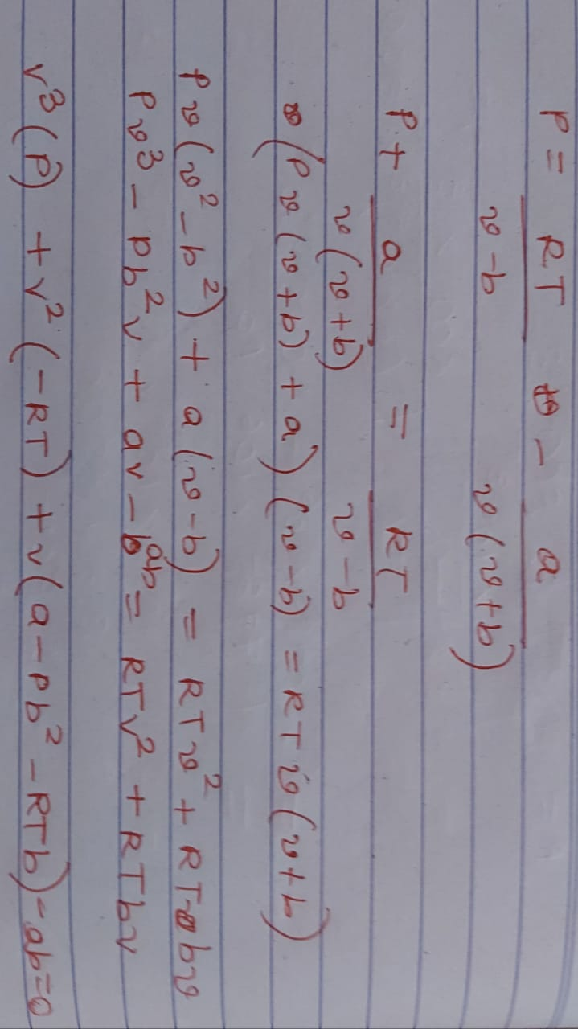

* The three roots obtained could be 3 real or 1 real and 2 imaginary. In the case of three real roots, Vl and Vg are obtained by taking the minimum and the maximum of them. For the 2 imaginary roots the saturation pressure is increased till the roots obtained are real or the maximum iteration is reached for which the temperature would be above critical point.
* The compressibility factor and thus the fugacity coefficients are derived from the following equations-

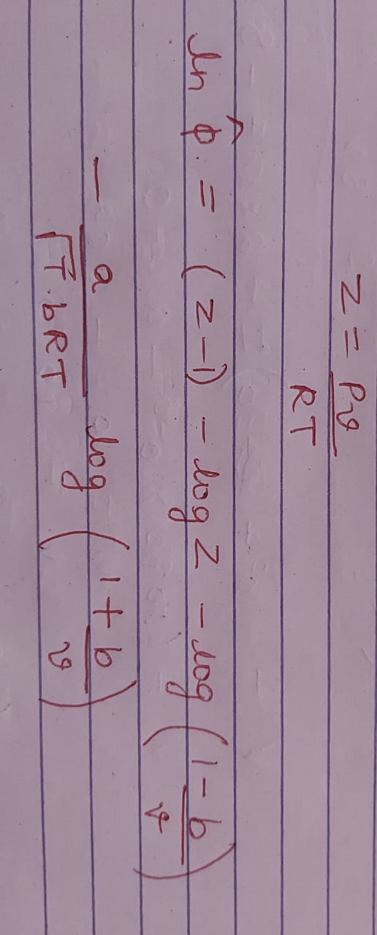

* The curve is then obtained by plotting the saturation points obtained and interpolating using spline the rest of the curve.

1. The temperature range for the saturation dome [716:1:719] and [718.01:0.01:718.99] is obtained by subsequently analysing the temperature around which the volumes obtained has one real and two complex roots i.e., around the critical temperature.
2. The critical point is thus obtained by computing the maxima of the spline.

P-V DIAGRAM PLOT-

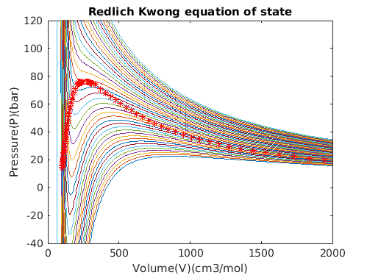

SATURATION DOME CURVE-

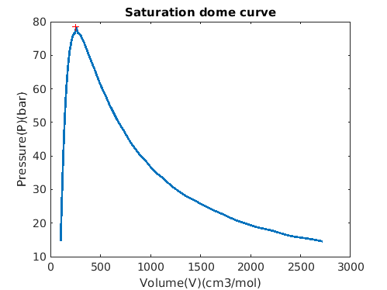

The ‘+’ point is the critical point of the system.

INFERENCE-

* The region under the saturation dome curve is the liquid-vapor mixture. The points that create the left-hand side of the dome represent the saturated liquid states, while the points on the right-hand side represent the saturated vapor states. On the left-hand side of the dome there is compressed liquid and on the right-hand side there is superheated gas.
* The critical point is where the saturated liquid and vapor lines meet. Beyond the point, it is impossible to distinguish between the liquid and vapor phases, thus we obtain only a single real root of volume.
* The error obtained for the critical values in the Redlich Kwong equation is about 33 percent. Thus, the equation does not exactly predict the behaviour of the real gas, but gives a good approximation.