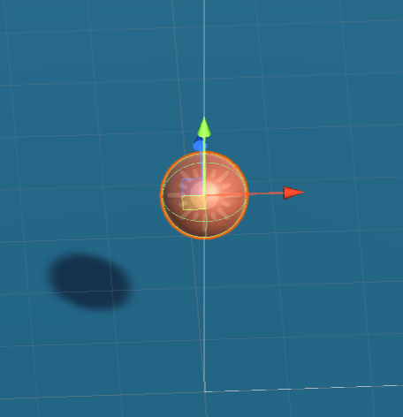 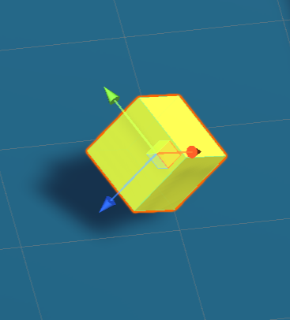

Player Food

|  |  |  |  |  |  |
| --- | --- | --- | --- | --- | --- |
|  | 质量 | 体积 | 表面积 | 包围盒 | |
| Center | Extents |
| 小球(Player) | 1 | 0.51 | 3.11 | (0.0,3.0,0.0) | (0.5,0.5,0.5) |
| 方块(Food) | \ | 0.125 | 1.5 | (7.9,0.6,6.0) | (0.4,0.4,0.4) |

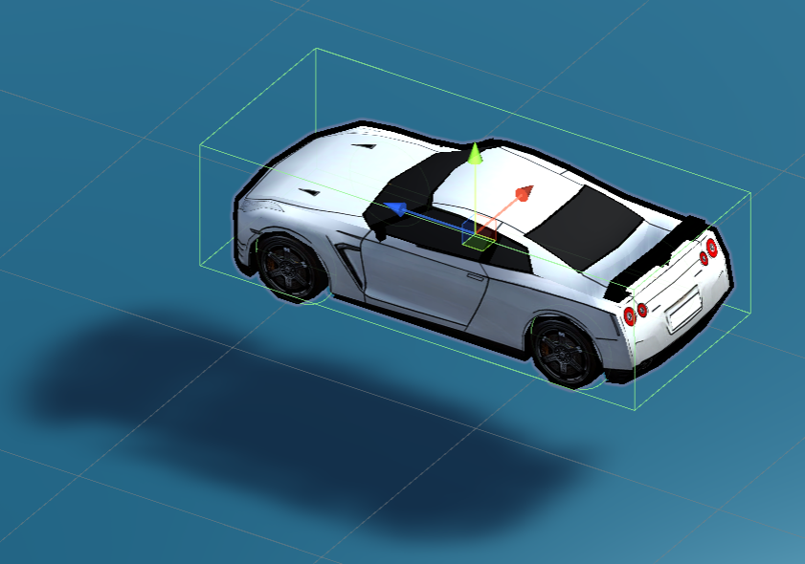 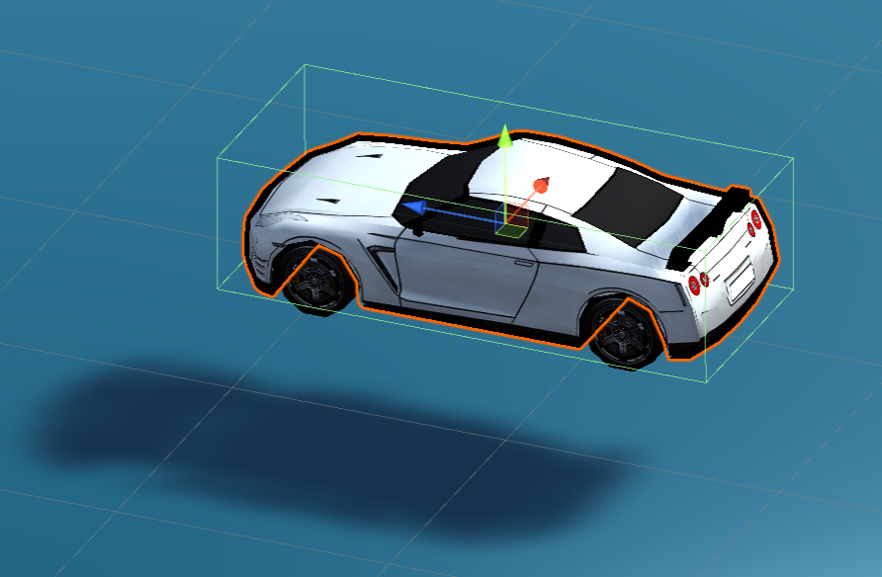

Car CarBody

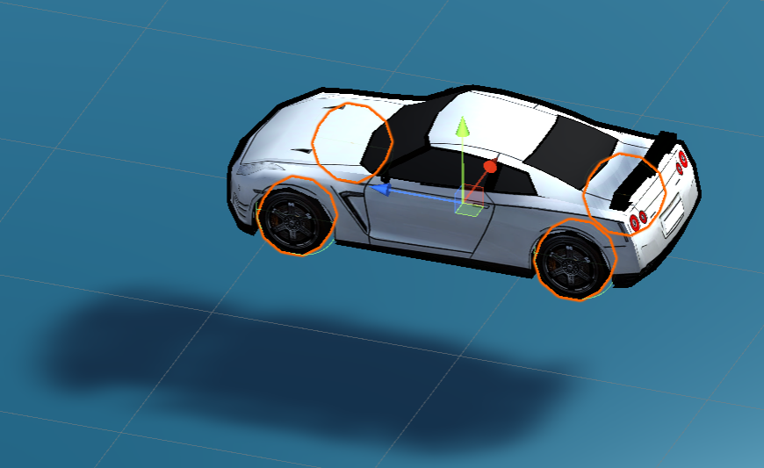

Wheels

|  |  |  |  |  |  |
| --- | --- | --- | --- | --- | --- |
|  | 质量 | 体积 | 表面积 | 包围盒 | |
| Center | Extents |
| 车体 | 1420 | 0.05 | 6.23 | (-2.0,0.8,0.0) | (0.4,0.3,0.9) |
| 前左车轮 | 20 | 0.006 | 0.21 | (-2.3,0.7,0.5) | (0.1,0.1,0.1) |
| 前右车轮 | 20 | 0.006 | 0.21 | (-1.7,0.7,0.5) | (0.1,0.1,0.1) |
| 后左车轮 | 20 | 0.006 | 0.21 | (-2.3,0.7,-0.6) | (0.1,0.1,0.1) |
| 后右车轮 | 20 | 0.006 | 0.21 | (-1.7,0.7,-0.6) | (0.1,0.1,0.1) |