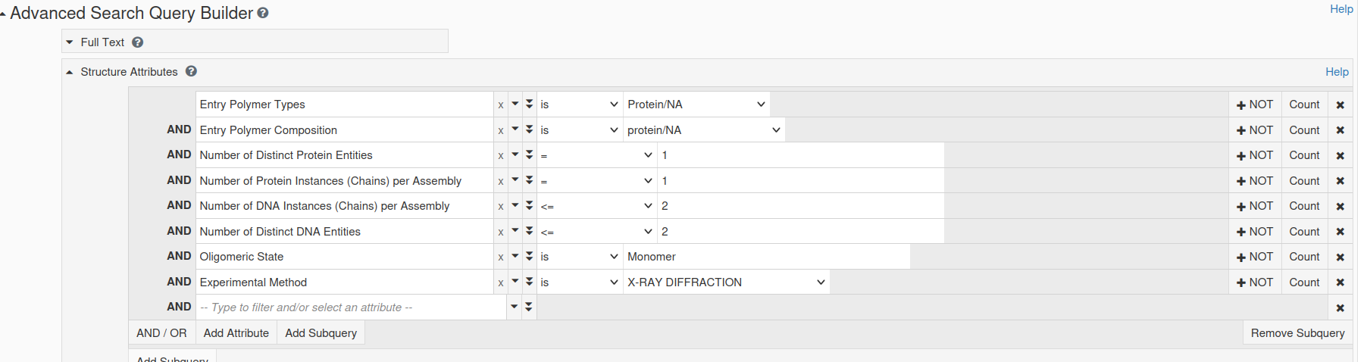

Lets look for structures with 1 protein entity and 1 dna entity, these will be monomers bound to palindromic DNA ?

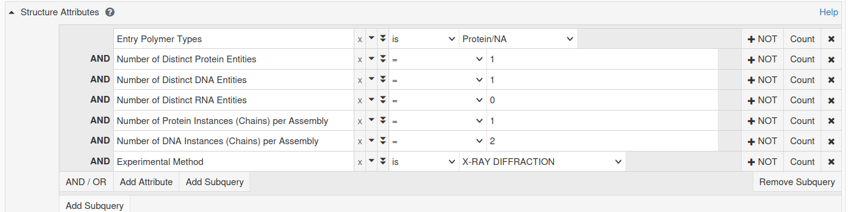
Result:
165 structures, but some appear to be homodimers?

1AZP,1AZQ,1BNZ,1C8C,1CA5,1CA6,1EFA,1FJX,1G3X,1ODG,1SA3,1TGH,1V14,1V15,1WD0,1WD1,1WTO,1WTQ,1WTR,1WTV,1WTW,1WTX,1XYI,1YFI,1YFJ,1ZNS,209D,2AOQ,2D55,2FKC,2FKH,2FL3,2I9K,2IVH,2PY5,2RVE,2ZO2,316D,3FBD,3KXT,3LWH,3LWI,3MLN,3NGD,3ORC,3OSN,3QMB,3QMH,3QMI,3UBT,3UXW,3VH0,4DWI,4ENN,4ESJ,4FS1,4FS2,4GZ1,4HP1,4HP3,4HTU,4HUE,4HUF,4HUG,4JBM,4JRP,4JRQ,4JS4,4KB6,4KI2,4L5R,4LG7,4NDH,4NM6,4NW3,4O0I,4OPJ,4OPK,4PZI,4Q44,4QCB,4QQW,4QQX,4QQY,4QQZ,4R55,4R56,4RDU,4RTJ,4XZF,4Z3C,5C5J,5EXH,5HNK,5HRB,5J3E,5K07,5K17,5NW9,5NWA,5T1J,5VC9,5VMV,5W9Q,5W9S,5WVW,5WVY,5WVZ,5WWC,5XFP,5YUR,5YUS,5YUT,5YYD,5YYE,5ZMN,5ZMO,6AKP,6ASB,6ASD,6BEK,6C1Y,6CC8,6CCG,6CNP,6CNQ,6CVS,6D1T,6FQQ,6H3R,6IG1,6JUL,6JUM,6JUN,6JUO,6JUR,6JUS,6LBM,6SY0,6TBZ,6WS3,7BJQ,7CSZ,7CY6,7CY7,7CY8,7FEF,7LH9,7MWK,7MWM,7NE3,7NE6,7NQF,7RAY,7XM0,7Y43,7YUK,7ZVN,8A4I,8HTX,8I6K,8ILG,8SV3,8SV4,8YZS

red: not monomers or not duplex DNA
underlined: manually checked
notes:
# 1g3x is a peptide drug --- exclude
# 5xfp assembly 1 lacks dna, use assembly 2

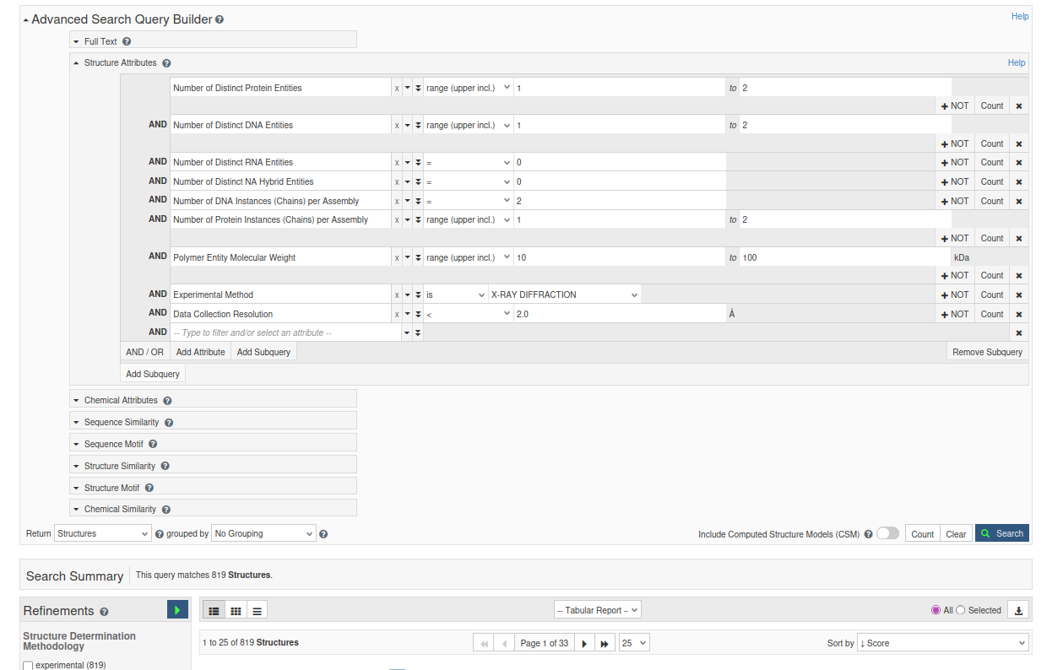

1A1G,1A1H,1A1I,1A1K,1AAY,1B94,1B97,1BC8,1BUA,1CDW,1CKQ,1CL8,1CYQ,1D02,1D2I,1DC1,1DFM,1DSZ,1EMH,1EO4,1EON,1ESG,1EYU,1H6F,1JK1,1JK2,1JX4,1K3W,1K3X,1L1T,1L1Z,1L3L,1L3S,1L3T,1L3U,1L3V,1L5U,1LLM,1LMB,1LV5,1M3Q,1M5R,1MNN,1NJW,1NJX,1NK0,1NK4,1NK7,1NK8,1NK9,1NKC,1NKE,1NKP,1NNJ,1ORN,1P71,1PJI,1PJJ,1PM5,1Q3F,1QN3,1QN4,1QN5,1QN9,1QNA,1QNE,1R2Z,1RXW,1S9F,1SA3,1SSP,1SUZ,1SXQ,1T9I,1TDZ,1TRO,1U47,1U4B,1VTO,1WTE,1XC8,1XC9,1Y8Z,2ASD,2B0E,2BDP,2C7O,2C7P,2C7Q,2C7R,2DEM,2DP6,2EA0,2ETW,2EUV,2EUW,2EUX,2EUZ,2EVF,2EVG,2EVH,2EVI,2EVJ,2G1P,2GB7,2GIG,2GIJ,2H7G,2HAN,2HHQ,2HHS,2HHU,2HHV,2HHW,2HR1,2HVI,2HW3,2I13,2IBT,2IH2,2IH5,2JEJ,2JG3,2NLL,2NP7,2O4A,2OAA,2ODI,2OFI,2OPF,2OXV,2PVI,2PY5,2Q10,2VBJ,2VBO,2VLA,2VOA,2W42,2WBS,2WIW,2XHI,2XZF,2XZU,2ZKD,2ZO1,3AAF,3BDP,3BEP,3BI3,3BIE,3BKZ,3BM3,3BS1,3C58,3D0A,3D0P,3D2W,3DPG,3DVO,3EEO,3EY1,3EZ5,3F8J,3FC3,3FDE,3FDQ,3G00,3G6T,3GA6,3GO8,3GOX,3GPU,3GPX,3GPY,3GQ3,3GQ4,3GQ5,3GV5,3H8R,3H8X,3HP6,3HPO,3HT3,3HTS,3I0W,3I0X,3I8D,3IGK,3IGL,3IMB,3JR5,3JX7,3JXY,3JXZ,3JY1,3K59,3L2C,3LDY,3M4A,3M9N,3MFI,3MR2,3MR3,3MR5,3MR6,3MXM,3NDH,3O1M,3O1O,3O1P,3O1R,3O1S,3O1T,3O1U,3O1V,3OGU,3OJS,3OJU,3OQG,3OSN,3PO4,3PV8,3PVI,3PVV,3PX0,3PX4,3PX6,3PY8,3Q8P,3RAX,3RR7,3RRH,3RTV,3RZG,3S57,3S5A,3SAR,3SAU,3SPD,3SV4,3SYZ,3T3F,3TAN,3TAP,3TAQ,3TAR,3THV,3TI0,3U6C,3U6D,3U6E,3U6L,3U6O,3U6P,3U6Q,3U6S,3V6T,3V9W,3V9X,3V9Z,3VAJ,3VD6,3WPC,3ZDA,3ZDB,3ZDD,4AIK,4AIL,4B22,4B9S,4BDP,4BWJ,4C8L,4C8M,4C8N,4C8O,4DF4,4DFJ,4DFK,4DFM,4DL7,4DLG,4DQI,4DQP,4DQQ,4DQR,4DS4,4DS5,4DSE,4DSF,4DWI,4E0D,4E9F,4ECQ,4ECR,4ECS,4ECT,4ECU,4ECV,4ECW,4ECX,4ECY,4ECZ,4ED0,4ED1,4ED2,4ED3,4ED7,4ED8,4ELU,4ELV,4EZ6,4EZ9,4F2R,4F2S,4F3O,4F4K,4F4W,4F8R,4G4N,4G4O,4G4Q,4G4R,4GZ1,4GZ2,4HC9,4HN5,4HSB,4HTU,4HUE,4HUF,4HUG,4I2O,4IBW,4IX7,4J9L,4J9N,4J9Q,4J9S,4JCY,4JRP,4K98,4K99,4L5R,4LJR,4LVI,4M95,4M9E,4MDE,4MDF,4N5S,4NDH,4NID,4NIG,4NIH,4NII,4O3N,4O3O,4O3P,4O3Q,4O3R,4O3S,4OFA,4OPJ,4OPK,4OSR,4OT3,4P4M,4PCZ,4PD2,4Q8E,4QWA,4QWB,4QWE,4R2A,4R2C,4R2E,4R2P,4R2Q,4RNN,4ROC,4RTJ,4RTK,4RTQ,4TQR,4TU8,4TU9,4UQM,4WCG,4X9J,4XEG,4XO0,4XPC,4XPE,4XQJ,4XZF,4YFU,4YP3,4YR0,4YR2,4Z3A,4Z47,4Z7Z,4Z8F,4ZSF,5A3D,5BNH,5BUA,5CIY,5CL3,5CL4,5CL5,5CL6,5CL7,5CL8,5CL9,5CLA,5CLB,5CLC,5CLD,5CLE,5D8K,5D9I,5D9Y,5DEU,5DFI,5DFJ,5DG0,5DGB,5DLF,5DLO,5DQH,5DWA,5E41,5E69,5EGB,5EI9,5EWE,5EWF,5EWG,5F8A,5FB2,5FF8,5HDN,5HF7,5HNF,5HNH,5HRB,5HRD,5HRE,5HT2,5INL,5INP,5INQ,5JXY,5KE6,5KFA,5KFB,5KFC,5KFD,5KFE,5KFF,5KFG,5KFH,5KFI,5KFJ,5KFK,5KFL,5KFM,5KFN,5KFO,5KFP,5KFQ,5KFR,5KFS,5KFT,5KFU,5KFV,5KFW,5KFX,5KFY,5KFZ,5KG0,5KG1,5KG2,5KG3,5KG4,5KG5,5KG6,5KG7,5KKQ,5KL2,5KL3,5KL4,5KL6,5KL7,5KN8,5KN9,5KUB,5L1J,5L1K,5L1L,5L9X,5LCM,5NKL,5NPK,5O63,5O7T,5SZT,5TRD,5ULX,5UUF,5UUG,5UUH,5VBS,5VHV,5WM1,5WM8,5WX9,5XZG,5Y3J,5YTF,5YUS,5YUU,5YUY,5YUZ,5YV2,5YWT,5Z3N,5ZFZ,5ZMO,6B0O,6B0R,6BCE,6BD0,6BDB,6BEK,6BLW,6BOQ,6BOR,6BOV,6BOW,6D0M,6D0Z,6DF5,6DFA,6DFB,6DFC,6DSU,6DSV,6DSW,6DSX,6DSY,6E93,6E94,6EL8,6FAS,6FBC,6FBE,6FBG,6FBH,6FBI,6FBQ,6FL1,6G1T,6GCD,6GCE,6GCF,6GED,6H0S,6IG1,6IS8,6J9B,6JUM,6LFF,6LQF,6M3D,6M7P,6MIG,6MIH,6MIK,6ML2,6ML3,6ML4,6ML5,6ML6,6ML7,6MP3,6MQ8,6MU4,6MU5,6OGJ,6OGK,6QIL,6RAU,6RNM,6RO2,6ROK,6TBZ,6U16,6U17,6U9Q,6UEU,6UKE,6UKF,6UKG,6UWJ,6X1J,6X6Z,6X71,6X74,6X75,6X77,6X9J,6YCQ,6YJB,6ZNC,7ABS,7B4D,7B4E,7B4F,7B4G,7B4H,7B4N,7CBY,7CSW,7CSZ,7DCI,7EDS,7EF9,7EL3,7F9H,7K5P,7K5S,7KZ0,7KZ1,7KZG,7L69,7LCD,7LXH,7LXJ,7M7L,7M7N,7M7O,7M7P,7M7S,7M7T,7M7U,7M7Y,7M7Z,7M80,7M83,7M84,7M85,7M86,7M87,7M88,7MWL,7OM3,7OWF,7OY7,7P0W,7P8L,7P9Z,7RSR,7SFC,7T18,7T1A,7T1B,7U72,7U73,7U74,7U75,7U76,7U77,7U78,7U79,7U7A,7U7B,7U7C,7U7D,7U7E,7U7F,7U7G,7U7I,7U7J,7U7K,7U7L,7U7R,7U7S,7U7T,7U7U,7U7V,7U7W,7U7X,7U7Y,7U7Z,7U80,7U81,7U82,7U83,7U84,7VN3,7VN5,7VN6,7VN8,7VP2,7W27,7WM3,7YC7,7YUL,7YZ7,7YZA,7YZB,7YZE,7ZVN,8C57,8C58,8C59,8C84,8DVP,8DW0,8DW7,8DWD,8E3K,8E3R,8E4H,8E5Y,8E8A,8EBH,8EE9,8EJ6,8EJ8,8EK3,8EKJ,8EKU,8EKV,8EKZ,8EMD,8ENG,8EO1,8EO4,8EQG,8EQK,8EQL,8FAY,8G8H,8G8J,8H0L,8HCL,8IJO,8IJP,8IK8,8ILG,8ILI,8J70,8J71,8RPX,8SCO,8SMH,8SMJ,8SP1,8SV3,8T9U,8TLF,8TLH,8UFF,8UUC,8V7A,8V7B,8V7C,8V7D,8V7E,8V7G,8V7H,8V7I,8V7J,8V7K,8V9N,8VDH,8VDI,8VMO,8VMP,8VMQ,8VMR,8VMS,8VMT,8VMU,8VMW,8VMX,8VMY,8VMZ,8VN0,8VN1,8VN2,8VN5,8VN6,8VN8,8VN9,8VNA,8VNE,8VNF,8VNG,8VNH,8VNJ,8VNK,8VNM,8VNP,8VNQ,8VNR,8YFJ,8YLG,8YVA,8YVB,9BDV,9BDW,9BS2,9F7G

