Homework19

**1. You are a Systems Admin at NIH. You just had a meeting with your Boss and he said 2 Temps will be starting on Monday and will be working on a one month project, upgrading your Company’s Oracle Server.**

**a. These two Temps, named Mike Jones, and Sarah Peters will need accounts on the Homesol Server with the following specs. Create the accounts as needed. (Note you may have to do additional server configuration to complete this project. )**

|  |  |  |  |
| --- | --- | --- | --- |
| **Full User Name** | | **Mike Jones** | **Sarah Peter** |
| **Login Name** | | **mjones** | **speter** |
| **Home Directory** | | **/export/home/jones** | **/export/home/speter** |
| **Primary Group** | | **temps** | **staff** |
| **User ID** |  | **600** | **601** |
| **Account Expiration Date** | | **12/30/2022** | **12/30/2022** |
| **Password** | | **school1** | **school1** |
|  |  |  |  |
| **i.** | **Display each account components.** | |  |
| **ii.** | **Display accounts’ group membership** | |  |

**Mike Jones**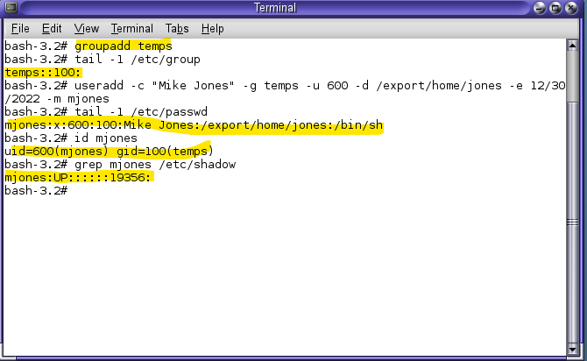

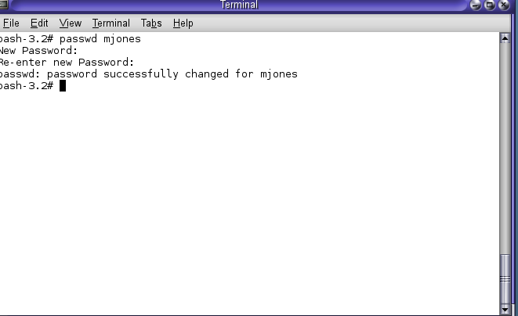

**Sarah Peter**

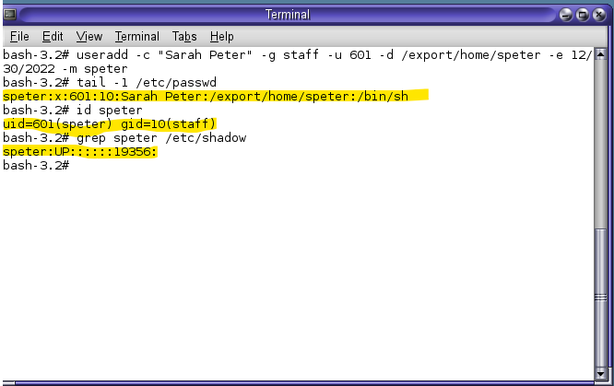

**2. You just had your routine Friday meeting at your job as UNIX System Admin at NIH, and your Boss has informed you that the Temp, Mike Jones has been offered a permanent position with your company. Sarah Peters the other Temp will be leaving and will be replaced by a new Human Resources Director called Jennifer Cruz. Now your Boss has requested you to; a. Upgrade Mike’s account from temp to employee status as follows;**

|  |  |  |
| --- | --- | --- |
|  | **Old Temp Specs** | **New Employee Specs** |
| **Home Directory** | **/export/home/jones** | **/export/home/mjones** |
| **Primary Group** | **temps** | **other** |
| **User ID** | **600** | **800** |
|  |  |  |

**b. Type commands to display Mike’s account components.**

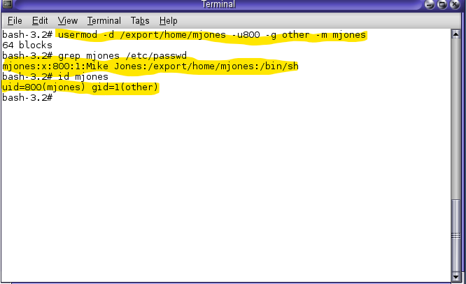

**3. Again Sarah is leaving but a new HR Director, called Jennifer has been hired.**

**Your Boss has asked you not to delete Sarah’s account but to convert it to Jennifer’s account and maintain the home directory.**

**Change the name of the temps group to executives**

**Convert Sarah’s account to Jennifer’s new account using the following guide;**

|  |  |  |
| --- | --- | --- |
|  | **Sarah’s Specs** | **Convert to Jennifer Specs** |
| **Full Name** | **Sarah Peters** | **Jennifer Cruz** |
| **Username** | **speters** | **jcruz** |
| **Home Directory** | **/export/home/speter** | **/export/home/jcruz** |
| **Primary Group** | **staff** | **executives** |
| **Userid** | **601** | **801** |
| **Password** | **school1** | **school1** |

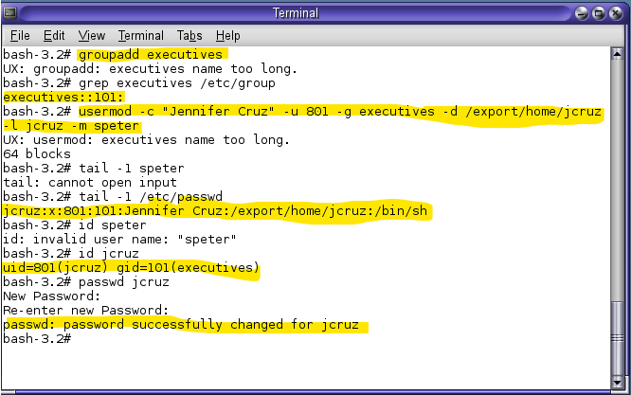

4. Watch the "User Management in Windows Active Directory" Video and familiarize yourself with the concept

