1.Abstract
2.sds

What is the optimum in Hadfield model? in
Next thing: visser sds for pied flycatcher

Individual optimization of reproduction in a long-lived migratory bird: a test of the condition-dependent model of laying date and clutch size
Oostra V, Saastamoinen M, Zwaan BJ, Wheat CW. 2018 Strong phenotypic plasticity limits potential for evolutionary responses to climate change. Nat. Commun. 9, 1005. (doi:10. 1038/s41467-018-03384-9)
Charmantier, A., and P. Gienapp. 2014. Climate change and timing of avian
breeding and migration: evolutionary versus plastic changes. Evol. Appl.
7:15–28.

Need to integrate earlier seasons, higher clutch,, and advances induced by supplemental feeding (daan in ioc)
Husby A, Visser ME, Kruuk LEB (2011) Speeding up micro-evolution: annual strength of selection and heritability are positively associated in a wild bird population. PLoS Biology 9: e1000585. doi: 10.1371/ journal.pbio.1000585 PMID: 21408101

Changes in phenology can alter patterns of natural selection: the joint evolution of germination time and postgermination traits

Within a season, late reproducing individuals commonly have lower reproductive success than those that reproduce earlier, generating a correlation of fitness with breeding date (i.e. a selection differential). Under the individual optimization hypothesis, this is expected if a delay in breeding increases parental fitness, but decreases offspring survival, individuals in lower nutritional condition lag in their accumulation of resources to invest. Here we ask how the mean and variance in breeding date, the correlation of breeding date with fitness, and its heritability evolve under individual optimization. We show that mean breeding date evolves to be later than the optimum for offspring survival, that selection differentials can be high, h2.. alterations in individual condition can relatively easily account for shifts in sd…

The correlation between lay date generates a selection

iler et al 2021 However, early snowmelt reduces projected population growth rates mainly through reductions in survival, not seed production, showing that earlier flowering in this case has little population-level consequence (Iler et al. 2019).
E. M. Wolkovich, M. J. Donahue, How phenological tracking shapes species and
communities in non-stationary environments. Biological Reviews 96, 2810–2827 (2021).

Individual optimization and the evolution of breeding date in birds

In seasonal environments for both plants and animals, relatively late reproduction is commonly associated with reduced reproductive success (Donohue et al., 2010; Munguía-Rosas et al., 2011; Radchuk et al., 2019; De Villemereuil et al., 2020). Underlying causes have been most studied in bird species from the temperate region, in which both a female’s fecundity (clutch size, Klomp, 1970) and the number of surviving offspring coming from her brood (Radchuk et al., 2019) frequently decline through the season. Drent and Daan (1980) presented a compelling explanation for why this should be. They started by noting that the reproductive value of a juvenile bird (the product of its survival and future reproduction) should decline through the season because of environmental conditions. Several reasons have been proposed for why such a decline is to be expected (Verhulst et al., 1995; Verhulst & Nilsson, 2008; Sutton & Freeman, 2023). The most general ones are the longer time available to prepare for the lean (winter) season, and competition from earlier fledged birds. While offspring value may decline, a delay in breeding enables parents to garner more resources and invest more in the brood (Perrins, 1970). At some point in time the gain in fecundity from reproducing late is balanced by the decline in reproductive value of offspring; this is the point at which an individual should start to breed.
In these models, external conditions affecting fitness decline at the same rate for all, but individuals differ in access to resources (Daan et al., 1990), or their condition (Drent & Daan, 1980; Rowe et al., 1994). Condition has also been termed nutritional state (Price et al., 1988), or quality (Winder et al., 2025) and may be defined as that combination of traits that give one individual higher overall fitness than another (van Noordwijk & de Jong, 1986; Winder et al., 2025). #age Ferreira. Similar consequences apply if a female’s quality reflects not her own state, but that of her mate, or territory, as in the case of the kestrel, Falco tinnunculus, (described further in the discussion). Given differences in nutritional state among females, the date on which a female should start to lay a clutch (termed the ‘switch point’ by Rowe et al., 1994), is earlier for higher quality individuals, who should also invest more in the clutch (e.g., Figure 1). Individual optimization therefore creates a negative covariance of lay date with measures of components of fitness including clutch size, number of fledged young, and the number of young surviving to the following year. Experimental and correlational approaches have demonstrated the presence of all ingredients of the individual optimization model (Daan et al., 1990; Verhulst et al., 1995; Verhulst & Nilsson, 2008). One consequence is the presence of persistent directional selection at equilibrium (Price et al., 1988; Daan et al., 1990).

While the maintenance of a persistent selection differential at an evolutionary equilibrium is now well understood (Price et al., 1988; Price & Liou, 1989; Alatalo et al., 1990; Rausher, 1992), exactly how lay date will evolve in the face of nutritional effects is uncertain. Price et al. (1988) treated the correlation of nutritional condition with lay date as a constraint. In this case the mean lay date evolves to be later than the externally-imposed optimum (Figure 2). Individuals breeding early are in higher nutritional state and produce more offspring. Consequently, the earlier breeding segment of the population experiences stronger selection towards the optimal times than the later breeding segment. At equilibrium, the total production of surviving offspring from the earliest half of the population must be equal to the total production from latest half of the population. This can only be the case if fewer individuals breed before the optimum.

Tinbergen and Daan (1990) and Hadfield and Reed (2022) noted that the Price et al. (1988) result involves the unrealistic assumption that individuals in high nutritional state are constrained to breed earlier than is optimal for them. Hadfield and Reed (2022) relaxed this constraint by assuming that the optimal breeding date is indeed earlier for individuals in high nutritional state. Modelling this optimum as a linear function of nutritional state, they obtained the opposite result to Price et al. (1988), finding that the average breeding date should evolve to be earlier than that imposed by the environment. The reason for this is that costs to plasticity (and/or uncertain cues) mean that the early breeders in high nutritional state are likely to breed too late for their optimum, whereas the late, low nutritional state, individuals are likely to breed too early for their optimum. Because more offspring are produced by the early breeding individuals than the late breeding individuals, selection towards the earlier optimum is stronger (Figure 2).

Neither Price et al. (1988) nor Hadfield and Reed (2022) provided an adaptive explanation for why lay date and nutritional state should be correlated. The individual optimization hypothesis does so, by assuming that individuals only breed when they have garnered sufficient resources, which takes time (Perrins, 1970). If nutritional state increases monotonically with date, and external conditions impose symmetrical selection pressures around an optimum, it should always pay individuals to delay breeding until after the optimum, rather than before (Figure 1), but exactly where is unclear. Here we model the evolution of breeding date assuming individual optimization, assessing both the strength of a persistent selection differential and displacement of the mean from the externally imposed optimum.

Model

The model is developed in 4 stages, as in Hadfield and Reed (2022). First, we compute the individual fitness function for lay date. Second, we turn this into the mean fitness function by integrating across the phenotypic distribution. Third, we differentiate the mean fitness with respect to mean phenotype to obtain the directional selection gradient, β (Lande, 1979). Finally, we set β = 0 to obtain the equilibrium. The key feature that separates this from earlier models is that nutritional state is not a constant. In the present model nutritional state, and investment into the brood increases linearly with breeding date, y, as a female accumulates resources (Daan et al., 1990; Rowe et al., 1994).
Breeding date,
y = x + p + e (1),

where x is the genetic value, p the plastic response to on the date of breeding nutritional state, and e the environmental deviation, each assumed to follow a normal distribution. Variance in breeding dates is the sum of the genetic, plastic and environmental variances, i.e. $σ_{y}^{2}$ = $σ_{x}^{2}$ + $σ_{p}^{2}$+ $σ_{e}^{2}$. $σ_{x}^{2}$, $σ_{e}^{2}$ are assumed constant, but $σ_{p}^{2}$ allowed to evolve.

As shown in Figure 1, we assume that a Gaussian function describes fitness attributed to direct effects of breeding date, y, with optimal breeding date = 0:

$C\left(y\right)∝exp⁡(-\frac{y^{2}}{{2ω}^{2}})$ (2)

A linear function describes increase in fecundity with breeding date:
F(n, y) = a_{f} n + cy (3)
Here n is the intercept. Individuals in higher nutritional state, n, start the season with more resources available to invest in offspring than do those in lower nutritional state. Starting from this point, all individuals are assumed to accumulate resources at the same rate, c. While in nature we might expect slopes to differ among individuals, including this possibility into the analysis makes for several complications. Incorporating a slope term makes the analysis exceptionally complicated (Hadfield & Reed, 2022) and become over-parameterized, in that the same resource investment can result from multiple combinations of intercept and slope. The focus on intercept is justified from studies in nature which find the slope to be less variable than the intercept (Daan et al., 1990; Ramakers et al., 2019; Winder et al., 2025). Rowe et al. (1994) note in their review of experiments that “The pattern suggests that the primary effect of most manipulations has been to advance the time at which birds begin gaining condition for breeding, without greatly increasing the rate of condition gain during the breeding season” (p.711).
Fitness is given as the product of (1) and (2):
$W\left(n,y\right)∝exp⁡(-\frac{y^{2}-μ_{y}}{{2ω}^{2}})(af n + cy)$ (4)

The optimal breeding date is given by taking the derivative of equation (3) with respect to y, and setting the result = 0:

$\hat{y}= \frac{-a_{f}n+\sqrt{{{(a}_{f}n)}^{2 }+4c^{2}ω^{2} }}{2c}$ (5)

Figure 3 gives an example of how fitness varies with respect to both breeding date and nutritional state.
Averaging fitness (equation 4) over the breeding date distribution y, we obtain:
$\overline{W}\left(n,\overline{y}\right)= \sqrt{\frac{ω^{2}+σ_{y}^{2}}{2π}} e^{\frac{-{(ω}^{2}+σ_{y}^{2}){\overline{y}}^{2}}{2}} (a_{f}n+{c(ω}^{2}+σ_{y}^{2})ω^{2}\overline{y}$)

##I am afraid from here on, we need to redo stuff.
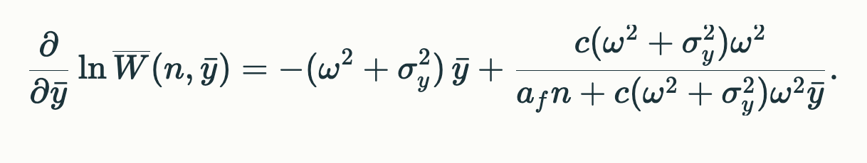
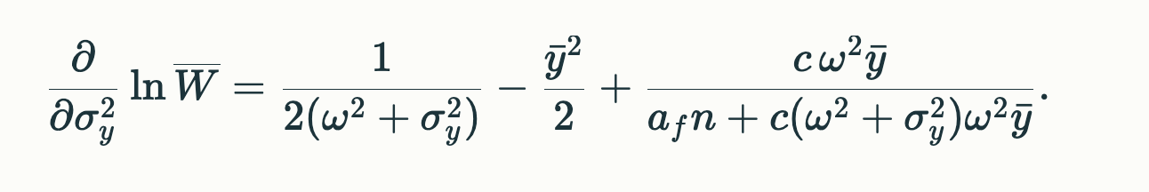

To get Beta for z, need to average over n.
Intergrate 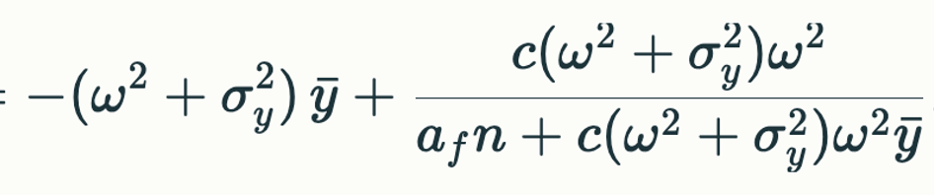
${\int_{-0}^{∞}{}(-(ω}^{2}+σ_{y}^{2})\overline{y}+\frac{{c(ω}^{2}+σ_{y}^{2})ω^{2}}{a_{f}n+{c(ω}^{2}+σ_{y}^{2})ω^{2}\overline{y}} ) \left(\frac{1}{\sqrt{2πσ_{n}^{2}}}\right)e^{{-(n}^{2}/2σ_{n}^{2})}$ dn

$$\sqrt{\frac{ω^{2}+σ_{y}^{2}}{2π}} e^{\frac{-{(ω}^{2}+σ_{y}^{2}){\overline{y}}^{2}}{2}} (a_{f}n+{c(ω}^{2}+σ_{y}^{2})ω^{2}\overline{y}$$

##new approach, set beta = o then integrate over n

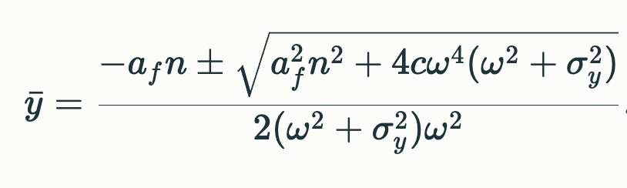

Produce figure of how selection differentials vary at equilibrium with alterations in α_{f} and c
- Produce similar figure for displacement from the optimum
- And for heritability.

Parameters from the kestrel:

Variance in lay date:

Effects of nutritional state cause a displacement of the mean phenotype from the optimal phenotype (as imposed by the external environment, Price et al., 1988; Hadfield & Reed, 2022). We model these effects to ask how individual optimization affects evolution of lay date, and potential responses to climate change. The advancement of lay dates in birds is one of the more conspicuous consequences of climate change (Neate-Clegg et al., 2024), and is considered to be largely a result of plasticity in response to warming temperatures (Charmantier et al., 2008; Bonamour et al., 2019). Plastic responses in lay date affect how populations will respond to earlier springs. First, variation within populations associated with nutritional state lowers heritability and potentially inhibits response to selection (Visser et al., 2015). Second, even in an unchanging environment, individual optimization creates a persistent selection differential on a non-heritable component of lay date. hence any contribution of individual optimization to the selection differential is not relevant to whether populations track climate change. Hence a persistent selection differential does not imply adaptative changes lag a moving optimum towards earlier breeding; such an inference first requires correction for individual optimization. Likewise, varying magnitudes of the selection differential does not mean that the intensity of selection on breeding date is necessarily varying (cf. Martin et al., 2025), but instead the translation of nutritional state into laying date may vary.

The selection differential is often presented as a quantitative measure of selection on lay date (Radchuk et al., 2019; De Villemereuil et al., 2020). The covariance is equivalent to the selection differential, defined as the difference between average lay date after weighting by relative fitness and the average lay date (Price, 1970).

Kestrel breeds earlier.
Discussion
The evidence for individual optimization in birds is strong (Rowe et al., 1994). Particularly persuasive are experiments with clutch size, whereby increasing or decreasing the clutch lowers parental fitness whatever the original clutch size (Tinbergen & Daan, 1990; Winder et al., 2025). On the basis of such experiments, Tinbergen & Daan (1990) showed that the clutch laid by most individuals in a great tit population (9-10 eggs) maximizes these individuals’ fitness, even though birds laying 15 eggs have the highest fitness. They concluded that the optimal size of the clutch varies substantially between individuals in the population. Experimental manipulations of lay date are more difficult, but they also support individual optimization (Verhulst & Nilsson, 2008). Verhulst and Nilsson (2008) found evidence for influences of both parental quality and date directly, and noted that both effects should be prevalent because it is “only if date per se is important, does an incentive exist for high-quality birds to breed early” (Verhulst & Nilsson, 2008, p.399). Advancements of lay date naturally occur from one year to the next and have also been induced many times by supplemental feeding. In both natural and experimental cases, clutch sizes regularly increase with advancement, and may lie on the within-season regression line (Perrins & Mccleery, 1989; Meijer et al., 1990; Rowe et al., 1994) Rowe et al. (1994) noted that the shift in the optimum clutch can be predicted if advancements simply start the accumulation of condition earlier (so birds move from tracking the lower line in Figure 1 to the upper line).
Individual optimization in the kestrel

Individual optimization of lay date has been most thoroughly investigated in the kestrel, Falco tinnunculus (Beukeboom et al., 1988; Dijkstra, 1988; Daan et al., 1990; Meijer et al., 1990). In this species the question of why birds in different condition should accumulate fitness at different rates has been addressed through demonstrations on effects on adult survival.

In the kestrel clutch size, survival in the nest, and survival through the first year all decline with lay date (over the 60 days of the main breeding season, clutch size declined by 40% (from 6 to less than 4 eggs) and offspring survival from fledging to reproduction declines by 50% and (from 0.45 to 0.3). The three components to be estimated are (Figure 1), the decline in offspring fitness due to environmental conditions as a function of lay date, gain in female fitness as a function of lay date, and how females differ in this gain. Individual optimization arises differently than is modelled, with advantages to a delay in breeding primarily operating through effects on female survival, not fecundity:
- Lay date manipulations of captive birds were achieved by altering photoperiod, thereby holding food effects constant. Subsequent release of 199 offspring from these birds showed that the earliest and latest hatching young had highest mortality, consistent with the stabilizing selection function in Figure 1, and assumed to drive declines in offspring survival with lay date in nature. ##assumes parents don’t affect##. omega = 27 days.

- As the season progresses, abundance of the kestrel’s primary prey (voles) increases. This benefit primarily affects adult survival, which balances the costs to survival of offspring. Hence variance in realized fecundity (i.e. clutch size) is considered to be equivalent to variance at the intercept. Tracking only female offspring, we divide clutch sizes by 2, and the from Figure 13 in (Daan et al., 1990) we obtain a value of σ_{n} = 0.44 female eggs.

Casting energy obtained from other prey into “vole equivalents”, capture rates increased on average at a rate of Y = n + 0.047 vole equivalents/day. The increase in capture rates means that

Different territories differ in quality (n), matching the assumption that the intercept rather than slope is the main determinant of a seasonal increase in parental fitness. The challenge is to translate this into parental fitness.

How do voles reduce flight time?

#note: offspring reproductive value is assumed to be all due to tie of breeding and not female investment. all investment is in to clutch size

note fecundity is higher on better territories. we want variance in n from flight times at intercept.

work with just females: female to female, and survival probability

so how many extra females can one raise if one waits? this is not Vo*c*0.5 because that includes survival probability.

many complications including survival in nest declines with season, so this is parental?

Hence adults which delay breeding spend less time foraging to catch a brood’s requirements. Daan et al. (1990) estimated the cost to survival of raising young through brood size manipulations. From an average of 3 hours flight time in a day, experimentally enlarging the brood by an average of 2.5 nestlings increased flight time to 4 hours/day, whereas reducing the brood by 1.74 nestlings decreased flight hours to 2 hours/day. Parental survival was also increased by brood reductions and decreased by brood enlargements, enabling the translation of flight time durations into survival costs. The lower prey densities early in the season imply a higher survival cost for the same number prey captured, and that survival costs decrease as time goes on. For a given territory the switch point is the point where the parental survival benefits of breeding later and with a smaller clutch are matched by offspring survival costs.
- Finally, individuals differ in density of voles on their territory throughout the season, as measured by variation in the intercept a (the empirical analysis matches the model depicted in Figure 1), generating later switch points for birds on poorer territories.

The predictions provide a very good fit to the data, implying that individual optimization accounts for practically the entire selection differential in this species.

Analyses in the great tit and pied flycatcher # next to read.
#remember: nothing about between year fluctuation
Selection differentials

A role for individual optimization (or more generally non-heritable nutritional state) as the explanation for the negative selection differential has been questioned along at least three lines.

First, substantial genetic evolution of lay date has been inferred, even as lay dates themselves have not advanced (Merilä et al., 2001; Gienapp et al., 2006). This inference was based on breeding values estimated using Best Linear Unbiased Prediction (BLUP). BLUP is now known to greatly overestimate genetic variance (Hadfield et al., 2010). However, a small contribution to genetic change may come from variation in heritable nutritional state. Despite persistent directional selection, heritability may be maintained by deleterious mutations, parasites, etc., with advances in every generation falling back through limits on resources (Cooke et al., 1990). The most recent estimate for total fitness is an average heritability of ~3% in bird and mammal populations (Bonnet et al., 2022).

Second, a selection differential associated with reproduction may persist because of trade-offs with other components (e.g. adult survival), so that integrated over the whole life cycle directional selection is absent. Such a trade-off for clutch size has been demonstrated after experimental manipulation, but is not observed in unmanipulated cases, attributed to over-riding effect of nutritional state (van Noordwijk & de Jong, 1986; Winder et al., 2025). In the case of lay date, the trade-off would imply late breeding, low fertility, individuals have higher survival than earlier breeding high fertility individuals, but we have no evidence that this is the case #great tit

Third, recent analyses have considered that the negative selection differential on lay date represents selection for earlier laying associated with climate change. In meta-analyses Radchuk et al. (2019) explicitly assumed an absence of condition effects, whereas de Villemereuil et al. (2020) considered such affects may make a small contribution.

Displacement from the optimum

Heritability cues, and directional selection increases plasticity, high variance across time (Perrins vs Charmantier).
Second, advantages to early breeding represent a transient phenomenon, reflecting impacts of advancing springs.

All models for the evolution of lay date, including the present one, have assumed that female condition operates as a constraint. This may be justified if females in low condition

- Does the mean lay date lie later than the optimum? Empirically it does to some extent in the kestrel

Several explanations resolving the conflict. ### higher fitness of earlier rather than later breeders are currently circulating in the literature. The third is that the negative correlation of lay date with fitness results from the joint effects of nutritional state (or access to resources), as in the individual optimization model.

Heritability of lay date is very difficult to estimate because of gene-environment correlations Heritability It was originally thought to be quite high, but after controlling for some environmental effects, the most recent estimates suggest they may be on the order of 12% (Jones et al., 2025) or less (Germain et al., 2016). Even these may be overestimates, as the perfect assortative mating (unlike all other traits) makes it extremely difficult to control for maternal and paternal effects, given high quality, early hatched, individuals are expected to breed early in the following year (Daan et al., 1990). Low heritability is expected if a large fraction of the phenotypic variance results from individual optimization. Quality differences are generally expected to lead to large environmental and phenotypic variances (Price et al and we should show that here).

Don;’t forget the huge variation between years. It is this variation that favors plasticity in the fisret place.

Is the result on the kestrel entirely individual optimization?
Rowe:

Our model makes a more specific prediction: if the start of
the breeding season is experimentally advanced or retarded, but rate of condition
gain is not altered by the manipulation, then manipulated birds will alter their
clutch size and lay date, but the clutches will be equal in size to unmanipulated
birds laying on the same date.
Mean a increases

radchuck

Experimental studies of ay date are relatively few, but more for clutch size and they do indicate trade-offs. However, non-experimental studies show no such evidence, suggesting the

Winder: no tradeoff (also in kestrel). But only looking at clutch size. And parental survival (not future reproduction or lay date). See p.99 daan et al

Remember IOC for assessment of breeding date, but also kestrel later.
Fluctuating environments (Perrins and McCleery note 1 month difference, but charmantier has a limited advance).
Winder: trade-ofs produce a set of equivalent fitnesses, but they are only looking at one dimension of reproduction (clutch) and one dimension of future reproduction (survival). For example, in the kestrel joint optimization…

Heritability of total fitness is 3% (Kruuk).
Avian breeding time also shows moderate heritability (van Noordwijk et al. 1981; van der Jeugd and McCleery 2002; Sheldon et al. 2003).

Comparisons of two populations of Great tits found that variation among individuals in their response to temperature shifts was much larger in one population than the other. This difference has proven difficult to explain. Given within population patterns are affected by individual optimization, we suggest that it reflects greater variation in nutritional state, territory quality, etc. in the population with more variable responses.

Contrasting patterns of phenotypic plasticity in reproductive traits in two great tit (Parus major) populations: multivariate patterns of phenotypic plasticity husby

Note declines in clutch size attributable to lay date in multiple species (Meijer et al)

Despite the costs of breeding early and raising large broods, the early breeders occupy better territories than the late breeders, and have similar survival probability: the selection differential on breeding date is close to zero.

Why would clutches be slightly larger for the same date?

Because food increases through the season, increased flight hours to catch voles are needed (1) early in the season and (2) for a larger clutch. For example, a clutch of 4 on day 100 creates the same parental effort as a clutch of 5 on day 120.

From data in Beukeboom et al (1988) and Daan et al. (1990) we calculate corresponding standardized selection differentials of # respectively..

Lay date is advanced by both food supplementation and in response to earlier emergence of natural food (voles). In both cases, clutch size increases are as expected from the within-year association of clutch size with lay date (as predicted from rowe et al linear increase).

The key assumption is that laying date is causally (and only?) involved in decline of Vo which is can’t be

Clutch value is assumed causally related to lay date (this is the problem) so estimated directly from measurements of survival etc. (do we need to worry about offspring genotype too?).

Parental survival is not correlated with lay date, but clutch size manipulations indicate it is by number of nestlings in the brood:.

Correlation mother and daughter = 0.07 (N = 104)

Remember Meijer et al has better list of clutch and lay date changes.

Visser data

x_values <- seq(-2, 2, length.out = 1000)

fun<-dnorm(x_values, mean(mismatch $seldiff), sd(mismatch $seldiff))

hist(mismatch$seldiff, prob = TRUE, col = "white",

ylim = c(0, 2), xlim=c(-1.2, 1.2),

main = "Histogram sel diff")

lines(fun~x_values, lwd=2)

the correlation of clutch size and lay date is r = -0.62)

Figure 1. Left: Offspring survival due to external conditions is modelled as a bell shaped (Gaussian) curve (purple); here drawn as a normal density with unit variance. Fecundity (including clutch size and parental provisioning of offspring) increase through the season as a linear function, with different start times depending on an individual’s nutritional state at the beginning of the breeding season. The illustrated lines are W(y) = n + cy, where n = 0.04 (low) and 0.34 (high), and c = 0.7. The product of offspring numbers and offspring survival is maximized whereby initially low nutritional state individuals (black lines) breed later and with smaller investment into the clutch than initially high nutritional state (equation 4). Right: Plot of displacement from the optimum versus nutritional state, n (in units of standard deviations of the survival curve).

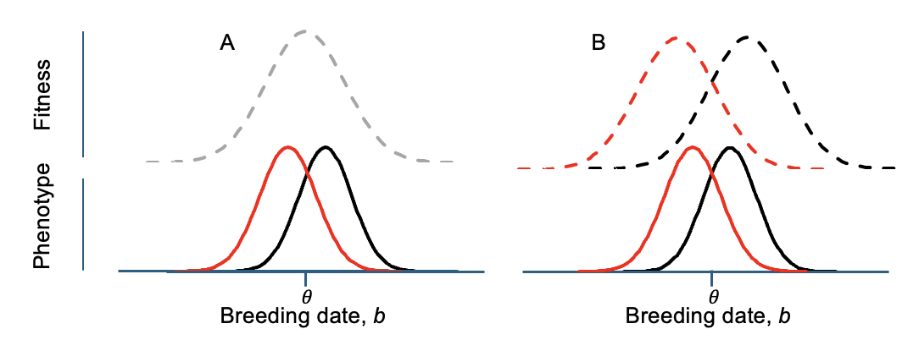

Figure 2. Models for the evolution of breeding date. Dashed lines give fitness functions. The population is assumed to be centered around the environmentally imposed optimum, $θ$, as would be the case in the absence of any nutritional effects. Solid lines give distributions of phenotypes for individuals in the top (red) and lower (black) half of nutritional state. (A) Both the top and bottom halves are under selection towards the optimum. Because more individuals are produced from the top half, the population mean shifts right (Price et al., 1988). (B) The top and bottom halves lie closer to $θ$ than their respective optima. Because more individuals are produced from the top half, the population mean shifts left (Hadfield & Reed, 2022).

