Individual optimization and the evolution of breeding date

In seasonal environments for both plants and animals, relatively late reproduction is commonly associated with reduced reproductive success (Donohue et al., 2010; Munguía-Rosas et al., 2011; Radchuk et al., 2019; De Villemereuil et al., 2020). The reasons have been most studied in bird species from the temperate region, in which a female’s fecundity (clutch size and number of fledged young) as well as the number of surviving offspring she has generally decline through the season (Klomp, 1970; Radchuk et al., 2019; De Villemereuil et al., 2020). Drent and Daan (1980) presented a compelling explanation for why this should be. They started by noting that the reproductive value of a juvenile (the product of its survival and future reproduction) should decline through the season because of environmental conditions. Several reasons have been proposed for why such a decline is to be expected (Tinbergen & Daan, 1990; Verhulst et al., 1995; Verhulst & Nilsson, 2008; Sutton & Freeman, 2023). The most general ones are the longer time available to prepare for the lean (winter) season, and competition from earlier fledged birds. While offspring value may decline, a delay in breeding enables parents to garner more resources and invest more in the brood (Perrins, 1970). At some point in time the gain in fecundity from reproducing late is balanced by the decline in reproductive value of offspring; this is the point at which an individual should start to breed.
In these models, external conditions affecting fitness decline at the same rate for all, but individuals differ in access to resources (Daan et al., 1990), or their condition (Drent & Daan, 1980; Rowe et al., 1994). Condition has also been termed nutritional state (Price et al., 1988), or quality (Winder et al., 2025) and may be defined as that combination of traits that give one individual higher overall fitness than another (van Noordwijk & de Jong, 1986; Winder et al., 2025). Similar consequences apply if a female’s quality reflects the quality of the territory she occupies. Given differences in nutritional state among females, the date on which a female should start to lay a clutch (termed the ‘switch point’ by Rowe et al., 1994), is earlier for higher quality individuals, who should also invest more in the clutch (e.g., Figure 1). As noted by Hadfield and Reed (2022) this is an example of phenotypic plasticity whereby date of breeding is set by the cue of an individual’s nutritional state. Experimental and correlational approaches have demonstrated the presence of all ingredients of the individual optimization model (Daan et al., 1990; Verhulst et al., 1995; Verhulst & Nilsson, 2008).

The advancement of average breeding date across years in bids is one of the more conspicuous consequences of climate change (Neate-Clegg et al., 2024). In an unchanging environment, individual optimization leads to a negative environmental covariance between fitness and lay date, i.e. a negative selection differential on the non-heritable component of lay date (Price et al., 1988), which persists at equilibrium (Price et al., 1988; Price & Liou, 1989; Alatalo et al., 1990; Rausher, 1992). The presence of such a selection differential, with no apparent response, as led recent authors to suggest that evolutionary change is not keeping up with the selection pressures for earlier breeding. However, assessment of the extent to which selection directly favors earlier breeding under climate change first requires correction for environmentally induced correlation. A corollary is that different values for the selection differential across years does not mean that the intensity of selection on breeding date is necessarily varying (cf. Visser et al., 2021; Martin et al., 2025); instead variance and mean in nutritional state may vary across years (De Villemereuil et al., 2020).

The presence of individual optimization within a season also directly affects how populations will respond to a warming climate. First, variation associated with nutritional state lowers heritability and potentially inhibits evolutionary responses to selection (Visser et al., 2015). Second, individual optimization impacts evolution of mean breeding date. Previous explanations for the way in which breeding date will evolve in the face of nutritional effects have produced conflicting answers. Price et al. (1988) treated the correlation of nutritional condition with lay date as a constraint. In this case the mean lay date evolves to be later than the externally-imposed optimum (Figure 2). Individuals breeding early are in higher nutritional state and produce more offspring. Consequently, the earlier breeding segment of the population experiences stronger selection towards the optimal times than the later breeding segment. At equilibrium, the total production of surviving offspring from the earliest half of the population must be equal to the total production from latest half of the population. This can only be the case if fewer individuals breed before the optimum.

Tinbergen and Daan (1990) and Hadfield and Reed (2022) noted that the Price et al. (1988) result involves the unrealistic assumption that individuals in high nutritional state are constrained to breed earlier than is optimal for them. Hadfield and Reed (2022) relaxed this constraint by assuming that the optimal breeding date is indeed earlier for individuals in high nutritional state. Modelling this optimum as a linear function of nutritional state, they obtained the opposite result to Price et al. (1988), finding that the average breeding date should evolve to be earlier than that imposed by the environment. The reason for this is that costs to plasticity (and/or uncertain cues) mean that the early breeders in high nutritional state are likely to breed too late for their optimum, whereas the late, low nutritional state, individuals are likely to breed too early for their optimum. Because more offspring are produced by the early breeding individuals than the late breeding individuals, selection towards the earlier optimum is stronger (Figure 2).

Neither Price et al. (1988) nor Hadfield and Reed (2022) provided an adaptive explanation for why lay date and nutritional state should be correlated. The individual optimization hypothesis does so, by assuming that individuals only breed when they have garnered sufficient resources, which takes time (Perrins, 1970). If nutritional state increases approximately linearly with date, and external conditions impose symmetrical selection pressures around an optimum, it should always pay individuals to delay breeding until after the optimum, rather than before (Figure 1), but exactly where is unclear. Here we model the evolution of breeding date assuming individual optimization, assessing (1) how the selection differential varies as a function of nutritional state, and (2) displacement of the mean from the externally imposed optimum.

Model

The key feature that separates the model from that of Hadfield and Reed (2022) is that nutritional state is not a constant. In the present case, nutritional state, and investment into the brood increases linearly with breeding date, y, as a female accumulates resources (Daan et al., 1990; Rowe et al., 1994). Apart from new parameters, notation follows that of Hadfield and Reed (2022)
First, an individual’s breeding date is modeled as
y = x + p + e (1),

where x is the genetic value, p the plastic response to nutritional state, and e an environmental deviation, each assumed to follow a normal distribution. Variance in breeding dates is the sum of the genetic, plastic and environmental variances, i.e. $σ_{y}^{2}$ = $σ_{x}^{2}$ + $σ_{p}^{2}$+ $σ_{e}^{2}$. $σ_{x}^{2}$, $σ_{e}^{2}$ are assumed constant, but $σ_{p}^{2}$ results from the resolution of the fitness functions affected by the environment and nutritional state.

As shown in Figure 1, we assume that a Gaussian function describes fitness attributed to direct effects of breeding date, y (e.g., De Villemereuil et al., 2020).

$C\left(y\right)∝exp⁡(-\frac{{(y-θ)}^{2}}{{2ω}^{2}})$ (2).

For simplicity in further development we set the optimal breeding date, $θ$ = 0, so an individual’s breeding date is written relative to the optimum.

A linear function describes increase in fecundity, F, with breeding date:
F(n, y) = n + cy (3).
Here n is the intercept on the Y-axis defining nutritional state when breeding date = 0, and assumed to be normally distributed with mean, $\overline{n,}$ and variance, $σ_{n}^{2}$. Subsequently, all individuals are assumed to accumulate resources at the same rate, c. While in nature c may differ among individuals #check Ramakers#, including this possibility into the analysis makes for several complications (Hadfield & Reed, 2022). The model is also over-parameterized, in that the same resource investment can result from multiple combinations of intercept and slope. The focus on intercept is further justified from studies in nature which find the slope to be less variable than the intercept (Daan et al., 1990; Ramakers et al., 2019; Winder et al., 2025). Rowe et al. (1994, p.711) in their review of experiments up to that time note that “The pattern suggests that the primary effect of most manipulations has been to advance the time at which birds begin gaining condition for breeding, without greatly increasing the rate of condition gain during the breeding season”.
Individual fitness is given as the product of (2) and (3):
$W\left(n,y\right)∝exp⁡(-\frac{y^{2}}{{2ω}^{2}})(n + cy)$ (4)

The optimal breeding date for an individual of a given initial nutritional state, n, is given by taking the derivative of equation (3) with respect to y, and setting the result = 0:

$\hat{y}(n)= \frac{-a_{f}n+\sqrt{n^{2 }+4c^{2}ω^{2} }}{2c}$ (5)

Figure 3 gives an example of how individual fitness varies with respect to both breeding date and nutritional state.

Produce figure of how selection differentials vary at equilibrium with alterations in nbar and sigma n

Produce similar figure for displacement from the optimum

And for heritability.

Parameters from the kestrel:

Variance in lay date:

Discussion
The evidence for individual optimization in birds is strong (Rowe et al., 1994), often explaining > 80% of the variation in lay date. Particularly persuasive are experiments with clutch size, whereby increasing or decreasing the clutch lowers parental fitness whatever the original clutch size (Tinbergen & Daan, 1990; Winder et al., 2025). On the basis of such experiments, Tinbergen & Daan (1990) showed that the clutch laid by most individuals in a great tit, Parus major, population (9-10 eggs) maximizes these individuals’ fitness, even though birds laying 15 eggs have the highest fitness, concluding that “individuals have a clutch size that is adapted to their environment and/or quality”. Experimental manipulations of lay date are more difficult than those of clutch size, but they also support individual optimization (Verhulst & Nilsson, 2008). For example, changes in average lay date naturally occurs from one year to the next, and advances in lay date have been induced many times by supplemental feeding (Ruffino et al., 2014). In both natural and experimental cases, average clutch sizes regularly increase with advancement, and often lie on the within-season regression of clutch size on date (Perrins & McCleery, 1989; Meijer et al., 1990; Rowe et al., 1994). Rowe et al. (1994) noted that the shift in the average clutch is expected if advancements result in the accumulation of nutritional state earlier (so birds move from tracking the lower line in Figure 1 to the upper line). The match between prediction and observation therefore provides strong support that most of the variation among individuals is a consequence of individual optimization.

Here we have asked three questions about how individual optimization affects

remember in de vill means are to right of optimum, and many show no sign of optimum

#remember: nothing about between year fluctuation
Selection differentials

A role for individual optimization (or more generally non-heritable nutritional state) as the explanation for the negative selection differential has been questioned along at least three lines.

First, substantial genetic evolution of lay date has been inferred, even as lay dates themselves have not advanced (Merilä et al., 2001; Gienapp et al., 2006). This inference was based on breeding values estimated using Best Linear Unbiased Prediction (BLUP). BLUP is now known to greatly overestimate genetic variance (Hadfield et al., 2010). However, a small contribution to genetic change may come from variation in heritable nutritional state. Despite persistent directional selection, heritability may be maintained by deleterious mutations, parasites, etc., with advances in every generation falling back through limits on resources (Cooke et al., 1990). A recent estimate for total fitness is an average heritability of ~3% in bird and mammal populations (Bonnet et al., 2022).

Second, a selection differential associated with reproduction may persist because of trade-offs with other components (e.g. adult survival), so that integrated over the whole life cycle directional selection is absent. Such a trade-off for clutch size has been demonstrated after experimental manipulation, but is not observed in unmanipulated cases, attributed to over-riding effect of nutritional state (van Noordwijk & de Jong, 1986; Winder et al., 2025). In the case of lay date, the trade-off would imply late breeding, low fertility, individuals have higher survival than earlier breeding high fertility individuals, but we have no evidence that this is the case #great tit

Third, recent analyses have considered that the negative selection differential on lay date represents selection for earlier laying associated with climate change. In meta-analyses Radchuk et al. (2019) explicitly assumed an absence of condition effects, whereas de Villemereuil et al. (2020) considered such affects may make a small contribution.

Displacement from the optimum

Heritability cues, and directional selection increases plasticity, high variance across time (Perrins vs Charmantier).
Second, advantages to early breeding represent a transient phenomenon, reflecting impacts of advancing springs.

Estimates of heritability of
breeding time in birds range from 0.001 to 0.45 (Teplitsky
et al., 2010; van Noordwijk et al., 1981)
Compared to other reproductive traits in birds,
like clutch size, breeding timing shows lower heritability, but
greater variation between and within years, suggesting there
is a larger influence of environmental factors (Evans et al.,
2020; Van Der Jeugd & McCleery, 2002).
All models for the evolution of lay date, including the present one, have assumed that female condition operates as a constraint. This may be justified if females in low condition

- Does the mean lay date lie later than the optimum? Empirically it does to some extent in the kestrel

Several explanations resolving the conflict. ### higher fitness of earlier rather than later breeders are currently circulating in the literature. The third is that the negative correlation of lay date with fitness results from the joint effects of nutritional state (or access to resources), as in the individual optimization model.

Both C, Piersma T, Roodbergen SP (2005) Climatic change explains much of the 20th century advance in laying date of northern lapwing Vanellus vanellus in the Netherlands. Ardea, 93, 79–88.
for condition effects on selection differential, see visser et al
drent and daan
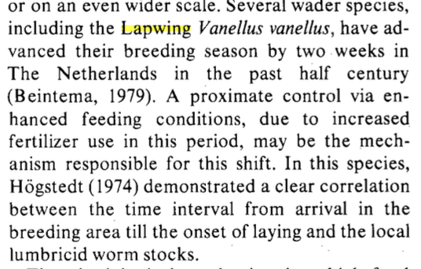
Heritability
Heritability of lay date is very difficult to estimate because of gene-environment correlations. It was originally thought to be quite high, but after controlling for some environmental effects, the most recent estimates suggest they may be on the order of 10%-20% (Gienapp et al., 2006; Brommer & Rattiste, 2008; Jones et al., 2025) or less (Germain et al., 2016). Even these may be overestimates, biased upwards especially if maternal and paternal effects result in high quality, early hatched, individuals breeding early in the following year. Such parental effects are apparent in many datasets, and when controlled for as far as possible reduce heritability estimates (Jones et al., 2025). Unlike all other traits, the phenotypic correlation between breeding time of males and females = 1.0, and it is unclear how much further this will bias estimates, and whether they have been controlled. In summary, low heritability for breeding time appears to be widespread. We show here a low heritability is expected if a large fraction of the phenotypic variance results from individual optimization. Consequently responses to direct selection on lay date will be slow (Gienapp et al., 2006).(Visser et al., 2015)

Don;’t forget the huge variation between years. It is this variation that favors plasticity in the fisret place.

Is the result on the kestrel entirely individual optimization?
Rowe:

Our model makes a more specific prediction: if the start of
the breeding season is experimentally advanced or retarded, but rate of condition
gain is not altered by the manipulation, then manipulated birds will alter their
clutch size and lay date, but the clutches will be equal in size to unmanipulated
birds laying on the same date.
Mean a increases

radchuck

Experimental studies of ay date are relatively few, but more for clutch size and they do indicate trade-offs. However, non-experimental studies show no such evidence, suggesting the

Winder: no tradeoff (also in kestrel). But only looking at clutch size. And parental survival (not future reproduction or lay date). See p.99 daan et al

Remember IOC for assessment of breeding date, but also kestrel later.
Fluctuating environments (Perrins and McCleery note 1 month difference, but charmantier has a limited advance).
Winder: trade-ofs produce a set of equivalent fitnesses, but they are only looking at one dimension of reproduction (clutch) and one dimension of future reproduction (survival). For example, in the kestrel joint optimization…

Heritability of total fitness is 3% (Kruuk).
Avian breeding time also shows moderate heritability (van Noordwijk et al. 1981; van der Jeugd and McCleery 2002; Sheldon et al. 2003).

Comparisons of two populations of Great tits found that variation among individuals in their response to temperature shifts was much larger in one population than the other. This difference has proven difficult to explain. Given within population patterns are affected by individual optimization, we suggest that it reflects greater variation in nutritional state, territory quality, etc. in the population with more variable responses.

Contrasting patterns of phenotypic plasticity in reproductive traits in two great tit (Parus major) populations: multivariate patterns of phenotypic plasticity husby

Note declines in clutch size attributable to lay date in multiple species (Meijer et al)

Despite the costs of breeding early and raising large broods, the early breeders occupy better territories than the late breeders, and have similar survival probability: the selection differential on breeding date is close to zero.

Why would clutches be slightly larger for the same date?

Because food increases through the season, increased flight hours to catch voles are needed (1) early in the season and (2) for a larger clutch. For example, a clutch of 4 on day 100 creates the same parental effort as a clutch of 5 on day 120.

From data in Beukeboom et al (1988) and Daan et al. (1990) we calculate corresponding standardized selection differentials of # respectively..

Lay date is advanced by both food supplementation and in response to earlier emergence of natural food (voles). In both cases, clutch size increases are as expected from the within-year association of clutch size with lay date (as predicted from rowe et al linear increase).

The key assumption is that laying date is causally (and only?) involved in decline of Vo which is can’t be

Clutch value is assumed causally related to lay date (this is the problem) so estimated directly from measurements of survival etc. (do we need to worry about offspring genotype too?).

Parental survival is not correlated with lay date, but clutch size manipulations indicate it is by number of nestlings in the brood:.

Correlation mother and daughter = 0.07 (N = 104)

Remember Meijer et al has better list of clutch and lay date changes.

Visser data

x_values <- seq(-2, 2, length.out = 1000)

fun<-dnorm(x_values, mean(mismatch $seldiff), sd(mismatch $seldiff))

hist(mismatch$seldiff, prob = TRUE, col = "white",

ylim = c(0, 2), xlim=c(-1.2, 1.2),

main = "Histogram sel diff")

lines(fun~x_values, lwd=2)

the correlation of clutch size and lay date is r = -0.62)

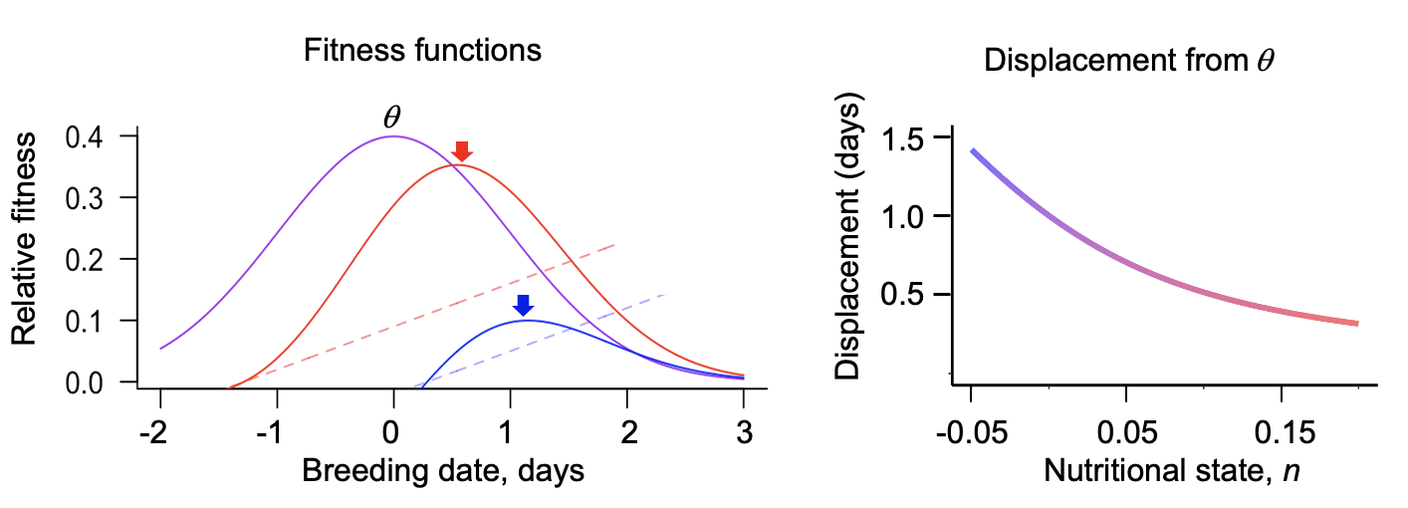

Figure 1. Left: The fitness component due to external conditions is modelled as a Gaussian curve (purple), drawn optimum with, $θ=0$ and width, $ω=1$. Fecundity due to the mother increases through the season as a linear function (dashed lines), with different start times depending on an individual’s nutritional state. The illustrated lines are F(y) = n + cy, where n = -0.02 (blue) and 0.09 (red), and c = 0.07. The solid curves plot female fitness, scaled 8x over the two components. Right: Plot of displacement of individual optima from $θ$versus nutritional state, n.

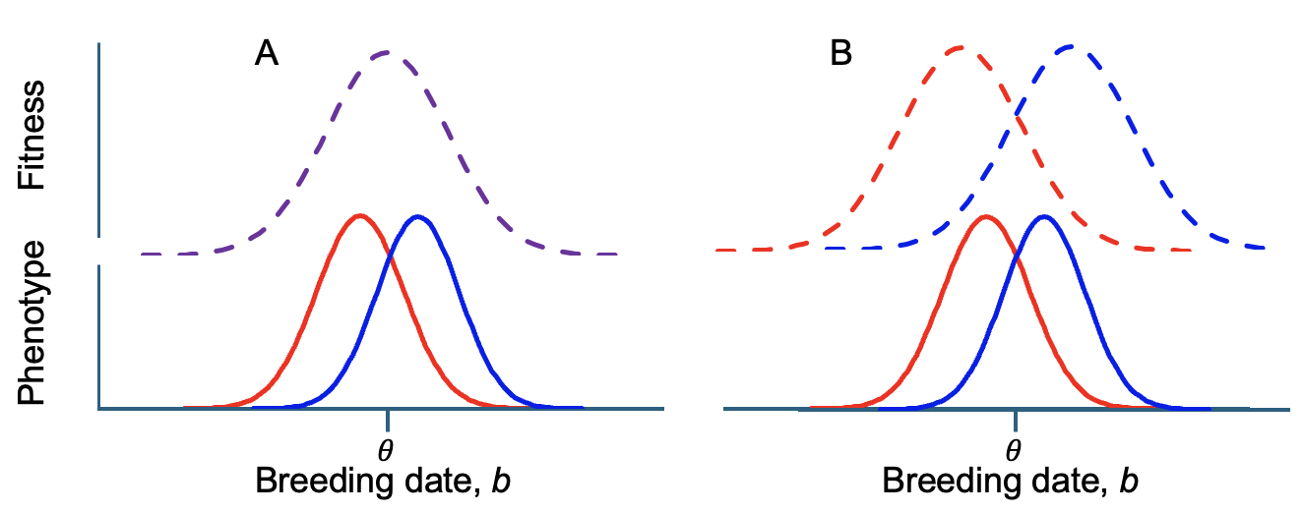

Figure 2. Previous models for the evolution of breeding date. Dashed lines give fitness functions. The population is assumed to be initially centered around the environmentally imposed optimum, $θ$. Solid lines give distributions of phenotypes for individuals in the top (red) and lower (blue) half of nutritional states. (A) Both the top and bottom halves are under selection towards the optimum. Because more individuals are produced from the top half, the population mean shifts later (Price et al., 1988). (B) The top and bottom halves lie closer to $θ$ than their respective optima. Because more individuals are produced from the top half, the population mean shifts earlier (Hadfield & Reed, 2022)

Appendix: Individual optimization in the kestrel
To model evolution under individual optimization, we need estimates of the width, $ω$and optimum $θ$, in the stabilizing selection function, the mean nutritional state, $\overline{n,}$ at y = 0 and its variance, $σ_{n}^{2},$and the linear increase with date, c. Empirical separation of these effects has been difficult. One reason is that fecundity will often be maximized not just through number of eggs laid but also through investment into the provisioning of young. Accordingly, parental nutritional state affects offspring survival. Indeed, much effort has gone into attempting to separate effects of ‘date’ from ‘quality’ on offspring survival with evidence for influences of both (Verhulst & Nilsson, 2008).

We are aware of only one study where point estimates for parameters associated with fitness can be estimated. Estimates come with large confidence limits but at least give a starting point for evaluation. This concerns a Dutch population of kestrels, Falco tinnunculus (Beukeboom et al., 1988; Dijkstra, 1988; Daan et al., 1990; Meijer et al., 1990). Two features of this system differ from the conceptualization we have followed. First, nutritional state is measured as territory quality. Second, increase in female fitness with date results not through fecundity, but primarily through future survival.

In the kestrel clutch size, survival in the nest, and survival through the first year all decline with lay date. Over the 60 days of the main breeding season, clutch size declined by 40% (from 6 to less than 4 eggs) and offspring survival from fledging to reproduction declines by 50% and (from 0.45 to 0.3). The three components to be estimated are selection on offspring as a function of lay date $ω$, gain in female fitness as a function of lay date (c), and how females differ in this gain (σ_{n}) (Figure 1).
- Direct selection on offspring as a function of lay date $ω.$ Lay date manipulations of captive birds independent of the effect of parental quality were achieved by altering photoperiod. Subsequent release of 199 offspring from these birds showed that the earliest and latest hatching young had highest mortality, consistent with the stabilizing selection function in Figure 1, and assumed to drive declines in offspring survival with lay date in nature, $ω$ = 27 days.

- Because voles increase through the season, kestrels need to spend less time hunting to get the same yield as the season progresses. Hunting yield goes up by 0.047 vole equivalents per hour per day (one bird equals 2 voles). This increase is modelled as constant across territories, implying that for the same yield, flight times can be reduced by 0.045 hours per day. Unlike the basic model, in the kestrel, the benefit to the female is primarily realized in survival and future reproduction (Vp in the notation of Daan et al. (1990)) and not immediate fecundity. Experiments involving brood enlargement and reduction measured both changes in hours of flight times and subsequent survival and future reproduction (Daan et al., 1990, Fig. 9). They lead to an estimate of Vp = 2* 0.045 or c = 0.09 femaleeggs/day.

- Because benefits accrue through future reproduction, variance in realized fecundity (i.e. the clutch size) is equivalent to variance in n. Tracking only female offspring, we divide clutch sizes by 2, and from Figure 13 in Daan et al. (1990) obtain a value of $\overline{n}$ = 2.6, σ_{n} = 0.44 female eggs.

what fraction of the distribution lies to the left of theta?

What is the optimum in Hadfield model? in
Next thing: visser sds for pied flycatcher

Individual optimization of reproduction in a long-lived migratory bird: a test of the condition-dependent model of laying date and clutch size
Oostra V, Saastamoinen M, Zwaan BJ, Wheat CW. 2018 Strong phenotypic plasticity limits potential for evolutionary responses to climate change. Nat. Commun. 9, 1005. (doi:10. 1038/s41467-018-03384-9)
Charmantier, A., and P. Gienapp. 2014. Climate change and timing of avian
breeding and migration: evolutionary versus plastic changes. Evol. Appl.
7:15–28.

Need to integrate earlier seasons, higher clutch,, and advances induced by supplemental feeding (daan in ioc)
Husby A, Visser ME, Kruuk LEB (2011) Speeding up micro-evolution: annual strength of selection and heritability are positively associated in a wild bird population. PLoS Biology 9: e1000585. doi: 10.1371/ journal.pbio.1000585 PMID: 21408101

Changes in phenology can alter patterns of natural selection: the joint evolution of germination time and postgermination traits

Within a season, late reproducing individuals commonly have lower reproductive success than those that reproduce earlier, generating a correlation of fitness with breeding date (i.e. a selection differential). Under the individual optimization hypothesis, this is expected if a delay in breeding increases parental fitness, but decreases offspring survival, individuals in lower nutritional condition lag in their accumulation of resources to invest. Here we ask how the mean and variance in breeding date, the correlation of breeding date with fitness, and its heritability evolve under individual optimization. We show that mean breeding date evolves to be later than the optimum for offspring survival, that selection differentials can be high, h2.. alterations in individual condition can relatively easily account for shifts in sd…

The correlation between lay date generates a selection

iler et al 2021 However, early snowmelt reduces projected population growth rates mainly through reductions in survival, not seed production, showing that earlier flowering in this case has little population-level consequence (Iler et al. 2019).
E. M. Wolkovich, M. J. Donahue, How phenological tracking shapes species and
communities in non-stationary environments. Biological Reviews 96, 2810–2827 (2021).

p half, the population mean shifts left (Hadfield & Reed, 2022).

age specific reproduction:
https://doi.org/10.1111/j.1365-2656.2007.01234.x
Forrest, J., & Miller-Rushing, A. J. (2010). Toward a synthetic
understanding of the role of phenology in ecology and evolu-
tion. Philosophical Transactions of the Royal Society of London,
Series B: Biological Sciences, 365(1555), 3101–3112. https://doi.

org/10.1098/rstb.2010.0145

shows also that early breeding individuals produce early breeding individuals likely through quality

this one shows how messed up by annual variation

Unpredictable food supply modifies costs of reproduction and hampers individual optimization

By
Török, J (Török, J) ; Hegyi, G (Hegyi, G) ; Töth, L (Töth, L) ; Könczey, R (Könczey, R)

gustafson paper in scientific reports

We found that young and old females, but not middle-aged females, breeding under low NDVI started to lay eggs later and produced smaller clutches than females of the same age breeding under higher NDVI.

#age Ferreira.

plasticity:

and is considered to be largely a result of phenotypic plastic responses to earlier springs (Charmantier et al., 2008; Bonamour et al., 2019).

#I am unsure we can do this now, because $σ_{y}^{2}$depends on $σ_{p}^{2}$ and $σ_{p}^{2}$ depends on where the equilibrium is.

The model is developed in five stages. First, we compute the individual fitness function breeding date as a function of nutritional state. Second, we turn this into the mean fitness function by integrating across the phenotypic distribution. Third, we differentiate log (mean fitness) with respect to mean breeding date to obtain the directional selection gradient, β (Lande, 1979), operating directly on lay date. Fourth, we integrate over nutritional states to obtain the average selection gradient with respect to mean breeding date. Fifth, we set β = 0 to obtain the equilibrium.

Averaging fitness (equation 4) over the breeding date distribution y, we obtain:
$\overline{W}\left(n,\overline{y}\right)= \sqrt{\frac{1}{2π{(ω}^{2}+σ_{y}^{2})}} exp⁡(\frac{-{\overline{y}}^{2}}{2{(ω}^{2}+σ_{y}^{2})})(a_{f}n+\frac{cω^{2}\overline{y}}{ω^{2}+σ_{y}^{2}}$)
- differentiate with respect to ybar, for beta
- set equal to zero to solve for ybar for each n
- integrate over n to get mean
- The selection differential is often presented as a quantitative measure of selection on lay date (Radchuk et al., 2019; De Villemereuil et al., 2020). The covariance is equivalent to the selection differential, defined as the difference between average lay date after weighting by relative fitness and the average lay date (Price, 1970).
- Kestrel breeds earlier.
- Analyses in the great tit and pied flycatcher # next to read.

#mean fitness plot now defunct, as we don';'t know sigmasqy

computessd<-function(lay, fit) {

freq=(1/sqrt(2*pi*var(lay)))*exp(-((mean(lay)-lay)^2)/(2*var(lay)))

prop<-freq/sum(freq)

relfit<-fit/sum(prop*fit)

sdiff<-sum(prop*relfit*lay)-sum(prop*lay)

SSD<-sdiff/sqrt(var(lay))

return(SSD)}

p3<-p2 + theme(panel.grid.major = element_blank(), panel.grid.minor = element_blank(),

panel.background = element_blank(), axis.line = element_line(colour = "black"))+theme(legend.position = "none")

return(p3)}

omegasq=1

sigmasqy=1

c=1

af=1

ybar <- seq(-3, 3, 0.1)

n <- seq(-3, 3, 0.1)

Wbar<-function(ybar, n){

gamma<-1/(omegasq+sigmasqy)

Wb<- sqrt(gamma/(2*pi)) *exp(-(gamma*ybar^2)/2)* (af*n + gamma*c*omegasq*ybar)}

#setting omegasq=sigmasq=1, so gamma = 1/2, c=1, af=1

Wbar2<-function(ybar, n) (n + ybar/2)*sqrt(1/(4*pi))*exp(-(ybar^2/4)) #these do not average over n so not helpful.

z <- outer(ybar,n, Wbar2)

open3d()

persp3d(ybar,n, z,

theta = 40, phi = 30,

ylab = "n", xlab = "ybar", zlab = "Wbar",

col = "lightblue", shade = 0.5, border = NA, box=F)

plot(Wbar2(ybar, 2)~ ybar, type="l", las=1, bty="l", col="blue", ylab="Mean Fitness", xlab="Mean Breeding date", yaxt="n", ylim=c(0,2))

at2 <- pretty(range(n))

lab <- sprintf("%.0f", at2)

axis(2, at2, labels = lab)

lines(Wbar2(ybar, 1)~ ybar, col="purple")

lines(Wbar2(ybar, 3)~ ybar,col="red")

Verhulst and Nilsson (2008) noted that both are expected under individual optimization because it is “only if date per se is important, does an incentive exist for high-quality birds to breed early” (Verhulst & Nilsson, 2008, p.399).

