Dear Jose
I hope I am not writing this one prematurely. The earlier ask unfortunately had a conceptual error, and perhaps I have it right now. Anyway, I think it wasn’t entirely wasted as the same math machinery seems required.

We started with the function for the mean fitness which looks correct: 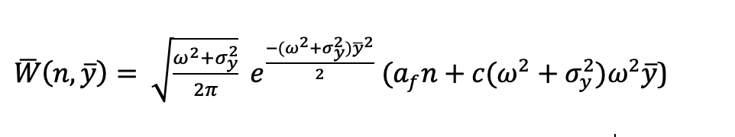

But we want to get the equilibrium solutions for $\overline{y}$and $σ_{y}^{2}$ if that is possible (not a and c). This would give us the mean breeding date and variance in breeding date, the latter being important as it would indicate plasticity.

Without really knowing what I was doing I used ai to calculate the partial derivatives of log fitness (the selection gradient, which gives the direction and intensity of selection for every n):

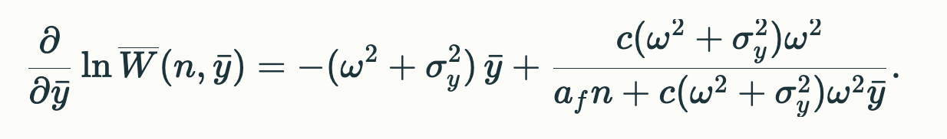
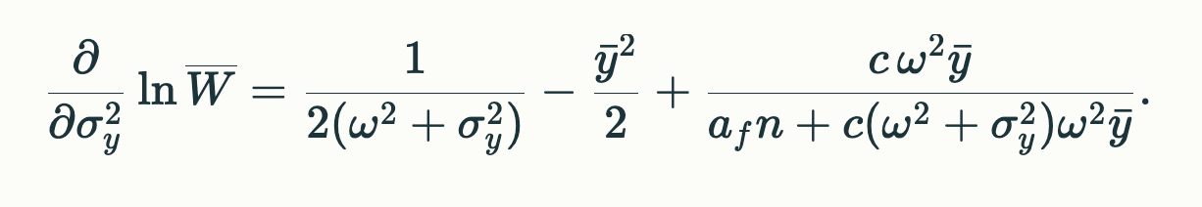

These now must be averaged over n, which is distributed as N(0, $σ_{n}^{2}$).

Of course I tried that and got “That expectation does not simplify to elementary functions in general; it is usually expressed via special functions (related to the Faddeeva/error function) or evaluated numerically, and it is finite only if the distribution of $a_{f}N+d$ does not put mass near zero (otherwise the integral diverges).”

So, is there any way we can get an expression for the selection gradient averaged across n? We would then set it equal to zero and solve for $\overline{y}$and $σ_{y}^{2}$. Even if I am not quite on the right track, I feel this result would be helpful if it is at all possible. Meanwhile I’ve written a fair chunk of the empirical part, but most of the rest hangs on results.

