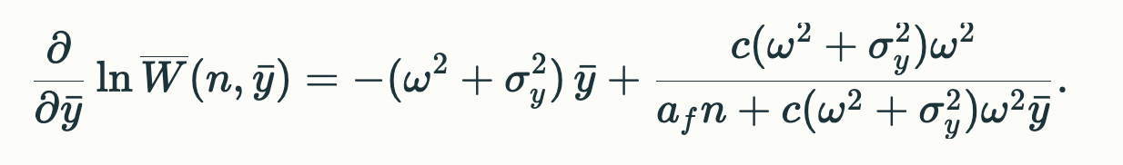
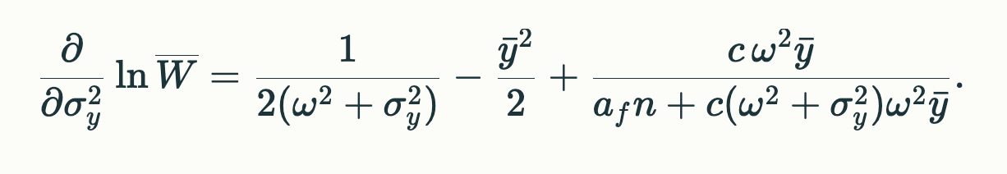

Yesterday the plan was (following other treatments) to integrate these expressions over n, which would give us the selection gradient. The goal was to set these gradients equal to zero to figure out the equilibria for $σ_{y}^{2}$ and $\overline{y}$.

I think it may be easier and give the same result?:

Alternatively set the above equations equal to zero and then integrate over n. Of course, I tried it in AI for the first equation (in $\overline{y})$ and got:

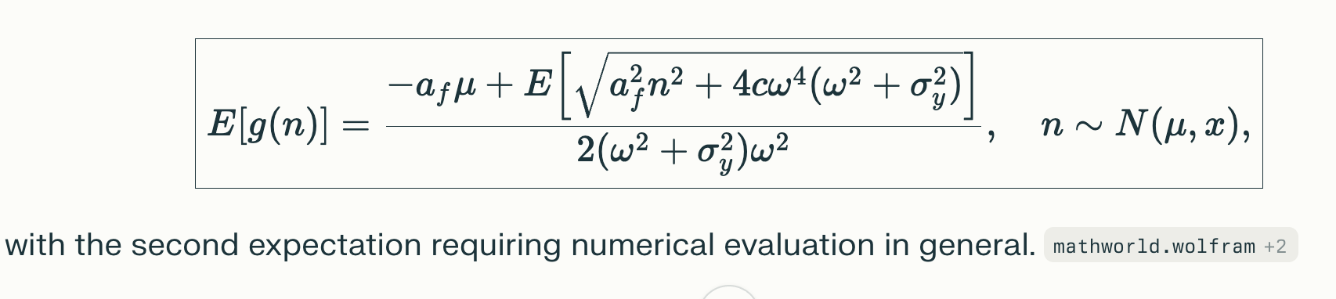 apparently, Gauss–Hermite quadrature or standard quadrature routines…
This is beyond me, but can it be done?
Thanks much

