I have a question that depends on the precise meaning of n (which I still don't get completely): why not average the mean fitness function W over n first, and then find the optimum condition by taking the partial derivatives of the logarithm of that average?

Just to confirm, by optimum you mean equilibria for $σ_{y}^{2}$ and $\overline{y}$? This seems to make total sense to me, but I have no intuition for how the now 3 different ways would lead to different results.

Regarding n, it should be considered only in the context of this equation, which is individual fitness (before averaging over y):
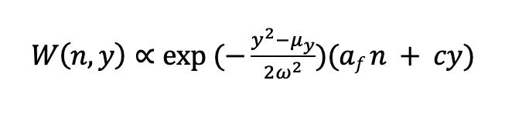

Hence n is the intercept in a linear term that describes how an individual’s fitness increases with date (y) (previously we had it appearing somewhere else as well, that was incorrect).

In this equation fitness can go negative, which seems to have been the problem throughout.

I had thought we could set both optimal breeding date $μ_{y}$= 0 and $\overline{n}$ = 0 as well. This gives us intermediate optima in the positive side for y, but not equilibria. Now I am wondering about 2 options.

- Can we just integrate over y with constrained limits? With limits of 0, $∞$ a lot of the density for would lie in the negative portion. But say somehow, we set $μ_{y}$ to be very large say 100?
- Is there is a way to place constraints on both n and y so that W(n,y) doesn’t go below zero?

here’s a plot of $\overline{W}$that shows how weird it looks. Fitness is higher for extreme negative values in both n and $\overline{y}$ because the gaussian function goes close to 0, so the negative quadrant is completely unrealistic.
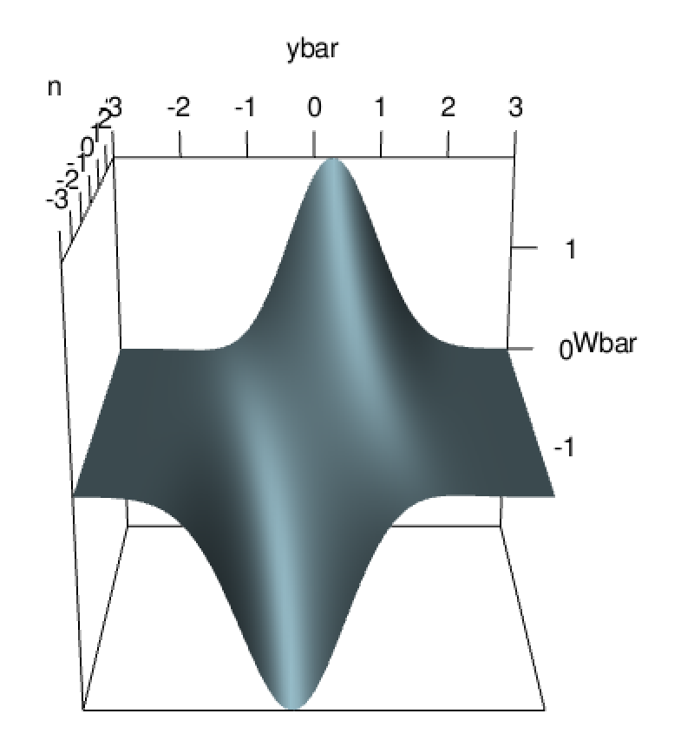

Hence that the optimum condition is not satisfied for every specific value of n without some sort of constraint.
(We can’t simply substitute $e^{n}$, because then there is no intermediate optimum)

