MEMORANDUM

Date : May 19, 2023
To : Finance / HRD
From : TS - Production
Re : Off- set Schedule

Please be informed that I, Mydel Alcazar with E.N. R020 was on off-set schedule last May 16, 2023. I have to accomplish some reports that will be presented early in the morning, with this I reported to work from 7:30PM of May 15, 2023 to 7:30AM of May 16, 2023.
With this, I am requesting on your good office to consider that day as regular work schedule.

Hoping that this request will find favor on your sight.

Thank you for your consideration.

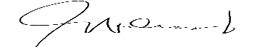
Prepared by:
Mydel B. Alcazar
Jr. Production Supervisor

Checked by:
Malou M. Malabanan
Sr. Production Manager

