E-Portal
Employee Complaint
User Manual

Submit Complaint
Step 1: Login with your E-Portal account
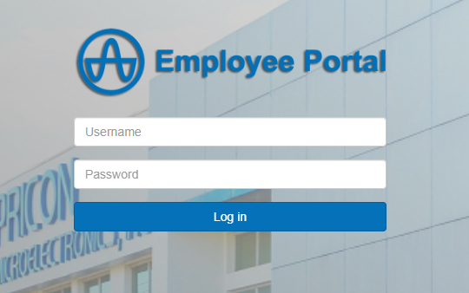

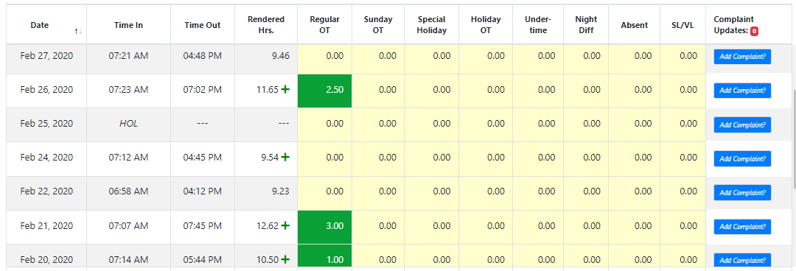
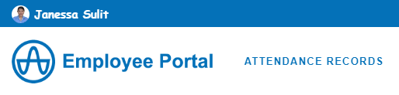
Step 2: Click “ATTENDANCE RECORDS” link, select one concern date then, click “Add Complaint” button
1

2
3

Step 3: Select Immediate Superior and input your complaint then, click “Send Complaint” button
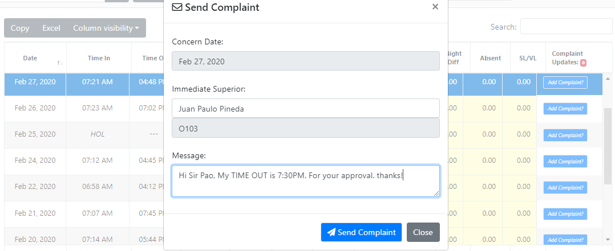
1
2
3

Step 4: Click “OK” button.
System will prompt alert notification and will send email notification to your Immediate Superior for approval.

4
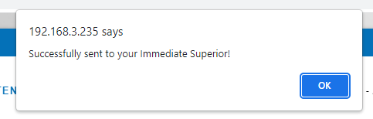
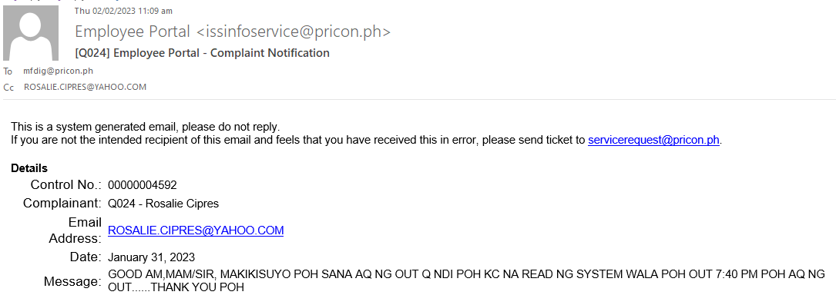

Once Conformed by Finance, Complaint updates will be displayed.
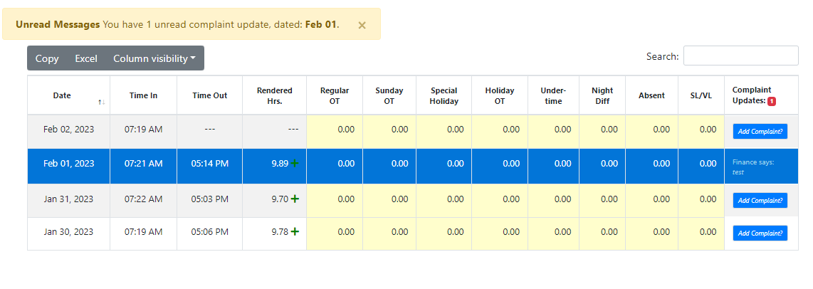

Complaint – Approval (Superior)
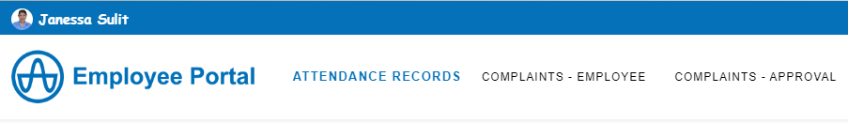
Step 1: Click “COMPLAINTS – APPROVAL” link then, click Employee’s complaint
1
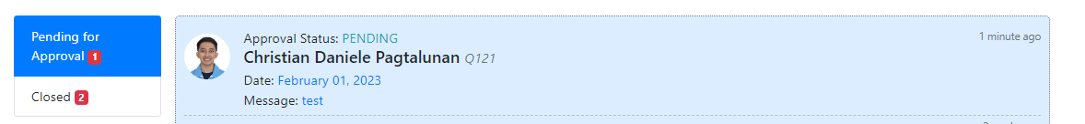
2

Step 2: Select “Approved” or “Disapproved” button, input your approval remarks then, click “Submit” button.
If Approved, Approval remarks is optional.
If Disapproved, Approval remarks is required.
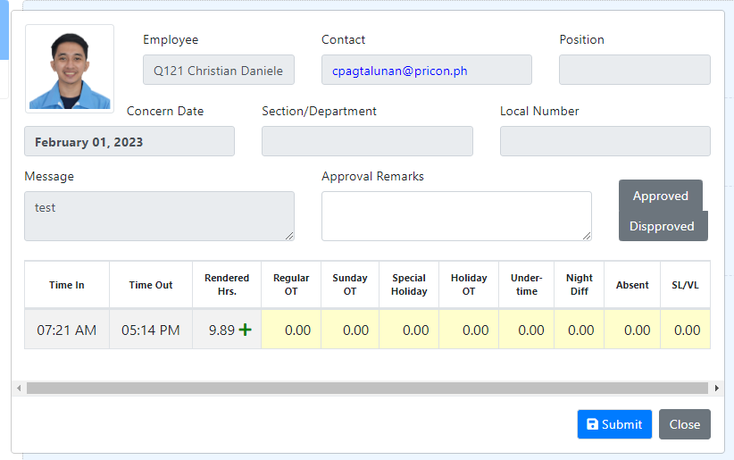

3
2
1

Step 3: Click “OK” button.
System will prompt alert notification and will send email notification to Ms. Joy Serrac for conformance.
Note: Only APPROVED complaints will be served by Finance. If disapproved, please ask your Immediate Superior.
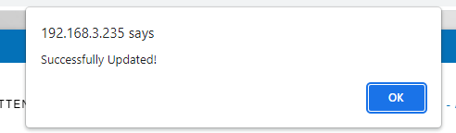
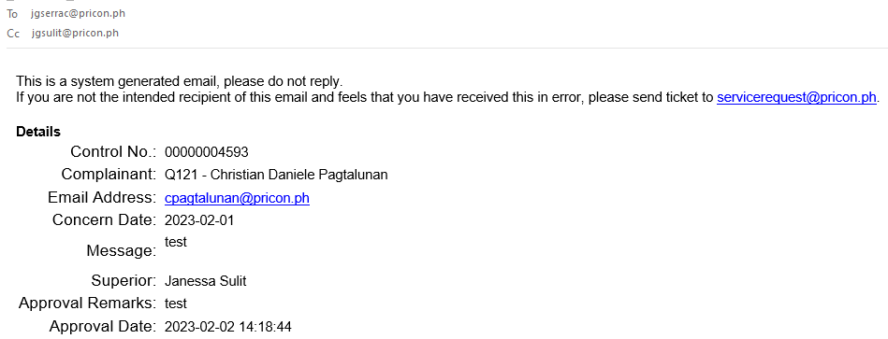
4

