
08 January 2020
Pricon Microelectronics, Inc
No. 14 Ampere St., Light Industry And Science Park 1
Brgy. Diezmo, Cabuyao, Laguna

ATTN: MS. REBECCA D. VALENZUELA

Please see below our quotation for the of PB22 Portable Printer:
Unit Model | Serial Number | Plant | Problem | Pulled Out Date | Status | Repair Cost  VAT EX
PB22A | 25621335313 | Cabuyao | Unable to detect label gaps | 01/06/2020 | Defective Label Gap Sensor | P17,754.00

TERMS AND CONDITIONS:
- Price is quoted in Php Philippine Peso (VAT Exclusive)
- Standard leadtime: 4 to 6 weeks
- Payment: 30 days
- Quotation is valid 15 days upon receipt

Should you need further clarifications concerning this proposal, please do not hesitate to contact us.
Very truly yours,
TECHNOLOGY LINKS INTERNATIONAL CORPORATION

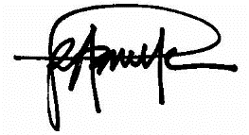
By: Conforme:

_________________________
ROBERT A. BONITE Signature Over Printed Name
_________________________
Date

