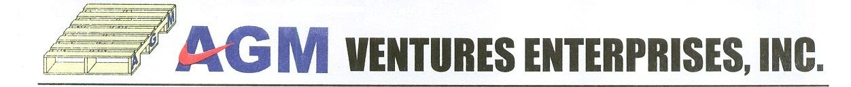

July 18 2016

Pricon Microelectronics Inc.
LISP I
Cabuyao,Laguna

Attention : Ms.Rebecca Valenzuela
Purchasing Officer

Dear Ma’am,

We are pleased to submit our offer to sell Plywood Crate to wit:

I. Dimension : 45” x 30”
Description : Plywood crate
Price : $244.23 /pc ( fumigated )

Notes:
1) Price inclusive of Materials,labor,Delivery,Fumigation (w certificate)
2) Delivery Leadtime:Maximum of 3-5 days upon received of p.o
3) Terms of payment: 30 days
4) Cabuyao Delivery

We trust and hope you will find the aforesaid terms and conditions agreeable and that
we shall be favored with your kind order at your earliest convenience.
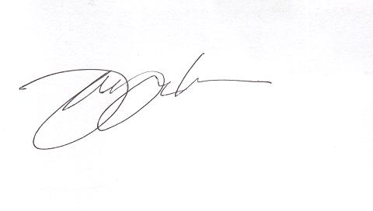
Very truly yours,

John Raymond G. Mendoza
Marketing Manager

