Enhanced NLP models via adversarial training
Pricop Tudor-Constantin

Project’s short description – project’s goal (max 150 words):
The project aims to improve the robustness of AI-text detection in the face of large language models (LLMs) like ChatGPT. These LLMs have blurred the boundary between human and machine-generated text, leading to challenges related to misuse, fairness, and false accusations. To address this, the proposed framework jointly trains a robust AI-text detector using adversarial learning. Specifically, it combines a paraphraser (which generates realistic content to evade detection a.k.a adversarial examples) with a detector. The paraphraser and detector provide feedback to each other during training, resulting in improved performance, especially when dealing with LLM-based paraphrasing.

Motivation
Why did you choose this project?
As LLMs like GPT-3 and its variants gain prominence, AI-generated text increasingly resembles human-written content. However, this convergence poses challenges related to misuse, fairness, and reliability, especially when distinguishing between human and AI-generated text. Ensuring reliable AI-text detection is essential to combat issues like fake content, plagiarism, and false accusations. Existing AI-text detectors struggle when faced with LLM-generated paraphrasing, complicating the differentiation between human and AI-generated text.
State of the art
Discuss similar approaches (min. 4 articles) in the same domain. Give a short paragraph for each article you analysed, stating which was the method the authors used, the resources involved, the main findings. Also provide the full citation at the end, in the Reference section.
At the end of this section, discuss how your approach is different than the ones analysed before.
Similar approaches were analyzed in the previous provided document.
The approach is different in the sense that instead of building attack models based on the TextAttack framework and a separate detection model based on RDE, the attacker and the detector are trained altogether, in a GAN-like manner, enhancing each other’s performance.
Architecture (schema + details for each module)
- Overall schema
- Modules/Objectives:
Mainly the major steps towards the full architecture. Each objective can have different activities (sub-tasks) associated.
- Short description of each module in the architecture, including datasets, methods used, programming language, additional resources (if any), input/output formats, etc.
- Description of the integration of different modules: problems foreseen, if any (incompatibility of programming languages, input/output format changes, etc.).

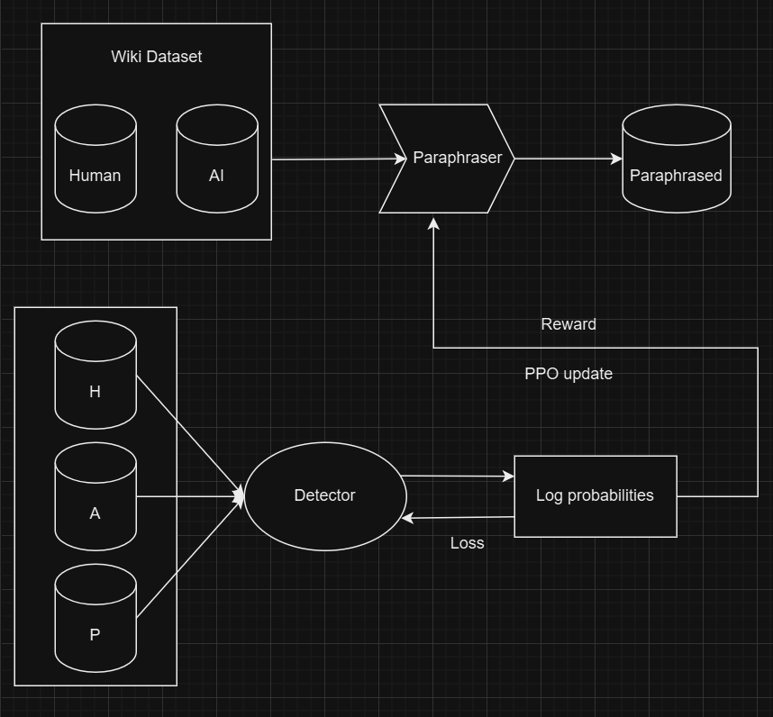

Dataset - Wiki GPT Intro
Dataset for training models to classify human written vs GPT/ChatGPT generated text. This dataset contains Wikipedia introductions and GPT (Curie) generated introductions for 150k topics.
Prompt used for generating text: „200 word wikipedia style introduction on '{title}' {starter_text}”, where title is the title for the wikipedia page, and starter_text is the first seven words of the wikipedia introduction.
10% of the dataset taken as validation data.

Attacker - BERT Paraphraser
BERT paraphraser model adapts the Bidirectional Encoder Representations from Transformers (BERT) architecture to generate paraphrases by fine-tuning it on a dataset of sentence pairs that are paraphrases of each other.
BERT is fine-tuned in a sequence-to-sequence (seq2seq) manner where the model learns to produce sentences similar in meaning but different in wording from the input. The process involves tokenizing input sentences, using BERT to generate contextual embeddings, and applying decoding techniques like beam search to create paraphrases.

Detector - RoBERTa
The OpenAI RoBERTa detector model is designed to identify text generated by language models like GPT-3. Built upon the robust RoBERTa (Robustly optimized BERT approach) architecture, which is a variant of the BERT (Bidirectional Encoder Representations from Transformers) model, it excels in understanding and processing natural language by leveraging extensive pre-training on diverse datasets.
The detector works by analyzing input text and assessing various linguistic patterns, structures, and inconsistencies that are indicative of machine-generated content. During training, the model is exposed to both human-written and machine-generated texts, learning to distinguish between the two based on subtle differences. This results in a tool that can effectively flag AI-generated text by evaluating stylistic and content-related features, providing a reliable means of identifying non-human authorship.

Both the attacker and the detector are pretrained models, loaded from Huggingface, and fine-tuned on this specific task.

Training
The GAN-like training enhances AI-text detection by employing adversarial learning involving 2 models: a paraphraser and a detector. Training begins with generating AI text from the target model and updating the paraphraser to create paraphrased versions aimed at evading detection. The detector is trained to distinguish between human text and AI text. The process involves an iterative adversarial loop where the paraphraser and detector continuously improve against each other. This iterative training enhances the detector's robustness, ensuring it remains effective against sophisticated paraphrasing techniques​. Proximal Policy Optimization (PPO) is used to enhance the paraphraser model's training: initially, the paraphraser creates alternate versions of text to evade detection by the detector, which then evaluates these variations and provides feedback in the form of rewards. PPO is leveraged to adjust the paraphraser's parameters based on these rewards, balancing between exploring new strategies and exploiting existing ones. This integration enables the paraphraser to progressively generate more sophisticated paraphrases, thus strengthening the overall system through iterative adversarial training.

Experiments were run in Kaggle cloud notebook, in Python, making use only of the CPU available, as the GPU overloaded with the models and crashed.
Other project’s details, including:
- Challenges:
What was difficult/different that you expected/easier/…
The training was difficult, as the models require a lot of resources, overloading both the local and the cloud GPUs. CPU resources were plentiful, but slow, resulting in an exacerbated training time, as the dataset is large on its own (150k samples).
What was really enjoyable to work at?
Playing with the trained model, giving it both GPT-generated instances prompted to make human-like examples and personal examples, made with the though to sound as AI-like as possible.

- Performance
  - accuracy/recall/precision/f-measure, etc.
- Statistics/confusion matrix/
- Analysis of error cases
- Interface (if any)
Metrics:
Area Under the Receiver Operating Characteristic Curve (AUROC):
This metric quantifies the ability of a classification model to distinguish between classes. It plots the true positive rate (sensitivity) against the false positive rate (1 - specificity) for different threshold values. AUROC ranges from 0 to 1, where 1 indicates a perfect classifier, and 0.5 represents a random classifier.
Score: 85.5%
Accuracy:
It measures the proportion of correctly predicted instances out of the total instances. Accuracy is a straightforward metric but can be misleading in the case of imbalanced datasets where one class dominates the others.
Score: 85.5%
Precision:
Precision is the ratio of correctly predicted positive observations to the total predicted positives. It quantifies the accuracy of positive predictions, indicating how many of the predicted positive instances are actually positive.
Score: 84.9%
Recall (also known as Sensitivity):
Recall is the ratio of correctly predicted positive observations to all observations in the actual positive class. It measures the ability of the model to capture all the positive instances, minimizing false negatives.
Score: 86.3%
F1 Score:
The F1 score is the harmonic mean of precision and recall. It provides a balance between precision and recall, particularly useful when the classes are imbalanced. F1 score ranges from 0 to 1, with 1 being the best score, indicating perfect precision and recall.
Score: 85.6%

Use cases
Present two possible use case where your application would be really useful.
- Detecting fake content and plagiarism.
- Countering false accusations.

References
Place here the full citation for the articles you studied for the state of the art, numbered.
[1] https://arxiv.org/pdf/2005.05909
[2] https://arxiv.org/pdf/2004.14174
[3] https://arxiv.org/pdf/1804.07998
[4] https://arxiv.org/pdf/1804.06059
[5] https://arxiv.org/pdf/2009.06368
[6] https://aclanthology.org/2022.findings-acl.289.pdf
[7] https://arxiv.org/pdf/2307.03838

