***Install POSTMAN as a Standalone Application***

1.Go to [***https://www.getpostman.com/apps***](https://www.getpostman.com/apps)

2. Select installer for your OS and download

3. Install the application and once installed click on Take me straight to the app, i will create an account another time.

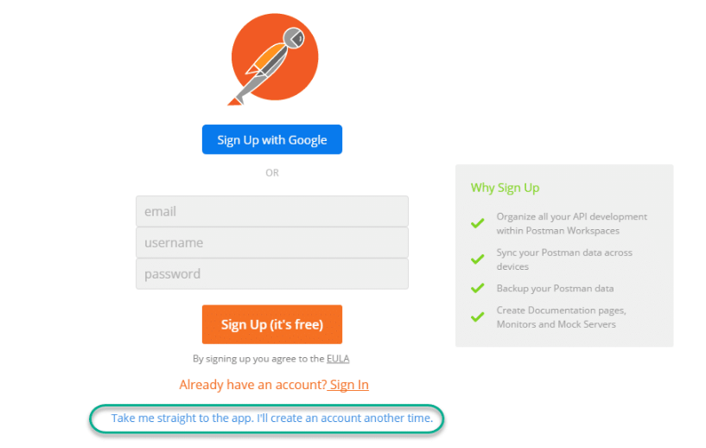

4. If you see this page then you have successfully installed Postman on your system

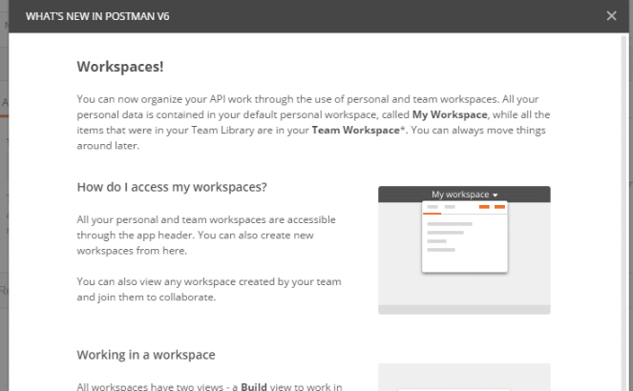

***Install POSTMAN as a Chrome Extension***

1. Go To <https://chrome.google.com/webstore/detail/postman/fhbjgbiflinjbdggehcddcbncdddomop?>
2. Click on Add to Chrome
3. on Chrome Apps
4. Click