1. Show the age distribution in the data using a histogram.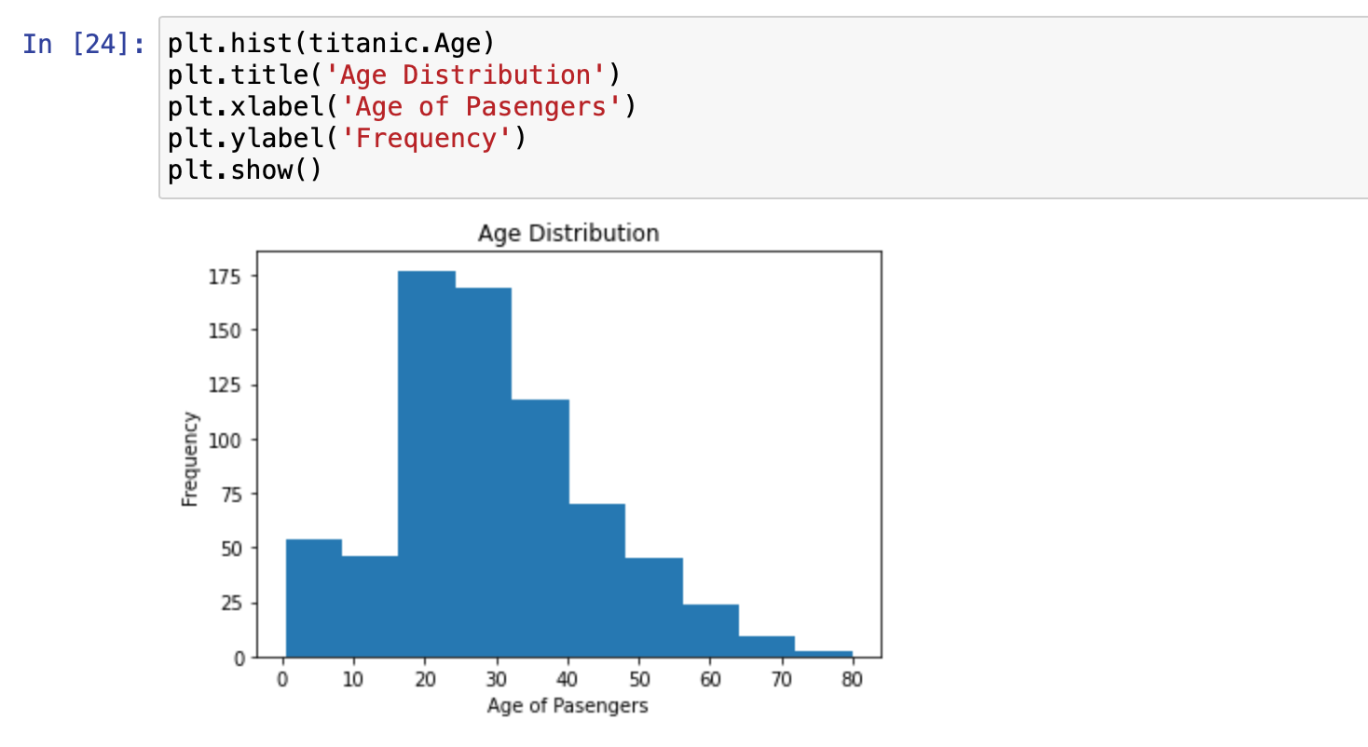

2. Show the age distribution based on gender using a histogram.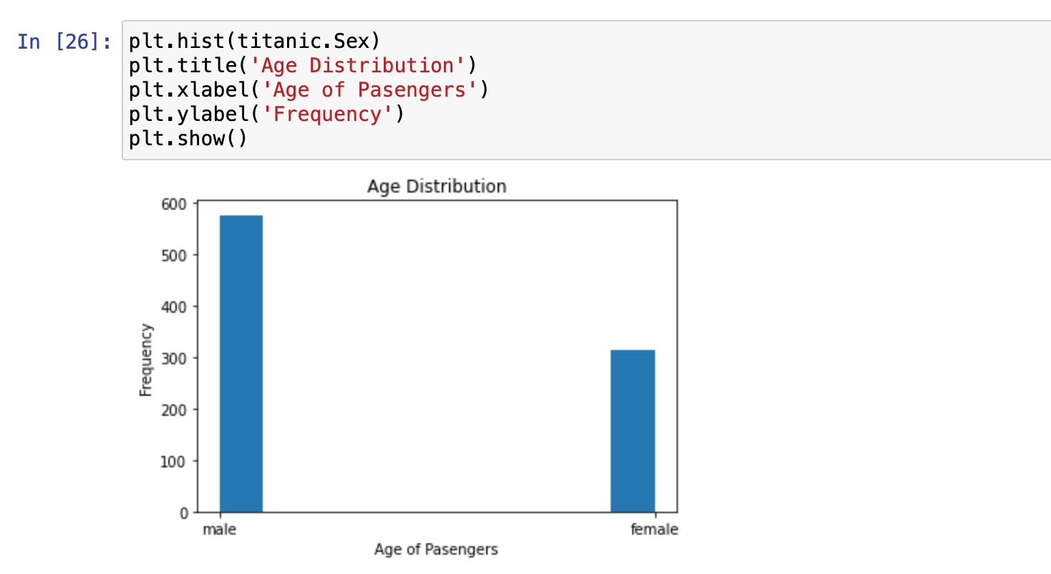

3. Using the function df.corr() to identify the correlation within the data, represent its results using a form of a matrix plot.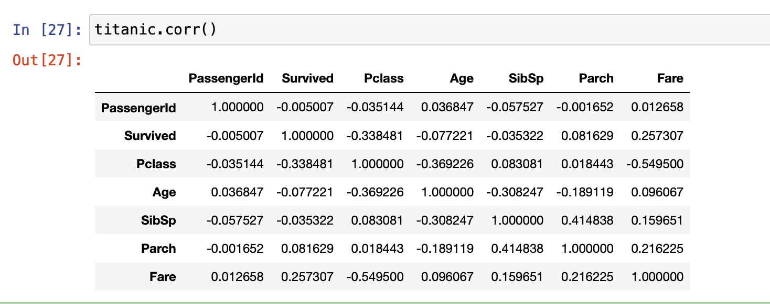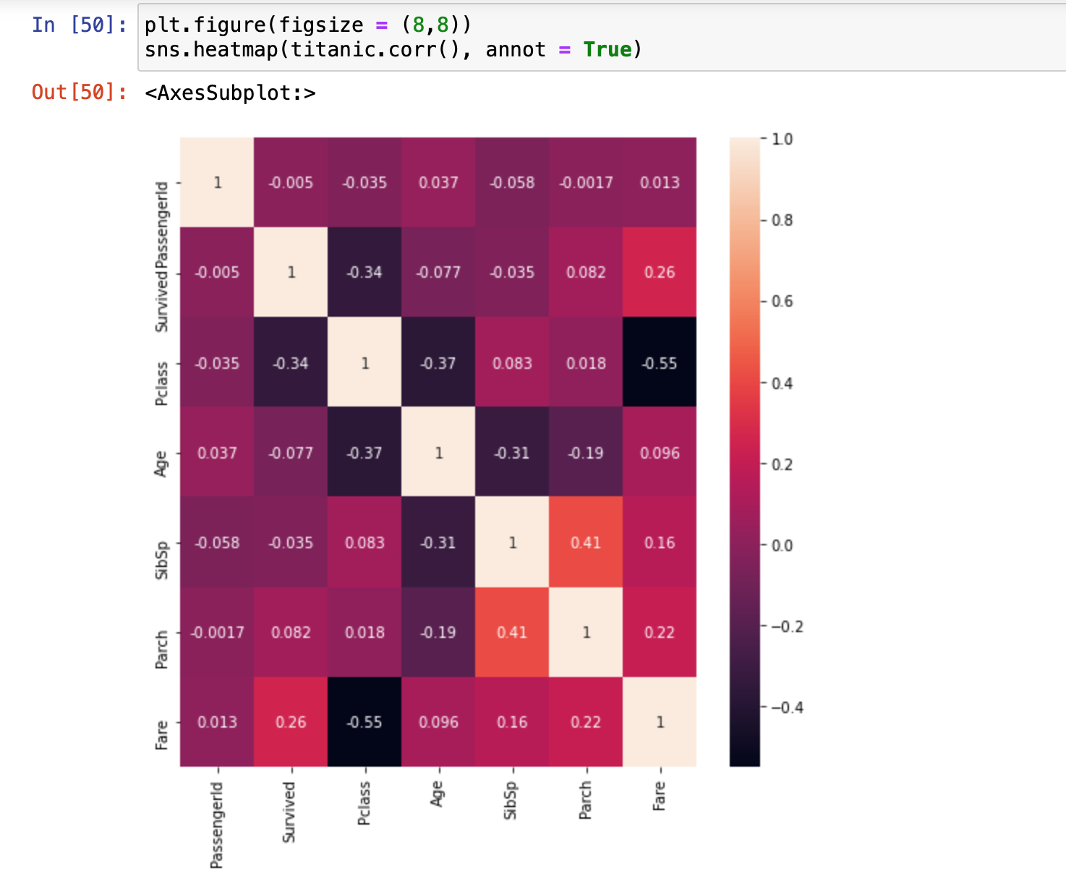

4. Pivot the data setting the column Pclass as the columns and Fare as the values. From the resulting structure, use a boxplot to show the distribution of the values in its 3 columns.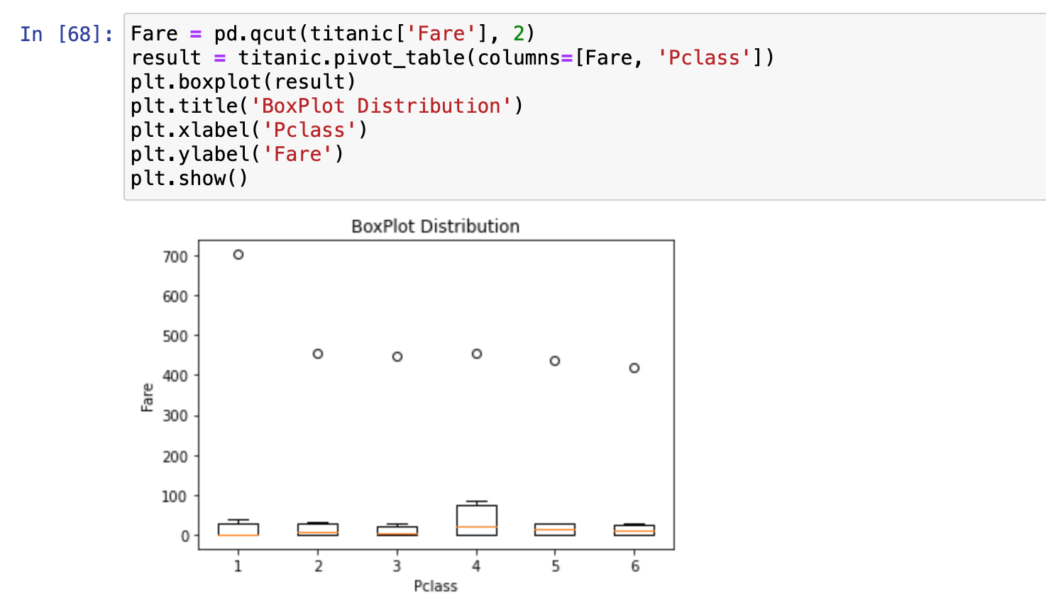

5. Graph the value counts of the number of passengers who survived and did not survive based on gender using a stacked bar graph.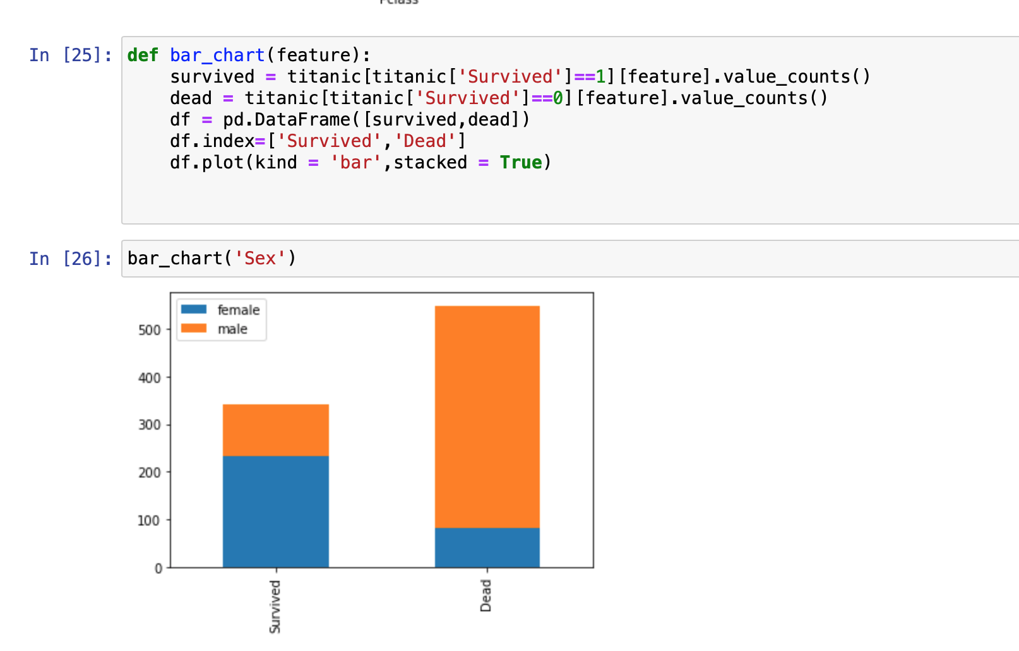

6. Using a scatter plot, plot the ages to the fare paid by the each passenger based on their gender.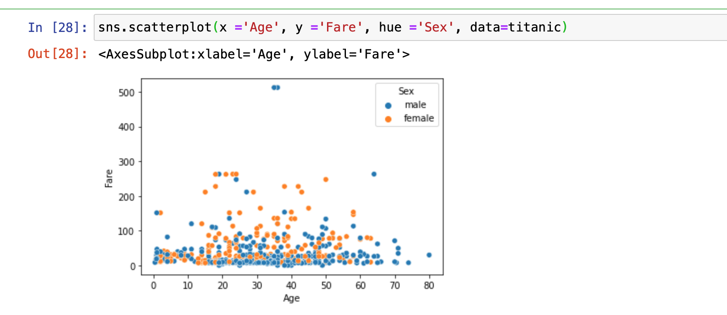

7. Plot a bubble plot of the ages to the fare paid by each passenger categorizing whether they survived or not. The size of each bubble should be determined by the passenger class and the name of each individual as the hover name.