INT217
PROJECT REPORT
(Project Semester January-April 2025)

(Air Quality Data Analysis using Excel Dashboard )

Submitted by

ISHAAN SONI

Registration No:- 12321251

Programme and Section ……BTECH-CSE-K23RX……
Course Code ........INT217......

Under the Guidance of

BALJINDER KAUR

Discipline of CSE/IT

Lovely School of Computer Science and Engineering

Lovely Professional University, Phagwara

CERTIFICATE

This is to certify that Ishaan Soni bearing Registration no.12321251 has completed INT217 project titled, “Air Quality Data Analysis Using Excel Dashboard” under my guidance and supervision. To the best of my knowledge, the present work is the result of his/her original development, effort and study.

Signature and Name of the Supervisor
Designation of the Supervisor
School of Computer Science
Lovely Professional University
Phagwara, Punjab.

Date: 13th April 2025

DECLARATION

I, Ishaan Soni, student of Lovely Professional University (BTECH) under CSE/IT Discipline at, Lovely Professional University, Punjab, hereby declare that all the information furnished in this project report is based on my own intensive work and is genuine.

Date: 13-04-2025 Signature:
Registration No. 12321251 Ishaan Soni

📑 Table of Contents
- Introduction
- Source of Dataset
- Dataset Preprocessing
- Analysis on Dataset
i. General Description
ii. Specific Requirements
iii. Analysis Results
iv. Visualization
- LinkedIn Link for the presented project
- Conclusion
- Future Scope

- Introduction
India, a country known for its geographic and cultural diversity, also faces a pressing environmental concern—air pollution. Despite advancements in industrialization and urban planning, the deteriorating quality of air across many regions has become a serious public health and ecological issue. Cities and states continue to grapple with rising levels of harmful pollutants that pose significant risks to human health and the environment.
This project presents a detailed exploration of air quality data collected across different regions of India. The focus is on understanding the severity, distribution, and key contributors to pollution through structured analysis and visualization. The aim is not just to display numbers, but to highlight critical trends, identify highly polluted areas, and uncover correlations between pollutant types and regions.
From particulate matter (PM2.5 and PM10) to harmful gases like NO₂, SO₂, and CO, the dataset reveals how the nature of air pollution varies regionally and seasonally. While the raw data provides pollutant levels, this dashboard attempts to offer insights into how these values translate into real-world environmental concerns and health risks.
This report aims to answer some crucial questions:
- Which cities and states exhibit the highest levels of air pollution?
- What pollutants are most prevalent in different regions?
- How can visual dashboards aid in creating awareness and triggering timely interventions?

2. Source of Dataset
The dataset used in this air quality analysis project has been obtained from Data.gov.in, the official open data portal of the Government of India. This platform hosts datasets from various ministries and departments, ensuring credibility and transparency.
The dataset includes air quality monitoring data collected from various Indian cities and states. It covers a wide range of pollutants such as PM2.5, PM10, NO₂, SO₂, CO, and O₃, offering a comprehensive view of regional air pollution patterns.
Key components of the dataset:
- City-wise and state-wise pollutant concentrations recorded across multiple locations.
- Daily, average, and maximum values of major air pollutants.
- Comparative indicators for identifying pollution hotspots and monitoring regional air quality levels.
The data was downloaded from data.gov.in and organized into a structured Excel format to facilitate analysis and dashboard visualization. This structured approach enables both granular insights and broader trend analysis across different regions and pollutant types.
Dataset Link:- https://www.data.gov.in/resource/real-time-air-quality-index-various-locations

3. Dataset Preprocessing
The raw air quality data, although structured, required substantial cleaning and transformation to make it suitable for effective visualization and analytical insights. The preprocessing steps ensured that the dataset was ready for dynamic filtering, comparative analysis, and interactive dashboard design in Excel.
i. Consolidation
The Excel file was structured into multiple sheets, each serving a specific analytical purpose. These sheets included:
- City-wise pollutant levels
- Average and maximum pollutant concentrations
- Gas composition data
- State-wise pollution ranking and trends
All data was organized into a unified Excel workbook with standardized column headers for consistent referencing.
ii. Data Cleaning
- Removed redundant columns (e.g., serial numbers, merged cells, and footnotes).
- Standardized city and state names for uniform grouping (e.g., “Delhi (Urban)” → “Delhi”).
- Handled missing or blank values by applying zero imputation or interpolation where contextually appropriate.
- Ensured uniform date formats and pollutant unit consistency for filtering and trend analysis.
iii. Feature Engineering
- Created new metrics such as Total Pollutant Load by summing values of key pollutants (PM2.5, PM10, NO₂, SO₂).
- Generated Pollution Severity Index scores to rank cities and states based on pollutant concentrations.
- Calculated city/state-wise pollution contribution percentages for comparative regional insights.
- Added categorical flags for identifying high-risk zones based on average threshold exceedance.
iv. Formatting for Dashboard
To enable effective use of Power Pivot, slicers, and interactive visuals in Excel:
- Data was normalized into structured fact and dimension tables, allowing dynamic filtering.
  - Fact Table: Pollutant Measurements
  - Dimension Tables: Cities, States, Pollutants, Dates
- Custom formatting and structured tables supported KPI card creation, dropdown-based navigation, and data drill-downs.
- The dashboard layout was optimized with slicers and interactive charts for real-time pollutant insights, comparisons, and alert generation.
The processed dataset thus served as a solid foundation for designing an interactive and informative air quality dashboard tailored for analysis and awareness.

4. Analysis on Dataset
i. General Description
Air pollution has become one of the most pressing environmental issues in India, affecting both urban and rural populations. The dataset, compiled from various monitoring stations across the country, reveals alarming patterns of elevated pollutant levels, especially in urbanized and industrial belts. Several Indian cities have consistently recorded pollutant concentrations far exceeding safe limits prescribed by the Central Pollution Control Board (CPCB) and the World Health Organization (WHO).
The most frequently monitored pollutants in the dataset include:
- PM2.5 – fine particulate matter with severe respiratory and cardiovascular effects.
- PM10 – coarse particulate matter affecting the upper respiratory tract.
- NO₂ (Nitrogen Dioxide) – a major contributor to respiratory illnesses.
- SO₂ (Sulphur Dioxide) – mainly from industrial emissions and fossil fuels.
- CO (Carbon Monoxide) – from vehicular emissions, with serious health impacts at high concentrations.
- O₃ (Ozone) – a secondary pollutant formed by chemical reactions under sunlight, often peaking in summer.
The data highlights a grim reality: increasing urbanization, industrial activity, and vehicular growth have led to a sustained rise in air pollution levels. Seasonal variations further aggravate the situation—especially during winter, when poor dispersion and crop burning in northern India spike PM levels drastically.

ii. Specific Requirements
The analysis was designed to address the following key objectives:
- Identify the top 5 most polluted cities and states based on average annual pollutant concentrations.
- Track trends in PM2.5, PM10, and NO₂ levels over time to assess regional air quality deterioration.
- Create an interactive Excel dashboard enabling filtering by pollutant type, state, and city for easy visualization.
- Generate dynamic KPIs showing most polluted regions, pollution severity scores, and changes over time.
- Compare regional pollutant profiles to identify industrial vs. vehicular-dominated pollution zones.
- Enable real-time alerting mechanisms through conditional formatting to flag cities exceeding pollution thresholds.

iii. Analysis Results
Top 3 Most Polluted States Based on Average Pollutant Levels:
- Delhi (NCT)
With exceptionally high PM2.5 and PM10 levels, Delhi consistently ranks as one of the world’s most polluted cities. Annual winter smog, vehicular congestion, and stubble burning contribute significantly to its air quality crisis.
- Uttar Pradesh
Cities like Ghaziabad and Kanpur show high concentrations of PM2.5, PM10, and NO₂ due to industrial activity and limited green cover. The region experiences frequent AQI breaches, especially during post-monsoon periods.
- Bihar
Urban centers like Patna report elevated pollutant levels year-round, with poor waste management and vehicle emissions being major contributors.

A Nation Gasping: A Timeline of Escalating Pollution
2001–2014: The Slow Burn Begins
Air quality began to decline steadily during these years, with rising industrialization, poor enforcement of emission norms, and the increasing number of vehicles. While awareness was minimal, the impact on public health began to surface in the form of increased respiratory illness cases, especially among children and the elderly.
Post-2015: Awakening to a Crisis
The launch of the National Air Quality Index (NAQI) and initiatives like Smart Cities brought some focus on pollution control. However, the implementation was patchy. Crop burning incidents, urban sprawl, and lagging clean energy adoption kept pollution high. Cities in the Indo-Gangetic plain suffered the most.
2022: The Breaking Point
Despite growing digitalization and "Green India" campaigns, pollution levels remained dangerously high. Advanced cities failed to curb vehicle emissions effectively, while smaller towns faced rising industrial emissions. Even tier-2 cities began to breach safe limits.

Emerging Threats: Air Pollution in the Digital Age
Pollution is no longer just an outdoor issue. Indoor air pollution, vehicular cabin pollution, and urban heat island effects emerged as new-age threats. Some observations:
- PM2.5 levels remained elevated even in non-industrial towns, indicating regional transport and household fuel usage as culprits.
- Ozone levels spiked during the summer months, particularly in cities with high vehicular emissions.
- AQI-based alert systems exposed frequent exceedances that rarely triggered policy-level responses.

Invisible but Deadly: The Human Impact
Every data point represents:
- A child developing asthma.
- An elderly person struggling with bronchitis.
- A working professional silently inhaling toxins on the daily commute.
The report does not just reflect environmental degradation but a public health emergency that affects millions. While the data presents averages and max values, it masks the long-term impact on quality of life and life expectancy—especially for vulnerable populations.

Call to Action: Beyond Visualization
The dashboard aims to not just present data, but to drive awareness and action. By enabling comparisons, highlighting trends, and exposing pollution hotspots, it serves as:
- A tool for governments to prioritize pollution control efforts.
- A resource for researchers and policymakers to formulate targeted interventions.
- A wake-up call for citizens to demand cleaner air and adopt sustainable habits.

Visualization:
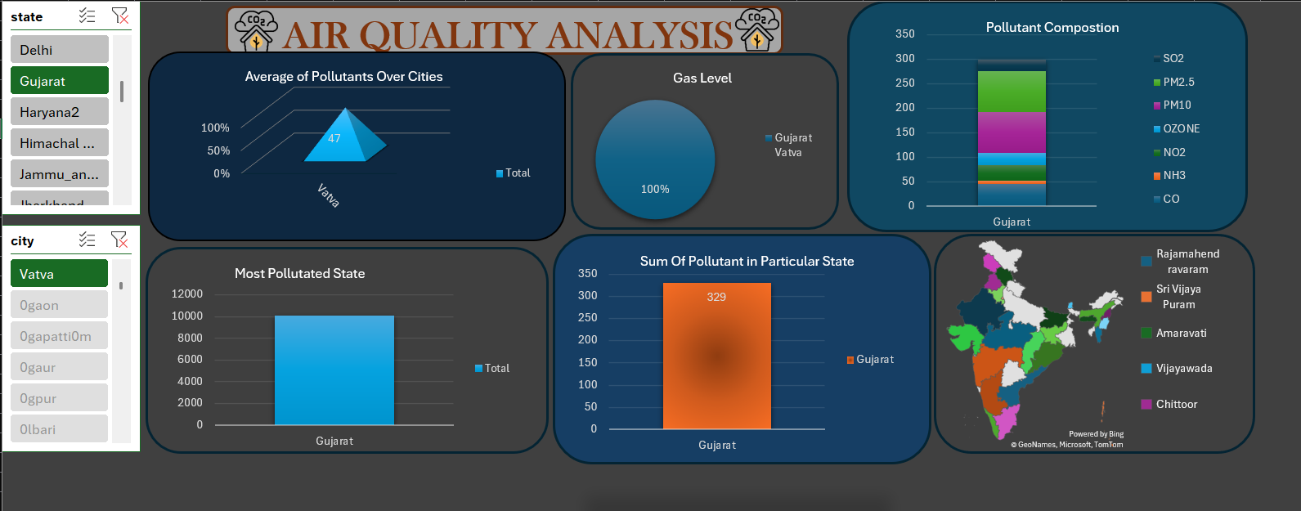
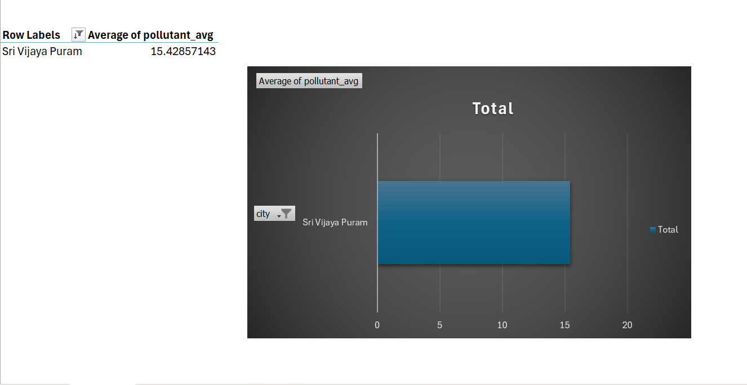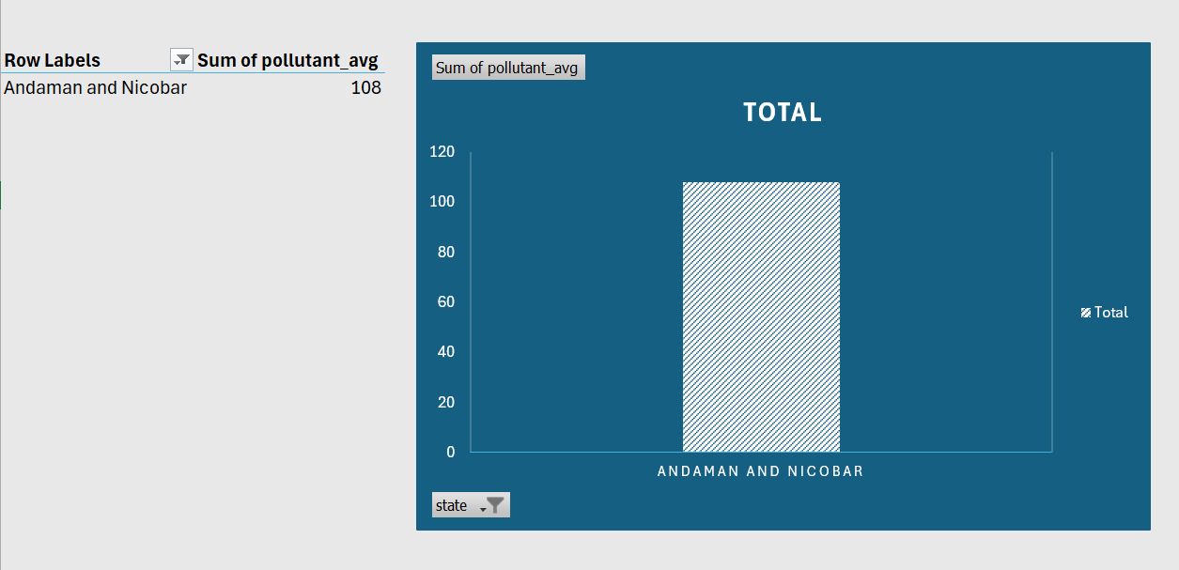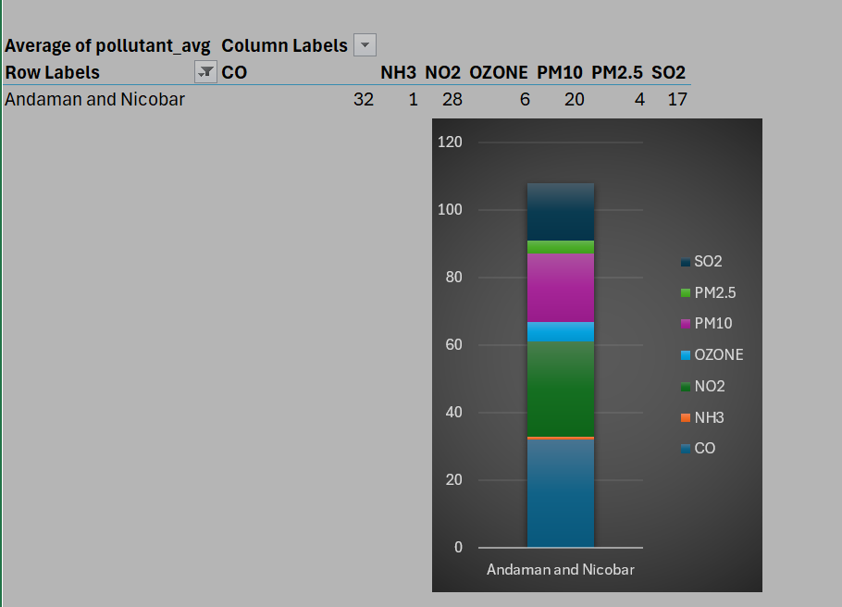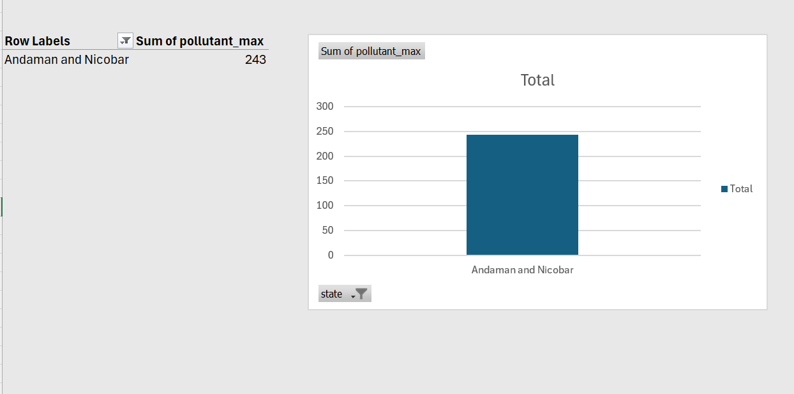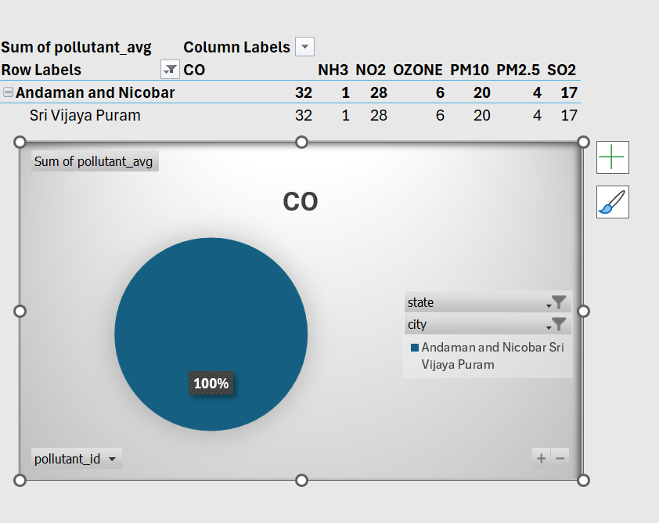

Github Link:- https://github.com/Priyanshu007k/Air-Quality-Analysis-Dashboard/tree/main

6. Conclusion
The data doesn’t lie — and what it reveals is deeply alarming. Despite years of environmental policies, awareness campaigns, and global climate commitments, India’s air quality continues to deteriorate at an unsettling pace. From the early 2000s to 2022, pollutant levels in many regions have not only remained dangerously high but, in several cases, worsened — especially for PM2.5, PM10, and NO₂.
This isn’t just about environmental metrics. It’s about people gasping for breath in overcrowded cities. About children developing chronic asthma. About the silent suffering of millions due to long-term exposure. The numbers make it clear: the right to clean air — a basic human need — is being denied to a significant portion of the population.
While major cities like Delhi continue to dominate headlines, smaller towns and rural belts are increasingly becoming victims of unchecked industrialization and vehicular growth. Seasonal stubble burning, construction dust, and inadequate enforcement of pollution norms add to the crisis, creating a year-round health hazard. And while technology has made it easier to monitor pollution, policy action has not kept pace.
This dashboard is not just a tool for visualizing air quality data — it is a mirror held up to governance, development, and public awareness. It shows that despite rising literacy, smarter infrastructure, and ambitious climate goals, environmental justice remains elusive.
The illusion of progress is broken when AQI levels breach hazardous limits month after month, and yet no decisive, sustained action follows. When people begin to normalize masks not just for pandemics but for daily commutes. When headlines about toxic air barely register anymore.
This report is more than just an analytical exercise — it is a wake-up call. A call to policymakers, urban planners, environmental agencies, and every citizen to act now. Because behind every row of data is a breath we’re all struggling to take — a future generation’s health already compromised.
Let this not be just a dashboard. Let it be a catalyst for clean air — and real change.

7. Future Scope
The potential for expanding this air quality analysis is vast, both in terms of technology integration and actionable policy insights. Future work could explore the following directions:
- Integration with Real-Time Air Monitoring APIs
By connecting to APIs from CPCB, OpenAQ, or regional monitoring bodies, future dashboards can display live AQI updates, pollutant levels, and health advisories, transforming the tool into a real-time air quality alert system.
- Geo-Spatial Visualization
Incorporating latitude-longitude data and GIS maps will allow for dynamic heatmaps, helping identify hyper-local pollution hotspots — critical for targeted action by municipalities and urban planners.
- Time-Series Forecasting and Predictive Modelling
Using machine learning models like ARIMA, LSTM, or Prophet on historical pollutant data can help predict future pollution surges, seasonal smog episodes, or industrial emissions trends.
- Correlation with Health and Climate Data
Linking air quality metrics with health indicators (e.g., asthma rates, hospitalization data) or climate data (like temperature inversions) could enrich the analysis and support environmental health policymaking.
- Mobile-Friendly Dashboard Deployment
A lightweight, responsive version of the dashboard can empower citizens to monitor local air quality on-the-go, receive health warnings, and even suggest safe hours for outdoor activity.
- Macro-Enabled Intelligent Dashboards
Further enhancement of Excel macros can simulate an AI-like assistant within the dashboard, guiding users through critical insights, visual patterns, or anomalies in air quality data.
- Policy Tracker and Intervention Logging
Future dashboards can incorporate overlays of government interventions — like emission control deadlines, green zone declarations, or anti-stubble burning campaigns — to assess their impact.
- Educational and Community Awareness Tools
This project can be extended into school/college outreach programs, public webinars, and awareness campaigns using simplified visualizations to foster citizen participation in combating air pollution.

