Priscila Fry

CIS480

February 21, 2024

**5.2 Assignment: Final Project and Presentation Submission (GitHub)**

**GitHub:** <https://github.com/prifry/cleaningwebsite-project.git>

I have made some minimal changes this week:

Added data so the main table contains at least 12 records.

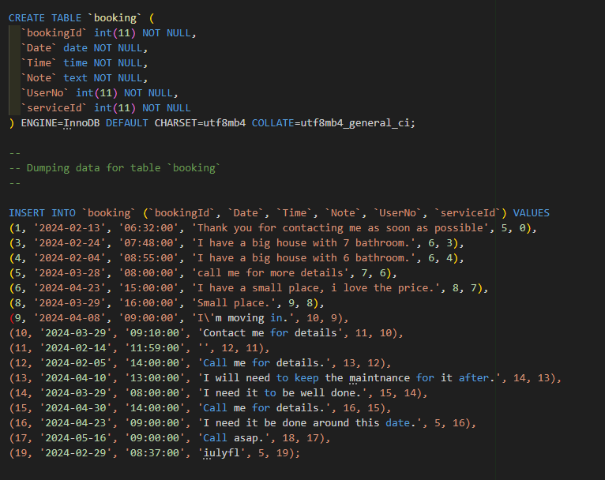

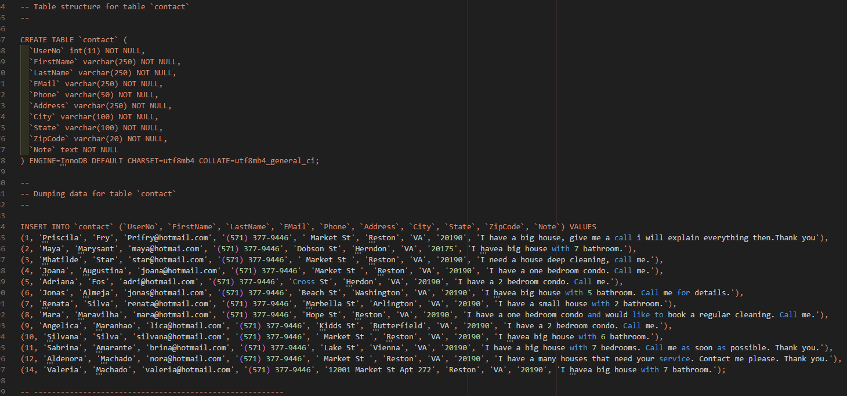

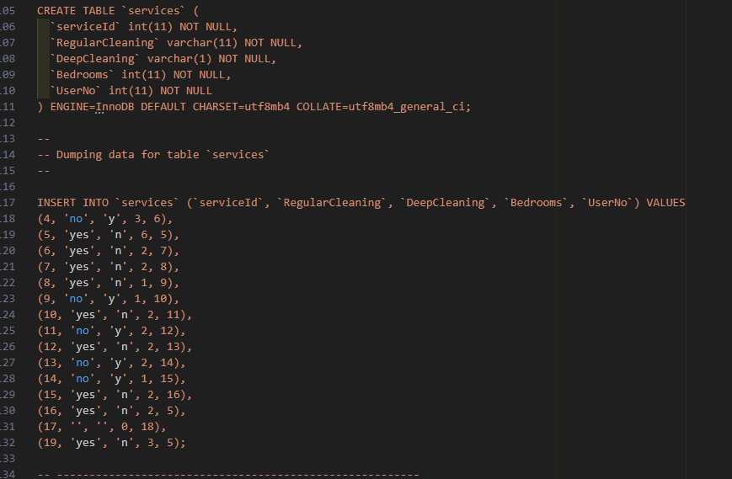

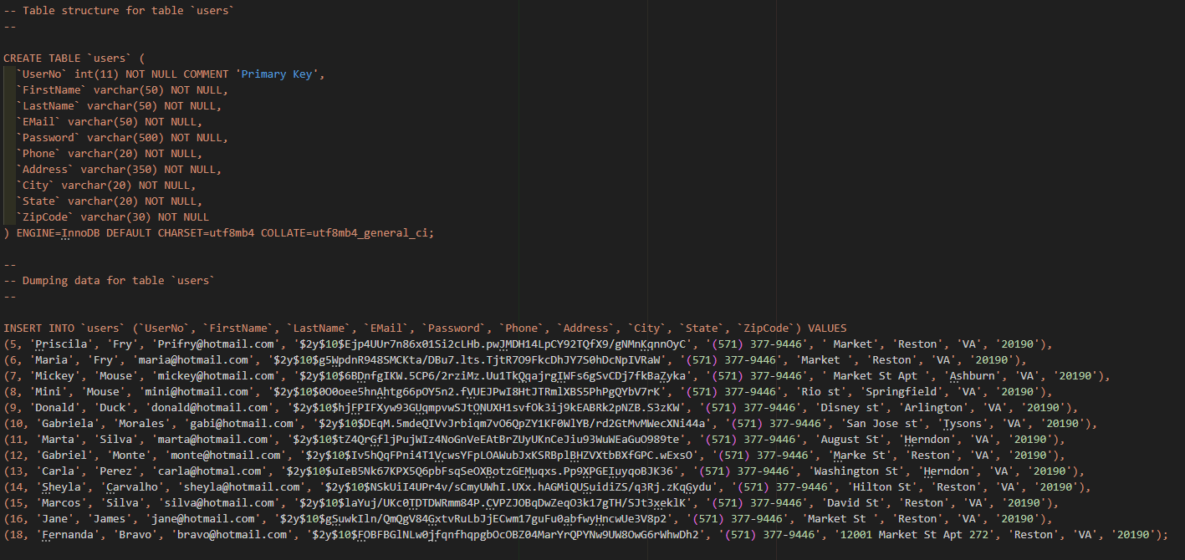

Required input:

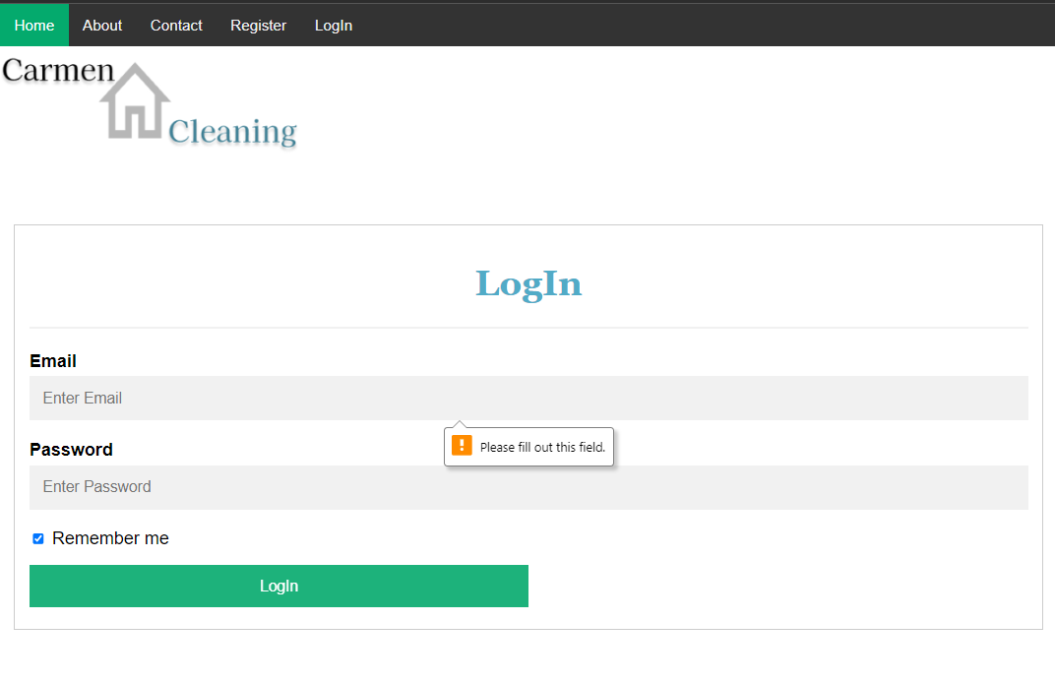

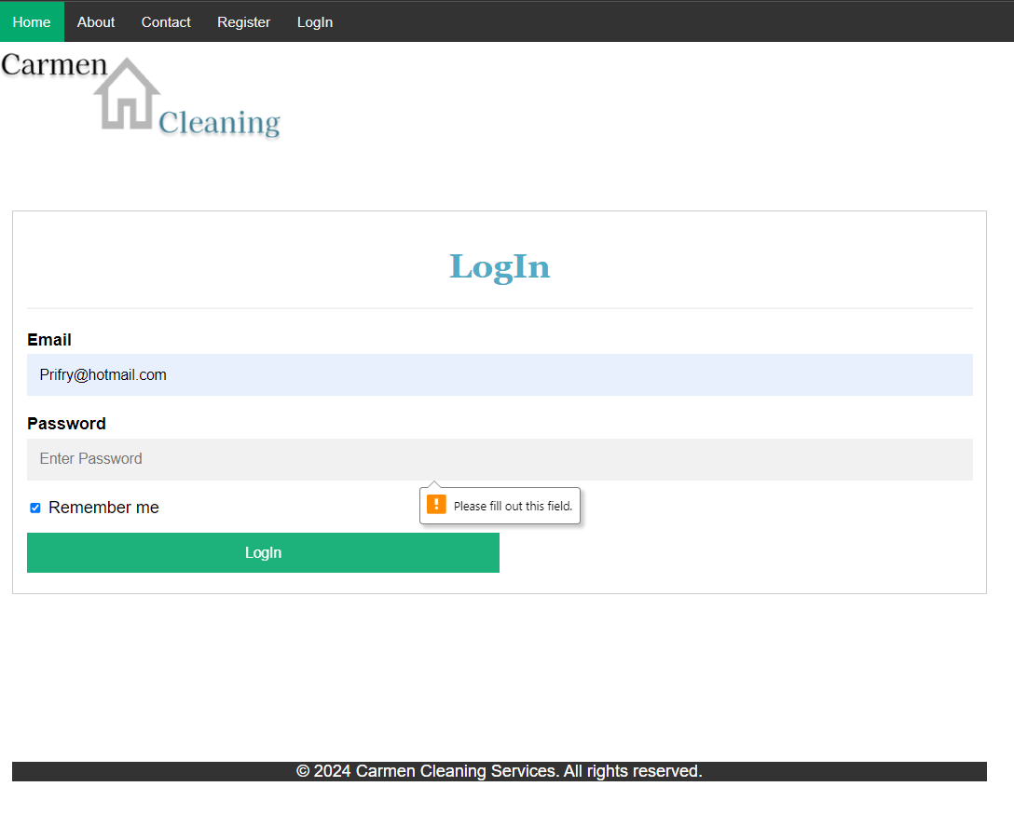

I've enhanced the Booking page functionality. Now, after users make a booking, they'll remain on the page, where they can conveniently view their service records along with the booked date and time. Once they're finished, they can simply log out using the button located at the bottom of the page. Upon logout, they'll be smoothly directed to the thank you page for a seamless experience.

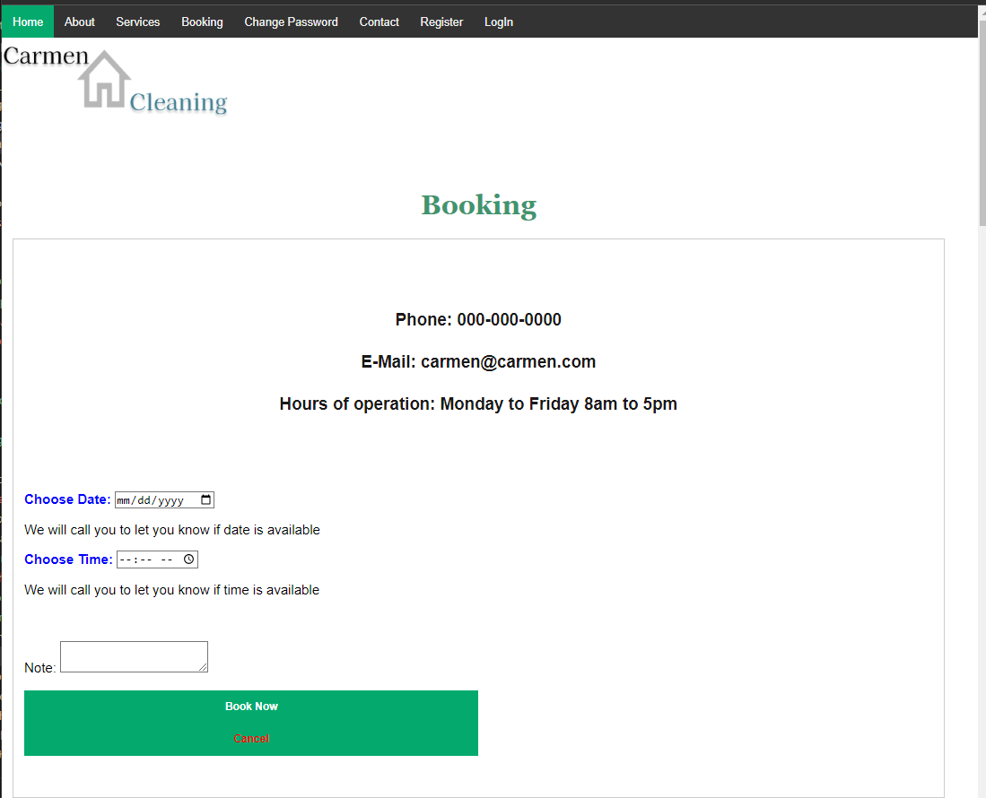

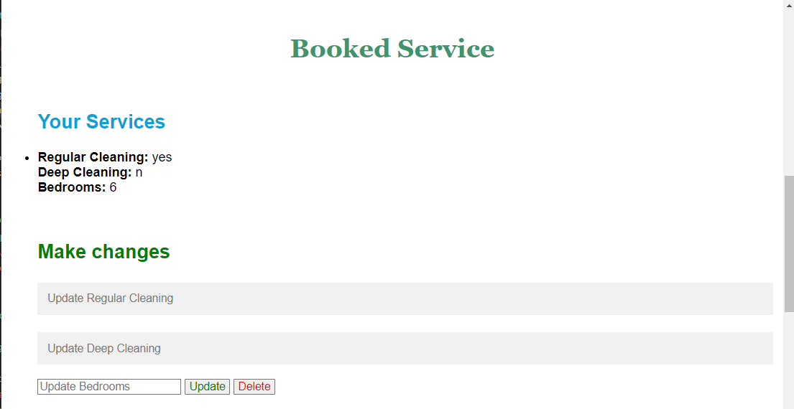

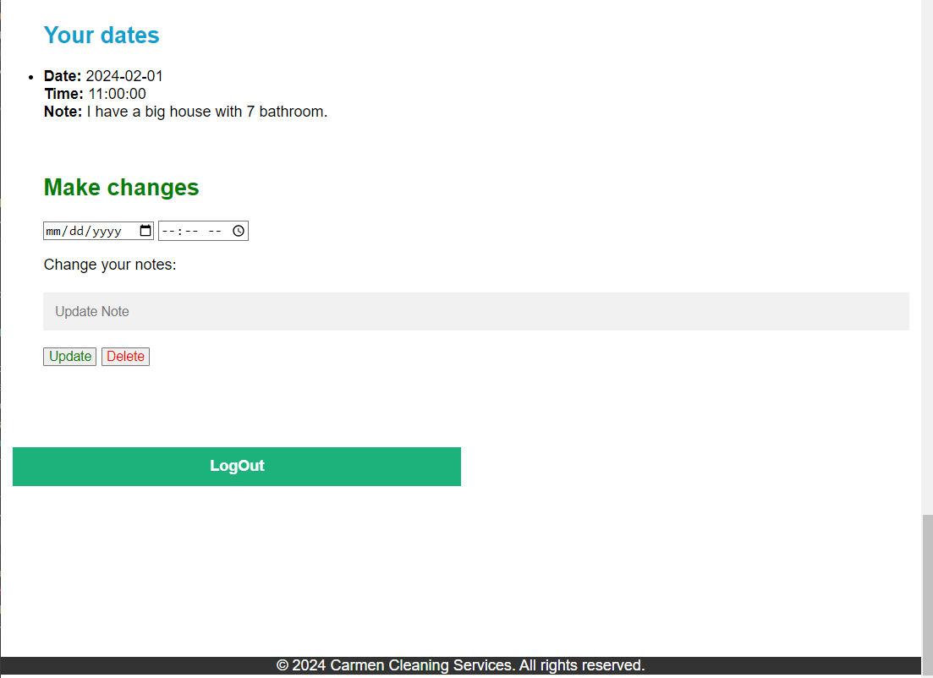

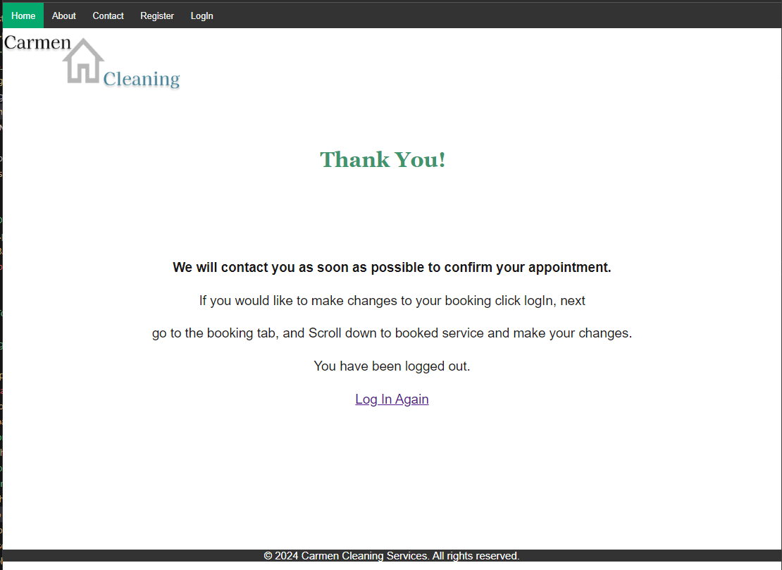

Data submission will only occur if all inputs are correct.

