Priscila Fry

November 14, 2023

**MotiVateMe - Final Project Design Document**

**Final/Updated Project Proposal:**

MotiVateMe is a C# application designed to motivate users in their daily work routines by allowing them to set and track personal and professional goals. The application will provide a positive and encouraging environment through motivational quotes, goal-setting features, and progress tracking. Utilizing SQLite, MotiVateMe will store user information, goals, and achievements, contributing to improved mental well-being and sustained motivation in the workplace.

**Class Definitions:**

**User Class:**

*Properties:*

Username (string): The username of the user.

Goals (List<Goal>): List of goals associated with the user.

MoivationalQuotes (List<string>): List of quotes for the user

*Methods:*

DisplayMotivationalQuote(): Displays a motivational quote to the user.

AddGoal(goal: Goal): Adds a goal to the user's list.

Tostring() method: This method will be overridden in relevant classes to provide a formatted string representation.

**Goal Class (Abstract):**

*Properties:*

Title (string): The title of the goal.

IsCompleted (bool): Indicates whether the goal is completed or not.

*Methods:*

DisplayProgress(): Displays the progress of the goal (to be implemented by concrete subclasses).

Tostring() method: This method will be overridden in relevant classes to provide a formatted string representation.

**DailyTask Class (Concrete, inherits from Goal):**

*Methods:*

DisplayProgress(): Overrides the abstract method in the base class to display progress specifically for daily tasks.

Tostring() method: This method will be overridden in relevant classes to provide a formatted string representation.

**DatabaseManager Class:**

*Properties:*

ConnectionString (string): The connection string for the SQLite database.

Methods:

CreateTables(): Creates User and Goals tables if they don't exist.

InsertSampleData(): Inserts sample user and goal data for demonstration purposes.

DisplayUserData(): Retrieves and displays user and goal data.

Data Storage:

**Users Table:**

Fields:

UserId (INTEGER, PRIMARY KEY, AUTOINCREMENT)

Username (TEXT, NOT NULL)

**Goals Table:**

Fields:

GoalId (INTEGER, PRIMARY KEY, AUTOINCREMENT)

UserId (INTEGER, FOREIGN KEY REFERENCES Users(UserId))

Title (TEXT, NOT NULL)

IsCompleted (INTEGER)

**Special Considerations:**

**Output Format:**

Output will be displayed in the console window through appropriate methods.

ToString() method will be overridden in relevant classes to provide a formatted string representation.

**Class Hierarchy:**

User class stands at the top of the hierarchy.

Goal class is an abstract base class for specific goal types (e.g., DailyTask).

Composition is used, as the User class contains a list of Goal objects.

**Access Specifiers:**

Classes and methods will use appropriate access specifiers for encapsulation and proper information hiding.

SQLite database access will be encapsulated within the DatabaseManager class.

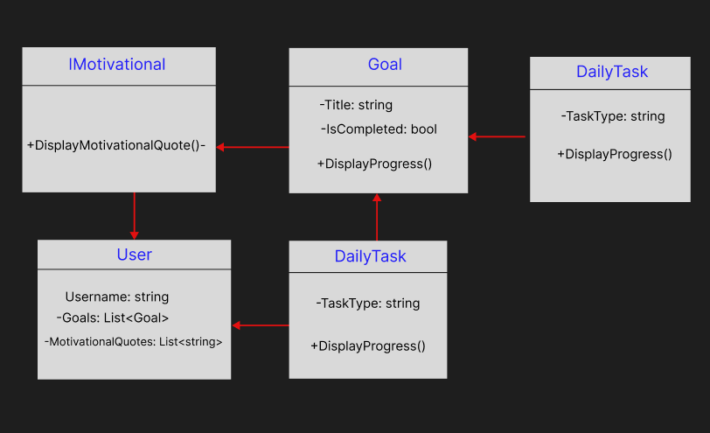

This design document provides a detailed overview of the classes, their properties and methods, the data storage structure, and special considerations for the MotiVateMe application. It ensures a clear understanding of how the application will be built and organized.