Simple Calculator :
안상완

목차
- Class --- Cal_Gui / GUI 계산기 구현
- Class --- Calculator / 콘솔형 계산기 구현
- Class --- OperatingClass / 메인메소드
- 실행사진

1. Class --- Cal_GUi

package Lecture;
import javax.swing.*;
import java.awt.*;
import java.awt.event.ActionEvent;
import java.awt.event.ActionListener;
import java.awt.event.KeyAdapter;
import java.awt.event.KeyEvent;
public class Cal_GUI extends JFrame {
final int txtWidth = 70, lblWidth = 20, height = 20;
final int btnWidth = 60, btnExtWidth = 90;
JTextField txtNum1, txtNum2, txtResult; // 왼쪽 오른쪽 결과값
JLabel lblOp, lblEqual;
JButton btnAdd, btnSub, btnMul, btnDiv, btnComp, btnReset;
Container c;
private void txt_lbl_Layout() {
txtNum1 = new JTextField("",15);
txtNum1.setLocation(10, 10);
txtNum1.setSize(txtWidth, height);
txtNum1.setHorizontalAlignment(JTextField.RIGHT);
txtNum1.addKeyListener(new KeyAdapter() {
@Override
public void keyTyped(KeyEvent e) {
if(e.getKeyChar() <'0' || e.getKeyChar() >'9')
e.consume();
}
});
lblOp = new JLabel("?");
lblOp.setLocation(85,10);
lblOp.setSize(lblWidth, height);
txtNum2 = new JTextField("",15);
txtNum2.setLocation(100, 10);
txtNum2.setSize(txtWidth, height);
txtNum2.setHorizontalAlignment(JTextField.RIGHT);
txtNum2.addKeyListener(new KeyAdapter() {
@Override
public void keyTyped(KeyEvent e) {
if(e.getKeyChar() <'0' || e.getKeyChar() >'9')
e.consume();
}
});
lblEqual = new JLabel("=");
lblEqual.setLocation(180, 10);
lblEqual.setSize(lblWidth, height);
txtResult = new JTextField("0", 10);
txtResult.setLocation(200, 10);
txtResult.setSize(txtWidth, height);
txtResult.setHorizontalAlignment(JTextField.RIGHT);
}
private void btn_Layout() {
btnAdd = new JButton("+");
btnAdd.setLocation(10, 40);
btnAdd.setSize(btnWidth, height);
btnAdd.addActionListener(new ActionListener() {
@Override
public void actionPerformed(ActionEvent e) {
lblOp.setText("+");
}
});
btnSub = new JButton("-");
btnSub.setLocation(80, 40);
btnSub.setSize(btnWidth,height);
btnSub.addActionListener(new ActionListener() {
@Override
public void actionPerformed(ActionEvent e) {
lblOp.setText("-");
}
});
btnMul = new JButton("*");
btnMul.setLocation(150, 40);
btnMul.setSize(btnWidth,height);
btnMul.addActionListener(new ActionListener() {
@Override
public void actionPerformed(ActionEvent e) {
lblOp.setText("*");
}
});
btnDiv = new JButton("/");
btnDiv.setLocation(220, 40);
btnDiv.setSize(btnWidth,height);
btnDiv.addActionListener(new ActionListener() {
@Override
public void actionPerformed(ActionEvent e) {
lblOp.setText("/");
}
});
btnReset = new JButton("Reset");
btnReset.setLocation(50, 70);
btnReset.setSize(btnExtWidth,height);
btnReset.addActionListener(new ActionListener() {
@Override
public void actionPerformed(ActionEvent e) {
txtNum1.setText("");
txtNum2.setText("");
txtResult.setText("");
lblOp.setText("?");
lblEqual.setText("=");
txtNum1.requestFocus();
}
});
btnComp = new JButton("Compute");
btnComp.setLocation(150, 70);
btnComp.setSize(btnExtWidth,height);
btnComp.addActionListener(new ActionListener() {
@Override
public void actionPerformed(ActionEvent e) {
String distinct = lblOp.getText();
double num1 = Double.parseDouble(txtNum1.getText());
double num2 = Double.parseDouble(txtNum2.getText());
switch (distinct){
case "+":
txtResult.setText(Double.toString(num1 + num2));
break;
case "-":
txtResult.setText(Double.toString(num1 - num2));
break;
case "*":
txtResult.setText(Double.toString(num1 / num2));
break;
case "/":
txtResult.setText(String.format("%.5f", num1 / num2));
break;
default:
txtResult.setText("알수없는 오류 또는 NaN");
}
}
});
}
private void GUI_Setup() {
setTitle("Simple Calculator");
setDefaultCloseOperation(JFrame.EXIT_ON_CLOSE);
txt_lbl_Layout();
btn_Layout();
c = getContentPane();
c.setLayout(null);
// c.setLayout(new GridLayout(0,1));
// JPanel panel1 = new JPanel();
// c.add(panel1);
c.add(txtNum1);
c.add(lblOp);
c.add(txtNum2);
c.add(lblEqual);
c.add(txtResult);
// panel1.add(txtNum1);
// panel1.add(lblOp);
// panel1.add(txtNum2);
// panel1.add(lblEqual);
// panel1.add(txtResult);
// JPanel panel2 = new JPanel();
// c.add(panel2);
c.add(btnAdd);
c.add(btnSub);
c.add(btnMul);
c.add(btnDiv);
// panel2.add(btnAdd);
// panel2.add(btnSub);
// panel2.add(btnMul);
// panel2.add(btnDiv);
// JPanel panel3 = new JPanel();
// c.add(panel3);
c.add(btnReset);
c.add(btnComp);
// panel3.add(btnReset);
// panel3.add(btnComp);
setSize(300, 150);
setVisible(true);
}
public Cal_GUI() {
GUI_Setup();
}
}

2. Class --- Calculator
package Lecture;
import java.util.Scanner;
public class Calculator {
double num1;
double num2;
char op;
Scanner scannerCal;
public Calculator(Scanner scannerCal){
this(0, ' ', 0);
this.scannerCal = scannerCal;
}
public Calculator(double n1, char o, double n2){
num1 = n1;
op = o;
num2 = n2;
}
public double compute() {
switch (op){
case '+': return num1 + num2;
case '-': return num1 - num2;
case '*': return num1 * num2;
case '/': return num1 / num2;
default: return Double.NaN;
}
}
private boolean check(){
return num1 == 0 && num2 == 0 && op == '0'; // char 형이라 이렇게 가능할껄?
}
public void operation(){
while (true){
try {
System.out.print("피연산자 연산자 피연산자 로 입력하십시오 종료 == 0 0 0>>> ");
num1 = scannerCal.nextInt();
op = scannerCal.next().charAt(0);
num2 = scannerCal.nextInt();
if(check()){
System.out.println("시스템을 종료합니다...");
break;
}
System.out.println("연산 결과는>>>"+compute());
}catch (Exception e){
e.printStackTrace();
System.out.println("오류 발생 다시합시다.");
scannerCal.nextLine(); // 이거 꼭 필요함
}
}
}
}

3. Class --- OperatingClass

package Lecture;
import java.util.Scanner;
public class OperatingClass {
public void operation(){
Scanner scanner = new Scanner(System.in);
String str = "default";
while (!str.equals("종료")){
try {
System.out.print("구이:GUI / 콘솔: Console / 종료 : 종료>>>");
str = scanner.next();
switch (str){
case "구이":
new Cal_GUI();
break;
case "콘솔":
Calculator c = new Calculator(scanner);
c.operation();
break;
case "종료":
break;
default:
System.out.println("다시 하십시오");
}
}catch (Exception e){
e.printStackTrace();
System.out.println("오류 발생 다시합시다.");
scanner.nextLine(); // 이거 꼭 필요함
}
}
scanner.close();
}
public static void main(String[] args) {
OperatingClass op = new OperatingClass();
op.operation();
}
}

4. 실행사진
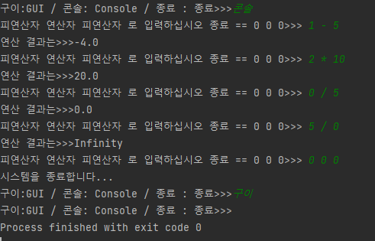
처음 선택화면 및 콘솔계산기 구동 화면

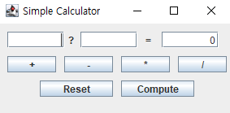 => 구이 첫 화면

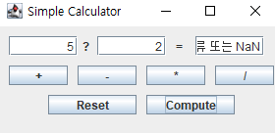 => 설정 없이 계산 시 오류처리

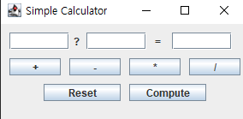 => 리셋 버튼 작동이후 화면

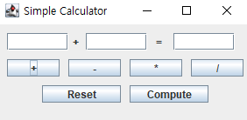 => 플러스 버튼만 누른 상태

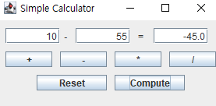 => 빼기 연산 결과

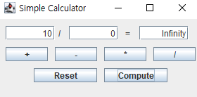 => 0으로 나눈 결과
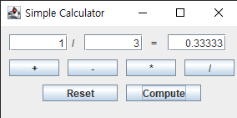 => 소수점 제한 구현

마침.

