UNIVERSITATEA „ALEXANDRU IOAN CUZA” DIN IAȘI
FACULTATEA DE ECONOMIE ȘI ADMINISTRAREA AFACERILOR
MASTER: SISTEME INFORMAȚIONALE PENTRU AFACERI (SIA / SDBIS)
DISCIPLINA: ANALIZA ȘI PROIECTAREA ORIENTATĂ PE OBIECTE (APOO)
AN UNIVERSITAR 2026-2027
ERASMUS MOBILITY PLATFORM (EMP)
Sistem Distribuit bazat pe Domain-Driven Design și UML 2.5 pentru Gestiunea Mobilităților Academice Internaționale conform Standardelor Erasmus Without Paper
PROIECT DE SPECIALITATE - PARTEA I (LIVRABILUL P1: SECȚIUNILE 1–6)
Echipa de Proiect & Repartizare Subdomenii:
- Prigoreanu Alin-Gabriel (Student 1): Learning Agreement Management (Core Domain)
- Bîrgovan A. Mihai-Daniel (Student 2): Equivalence Management (Supporting Subdomain)
- Schipor Ana-Maria (Student 3): Mobility Preparation (Supporting Subdomain)

Chapter 1. Defining and Structuring Functional and Non-Functional Requirements

1.1 Executive Summary of Main Application Requirements
Master in Software Development and Business Information Systems (SDBIS / SIA), 1st Year
Course: Object-Oriented Analysis and Design (OOAD)
Project: Erasmus Mobility Platform (EMP): Enterprise Distributed Architecture for International Academic Exchanges
Authors:
- Prigoreanu Alin-Gabriel (Student 1)
- Bîrgovan A. Mihai-Daniel (Student 2)
- Schipor Ana-Maria (Student 3)

Problem Statement and Academic Background
Within European higher education institutions participating in the Erasmus+ framework, student academic mobility is a strategic cornerstone of internationalization. However, managing exchange programs is plagued by operational fragmentation: workflows are mediated by disjointed email threads, manually scanned paper documents, out-of-date course catalogs, and a lack of real-time curricular synchronization between the sending institution (Home University) and the receiving institution (Host University).
To eliminate administrative bottlenecks and achieve strict compliance with European Commission standards, specifically the Erasmus Without Paper (EWP)network, there is an urgent need to engineer an enterprise web application: theErasmus Mobility Platform (EMP). The platform orchestrates the complete mobility lifecycle: from student nomination confirmation and automated administrative onboarding checklists, to querying historic syllabus equivalence catalogs, authoring tripartite study contracts (Learning Agreements), validating European Credit Transfer and Accumulation System (ECTS) parity, and securing digital institutional approvals.
Following the principles of Domain-Driven Design (DDD), the application's complexity is decomposed into three primary Bounded Contexts, supported by generic infrastructural subdomains:

1) Learning Agreement Management (Core Domain)
The Learning Agreement Management subdomain constitutes the core business engine and strategic differentiator of the enterprise platform. While managing administrative checklists or authentication represents generic or supporting operational tasks, the tripartite study contract (Learning Agreement - LA) represents the legal and academic foundation guaranteeing automatic credit recognition. This context encapsulates the platform's most rigorous business rules: multi-institution curricular parity, aggregate transaction integrity, and digital signature orchestration across three distinct stakeholders (Student, Home Academic Coordinator, and Host Institutional Coordinator).
The functional requirements grouped in this domain are:
- Create and Initialize Learning Agreement (Create LA): A nominated student creates a study contract linked to their unique mobility dossier (MobilityId, StudentId). Upon creation, the agreement enters the DRAFT state, encapsulating metadata regarding the host partner institution, academic year, target semester (Autumn, Spring, or Full Year), and mobility modality (Study vs. Traineeship).
- Manage Course Lines (Manage Course Lines): The student authors and mutates academic components partitioned into two strictly correlated tables:
- Table A (Study Programme at Receiving Institution): Educational components to be completed abroad, capturing foreign course codes, official titles, semester term, language of instruction, and allocated ECTS credits.
- Table B (Recognition at Sending Institution): Curricular courses from the home faculty degree plan that will be replaced and recognized upon successful completion of Table A.
- Validate ECTS Credit Balance (Check ECTS Balance): The aggregate enforces the core domain invariant: the cumulative credits earned in Table A must equal the recognized credits in Table B, strictly fulfilling the standard benchmark of at least 30 ECTS credits per semester (subject to bilateral agreement thresholds). This invariant check executes transactionally in memory prior to any submission attempt.
- Propose New Academic Equivalences (Propose New Equivalence): If a student discovers during study plan composition that a foreign course is missing from the institutional equivalence catalog, an extension flow (<<extend>>) is triggered, forwarding the syllabus and learning outcomes to the departmental teaching committee for expedited review.
- Submit Learning Agreement (Submit LA): The student formally submits the finalized study plan for departmental review. This command mandatorily includes the automated ECTS balance validation (<<include>>). Upon success, the aggregate transitions to SUBMITTED, locking the course lines from uncoordinated student edits.
- Home Academic Coordinator Review (Review LA): The home faculty coordinator reviews curricular compatibility. The coordinator may:
- Approve the agreement: Transitioning the contract to APPROVED_BY_FACULTY.
- Request changes (Request Amendment): Transitioning the contract to UNDER_REVIEW, returning it to the student accompanied by contextual audit notes identifying incompatible courses.
- Notify student of decision (Notify Student of Decision): Every state transition automatically publishes an in-app and email alert (<<include>>).
- Escalate Overdue Academic Reviews (Escalate Overdue Review): A background temporal scheduler monitors agreements resting in the SUBMITTED state. If the designated coordinator fails to render a decision within 5 business days, the scheduler triggers an automated escalation notification to the Vice-Dean for International Relations (<<extend>>).
- Host Partner Institutional Confirmation (Confirm LA at Host University): Following home faculty endorsement, the contract is transmitted securely across the European network via the EWP REST API. Upon digital signature by the host coordinator, the agreement achieves full tripartite validity and transitions to CONFIRMED_BY_HOST.
- In-Mobility Exceptional Amendments (Request Amendment): During the initial weeks of mobility, if courses at the host university are cancelled or rescheduled, the student can initiate an amendment request (AMENDED state), triggering an isolated tripartite approval cycle for altered lines only.
- Contract Cancellation (Cancel LA): Upon student withdrawal or force majeure, the agreement transitions to the terminal CANCELLED state, cascading closures through dependent subsystems.

2) Equivalence Management (Supporting Subdomain)
The Equivalence Management subdomain operates as a vital supporting catalog, maintaining a centralized repository of validated academic syllabus comparisons between the home faculty and international partner institutions. Its operational role is to relieve academic committees from redundantly evaluating identical syllabi each semester while providing students with pre-approved curricular paths prior to departure.
The functional requirements grouped in this domain are:
- Search Course Equivalences (Search Equivalences): Students and faculty query the active catalog using multi-criteria filters: partner university, country, degree program (BSc / MSc), field of study, and course codes.
- Compare ECTS and Syllabi (Compare ECTS & Syllabus): Side-by-side comparative inspection of course syllabi: instructional objectives, covered thematic units, learning outcomes, laboratory/project hours, and credit weights.
- Register Institutional Equivalence (Register Equivalence): Academic coordinators establish canonical 1:1 or N:M mappings between foreign courses and home degree subjects.
- Validate ECTS Values (Validate ECTS Values): The system enforces (<<include>>) that the credit allocation of mapped courses preserves academic credit parity without causing a graduation deficit.
- Import Historical Curricular Mappings (Import Historical Equivalences): Administrative bulk ingestion of legacy bilateral agreements and accredited equivalence matrices via structured CSV/JSON payloads (<<extend>>).
- Approve Student Equivalence Proposals (Approve Proposed Equivalence): Faculty evaluation of student-submitted syllabi, promoting vetted rules into the public institutional catalog.
- Retire Outdated Equivalences (Retire Equivalence): When either institution updates its degree curricula, obsolete equivalences transition to RETIRED, preserving historical validity for existing contracts while preventing future selection.
The central entity AcademicEquivalence traverses the lifecycle states: PROPOSED, UNDER_EVALUATION, APPROVED, ACTIVE, and RETIRED.

3) Mobility Preparation (Supporting Subdomain)
The Mobility Preparation subdomain governs administrative compliance, document onboarding, and logistical readiness between initial student nomination and physical departure abroad.
The functional requirements grouped in this domain are:
- Confirm Student Nomination (Confirm Nomination): International Relations Officers (DRI) log the official allocation of a student to a partner destination, initializing the mobility lifecycle.
- Automated Checklist Generation (Generate Checklist): Confirmation triggers (<<include>>) the generation of a customized collection of ChecklistTask entities derived from country- and cycle-specific templates. Standard onboarding tasks include:
1. Online Linguistic Support (OLS) language assessment;
2. European Health Insurance Card (EHIC) or private international medical coverage;
3. Student visa and residency documentation (for non-EU/EEA destinations);
4. Erasmus+ Financial Grant Agreement signature;
5. Final tripartite signature of the Learning Agreement;
6. Host institution formal acceptance letter and accommodation confirmation.
- Manage Checklist Templates (Manage Checklist Template): Administrators define task templates, relative deadlines (e.g., Departure Date minus 30 days), and mandatory compliance criteria.
- View Student Task Dashboard (View Checklist): Real-time student progress tracking, displaying deadlines, instructions, and task states.
- Deep-Link to Official Portals (Open Official Form): Tasks linking to standardized external web applications (e.g., European Commission OLS portal or bank registration) offer contextual single-sign-on launch links (<<extend>>).
- Upload Documents & Verify Submissions (Mark Task Done / Submit for Verification): Students submit PDF certificates, transitioning tasks to SUBMITTED_FOR_VERIFICATION. DRI coordinators validate document authenticity, advancing tasks to COMPLETED.
- Monitor Student Readiness Progress (Monitor Student Progress): Coordinators oversee cohort onboarding metrics via progress percentages and bottleneck dashboards.
- Flag Overdue Tasks (Flag Overdue Task): The temporal background engine flags overdue items (<<extend>>), triggering administrative escalations.
- Automated Deadline Notifications (Send Deadline Reminder): Scheduled notifications dispatched at milestone intervals: T - 7 days, T - 3 days, and on the date of expiration.
The central aggregate ChecklistTask traverses the lifecycle: INITIALIZED, PENDING_STUDENT_ACTION, SUBMITTED_FOR_VERIFICATION, COMPLETED, and OVERDUE.

4) Generic Subdomains
- Notification Service: Decoupled asynchronous messaging subsystem dispatching transaction alerts across email, push notifications, and EWP webhook integrations.
- Security, Identity & Audit (GDPR): Federated Single Sign-On (eduGAIN / Institutional SSO), Role-Based Access Control (RBAC), and an immutable, append-only cryptographic audit ledger tracking all personal data accesses and academic decisions.

5) End-to-End Transactional Architecture & Data Flow
Data flows across Bounded Context boundaries through five coordinated transactional stages:
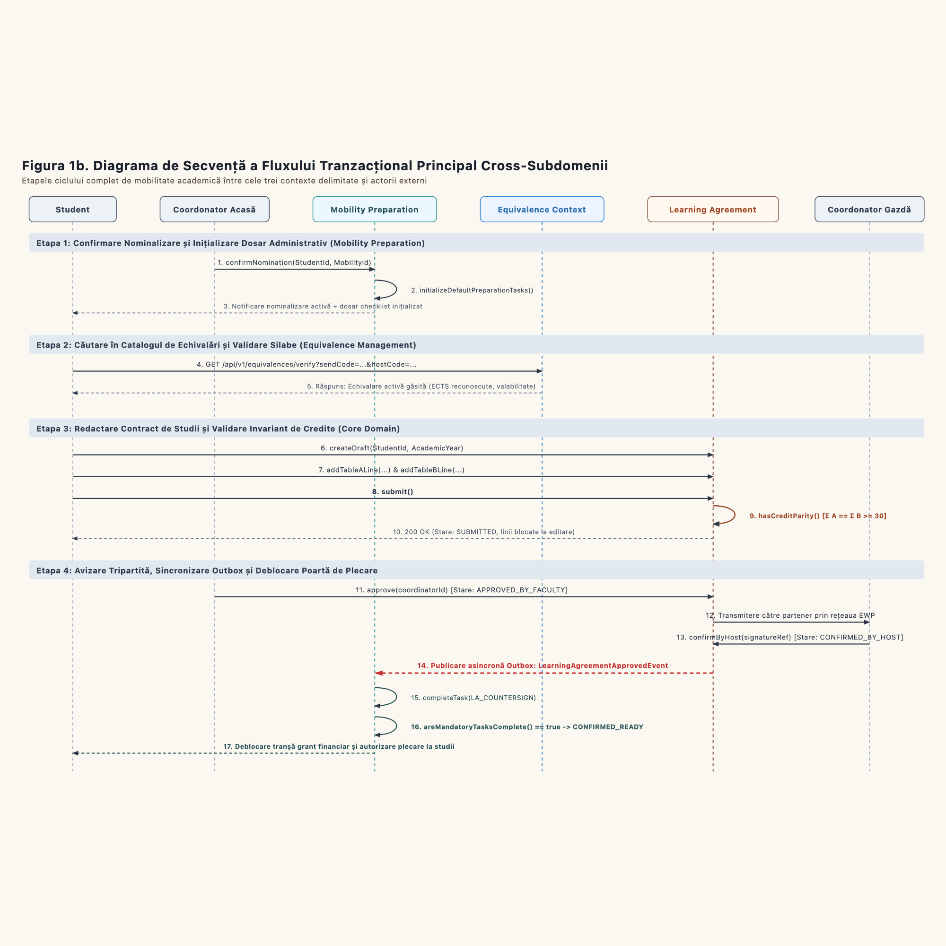
Figure 1b. Main End-to-End Transaction Flow Sequence Diagram across Subdomains

Detailed Transaction Breakdown:
1. Transaction T1: Nomination & Automated Onboarding Checklist (Mobility Preparation)
- Trigger: Institutional selection committee allocates a mobility grant.
- Data Flow: The coordinator invokes Confirm Nomination, providing StudentId, MobilityId, destination host, and term.
- Consistency: An ACID transaction instantiates the mobility dossier and populates the personalized ChecklistTask entities. The domain event StudentNominatedEvent is emitted.
2. Transaction T2: Equivalence Discovery & Catalog Enrichment (Equivalence Management)
- Trigger: The student identifies courses at the partner institution.
- Data Flow: A synchronous REST query (Search Equivalences) returns accredited mappings and credit values.
- Exception Branch: If a syllabus is missing, the student invokes Propose New Equivalence. The coordinator approves the syllabus, promoting it to ACTIVE for institutional reuse.
3. Transaction T3: Study Plan Authoring & Invariant Enforcement (Learning Agreement)
- Trigger: Student composes Table A and Table B.
- Data Flow: Create LA instantiates the LearningAgreement aggregate in the DRAFT state. The student maps foreign course lines to domestic degree subjects.
- Invariant Check: Invoking Submit LA triggers internal aggregate validation (Check ECTS Balance). The transaction enforces Σ ECTS(Table A) = Σ ECTS(Table B) ≥ 30. Non-compliant attempts are rejected with zero database mutation. Compliant contracts transition to SUBMITTED.
4. Transaction T4: Tripartite Digital Review & Outbox Event Synchronization (Integrations)
- Trigger: Home coordinator executes Review LA.
- Data Flow: If approved, the contract advances to APPROVED_BY_FACULTY and is transmitted across the European EWP network. Upon partner endorsement, the contract becomes CONFIRMED_BY_HOST.
- Outbox Pattern: State persistence writes LearningAgreementApprovedEvent to the local transactional Outbox table. An asynchronous message broker guarantees at-least-once delivery to Mobility Preparation, which idempotently marks the checklist task as COMPLETED.
5. Transaction T5: Exceptional Amendments & Force Majeure Abort (Interruptible Region)
- In-Mobility Amendments: If foreign courses are cancelled, Request Amendment transitions the contract to AMENDED for an isolated tripartite delta approval.
- Mobility Cancellation: In the event of force majeure, the cancellation signal traverses the «interrupting edge» of the InterruptibleActivityRegion. This cancels the LearningAgreement (CANCELLED), marks active checklist tasks as OVERDUE/ABORTED, and deallocates reserved Erasmus scholarship funds.

Table 1.1. Measurable Non-Functional Requirements Matrix (SLA & Acceptance Criteria)
Erasmus Mobility Platform (EMP)
Methodological Alignment: Course Chapter 2 - Functional Modeling (FEAA Master SDBIS / SIA)
Specification Standard: Every non-functional requirement specifies an architectural category, a quantifiable metric, an explicit Service Level Agreement (SLA) threshold, a verification method, and the corresponding architectural decision.

1. Methodological Foundations
According to Dennis et al. and course lectures:
> "A functional requirement decides which classes and operations must exist. A non-functional requirement decides which architecture you need (layering, caching, database partitioning, asynchronous event processing, security boundaries)."
> "Statements like 'the system must be fast and user-friendly' are wishes, not requirements. Make them measurable or delete them."
The following matrix governs the architectural quality attributes of the Erasmus Mobility Platform.

2. Extended Quality Attribute Matrix
ID | Architectural Category | Measurable Quality Attribute | Quantifiable Metric | Service Level Agreement (SLA Target) | Verification & Testing Condition | Architectural Decision & Implementation
NFR-01 | Performance & Latency | Equivalence Catalog Search Response Time | HTTP Endpoint Latency (p95, p99) | p95 < 250 ms, p99 < 500 ms | Gatling / JMeter load test executing 100 concurrent multi-attribute filter queries (partner university, country, degree program) against a database holding at least 50,000 course syllabus records. | Composite B-Tree index on (partner_id, course_code), PostgreSQL query plan optimization, and Redis / Hibernate L2 Cache for active semester partner catalogs.
NFR-02 | Performance & Integrity | ECTS Parity Validation Execution Latency | In-Memory Method Execution Duration | Latency < 100 ms | Automated JMH / JUnit benchmark executing LearningAgreement.validateEctsBalance() on contracts holding up to 30 curricular lines (Table A / Table B). | Pure in-memory Domain Model execution within the Aggregate Root boundary, free of blocking I/O or downstream remote service calls.
NFR-03 | Security & Compliance (GDPR) | Tamper-Evident Immutable Audit Trail | Capture Ratio & Persistence Write Latency | 100% of mutating actions captured, synchronous persistence in < 20 ms | Automated security test asserting that all grade modifications, approval signatures, and PII accesses (National ID, bank IBAN) generate an append-only ledger entry signed with HMAC SHA-256. | Spring Security AOP Aspect (@Audited), dedicated append-only ledger table with restricted database update/delete privileges.
NFR-04 | Scalability & Batch Processing | Automated Deadline Sweep & Reminder Dispatching | Batch Job Execution Throughput | 10,000 active dossiers processed in < 60 seconds | Nightly batch benchmark scanning 10,000 student mobility dossiers, computing milestone intervals (T-7, T-3, Overdue), and queuing alert payloads. | Asynchronous Spring Batch / Scheduled Task accelerated by Java 23 Virtual Threads, partitioned database pagination, and RabbitMQ message broker.
NFR-05 | Transactional Consistency | State Convergence on Mobility Abort (Interruptible Region) | End-to-End State Convergence Window | Atomic ACID consistency(single transaction) or eventual consistency in< 1,500 ms | Distributed integration test asserting that invoking CancelMobility cascades state transitions across LearningAgreement (CANCELLED) and active ChecklistTask records (ABORTED). | Transactional Outbox Pattern: state mutation and MobilityCancelledEvent committed within the same ACID boundary, followed by idempotent downstream message consumption.
NFR-06 | Availability & Resilience | Platform Operational Availability during Peak Submission Windows | Monthly Operational Uptime | Availability ≥ 99.5%during peak academic windows (September–October & January–February);MTTR < 15 minutes | Continuous synthetic probing via Prometheus and Grafana on the /actuator/health endpoint under simulated peak concurrency; automated container self-healing. | Containerized multi-instance deployment on Kubernetes, Horizontal Pod Autoscaling (HPA) driven by CPU/memory thresholds, and PostgreSQL active-passive read replica failover.
NFR-07 | Security & Authorization | Role-Based Access Control Segregation (RBAC) | Unauthorized Access Rejection Rate | 100% unauthorized requests rejected (HTTP 403 Forbidden) | Automated OWASP Top 10 Broken Access Control test suite attempting cross-student contract modification and privilege escalation. | Federated eduGAIN / OAuth2 JWT authentication, Spring Security method-level @PreAuthorize, and entity tenancy verification SecurityContext.getCurrentStudentId() == LA.getStudentId().

1.2 Structuring and Detailing Functional Requirements

1.2.1 Problem Domain Decomposition (Strategic DDD) and Context Mapping
Erasmus Mobility Platform (EMP)
Methodological Alignment: Strategic Domain-Driven Design (Eric Evans, Vaughn Vernon) & Model Project Guidelines (FEAA Master SDBIS / SIA)

1. Strategic Context Map
The strategic architecture decomposes the problem domain into three core operational Bounded Contexts, an integration Shared Kernel, and two supporting generic subdomains:
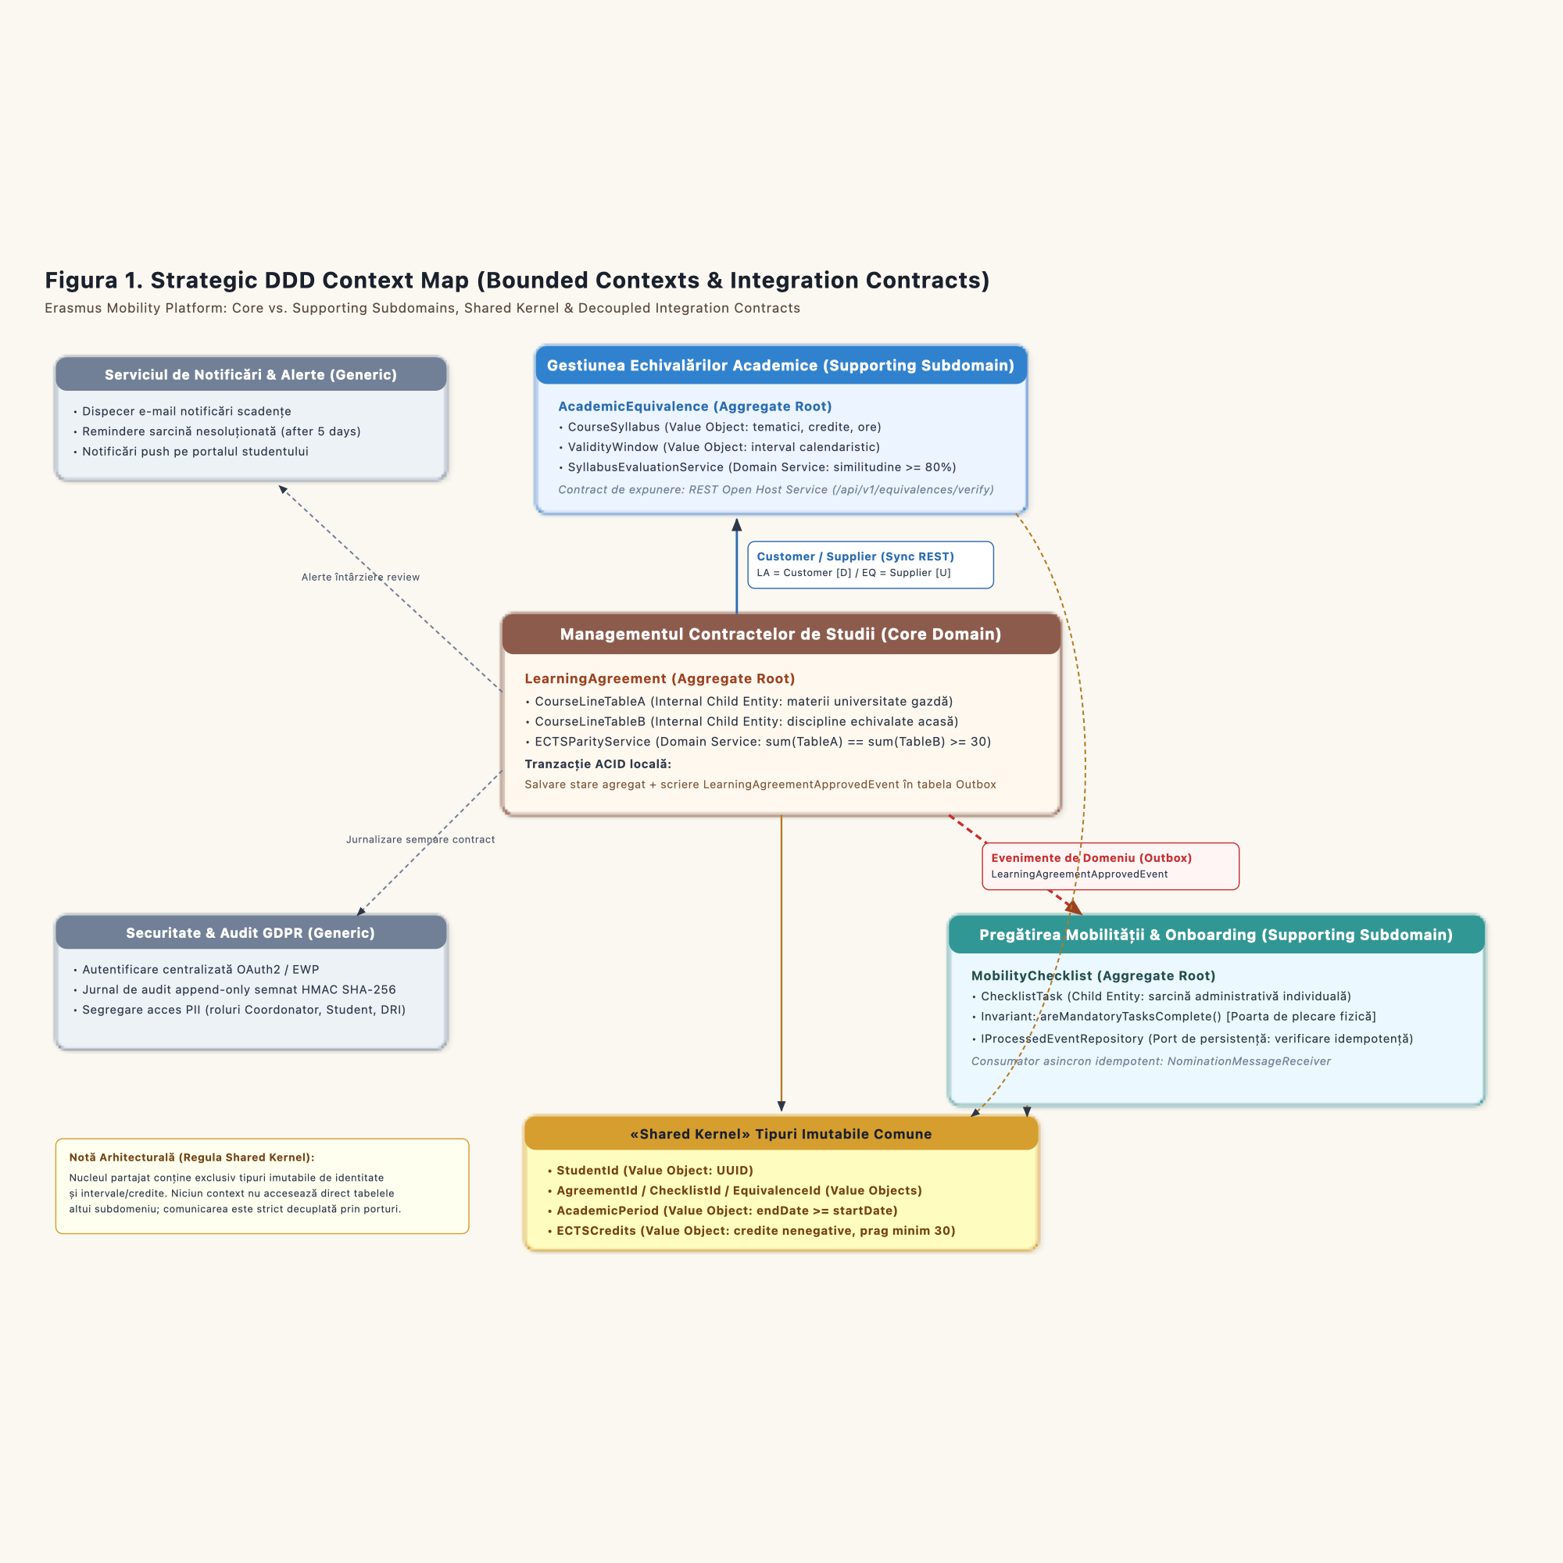
Figure 1. Strategic DDD Context Map (Bounded Contexts & Integration Contracts)
##### Formal Integration Contracts:
1. Shared Kernel: The three Bounded Contexts share a minimal set of immutable identity and measurement Value Objects: StudentId, MobilityId, AcademicPeriod, and ECTSCredits. Modifications to these types require cross-team consensus.
2. Customer / Supplier (Synchronous REST with Anti-Corruption Layer): Learning Agreement Managementacts as a Customer consuming the course catalog services exposed byEquivalence Management (Supplier). Queries pass through a domain Port and an infrastructure REST Adapter to preserve aggregate encapsulation.
3. Asynchronous Event-Driven Integration (Transactional Outbox Pattern): Inter-context synchronization between Learning AgreementandMobility Preparation is temporal and asynchronous. Upon partner endorsement (CONFIRMED_BY_HOST), domain events (LearningAgreementApprovedEvent, LearningAgreementCancelledEvent) are committed atomically to the local Outbox table and delivered via message broker to update onboarding checklist states idempotently.

2. Ubiquitous Language Glossary
Term / Concept | Bounded Context | DDD Element / Pattern | Formal Business Role & Architectural Significance
LearningAgreement | Learning Agreement Management | Aggregate Root | The official tripartite legal and academic contract executed between student, home faculty, and partner host institution, establishing pre-approved credit recognition.
CourseLineTableA | Learning Agreement Management | Internal Entity | An educational component at the receiving host institution to be completed abroad, possessing a course code, official title, term, language, and ECTS credits.
CourseLineTableB | Learning Agreement Management | Internal Entity | An accredited educational component from the home degree syllabus that will be replaced and recognized upon passing Table A components.
LearningAgreementStatus | Learning Agreement Management | Enum / Value Object | Contract lifecycle states: DRAFT, SUBMITTED, UNDER_REVIEW, APPROVED_BY_FACULTY, CONFIRMED_BY_HOST, AMENDED, CANCELLED.
AcademicEquivalence | Equivalence Management | Aggregate Root | Institutional mapping binding foreign course syllabi to domestic degree subjects based on verified learning outcomes and credit equivalence.
EquivalenceStatus | Equivalence Management | Enum / Value Object | Equivalence lifecycle states: PROPOSED, UNDER_EVALUATION, APPROVED, ACTIVE, RETIRED.
MobilityChecklist | Mobility Preparation | Aggregate Root | Central administrative dossier managing the student's preparation checklist and enforcing overall readiness invariants.
ChecklistTask | Mobility Preparation | Child Entity | An atomic unit of administrative onboarding compliance (e.g., EHIC card, grant contract, OLS assessment) encapsulated within MobilityChecklist.
TaskStatus | Mobility Preparation | Enum / Value Object | Task lifecycle states: INITIALIZED, PENDING_STUDENT_ACTION, SUBMITTED_FOR_VERIFICATION, COMPLETED, OVERDUE, ABANDONED.
StudentId | Shared Kernel | Value Object | Globally unique immutable identifier representing the matriculated student across all university subsystems.
MobilityId | Shared Kernel | Value Object | Globally unique immutable identifier representing the academic exchange grant instance.
AcademicPeriod | Shared Kernel | Value Object | Immutable date interval capturing mobility start and end dates, enforcing endDate >= startDate.
ECTSCredits | Shared Kernel | Value Object | Decimal numerical value quantifying academic workload according to European Credit Transfer and Accumulation System conventions.

1.2.2 Business Process Activity Diagram across Bounded Contexts (Figure 2)
Erasmus Mobility Platform (EMP)
Methodological Alignment: Course Chapter 2 - Functional Modeling (Alan Dennis et al., UML 2.5 Metamodel) & Project Guidelines (FEAA Master SDBIS / SIA)
Visual Artifact: models/diagrams-png/Figura2-Activity-Diagram-Across-Bounded-Contexts.png
Scalable Vector Graphics (SVG): models/diagrams-png/Figura2-Activity-Diagram-Across-Bounded-Contexts.svg
PlantUML Source: docs/diagrams/activity-diagram-erasmus-platform.puml

1. Architectural Partitioning across Swimlanes (Vertical Partitions)
In strict accordance with Domain-Driven Design (DDD)and the UML 2.5 metamodel, the macro-level business workflow of the platform is partitioned intothree parallel vertical swimlanes mapping directly to the three Bounded Contexts:
1. Swimlane 1 (Left): `Mobility Preparation (Supporting Subdomain)`
- Operational Responsibility: Initializes the mobility dossier post-selection, automatically generates onboarding checklist tasks (ChecklistTask), tracks administrative readiness (EHIC medical card, OLS linguistic assessment), coordinates Erasmus+ scholarship grant contract execution, and enforces compliance deadlines.
2. Swimlane 2 (Center): `Equivalence Management (Supporting Subdomain)`
- Operational Responsibility: Queries active accredited syllabus equivalence records, compares learning outcomes, and handles missing course exceptions (student proposal → academic review → ECTS validation → institutional catalog registration).
3. Swimlane 3 (Right): `Learning Agreement Management (Core Domain)`
- Operational Responsibility: Governs the authoring and tripartite approval of the study plan (Table A foreign courses mapped to Table B home degree components), enforces the core credit parity invariant (Σ Table A == Σ Table B ≥ 30 ECTS), manages faculty review, and secures digital institutional confirmation from the host partner across the European EWP network.

2. Concurrency, Synchronization, and Interruptible Region Semantics

2.1 Parallel Synchronization (Fork & Join)
Physical departure preparation requires simultaneous administrative onboarding and academic curriculum planning:
- Fork Synchronization Bar (Top Black Bar): Splits the initial control flow into concurrent streams:
- Administrative Stream (Swimlane 1): Progresses through document uploads and scholarship agreements.
- Academic Stream (Swimlane 2 $\rightarrow$ Swimlane 3): Searches equivalences, composes the Learning Agreement, and traverses departmental review.
- Join Synchronization Bar (Bottom Black Bar): Blocks final departure readiness until both concurrent streams have completed successfully (all mandatory checklist tasks verified AND the Learning Agreement confirmed by the host partner).

2.2 Canonical UML 2.5 «InterruptibleActivityRegion» & Interrupting Edge
The concurrent lifecycle between the Fork and Join bars is enclosed within an `InterruptibleActivityRegion`:
- `AcceptEventAction` (Concave Pentagon): Located in the upper section of the region, Receive Mobility Cancellation Request (Student / Force Majeure Signal) possesses no incoming control flow. It remains continuously active throughout the preparation phase.
- `«interrupting edge»` (Red Dashed Arrow with Lightning Bolt ⚡): If an abort signal arrives:
1. Traversal of the interrupting edge instantly destroys all active parallel tokens within the region, cleanly halting in-flight tasks in all three swimlanes.
2. The control flow exits the region boundary and executes the cascading cancellation procedure.

3. Atomic Cascading Cancellation Flow (Right-Hand Path)
Triggered exclusively by the interrupting edge, this path enforces cross-context consistency and financial accountability:
1. Cancel Mobility Dossier: The root mobility record transitions to CANCELLED.
2. Cascade Cancel Learning Agreement: The LearningAgreement aggregate transitions atomically to CANCELLED, revoking pending or partial signatures.
3. Abort Active Checklist Tasks: Unfinished ChecklistTask records are aborted, locking student upload portals.
4. Publish MobilityCancelledEvent: The domain event is emitted via the Outbox to notify the host university and European EWP nodes.
5. Deallocate Erasmus Grant Funds & DRI Reconciliation: Reserved scholarship budgets are released back into the institutional mobility fund.
6. Activity Final Node (Bullseye): The entire process terminates cleanly.

4. Normal Successful Completion Flow
Upon receiving arrival tokens from both parallel streams at the Join Bar:
1. Validate Complete Mobility Dossier & Issue Departure Certificate: Verifies 100% compliance across administrative and academic deliverables.
2. Finalize Mobility Preparation Phase: Marks the preparation phase as successfully concluded.
3. Publish MobilityPreparedEvent: Emits the completion domain event.
4. Activate "Student Abroad" Academic Status: The student's academic status is formally updated to active exchange participant.
5. Activity Final Node (Bullseye): Successful termination of the onboarding process.
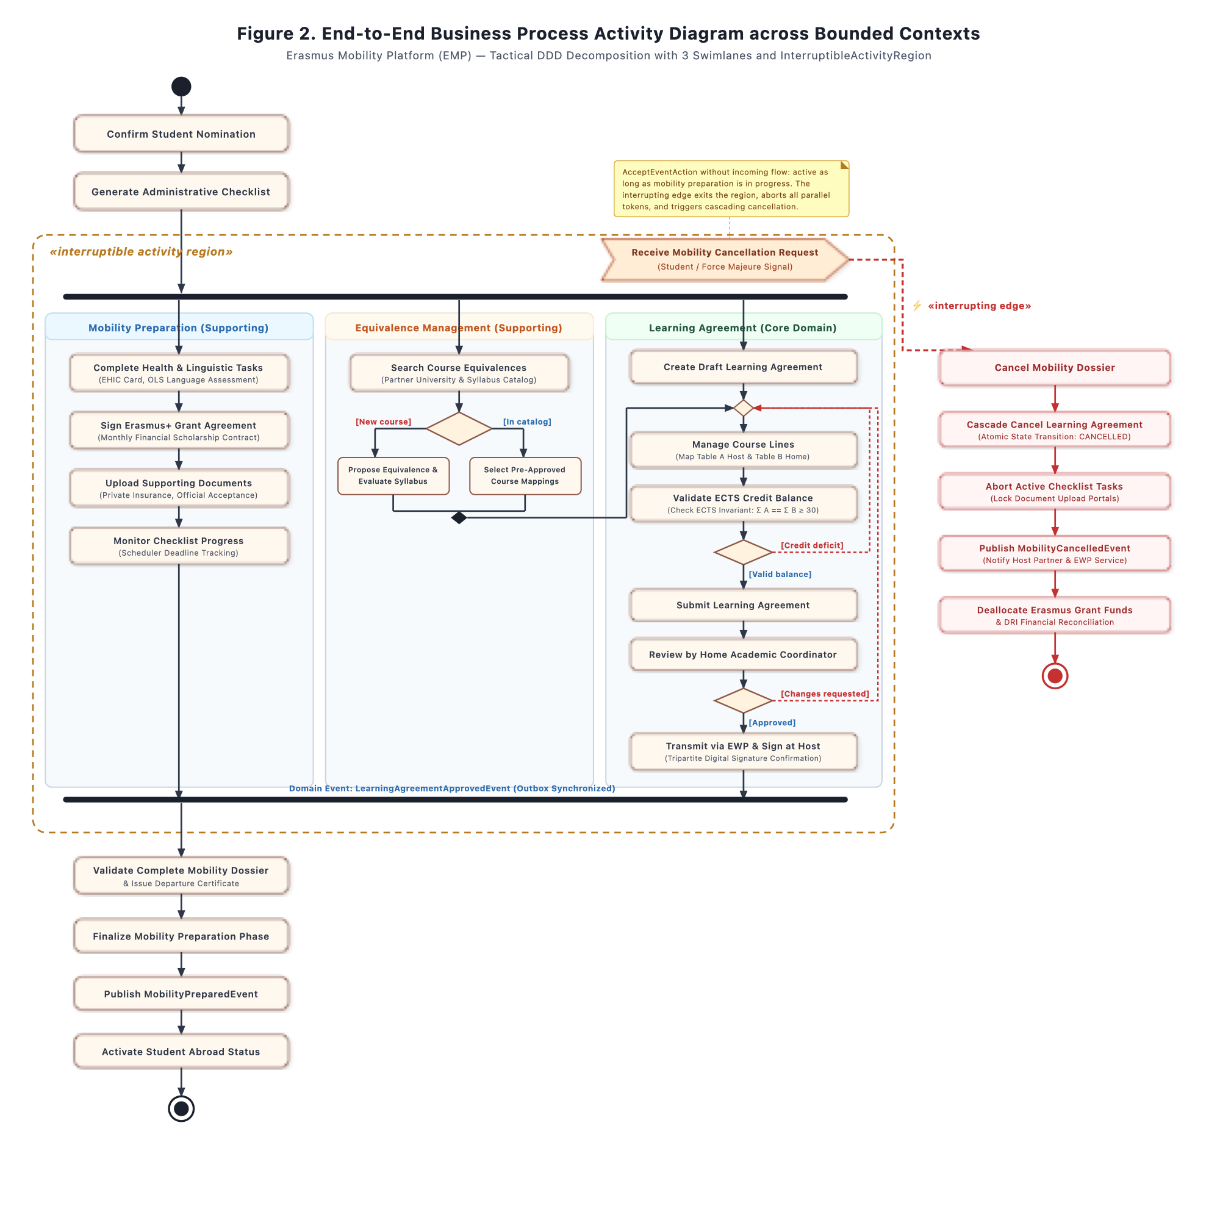
Figure 2. Business Process Activity Diagram across Bounded Contexts with Swimlanes and InterruptibleActivityRegion

1.2.3 Subdomain Use Case Diagrams (Figures 3, 4, 5)
For each of the three primary subdomains established in the strategic context map, a dedicated UML 2.5 Use Case Diagram was designed, detailing business actors, associations, and advanced «include» and «extend» relationships:
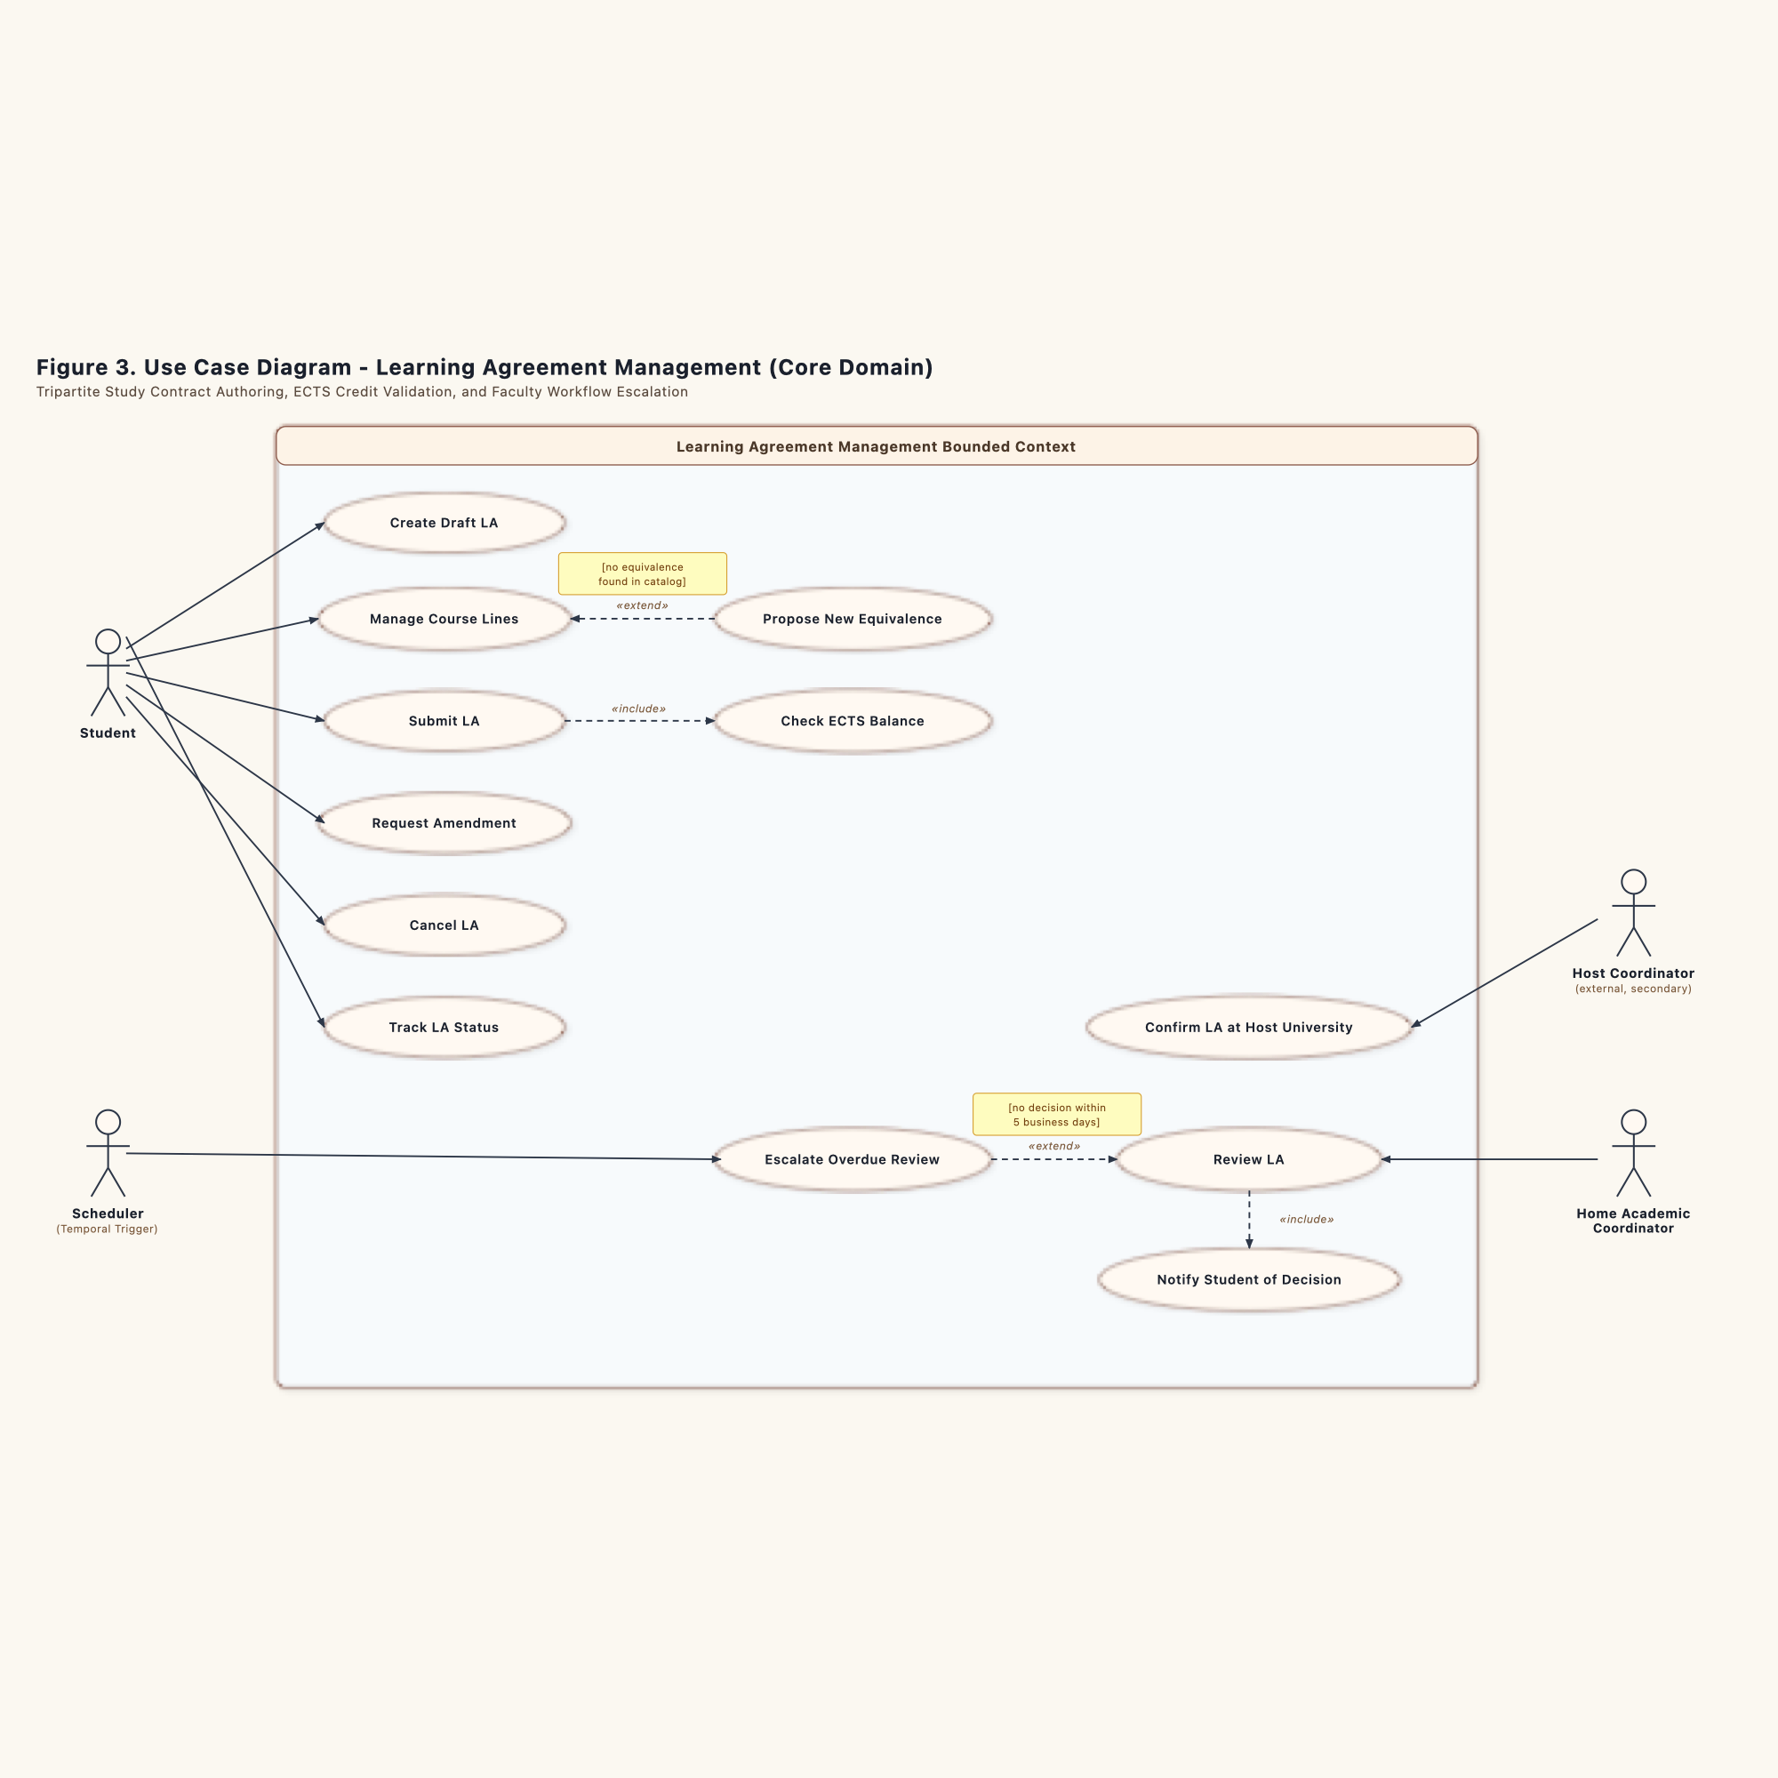
Figure 3. Use Case Diagram: Learning Agreement Management (Student 1: Prigoreanu Alin-Gabriel)
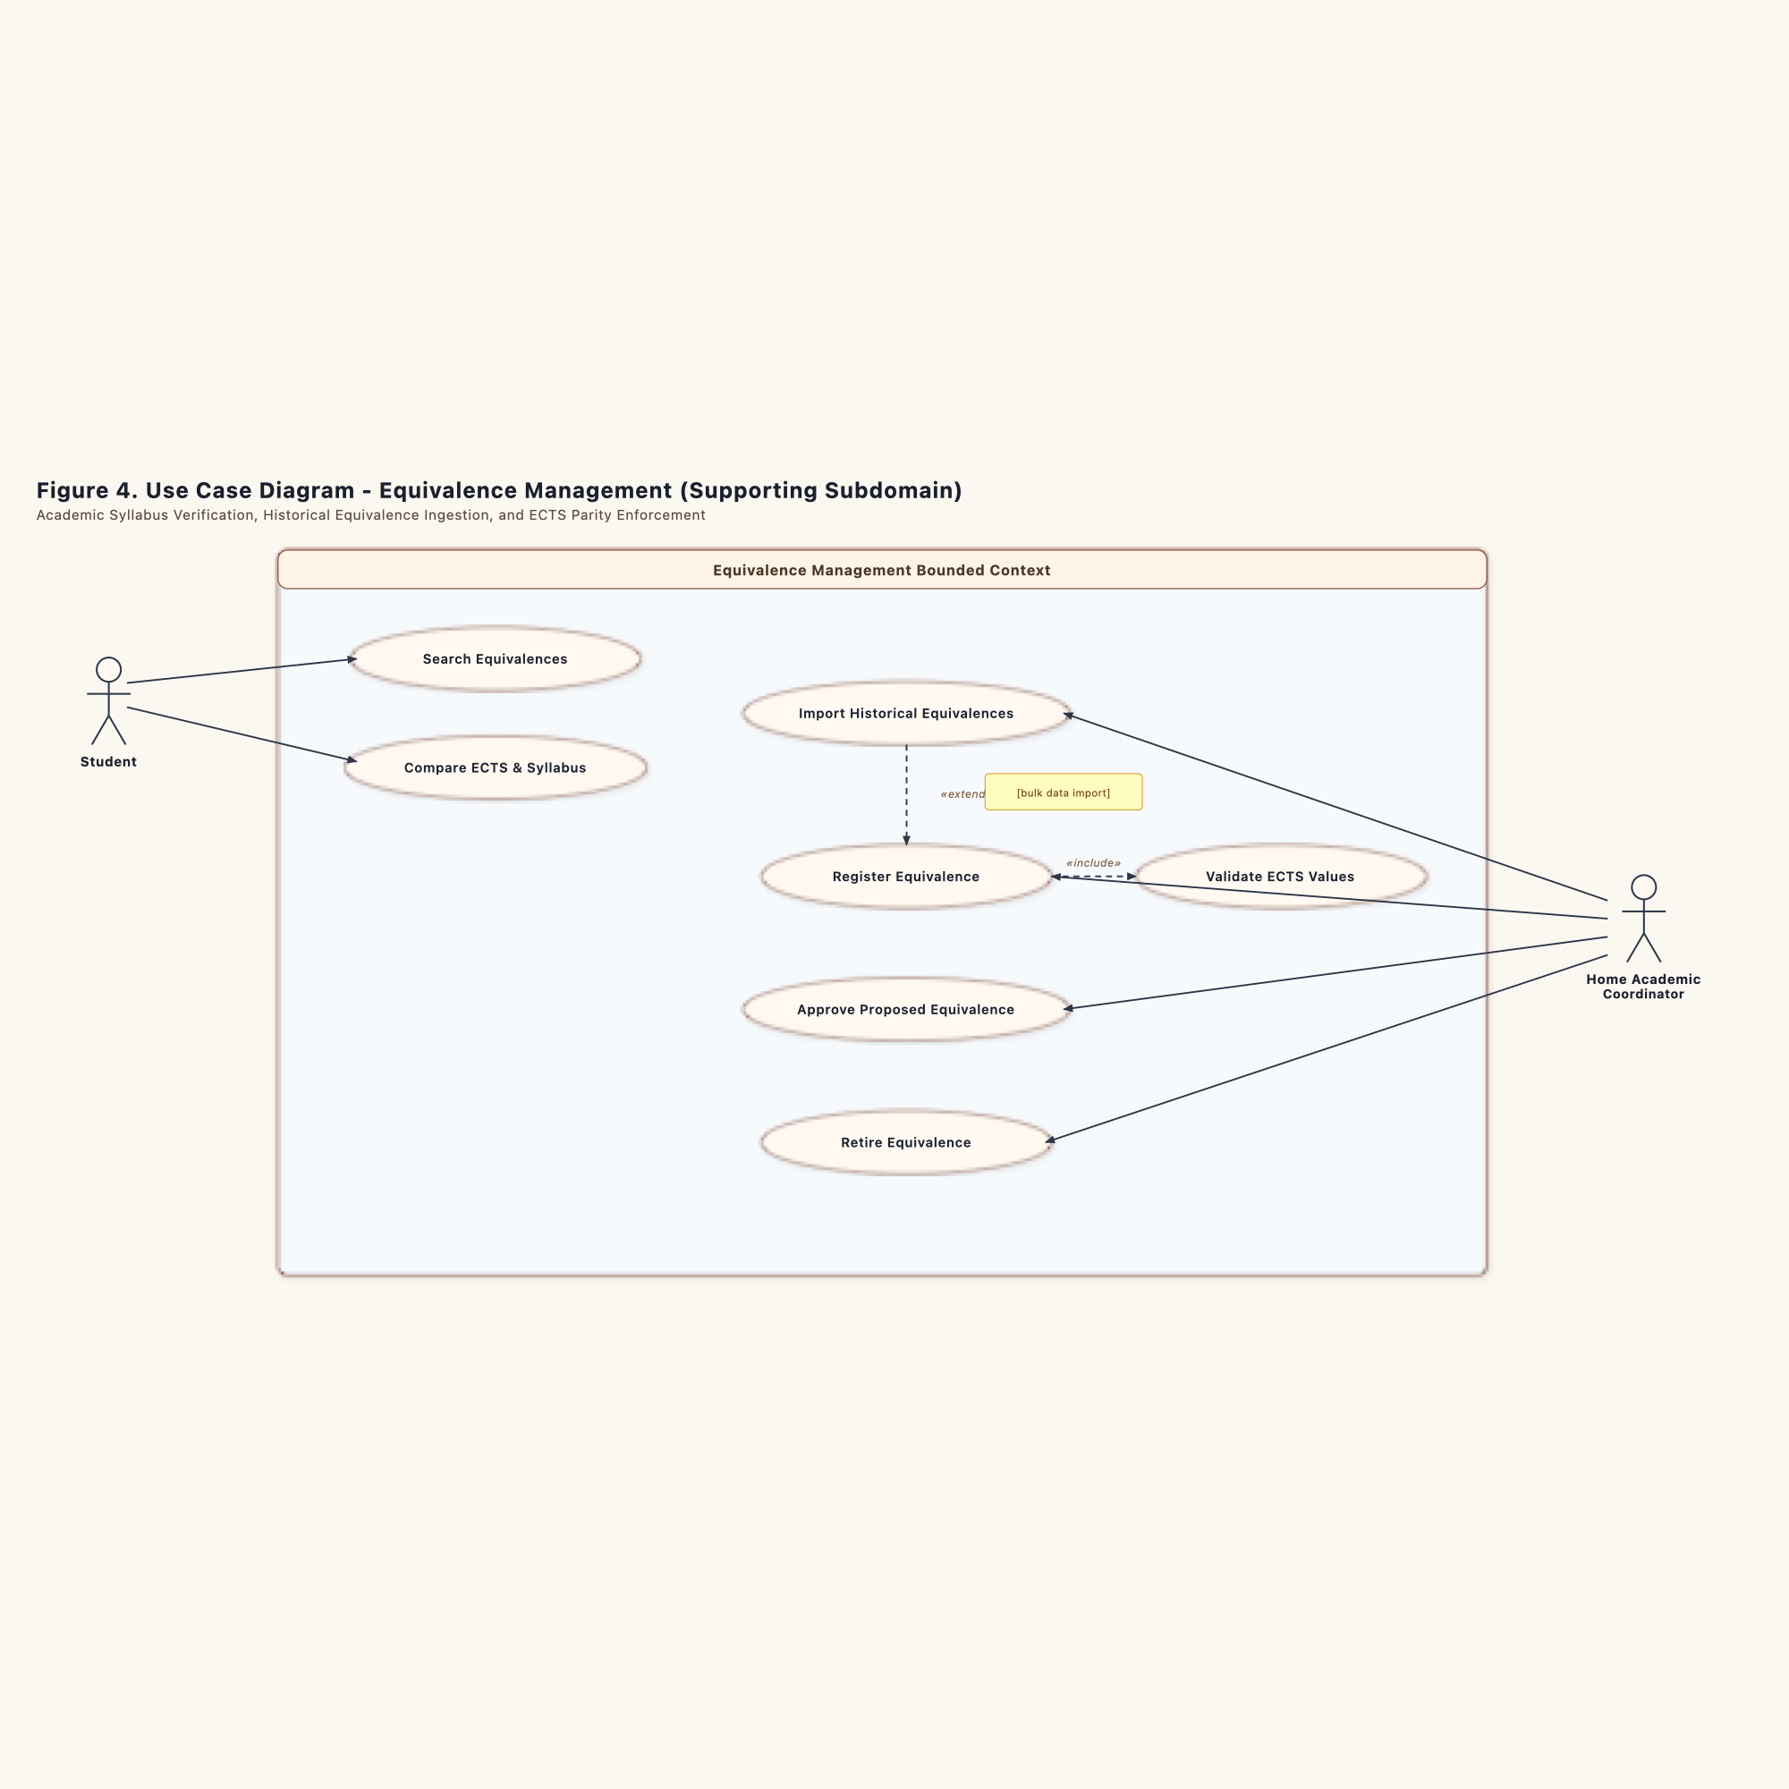
Figure 4. Use Case Diagram: Equivalence Management (Student 2: Bîrgovan A. Mihai-Daniel)
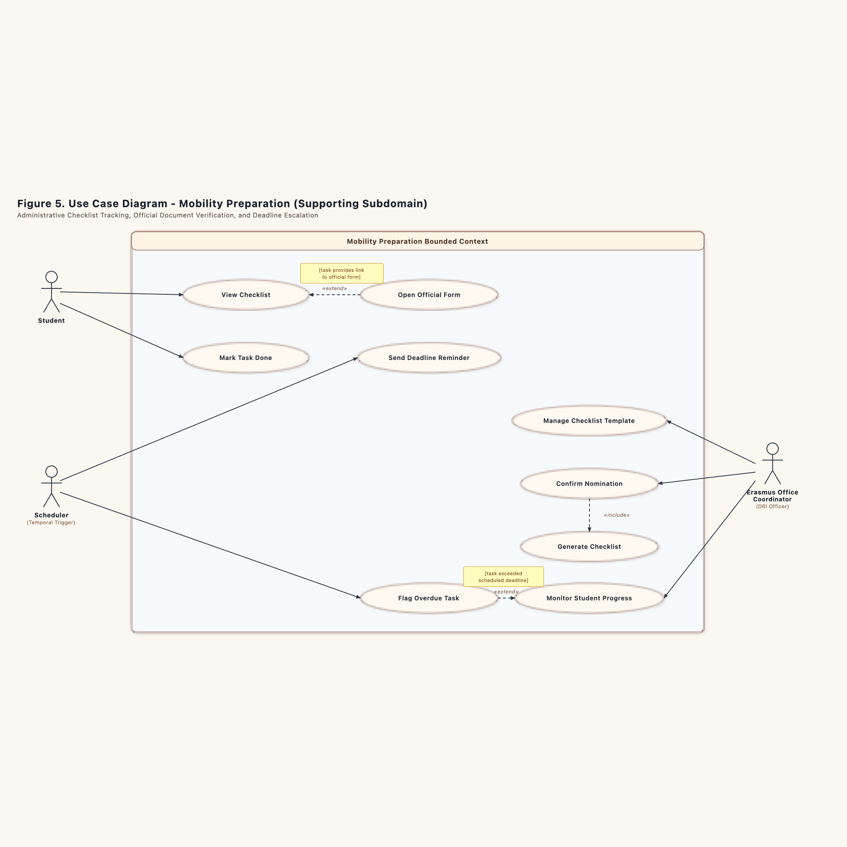
Figure 5. Use Case Diagram: Mobility Preparation (Student 3: Schipor Ana-Maria)

1.2.4 Use Case Narrative Specifications (SVDPI Format: UC01, UC02, UC03)
In strict compliance with the reference course methodology, each team member detailed a core use case conforming to SVDPI standards (active voice, alternating Actor/System steps, and extension points decoupled from graphical UI widgets):

Use Case Specification: UC01 - Submit Learning Agreement
- Author: Prigoreanu Alin-Gabriel (Student 1)
- Subdomain: Learning Agreement Management (Core Domain)
- Primary Aggregate: LearningAgreement
- Associated Diagram: Figure 3 (Use Case Diagram), Figure 19 (State Machine), Figure 22 (Sequence Diagram)

1. Context and Value Proposition
- Scope: Erasmus Mobility Platform (EMP) Academic Module.
- Goal in Context: Allow an outgoing exchange student to assemble study course pairs across host and home curriculums, verify their academic equivalence against institutional catalogs, and formally submit the agreement for faculty review.
- Business Value: Guarantees that outgoing students submit credit-compliant learning contracts before departure, preventing credit loss upon return and ensuring alignment with European Commission EWP standards.

2. Actors and Stakeholders
- Primary Actor: Outgoing Student (initiates agreement drafting, enters courses, submits contract).
- Secondary Actor: Faculty Coordinator (evaluates submitted contracts, requests revisions, grants institutional approval).
- Supporting System: Equivalence Management Service (remote catalog accessed synchronously via REST).
- Stakeholders:
- Home Faculty Department: Requires that incoming recognition matches degree program requirements.
- Receiving Host Institution: Requires bilateral course transparency.
- Department of International Relations (DRI): Monitors institutional compliance.

3. Preconditions and Postconditions

3.1 Preconditions
1. The student holds an active exchange nomination for an approved bilateral partner institution.
2. The current academic term permits contract submissions according to faculty calendar windows.
3. The student has opened a draft learning agreement in status DRAFT.

3.2 Postconditions
1. The LearningAgreement aggregate transitions to status SUBMITTED.
2. The course lines in Table A and Table B become immutable for student editing.
3. The agreement enters the review queue of the appointed departmental faculty coordinator.
4. An automated confirmation email reaches the student inbox with the timestamped submission manifest.

4. Invariants and Business Rules (BR)
- BR-LA-01 (Credit Volume Invariant): The total ECTS credits in Table A must be greater than or equal to 30.0 credits for a single semester exchange (or 60.0 for a full academic year).
- BR-LA-02 (Credit Parity Invariant): The sum of recognized home credits in Table B must exactly match the sum of completed host credits in Table A (sum(TableA.credits) == sum(TableB.credits)).
- BR-LA-03 (Course Line Association): Every course line in Table A must map to at least one valid recognition counterpart in Table B. Orphaned course lines are rejected.
- BR-LA-04 (Submission Immutability): Once submitted, neither Table A nor Table B can be modified without a formal rejection or coordinator-requested revision.

5. Main Success Scenario (MSS)
Step | Initiator | Interaction Description (Active Voice Only)
1 | Actor | The student opens the Learning Agreement drafting dashboard.
2 | System | The platform displays the current draft containing Table A and Table B course line grids.
3 | Actor | The student enters course codes, titles, and ECTS credit values for host subjects (Table A).
4 | Actor | The student selects corresponding home university degree courses for academic recognition (Table B).
5 | Actor | The student triggers the "Verify Equivalences" action.
6 | System | The platform queries the Equivalence Management catalog via REST adapter and displays verified credit matches.
7 | Actor | The student reviews the verified course pairs and submits the draft learning agreement to the platform for institutional review.
8 | System | The platform verifies the credit volume invariant (total ECTS >= 30.0 credits).
9 | System | The platform verifies the credit parity invariant (sum(TableA) == sum(TableB)).
10 | System | The platform transitions the agreement status from DRAFT to SUBMITTED.
11 | System | The platform locks all course rows against further edits.
12 | System | The platform assigns the contract to the faculty coordinator and displays a submission receipt to the student.

6. Alternative and Exception Flows

6a. Course Equivalences Pending in Catalog
- Condition at Step 6: One or more course pairs do not exist in the active equivalence catalog.
- 6a1: The platform displays an advisory banner indicating that unverified courses will require manual coordinator syllabus assessment.
- 6a2: The student confirms intent to submit unlisted courses with attached syllabus URLs.
- 6a3: The system records the syllabus attachments and allows the student to proceed to Step 7.

8e. Total Credits Under Statutory Threshold
- Condition at Step 8: The aggregate calculates total host credits strictly below 30.0 ECTS.
- 8e1: The platform rejects the submission request.
- 8e2: The platform highlights Table A with the message: "Minimum semester requirement is 30.0 ECTS. Current total is [X] ECTS."
- 8e3: The agreement remains in status DRAFT.
- 8e4: The student returns to Step 3 to add complementary course selections.

9e. Credit Parity Discrepancy
- Condition at Step 9: The credit sum of Table A does not equal the credit sum of Table B.
- 9e1: The platform blocks the transition and flags mismatched course mappings.
- 9e2: The platform displays the error: "Table A sum ([X] ECTS) does not equal Table B sum ([Y] ECTS). Balance course recognition before submitting."
- 9e3: The aggregate preserves state DRAFT. The student returns to Step 4 to balance course credit assignments.

Use Case Specification: UC02 - Register Academic Equivalence
- Author: Bîrgovan A. Mihai-Daniel (Student 2)
- Subdomain: Equivalence Management (Supporting Subdomain)
- Primary Aggregate: AcademicEquivalence
- Associated Diagram: Figure 4 (Use Case Diagram), Figure 20 (State Machine), Figure 23 (Sequence Diagram)

1. Context and Value Proposition
- Scope: Erasmus Mobility Platform (EMP) Academic Catalog Module.
- Goal in Context: Enable departmental academic evaluators and professors to examine course syllabi pairs between partner institutions, certify curricular parity, establish a validity window, and register the approved equivalence into the searchable institutional catalog.
- Business Value: Builds a reusable knowledge bank of certified course equivalences across academic years. Eliminates redundant manual syllabus evaluations and accelerates learning agreement approvals.

2. Actors and Stakeholders
- Primary Actor: Departmental Evaluator (professor or academic delegate reviewing syllabus overlap).
- Secondary Actor: Academic Head of Studies (validates institutional program alignment).
- Supporting System: Learning Agreement Service (inbound REST client querying active rules).
- Stakeholders:
- Degree Program Committee: Protects degree qualification standards and learning outcomes.
- Outgoing Exchange Students: Depend on pre-approved equivalences for predictable course selection.
- Institutional Registrar: Requires authoritative audit trails for diploma supplement credit recognitions.

3. Preconditions and Postconditions

3.1 Preconditions
1. The evaluator holds authenticated credentials with departmental course review permissions.
2. The proposal contains validated course descriptors for both the sending degree program and the receiving institution.
3. The equivalence record exists in status PROPOSED or UNDER_EVALUATION.

3.2 Postconditions
1. The AcademicEquivalence aggregate reaches status ACTIVE.
2. The record receives an indexed ValidityWindow spanning the designated academic terms.
3. The Open Host Service REST API exposes the equivalence for automated remote lookups.
4. An audit log entry records the approving professor ID, timestamp, and certified syllabus checksums.

4. Invariants and Business Rules (BR)
- BR-EQ-01 (Curricular Parity Threshold): Course equivalence approval requires at least 80% topical and competencies overlap between course syllabi (contentOverlapPercentage >= 80).
- BR-EQ-02 (Credit Value Correspondence): Recognized home credits must equal or exceed host credit ratings for equivalent subject coverage (recognizedCredits >= hostCourse.credits).
- BR-EQ-03 (Validity Window Boundary): An active equivalence must define explicit validFrom and validUntil calendar dates. The validity window cannot exceed 3 academic years without re-evaluation.
- BR-EQ-04 (Bilateral Uniqueness): Only one active equivalence record may link a specific (sendCourseCode, hostCourseCode) pair at any given time.

5. Main Success Scenario (MSS)
Step | Initiator | Interaction Description (Active Voice Only)
1 | Actor | The evaluator navigates to the Academic Equivalence registration console.
2 | System | The platform presents the evaluation workspace with comparative syllabus views.
3 | Actor | The evaluator enters home course details and corresponding partner university course descriptors.
4 | Actor | The evaluator enters the thematic match breakdown and computed syllabus overlap score.
5 | System | The platform validates that the overlap rating satisfies the statutory threshold (score >= 80%).
6 | Actor | The evaluator defines the validity term (start date and expiration date).
7 | Actor | The evaluator approves the verified equivalence for institutional publication in the academic catalog.
8 | System | The platform verifies the credit correspondence invariant.
9 | System | The platform verifies that no duplicate active equivalence exists for the course pair.
10 | System | The platform transitions aggregate status from UNDER_EVALUATION to APPROVED and subsequently to ACTIVE.
11 | System | The platform indexes the record in the catalog repository and publishes it to the REST API query cache.
12 | System | The platform generates an institutional registration certificate and confirms publication to the evaluator.

6. Alternative and Exception Flows

4a. Multiple Course Combined Equivalence
- Condition at Step 4: Two partner courses together cover the scope of one extensive home subject.
- 4a1: The evaluator specifies a compound course mapping (Table A lines 1 and 2 map to Table B line 1).
- 4a2: The platform aggregates ECTS credits across the composite lines.
- 4a3: The evaluator proceeds to Step 6 with composite recognition rules.

5e. Insufficient Curricular Parity
- Condition at Step 5: The thematic syllabus overlap measures below 80%.
- 5e1: The platform rejects the approval action.
- 5e2: The platform displays the alert: "Curricular overlap of [X]% does not meet the mandatory 80% threshold. Equivalence cannot be certified in current form."
- 5e3: The evaluator chooses either to request additional course syllabus documents from the partner university (returning to PROPOSED) or to formally reject the proposal (moving to RETIRED).

9e. Duplicate Active Rule Collision
- Condition at Step 9: An active equivalence already exists for the identical course code pair.
- 9e1: The platform halts registration.
- 9e2: The platform displays the existing active record identifier and expiration date.
- 9e3: The evaluator reviews the existing record to amend its validity window or aborts the duplicate registration.

Use Case Specification: UC03 - Confirm Nomination
- Author: Schipor Ana-Maria (Student 3)
- Subdomain: Mobility Preparation (Supporting Subdomain)
- Primary Aggregate: MobilityChecklist
- Associated Diagram: Figure 5 (Use Case Diagram), Figure 21 (State Machine), Figure 25 (Sequence Diagram)

1. Context and Value Proposition
- Scope: Erasmus Mobility Platform (EMP) Student Onboarding and Compliance Module.
- Goal in Context: Process an inbound institutional nomination or approved agreement, create a student compliance dossier with personalized preparation tasks, receive verified document proofs (grant agreements, insurance certificates), and confirm student departure readiness.
- Business Value: Guarantees that outgoing students satisfy all legal, medical, and financial regulations before travelling abroad. Protects the university from liability and ensures compliance with Erasmus+ grant disbursement conditions.

2. Actors and Stakeholders
- Primary Actor: Mobility Officer (verifies uploaded documents, confirms nomination readiness).
- Secondary Actor: Nominated Student (uploads required proofs, signs grant agreements).
- Supporting System: Enterprise Messaging System (delivers asynchronous nomination and approval events).
- Stakeholders:
- Erasmus Institutional Office: Oversees student welfare and international travel authorizations.
- Faculty Dean's Office: Requires confirmation that nominated students maintain active enrollment.
- National Agency: Audits grant allocations against verified mobility files.

3. Preconditions and Postconditions

3.1 Preconditions
1. The student holds an approved nomination from the selection committee.
2. The Learning Agreement context has published an approved contract event over the message broker.
3. The Mobility Preparation message receiver has ingested the event and verified idempotency.

3.2 Postconditions
1. The MobilityChecklist aggregate holds verified completions for all mandatory tasks.
2. The checklist status marks the student as READY_FOR_DEPARTURE.
3. The platform unlocks the first installment of the Erasmus+ financial grant.
4. An official nomination confirmation package reaches the partner university international office.

4. Invariants and Business Rules (BR)
- BR-MP-01 (Mandatory Task Set Invariant): Every student checklist must contain at least three non-waivable tasks:
1. Signed Erasmus+ Grant Agreement.
2. Valid European Health Insurance Card (EHIC) or equivalent private coverage.
3. Official Acceptance Letter from the host institution.
- BR-MP-02 (Departure Readiness Gate): The platform strictly prohibits confirming nomination departure readiness while any mandatory task remains in status INITIALIZED, PENDING_STUDENT_ACTION, SUBMITTED_FOR_VERIFICATION, or OVERDUE.
- BR-MP-03 (Idempotent Nomination Processing): An incoming event with identifier eventId can generate at most one preparation checklist. Duplicate broker redeliveries must terminate without creating redundant records.
- BR-MP-04 (Document File Integrity): Uploaded proof attachments must be verified PDF documents with cryptographic integrity hashes stored in the audit ledger.

5. Main Success Scenario (MSS)
Step | Initiator | Interaction Description (Active Voice Only)
1 | System | The platform detects the institutional approval of the student's learning agreement.
2 | System | The platform queries the idempotency port and confirms the event is unhandled.
3 | System | The platform instantiates a MobilityChecklist aggregate and populates default compliance tasks.
4 | System | The platform dispatches an onboarding email with task deadlines to the student.
5 | Actor | The student accesses the preparation portal and uploads the signed grant agreement and insurance proof.
6 | System | The platform stores the document references and transitions the tasks to SUBMITTED_FOR_VERIFICATION.
7 | Actor | The mobility officer opens the verification dashboard and inspects the attached document proofs.
8 | Actor | The mobility officer approves each submitted proof.
9 | System | The platform transitions all task statuses to COMPLETED.
10 | System | The platform evaluates the departure readiness invariant (areMandatoryTasksComplete()).
11 | System | The platform transitions checklist status to CONFIRMED_READY_FOR_DEPARTURE.
12 | System | The platform triggers grant payment authorization and transmits departure confirmation to the student.

6. Alternative and Exception Flows

5a. Student Requests Task Waiver for Private Insurance
- Condition at Step 5: The student holds alternative international insurance not covered by EHIC.
- 5a1: The student uploads an private insurance policy with an exemption request.
- 5a2: The mobility officer reviews the policy coverage limits against institutional liability minimums.
- 5a3: The officer approves the alternative proof with a waiver annotation and proceeds to Step 8.

8e. Rejected Document Proof
- Condition at Step 8: An uploaded document is expired, incomplete, or illegible.
- 8e1: The mobility officer rejects the submission and inputs feedback notes.
- 8e2: The platform reverts the specific task to PENDING_STUDENT_ACTION.
- 8e3: The platform sends an urgent rejection notification to the student with instructions to resubmit.
- 8e4: The departure gate remains locked. Execution loops back to Step 5.

2e. Duplicate Event Ingestion
- Condition at Step 2: The event ID already exists in the processed_events table.
- 2e1: The application service flags a duplicate event redelivery.
- 2e2: The platform logs an idempotency notice and skips aggregate instantiation.
- 2e3: The platform acknowledges receipt of the duplicate notification to finalize transaction processing.

1.2.5 Living BDD Specifications in Gherkin Language (.feature)
Declarative executable specifications formalize the acceptance criteria for each use case, capturing system invariants and business preconditions:
Specification 1: A. Gherkin Specification: Learning Agreement Management (Student 1: Prigoreanu Alin-Gabriel)
Feature: Learning Agreement Management and Invariant Enforcement
As an outgoing exchange student
I want to assemble and submit my Learning Agreement
So that my academic recognition is guaranteed by both home and host faculties
Background:
Given an authenticated student "Alin Prigoreanu" with studentId "s-1001"
And an active nomination to "Technical University of Munich" for the "Winter 2026" semester
And an empty learning agreement draft with status "DRAFT"
Scenario: Successful submission of a credit-balanced learning agreement
Given the student adds the following host courses to Table A:
| Course Code | Course Title | ECTS Credits |
| IN2001 | Advanced Software Engineering | 8.0 |
| IN2002 | Distributed Systems | 7.0 |
| IN2003 | Cloud Computing Architecture | 8.0 |
| IN2004 | Database Internals | 7.0 |
And the student maps the following recognized home courses in Table B:
| Course Code | Course Title | ECTS Credits |
| CS-M101 | Software Design Patterns | 8.0 |
| CS-M102 | Distributed Systems Lab | 7.0 |
| CS-M103 | Cloud Infrastructure | 8.0 |
| CS-M104 | Advanced Databases | 7.0 |
When the student submits the learning agreement
Then the platform verifies that Table A total ECTS is 30.0
And the platform verifies that Table B total ECTS is 30.0
And the platform transitions the agreement status to "SUBMITTED"
And all course lines in Table A and Table B become immutable
And a submission receipt is issued to "Alin Prigoreanu"
Scenario: Rejection of agreement submission due to credit volume deficit
Given the student adds the following host courses to Table A:
| Course Code | Course Title | ECTS Credits |
| IN2001 | Advanced Software Engineering | 8.0 |
| IN2002 | Distributed Systems | 7.0 |
| IN2003 | Cloud Computing Architecture | 8.0 |
And the student maps the following recognized home courses in Table B:
| Course Code | Course Title | ECTS Credits |
| CS-M101 | Software Design Patterns | 8.0 |
| CS-M102 | Distributed Systems Lab | 7.0 |
| CS-M103 | Cloud Infrastructure | 8.0 |
When the student attempts to submit the learning agreement
Then the platform rejects the submission with error "INSUFFICIENT_CREDITS"
And the error message states "Total host credits must be at least 30.0 ECTS. Current total is 23.0 ECTS."
And the agreement status remains "DRAFT"
And course lines in Table A remain open for editing
Scenario: Rejection of agreement submission due to credit parity discrepancy
Given the student adds host courses to Table A totaling 30.0 ECTS
But the student maps home courses in Table B totaling only 25.0 ECTS
When the student attempts to submit the learning agreement
Then the platform rejects the submission with error "CREDIT_PARITY_MISMATCH"
And the error message states "Table A credits (30.0) do not equal Table B credits (25.0)."
And the agreement status remains "DRAFT"

Specification 2: B. Gherkin Specification: Equivalence Management (Student 2: Bîrgovan A. Mihai-Daniel)
Feature: Academic Equivalence Registration and Catalog Verification
As a departmental academic evaluator
I want to review course syllabus parity and register approved equivalences
So that students can automatically validate course mappings during mobility drafting
Background:
Given an authenticated departmental evaluator "Mihai Birgovan" with evaluatorId "ev-2002"
And access to the "Computer Science" departmental catalog console
Scenario: Successful registration and publication of academic equivalence
Given a proposed equivalence between home course "CS301" (Object-Oriented Design, 6 ECTS) and host course "INF405" (Software Architecture, 6 ECTS)
And the evaluator inputs an assessed syllabus thematic overlap of 85 percent
And the evaluator specifies a validity window from "2026-10-01" to "2029-09-30"
When the evaluator confirms the equivalence registration
Then the platform verifies that curricular parity is at least 80 percent
And the platform verifies that recognized credits match the 6 ECTS host value
And the platform transitions the equivalence status to "ACTIVE"
And the equivalence is indexed and published to the REST catalog endpoint
And remote clients querying "CS301" and "INF405" receive a valid equivalence response
Scenario: Rejection of equivalence due to insufficient curricular overlap
Given a proposed equivalence between home course "CS204" (Algorithms and Data Structures, 6 ECTS) and host course "INF102" (Introduction to Programming, 6 ECTS)
And the evaluator inputs an assessed syllabus thematic overlap of 55 percent
When the evaluator attempts to confirm the equivalence registration
Then the platform blocks approval with error "CURRICULAR_PARITY_DEFICIT"
And the error message states "Assessed syllabus overlap of 55% is below the mandatory 80% threshold."
And the equivalence status remains "UNDER_EVALUATION"
And the record is not published to the public REST catalog endpoint
Scenario: Prevention of duplicate active equivalence registration
Given an existing active equivalence in the catalog for "CS301" and "INF405" expiring on "2029-09-30"
When an evaluator attempts to register a new active equivalence for the identical pair "CS301" and "INF405"
Then the platform rejects the request with error "DUPLICATE_ACTIVE_RULE"
And the error message identifies the existing active record ID
And no redundant catalog entry is created

Specification 3: C. Gherkin Specification: Mobility Preparation (Student 3: Schipor Ana-Maria)
Feature: Mobility Preparation Checklist and Departure Gate Verification
As an institutional mobility officer
I want to verify student onboarding document proofs and confirm departure readiness
So that outgoing students comply with legal, medical, and grant regulations
Background:
Given an authenticated mobility officer "Ana-Maria Schipor" with officerId "off-3003"
And an outgoing exchange student "s-1001" with an approved learning agreement "la-9001"
Scenario: Successful checklist completion and departure clearance
Given an inbound message on "mobility.preparation.agreement.approved" with eventId "evt-8801"
When the message receiver processes the event
Then a new MobilityChecklist is instantiated for student "s-1001"
And the checklist contains the default mandatory tasks:
| Task Code | Title | Mandatory | Initial Status |
| TASK-01 | Erasmus+ Grant Agreement | true | PENDING_STUDENT_ACTION |
| TASK-02 | Health Insurance Proof | true | PENDING_STUDENT_ACTION |
| TASK-03 | Host Acceptance Letter | true | PENDING_STUDENT_ACTION |
When the student uploads valid PDF proofs for all mandatory tasks
And the mobility officer reviews and approves all attached proofs
Then all mandatory tasks transition to status "COMPLETED"
And the departure gate evaluates "areMandatoryTasksComplete()" as true
And the checklist status transitions to "CONFIRMED_READY_FOR_DEPARTURE"
And the first grant installment is unlocked for disbursement
Scenario: Departure gate blocks confirmation when a mandatory task is overdue
Given an active MobilityChecklist for student "s-1001" with a deadline of "2026-08-15"
And the student uploaded the grant agreement and acceptance letter
But the student failed to submit the health insurance proof before "2026-08-15"
When the daily compliance scanner runs on "2026-08-16"
Then the health insurance task status transitions to "OVERDUE"
When the mobility officer attempts to confirm departure readiness
Then the platform rejects confirmation with error "MANDATORY_TASKS_INCOMPLETE"
And the error message lists "Health Insurance Proof (OVERDUE)" as blocking departure
And the checklist status remains "IN_PROGRESS"
And grant disbursement remains locked
Scenario: Idempotent message consumption prevents duplicate checklist creation
Given that eventId "evt-8801" already exists in the "processed_events" table
When a duplicate AMQP message with eventId "evt-8801" is delivered to the receiver
Then the platform detects the event identifier in the idempotency ledger
And the application service skips checklist instantiation
And the receiver acknowledges the message with channel basicAck
And exactly one checklist remains associated with student "s-1001"

Chapter 2. Domain Model (Tactical Domain-Driven Design Patterns)
Erasmus Mobility Platform (EMP)
Methodological Alignment: Strategic & Tactical DDD (Eric Evans, Vaughn Vernon) and Course Structural Modeling (FEAA Master SDBIS / SIA)
Visual Artifact: models/diagrams-png/Figura8-Tactical-DDD-Domain-Model.png
Scalable Vector Graphics (SVG): models/diagrams-png/Figura8-Tactical-DDD-Domain-Model.svg
PlantUML Source: docs/diagrams/fig8-tactical-domain-model.puml

2.1 Tactical Patterns and Consistency Boundaries
Up to this point, the analysis focused on the functional perspective. We now shift to the structural perspective. We apply Tactical Domain-Driven Design (DDD) to enforce consistency boundaries and protect transactional invariants across the three subdomains.
In DDD, the domain model does not serve query projection workloads. It serves command processing and business rule enforcement.
The tactical patterns applied include:
- Aggregate Root (`«Aggregate Root»`): The primary entry point for modifying business state. External classes never hold persistent references to internal child entities.
- Internal Entity (`«Entity»`): Objects with explicit identity whose state mutates over time, accessible only through their owning Aggregate Root.
- Value Object (`«Value Object»`): Immutable concepts defined entirely by their attributes without independent identity. They contain zero setter methods.
- Domain Service (`«Domain Service»`): Stateless operations implementing calculations or multi-entity comparisons that do not belong to a single entity.
- Shared Kernel: Common identity types shared across Bounded Context boundaries to correlate records without tight structural coupling.

2.2 Table 2.1 Transactional Invariants Matrix for Aggregate Roots
Business Invariant Rule | Guaranteed by Aggregate Root Method | Failure Mode if Aggregate Root is Bypassed
ECTS Parity Invariant: Cumulative credits in Table A must strictly equal Table B and meet the minimum threshold (Σ A = Σ B ≥ 30.00 ECTS per semester). | LearningAgreement.validateEctsBalance() | A student modifies course lines directly in the database, creating a contract with credit deficits that the faculty cannot legally graduate.
Atomic Cascading Cancellation: Cancelling a mobility contract marks the agreement as CANCELLED and cascades through child lines atomically. | LearningAgreement.cancel() | A cancelled exchange program leaves active course lines in registration tables, causing unauthorized grade requests from host institutions.
Submissions Lock Mutation: Transitioning from DRAFT to SUBMITTED locks course line collections against direct client edits. | LearningAgreement.submit() | A student swaps difficult courses for unapproved electives while the coordinator is reviewing the contract.
Tripartite Endorsement Sequence: Partner confirmation (CONFIRMED_BY_HOST) is illegal unless faculty approval (APPROVED_BY_FACULTY) has occurred. | LearningAgreement.confirmByHost() | An unvetted curriculum receives foreign endorsement without faculty oversight, triggering institutional liability.

2.3 Structural Decomposition across Contexts

Common Types (Shared Kernel)
The Shared Kernel encapsulates four immutable Value Objects:
1. StudentId: UUID wrapper enforcing non-null university matriculation identity.
2. MobilityId: UUID wrapper identifying the specific exchange allocation dossier.
3. AcademicPeriod: Encapsulates startDate and endDate, strictly validating endDate >= startDate.
4. ECTSCredits: Encapsulates a positive decimal BigDecimal, preventing negative or zero credit allocations.

Learning Agreement Management (Core Domain)
The core package isolates the contract aggregate:
- `LearningAgreement` (Aggregate Root): Enforces credit parity and orchestrates approvals. Holds private collections of Table A and Table B lines.
- `CourseLineTableA` and `CourseLineTableB` (Internal Entities): Maintain line items for host and home courses. Their lifespan is bound to the parent agreement via strict UML composition (1 to 1..*). Deleting the agreement destroys all internal lines.
- `ECTSParityService` (Domain Service): Stateless calculator verifying credit totals across foreign and domestic tables.
- `LearningAgreementStatus` (Enum): Governs lifecycle transitions (DRAFT, SUBMITTED, UNDER_REVIEW, APPROVED_BY_FACULTY, CONFIRMED_BY_HOST, AMENDED, CANCELLED).

Equivalence Management (Supporting Subdomain)
- `AcademicEquivalence` (Aggregate Root): Maintains the canonical link between a host course syllabus and a domestic subject.
- `CourseSyllabus` (Value Object): Immutable record capturing learning outcomes, contact hours, and grading rubrics.
- `SyllabusEvaluationService` (Domain Service): Computes text and credit similarity metrics between two course syllabi.
- `EquivalenceStatus` (Enum): Lifecycle states (PROPOSED, UNDER_EVALUATION, APPROVED, ACTIVE, RETIRED).

Mobility Preparation (Supporting Subdomain)
- `MobilityChecklist` (Aggregate Root): Central administrative dossier managing the student's preparation checklist and enforcing overall departure readiness.
- `ChecklistTask` (Child Entity): Discrete administrative compliance task enforcing verification deadlines, encapsulated within the MobilityChecklist aggregate.
- `DocumentAttachment` (Value Object): Stores file names, SHA-256 cryptographic hashes, and cloud storage references.
- `GrantAmount` (Value Object): Immutable currency and financial calculation model.
- `TaskStatus` and `MobilityStatus` (Enums): Lifecycle states for onboarding milestones and student mobility stages.
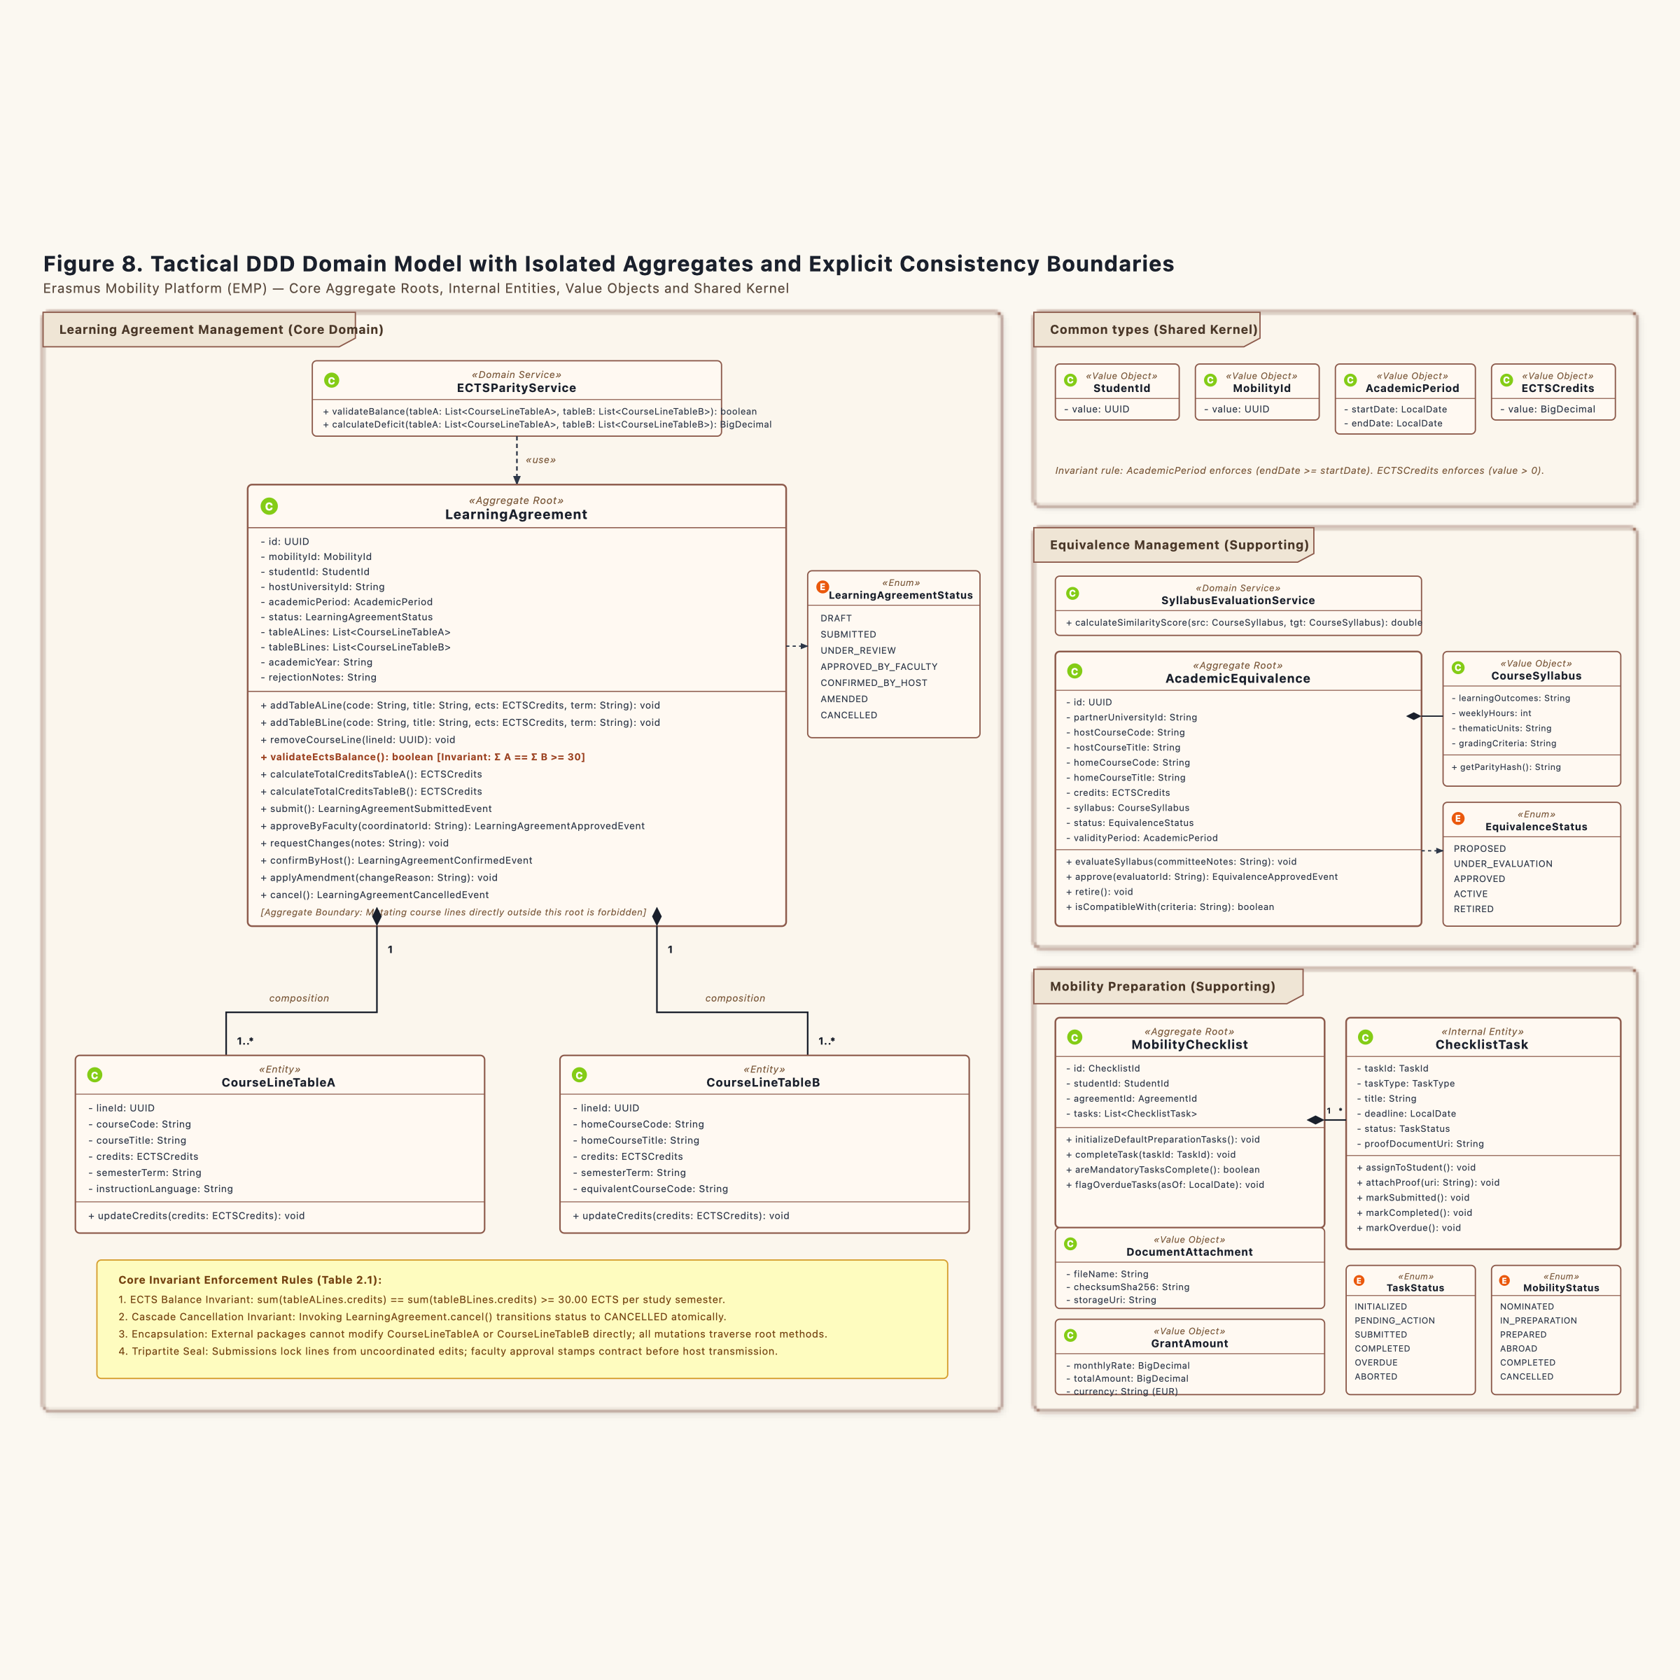
Figure 8. Tactical DDD Domain Model: Aggregate Roots, Internal Entities, Value Objects, and Domain Events

Chapter 3. Architectural Solution Design (Logical Architecture)

3.1 Layered Onion / Clean Architecture (Figures 9, 9b, and 10)
Erasmus Mobility Platform (EMP)
Methodological Alignment: Onion / Hexagonal Architecture (Alistair Cockburn, Jeffrey Palermo) & Course Specifications (FEAA Master SDBIS / SIA)
Visual Artifacts:
- Figure 9 (Core Domain): models/diagrams-png/Figura9-Layered-Architecture-Core-Domain.png
- Figure 10 (Supporting Subdomain): models/diagrams-png/Figura10-Layered-Architecture-Supporting-Subdomain.png
PlantUML Sources:
- docs/diagrams/fig9-layered-architecture-core.puml
- docs/diagrams/fig10-layered-architecture-supporting.puml

3.1.1 Architectural Principles of the Four-Layer Model
The system isolates domain logic from technical infrastructure using a four-layer architecture. Dependencies flow inward toward the domain. The domain model contains zero imports from web frameworks, SQL libraries, or messaging drivers.
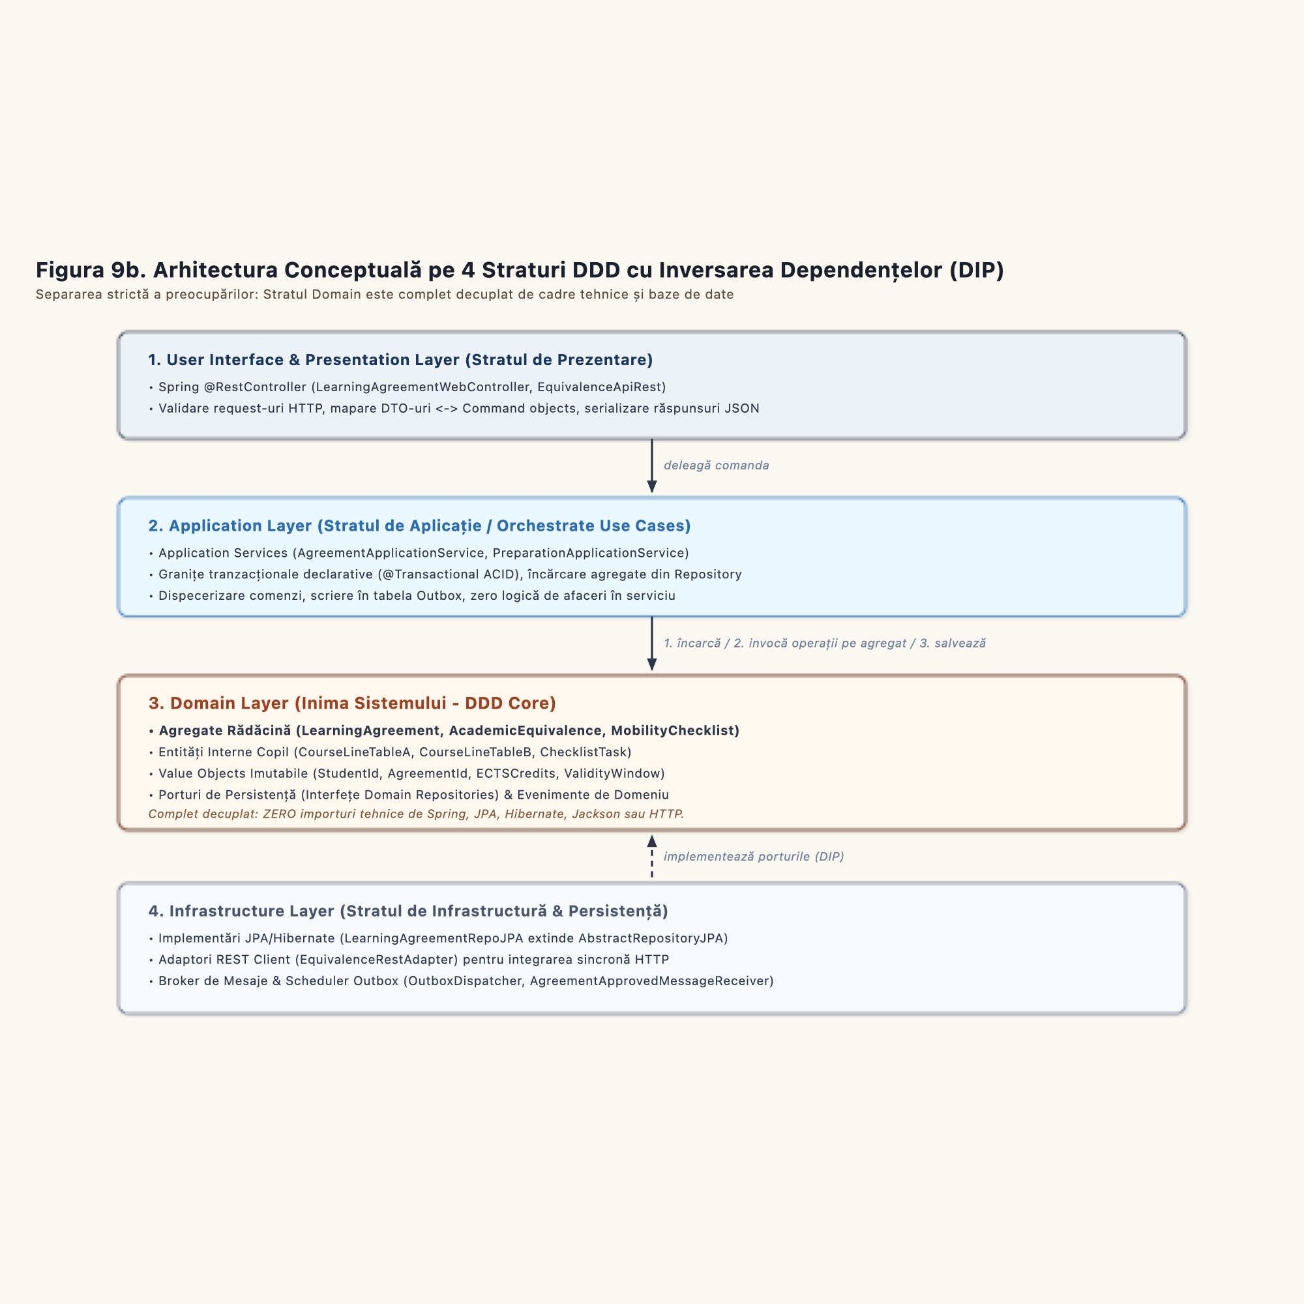
Figure 9b. Conceptual 4-Layer Architecture with Dependency Inversion Principle

Layer Responsibilities and Constraints
1. User Interface Layer:
Acts as the reception desk. It converts external HTTP JSON payloads into internal Command objects. It handles authentication tokens and returns standard HTTP status codes. It contains zero business validation logic.
2. Application Layer:
Acts as the workflow coordinator. It starts database transactions. It loads aggregates through repository interfaces, verifies cross-context conditions via domain ports, delegates state mutations to aggregate methods, and writes committed domain events to the outbox. It does not calculate domain math.
3. Domain Layer:
Acts as the vault. It holds the entities, aggregate roots, value objects, and business invariants. It defines repository interfaces as outbound ports. It has zero external dependencies.
4. Infrastructure Layer:
Acts as the engine room. It implements repository interfaces using JPA Hibernate and Spring Data. It implements messaging ports using RabbitMQ or JMS. It manages network sockets and physical database connections.

3.1.2 Figure 9: Core Bounded Context (Learning Agreement Management)
In Figure 9, the core domain orchestrates the authoring, ECTS validation, and approval of study contracts:

Execution Sequence inside `LearningAgreementApplicationService`
1. Load: The service loads the LearningAgreement aggregate from LearningAgreementRepo using findById(id).
2. Port Check: The service invokes EquivalenceQueryPort.verifyCourseAccredited(partnerId, hostCode) to ensure the foreign subject is accredited.
3. Domain Execution: The service invokes agreement.validateEctsBalance() and agreement.submit(). The aggregate checks the invariant (Σ A == Σ B ≥ 30). If invalid, it raises an exception and halts the transaction.
4. Save: The service commits the mutated aggregate back through LearningAgreementRepo.save(agreement).
5. Publish Event: The service routes LearningAgreementApprovedEvent to OutboxEventPublisher.

Dependency Inversion in Action
LearningAgreementRepoJPA resides in the Infrastructure layer. It implements LearningAgreementRepo, which resides in the Domain layer. The domain remains decoupled from SQL or relational tables.

3.1.3 Figure 10: Supporting Subdomain (Equivalence Management)
In Figure 10, the supporting domain manages the catalog of course syllabi and pre-approved mappings:

Key Components
- `EquivalenceCtrl`: Exposes endpoints for searching the catalog (/api/equivalences/search) and registering mappings (/api/equivalences/register).
- `EquivalenceApplicationService`: Enforces command authorization, loads the AcademicEquivalence aggregate, and records audit logs through AuditLogPort.
- `AcademicEquivalenceRepo`: Domain repository interface defining queries by partner university and course codes.
- `AcademicEquivalenceRepoJPA`: Infrastructure adapter providing database persistence.
- `AuditLogServiceJPA`: Infrastructure adapter writing immutable audit records directly to the AUDIT_TRAIL ledger table.
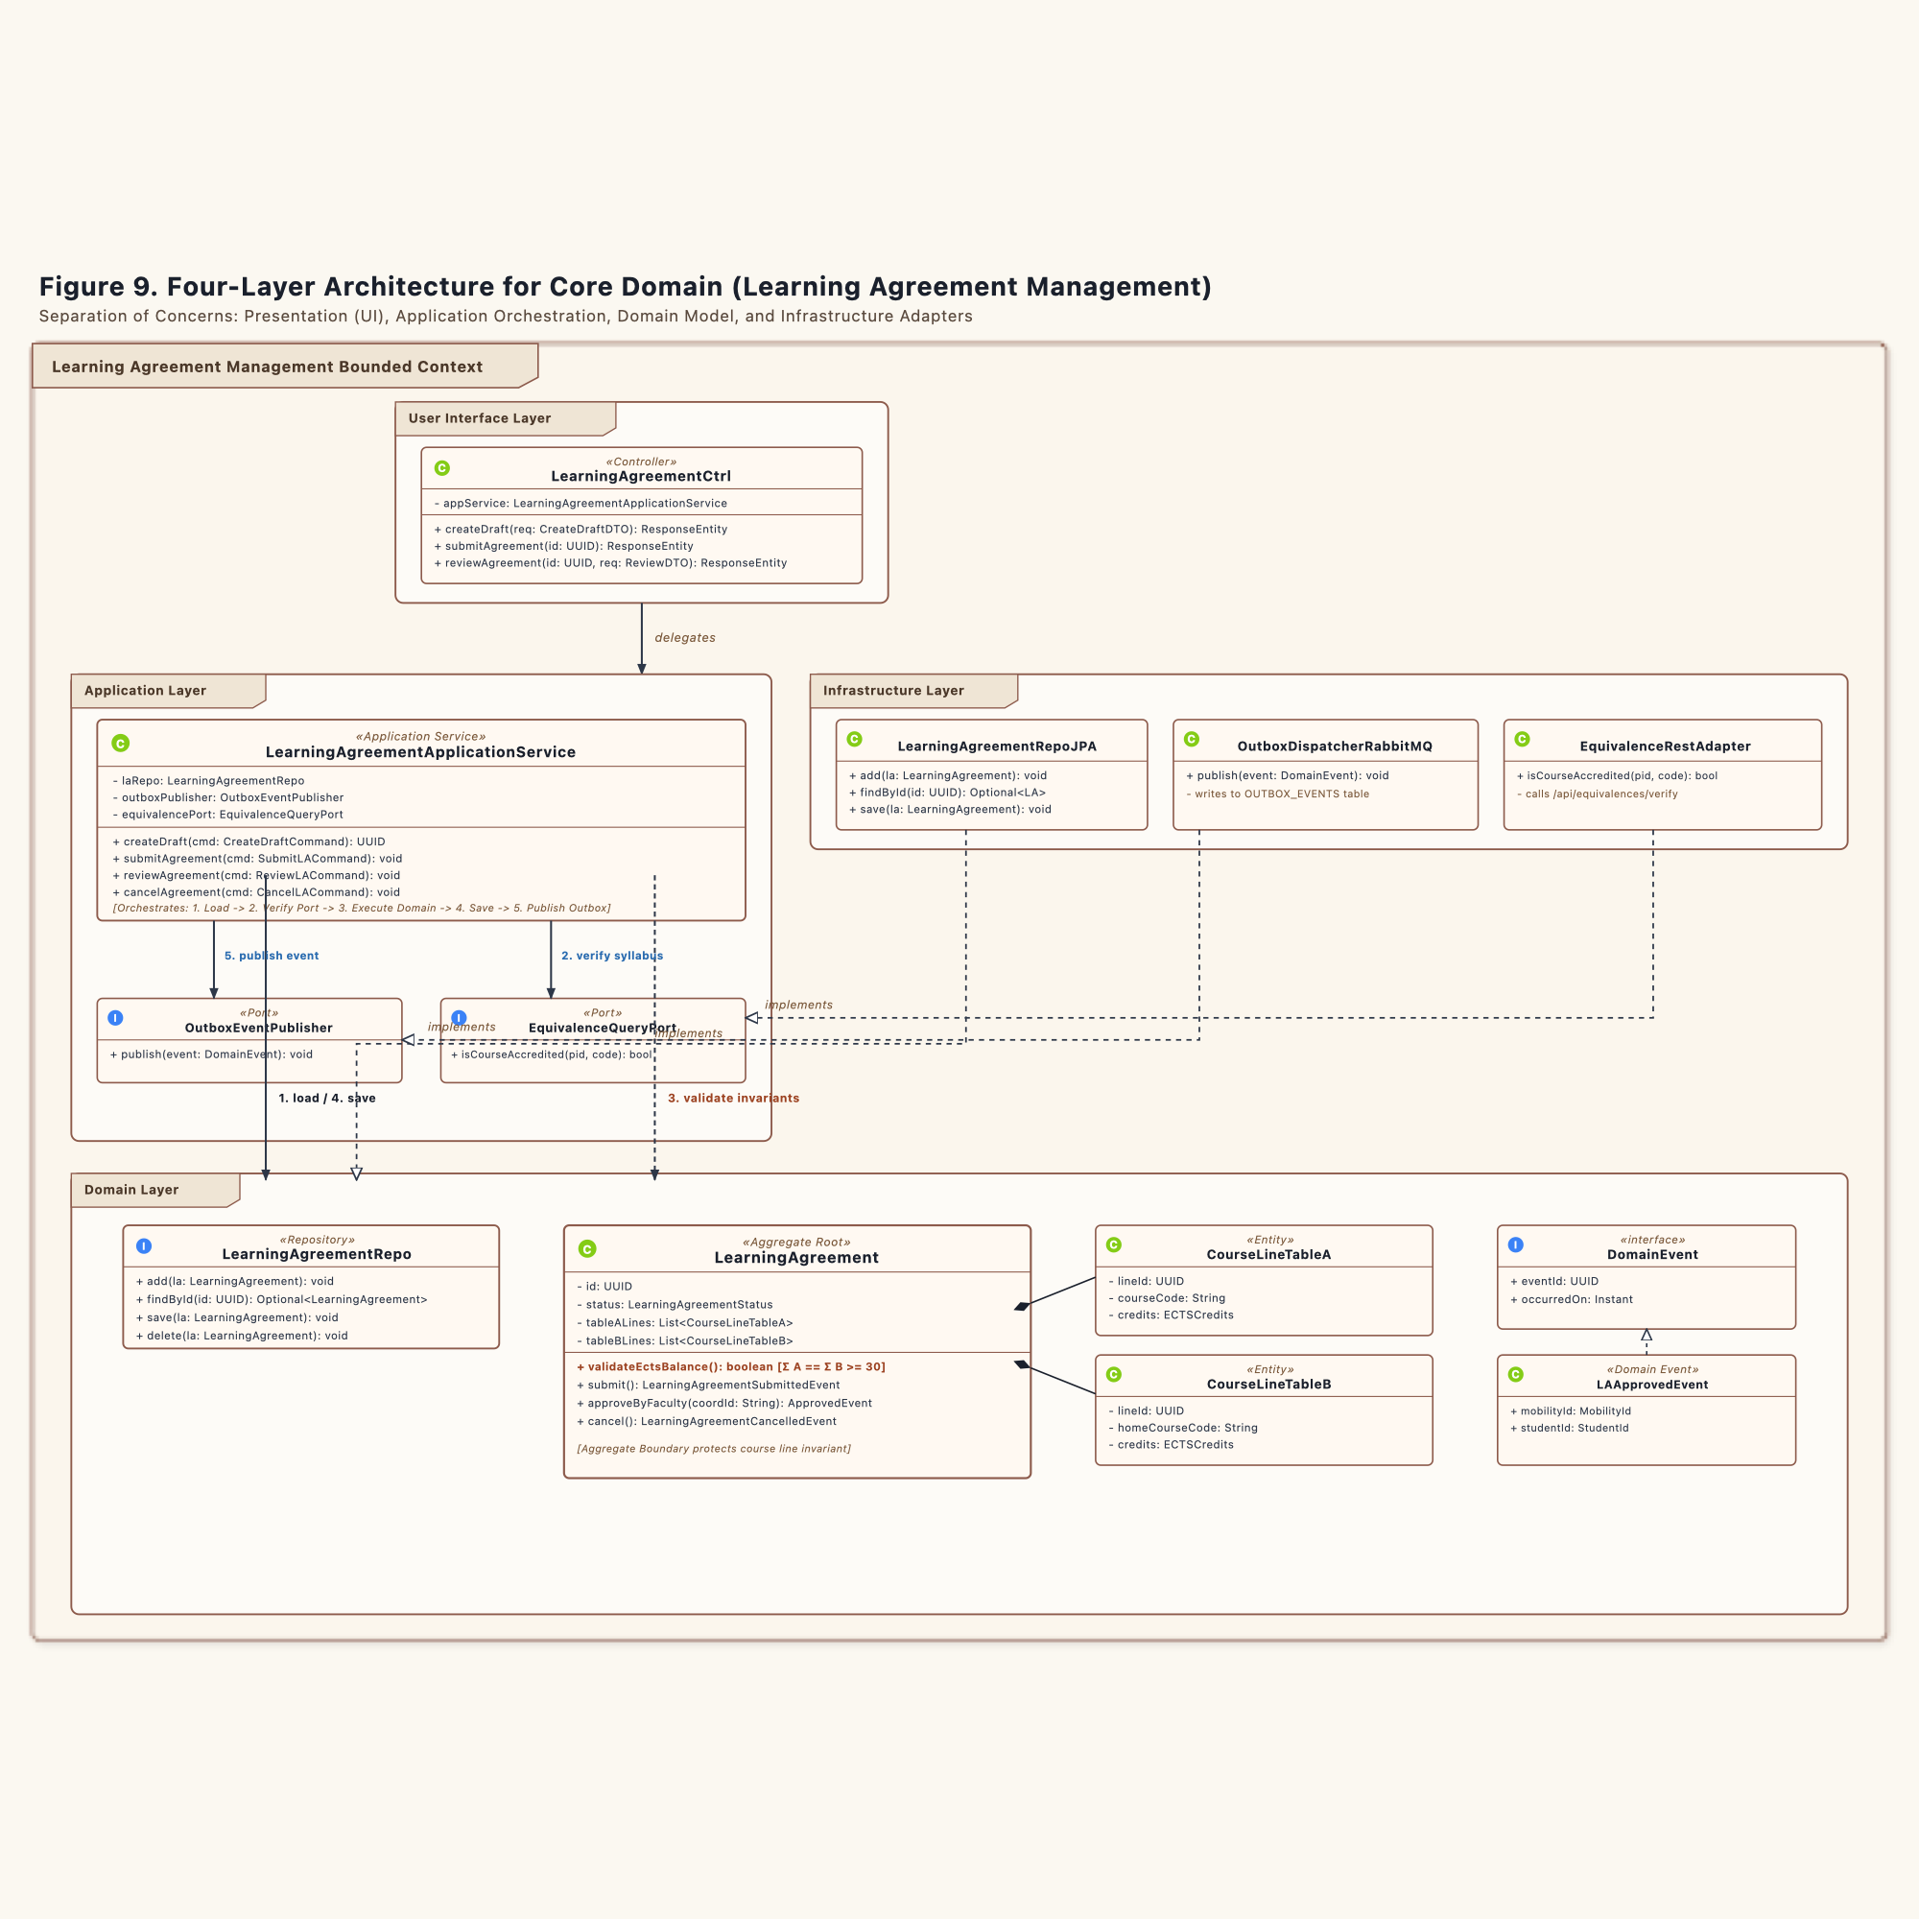
Figure 9. Layered Architecture: Core Domain (Learning Agreement Management)
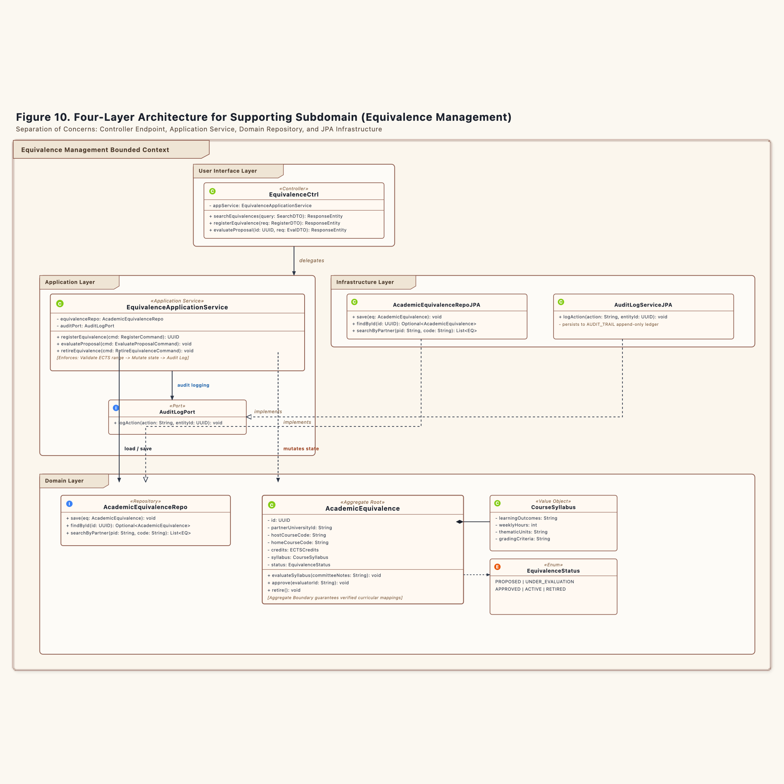
Figure 10. Layered Architecture: Supporting Subdomain (Equivalence Management)

3.2 Repository Class Hierarchy (Figure 11)
Erasmus Mobility Platform (EMP)
Methodological Alignment: Tactical Domain-Driven Design (Eric Evans) & Course Repository Specifications (FEAA Master SDBIS / SIA)
Visual Artifact: models/diagrams-png/Figura11-Repository-Hierarchy.png
Scalable Vector Graphics (SVG): models/diagrams-png/Figura11-Repository-Hierarchy.svg
PlantUML Source: docs/diagrams/fig11-repository-hierarchy.puml

3.2.1 Tactical Purpose of the Repository Pattern
In Domain-Driven Design, a repository provides the illusion of an in-memory collection of all aggregate roots of a given type. It mediates between the domain model and data mapping layers.
The architecture enforces a strict physical separation:
1. The Domain Layer owns the interface:
The interface (LearningAgreementRepo, ChecklistTaskRepo) defines the persistence contract. It resides in the domain package. It knows only about domain entities, value objects, and domain exceptions.
2. The Infrastructure Layer owns the implementation:
The concrete class (LearningAgreementRepoJPA, ChecklistTaskRepoJPA) resides in the infrastructure package. It imports Hibernate, JPA annotations, and relational drivers.

3.2.2 The Abstract Base: AbstractRepositoryJPA
All concrete repository implementations extend AbstractRepositoryJPA.
package ro.uaic.feaa.erasmus.infrastructure.persistence;
import jakarta.persistence.EntityManager;
import jakarta.persistence.PersistenceContext;
import java.io.Serializable;
import java.util.Optional;
public abstract class AbstractRepositoryJPA<T, ID extends Serializable> {
@PersistenceContext
protected EntityManager em;
protected final Class<T> entityClass;
protected AbstractRepositoryJPA(Class<T> entityClass) {
this.entityClass = entityClass;
}
public Optional<T> findById(ID id) {
return Optional.ofNullable(em.find(entityClass, id));
}
public void add(T entity) {
em.persist(entity);
}
public void save(T entity) {
em.merge(entity);
}
public void delete(T entity) {
em.remove(em.contains(entity) ? entity : em.merge(entity));
}
}

The Transactional Boundary Rule
The base class exposes persistence operations. It declares zero transaction boundaries.
- Transactions belong in the Application Service Layer via @Transactional.
- If a repository method managed its own transaction, calling findById, updating course lines, and writing an outbox event would run in separate database commits. A system crash halfway through would produce orphaned database records.
- Application Services open the transaction at the start of a command, execute all domain operations, and close the transaction in one atomic commit.

3.2.3 Structural Breakdown of Repository Classes

`LearningAgreementRepo` (Core Domain)
- Domain Interface: Exposes add, findById, findByStudentId, save, and delete.
- Concrete JPA Class: LearningAgreementRepoJPA extends AbstractRepositoryJPA<LearningAgreement, UUID>.
- Responsibility: Loads and persists the complete LearningAgreement aggregate. It loads all CourseLineTableA and CourseLineTableB lines within the same entity graph.

`CourseLineQueryRepo` (Read-Only Projection)
- Domain Interface: Exposes projection queries findLinesByAgreementId and findHostCourseByCode.
- Concrete JPA Class: CourseLineQueryRepoJPA uses JPA Criteria queries to return read-only DTO records.
- Invariant Constraint: Direct mutations through this repository are forbidden. Adding, editing, or deleting lines must traverse LearningAgreement root methods to protect the 30 ECTS invariant.

`AcademicEquivalenceRepo` (Supporting Subdomain)
- Domain Interface: Exposes save, findById, searchByPartnerAndCode, and findActiveByDegreeProgram.
- Concrete JPA Class: AcademicEquivalenceRepoJPA queries syllabus mappings.
- Type Safety: Returns typed AcademicEquivalence aggregates and CourseSyllabus value objects.

`ChecklistTaskRepo` (Supporting Subdomain)
- Domain Interface: Exposes save, findById, findAllByMobilityId, and findOverdueTasks.
- Concrete JPA Class: ChecklistTaskRepoJPA queries student administrative onboarding tasks.
- Batch Scheduling: Supports indexed date queries for the nightly temporal deadline sweep.
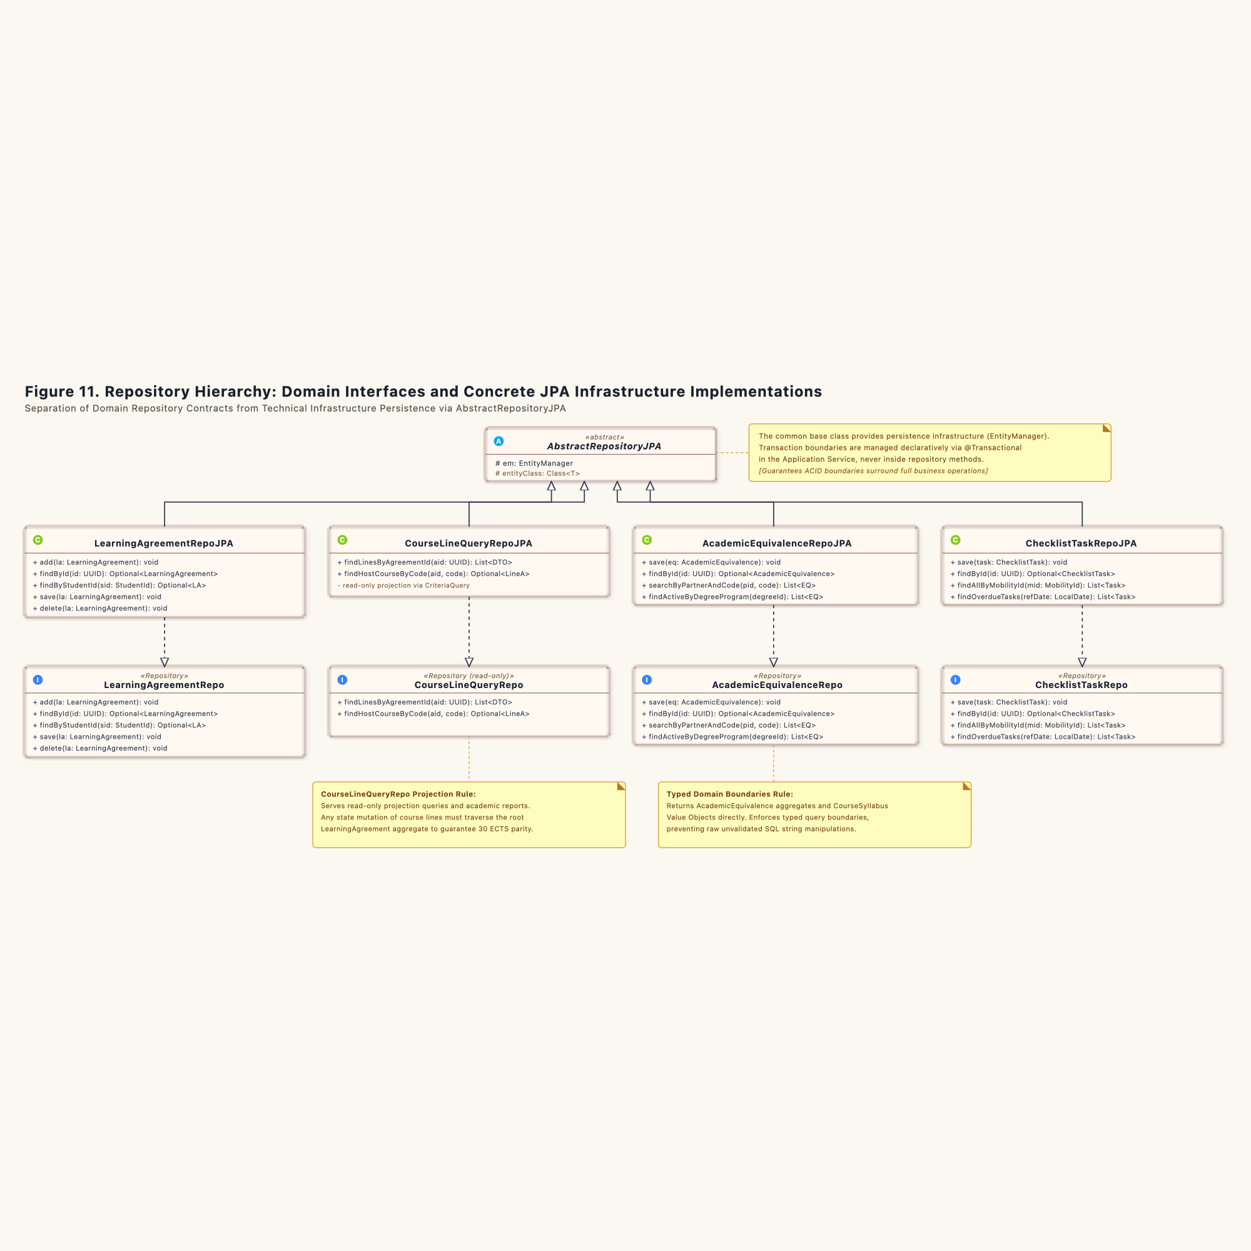
Figure 11. DDD Repository Pattern Class Hierarchy: Decoupling Ports from JPA Implementations

Chapter 4. Bounded Context Integration Mechanics

4.1 Synchronous REST Integration: Client and Server (Figures 12 and 13)

4.1.1 Overview and Physical Mechanics
Systems that exchange data synchronously act like two bank tellers communicating through an intercom window. The client teller cannot proceed with paperwork until the server teller stamps the request slip and slides it back through the slot. If the line drops or the server teller walks away, the client teller halts.
In the Erasmus Mobility Platform, the Learning Agreement Management context must verify whether foreign courses qualify for domestic academic credit before a student submits their agreement. Rather than sharing a database table or reading foreign records directly, the system uses a synchronous REST pipeline governed by Hexagonal Architecture principles (Ports and Adapters) and an Open Host Service (OHS).

4.1.2 Client Side: Learning Agreement Context (Figure 12)
The client architecture isolates the core domain from network protocols and remote server addresses.
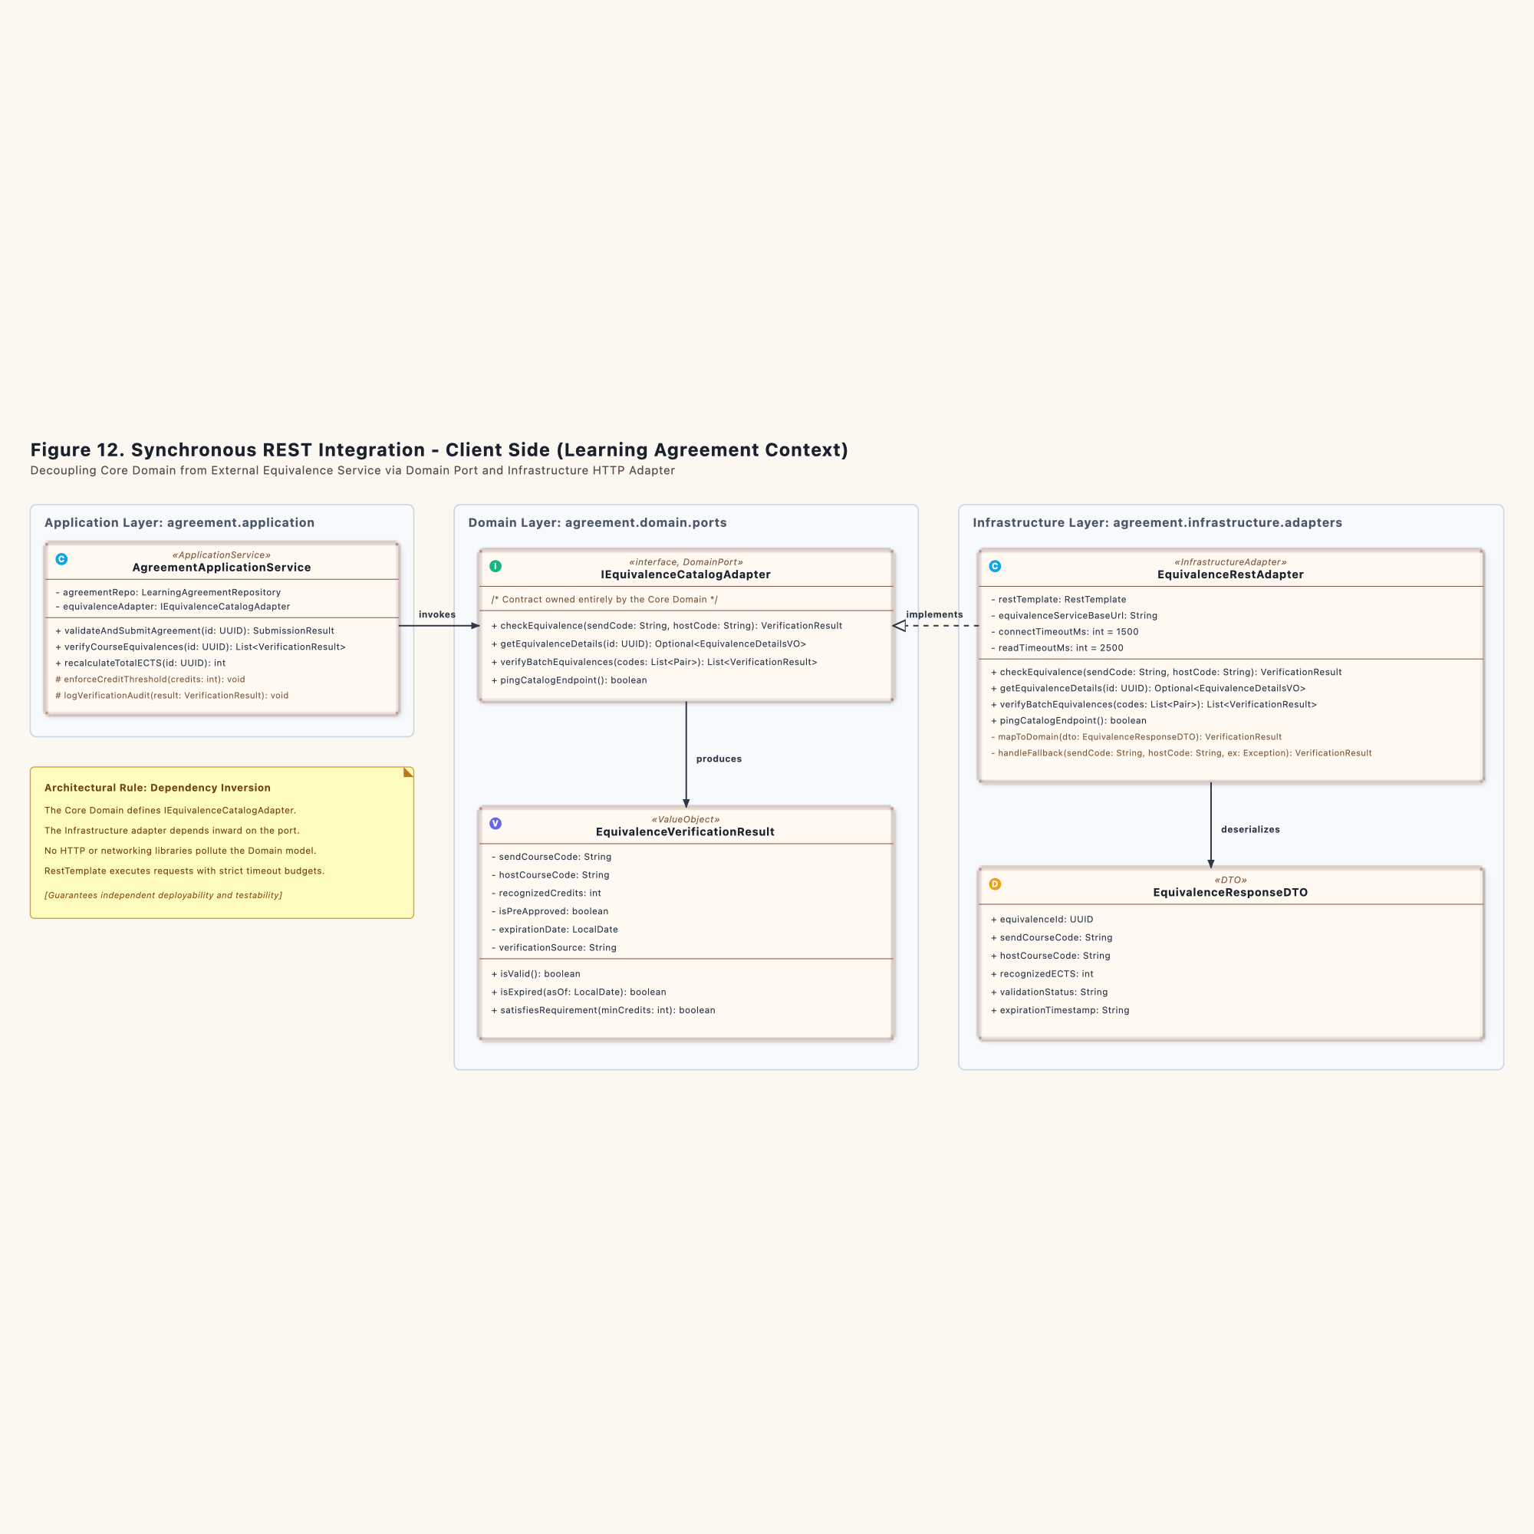
Figure 12. Synchronous REST Integration Client Side

The Domain Port: `IEquivalenceCatalogAdapter`
The domain model resides behind a protective boundary. The core domain defines its own requirement through the Java interface IEquivalenceCatalogAdapter:
package ro.uaic.feaa.erasmus.agreement.domain.ports;
import ro.uaic.feaa.erasmus.agreement.domain.models.EquivalenceVerificationResult;
import java.util.UUID;
import java.util.Optional;
public interface IEquivalenceCatalogAdapter {
EquivalenceVerificationResult checkEquivalence(String sendCourseCode, String hostCourseCode);
Optional<EquivalenceDetailsVO> getEquivalenceDetails(UUID equivalenceId);
}

The core domain owns this interface. No HTTP client, JSON annotation, or remote IP address enters this package.

The Infrastructure Adapter: `EquivalenceRestAdapter`
The EquivalenceRestAdapter lives in the Infrastructure layer. It implements IEquivalenceCatalogAdapter and translates domain inquiries into concrete HTTP GET calls:
1. Request Formation: The adapter builds an HTTP GET request targeting /api/v1/equivalences/verify?sendCode={send}&hostCode={host}.
2. Circuit Protection and Timeouts: The HTTP client enforces a connection timeout of 1500 milliseconds and a read timeout of 2500 milliseconds. If the remote endpoint hangs, the adapter halts execution rather than starving local server threads.
3. Payload Translation: The remote JSON string enters EquivalenceResponseDTO. The adapter parses the response and instantiates an immutable domain value object, EquivalenceVerificationResult.
package ro.uaic.feaa.erasmus.agreement.infrastructure.adapters;
import ro.uaic.feaa.erasmus.agreement.domain.ports.IEquivalenceCatalogAdapter;
import ro.uaic.feaa.erasmus.agreement.domain.models.EquivalenceVerificationResult;
import org.springframework.web.client.RestTemplate;
import org.springframework.stereotype.Component;
@Component
public class EquivalenceRestAdapter implements IEquivalenceCatalogAdapter {
private final RestTemplate restTemplate;
private final String equivalenceServiceBaseUrl;
public EquivalenceRestAdapter(RestTemplate restTemplate) {
this.restTemplate = restTemplate;
this.equivalenceServiceBaseUrl = "http://equivalence-service:8082/api/v1/equivalences";
}
@Override
public EquivalenceVerificationResult checkEquivalence(String sendCourseCode, String hostCourseCode) {
String url = String.format("%s/verify?sendCode=%s&hostCode=%s",
equivalenceServiceBaseUrl, sendCourseCode, hostCourseCode);
EquivalenceResponseDTO dto = restTemplate.getForObject(url, EquivalenceResponseDTO.class);
return mapToDomain(dto);
}
private EquivalenceVerificationResult mapToDomain(EquivalenceResponseDTO dto) {
if (dto == null) {
return EquivalenceVerificationResult.unverified();
}
return new EquivalenceVerificationResult(
dto.getSendCourseCode(),
dto.getHostCourseCode(),
dto.getRecognizedECTS(),
"ACTIVE".equalsIgnoreCase(dto.getValidationStatus()),
dto.getExpirationDate()
);
}
}

4.1.3 Server Side: Equivalence Management Context (Figure 13)
The supporting subdomain publishes an Open Host Service (OHS). It presents a standard contract to external consumers while isolating its own JPA entities.
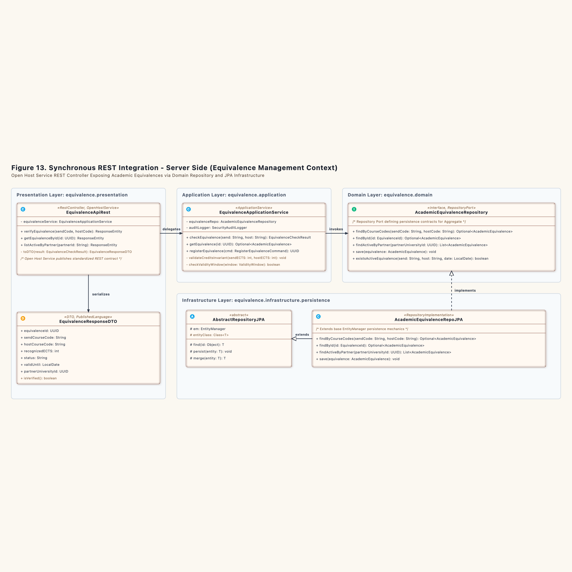
Figure 13. Synchronous REST Integration Server Side

The Open Host Service Controller: `EquivalenceApiRest`
The REST controller accepts inbound HTTP requests, unwraps query parameters, and delegates execution to EquivalenceApplicationService:
package ro.uaic.feaa.erasmus.equivalence.presentation;
import ro.uaic.feaa.erasmus.equivalence.application.EquivalenceApplicationService;
import ro.uaic.feaa.erasmus.equivalence.application.dto.EquivalenceResponseDTO;
import org.springframework.http.ResponseEntity;
import org.springframework.web.bind.annotation.*;
@RestController
@RequestMapping("/api/v1/equivalences")
public class EquivalenceApiRest {
private final EquivalenceApplicationService equivalenceService;
public EquivalenceApiRest(EquivalenceApplicationService equivalenceService) {
this.equivalenceService = equivalenceService;
}
@GetMapping("/verify")
public ResponseEntity<EquivalenceResponseDTO> verifyEquivalence(
@RequestParam String sendCode,
@RequestParam String hostCode) {
EquivalenceCheckResult result = equivalenceService.checkEquivalence(sendCode, hostCode);
return ResponseEntity.ok(toDTO(result));
}
private EquivalenceResponseDTO toDTO(EquivalenceCheckResult result) {
return new EquivalenceResponseDTO(
result.getEquivalenceId(),
result.getSendCode(),
result.getHostCode(),
result.getRecognizedECTS(),
result.getStatus().name(),
result.getValidUntil()
);
}
}

Application Service and Persistence Dispatch
EquivalenceApplicationService queries AcademicEquivalenceRepository. The call resolves against AcademicEquivalenceRepoJPA, which extends AbstractRepositoryJPA.
The query matches course identifiers and verifies that the current date falls inside ValidityWindow. If the course mapping exists and remains valid, the service returns confirmed credits. If the record is missing or expired, it returns an explicit invalid status. The database connection closes before HTTP response serialization begins.

4.1.4 Boundary Failure Modes and Defense Rules
1. Remote Timeout: If Equivalence Context exceeds the 2500 ms limit, EquivalenceRestAdapter throws a RemoteServiceUnavailableException. The calling agreement service marks verification as pending and prompts the student to retry later. It never submits unverified agreements.
2. Schema Drift: The server serializes responses into EquivalenceResponseDTO. If the server adds extra metadata fields, client deserialization ignores unknown properties. The contract remains intact.
3. Network Partition: If the network link breaks, read operations fail fast. The local database of Learning Agreement Management remains uncorrupted.

4.2 Asynchronous Integration via Transactional Outbox: Publisher and Consumer (Figures 14 and 15)

4.2.1 Overview and Physical Mechanics
Asynchronous messaging without distributed transactions behaves like an office clerk placing a carbon copy of a signed contract into an outgoing postal tray. The clerk does not walk the document across town immediately. The clerk signs the primary ledger, drops the duplicate envelope into the tray, and closes the safe. Both actions happen at the same desk in one motion.
Later, a courier empties the tray and carries letters to the postal hub. If the courier drops an envelope in the mud, the courier picks up another duplicate from the tray. The receiving clerk checks their inward logbook: if an identical letter arrived five minutes earlier, they file the duplicate into the shredder bin without re-entering the order.
The Transactional Outbox pattern guarantees at-least-once message delivery across bounded contexts while completely avoiding distributed two-phase commit (2PC) locks.

4.2.2 Producer Side: Learning Agreement Context (Figure 14)
When a faculty coordinator approves a student's learning agreement, downstream contexts must take immediate preparatory actions. Learning Agreement Context produces domain events without tying its local database transaction to an external message broker.
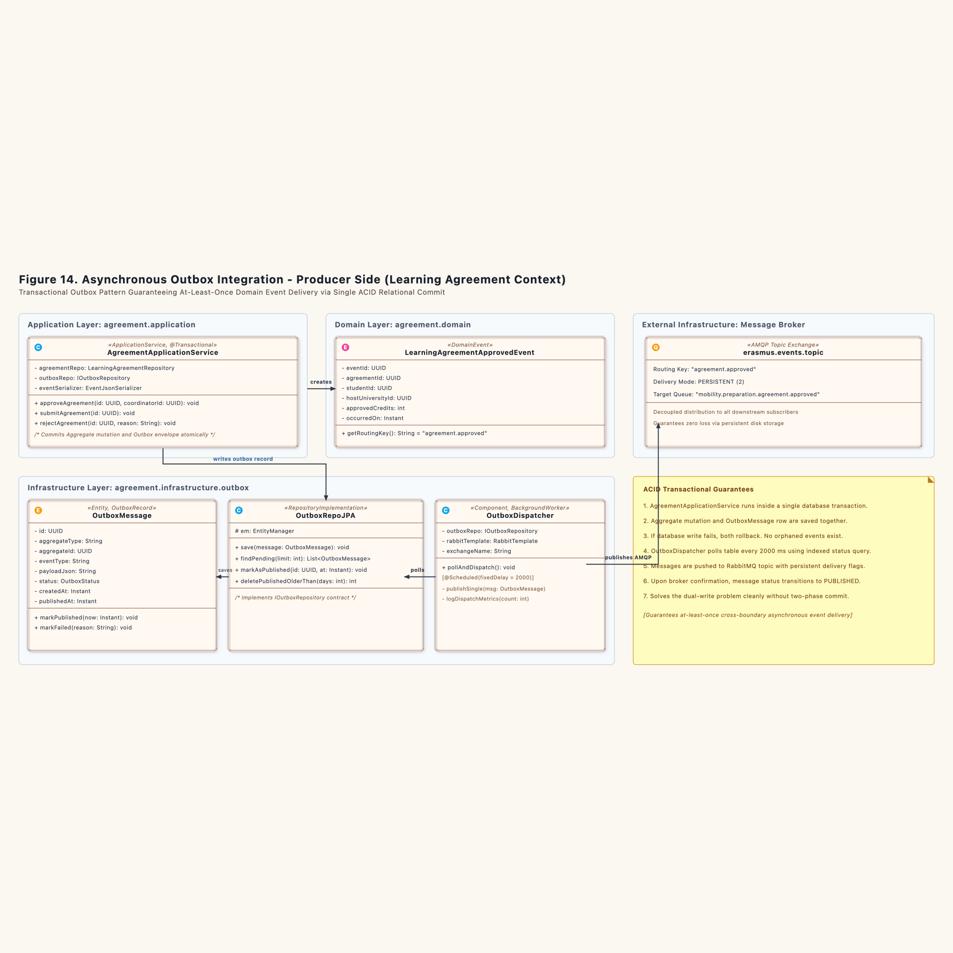
Figure 14. Asynchronous Outbox Integration Producer Side

The Atomic Local Transaction
AgreementApplicationService.approveAgreement() executes within a standard Spring @Transactional scope:
package ro.uaic.feaa.erasmus.agreement.application;
import ro.uaic.feaa.erasmus.agreement.domain.models.LearningAgreement;
import ro.uaic.feaa.erasmus.agreement.domain.events.LearningAgreementApprovedEvent;
import ro.uaic.feaa.erasmus.agreement.domain.ports.LearningAgreementRepository;
import ro.uaic.feaa.erasmus.agreement.domain.ports.IOutboxRepository;
import ro.uaic.feaa.erasmus.agreement.infrastructure.outbox.OutboxMessage;
import org.springframework.stereotype.Service;
import org.springframework.transaction.annotation.Transactional;
import java.util.UUID;
import java.time.Instant;
@Service
public class AgreementApplicationService {
private final LearningAgreementRepository agreementRepo;
private final IOutboxRepository outboxRepo;
private final EventJsonSerializer eventSerializer;
public AgreementApplicationService(LearningAgreementRepository agreementRepo,
IOutboxRepository outboxRepo,
EventJsonSerializer eventSerializer) {
this.agreementRepo = agreementRepo;
this.outboxRepo = outboxRepo;
this.eventSerializer = eventSerializer;
}
@Transactional
public void approveAgreement(UUID agreementId, UUID coordinatorId) {
LearningAgreement agreement = agreementRepo.findById(agreementId)
.orElseThrow(() -> new IllegalArgumentException("Agreement not found: " + agreementId));
// State mutation inside Aggregate Root
LearningAgreementApprovedEvent event = agreement.approve(coordinatorId);
agreementRepo.save(agreement);
// Serialize event envelope to outbox table in the same ACID transaction
OutboxMessage outboxMessage = new OutboxMessage(
UUID.randomUUID(),
"LearningAgreement",
agreement.getId(),
event.getClass().getSimpleName(),
eventSerializer.serialize(event),
Instant.now()
);
outboxRepo.save(outboxMessage);
}
}

If the database server loses power during execution, both the aggregate update and the outbox row vanish. If the write succeeds, both persist together.

The Background Scheduler: `OutboxDispatcher`
The application does not block HTTP requests to communicate with RabbitMQ. Instead, an independent background daemon polls the database table:
package ro.uaic.feaa.erasmus.agreement.infrastructure.outbox;
import ro.uaic.feaa.erasmus.agreement.domain.ports.IOutboxRepository;
import org.springframework.scheduling.annotation.Scheduled;
import org.springframework.amqp.rabbit.core.RabbitTemplate;
import org.springframework.stereotype.Component;
import java.util.List;
import java.time.Instant;
@Component
public class OutboxDispatcher {
private final IOutboxRepository outboxRepo;
private final RabbitTemplate rabbitTemplate;
private static final String EXCHANGE = "erasmus.events.topic";
private static final String ROUTING_KEY = "agreement.approved";
public OutboxDispatcher(IOutboxRepository outboxRepo, RabbitTemplate rabbitTemplate) {
this.outboxRepo = outboxRepo;
this.rabbitTemplate = rabbitTemplate;
}
@Scheduled(fixedDelay = 2000)
public void pollAndDispatch() {
List<OutboxMessage> pendingMessages = outboxRepo.findPendingMessages(50);
for (OutboxMessage msg : pendingMessages) {
try {
rabbitTemplate.convertAndSend(EXCHANGE, ROUTING_KEY, msg.getPayloadJson());
outboxRepo.markAsPublished(msg.getId(), Instant.now());
} catch (Exception ex) {
// Network drops or broker downtime leave record in PENDING state
break;
}
}
}
}

The worker reads up to 50 pending records. It forwards each payload to RabbitMQ exchange erasmus.events.topic and updates the outbox status to PUBLISHED. If RabbitMQ crashes, messages wait safely on disk until connectivity returns.

4.2.3 Consumer Side: Mobility Preparation Context (Figure 15)
The Mobility Preparation Context subscribes to the message broker to initialize logistical checklists as soon as nominations achieve formal approval.
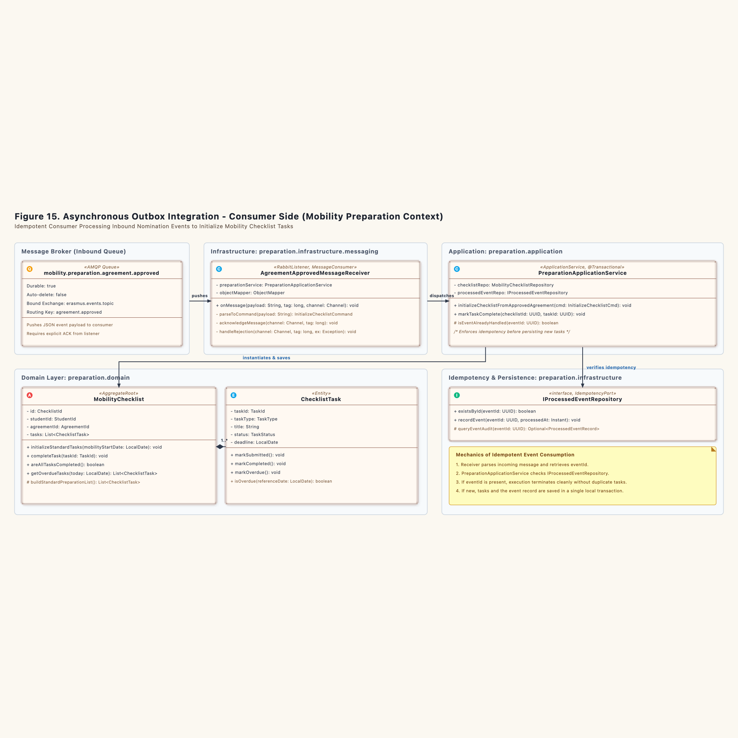
Figure 15. Asynchronous Outbox Integration Consumer Side

Idempotent Message Receiver: `AgreementApprovedMessageReceiver`
Because networks can fail during delivery acknowledgments, the broker may deliver identical messages multiple times. The receiver handles duplicate deliveries through explicit verification:
package ro.uaic.feaa.erasmus.preparation.infrastructure.messaging;
import ro.uaic.feaa.erasmus.preparation.application.PreparationApplicationService;
import ro.uaic.feaa.erasmus.preparation.application.commands.InitializeChecklistCommand;
import com.fasterxml.jackson.databind.ObjectMapper;
import com.rabbitmq.client.Channel;
import org.springframework.amqp.rabbit.annotation.RabbitListener;
import org.springframework.amqp.support.AmqpHeaders;
import org.springframework.messaging.handler.annotation.Header;
import org.springframework.stereotype.Component;
@Component
public class AgreementApprovedMessageReceiver {
private final PreparationApplicationService preparationService;
private final ObjectMapper objectMapper;
public AgreementApprovedMessageReceiver(PreparationApplicationService preparationService,
ObjectMapper objectMapper) {
this.preparationService = preparationService;
this.objectMapper = objectMapper;
}
@RabbitListener(queues = "mobility.preparation.agreement.approved", ackMode = "MANUAL")
public void onMessage(String payload,
@Header(AmqpHeaders.DELIVERY_TAG) long deliveryTag,
Channel channel) throws Exception {
try {
AgreementApprovedPayloadDTO dto = objectMapper.readValue(payload, AgreementApprovedPayloadDTO.class);
InitializeChecklistCommand cmd = new InitializeChecklistCommand(
dto.getEventId(),
dto.getAgreementId(),
dto.getStudentId(),
dto.getHostUniversityId()
);
preparationService.initializeChecklistFromApprovedAgreement(cmd);
channel.basicAck(deliveryTag, false);
} catch (Exception ex) {
channel.basicNack(deliveryTag, false, true);
}
}
}

Idempotency Filter in the Application Layer
The consumer verifies uniqueness before writing new records:
package ro.uaic.feaa.erasmus.preparation.application;
import ro.uaic.feaa.erasmus.preparation.domain.models.MobilityChecklist;
import ro.uaic.feaa.erasmus.preparation.domain.ports.MobilityChecklistRepository;
import ro.uaic.feaa.erasmus.preparation.domain.ports.IProcessedEventRepository;
import org.springframework.stereotype.Service;
import org.springframework.transaction.annotation.Transactional;
import java.time.Instant;
@Service
public class PreparationApplicationService {
private final MobilityChecklistRepository checklistRepo;
private final IProcessedEventRepository processedEventRepo;
public PreparationApplicationService(MobilityChecklistRepository checklistRepo,
IProcessedEventRepository processedEventRepo) {
this.checklistRepo = checklistRepo;
this.processedEventRepo = processedEventRepo;
}
@Transactional
public void initializeChecklistFromApprovedAgreement(InitializeChecklistCommand cmd) {
// Idempotency check: Guard against duplicate message deliveries
if (processedEventRepo.existsById(cmd.getEventId())) {
return;
}
// Initialize aggregate with standard preparation items
MobilityChecklist checklist = new MobilityChecklist(
cmd.getAgreementId(),
cmd.getStudentId()
);
checklist.initializeDefaultPreparationTasks();
checklistRepo.save(checklist);
processedEventRepo.recordEvent(cmd.getEventId(), Instant.now());
}
}

If the message arrives twice, processedEventRepo.existsById(cmd.getEventId()) returns true. The service drops duplicate execution immediately. The consumer then issues basicAck to remove the redundant message from the broker queue.

4.2.4 Failure Modes and Recovery Invariants
1. Broker Failure on Publish: If the message broker rejects connections, the dispatcher halts polling. Records stay marked as PENDING in the outbox table. No events are lost.
2. Crash Before Manual ACK: If the consumer server loses power after persisting tasks but before running basicAck, RabbitMQ redelivers the message upon server restart. The receiver runs its check against IProcessedEventRepository, detects the prior commit, skips duplicate task generation, and delivers the delayed ACK.
3. Poison Message Defense: If a corrupted JSON payload enters the queue, Jackson deserialization fails. The receiver dead-letters the message into erasmus.dlq after three attempts, preventing infinite processing loops.

Chapter 5. Consolidated Structural Perspective (Final Structural Solution)

5.1 Overview and Architectural Mechanics
A large software platform resembles an industrial dockyard divided into specialized workshops. The steel hull fabrication shop does not store nautical charts, and the navigation instrument lab does not pour molten ballast. Each shop maintains its own inventory counters, tools, and access doorways.
In the Erasmus Mobility Platform, the system divides responsibility across three Bounded Contexts. Each bounded context operates a four-layer architecture with strictly managed dependencies pointing inward toward the domain core.

5.2 Learning Agreement Management Structural Model (Figure 16)
The core domain owns the legal study contracts negotiated among the student, the home faculty, and the host institution.
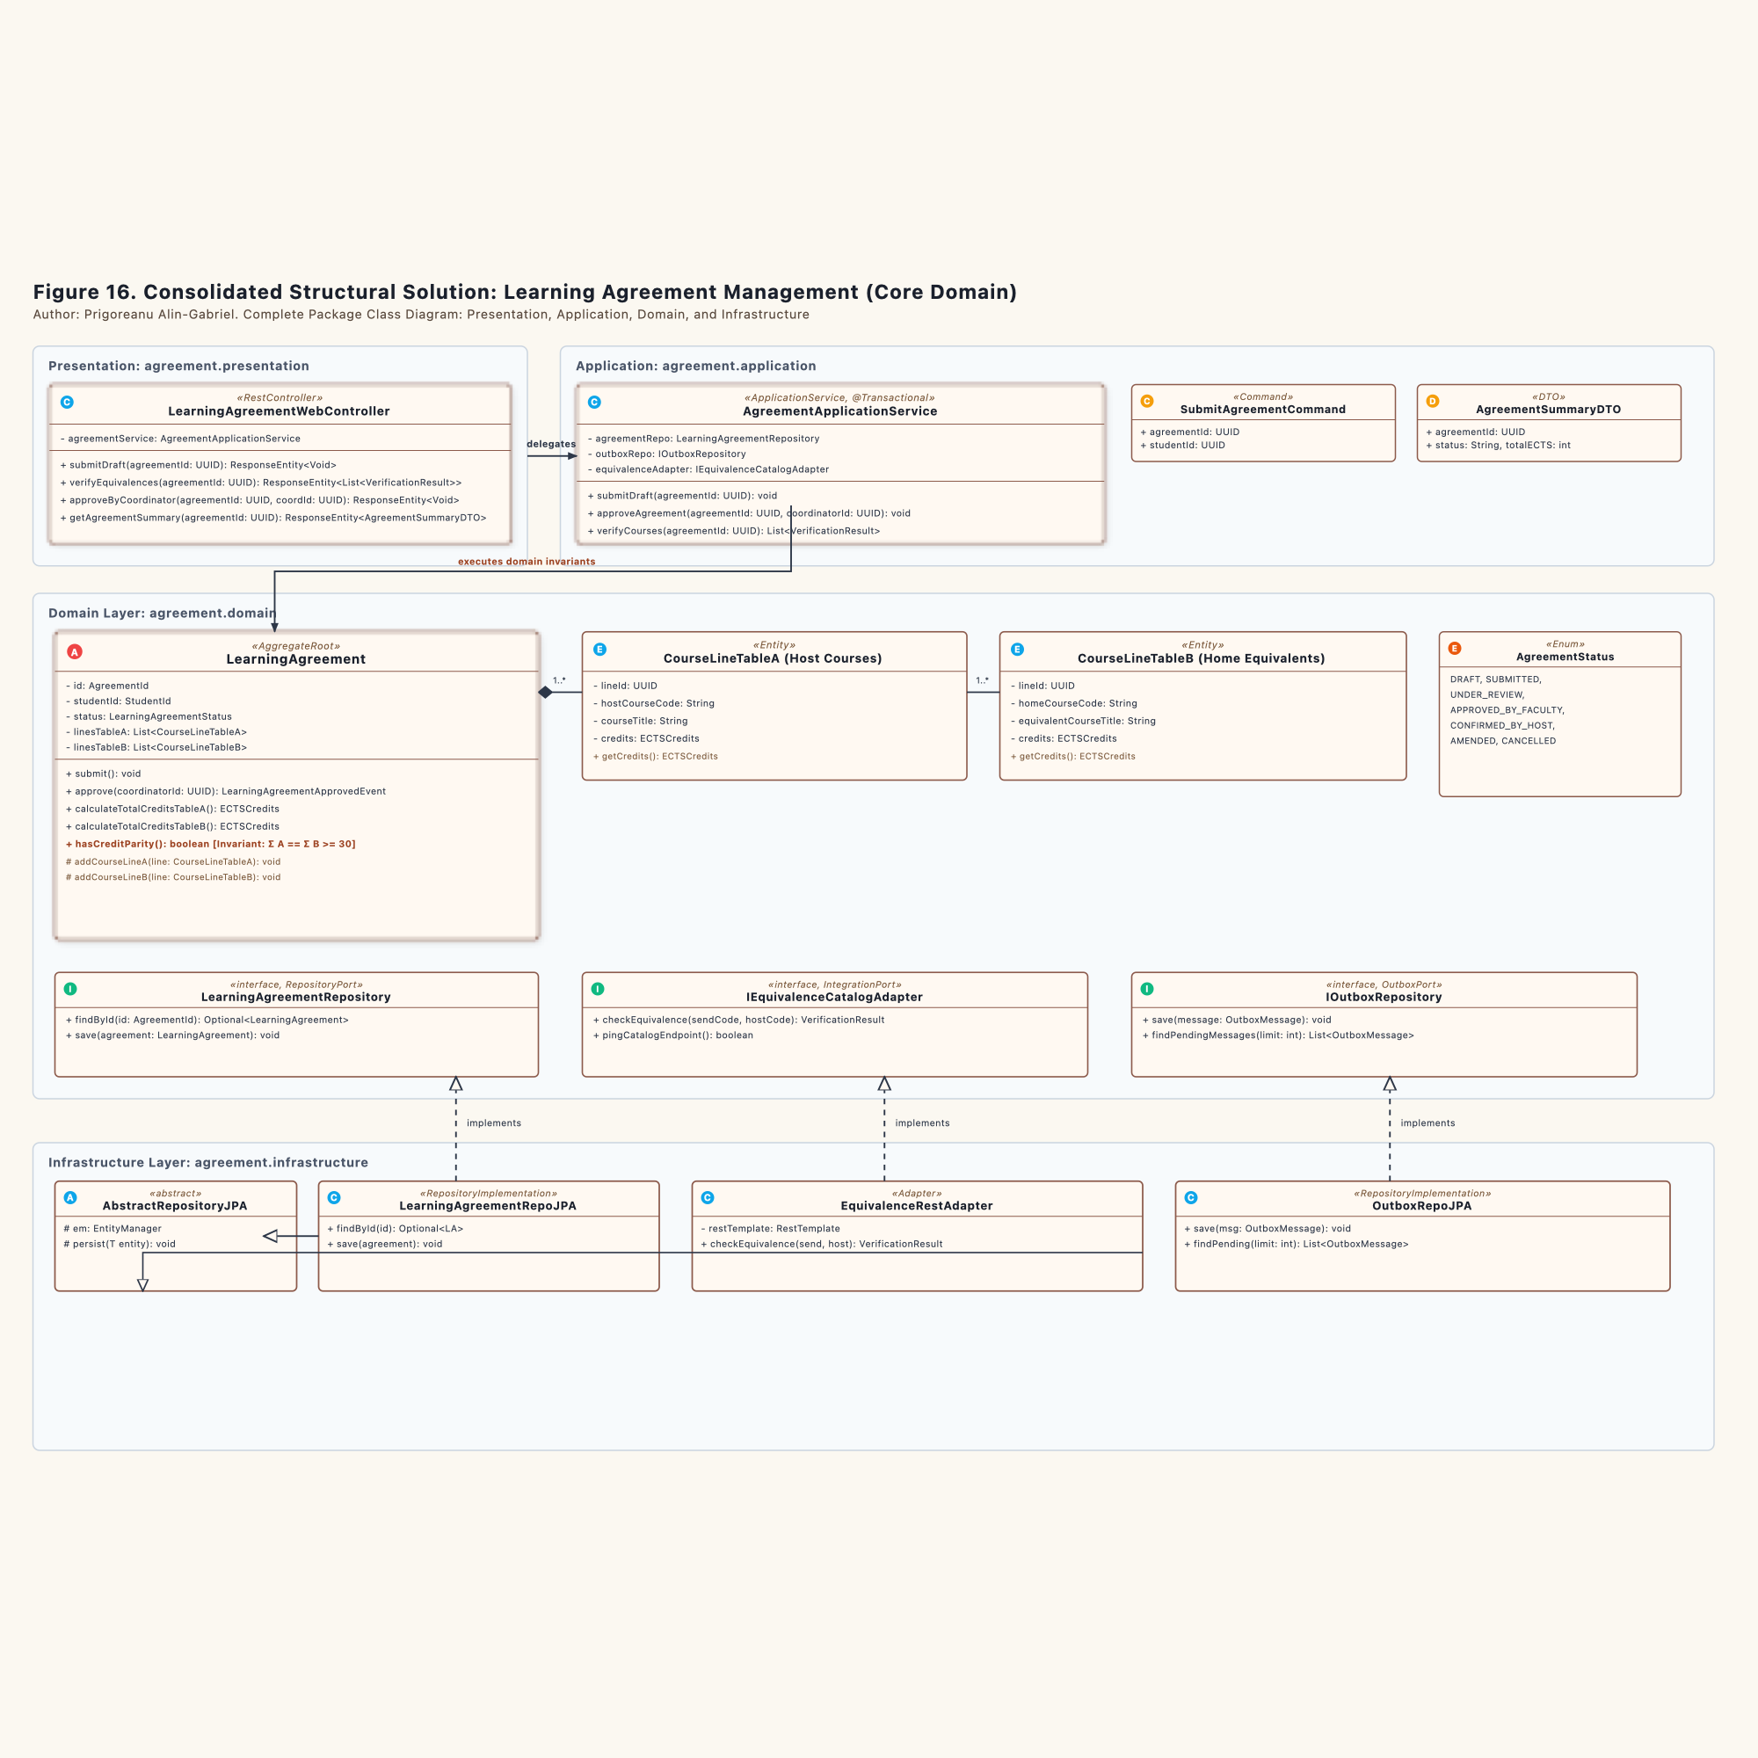
Figure 16. Consolidated Structural Solution - Learning Agreement Management

5.2.1 Package Decomposition
1. `ro.uaic.feaa.erasmus.agreement.presentation` : Houses LearningAgreementWebController. It parses incoming HTTP payloads, checks caller permissions, and translates application results into HTTP status codes.
2. `ro.uaic.feaa.erasmus.agreement.application` : Contains AgreementApplicationService. It acts as the coordinator. It loads the aggregate, calls domain ports to verify external syllabus mappings, invokes business invariants on the aggregate, and saves results atomically.
3. `ro.uaic.feaa.erasmus.agreement.domain` :
- Aggregate Root: LearningAgreement. Controls the consistency boundary. External callers cannot modify child course lines directly.
- Child Entities: CourseLineTableA (host institutional catalog items) and CourseLineTableB (home faculty equivalent items).
- Value Objects: AgreementId, StudentId, ECTSCredits, and AcademicYear.
- State Enum: LearningAgreementStatus with seven explicit phases.
- Domain Ports: LearningAgreementRepository, IEquivalenceCatalogAdapter, and IOutboxRepository.
4. `ro.uaic.feaa.erasmus.agreement.infrastructure` : Implements domain interfaces using technical persistence tools. LearningAgreementRepoJPA and OutboxRepoJPA derive from AbstractRepositoryJPA. EquivalenceRestAdapter uses Spring RestTemplate with strict timeouts.

5.3 Equivalence Management Structural Model (Figure 17)
The supporting subdomain functions as an authoritative reference catalog. It registers historical academic equivalences and assesses curricular overlap.
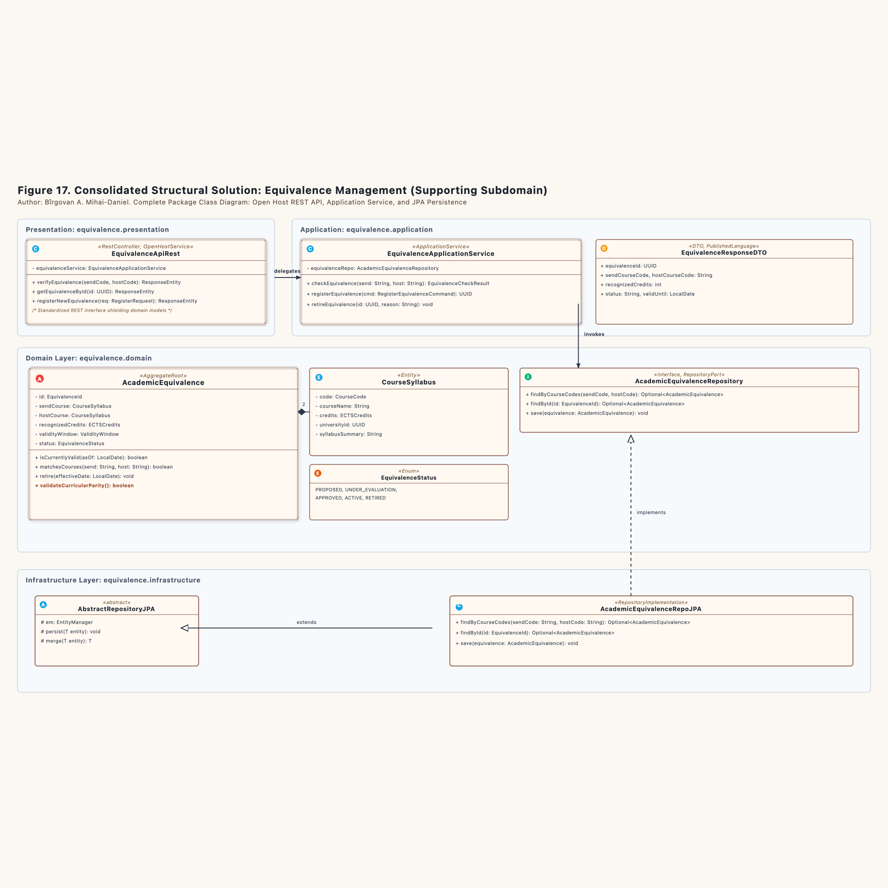
Figure 17. Consolidated Structural Solution - Equivalence Management

5.3.1 Package Decomposition
1. `ro.uaic.feaa.erasmus.equivalence.presentation` : Features EquivalenceApiRest, designed as an Open Host Service (OHS). It shields external consumers from internal table changes by returning immutable EquivalenceResponseDTO instances.
2. `ro.uaic.feaa.erasmus.equivalence.application` : Contains EquivalenceApplicationService. It handles command execution for syllabus evaluations, new equivalence registrations, and catalog retirement.
3. `ro.uaic.feaa.erasmus.equivalence.domain` :
- Aggregate Root: AcademicEquivalence. Pairs domestic courses with foreign counterparts and enforces European Credit Transfer System (ECTS) validity.
- Child Entity / Value Object: CourseSyllabus, detailing lecture hours, thematic modules, and grading criteria.
- Value Objects: EquivalenceId, CourseCode, ECTSCredits, and ValidityWindow.
- State Enum: EquivalenceStatus.
- Repository Port: AcademicEquivalenceRepository.
4. `ro.uaic.feaa.erasmus.equivalence.infrastructure` : Houses AcademicEquivalenceRepoJPA, extending AbstractRepositoryJPA to run queries against relational tables through the JPA EntityManager.

5.4 Mobility Preparation Structural Model (Figure 18)
The supporting subdomain manages administrative onboarding and logistical verification for selected students.
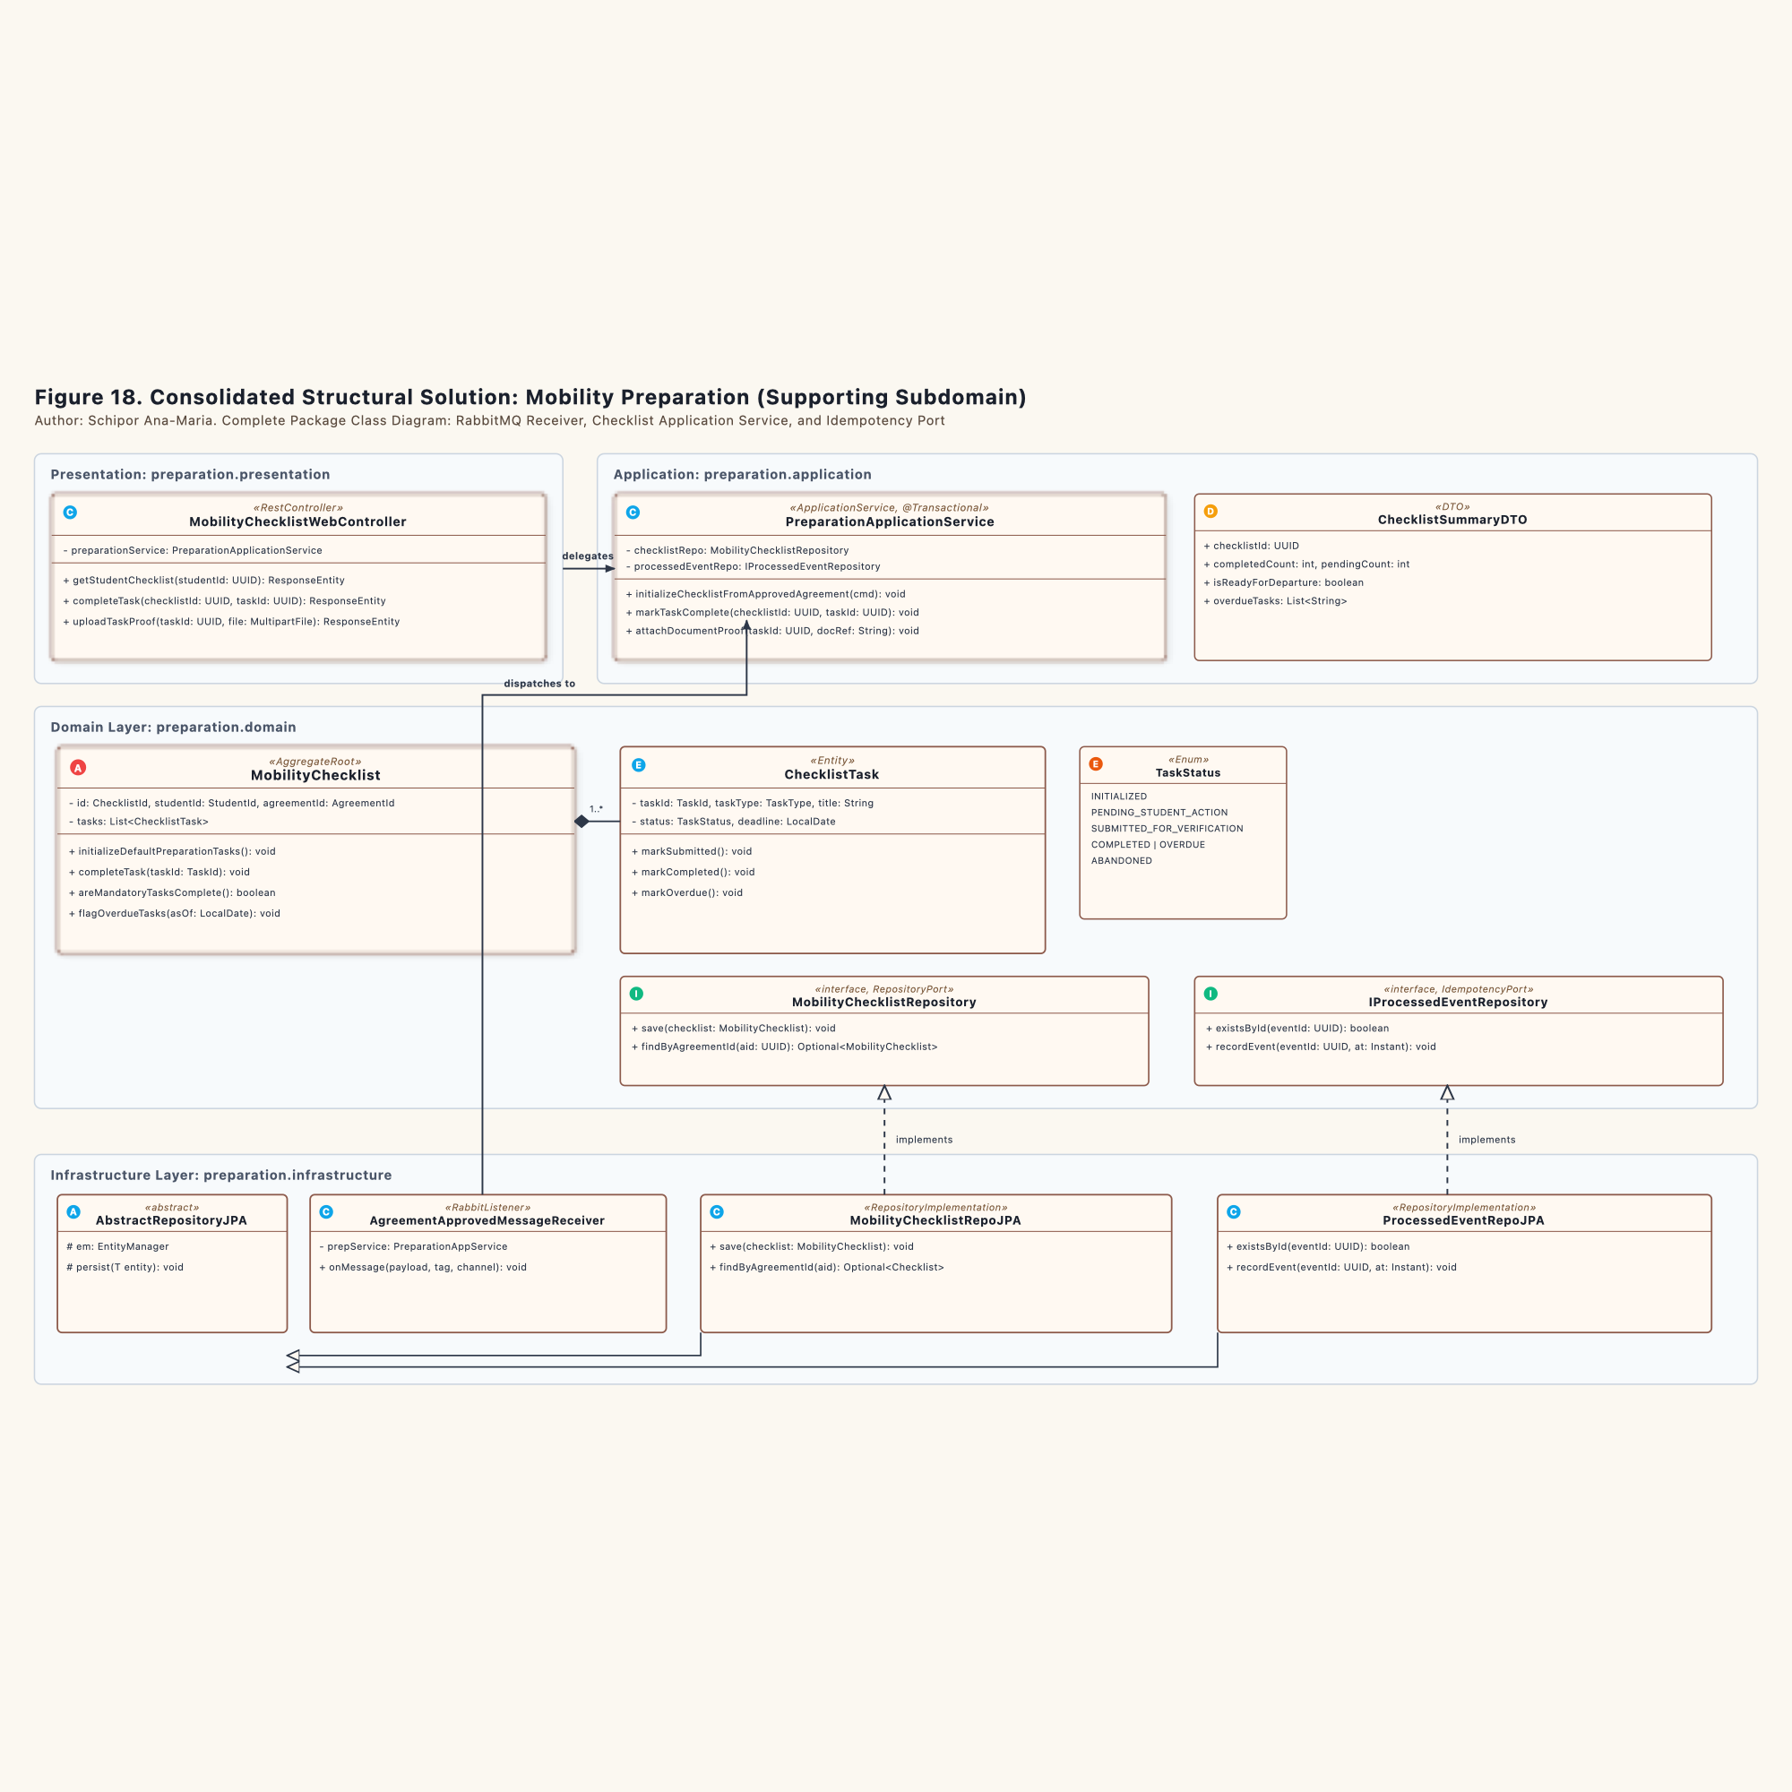
Figure 18. Consolidated Structural Solution - Mobility Preparation

5.4.1 Package Decomposition
1. `ro.uaic.feaa.erasmus.preparation.presentation` : Contains MobilityChecklistWebController for student self-service interactions, document uploads, and milestone progress queries.
2. `ro.uaic.feaa.erasmus.preparation.application` : Contains PreparationApplicationService. It verifies event idempotency, initializes checklist templates, and stamps completed milestones.
3. `ro.uaic.feaa.erasmus.preparation.domain` :
- Aggregate Root: MobilityChecklist. Manages the full list of preparation tasks assigned to a nominated student.
- Internal Entity: ChecklistTask, representing individual items such as insurance policies, language assessments, and grant contract signatures.
- Value Objects: ChecklistId, TaskId, TaskType, and Deadline.
- State Enum: TaskStatus with six distinct lifecycle stages.
- Ports: MobilityChecklistRepository and IProcessedEventRepository.
4. `ro.uaic.feaa.erasmus.preparation.infrastructure` : Contains AgreementApprovedMessageReceiver listening on RabbitMQ queue mobility.preparation.agreement.approved. Persistence relies on MobilityChecklistRepoJPA and ProcessedEventRepoJPA.

Chapter 6. Dynamic System Behavior (Behavioral Modeling)

6.1 Aggregate Lifecycle Modeling through State Machine Diagrams and Transition Tables (Figures 19, 20, 21)
This document defines the formal behavioral lifecycles for the core aggregates across the three bounded contexts of the Erasmus Mobility Platform (EMP). Each state machine is authored by a dedicated team member and enforces business invariants through package-private transition methods, guard conditions, and event publications.

6.1.1 Team Allocations and Lifecycle Scope
Aggregate Root / Entity | Subdomain Context | Primary Author | State Enum Class | Associated Diagram
LearningAgreement | Learning Agreement Management (Core Domain) | Prigoreanu Alin-Gabriel | LearningAgreementStatus | Figure 19
AcademicEquivalence | Equivalence Management (Supporting Subdomain) | Bîrgovan A. Mihai-Daniel | EquivalenceStatus | Figure 20
ChecklistTask | Mobility Preparation (Supporting Subdomain) | Schipor Ana-Maria | TaskStatus | Figure 21

6.1.2 Learning Agreement Aggregate Lifecycle (Student 1: Prigoreanu Alin-Gabriel)
The LearningAgreement aggregate coordinates the core academic contract between the exchange student, the home university, and the host institution.
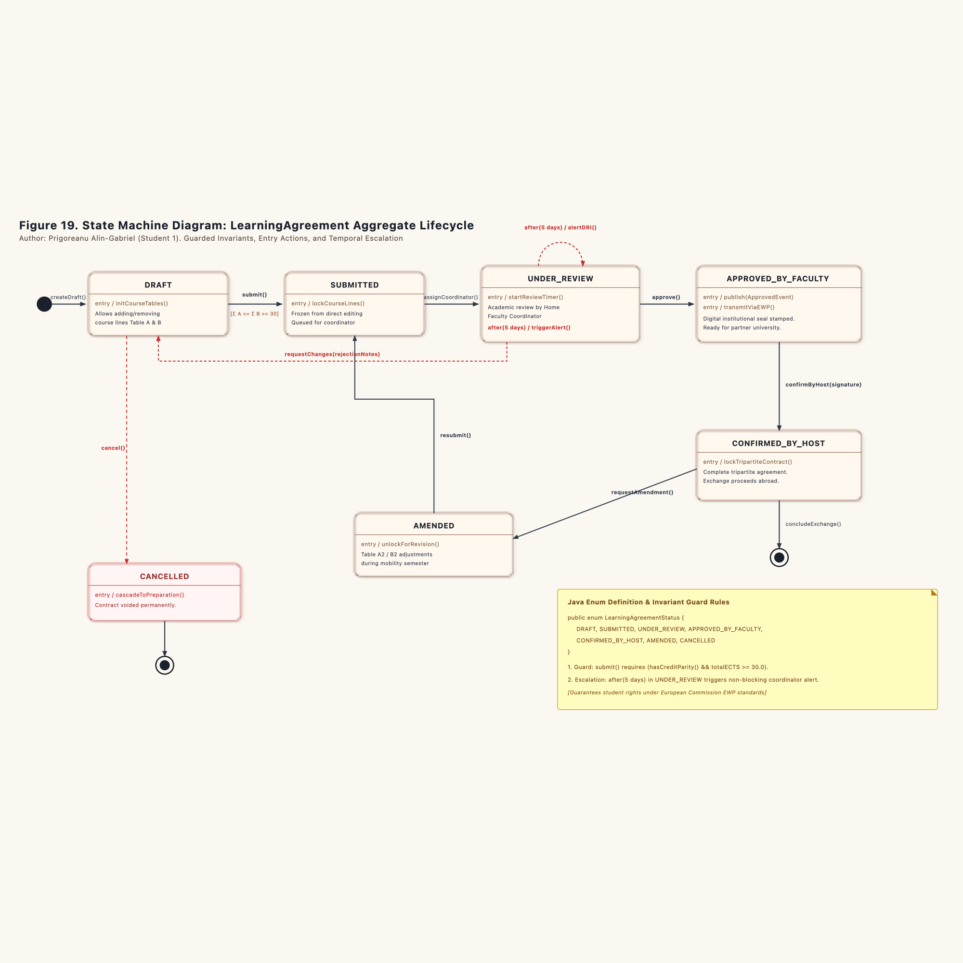
Figure 19. State Machine Diagram: LearningAgreement Aggregate Lifecycle

6.1.2.1 State Definitions (`LearningAgreementStatus`)
package ro.uaic.feaa.erasmus.agreement.domain;
public enum LearningAgreementStatus {
DRAFT,
SUBMITTED,
UNDER_REVIEW,
APPROVED_BY_FACULTY,
CONFIRMED_BY_HOST,
AMENDED,
CANCELLED
}

- `DRAFT` : The initial working slate. The student freely adds, edits, or removes course lines in Table A (host offerings) and Table B (home recognitions).
- `SUBMITTED` : The agreement is locked against student edits and queued for departmental assignment.
- `UNDER_REVIEW` : Assigned to the designated faculty coordinator for academic curriculum inspection.
- `APPROVED_BY_FACULTY` : Stamped with the institutional digital seal. Triggers publication of LearningAgreementApprovedEvent to the transactional outbox ledger.
- `CONFIRMED_BY_HOST` : Counter-signed by the receiving partner institution via Erasmus Without Paper (EWP) network. Represents a binding tripartite contract.
- `AMENDED` : Reopened during the mobility semester for exceptional course adjustments (Table A2 and Table B2).
- `CANCELLED` : Permanently revoked due to student withdrawal, severe credit deficit, or administrative disqualification.

6.1.2.2 Transitions and Invariant Guards (Formal State Transition Table)
Source State | Trigger Event / Method | Guard Condition | Action / Output Effect | Target State
[Initial State] | createDraft() | None | Instantiate aggregate with empty course collections | DRAFT
DRAFT | submit() | hasCreditParity() && totalECTS >= 30.0 | Lock course line editing (lockCourseLines()) | SUBMITTED
SUBMITTED | assignCoordinator(coordinatorId) | coordinatorId != null | Allocate agreement to coordinator review queue | UNDER_REVIEW
UNDER_REVIEW | approve(coordinatorId) | hasCreditParity() | Emit LearningAgreementApprovedEvent | APPROVED_BY_FACULTY
UNDER_REVIEW | requestChanges(rejectionNotes) | None | Unlock course lines for student adjustments | DRAFT
UNDER_REVIEW | after(5 business days) | None | Dispatch escalation notification to DRI | UNDER_REVIEW
APPROVED_BY_FACULTY | confirmByHost(signatureToken) | signatureToken != null | Seal official tripartite institutional contract | CONFIRMED_BY_HOST
CONFIRMED_BY_HOST | requestAmendment(reason) | None | Open exceptional curricular amendment session | AMENDED
AMENDED | resubmitAmendedDraft() | hasCreditParity() | Submit amended contract for faculty re-approval | SUBMITTED
{DRAFT, SUBMITTED, UNDER_REVIEW} | cancel(reason) | None | Cancel study contract across subsystems | CANCELLED
CONFIRMED_BY_HOST | concludeExchange() | None | Conclude mobility with full credit recognition | [Final State]
CANCELLED | None | None | Archive cancelled contract dossier | [Final State]

6.1.2.3 Operational Mechanics
1. Credit Parity Guard (`hasCreditParity()`): The aggregate prevents any transition from DRAFT to SUBMITTED unless the sum of ECTS credits in Table A equals the sum of credits in Table B, and the total reaches at least 30.0 credits for a standard semester.
2. Temporal Review Alert: If an agreement remains in UNDER_REVIEW for more than 5 business days without coordinator action, a non-blocking background timer fires alertDRI(). This notifies the Department of International Relations to prevent administrative bottlenecks.
3. Event Trigger on Approval: Entering APPROVED_BY_FACULTY executes an entry action that emits LearningAgreementApprovedEvent. The application service commits this event into the local outbox table inside the same database transaction.

6.1.3 Academic Equivalence Aggregate Lifecycle (Student 2: Bîrgovan A. Mihai-Daniel)
The AcademicEquivalence aggregate governs verified course mapping rules between sending and receiving academic programs.
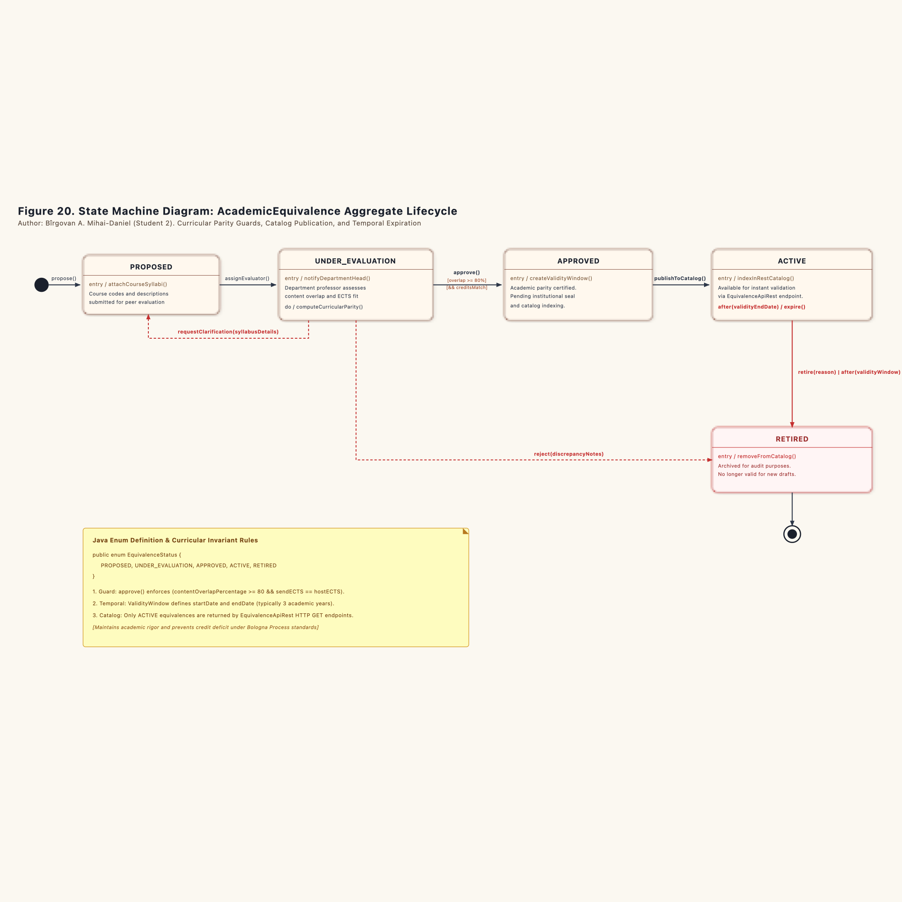
Figure 20. State Machine Diagram: AcademicEquivalence Aggregate Lifecycle

6.1.3.1 State Definitions (`EquivalenceStatus`)
package ro.uaic.feaa.erasmus.equivalence.domain;
public enum EquivalenceStatus {
PROPOSED,
UNDER_EVALUATION,
APPROVED,
ACTIVE,
RETIRED
}

- `PROPOSED` : Raw course syllabus mapping submitted by a student or academic advisor.
- `UNDER_EVALUATION` : Under rigorous assessment by a departmental subject-matter professor.
- `APPROVED` : Academic equivalence confirmed by faculty resolution. Validity window is established.
- `ACTIVE` : Published in the catalog and open for automatic verification via REST endpoints.
- `RETIRED` : Archived and no longer eligible for newly submitted learning agreements. Historical records remain preserved for audit compliance.

6.1.3.2 Transitions and Invariant Guards (Formal State Transition Table)
Source State | Trigger Event / Method | Guard Condition | Action / Output Effect | Target State
[Initial State] | propose() | None | Record new syllabus equivalence proposal | PROPOSED
PROPOSED | assignEvaluator(evaluatorId) | evaluatorId != null | Allocate to departmental discipline coordinator | UNDER_EVALUATION
UNDER_EVALUATION | requestClarification(details) | None | Request detailed syllabus from host institution | PROPOSED
UNDER_EVALUATION | approve() | contentOverlap >= 80% && creditsMatch | Validate academic recognition decision | APPROVED
UNDER_EVALUATION | reject(discrepancyNotes) | None | Reject proposal due to insufficient overlap | RETIRED
APPROVED | publishToCatalog() | None | Index in public REST catalog (indexInRestCatalog()) | ACTIVE
ACTIVE | retire(reason) | None | Manual retirement from active catalog | RETIRED
ACTIVE | after(validityWindow.endDate) | asOf > validityWindow.endDate | Automatic expiration upon validity window lapse | RETIRED
RETIRED | None | None | Historical preservation of syllabus mapping | [Final State]

6.1.3.3 Operational Mechanics
1. Curricular Parity Guard: The transition to APPROVED requires programmatic verification that the home and host syllabi share at least 80% core thematic overlap, and that the allocated ECTS credits match.
2. Catalog Indexing: Only records in ACTIVE state are exposed through the Open Host Service REST API (/api/equivalences/search). Any draft, pending, or retired records remain invisible to external queries.
3. Temporal Expiration: A scheduled maintenance task evaluates the ValidityWindow value object daily. When the end date lapses (typically after 3 academic years), the aggregate transitions into RETIRED.

6.1.4 Mobility Preparation Task Lifecycle (Student 3: Schipor Ana-Maria)
The ChecklistTask entity tracks individual administrative readiness requirements before a student departs for their study abroad program.
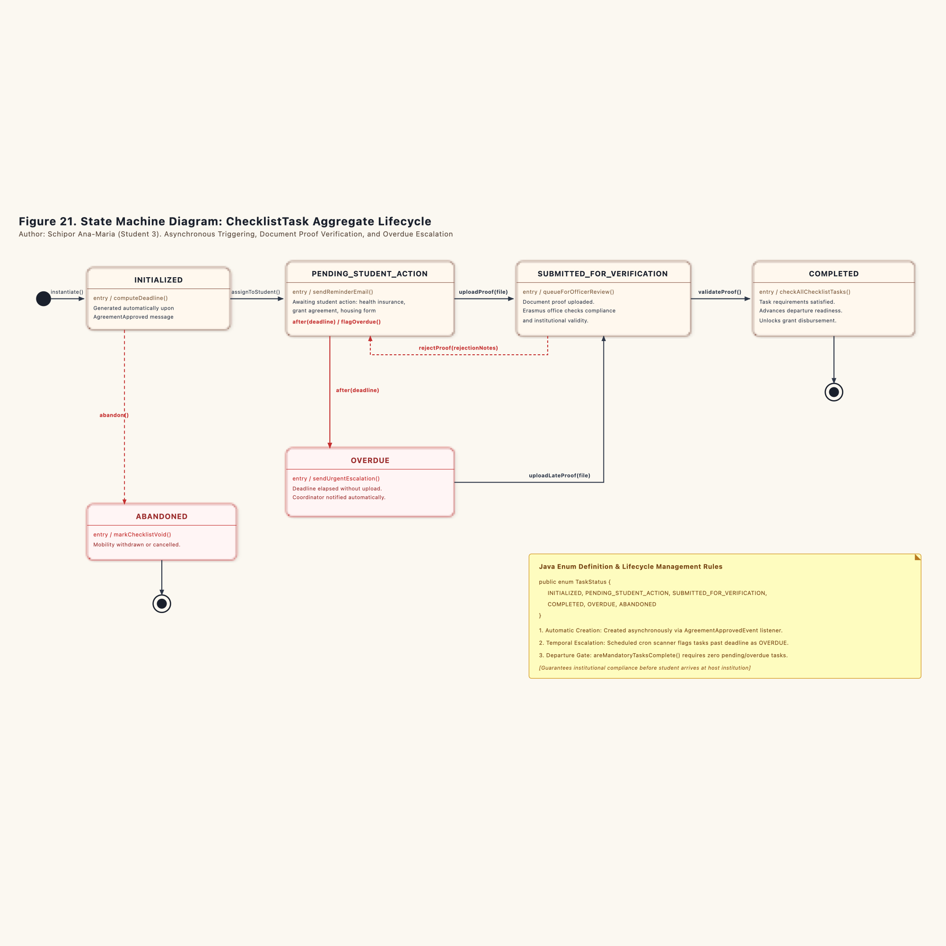
Figure 21. State Machine Diagram: ChecklistTask Entity Lifecycle

6.1.4.1 State Definitions (`TaskStatus`)
package ro.uaic.feaa.erasmus.preparation.domain;
public enum TaskStatus {
INITIALIZED,
PENDING_STUDENT_ACTION,
SUBMITTED_FOR_VERIFICATION,
COMPLETED,
OVERDUE,
ABANDONED
}

- `INITIALIZED` : The task record is instantiated by the asynchronous message consumer following receipt of LearningAgreementApprovedEvent.
- `PENDING_STUDENT_ACTION` : Assigned to the student profile. The student must upload evidence such as a signed grant agreement, health insurance proof, or housing confirmation.
- `SUBMITTED_FOR_VERIFICATION` : Proof documentation is attached. The task sits in the Erasmus office review queue.
- `COMPLETED` : Verified and signed off by an institutional mobility officer.
- `OVERDUE` : The statutory deadline passed without approved documentation.
- `ABANDONED` : Voided due to mobility cancellation or formal waiver.

6.1.4.2 Transitions and Invariant Guards (Formal State Transition Table)
Source State | Trigger Event / Method | Guard Condition | Action / Output Effect | Target State
[Initial State] | instantiate() | None | Instantiate onboarding task from country template | INITIALIZED
INITIALIZED | assignToStudent() | None | Assign to student dashboard and dispatch alert email | PENDING_STUDENT_ACTION
PENDING_STUDENT_ACTION | uploadProof(fileRef) | fileRef != null | Attach verified PDF certificate | SUBMITTED_FOR_VERIFICATION
SUBMITTED_FOR_VERIFICATION | rejectProof(notes) | None | Request document re-upload with coordinator audit notes | PENDING_STUDENT_ACTION
SUBMITTED_FOR_VERIFICATION | validateProof() | None | Verify dossier completeness (checkAllChecklistTasks()) | COMPLETED
PENDING_STUDENT_ACTION | after(deadline) | currentDate > deadline | Dispatch urgent escalation reminder | OVERDUE
OVERDUE | uploadLateProof(fileRef) | fileRef != null | Upload late proof document for urgent review | SUBMITTED_FOR_VERIFICATION
{INITIALIZED, PENDING, OVERDUE} | abandon() | None | Void task following mobility cancellation | ABANDONED
COMPLETED | None | None | Successfully fulfilled administrative milestone | [Final State]
ABANDONED | None | None | Closed task without liability | [Final State]

6.1.4.3 Operational Mechanics
1. Automated Initialization: Tasks are never entered manually. They are generated by the message listener following the arrival of a confirmed nomination event from the message broker.
2. Temporal Overdue Scanner: A background scheduler checks tasks whose status is PENDING_STUDENT_ACTION. When the local calendar date exceeds deadline, the system changes the status to OVERDUE and dispatches an escalation notice to the coordinator.
3. Departure Readiness Gate: The parent MobilityChecklist aggregate evaluates all child tasks via areMandatoryTasksComplete(). The platform forbids grant disbursement and final departure clearance while any task remains in OVERDUE or PENDING_STUDENT_ACTION.

6.2 Object Interaction Design through Sequence Diagrams (Figures 22–25)
This document details the dynamic collaboration between presentation controllers, application services, domain aggregates, repositories, and cross-boundary communication mechanisms across the Erasmus Mobility Platform.

6.2.1 Overview of Integration Flows
The system architecture employs two distinct integration paradigms to keep the three bounded contexts decoupled:
1. Synchronous REST Integration (Figures 22 and 23): Used for low-latency, read-only queries where immediate verification is required (checking course catalog equivalences during agreement drafting).
2. Asynchronous Transactional Outbox Integration (Figures 24 and 25): Used for business-critical state changes that trigger side effects across context boundaries (initializing student preparation checklists upon agreement approval).

6.2.2 Synchronous REST Integration: Client Side (Figure 22)
Figure 22 captures the execution path when a student triggers course verification in the Learning Agreement workspace.
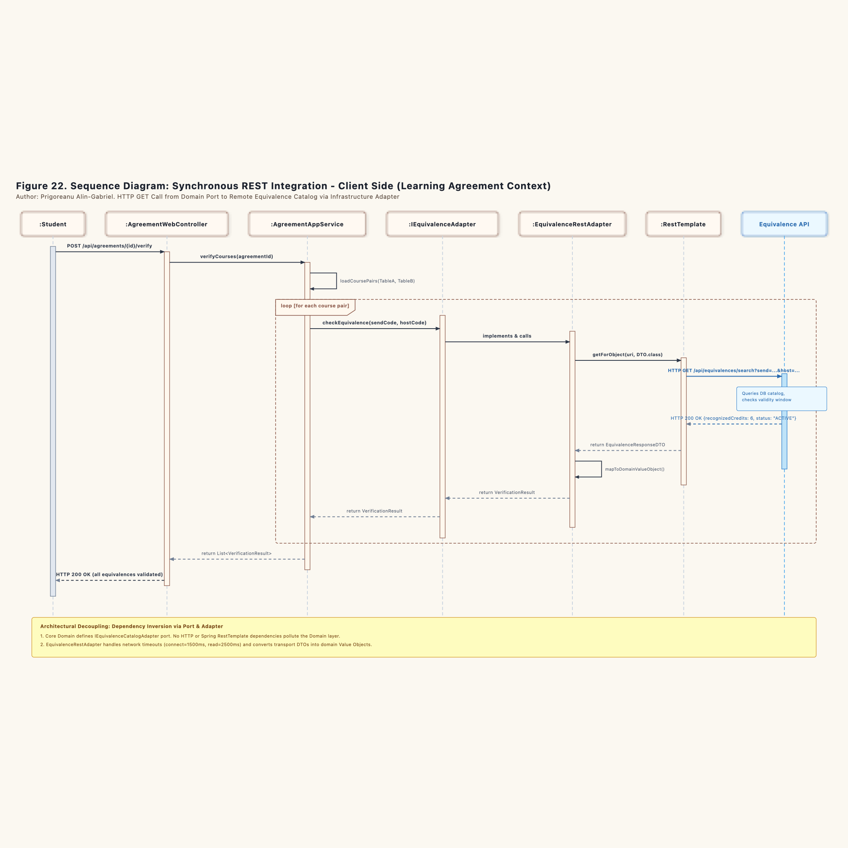
Figure 22. Sequence Diagram: Synchronous REST Integration - Client Side

Execution Sequence
1. Trigger: The :Student clicks "Verify Course Equivalences", issuing an HTTP POST /api/agreements/{id}/verify to :AgreementWebController.
2. Application Orchestration: The controller delegates to AgreementApplicationService.verifyCourses(agreementId).
3. Course Pair Extraction: The application service reads the learning agreement from agreementRepo, extracting the paired course codes from Table A and Table B.
4. Loop over Course Pairs: For each pair, the service calls the domain port IEquivalenceCatalogAdapter.checkEquivalence(sendCode, hostCode).
5. Infrastructure Dispatch: The port delegates to EquivalenceRestAdapter. The adapter formats the target URI and invokes Spring's RestTemplate.getForObject(...) with strict timeout settings (1500ms connect timeout, 2500ms read timeout).
6. Network Request: The adapter issues an HTTP GET call over the local network to the Equivalence Management API endpoint (/api/equivalences/search).
7. Response Ingestion: The remote API responds with HTTP 200 and a JSON payload. RestTemplate deserializes this JSON into an EquivalenceResponseDTO.
8. Value Object Conversion: The adapter maps the transport DTO into a domain Value Object EquivalenceVerificationResult. This protects the domain layer from transport-level schemas.
9. Return to UI: The application service collects all verification results and returns them to the controller. The controller responds to the student with an HTTP 200 status payload.

6.2.3 Synchronous REST Integration: Server Side (Figure 23)
Figure 23 models the internal processing within the Equivalence Management context when answering inbound verification calls.
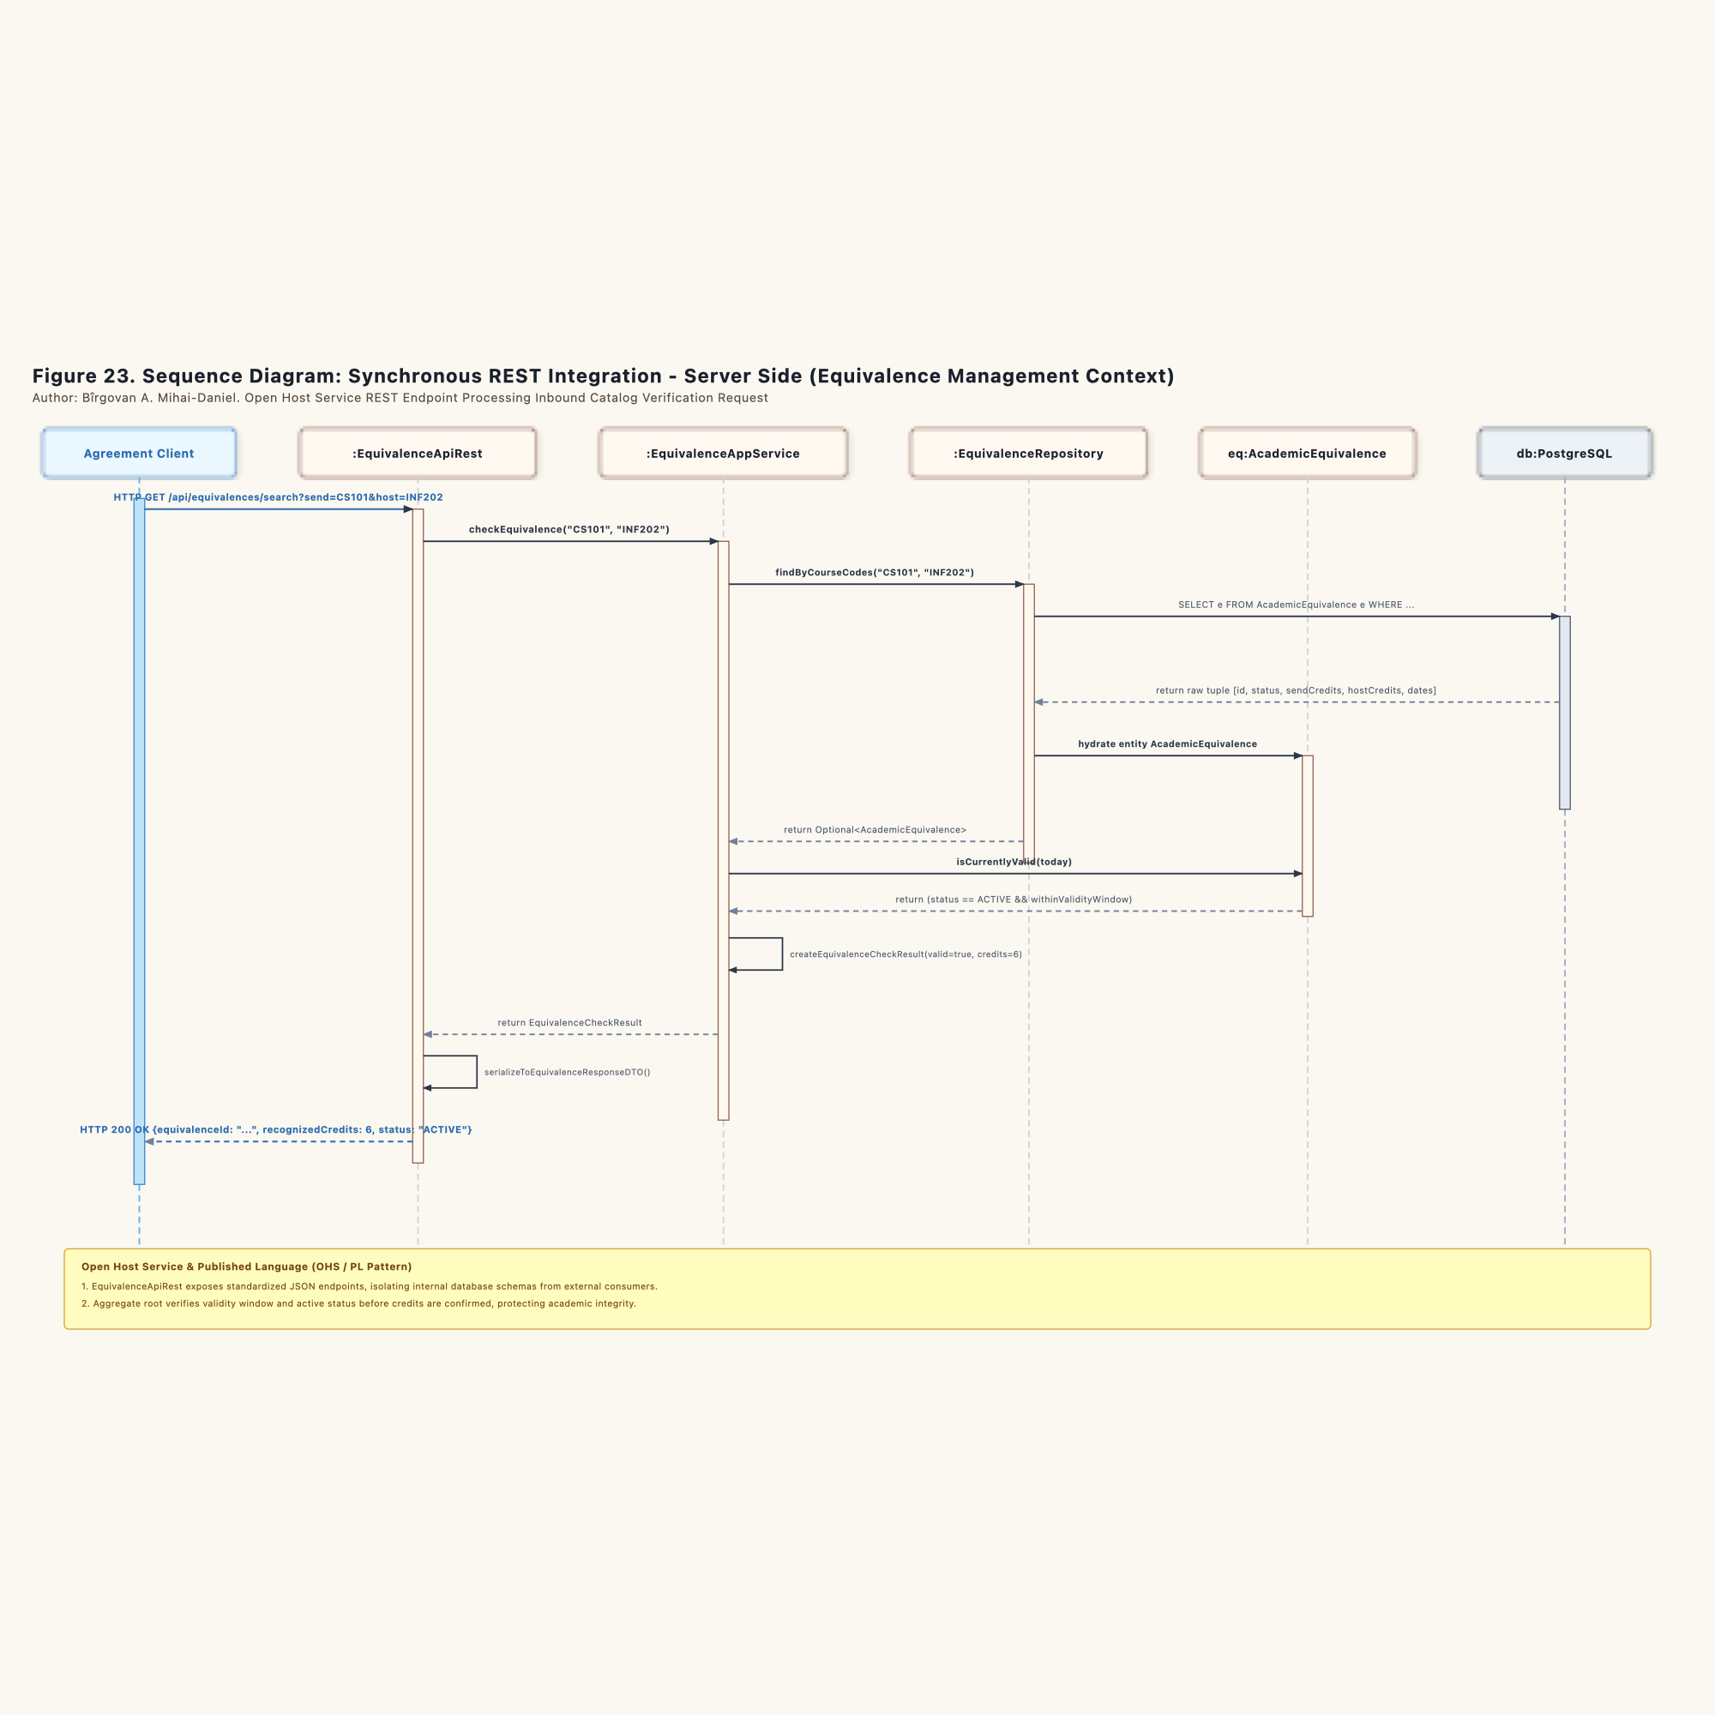
Figure 23. Sequence Diagram: Synchronous REST Integration - Server Side

Execution Sequence
1. Inbound HTTP Call: The remote client issues an HTTP GET to /api/equivalences/search?send=CS101&host=INF202.
2. Open Host Controller: :EquivalenceApiRest receives the request. As an Open Host Service, it verifies query parameter sanitization and calls EquivalenceApplicationService.checkEquivalence("CS101", "INF202").
3. Repository Query: The service calls AcademicEquivalenceRepository.findByCourseCodes(...).
4. Database Execution: AcademicEquivalenceRepoJPA runs a parameterized JPQL query against PostgreSQL (SELECT e FROM AcademicEquivalence e WHERE ...).
5. Entity Hydration: The repository loads the database tuple and reconstructs the AcademicEquivalence aggregate root.
6. Domain Validation: The service queries the aggregate using isCurrentlyValid(today). The aggregate confirms that its internal status is ACTIVE and that the current date falls within its ValidityWindow.
7. Published Language Mapping: The service constructs an EquivalenceCheckResult. The REST controller maps this domain object into an EquivalenceResponseDTO.
8. JSON Delivery: The controller returns an HTTP 200 OK containing the standardized JSON payload.

6.2.4 Asynchronous Outbox Integration: Producer Side (Figure 24)
Figure 24 illustrates how the Learning Agreement context guarantees message delivery using the Transactional Outbox pattern, eliminating dual-write failure modes.
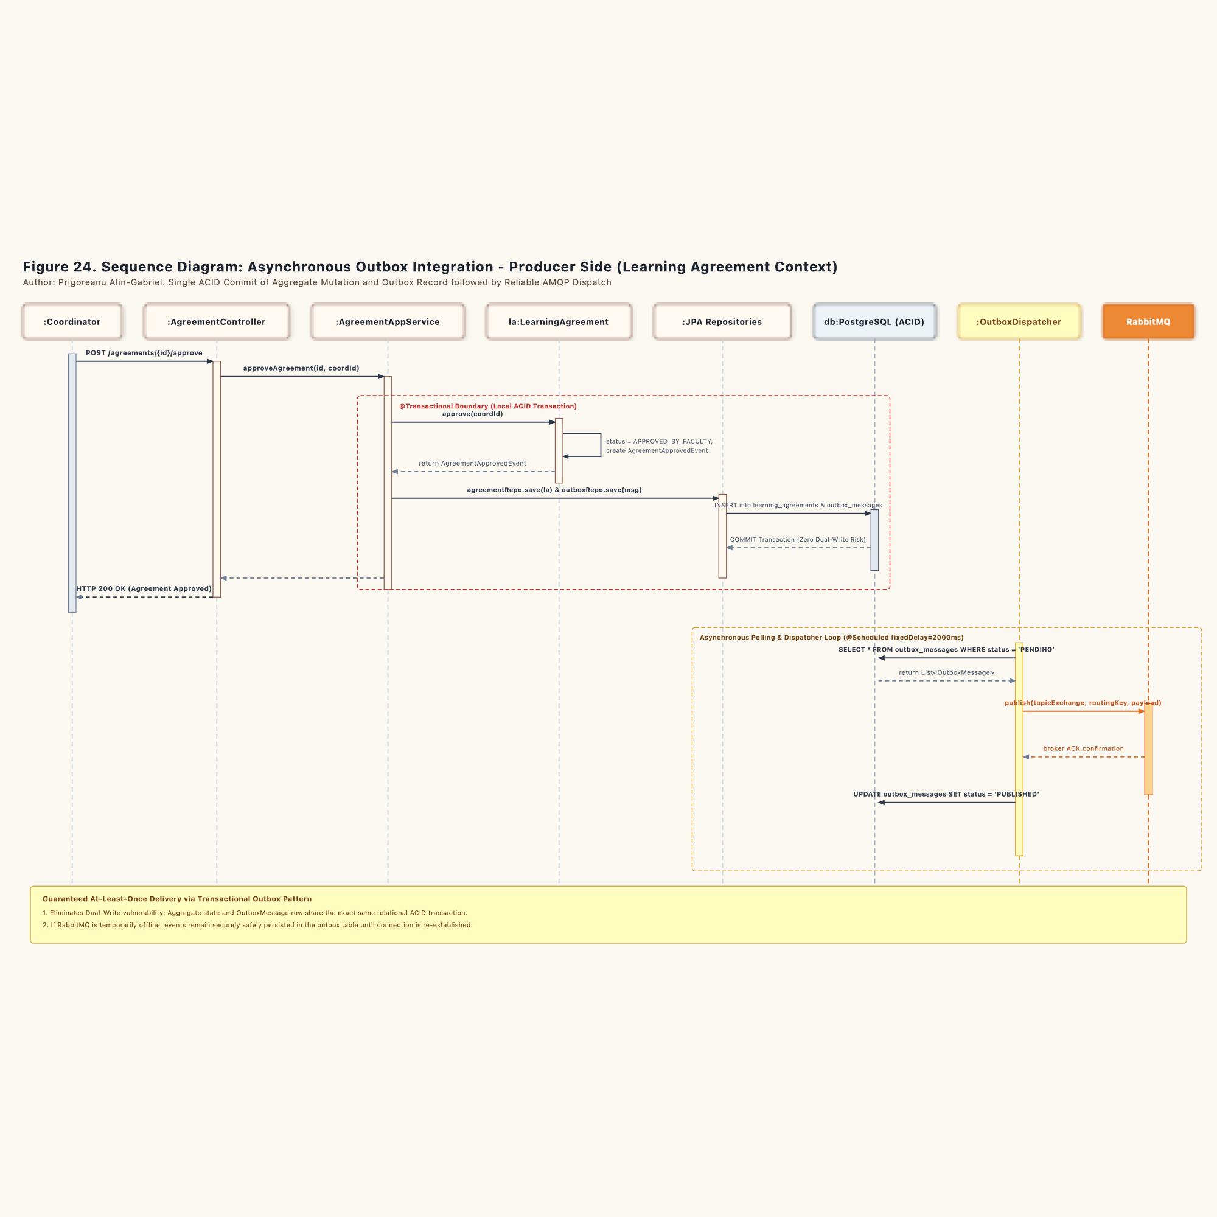
Figure 24. Sequence Diagram: Asynchronous Outbox Integration - Producer Side

Execution Sequence
1. Coordinator Sign-Off: The :Coordinator submits an approval command (POST /agreements/{id}/approve) to :AgreementController.
2. Transactional Entry: The controller invokes AgreementApplicationService.approveAgreement(id, coordId). Spring begins a local relational ACID transaction (@Transactional).
3. Aggregate State Mutation: The service loads the aggregate and invokes la.approve(coordId). The aggregate validates that credit parity is satisfied, transitions status to APPROVED_BY_FACULTY, and generates a LearningAgreementApprovedEvent.
4. Dual Write Avoidance: Inside the same database transaction:
- The updated aggregate is persisted via agreementRepo.save(la).
- The serialized domain event is saved to the outbox ledger via outboxRepo.save(outboxMessage) with status PENDING.
5. Atomic Commit: PostgreSQL commits both changes simultaneously. If either write fails, the entire transaction rolls back. Neither orphaned messages nor unsaved approvals can occur.
6. HTTP Response: The controller returns an immediate HTTP 200 confirmation to the coordinator.
7. Scheduled Dispatcher Worker: Operating in an independent background thread, :OutboxDispatcher triggers every 2000ms (@Scheduled(fixedDelay = 2000)).
8. Outbox Polling: The dispatcher executes SELECT * FROM outbox_messages WHERE status = 'PENDING' to retrieve unhandled messages.
9. Broker Publication: The dispatcher sends each message to RabbitMQ topic exchange erasmus.events.topic with routing key agreement.approved.
10. Delivery Confirmation: Upon receiving a broker ACK, the dispatcher executes UPDATE outbox_messages SET status = 'PUBLISHED' in the database.

6.2.5 Asynchronous Outbox Integration: Consumer Side (Figure 25)
Figure 25 traces the inbound message handling within the Mobility Preparation context, highlighting the idempotent receiver design.
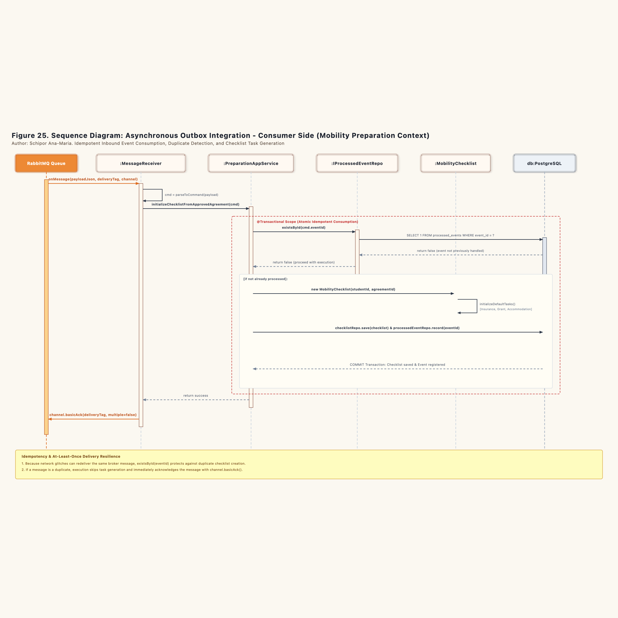
Figure 25. Sequence Diagram: Asynchronous Outbox Integration - Consumer Side

Execution Sequence
1. AMQP Delivery: The RabbitMQ queue (mobility.preparation.agreement.approved) delivers the message to :AgreementApprovedMessageReceiver.onMessage(...).
2. Command Translation: The receiver parses the JSON body into an InitializeChecklistCommand, extracting eventId, agreementId, and studentId.
3. Application Boundary: The receiver calls PreparationApplicationService.initializeChecklistFromApprovedAgreement(cmd). Spring opens a local database transaction.
4. Idempotency Verification: The service calls processedEventRepo.existsById(cmd.eventId). This port queries the processed_events table in PostgreSQL.
5. Duplicate Handling:
- If the event ID exists: The message was already processed in a previous attempt (such as during a network redelivery). The service logs a duplicate warning, skips aggregate generation, and commits the transaction cleanly.
- If the event ID does not exist: The service proceeds with checklist generation.
6. Aggregate Instantiation: The service instantiates a new MobilityChecklist aggregate root. The aggregate runs initializeDefaultTasks(), generating standard student requirements (Health Insurance, Grant Agreement, Accommodation Proof).
7. Atomic State Storage: The service executes:
- checklistRepo.save(checklist) to insert the checklist and child task rows.
- processedEventRepo.record(eventId) to record the event ID in processed_events.
8. Database Commit: The transaction commits both the tasks and the event ledger atomically.
9. Broker Acknowledgment: The receiver confirms message receipt to the broker with channel.basicAck(deliveryTag, false). RabbitMQ then removes the message from the queue.

Chapter 7. Technical Implementation & Verification Annex
To prove the concrete validity of the modeled structural and behavioral architecture, the project provides a full Java (JDK 23/25) domain implementation across 30 compiled classes, strictly enforcing DDD package layering and transactional invariants.

7.1 Java Package Architecture and 30 Compiled Domain Classes
The compiled domain skeleton in src/src/main/java/ro/uaic/feaa/erasmus/ is partitioned as follows:
- `ro.uaic.feaa.erasmus.shared` (Shared Kernel):
- Immutable Records: StudentId, AgreementId, EquivalenceId, TaskId, ChecklistId, CourseCode, AcademicYear.
- Invariant-Enforcing Value Objects: ECTSCredits (validates credits >= 0 and minimum 30 ECTS threshold), ValidityWindow (validates chronological order endDate >= startDate).
- `ro.uaic.feaa.erasmus.agreement` (Learning Agreement Management - Core Domain):
- Aggregate Root: LearningAgreement (manages Table A and Table B collections, enforces credit parity invariant, orchestrates tripartite approval lifecycle).
- Internal Child Entities: CourseLineTableA, CourseLineTableB.
- Domain Event: LearningAgreementApprovedEvent.
- Domain Ports: LearningAgreementRepository, IEquivalenceCatalogAdapter, IOutboxRepository.
- Infrastructure Types: OutboxMessage, OutboxStatus.
- `ro.uaic.feaa.erasmus.equivalence` (Equivalence Management - Supporting Subdomain):
- Aggregate Root: AcademicEquivalence (manages syllabus parity evaluation, temporal validity via isCurrentlyValid(asOf), and catalog indexing).
- Entity: CourseSyllabus.
- Domain Port: AcademicEquivalenceRepository.
- Lifecycle Enum: EquivalenceStatus.
- `ro.uaic.feaa.erasmus.preparation` (Mobility Preparation - Supporting Subdomain):
- Aggregate Root: MobilityChecklist (initializes mandatory administrative onboarding tasks, verifies dossier completion via areMandatoryTasksComplete()).
- Internal Child Entity: ChecklistTask (encapsulates task lifecycle from initialization to student submission, officer validation, or overdue escalation).
- Domain Port: MobilityChecklistRepository.
- Infrastructure Port: IProcessedEventRepository (guarantees idempotent message processing).

7.2 Automated Verification Report (JUnit 5 Invariants)
The automated test suite ro.uaic.feaa.erasmus.domain.DomainInvariantsTest verifies runtime behavior against the UML class models and state machine specifications:
1. testLearningAgreementInvariants: Asserts rejection of agreements holding under 30 ECTS credits, verifies exact credit parity between Table A and Table B, tests submission locking, coordinator review assignment, and automatic dispatch of LearningAgreementApprovedEvent upon faculty approval.
2. testAcademicEquivalence: Asserts state machine progression (PROPOSED -> UNDER_EVALUATION -> APPROVED -> ACTIVE) and temporal validity evaluation.
3. testMobilityChecklist: Asserts automated initialization of 5 mandatory administrative tasks, document proof attachment, submission for verification, and readiness completion gating via areMandatoryTasksComplete().
Maven Build Verification: mvn -f src/pom.xml test
- Tests run: 3, Failures: 0, Errors: 0, Skipped: 0
- Build Status: BUILD SUCCESS
- Execution Time: 0.031 seconds

7.3 Standardized OMG UML 2.1 XMI Structural Export
For seamless interoperability with CASE tools (Enterprise Architect v16+, Visual Paradigm), the structural model has been exported to the standard OMG UML 2.1 XMI format at models/xmi-exports/ErasmusModel.xmi (containing 50 structured model elements and 33 association relationships).

