NAME – Priyank Gupta
BRANCH - CSE SECTION - D
ROLL NO – 202401100200242
DevOps Assessment – Continuous Integration with GitHub Actions

Repository - https://github.com/prigup6002/github-skills-challenge

PR urls to verify –
https://github.com/prigup6002/github-skills-challenge/pull/2
https://github.com/prigup6002/github-skills-challenge/pull/1

successful workflow screenshots below

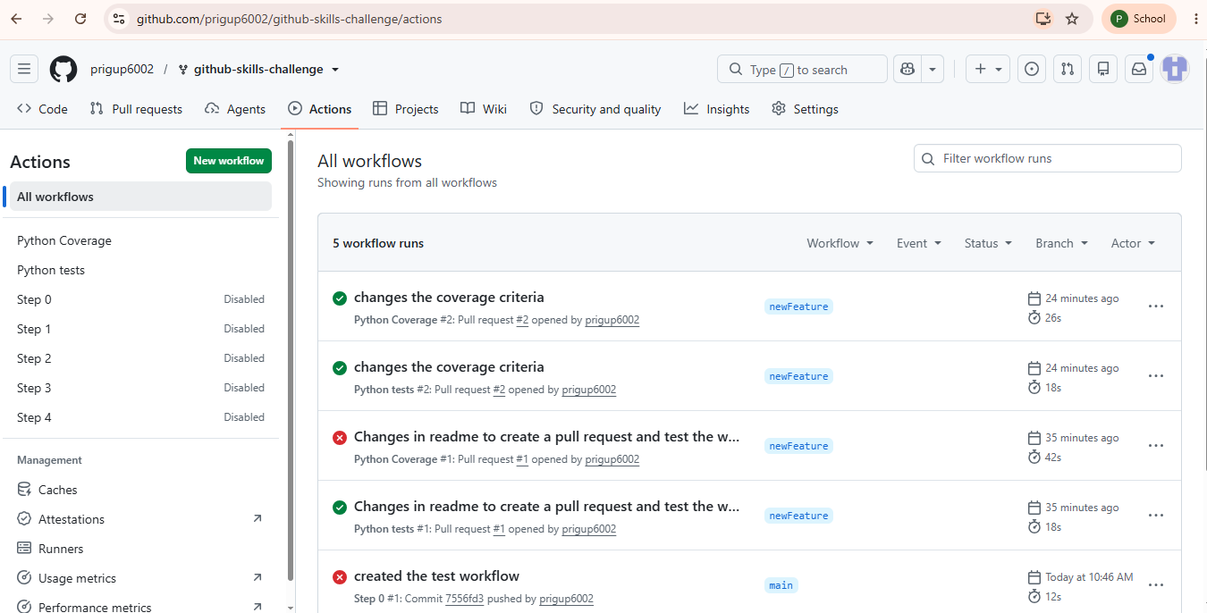
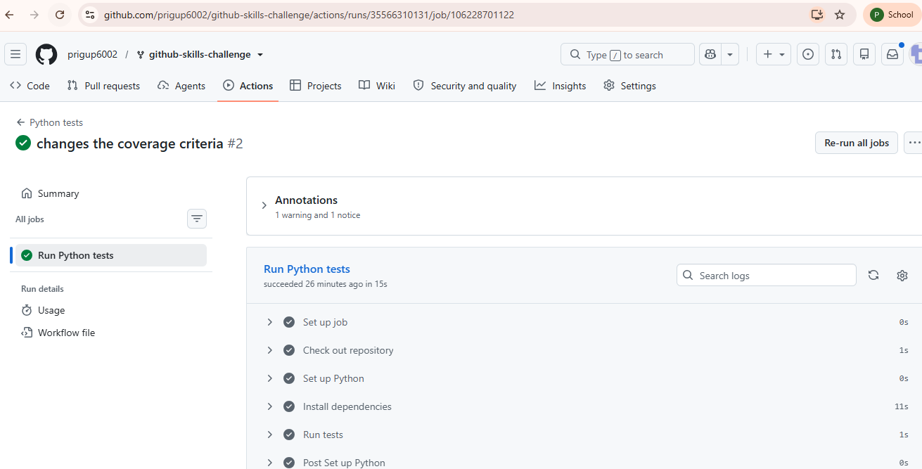
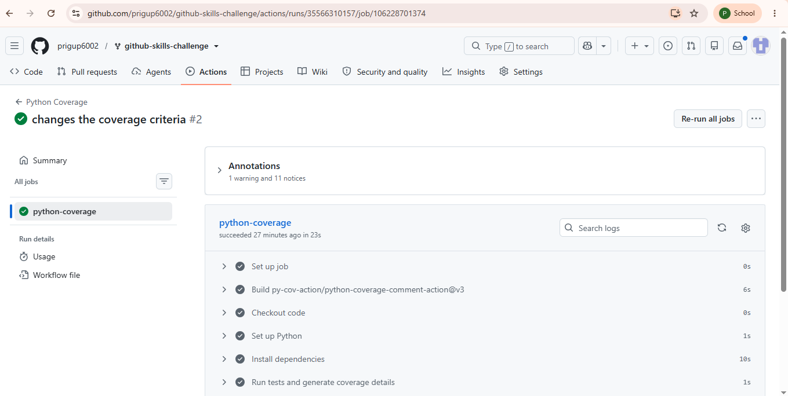

Final repo screenshot
