📖 Collocation Analysis User Guide
Collocations are pairs or groups of words that co-occur more frequently than would be expected by chance. It has 3 tabs, simple, Advanced, and Multi-Node Comparison
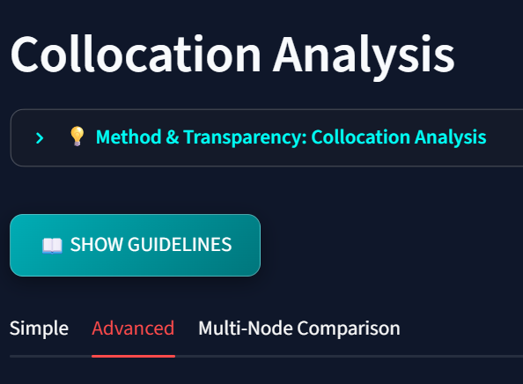
1. Search Settings
- Node Word: Input the target word around which to find collocates.
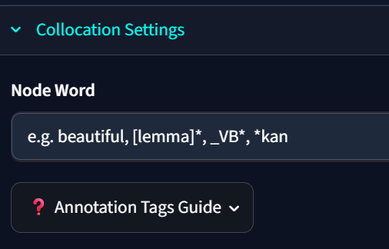
- Association Measure: Select the formula used to calculate collocation strength:
  - Log-Likelihood (LL): Best for high-frequency patterns.
  - Log-Dice: Reflects the exclusive co-occurrence (independent of corpus size).
  - Mutual Information (MI): Emphasizes strongly bound, rare terms.
  - Dice Coefficient: Evaluates overlap ratio.
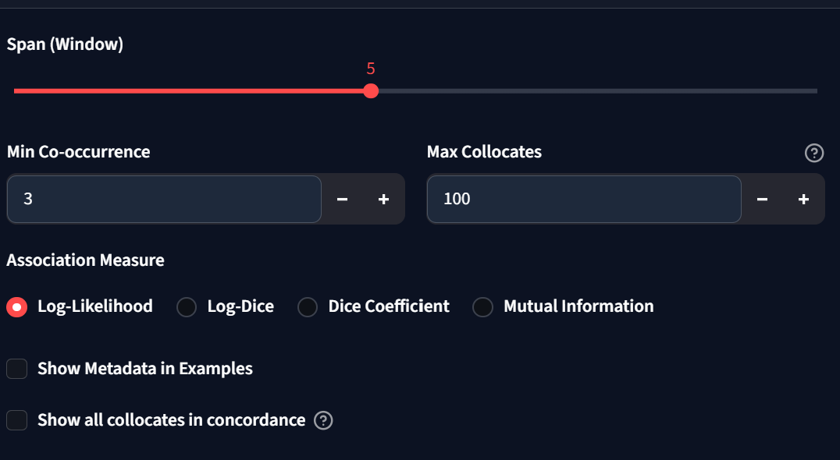
- Context Window: Determine the span of words surrounding the node word to search (e.g., 5 words to the left/right).
- Show all collocates in concordance: Check this box to retrieve and display all matching concordance lines for each collocate instead of a single sample instance.
2. Advanced Filters & XML Restrictions
- Apply positional filters (Tokens, Lemmas, and POS) and XML restrictions to analyze collocations in specific sub-corpora.
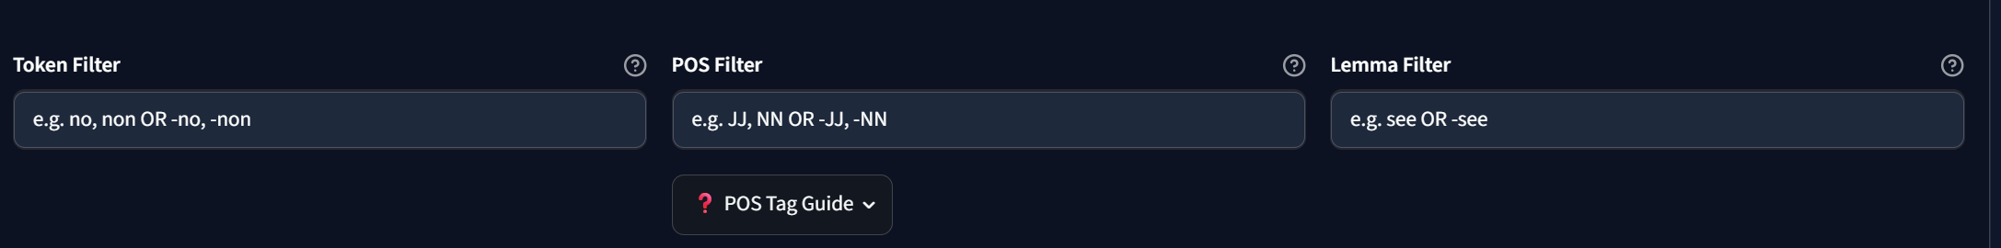
- Case-Insensitive Positive & Negative Filters:
  - Prefix a term with a minus sign (-) to exclude it. For example:
    - Token Filter: -the excludes "the".
    - POS Filter: -JJ excludes adjectives.
    - Lemma Filter: -buy excludes the lemma "buy".
  - Comparisons are completely case-insensitive (e.g., -jj works identically to -JJ).
- Union Syntax & Negation:
  - Wrap choices in parentheses and separate them with a pipe character, e.g. (JJ|NN) matches adjectives or nouns. This applies to token, lemma, and POS filters.
  - Supports negation inside parentheses, e.g. (-JJ|-NN|-RB) to exclude adjectives, nouns, and adverbs.
  - Supports negation outside parentheses, e.g. -(JJ|NN|RB) or -(buy|sell) which dynamically distributes the exclusion to all elements inside.
3. Collocation Patterns (Optional)
Cluster collocates dynamically using grammar patterns defined line-by-line (label : pattern). Make sure Apply pattern is checked.
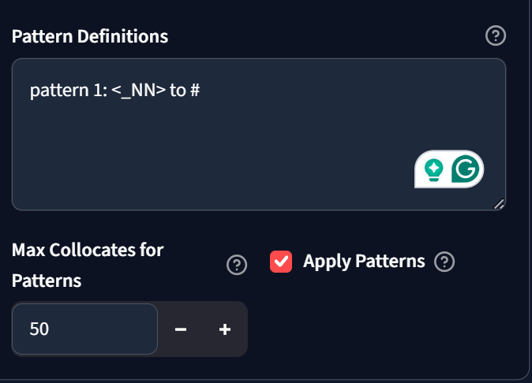
- Syntax Symbols:
  - # : Represents the node word.
  - <...> : Represents the collocate.
  - * : Optional token (0 or 1 words).
  - + : Required token (exactly 1 word).
  - _TAG : POS tag constraint (e.g. _VB).
  - [lemma] : Lemma constraint (e.g. [be]).
4. Multi-Node Collocation Comparison
Compare the collocates of up to 5 node words inside the active corpus to identify shared and distinct vocabulary environments.
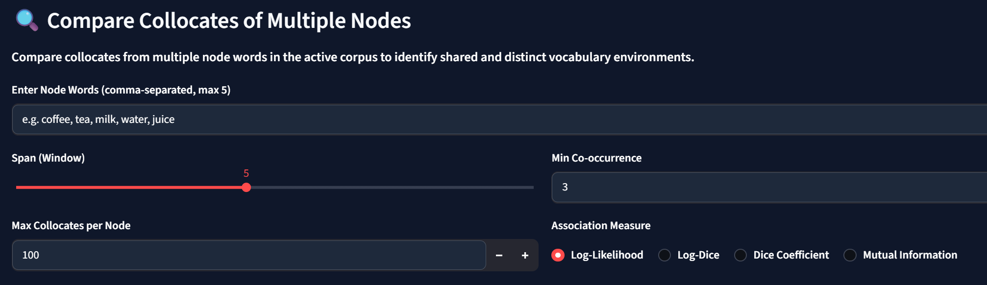
- Shared Collocates: Shows collocates appearing with more than one node word, sorted by Overlap Degree.
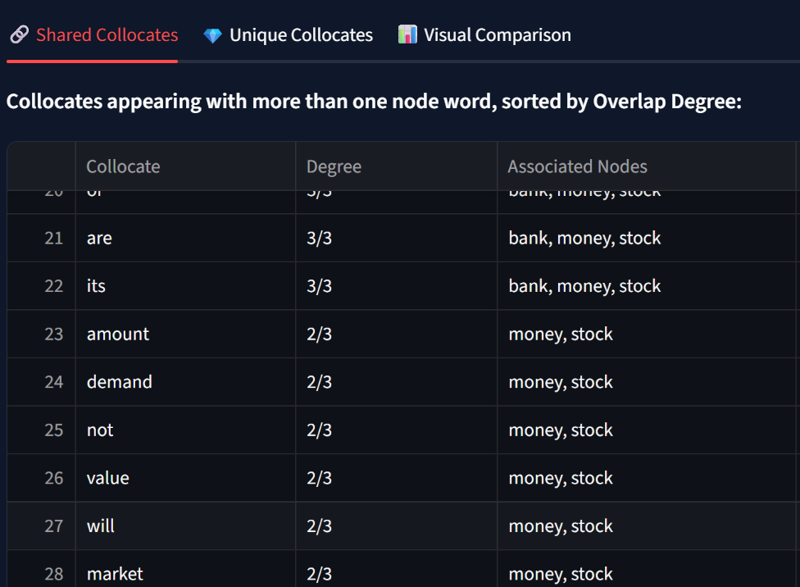
- Unique Collocates: Separate lists containing collocates exclusive to only one specific node word.
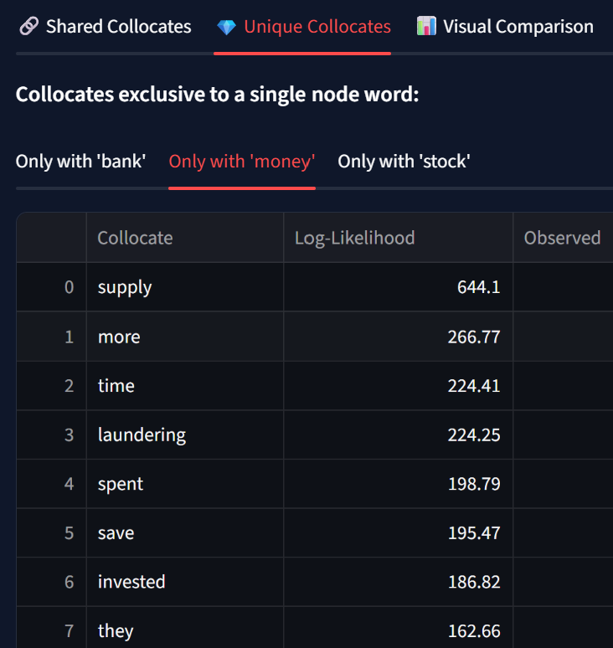
- Combined Strength Formulas: Choose how the overall association strength is calculated across multiple nodes:
  - Simple Aggregate: The raw sum of scores across node words: $\text{Combined Score}=\sum_{i=1}^{N}{{\text{Score}}_{i}}$
  - Harmonic Mean: A strict consensus metric that penalizes uneven association strengths (requires high scores across all nodes to rank high): $\text{Combined Score}=\frac{N_{\text{active}}}{\sum{\frac{1}{{\text{Score}}_{i}}}}$
  - Min-Max Normalization: Scales individual node collocate scores to a $\left[0 , 1\right]$ range before combining, eliminating scale differences: $\text{Normalized Score}=\frac{\text{Score}-{\text{Score}}_{\text{min}}}{{\text{Score}}_{\text{max}}-{\text{Score}}_{\text{min}}}$
  - Z-Score Standardization: Scores collocates by standard deviations ($σ$) from each node's mean score ($μ$), highlighting relative importance: $\text{Z-Score}=\frac{\text{Score}-μ}{σ}$
5. Interactive Visualizations

- Bubble Matrix (Clean Grid): Plotted on a clean grid (Node Words vs. Collocates) where circle size represents Frequency and circle color represents Association Score.
- Stacked Bar Chart: Displays combined strength as a single horizontal bar where segments are color-coded by node word.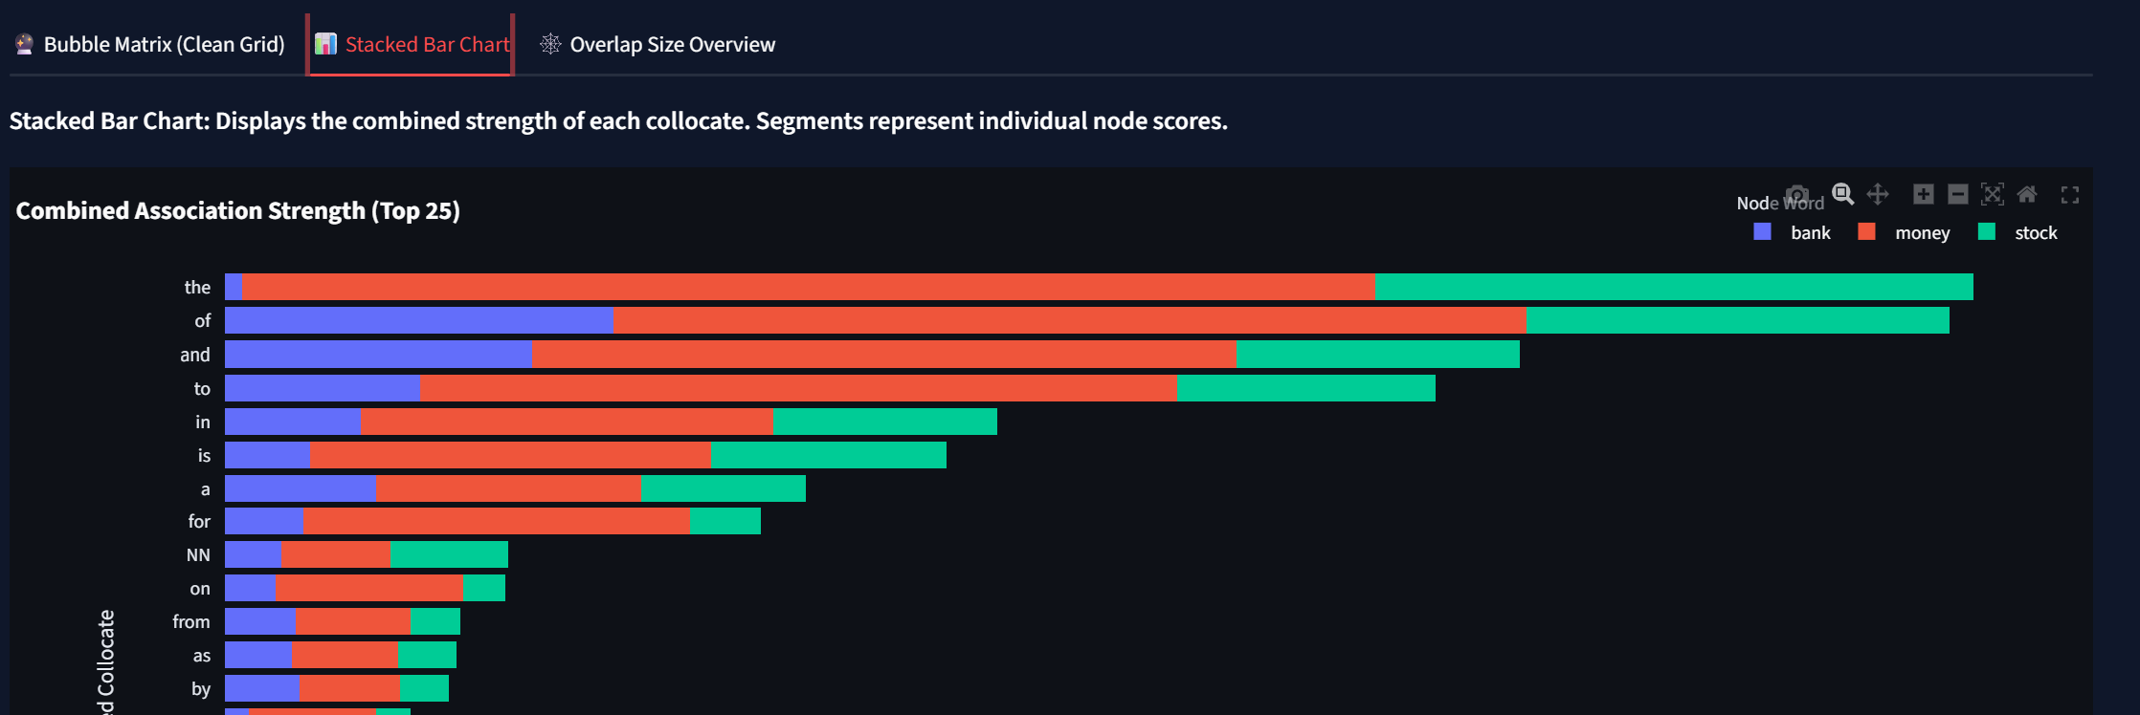
- Overlap Size Overview: Custom HTML horizontal bars mapping shared combinations. Collocate words are displayed directly inside each bar, with their font sizes dynamically scaled based on their combined association strength.
