Keyword Analysis Guide
Keywords are words whose frequency in a target (study) corpus is statistically higher (or lower) than in a reference corpus.
1. Reference Corpus Selection
- Pre-built or Uploaded: Choose one of the tabs. If Pre-Built, select a reference corpus (e.g. BNC or Brown)
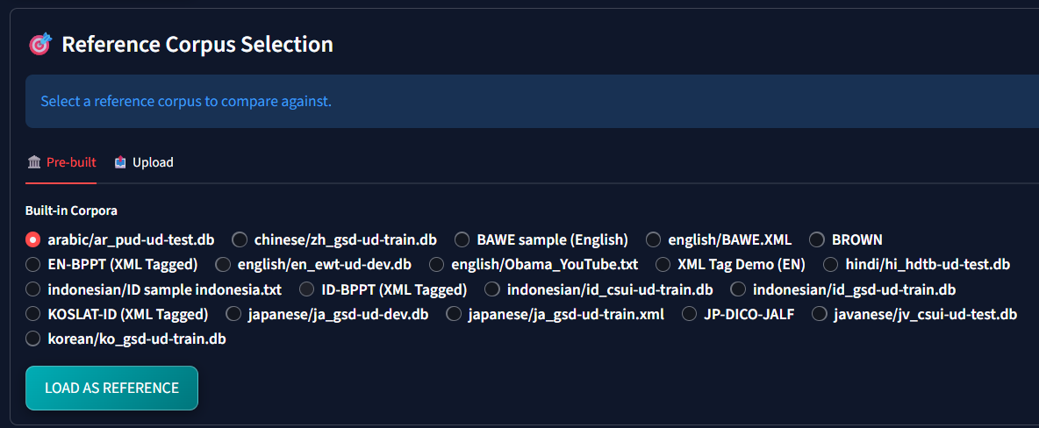
If Upload, upload a custom text/frequency file to serve as the baseline comparison.
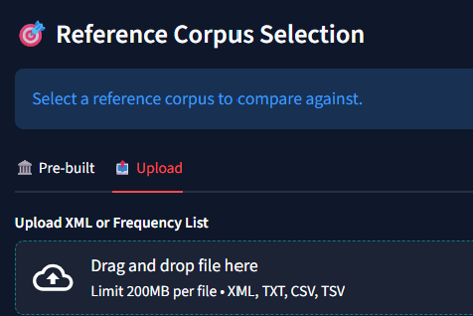
In a frequency file, one line consist of word, followed by space or tab, followed by its frequency. Here is an example
the 54321
and 45678
of 34567
to 23456
in 12345

2. Settings & Analysis Basis
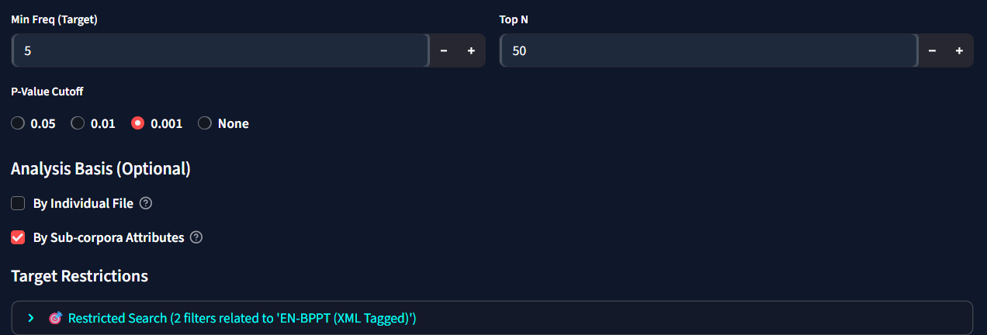
- Min Freq = minimum frequency of occurance, Top N: top N words to display in the visualisation
- P-Value Cutoff: Restrict keywords to those meeting significance thresholds (e.g., 0.01 or 0.05).
- Analysis Basis (Optional):
  - By Individual File: Checked to generate and compare separate keyword lists for every unique file in the study corpus (e.g., creating 4 lists for 4 files).
  - By Sub-corpora Attributes: Checked to generate separate keyword lists for each XML attribute group (e.g. producing lists for every year, genre, or sentiment attribute value).
  - Note: If these options are unchecked, the system calculates and displays only the 1 overall corpus-level keyword list, optimizing performance.
3. Interpretation
- Positive Keywords (High Keyness): Words used significantly more in the target than the reference (reflecting target-specific themes).
- Negative Keywords (Low Keyness): Words used significantly less or completely absent in the target.
- Comparable (stable): words that fail to reach statistically significant difference
