📖Word Profiler User Guide
The Word Profiler analyzes your corpus coverage using pre-defined wordlists (e.g. vocab bands, academic vocabulary lists).
1. Configuration Settings
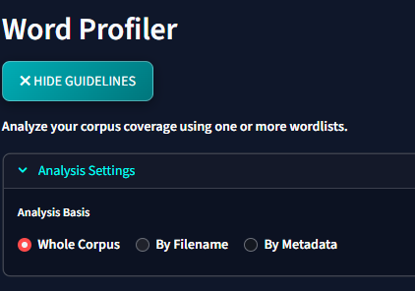
- Analysis Basis: Evaluate vocabulary coverage across:
  - Whole Corpus: Calculate total corpus coverage metrics.
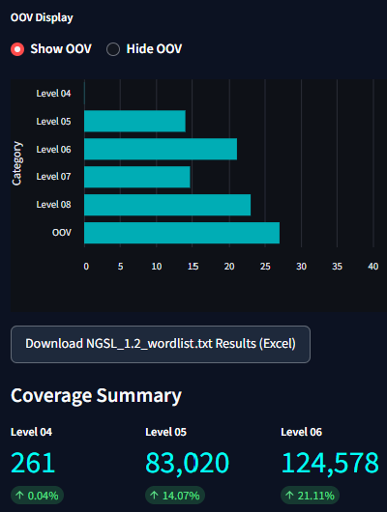
  - By Filename: Compare coverage levels between different files.
  - By Metadata: Segment and compare coverage based on document attributes (e.g. publication year, genre).
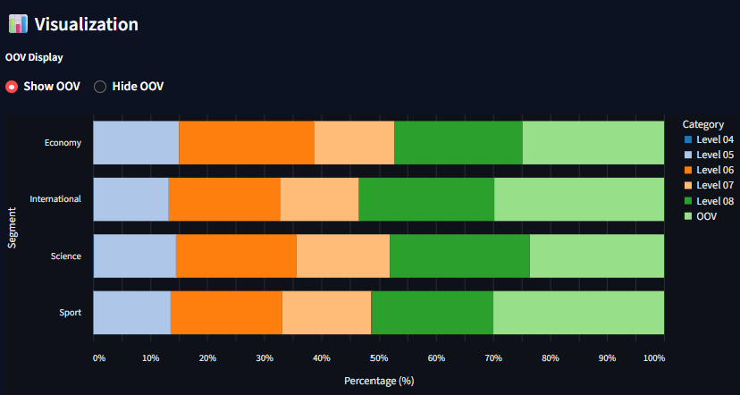
- Filtering: Restrict analysis to specific document cohorts using XML filters.
2. Load Existing Wordlist
Use the existing wordlist if you are happy with one of the current wordlists (tick it).
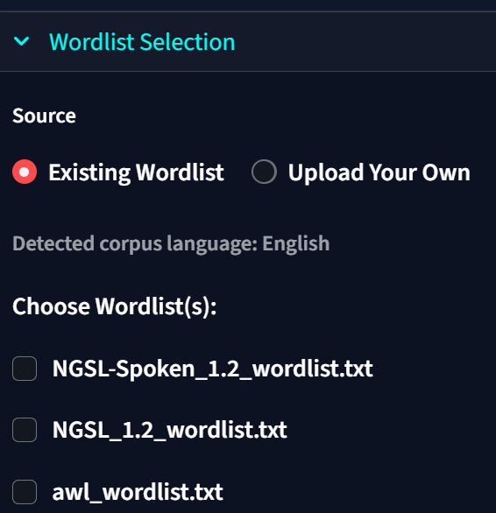
If you are not happy with the wordlist, you can use your own wordlist. Choose Upload your own
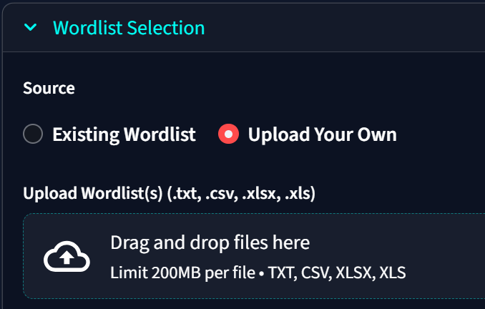
Wordlists can be uploaded or loaded from the following file formats:
- Plain Text (.txt): Tab-separated or single-word per line.
- CSV (.csv): Commas or tabs separated, containing 1 or 2 columns.
- Excel (.xlsx / .xls): Spreadsheet sheets containing 1 or 2 columns.

Layout Formats:
- Plain Wordlist (Single Column):
  - A list where each row contains a single word.
  - All matched words are aggregated under a default category labeled "Coverage".
  - Example:
  - coffee
  - tea
  - milk
- Categorized Wordlist (Two Columns):
  - Row structures where Column 1 contains the word and Column 2 contains the category label.
  - Tab-separated for .txt, comma-separated for .csv, or cells in columns A and B for Excel.
  - Useful for evaluating coverage across custom categories (e.g. GSL/AWL lists, vocabulary bands, or semantic domains).
  - Example:
apples | Fruit
coffee | Beverage
- Three-Column Wordlist (Word, Label, Lemma):
  - Row structures where Column 1 contains the literal word, Column 2 contains the category label, and Column 3 contains the base lemma.
  - Tab-separated for .txt, comma-separated for .csv, or columns A, B, and C for Excel.
  - Both the literal word (Col 1) and its lemma (Col 3) are mapped to the category. This ensures that corpus occurrences match correctly whether they appear as the inflected word or the base lemma (e.g. matching "ran" via its lemma "run").
  - Example:
apples | fruit | apple
coffee | Beverages | coffee
- Note: If the first row contains labels like word, token, lemma, collocate, or category, it will be automatically identified and treated as a header row (skipped during analysis). Any words in your corpus not matching the loaded wordlist will automatically be categorized under OOV (Out of Vocabulary). You can hide OOV if you want
