00 AI Connection Guide
CORTEX integrates advanced AI capabilities. You can choose to connect either to a cloud-based AI (Google Gemini) or a local, privacy-first AI (Ollama). Once connected, you will be able to ask questions via CORTEX assistant, or you can use AI Interpretation button to interpret corpus analysis results.
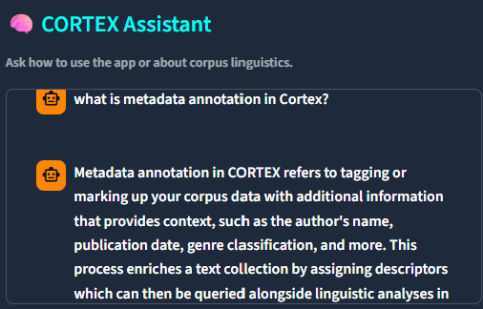

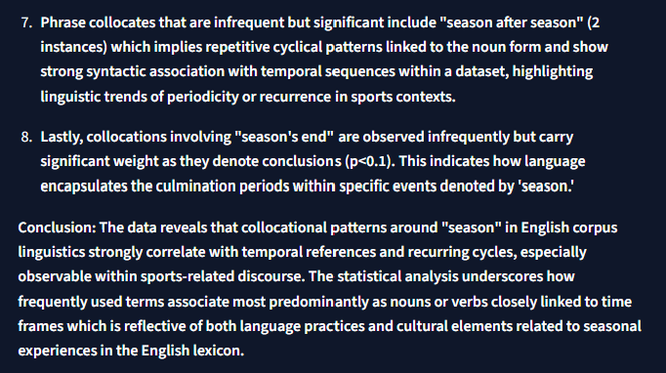

1. Google Gemini (Online Version)
Use Google Gemini if you want a fast, cloud-based AI and do not mind sending queries over the internet.
- Create API Key: Log into your Google account and navigate to Google AI Studio to generate a new Gemini API Key.
- Connect to CORTEX: In the CORTEX settings interface, select "Gemini" as your AI Provider. Enter the API Key you generated, select model, and click connect to authenticate.
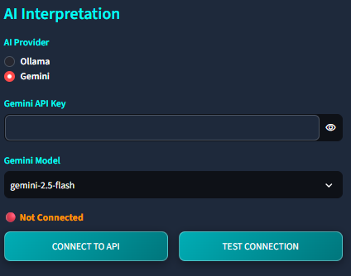

2. Ollama (Local Version)
Use Ollama if you are working with sensitive, proprietary corpora and require 100% offline, privacy-focused AI processing on your own computer.
- Download & Install: Download and install Ollama onto your machine from their official website.
- Select & Pull Model: Open your terminal or command prompt and pull a lightweight model (for example, run `ollama run phi3`). Keep Ollama running in the background.
- Connect to CORTEX: In the CORTEX settings interface, select "Ollama" as your AI Provider. Ensure the local URL (usually http://127.0.0.1:11434/api/generate) and model name are correct, then click connect.
