CORTEX System Manual: Custom Tagger (Advanced)

Use this when you have a pre-annotated corpus and a pre-anntoated lexicon written in TreeTagger format (one word entry per line; entry format = word tab POS-tag tab lemma, and additionally POS-tag lemma pair(s))
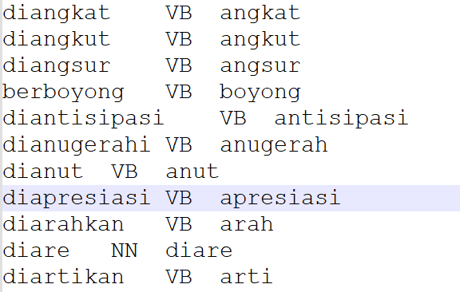

1. Select Tagger Type
- Tagging tool > Custom tagger
- Choose Data Driven (Note: Rule Based is currently under construction).

2. Model Selection
- Load Existing Model: If you already have a trained model generated from CORTEX, you can reuse it by selecting this option.
- Train New Model: If you do not have an existing model, choose this option to train a new one.
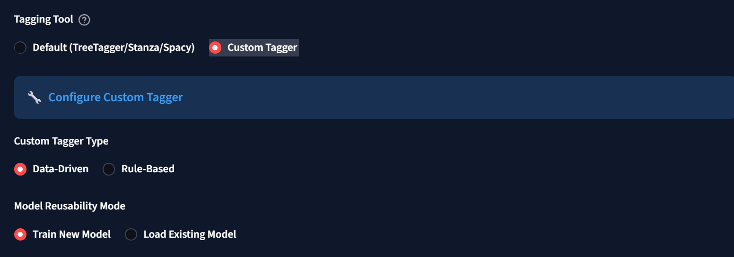

3. Training a New Model

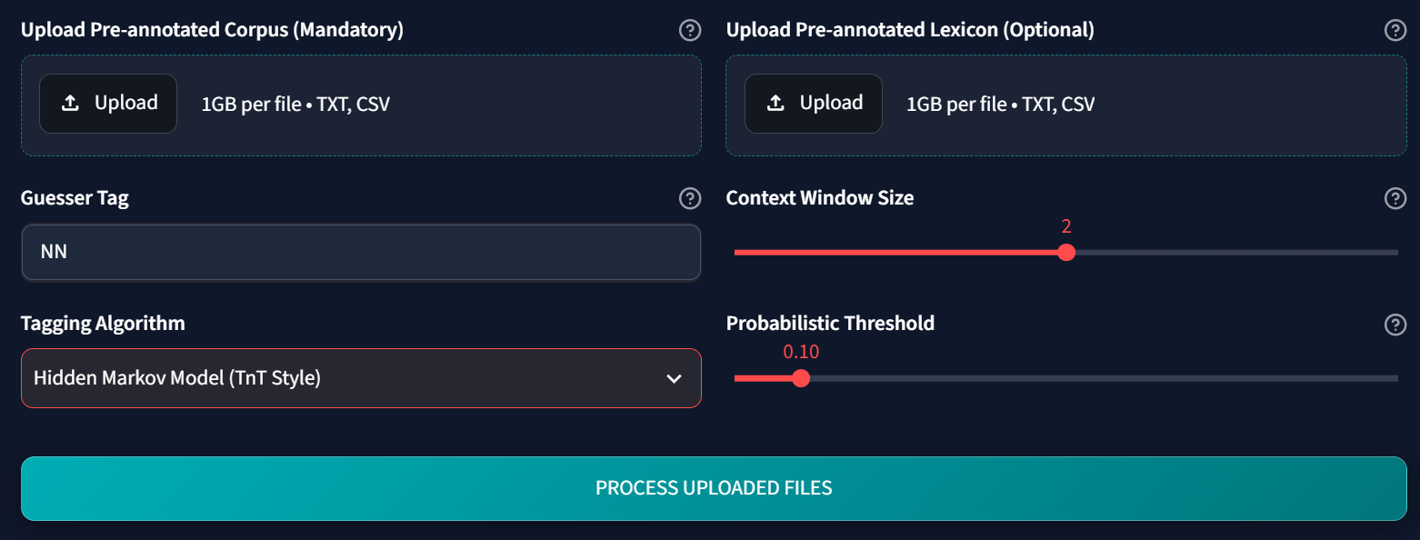
- Upload Files: Upload your pre-annotated corpus and lexicon. Ensure they are in the TreeTagger style format: `word POS lemma`.
- Add Guesser Tag: Define your guesser tag (e.g., `NN`, though you can use anything that fits your tagset).
- Tagging algorithm: Configure the training algorithm and parameters.
  - Note: Hidden Markov Model (HMM) is the fastest algorithm.
  - You can fine-tune the model by playing with the context window and probability threshold.
- Process: Click Process uploaded files.
- Finish: Once indexation is finished, your newly tagged corpus is ready.
- Download Model: You can download the model and reuse it later (no 2: Load existing model).

