Concordance (KWIC) User Guide

A concordance displays occurrences of a query word (the node word) in its immediate context. Here is how to use the Concordance module:

1. Node Word Input
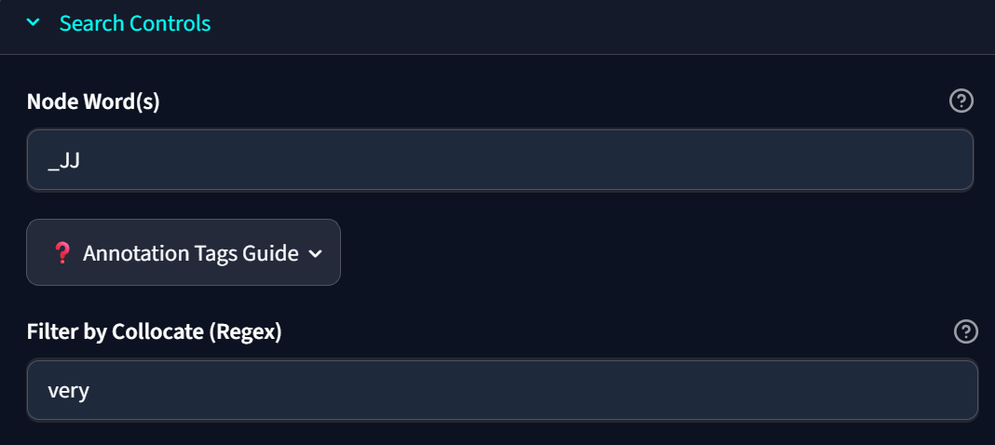
- You can search for direct words, wildcards, lemmas, or specific grammatical patterns:
- Direct Token: Type a literal word (e.g., run or beautiful).
- Wildcard (*): Use * to match prefix, suffix, or parts of words.
- Example: run* matches run, runs, running, runner.
- Example: *ing matches sing, playing, jumping.
- Union Search (|): Use the pipe symbol | to search for multiple strings simultaneously (OR logic).
- Example: can|could|will|would matches any of those literal words.
- Example: [be|have|do] matches all inflected forms of those base lemmas.
- Example: can|could_MD matches those specific words, restricted to the MD part-of-speech tag.
- Lemma Unit: Wrap the base form in square brackets to match all inflected forms.
- Example: [run] matches run, ran, running, runs.
- POS Restricted Tokens: Search for words with specific Part-of-Speech tags.
- Example: light_V* matches light when used as a verb.
- Example: _NN matches any singular noun.

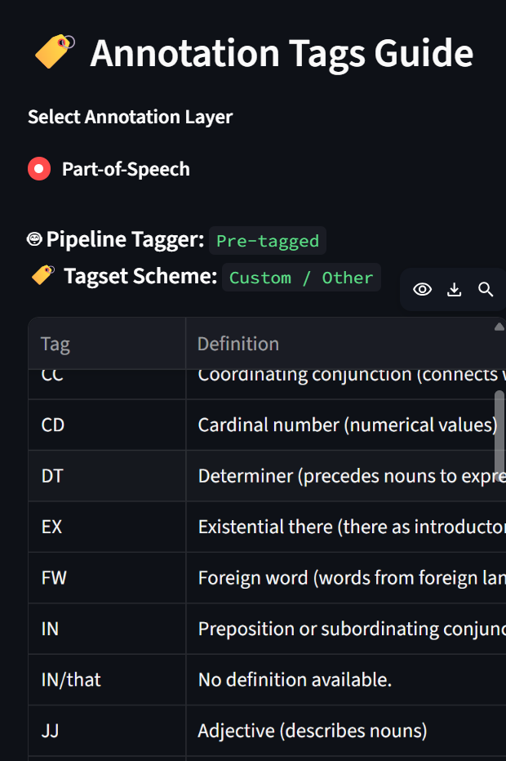

- XML Tags: Match structural XML tags and token-level metadata (like dependency tags) directly.
- Example: <PN type="human"> matches specific XML elements.
- Example: <dep_rel="nsubj"> matches token dependency relations (e.g. nominal subjects).

2. Context Window & Max Lines
- Context Window: Adjusts how many words are retrieved to the left and right of the node word (e.g., 5 words on each side).
- Max Lines: Limits the maximum number of matching rows to return (e.g., 100 lines), ensuring fast responsiveness.
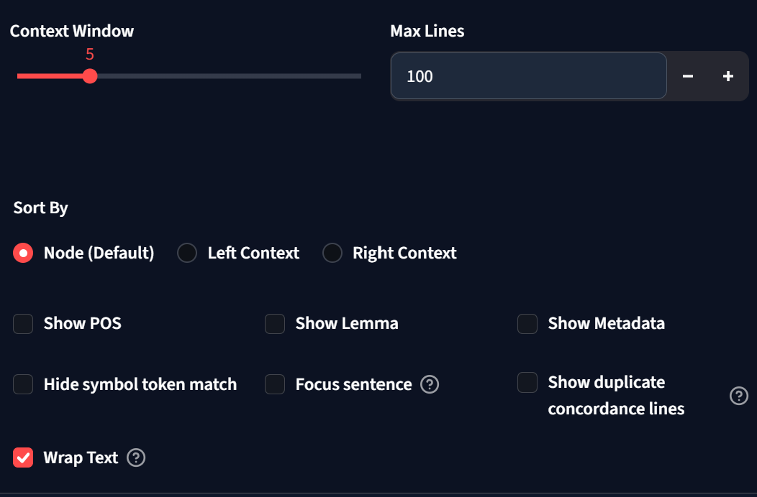

3. Filtering by Collocate (Regex)
- You can use simple word like ‘very’ or extremely’ and see where these words appear in the left or right context
- Apply a Regular Expression filter to narrow down results to only those where a specific pattern exists in the surrounding context.
- Example: \b(very|extremely)\b filters for lines containing either "very" or "extremely" near the node word.
- Example: not filters for lines containing the word "not".

4. Display Checkboxes (POS, Lemma, Metadata)
- Show POS: Appends Part-of-Speech tags to all words in the context windows.
- Show Lemma: Displays the base dictionary form for all words in the context windows.
- Show Metadata: Displays document/corpus metadata (such as Text ID, source, or subcorpus classification) in a column on the left.

5. Restriction and Query Triggering
- If you want, you can restrict searches to certain sub-corpora. Click Restricted search and choose sub-corpora (e.g. Biological sciences and business)
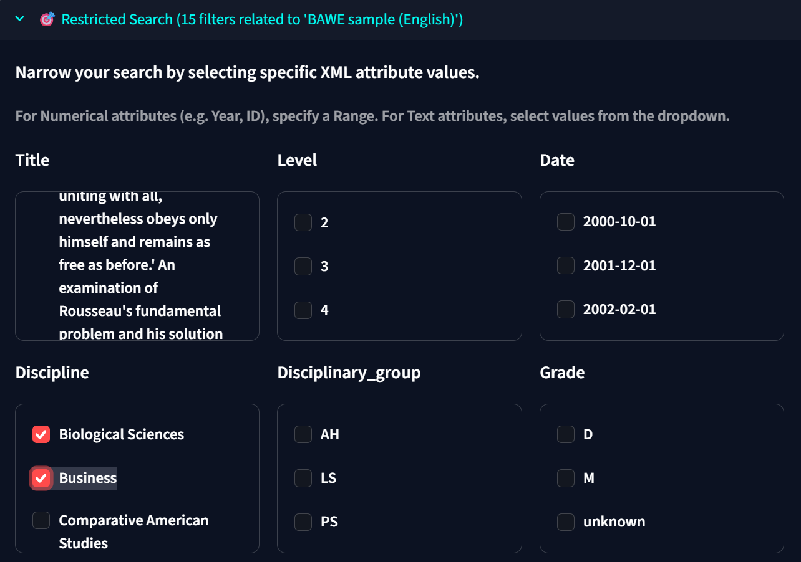
- Once you are satisfied with these controls, click the Generate Concordance Lines (or Generate Concordance) button to run the query and generate the concordance lines.
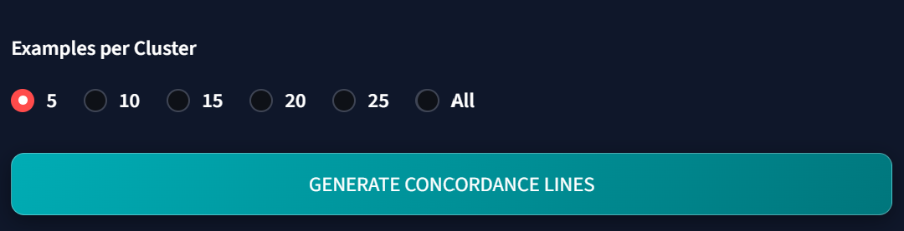

6. Clustering by Sub-corpora (Advanced)
- To cluster the results of concordance lines:
- In the Advanced tab, first restrict searches using the XML Restriction Filters based on sub-corpora present in the corpus.
- Generate your initial concordance lines.
- Select your categorical metadata filters in the restricted search.
- Click 🧩 Cluster Mode to group and sample results based on the selected sub-corpora.
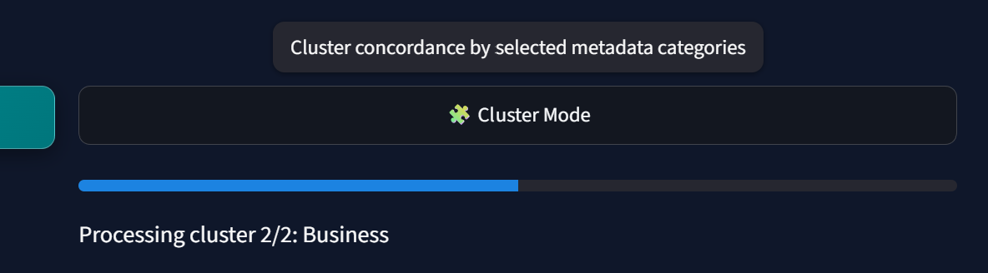
- Example: You can compare and analyze the presence of concordance lines in different combinations, such as negative sentiment vs. positive sentiment, or negative sentiments in the economy section vs. negative sentiments in the sports section.

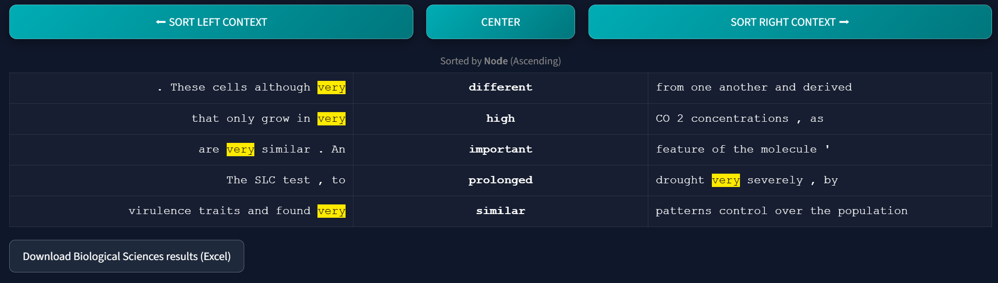

7. Interactive Annotation Mode
- Annotate Lines: Toggle ✍️ Annotation Mode to start annotating the concordance lines. You can tag occurrences with your own invented custom attributes and values.
- Save & Resume: You do not have to complete your annotations all at once. Click 💾 Save Annotation Progress to save your annotations to a JSON file on your machine.
- Upload & Restore: When you are ready to resume, click 📁 Continue Annotation and upload your saved JSON file to instantly restore your annotation progress.
- Index & Retrieve: Once you are happy with the labels, click 🏛️ Apply to Session to index and save these annotations directly into the corpus database. They are then fully retrieved and searchable across other views (like Overview and Restricted Search).

8. Annotation Tags Guide
- In the Search Controls (or Advanced Settings), you can click the ❓ Annotation Tags Guide popover to explore the active tags in your corpus.
- Use the dropdown menu to view definitions and random corpus examples for Part-of-Speech (POS) tags, as well as other annotations you might have added from the Overview module (such as Named Entity Recognition (NER), Dependency Parsing, or Sentiment Analysis).

9. Working with .eaf Corpora (Glossing Style)
When dealing with corpora imported from .eaf (ELAN) files, you can display the concordance lines in a glossing style. Follow these steps:
1. Choose sentence display: Ensure that your display mode is set to show sentences.
2. Set up annotation tier: Configure the tiers so that the annotations match your imported structure.
3. Sentence-level translation: Make sure that the translation tier is aligned at the sentence level.
4. Word-level alignment: Other tiers (such as gloss or POS) are ideally aligned at the word level.
5. Searching attributes: To search within specific tiers, use the syntax <attribute="value">.
For example, if the attribute for your gloss tier is 'gloss' and you want to search for a value 'ACT', type:
<gloss="ACT">
If you are in doubt about the exact position or want a partial match, use regex:
<gloss=".*ACT.*">

