SVKM's NMIMS
Mukesh Patel School of Technology Management & Engineering
A.Y. 2025 – 26

Course: Database Management Systems
Project Report

Program | B.Tech Computer Science & Business Systems
Semester | Semester IV
Project Title | PawHome Pet Adoption System
Date of Submission | 08.04.2026

Project Members
Batch | Roll No. | Name
B2 | 42 | Prisha Mistry
B2 | 57 | Daneeka Roy
B2 | 58 | Harshvardhan Sahi

GITHUB LINK : https://github.com/priisha26/PETADOPTION.git

Contribution of Each Project Member

Roll No. | Name | Contribution
B-042 | Prisha Mistry | Frontend, Readme file, final project report, SQL
B-057 | Daneeka Roy | designing schema and relationship of Database, ER diagram, SQL
B-058 | Harshvardhan Sahi | designing schema and relationship of Database, ER diagram, SQL

Submission Notes
- Create a readme file if you have multiple files.
- All files must be properly named (Example: R004_DBMSProject).
- Submit all relevant files of your work (Report, all SQL files, any other files).
- Plagiarism is highly discouraged — your report will be checked for plagiarism.

Rubrics for Project Evaluation

Phase | Marks
First Phase: Innovative Ideas (5 Marks) + Design and Partial Implementation (5 Marks) | 10 Marks
Final Phase: Implementation, Presentation & Viva, Self-Learning and Learning Beyond Classroom | 10 Marks

DBMS Project Report
PawHome Pet Adoption System

Prisha Mistry, B042 · Daneeka Roy, B057· Harshvardhan Sahi, B058

Course: DBMS · A.Y. 2025–26

Table of Contents

Sr. No. | Topic | Page No.
I | Problem Statement | 5
II | Components of Database Design | 6
III | Entity Relationship Diagram | 9
IV | Relational Model | 11
V | Normalization | 14
VI | SQL Queries | 15
VII | Project Demonstration | 22
VIII | Self-Learning Beyond Classroom | 24
IX | Learning from the Project | 25
X | Challenges Faced | 26
XI | Conclusion | 28

I. Problem Statement
Animal shelters face significant challenges in managing records of pets available for adoption, tracking adopter information, and maintaining the overall adoption workflow. Traditional manual or semi-digital systems are inefficient, error-prone, and lack scalability. These systems make it difficult to:
- Maintain updated and structured records of pets
- Efficiently search and filter pets
- Track adoption applications and their status
- Ensure secure and consistent user data storage
- Provide real-time updates to users
In addition to adoption management, shelters also face challenges in managing financial data such as donations, medical expenses, and operational costs associated with pet care. Lack of structured financial tracking leads to poor resource allocation and reduced transparency.
The PawHome Pet Adoption System is designed as a database-driven solution that integrates adoption management with financial tracking. The system provides:
- Structured database storage
- Interactive frontend interface
- Automated adoption tracking
- Financial data management (donations, expenses, medical costs)
- Analytical insights using SQL queries
The goal of the system is to simplify adoption workflows, improve accessibility, ensure data integrity, and enable shelters to make data-driven decisions.

II. Components of Database Design
Database design consists of several structured components that define how data is stored, retrieved, and managed efficiently.

1. Entities
The system consists of the following entities:
- USER – stores adopter information
- PET – stores pet details
- SHELTER – stores shelter information
- ADOPTION_REQUEST – tracks adoption applications
- FAVORITES – stores user wishlist data
- DONATION – tracks user donations
- MEDICAL_RECORD – stores pet treatment details
- EXPENSE – tracks operational costs for pets

2. Attributes
Each entity consists of specific attributes:

USER Entity
- user_id (Primary Key)
- full_name
- email (Unique)
- phone
- housing_type
- experience_level

PET Entity
- pet_id (Primary Key)
- name
- species
- breed
- age
- gender
- vaccinated
- urgent_status
- shelter_id (Foreign Key)
These attributes correspond directly to pet data displayed in the pet cards and modal views.

ADOPTION_REQUEST Entity
- request_id (Primary Key)
- user_id (Foreign Key)
- pet_id (Foreign Key)
- request_date
- status
This corresponds to the application form submission feature.

FAVORITES Entity
- favorite_id (Primary Key)
- user_id (Foreign Key)
- pet_id (Foreign Key)
Used when users mark pets as favorites using the heart icon.

SHELTER Entity
- shelter_id
- shelter_name
- location
- contact_number

DONATION Entity
- donation_id (Primary Key)
- user_id (Foreign Key)
- amount
- donation_type
- donation_date

MEDICAL_RECORD Entity
- record_id (Primary Key)
- pet_id (Foreign Key)
- treatment
- doctor_name
- cost
- treatment_date

EXPENSE Entity
- expense_id (Primary Key)
- pet_id (Foreign Key)
- category
- amount
- expense_date

3. Constraints
Constraints maintain data accuracy:
- Primary Key constraints ensure uniqueness of records
- Foreign Key constraints maintain referential integrity
- NOT NULL constraints enforce mandatory fields
- UNIQUE constraint prevents duplicate user emails
- CHECK constraints ensure valid values (e.g., age ≥ 0, amount > 0)

III. Entity Relationship Diagram

Entities & their roles:
- USER represents adopters interacting with the system
- PET represents animals available for adoption
- SHELTER represents organizations listing pets
- ADOPTION_REQUEST connects users and pets
- FAVORITES stores wishlist data
- DONATION tracks financial contributions
- MEDICAL_RECORD stores treatment history
- EXPENSE tracks operational costs

Relationships:
- USER → ADOPTION_REQUEST ← PET
(Many-to-Many relationship resolved using ADOPTION_REQUEST)
- USER → FAVORITES ← PET
(Many-to-Many relationship for wishlist functionality)
- SHELTER → PET
(One-to-Many: one shelter manages multiple pets)
- USER → DONATION
(One-to-Many: one user can make multiple donations)
- PET → MEDICAL_RECORD
(One-to-Many: one pet can have multiple medical records)
- PET → EXPENSE
(One-to-Many: one pet can have multiple expenses)

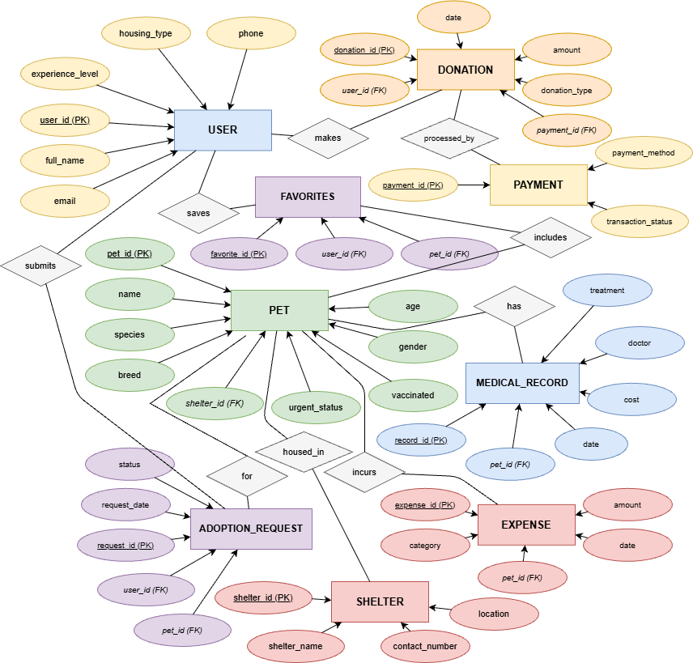

IV. Relational Model

USER Table
USER(
user_id INT PRIMARY KEY,
full_name VARCHAR(100),
email VARCHAR(100) UNIQUE,
phone VARCHAR(15),
housing_type VARCHAR(50),
experience_level VARCHAR(50)
)

PET Table
PET(
pet_id INT PRIMARY KEY,
name VARCHAR(50),
species VARCHAR(50),
breed VARCHAR(50),
age INT,
gender VARCHAR(10),
vaccinated BOOLEAN,
urgent_status BOOLEAN,
shelter_id INT,
FOREIGN KEY (shelter_id)
REFERENCES SHELTER(shelter_id)
)

ADOPTION_REQUEST Table
ADOPTION_REQUEST(
request_id INT PRIMARY KEY,
user_id INT,
pet_id INT,
request_date DATE,
status VARCHAR(20),
FOREIGN KEY(user_id)
REFERENCES USER(user_id),
FOREIGN KEY(pet_id)
REFERENCES PET(pet_id)
)

FAVORITES Table
FAVORITES(
favorite_id INT PRIMARY KEY,
user_id INT,
pet_id INT,
FOREIGN KEY(user_id)
REFERENCES USER(user_id),
FOREIGN KEY(pet_id)
REFERENCES PET(pet_id)
)

SHELTER Table
SHELTER(
shelter_id INT PRIMARY KEY,
shelter_name VARCHAR(100),
location VARCHAR(100),
contact_number VARCHAR(15)
)

DONATION Table

DONATION(
donation_id INT PRIMARY KEY,
user_id INT,
amount DECIMAL(10,2),
donation_type VARCHAR(50),
donation_date DATE,
FOREIGN KEY(user_id) REFERENCES USER(user_id)
)

MEDICAL_RECORD Table
MEDICAL_RECORD(
record_id INT PRIMARY KEY,
pet_id INT,
treatment VARCHAR(100),
doctor_name VARCHAR(100),
cost DECIMAL(10,2),
treatment_date DATE,
FOREIGN KEY(pet_id) REFERENCES PET(pet_id)
)

EXPENSE Table
EXPENSE(
expense_id INT PRIMARY KEY,
pet_id INT,
category VARCHAR(50),
amount DECIMAL(10,2),
expense_date DATE,
FOREIGN KEY(pet_id) REFERENCES PET(pet_id)
)

V. Normalization
Normalization is performed (1NF, 2NF, 3NF, BCNF) for the entire database to eliminate redundancy and ensure data integrity. The database is normalized to ensure minimal redundancy and maximum data integrity.

First Normal Form (1NF)

All attributes are atomic

No repeating groups

Second Normal Form (2NF)

No partial dependencies

Separate tables for USER, PET, SHELTER

Third Normal Form (3NF)

No transitive dependencies

Independent tables for financial and operational data

Result

The database is normalized up to Third Normal Form (3NF) and supports scalable operational and financial data management.

VI. SQL Queries

Database Initialization
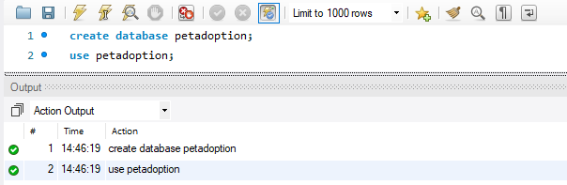

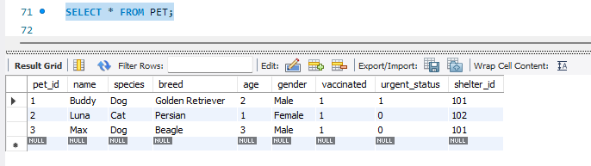

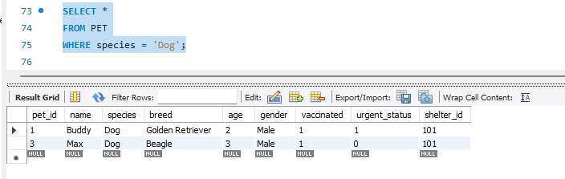

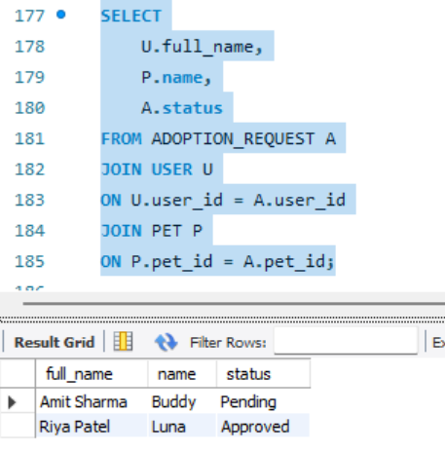

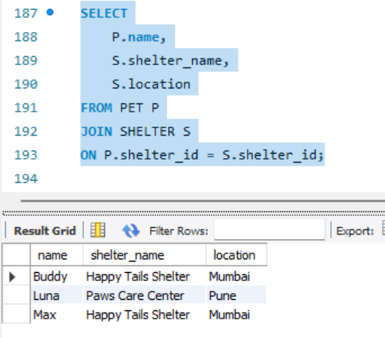

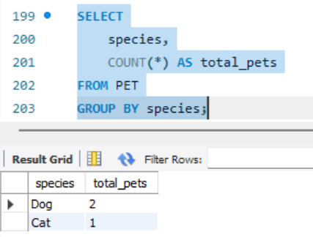
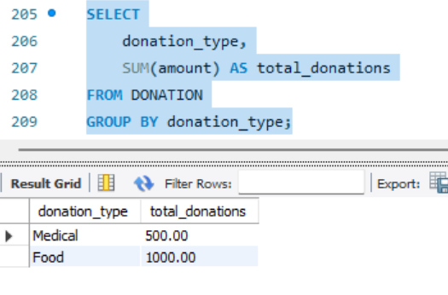
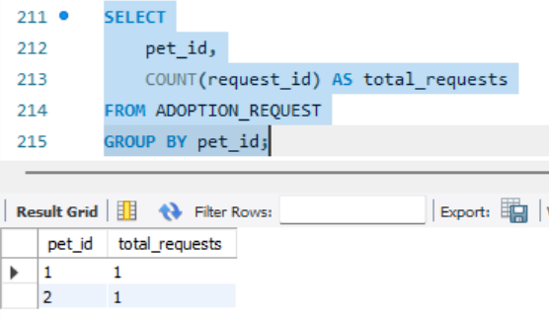

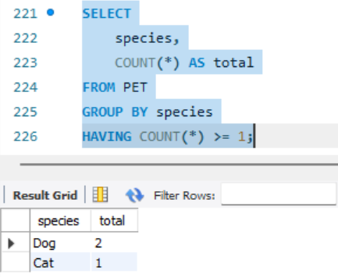

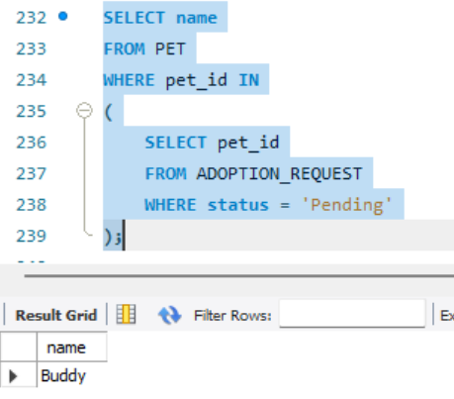

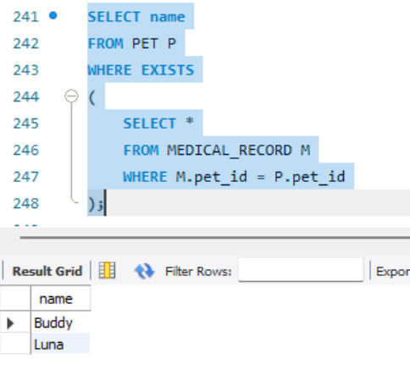

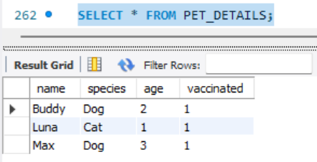

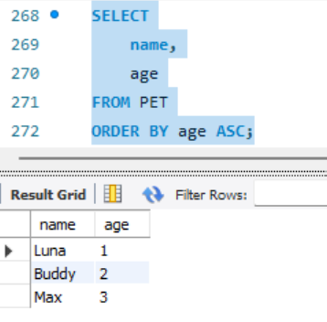

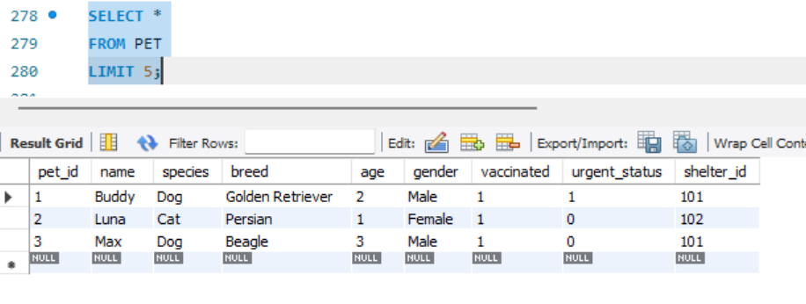

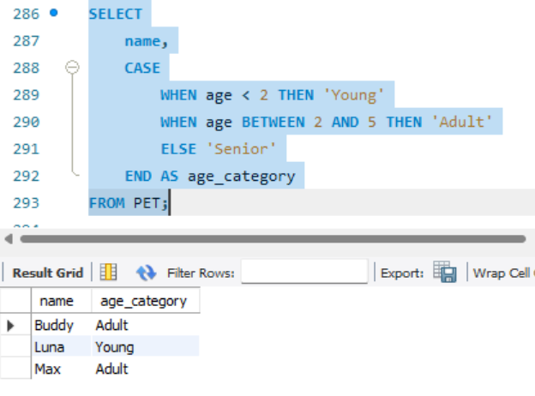

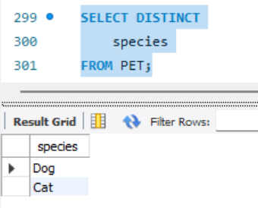

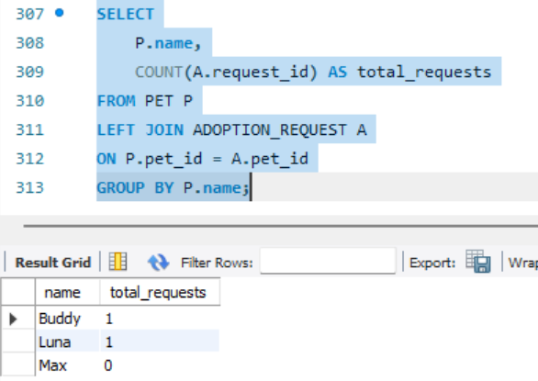

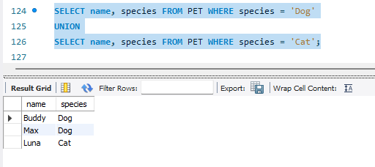

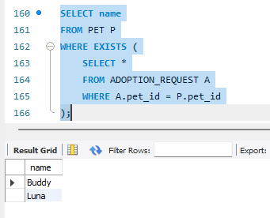

VII. Project Demonstration

Tools / Software Used
- MySQL Workbench — database creation and query execution
- Draw.io — ER diagram design
- HTML — basic frontend representation

Demonstration Description
The project demonstrates an interactive web interface integrated with database logic.

Key Demonstrated Features
1. Pet Browsing System
Users can view pets displayed in a card-based layout showing:
- Pet name
- Breed
- Age
- Gender
- Personality tags

2. Dynamic Search and Filtering
Users can filter pets based on:
- Species
- Age
- Breed
This is implemented using JavaScript filtering logic that dynamically updates results.

3. Favorite Pet Functionality
Users can:
- Click heart icon
- Add pets to favorites
- Store selections

4. Pet Details Modal
Detailed pet information is displayed in a modal window.
Includes:
- Vaccination status
- Personality traits
- Age
- Gender

5. Adoption Application Form
Users submit:
- Name
- Email
- Phone
- Housing Type
- Experience
- Reason for Adoption

6. Application Status Dashboard
Displays:
- Pet applied for
- Application date
- Status (Pending / Approved / Rejected)

Additional Features
- Donation tracking system
- Expense tracking per pet
- Medical history management
- Adoption analytics using SQL queries
- Financial insights (total donations, expenses)

VIII. Self-Learning Beyond Classroom
During the development of this project, we explored several concepts beyond what was covered in regular classroom lectures. While the syllabus provided a strong theoretical foundation, practical implementation required us to understand how these concepts function in real-world database environments.

One of the key areas of self-learning was gaining a deeper understanding of foreign key constraints and referential integrity. While performing operations such as deletion and updates, we encountered errors due to dependent records. This helped us understand how parent-child relationships are maintained in relational databases and the importance of handling such operations carefully. We also explored cascading operations and strategies for maintaining consistency across related tables.

Another important aspect was understanding the practical differences between various types of joins. Although joins were covered theoretically, implementing INNER JOIN, LEFT JOIN, and simulating FULL OUTER JOIN in MySQL allowed us to understand how data is retrieved from multiple tables in real-world scenarios.

We also learned advanced SQL concepts such as triggers and stored procedures. Triggers helped us automate database actions based on certain events, such as updating pet status after an adoption is approved. Stored procedures were used to perform analytical operations like calculating total donations, improving both efficiency and modularity of queries.

Additionally, we gained exposure to query optimization techniques, including the use of indexing and writing efficient queries using aggregation and subqueries. This helped improve performance and ensured faster data retrieval, especially as the database became more complex.
A significant extension of our learning was the integration of financial database concepts. By incorporating entities such as donations, medical records, and expenses, we understood how databases can be used not only for data storage but also for financial tracking and analysis in real-world systems.

Beyond SQL, we explored how databases interact with user interfaces. We developed a basic frontend using HTML, CSS, and JavaScript to visualize how stored data can be presented to users. This helped us understand the role of backend databases in supporting frontend applications and delivering dynamic content.

Overall, this project encouraged us to go beyond theoretical knowledge and gain practical exposure to database design, optimization, automation, and real-world application development.

IX. Learning from the Project
The project provided practical understanding of database design and implementation.

Key learning outcomes:
- Designing relational database schema
- Understanding entity relationships
- Implementing normalization techniques
- Writing structured SQL queries
- Creating interactive web interfaces
- Managing real-time data interactions
- Designing user-friendly dashboards
- Understanding financial database integration
- Applying advanced SQL concepts
- Designing scalable systems
This project improved:
- Logical thinking
- Database modeling skills
- Frontend development knowledge
- Problem-solving ability

Purpose of Using DBMS
The use of DBMS in this system provides several advantages:
- Structured Data Storage
All adoption, user, and financial data is stored in an organized format.
- Data Integrity
Constraints ensure accurate and consistent relationships.
- Financial Management
The system tracks donations, expenses, and medical costs.
- Analytical Capabilities
SQL queries provide insights such as:
  - Total donations received
  - Cost incurred per pet
  - Adoption trends
- Scalability
The system can handle increasing data efficiently.
- Real-Time Data Retrieval
Queries allow fast and accurate data access.

X. Challenges Faced
Several technical, design, and implementation challenges were encountered during the development of the system.

1. Designing Efficient Relationships
Ensuring correct mapping between multiple entities such as:
- Users
- Pets
- Adoption Requests
- Donations
- Medical Records
- Expenses
required careful schema design. Integrating financial and operational entities while maintaining referential integrity increased the complexity of relationships.

2. Integrating Financial Data into the Existing System
Extending the system to include financial components such as donations, medical costs, and expenses required restructuring of the database. Ensuring proper linkage between pets and their associated costs while avoiding redundancy was a key challenge.

3. Implementing Advanced SQL Features
Incorporating advanced SQL concepts such as:
- Triggers
- Stored Procedures
- Views
- Complex joins and subqueries
required a deeper understanding of database behavior and execution flow, especially in automation and analytical queries.

4. Maintaining Data Consistency and Integrity
Avoiding duplicate and inconsistent records required the implementation of:
- Primary key constraints
- Foreign key constraints
- Unique constraints
- Check constraints
Ensuring consistency across multiple related tables was critical, particularly with financial data.

5. Query Optimization and Performance
As the database grew with additional entities, writing efficient queries became important. Techniques such as indexing and optimized joins were required to ensure faster data retrieval and better performance.

6. Implementing Dynamic Frontend Features
Handling multiple filters and user interactions on the frontend required:
- Logical condition handling
- Efficient DOM manipulation
Ensuring smooth interaction between user inputs and displayed results was challenging.

7. Form Validation and User Input Handling
Ensuring that user inputs were accurate and complete required implementing validation rules to prevent incorrect or incomplete data entry.

8. User Interface Responsiveness
Designing a responsive interface that worked across different devices required the use of:
- Media queries
- Flexible layout structures
Maintaining usability and consistency across screen sizes was an important consideration.

XI. Conclusion
The PawHome Pet Adoption System demonstrates a comprehensive implementation of database management concepts by integrating adoption management with financial tracking.
The system provides:
- Efficient storage of operational and financial data
- Interactive user experience
- Structured adoption workflow
- Analytical insights for decision-making
By combining database design, SQL operations, and frontend interaction, the project simulates a real-world scalable system for animal shelters.

