(Johnson & Finn, 2017)

1. Poor usability detracts from everyone's user experience.
2. Poor usability *tends* (…) to affect older adults *more often* and *more seriously* than it affects younger people.
3. Other groups who experience usability issues similar to older adults include people with low tech literacy, second language learners, people with low general literacy, and those with low vision or other impairments.
4. By specifically designing digital user interfaces with these individuals' usability issues in mind, we can improve the user experience for *many* people.

The World Health Organization (WHO) reports that life expectancy increased by 5 years from 2000 to 2015. In 2015, global life expectancy was 73.8 years for females and 69.1 years for males [[WHO, 2016](http://viewer.books24x7.com/assetviewer.aspx?bkid=127987&destid=810#810)]. As a result, the numbers and percentages of older people in national populations have also grown. And they are continuing to grow.

Usability studies sometimes directly examine the performance differences between older and younger participants. Compared to younger participants, older ones *tend to*:

* take longer to learn new applications or devices;
* take longer to complete tasks;
* use different search strategies;
* perform worse on tasks relying on memory;
* be more distractible;
* have a harder time dealing with errors;
* make more erratic or accidental movements with the pointer;
* make more input errors;
* have more trouble hitting on-screen targets.

On the plus side, older study participants *tend* to have better vocabularies and can draw from more real-world knowledge and experiences. Perhaps because they *tend* to be less impulsive and more risk-averse, they often use fewer mouse clicks to complete a task

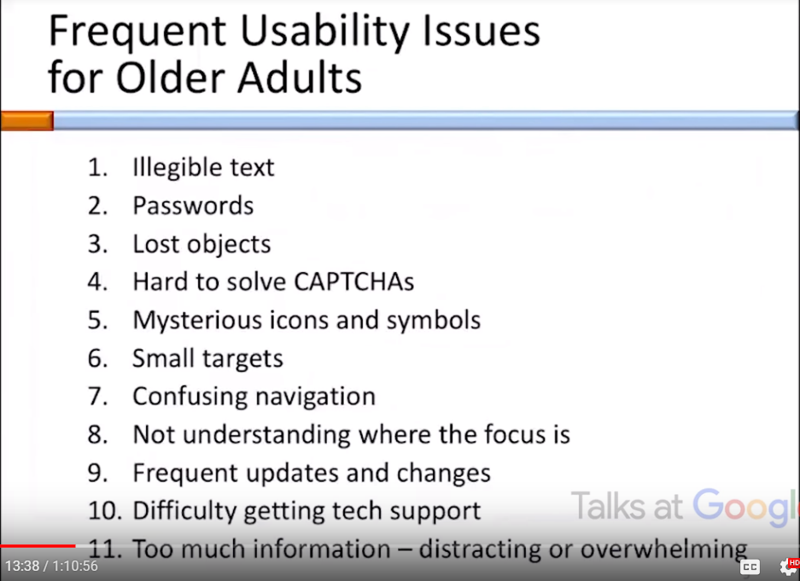 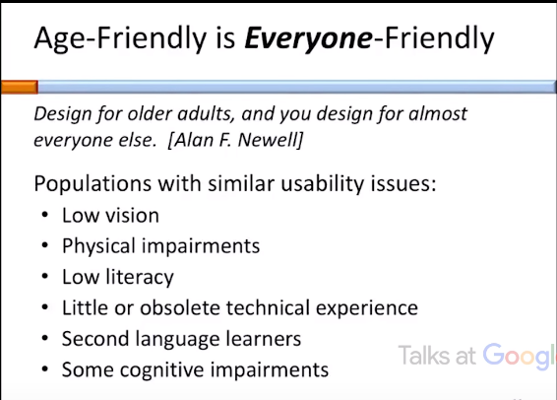 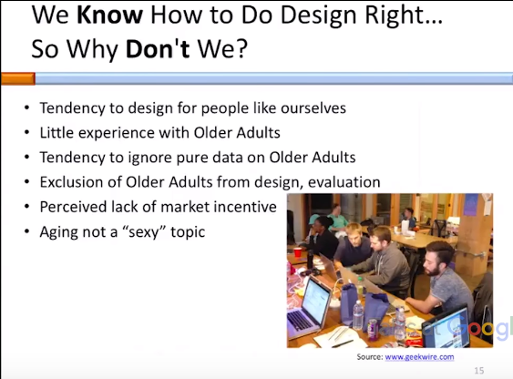 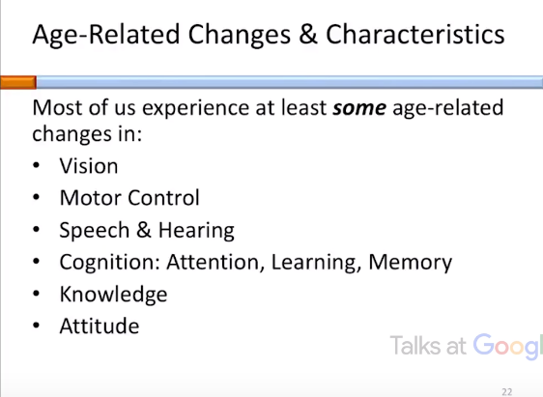 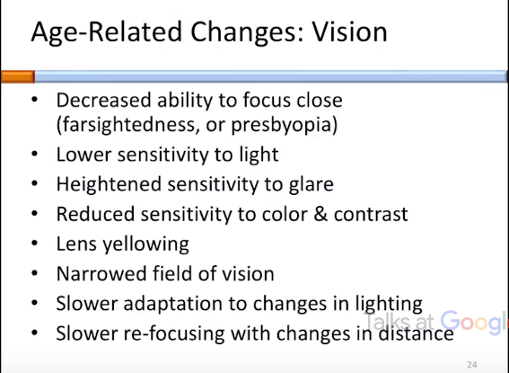

Visual design guide lines:

Avoid tiny text, increase text size – have a bar to increase text size

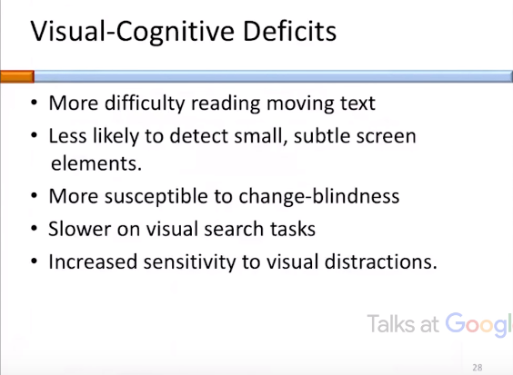 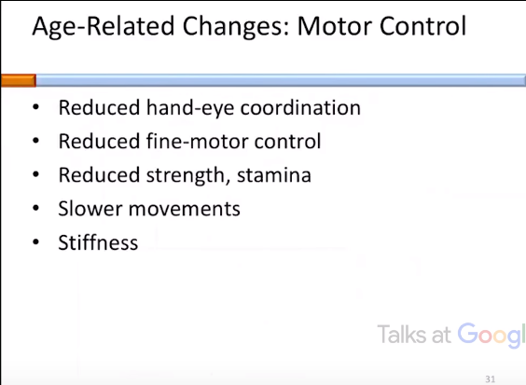 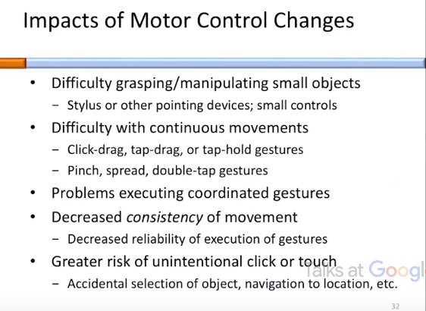 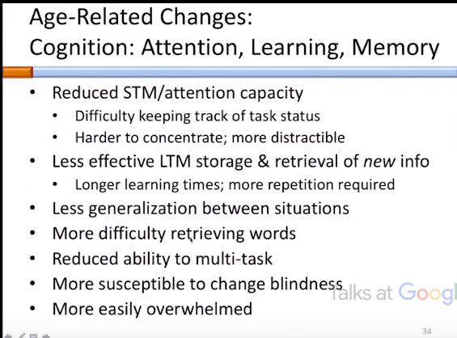

Cognitive Guidelines:

Focus Attention on important info & calls to action

Knowledge guidelines:

Use vocabulary familiar to your audience

Include older adults (>50) in development

Emotional relief with voice interaction as aging often leads to social isolation

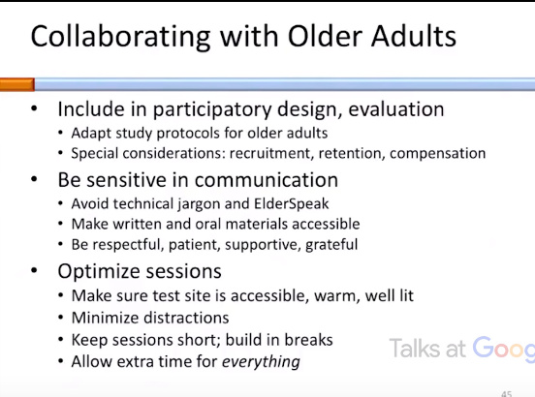 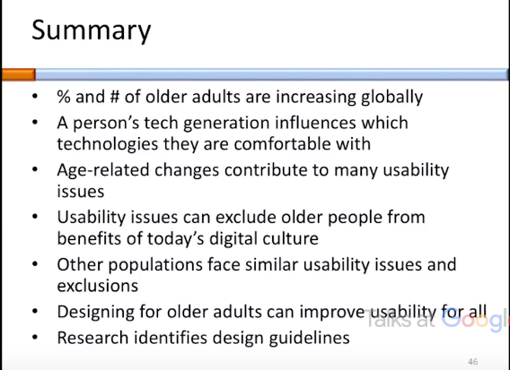

# Related work

Stash2Go – works by syncing with your Ravelry account – access patterns, talk in forums, look for yarn stores

StashBot – knitting calculator, calculates yarnage

StitchMastery

|  |  |
| --- | --- |
| Pros | Cons |
| Chart – very easy to use, simultaneously outputs written instruction when making changes on chart | Require prior knowledge of chart size |
| Extensive stitch library, well organized and easy to use | Not intuitive |
| Selected stitches are saved beside the chart for easy access and can be edited | Text – Written text input does not seem to correlate with chart |
| Stitches can be dragged across the row to apply to multiple boxes | Chart – size cannot be changed after creation |
| Adopted by design company Knitty | Hard to select stitches to repeat, repeating pattern not clear |
| Can view outline and zoom in different parts of chart | Layout similar to JDK workspace |
|  | No tutorial or pattern database |
|  | 60 euros |

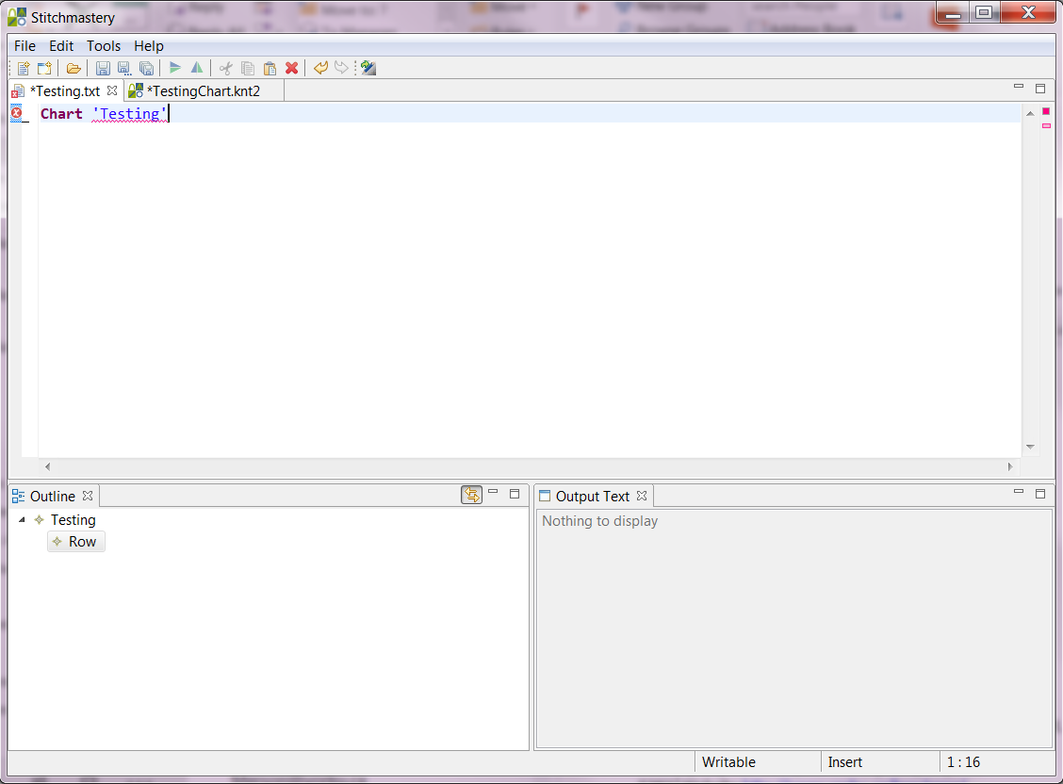

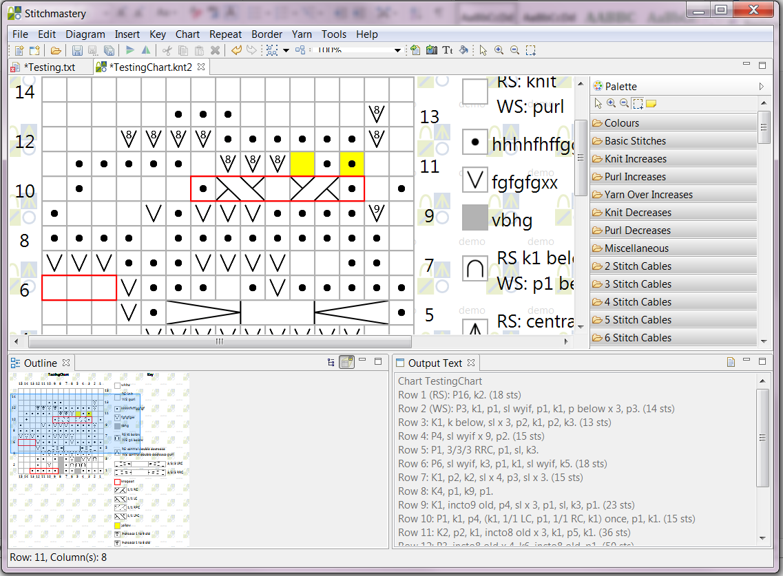 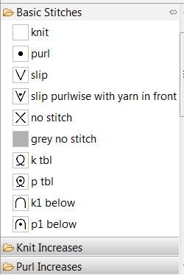

Marking Things

|  |  |
| --- | --- |
| Pros | Cons |
| All patterns are accessible | Database does not compete with Ravelry |
| Clean and easy navigation system | slow |
| Interactive patterns with digital tools for highlighting, counting rows and stitches | Patterns not downloadable or printable |
| 24/7 online help | Monthly subscription is expensive as it takes knitters months or years to finish some projects |