Lang smith Assignment
Token usage and Latency for three prompts(2 runs)
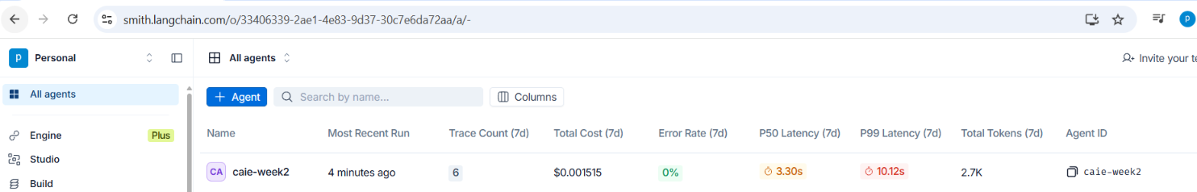

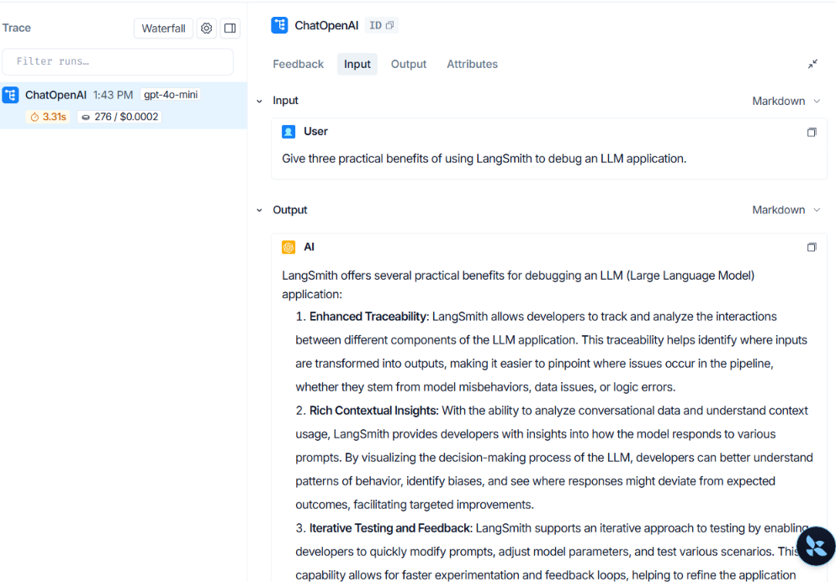

Response for Prompts:
--- Run 1 ---
Prompt: Explain LangSmith tracing in one sentence.
Answer:
LangSmith tracing is a method used in machine learning to systematically track and analyze the interactions and relationships between various components in a language model's outputs, aiding in debugging and improving model performance.

--- Run 2 ---
Prompt: Give three practical benefits of using LangSmith to debug an LLM application.
Answer:
LangSmith offers several practical benefits for debugging an LLM (Large Language Model) application:

1. **Enhanced Traceability**: LangSmith allows developers to track and analyze the interactions between different components of the LLM application. This traceability helps identify where inputs are transformed into outputs, making it easier to pinpoint where issues occur in the pipeline, whether they stem from model misbehaviors, data issues, or logic errors.

2. **Rich Contextual Insights**: With the ability to analyze conversational data and understand context usage, LangSmith provides developers with insights into how the model responds to various prompts. By visualizing the decision-making process of the LLM, developers can better understand patterns of behavior, identify biases, and see where responses might deviate from expected outcomes, facilitating targeted improvements.

3. **Iterative Testing and Feedback**: LangSmith supports an iterative approach to testing by enabling developers to quickly modify prompts, adjust model parameters, and test various scenarios. This capability allows for faster experimentation and feedback loops, helping to refine the application based on actual performance metrics and user interactions, ultimately enhancing the reliability and user experience of the LLM application.

These benefits collectively contribute to a more efficient debugging process, leading to improved performance and user satisfaction with LLM applications.

--- Run 3 ---
Prompt: Analyze the following scenario: an AI customer-support application uses an LLM to answer questions about refunds, shipping, and returns. Explain five possible causes of inaccurate answers, propose a debugging plan using traces, and recommend metrics for evaluating improvements. Present your answer with headings and concrete examples.
Answer:
# Analysis of Inaccurate Answers in AI Customer-Support Application

The use of a Large Language Model (LLM) for answering customer queries in an AI customer-support application can lead to inaccuracies for various reasons. Below are five possible causes of these inaccuracies:

## Possible Causes of Inaccurate Answers

### 1. Lack of Context
An LLM may not fully understand the context of the conversation. For example, if a customer asks about a refund after already receiving an answer on shipping, the model might fail to connect the dots and provide an irrelevant answer.

### 2. Ambiguity in Queries
Customers often phrase their questions ambiguously. For instance, a question like, "Can I return it?" could refer to a product that is damaged, defective, or simply unwanted. The model's inability to interpret ambiguities can lead to inaccurate answers.

### 3. Variability in Language
Different customers may use various terminologies or synonyms to describe similar issues. For example, a customer might say “dispute a charge” while another might say “challenge a payment.” The model may not recognize these terms as interchangeable unless it has been adequately trained on diverse datasets.

### 4. Insufficient Training Data
The LLM might not be sufficiently trained on specific company policies or the latest updates regarding refunds, shipping, and returns. If recent policy changes have not been integrated into the training data, the model could provide outdated or incorrect information.

### 5. Errors during Preprocessing
Data preprocessing errors, including tokenization or noise in the training dataset, could lead to the model misinterpreting user inputs or context. For instance, if abbreviations, shorthand, or special characters are not handled correctly, the model could struggle to derive the intended meaning.

# Debugging Plan Using Traces

To systematically address the causes of inaccurate answers, the following debugging plan focused on tracing information flows is recommended:

### Step 1: Query Logging
Capture all incoming customer queries along with the model's responses. For example, log queries such as, "What’s the status of my return request?" and the corresponding answers provided by the model.

### Step 2: Contextual Tracing
Create tracing to identify the flow of conversation context. Tie follow-ups back to previous queries. For instance, if the customer previously mentioned an order number, ensure this is retained and used in subsequent queries.

### Step 3: Review of Ambiguous Queries
Compile a list of ambiguous queries and the answers generated by the model. This step will help identify common phrases that lead to confusion. For example, collect instances of phrases similar to “Can I change my order?” and review the responses generated for consistency and accuracy.

### Step 4: Evaluate Training Data
Perform an audit of the training dataset to identify gaps in information about policy or recent changes. Look for low coverage areas where customer questions may skew. For example, if refund policies were just updated but the training set consists of prior versions.

### Step 5: Performance Monitoring
Implement continuous performance tracking to analyze changes in the accuracy of answers over time. For instance, if the model sees an uptick in correct responses after retraining, this indicates progress.

# Metrics for Evaluating Improvements

To assess the improvements made through the debugging plan, consider adopting the following metrics:

### 1. Accuracy Rate
Measure the proportion of correct answers provided by the LLM over a set period. For example, track the percentage of queries marked as accurate versus total queries answered over a month.

### 2. Response Time
Track the average time taken by the model to generate a response. A lower response time with maintained accuracy may indicate increased efficiency and satisfaction.

### 3. Customer Satisfaction Score (CSAT)
Through user feedback forms after interactions, gauge customer satisfaction levels. A CSAT score above a certain threshold indicates successful model improvement.

### 4. Resolution Rate
Measure the percentage of conversations that resolve customer issues without the need for human intervention. A higher resolution rate signifies a more effective model.

### 5. Error Rate Analysis
Identify and categorize the types of errors made by the model. This could include broken down categories of context loss, misunderstanding of ambiguity, or outdated information. Monitoring these types will guide further refinement efforts.

By executing this structured debugging plan and employing these metrics, organizations can systematically improve the accuracy of their AI customer-support application while enhancing the overall user experience.

