**SCREENSHOTS**

Mails triggered for unregistered

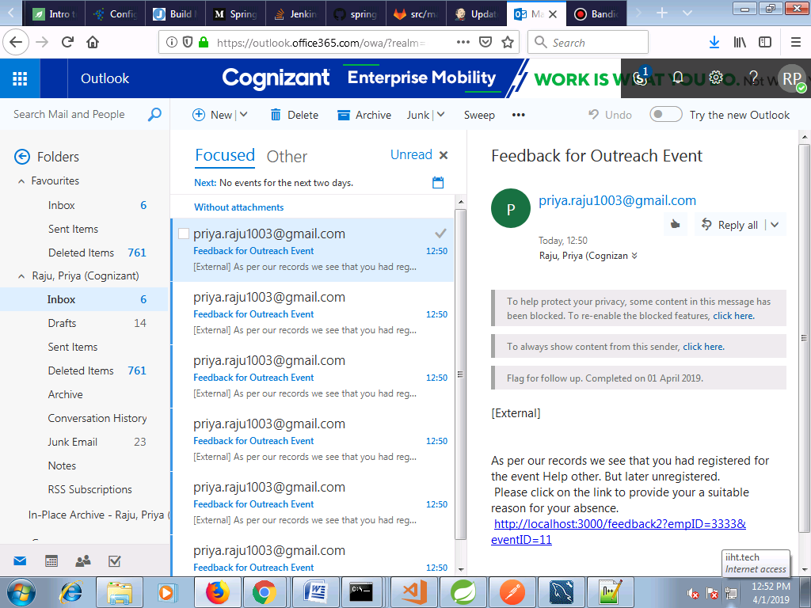

Feedback req email for volunteers who attended

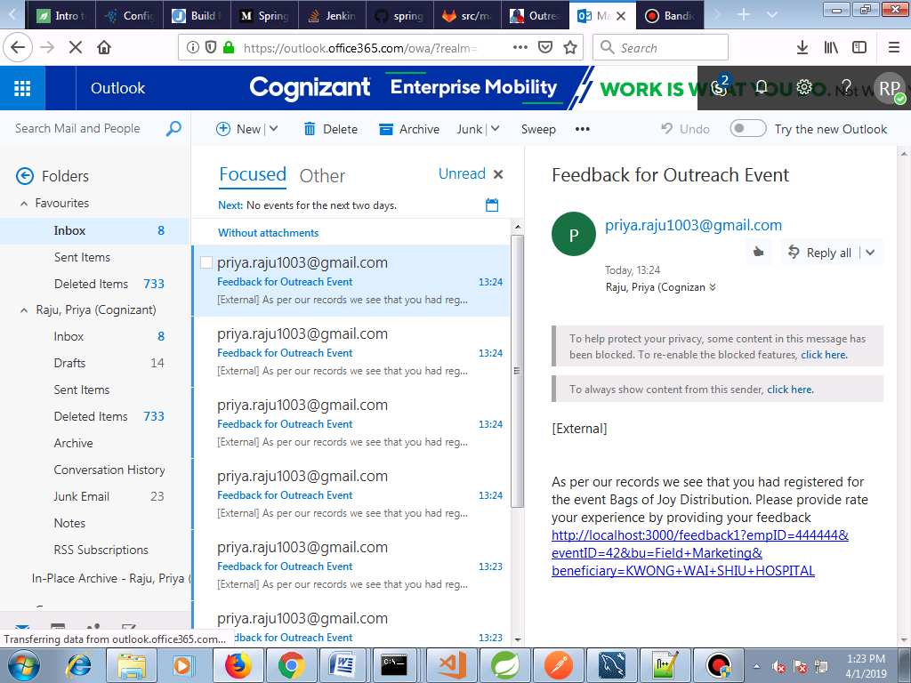

Login

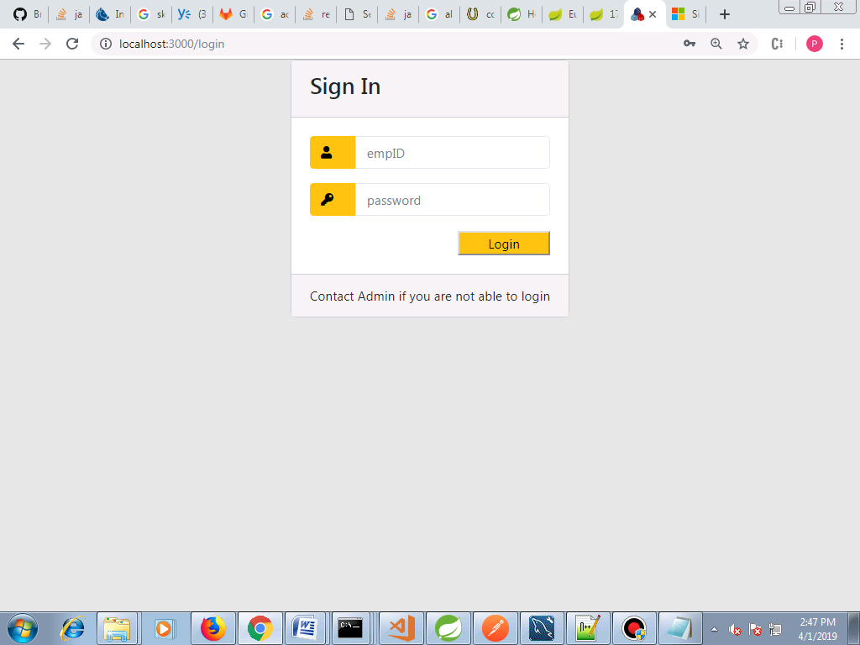

**Dashboard**

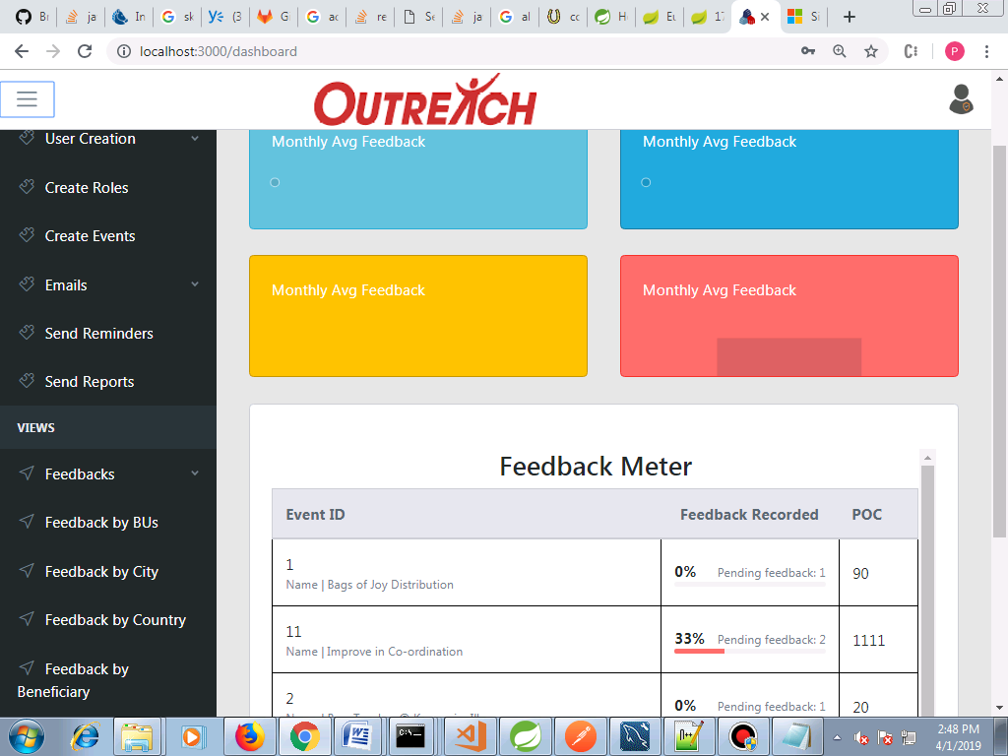

**Monthly avg feedback** shown based on the avg. feedback computed as per the associctes' inputs.

**Feedback meter** shows the number of associates yet to give feedback for variuos events with the respective POC

**Create Role**

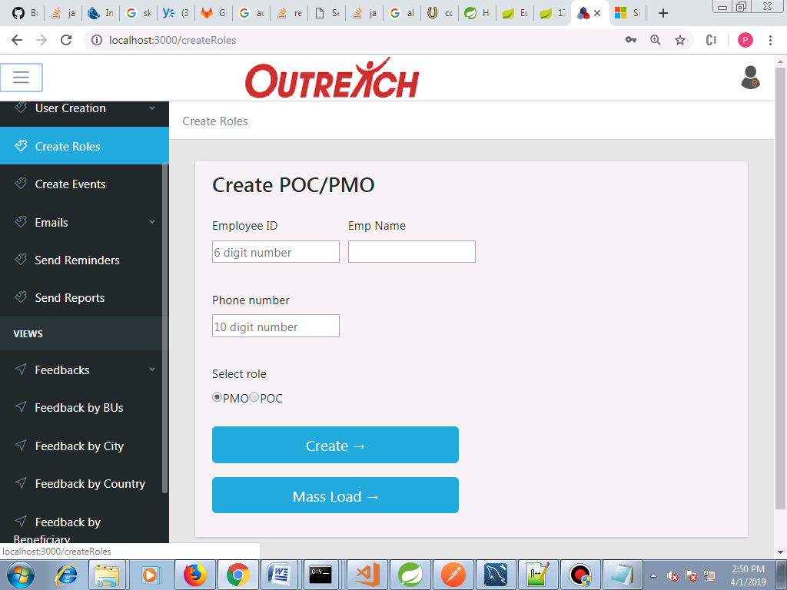

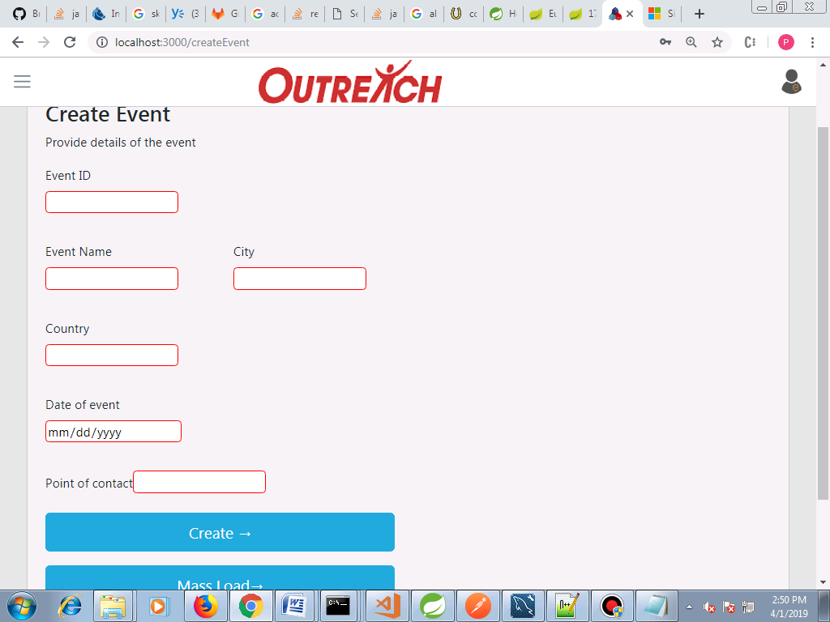

**Reminder email**

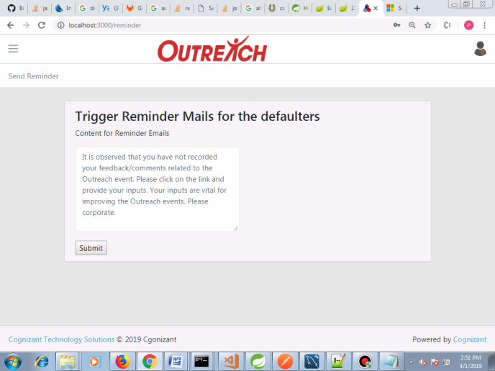

**Acknowledgement for associates who gave feedback**

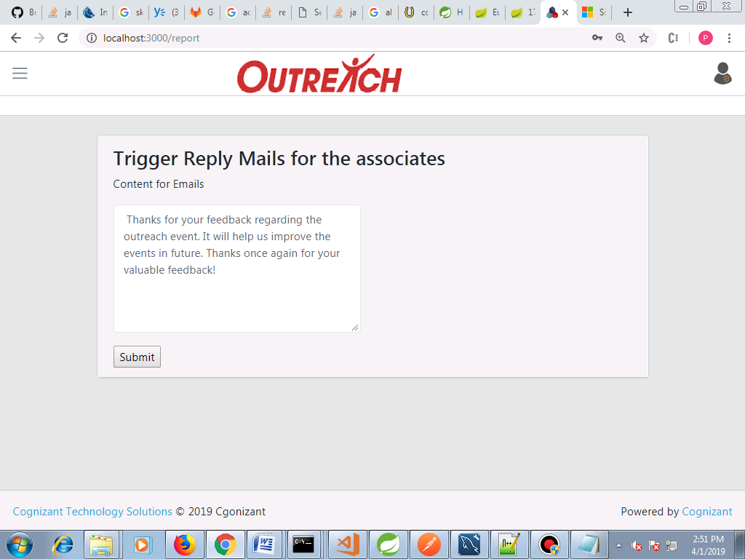

**Avg Feedbck by BU**

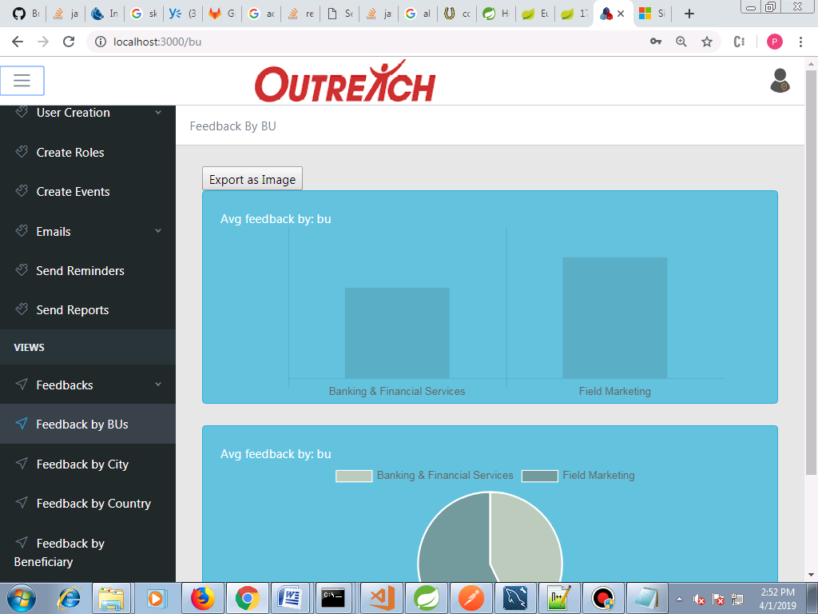

**Avg feedback by City**

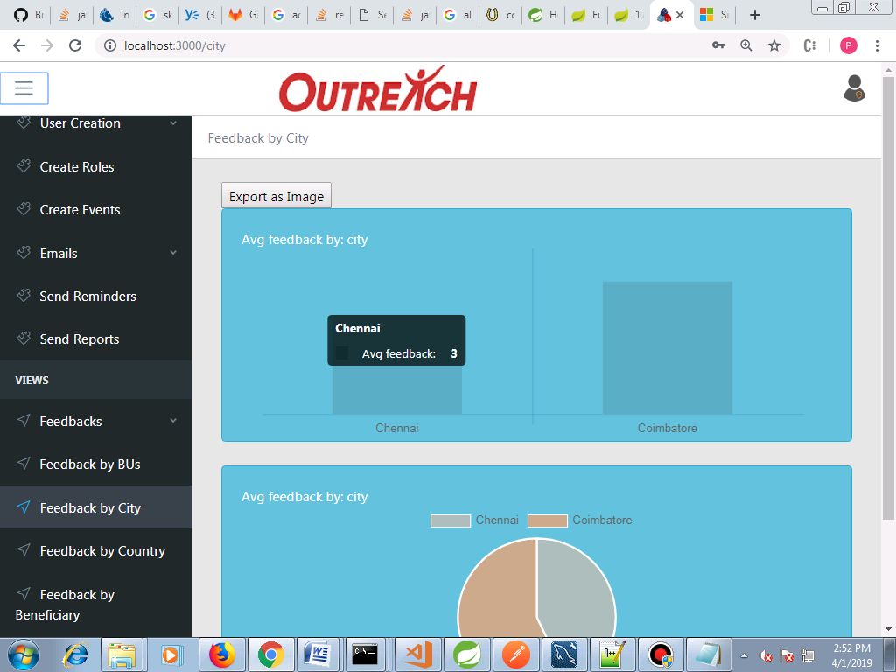

**Feedback by Country**

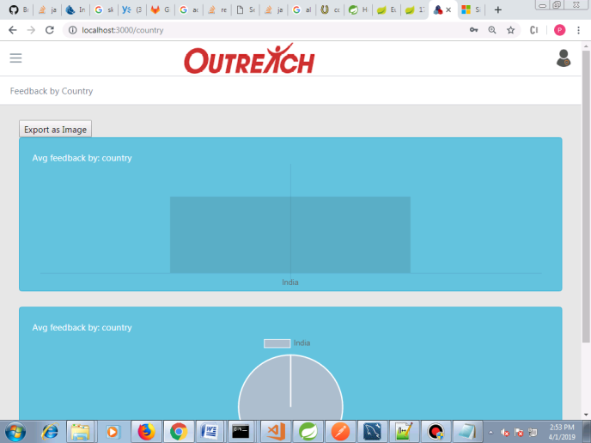

**Feedback by beneficairy**

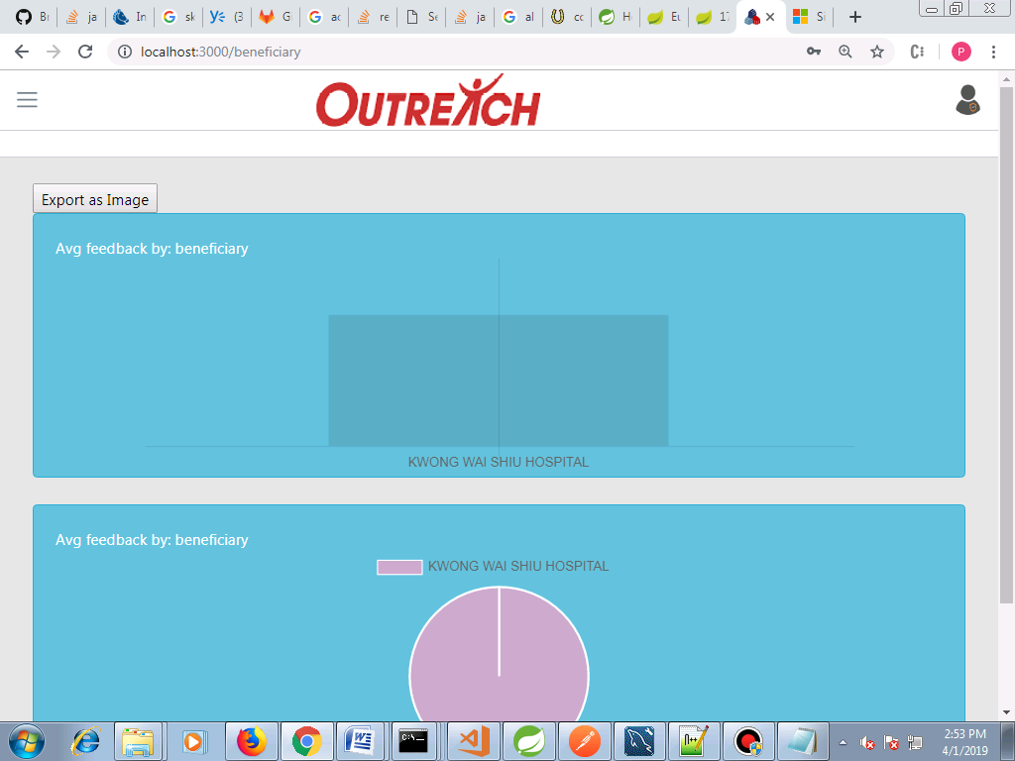

**Download feedback reports**

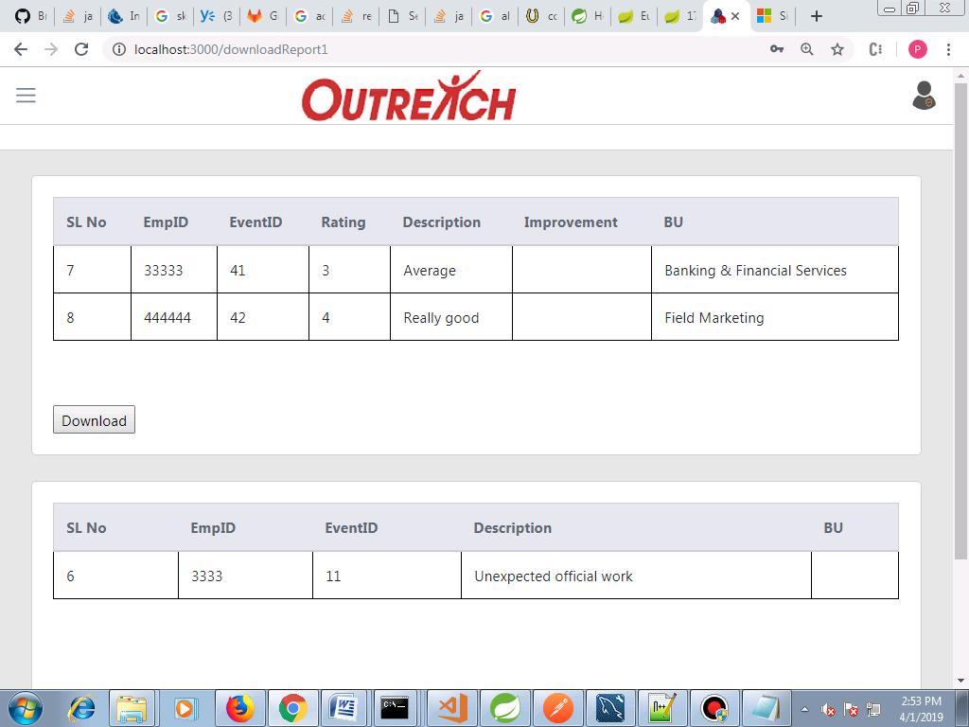

**Feedback Forms**

