Name : Gandhi , Pritesh

Assignment 1

1. Get full details of all jobs in London.

Query :

SELECT *

FROM JOB

WHERE CITY='London';

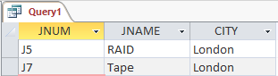Result :

D:\MS\Assignments\Game Development\Ass1\q1.PNG

Cardinality :

1. Get supplier numbers for suppliers who ship to job J1.

Query :

SELECT SNUM

FROM SHIPMENT

WHERE JNUM='J1';

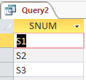Result :

D:\MS\Assignments\Game Development\Ass1\q2.PNG

Cardinality :

1. Get all shipments where the quantity is in the range 300 to 750, inclusive.

Query:

SELECT *

FROM SHIPMENT

WHERE QTY >= 300 AND QTY<= 750;

Result :

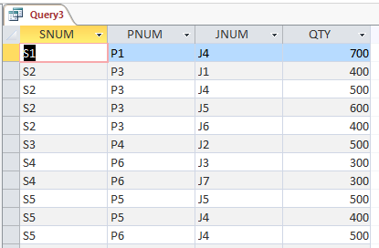

D:\MS\Assignments\Game Development\Ass1\q3.PNGCardinality :

1. Get all part-color/part-city combinations.

Query :

SELECT DISTINCT PART_COLOR.COLOR, PART_CITY.CITY

FROM PART AS PART_COLOR, PART AS PART_CITY;

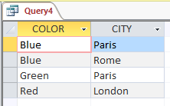 Result :

D:\MS\Assignments\DBMS\Ass1\SNAPS\q4.PNG

Cardinality :

1. Get all supplier-number/part-number/job-number triples such that the indicated supplier, part and job are all co-located.

Query :

SELECT DISTINCT S.SNUM, P.PNUM, J.JNUM

FROM SUPPLIER AS S, PART AS P, JOB AS J

WHERE S.CITY=P.CITY

AND P.CITY=J.CITY;

Result :

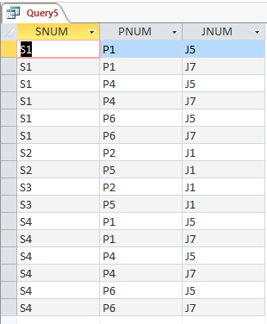

Cardinality :



1. Get all supplier-number/part-number/job-number triples such that the indicated supplier, part and job are not all co-located.

Query :

SELECT DISTINCT S.SNUM, P.PNUM, J.JNUM

FROM SUPPLIER AS S, PART AS P, JOB AS J

WHERE S.CITY<>P.CITY

OR J.CITY<>P.CITY;

Cardinality : D:\MS\Assignments\Game Development\Ass1\Query6.PNG

1. Get all supplier-number/part-number/job-number triples such that no two of the indicated supplier, part and job are co-located.

Query :

SELECT DISTINCT S.SNUM, P.PNUM, J.JNUM

FROM SUPPLIER AS S, PART AS P, JOB AS J

WHERE S.CITY<>P.CITY

AND P.CITY<>J.CITY

AND S.CITY<>J.CITY;

D:\MS\Assignments\Game Development\Ass1\Query7.PNG Cardinality :

1. Get part numbers for parts shipped by a supplier in London.

Query :

SELECT DISTINCT SP.PNUM

FROM SHIPMENT AS SP, SUPPLIER AS S

WHERE SP.SNUM=S.SNUM

AND S.CITY='London';

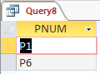Result :

D:\MS\Assignments\Game Development\Ass1\q8.PNG

Cardinality :

1. Get part numbers for parts shipped by a supplier in London to a job in London.

Query :

SELECT DISTINCT SP.PNUM

FROM SHIPMENT AS SP, JOB AS J, SUPPLIER AS S

WHERE SP.SNUM=S.SNUM

AND SP.JNUM=J.JNUM

AND J.CITY='London'

AND S.CITY='London';

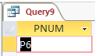 Result :

Cardinality : D:\MS\Assignments\Game Development\Ass1\q9.PNG

1. Get all pairs of city names such that a supplier in the first city ships to a job in the second city.

Query :

SELECT DISTINCT S.CITY, J.CITY

FROM SHIPMENT AS SP, SUPPLIER AS S, JOB AS J

WHERE SP.SNUM=S.SNUM

AND J.JNUM=SP.JNUM;

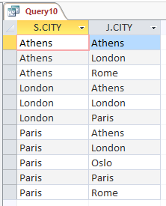 Result :

D:\MS\Assignments\Game Development\Ass1\q10.PNG

Cardinality :