**Lab 2**

**Name : Gandhi , Pritesh**

11. Get part numbers for parts shipped to any job by a supplier in the same city as that job.

Query:

SELECT DISTINCT SP.PNUM

FROM SHIPMENT AS SP, SUPPLIER AS S, JOB AS J

WHERE SP.SNUM=S.SNUM

AND SP.JNUM=J.JNUM

AND S.CITY=J.CITY;

Result:

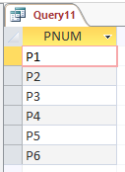

C:\Users\Pritz\AppData\Local\Microsoft\Windows\INetCache\Content.Word\q11.pngCardinality:

12. Get job numbers for jobs that receive shipment(s) from at least one supplier not in the same city as that job.

Query:

SELECT DISTINCT J.JNUM

FROM JOB AS J, SHIPMENT AS SP, SUPPLIER AS S

WHERE J.JNUM=SP.JNUM

AND S.SNUM=SP.SNUM

AND J.CITY<>S.CITY;

Result:

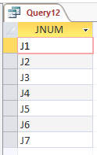

C:\Users\Pritz\AppData\Local\Microsoft\Windows\INetCache\Content.Word\q12.pngCardinality:

13. Get all pairs of part numbers such that some supplier ships both the indicated parts.

Query:

SELECT DISTINCT SP_FIRST.PNUM AS FIRST_PART, SP_SECOND.PNUM AS SECOND_PART

FROM SHIPMENT AS SP_FIRST, SHIPMENT AS SP_SECOND

WHERE SP_FIRST.SNUM=SP_SECOND.SNUM

AND SP_FIRST.PNUM < SP_SECOND.PNUM;

Result:

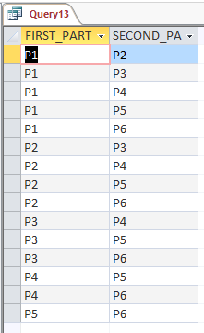

Cardinality:



14. Get the total number of jobs that receive shipments from supplier S5.

Query:

SELECT COUNT(SP.JNUM) AS TOTAL_JOBS

FROM (SELECT DISTINCT JNUM

FROM SHIPMENT

WHERE SNUM='S5') AS SP;

Result:

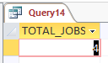

Cardinality:



15. Get the total quantity of part P1 shipped by supplier S1.

Query:

SELECT SUM(QTY) AS TOTAL_QTY

FROM SHIPMENT

WHERE PNUM='P1'

AND SNUM='S1';

Result:

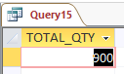

C:\Users\Pritz\AppData\Local\Microsoft\Windows\INetCache\Content.Word\q15.pngCardinality:

16. For each part being shipped to a job, get the part number, the job number, and the corresponding total quantity.

Query:

SELECT SP.PNUM, SP.JNUM, SUM(SP.QTY) AS TOTAL_QTY

FROM SHIPMENT AS SP

GROUP BY SP.PNUM, SP.JNUM;

Cardinality:



17. Get part numbers of parts shipped to some job in an average quantity of more than 320.

Query:

SELECT SP.PNUM

FROM SHIPMENT AS SP

GROUP BY SP.PNUM

HAVING AVG(SP.QTY)>320;

Result:

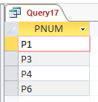

C:\Users\Pritz\AppData\Local\Microsoft\Windows\INetCache\Content.Word\q17.pngCardinality:

18. Get job names for jobs that receive shipment(s) from supplier S1.

Query:

SELECT DISTINCT J.JNAME

FROM JOB AS J, SHIPMENT AS SP

WHERE J.JNUM=SP.JNUM

AND SP.SNUM='S1';

Result:

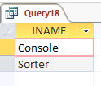

Cardinality:



19. Get colors of parts shipped by supplier S1.

Query:

SELECT DISTINCT P.COLOR

FROM SHIPMENT AS SP, PART AS P

WHERE SP.PNUM=P.PNUM

AND SP.SNUM='S1';

Result:

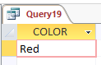

Cardinality:

20. Get part numbers for parts shipped to any job in London.

Query:

SELECT DISTINCT P.PNUM

FROM PART AS P, SHIPMENT AS SP, JOB AS J

WHERE P.PNUM=SP.PNUM

AND J.JNUM=SP.JNUM

AND J.CITY='London';

Result:

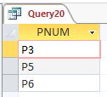

Cardinality: C:\Users\Pritz\AppData\Local\Microsoft\Windows\INetCache\Content.Word\q20.png