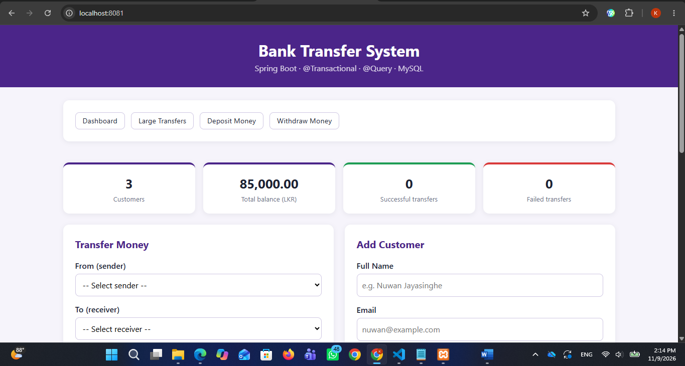
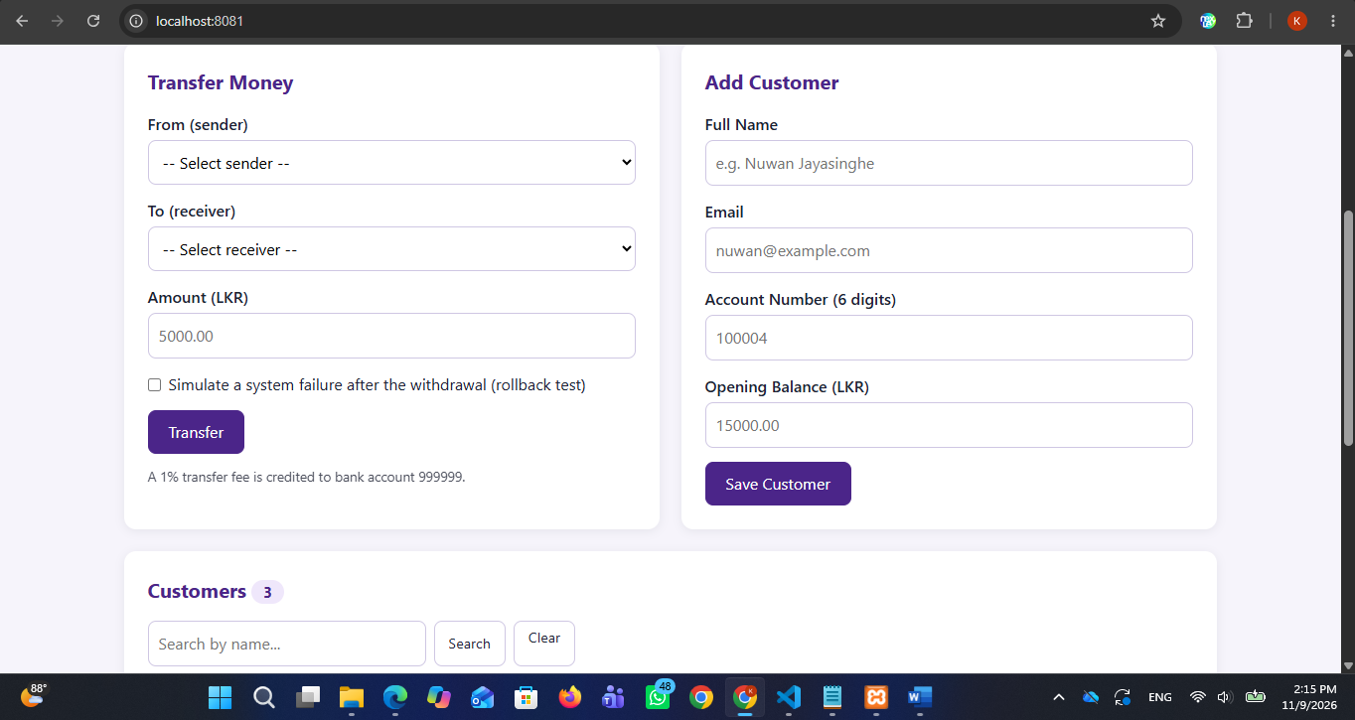

1. Project Overview & Introduction Section
- Objective: Build a secure Full-Stack Bank Transfer System using Spring Boot, Thymeleaf, Spring Data JPA, and MySQL to demonstrate robust transaction management (@Transactional), custom repository queries (@Query), and data integrity features.
- Tech Stack: Java 21, Spring Boot 4.0.9, MySQL 8.0, Thymeleaf, Maven.

- Application Execution Instructions:
  - Start the MySQL database server (e.g., via XAMPP Control Panel).
  - Open a terminal in the project root folder (bank-transfer-app) and run the command:
Bash
mvnw.cmd spring-boot:run
  - Open a web browser and access the local dashboard via URL: http://localhost:8081.
Test Cases & Screenshots Mapping
Test Case 1 (Successful Money Transfer):
Verify that transferring funds between valid customer accounts (e.g., from Kamal Perera to Nimali Silva) updates balances correctly and records a SUCCESS status entry in the transaction history table.
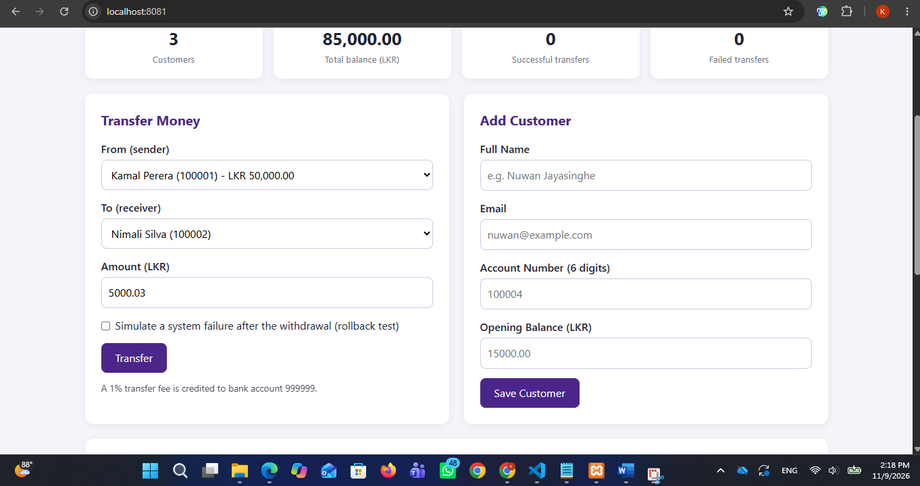
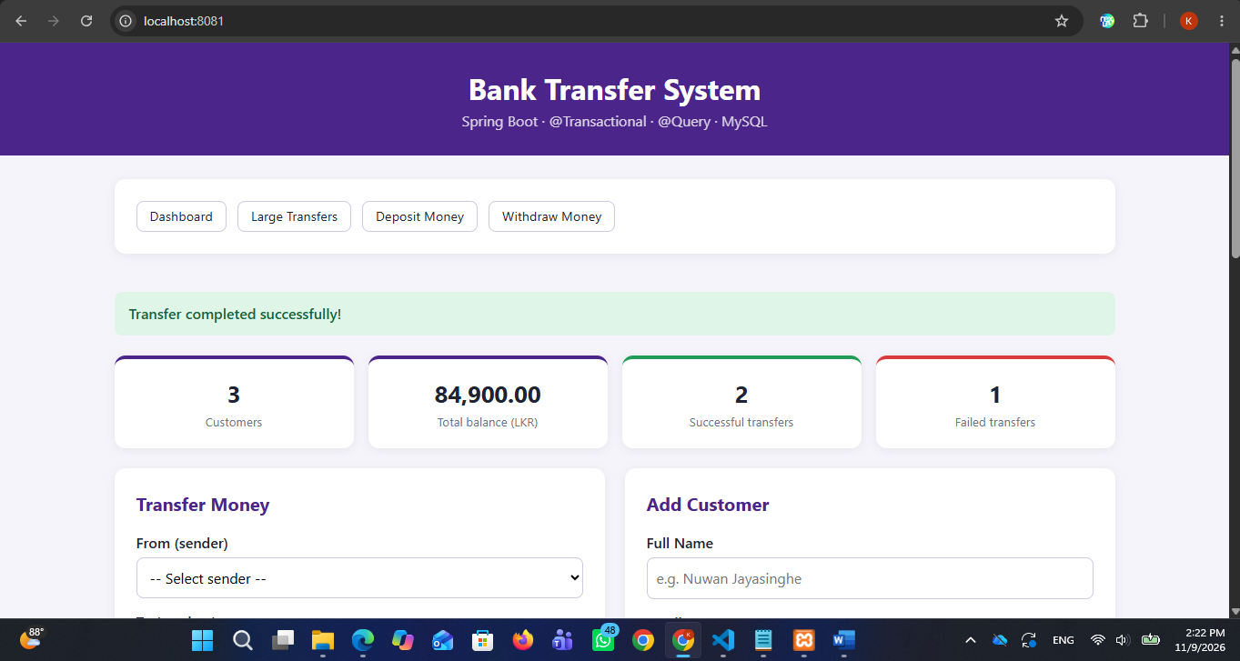
"Transfer completed successfully!" alert message, updated customer totals, and the successful transaction record here.
Test Case 2 (Insufficient Balance Error Test):
Verify that attempting a transfer with an amount exceeding the sender's available balance triggers a validation failure and records a FAILED transaction.
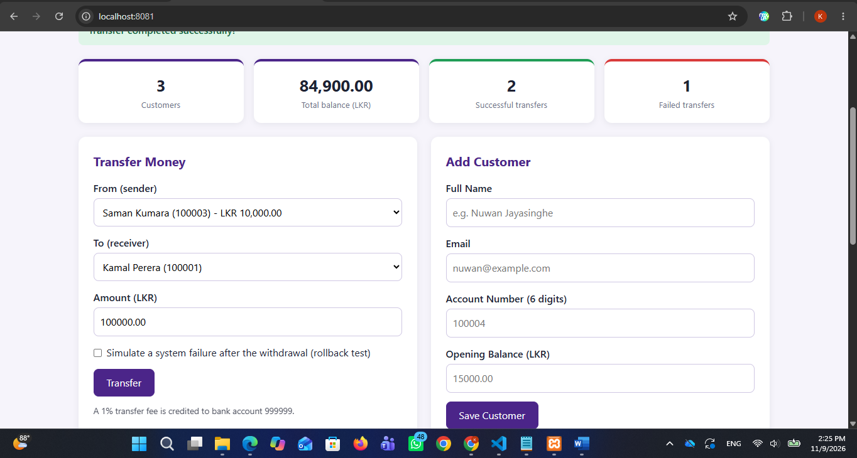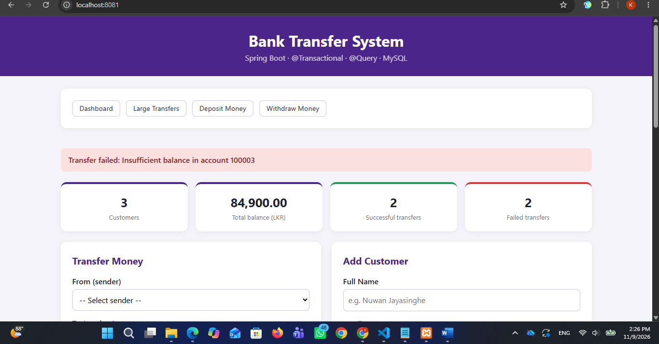
insufficient balance (e.g., trying to transfer LKR 100,000 from Saman Kumara) here.
Test Case 3 (Rollback Test / Simulate System Failure):
Verify the ACID properties and transaction atomicity by simulating a system crash immediately after the withdrawal step. Ensure that the debited funds are fully rolled back and no money is lost, while logging a FAILED record using independent propagation.
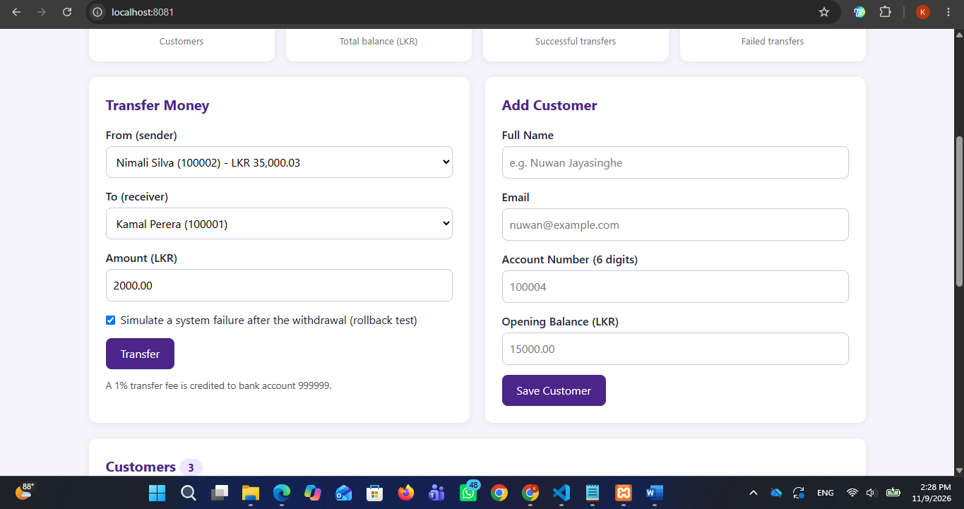
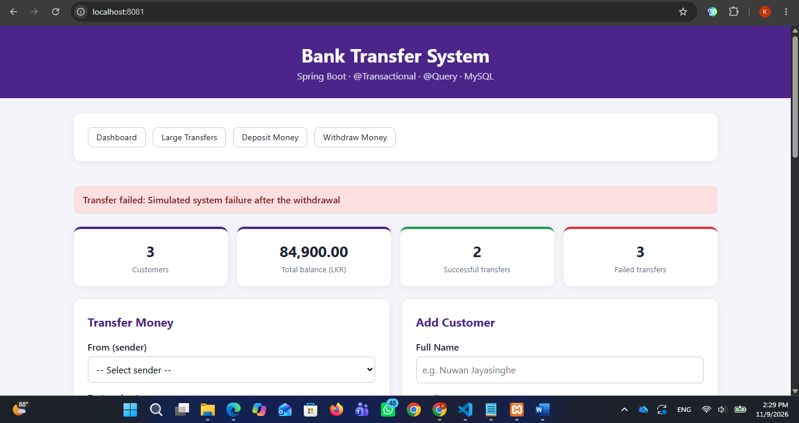
"Transfer failed: Simulated system failure after the withdrawal" warning banner and the resulting FAILED status entry here.

Test Case 4 (Extension Features)
Test advanced extension features including direct cash deposits, filtering large transfers above a threshold using custom JPQL queries, and inspecting individual account audit histories.

