Name : J.M.P.K Jayasundara
Student ID : PS/2022/194
Date :11/09/2026
Course Code : COSC 32133
Course Name : Full-Stack Software Development
GitHub Repository URL : https://github.com/prikavi28/bank-transfer-system

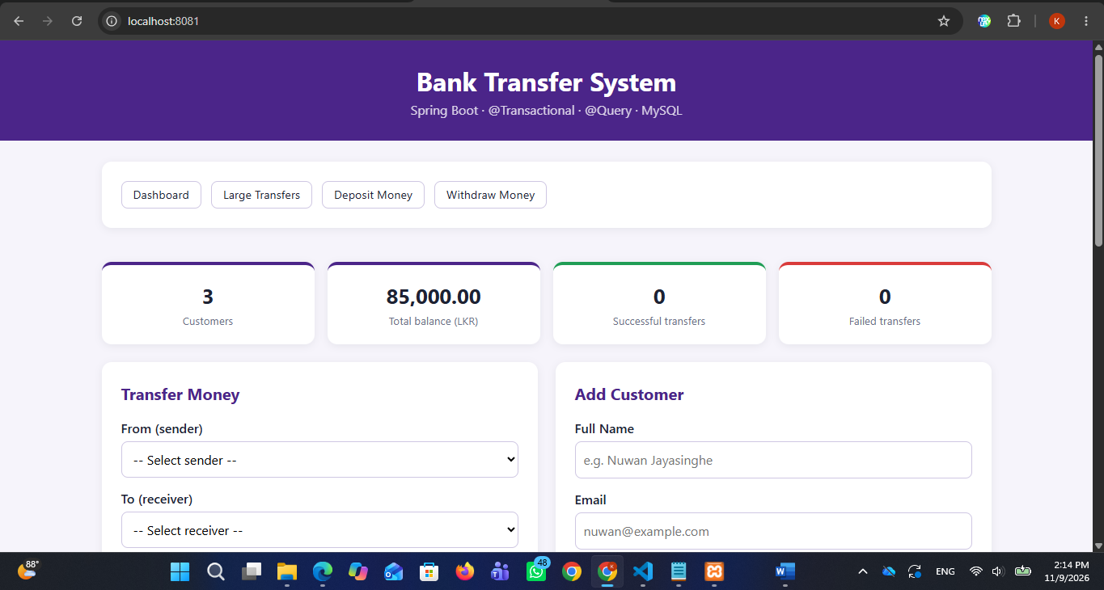
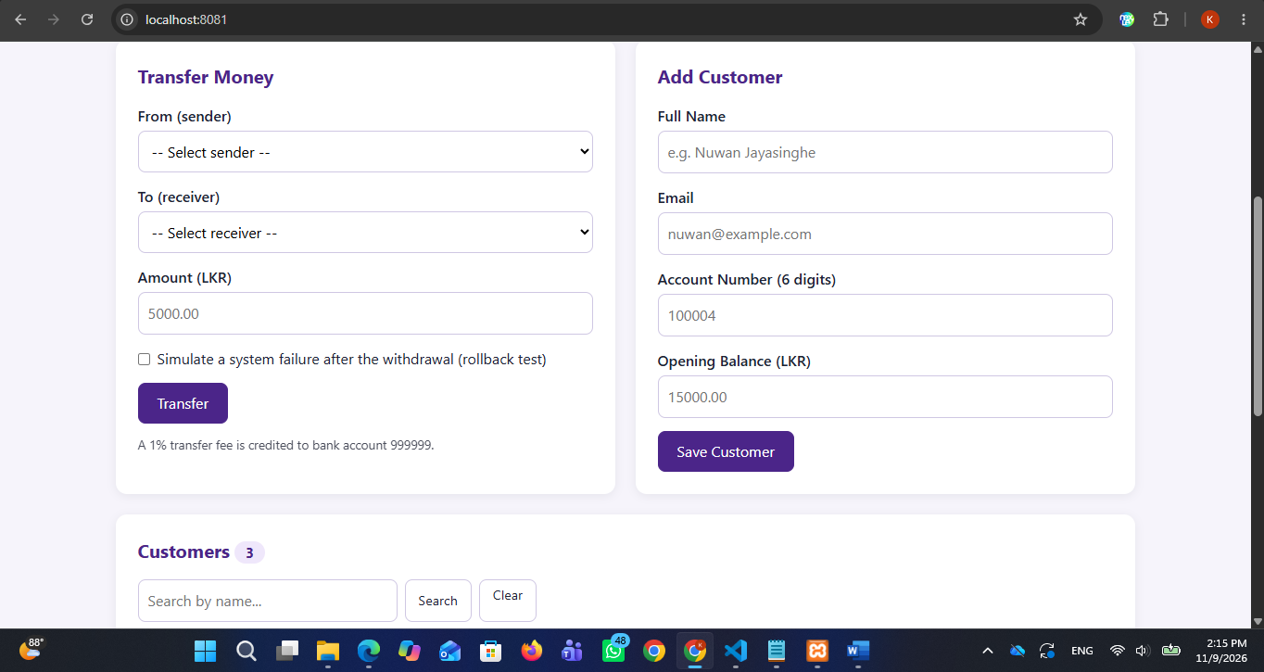

1. Project Overview & Introduction Section
- Objective: Build a secure Full-Stack Bank Transfer System using Spring Boot, Thymeleaf, Spring Data JPA, and MySQL to demonstrate robust transaction management (@Transactional), custom repository queries (@Query), and data integrity features.
- Tech Stack: Java 21, Spring Boot 4.0.9, MySQL 8.0, Thymeleaf, Maven.

- Application Execution Instructions:
  - Start the MySQL database server (e.g., via XAMPP Control Panel).
  - Open a terminal in the project root folder (bank-transfer-app) and run the command:
Bash
mvnw.cmd spring-boot:run
  - Open a web browser and access the local dashboard via URL: http://localhost:8081.
Test Cases & Screenshots Mapping
Test Case 1 (Successful Money Transfer):
Verify that transferring funds between valid customer accounts (e.g., from Kamal Perera to Nimali Silva) updates balances correctly and records a SUCCESS status entry in the transaction history table.
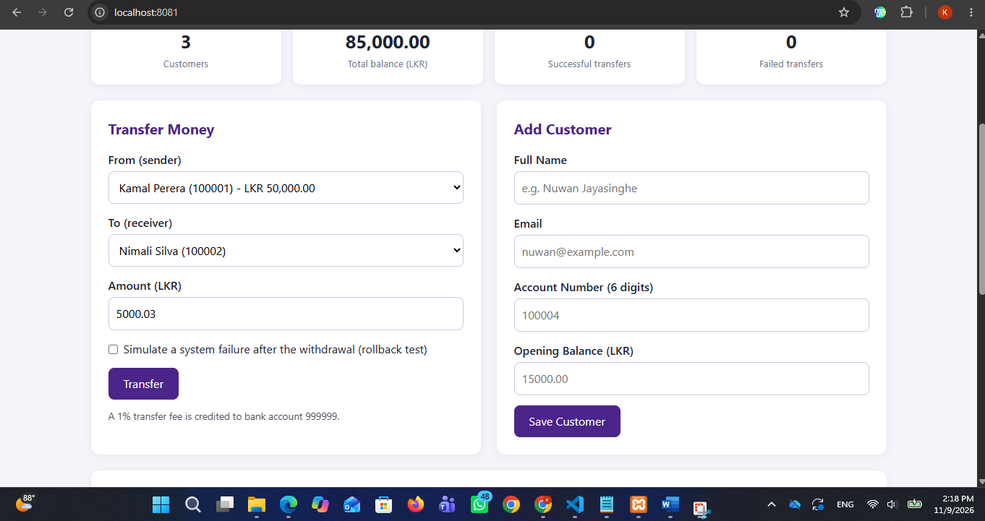
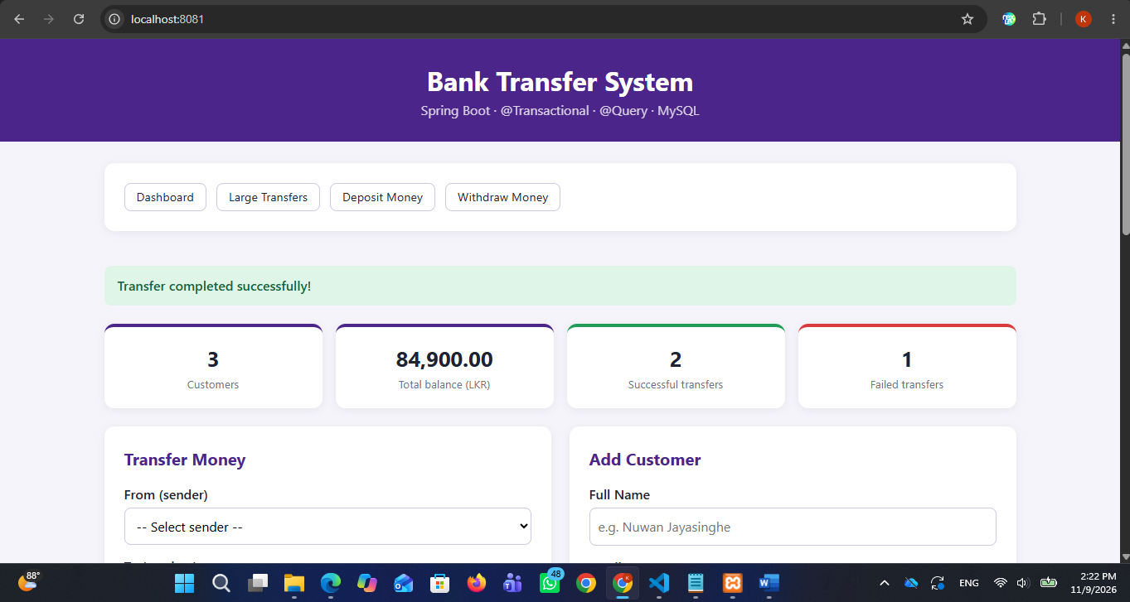
"Transfer completed successfully!" alert message, updated customer totals, and the successful transaction record here.
Test Case 2 (Insufficient Balance Error Test):
Verify that attempting a transfer with an amount exceeding the sender's available balance triggers a validation failure and records a FAILED transaction.
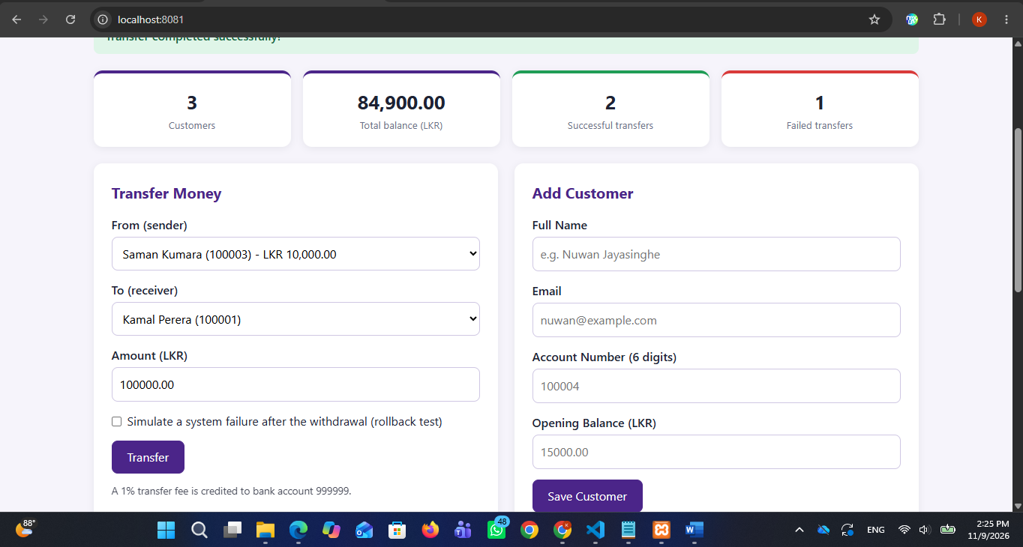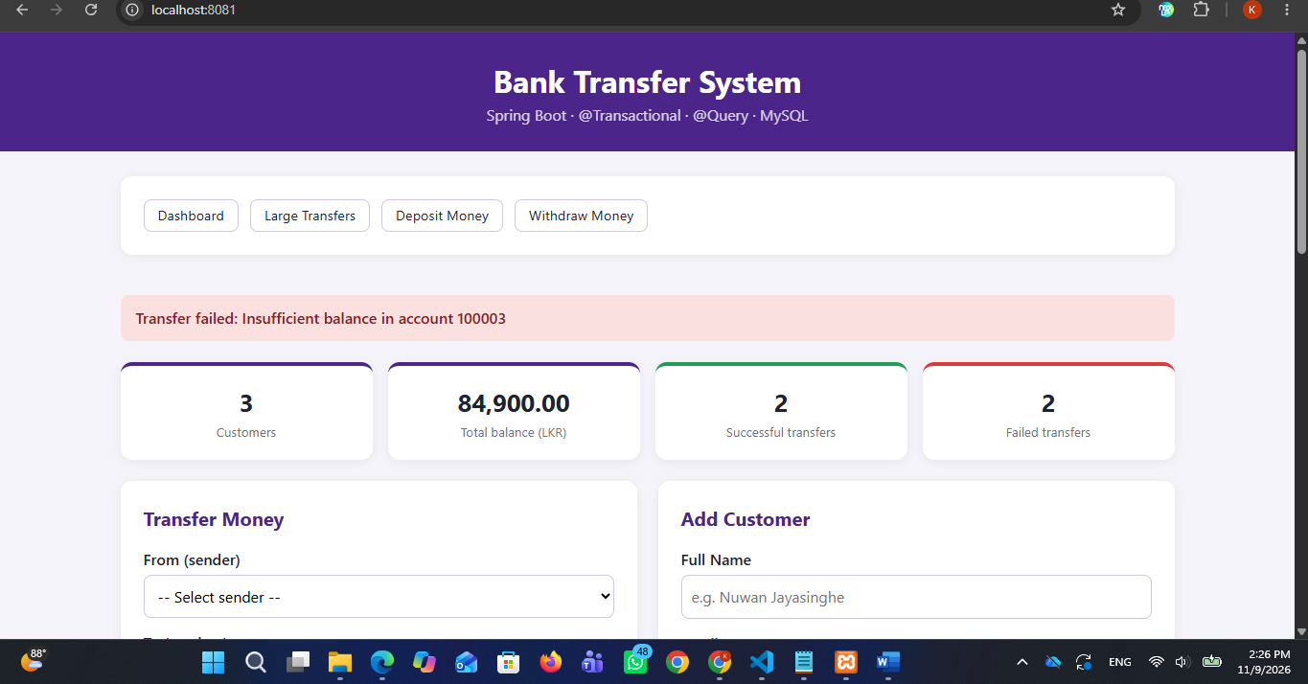
insufficient balance (e.g., trying to transfer LKR 100,000 from Saman Kumara) here.
Test Case 3 (Rollback Test / Simulate System Failure):
Verify the ACID properties and transaction atomicity by simulating a system crash immediately after the withdrawal step. Ensure that the debited funds are fully rolled back and no money is lost, while logging a FAILED record using independent propagation.
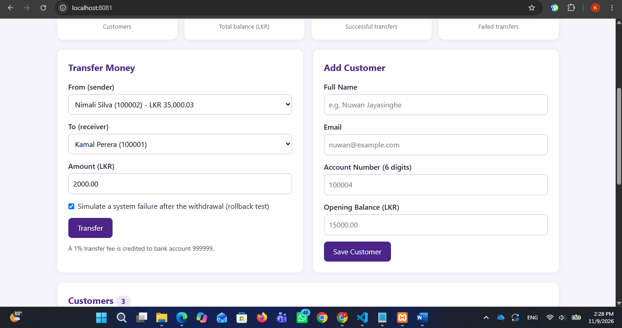
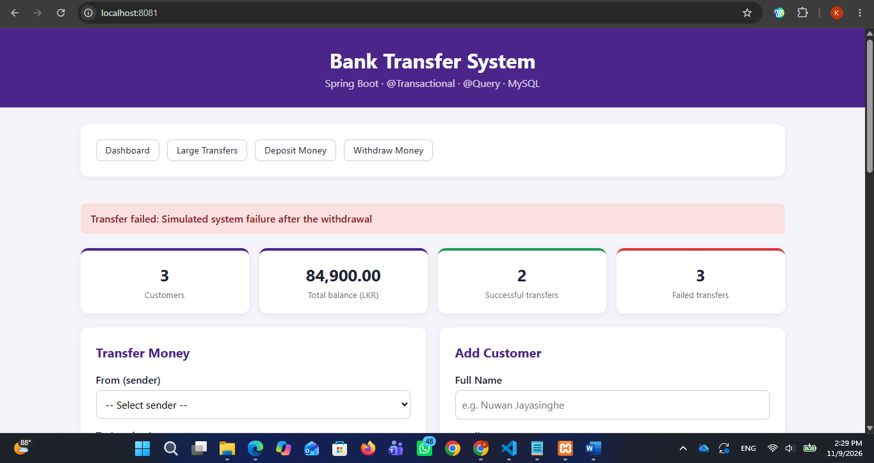
"Transfer failed: Simulated system failure after the withdrawal" warning banner and the resulting FAILED status entry here.

Test Case 4 (Extension Features)
Test advanced extension features including direct cash deposits, filtering large transfers above a threshold using custom JPQL queries, and inspecting individual account audit histories.
Deposit
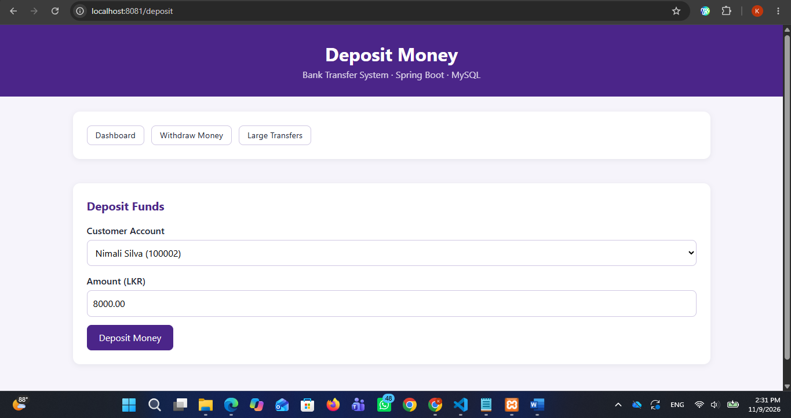
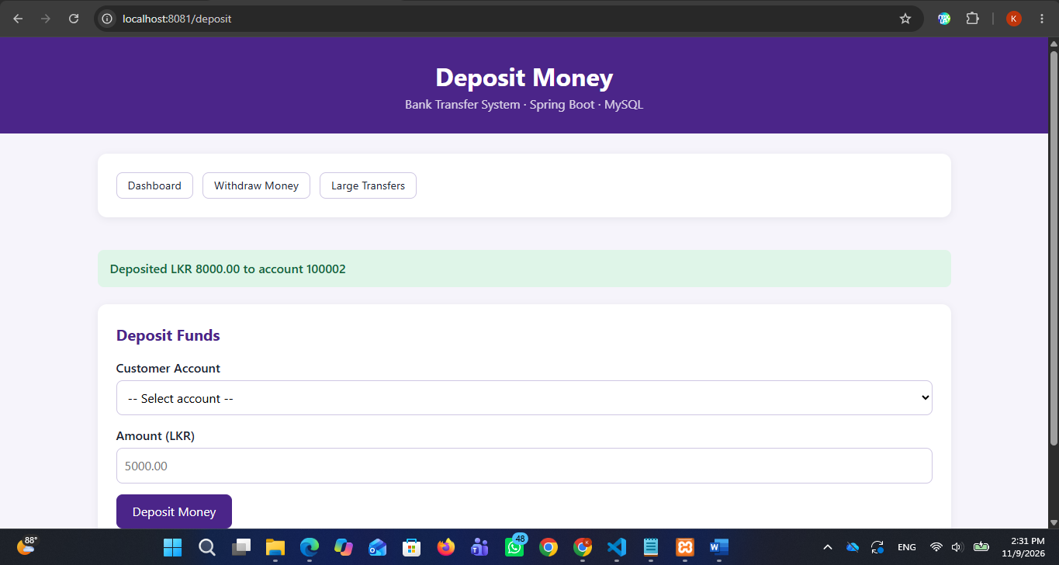

Large Transfers
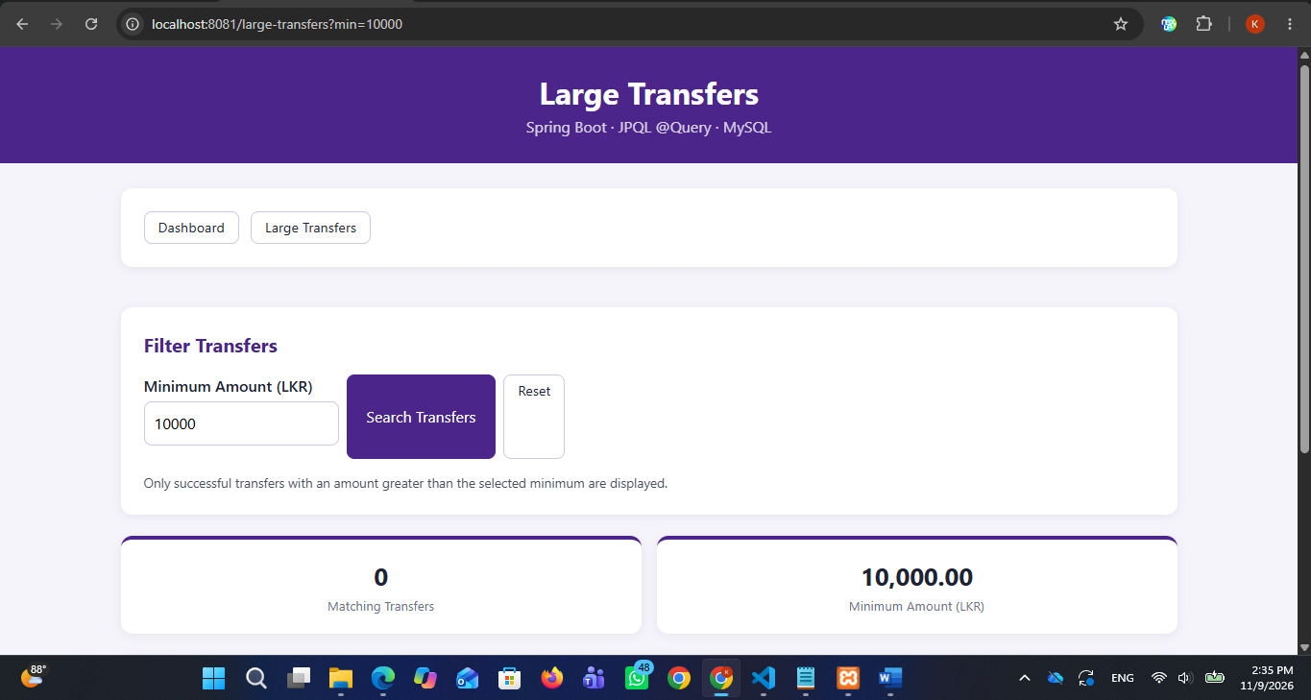

History
History Of Kamal Perera
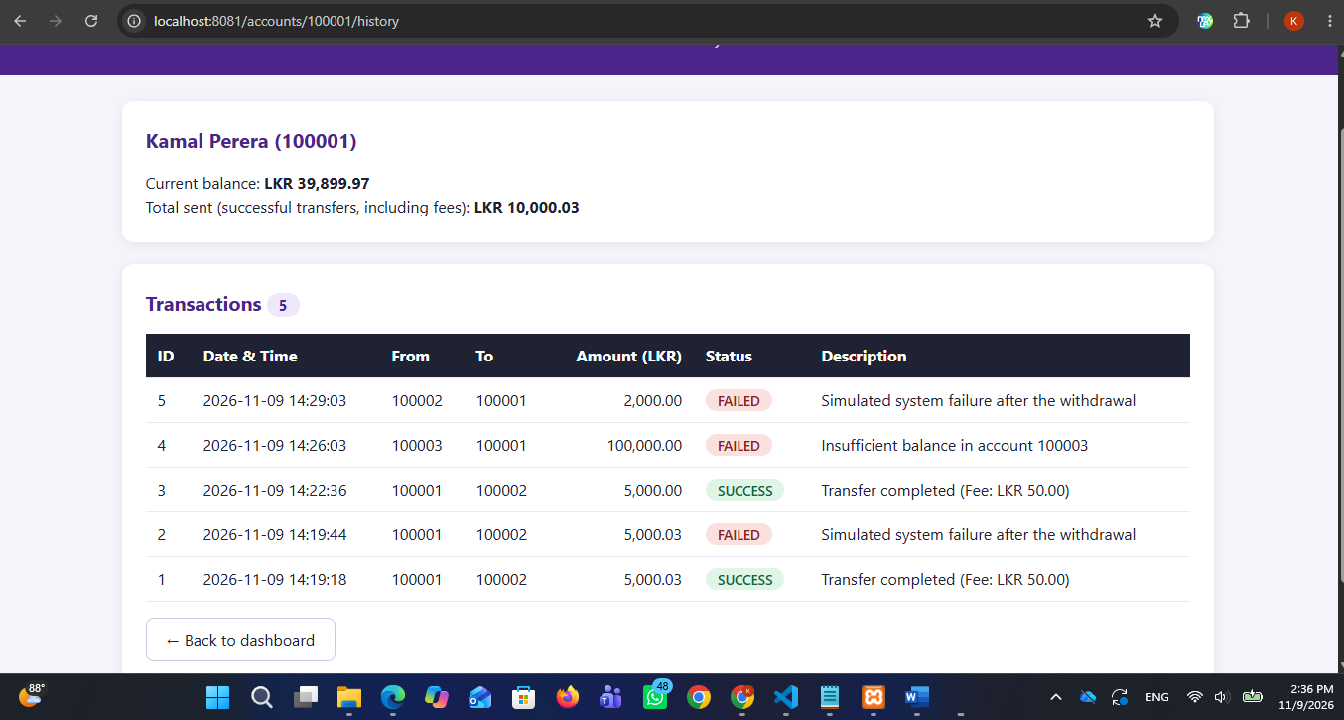
History Of Nilmini Silva
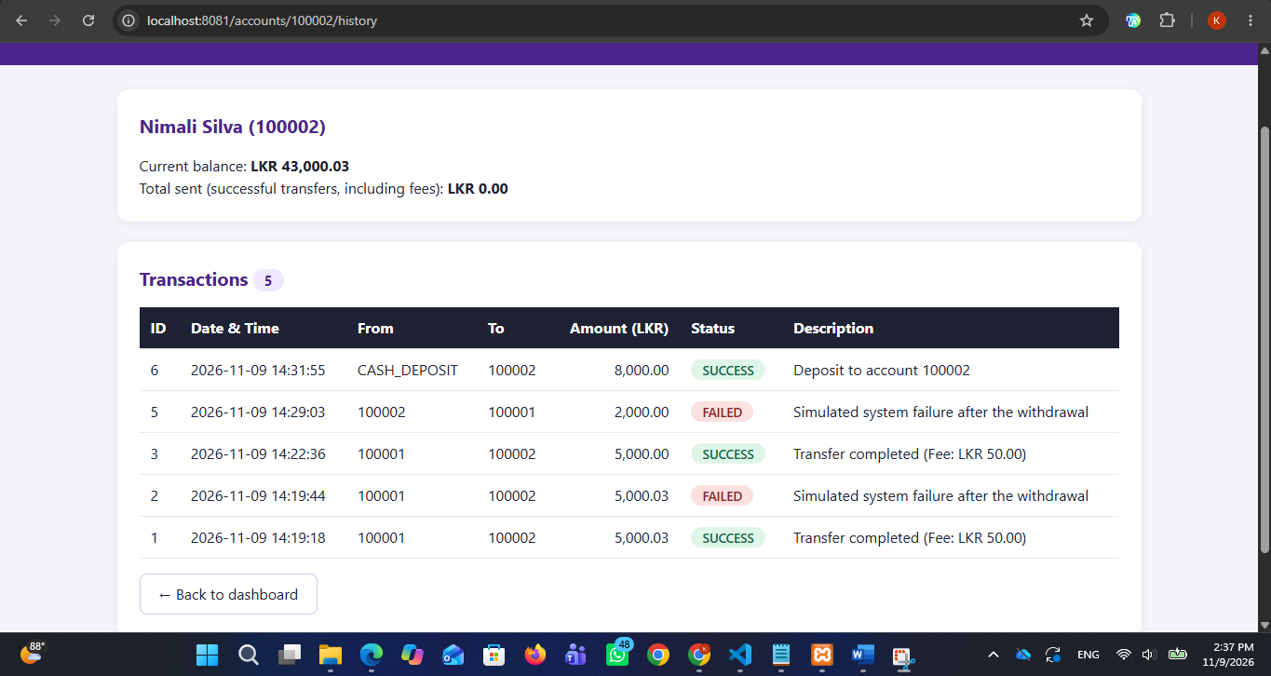

History Of Saman Kumara
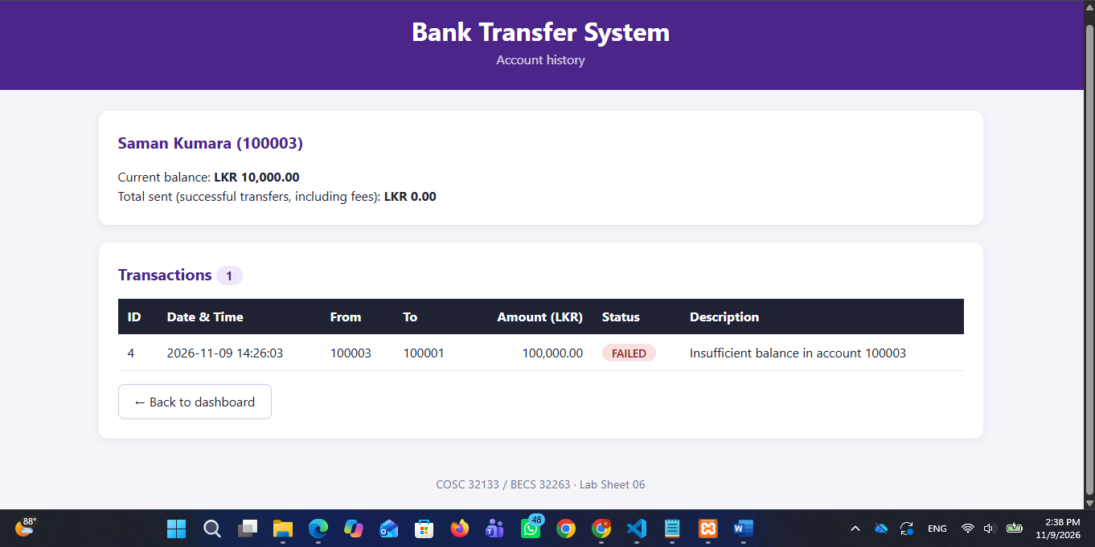
Latest Transactions
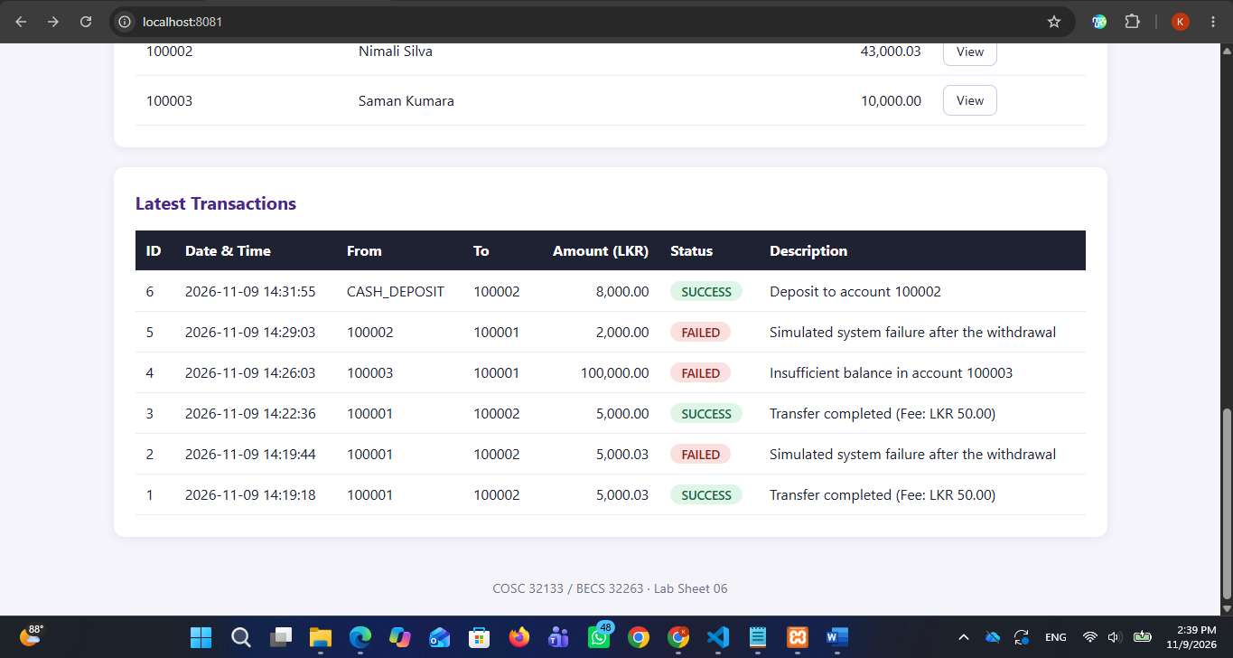

- What would have happened to the money in test 4 without
Without @Transactional, database operations execute independently as auto-committed steps. The withdrawal (debit) from the sender would commit instantly before the simulated exception occurs. When the exception triggers, the receiver's deposit (credit) would fail to execute, causing money to permanently vanish from the system without returning to the sender.
- Why is recordFailure in a separate class with REQUIRES_NEW?
Spring's transaction management relies on proxy-based interception, meaning self-invocation within the same class bypasses transaction boundaries. Moving failure logging into a separate service class (TransactionAuditService) with propagation = Propagation.REQUIRES_NEW enables Spring to suspend the main failing transaction (which rolls back) and open an independent, separate transaction to successfully save the FAILED audit record.
- Why does debit use UPDATE ... WHERE balance >= :amount instead of reading the balance first?
Reading the balance via a separate query prior to updating introduces race conditions and lost updates in multi-user concurrent environments. The atomic JPQL/SQL UPDATE statement evaluates the condition (balance >= :amount) and subtracts funds in a single database-level lock operation, ensuring thread-safe balance validation without requiring expensive pessimistic locking.

