Blizzard’s Mobile Chat System: MobileNet

Requirements Document
Table of Contents
1 Introduction 3
1.1 Purpose and Scope 3
1.2 Target Audience 3
1.3 Terms and Definitions 3
2 Product Overview 4
2.1 Users and Stakeholders 4
2.1.1 Blizzard 4
2.1.2 App Stores 4
2.2 Use cases 4
2.2.1 Type and Receive 4
2.2.2 Receive upon logging in and reply 4
2.2.3 Type to all, Receive message, and reply 4
3 Functional Requirements 5
3.1 Sending and Receiving Messages 5
3.1.1 Sending a Message 5
3.1.2 Receiving a Message 5
3.2 Offline and Online Users 5
3.3 Logging in/out 5
4 Nonfunctional Requirements 6
4.1 Newest version of IOS and Android and Updates 6
4.1.1 Updating 6
4.2 Speed and Performance 6
4.3 Friendly User Interface 6
5 Milestones and Deliverables 7
5.1 Accounts - User - Friends - Status 7
5.1.1 Accounts Stage 1 7
5.1.2 Accounts Stage 2 7
5.2 User Interface 7
5.3 Save Records/Information and Chat system 7

Introduction
The chat system for Blizzard’s communication hub is only limited to those that have access to a console or computer system. In order to sustain the communities need to stay connected, a mobile chat service is needed. This document will describe the necessary requirements that the chat system will need to be a successful messaging platform, as well as the non-technical requirements and information regarding the creation of this mobile service. Stakeholders will be discussed, and at the end, the milestone deliverables will also be stated and explained so that the project can move along and meet those expectations.

Purpose and Scope
The purpose of this requirements document is to showcase the production of the battle net mobile chat service and layout exactly how the project should look, feel, and work when it is at its milestone, and as the finished product.

Target Audience
The target audience for this documentation is directed to Blizzard and other blizzard software engineers who are a part of the production for this project, and may or may not be involved in the maintenance of MobileNet in the future.

Terms and Definitions
Battle.net: The hub that Blizzard has for their active users to communicate with other users as well as patch games and check news for all their favorite games and teams.
UI: User Interface

Product Overview
The users of MobileNet are those that play Blizzard games (Overwatch, Heroes of the Storm, Starcraft, or World of Warcraft) and are in need of an instant messaging system on their mobile devices to talk to their friends away from the computer or console. Mutual friends, or friends, are simply those that a user has added to their account as a ‘friend’ and that person added them back. MobileNet will require a user log in and allow them to chat with their registered friends that they have added onto the original Battle.net client. MobileNet allows users to see who is online and offline, and even when users log off or on. Personal messages are enables by double tapping onto the friend’s username, and typing in the chat without a friend tapped sends a message to all who are mutually added. New users can register accounts, and MobileNet allows users to log into multiple accounts rather than binding the app to the user’s mobile device. MobileNet will not allow users to play any games via the service, and typing to more than one person at once will not be implemented at this moment in design.

Users and Stakeholders
The users of MobileNet are those that play Blizzard games (Overwatch, Heroes of the Storm, Starcraft, or World of Warcraft) and are in need of an instant messaging system on their mobile devices to talk to their friends away from the computer or console. Stakeholders and use cases of MobileNet will be defined in the following sections.

Blizzard
Blizzard acts as the main employer and company overseeing the production of MobileNet. Blizzard will take hold of the final product and then distribute the final product to the app store.

App Stores
App stores for the IOS and Android are the distributors of MobileNet. App stores will be the one and only platforms in which MobileNet will be sold to the target audience and will keep track of counting the ratings users put up as well as how many downloads happen in certain time intervals and totals.

Use cases
Use cases are diagrams or a list of actions or events that happen in order to accomplish a big or small goal. In order to show how MobileNet is to be used, a few use cases will be presented to show MobileNet’s capabilities. For MobileNet, the use cases will show the interaction between two users (since it is a chat system) and the app itself.

Type and Receive
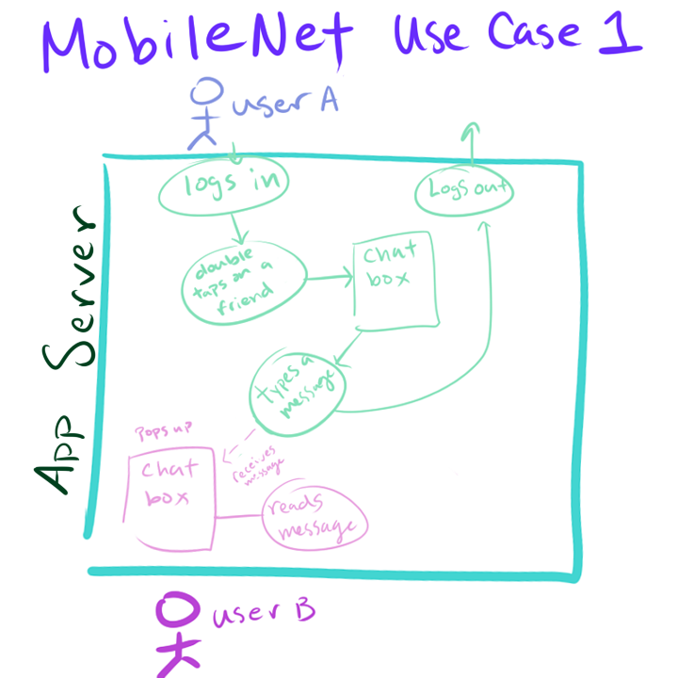
This Use Case diagram shows the steps and events that happen within the program when a user logs in and decides to type a message to a friend, and then logging out.

Receive upon logging in and replying
This Use Case shows what happens when User A from the first diagram logs in and receives a message they had gotten while they were offline, and replies back before logging out.

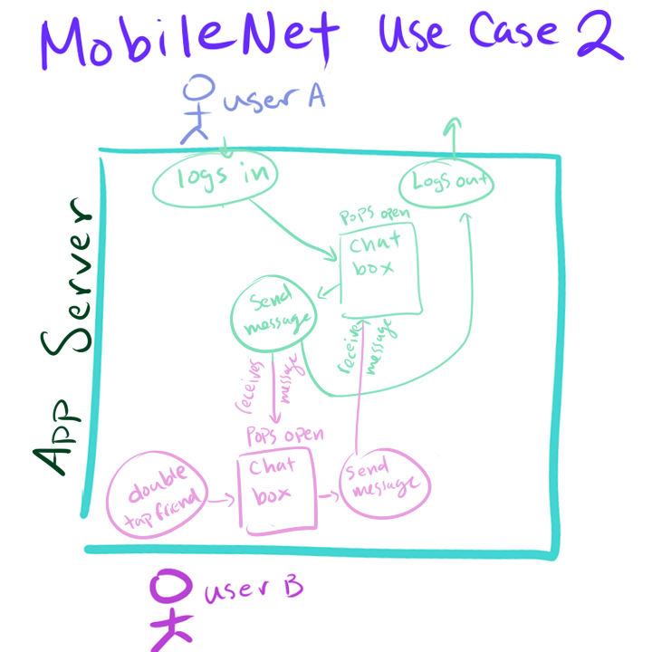

Type to all, receive message, and reply
This last Use Case represents the new feature of being able to mass send a message to all friends on their friends list by simply typing without double tapping. One friend then replies to User A, to which they respond to before logging out.
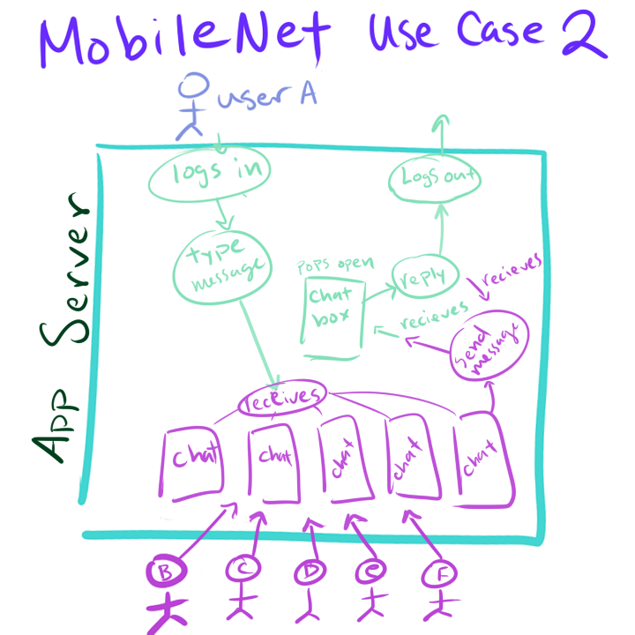

Functional Requirements
This section outlines in depth the functional and more technical requirements of how MobileNet’s final form is expected to work. One example of a functional requirement is that MobileNet needs to be able to keep records of chats for that particular user and allow for users to look back on them if they so choose.

Sending and Receiving Messages
Sending and receiving messages to other users is essential to MobileNet. Blizzard wants users to be able to send messages to mutual friends individually, or all at once, whilst also being able to receive messages with ease.

Sending a Message
In order to send a message to an individual, users will need to double tap the friend they want to send a message to. Once that happens, a chat box will open that holds the conversation of the two users. Double tapping another use will open another instance of a chat as long as it is with a different mutual friend than the ones that are already opened.

Receiving a Message
When a user receives a message from a mutual friend. A chat box will open just as if they had double tapped to type to their friend. If a chat box has already been opened, then messages received will stay in that chat box and differentiate who sent what message with the Receiver of the message on the right and the sender of the message on the left.

Offline and Online Users
In order for users to know who is online or offline, there needs to be a window displaying their mutual friends’ status. Online users are highlighted and offline users are greyed out to visually show who can or can’t receive messages. Any user can be double tapped and be sent messages. Those that are offline will receive all missed messages upon logging into the service. Online and offline statuses are purely monitored by the logging in and out functionality, which will be explained in the section 3.3.

Logging in/out
New users of MobileNet need to log into their Battle.net accounts upon installing the app onto their mobile devices. MobileNet requires the same username and password as their Battle.net account, as they are both technically the same. If the user types an incorrect username or password, the corresponding error will show up and allow users to retry until they have successfully logged into the right account. To log out of the system (usually done when users want to log into a different account), the user must click on the Log out button. The user is then prompted if they really want to log out, and shown a yes or no button. If yes is pressed, then the user is logged out, no longer on their account, and brought back to the log in screen, where they can log into whatever account they have access to.

Nonfunctional Requirements
Nonfunctional requirements are those that are not technical processes of MobileNet.
Describe the purpose of this section and outline its contents. Performance and interactions between the user, company, or distributor are all nonfunctional requirements.

Newest version of IOS and Android and Updates
Upon release, MobileNet needs to be created for the newest version of IOS and Android so that they can be used right away. Updating the app whenever necessary is also needed when newer versions of the phones come out to accommodate any changes that may affect MobileNet.

Updating
Being able to update the app means that MobileNet’s needs to be designed in a way in which future maintenance workers and engineers can easily change what needs to be changed without having to spend a lot of time learning everything there is about the program. Functions and classes need to be self-explanatory and modular.

Speed and Performance
MobileNet needs to be designed to be as efficient as possible. There should be no signs of delay or lag from interactions inside the program. Outside sources and platforms can lead to slow performance, but MobileNet’s interior layout is to be designed with the idea of high performance and efficiency in mind at all times.

Friendly User Interface
The layout and design of MobileNet must be user friendly. Buttons need to be obvious and prompts need to be both grammatically correct and easy to understand. Text all throughout the app must be visible and in a font big enough to see on the smallest mobile device there is today.

Milestones and Deliverables
This section describes which functionalities will be prepared and set as milestones. The smaller milestones are to be done in quicker increments, such as having a user be able to log in and out, and being able to see how is online and offline. These are the first milestones to get the project started. From then, the next milestone should be creating the UI for MobileNet. The last milestone will be to have MobileNet save records of the chat and allow users to see their previous conversations. This is the biggest milestone, and because of that, it is the final one that will result in the final production of MobileNet.

Accounts – User – Friends – Status
This milestone is sectioned into two different stages. The first stage is to be able to create an account and have it saved into a server. The server at this moment will be ignored and assumed that it works. By having that, if a user has a registered account, all of their friends will be saved under the correct category. The next smaller step is to determine the status of these friends by checking if the user is online or offline, and displaying the correct image to represent that.

Accounts – Stage 1
The first stage, as previously stated, will consist of creating what will be the log in / register screen. The deliverable for this milestone will be a smaller scope of what the actual version will hold. The log in menu will only be able to hold one account at a time, so once an account is registered, that instance of the program is binded to that one account. Logging in will result in nothing more than a success and failing to type the correct username or password will result in an error message, prompting the user to try again.

Accounts – Stage 2
The second smaller milestone is to have friends show up on the users friends list as online or offline. The deliverable at this stage will have no real server to work with, so the friends shown are already coded in and read in from somewhere else. It will show that the online and offline status works and users can see who is currently active or not. At this point in the stage, double tapping to open up messages will not be available.

User Interface
This milestone consists of building the user interface for MobileNet. This is mostly the aesthetic part of the process. The Log in screen, Friends tab, and chat boxes all need to be consistently the same design and have a similar feel as the Battle.net client.

Save Records/information and Chat System
For the final milestone, information within MobileNet needs to be saved onto the server on some sort of record so that users can access conversations and check history. The server must also be able to store registered accounts so that users can log into accounts they have access to. Many users nowadays have multiple accounts for streaming purposes, so being able to store multiple accounts for users to use. Information storage also means that the chat boxes can be used between users, so the deliverables at the end of this milestone will be: storage of multiple accounts, send and receive messages, and storage of chat history.

