Paper’s title should be the fewest possible words that accurately describe the content of the paper (Center, Bold, 16pt)

Mustofa Abi Hamid^{1,2}, Hazita Azman³, Julie Sarama⁴
¹Department of Electrical Engineering Vocational Education, Faculty of Teacher Training and Education, Universitas Sultan Ageng Tirtayasa, Serang, Indonesia
²Electrical Engineering Vocational Laboratory, Faculty of Teacher Training and Education, Universitas Sultan Ageng Tirtayasa,
Serang, Indonesia
³Centre for Language and Linguistics Research, Faculty of Social Sciences and Humanities, Universiti Kebangsaan Malaysia,
Bangi, Malaysia
⁴Morgridge College of Education, University of Denver, Denver, United States

Article Info |  | ABSTRACT (10 PT)
Article history:  Received month dd, yyyy  Revised month dd, yyyy  Accepted month dd, yyyy |  | An abstract is often presented separate from the article, so it must be able to stand alone. A well-prepared abstract enables the reader to identify the basic content of a document quickly and accurately, to determine its relevance to their interests, and thus to decide whether to read the document in its entirety. The abstract should be informative and completely self-explanatory, provide a clear statement of the problem, the proposed approach or solution, and point out major findings and conclusions. The Abstract should be 100 to 200 words in length. References should be avoided, but if essential, then cite the author(s) and year(s). Standard nomenclature should be used, and non-standard or uncommon abbreviations should be avoided, but if essential they must be defined at their first mention in the abstract itself. No literature should be cited. The keyword list provides the opportunity to add 5 to 7 keywords, used by the indexing and abstracting services, in addition to those already present in the title (9 pt).
Keywords:
First keyword
Second keyword
Third keyword
Fourth keyword
Fifth keyword
This is an open access article under the CC BY-SA license.

Corresponding Author:
Mustofa Abi Hamid
Department of Electrical Engineering Vocational Education, Faculty of Teacher Training and Education
Universitas Sultan Ageng Tirtayasa
Ciwaru Raya Road No. 25, Serang, Banten, Indonesia
Email: abi.mustofa@untirta.ac.id

- INTRODUCTION (10 PT)
The main text format consists of a flat left-right columns on A4 paper (quarto). The margin text from the left and top are 2.5 cm, right and bottom are 2 cm. The manuscript is written in Microsoft Word, single space, Time New Roman 10 pt, and maximum 12 pages for original research article, or maximum 16 pages for review/survey paper, which can be downloaded at the website: http://edulearn.intelektual.org.
The title of an article should consist of the fewest possible words that accurately describe the content of the paper. The title should be succinct and informative and no more than about 12 words in length. Do not use acronyms or abbreviations in your title and do not mention the method you used, unless your paper reports on the development of a new method. Titles are often used in information-retrieval systems. Avoid writing long formulas with subscripts in the title. Omit all waste words such as "A study of ...", "Investigations of ...", "Implementation of ...”, "Observations on ...", "Effect of.....", “Analysis of …”, “Design of…”, etc.
A concise and factual abstract is required. The abstract should state briefly the purpose of the research, the principal results and major conclusions. An abstract is often presented separately from the article, so it must be able to stand alone. For this reason, References should be avoided, but if essential, then cite the author(s) and year(s). Also, non-standard or uncommon abbreviations should be avoided, but if essential they must be defined at their first mention in the abstract itself. Immediately after the abstract, provide a maximum of 7 keywords, using American spelling and avoiding general and plural terms and multiple concepts (avoid, for example, 'and', 'of'). Be sparing with abbreviations: only abbreviations firmly established in the field may be eligible. These keywords will be used for indexing purposes.
Indexing and abstracting services depend on the accuracy of the title, extracting from it keywords useful in cross-referencing and computer searching. An improperly titled paper may never reach the audience for which it was intended, so be specific.
The Introduction section should provide: i) a clear background, ii) a clear statement of the problem, iii) the relevant literature on the subject, iv) the proposed approach or solution, and v) the new value of research which is innovation (within 3-6 paragraphs). It should be understandable to colleagues from a broad range of scientific disciplines. Organization and citation of the bibliography are made in Institute of Electrical and Electronics Engineers (IEEE) style in sign [1], [2] and so on. The terms in foreign languages are written italic (italic). The text should be divided into sections, each with a separate heading and numbered consecutively [3]. The section or subsection headings should be typed on a separate line, e.g., 1. INTRODUCTION. A full article usually follows a standard structure: 1. INTRODUCTION, 2. THE COMPREHENSIVE THEORETICAL BASIS AND/OR THE PROPOSED METHOD/ALGORITHM (optional), 3. METHOD, 4. RESULTS AND DISCUSSION, and 5. CONCLUSION. The structure is well-known as IMRaD style.
Literature review that has been done author used in the section "INTRODUCTION" to explain
the difference of the manuscript with other papers, that it is innovative, it are used in the section "METHOD" to describe the step of research and used in the section "RESULTS AND DISCUSSION" to support the analysis of the results [2]. If the manuscript was written really have high originality, which proposed a new method or algorithm, the additional section after the "INTRODUCTION" section and before the "METHOD" section can be added to explain briefly the theory and/or the proposed method/algorithm [4].

- METHOD (10 PT)
Explaining the research chronologically, including the research design, research procedures (in the form of algorithms, Pseudocode, or other), how to test, and data acquisition [5]–[7]. The description of the course of research should be supported references, so the explanation can be accepted scientifically [3], [4]. Figures 1-2 and Table 1 are presented center, as shown below and cited in the manuscript [5], [8]–[13]. The student responses based on their region of origin have been illustrated in Figure 1(a) and mastery of regional languages has been illustrated in Figure 1(b).

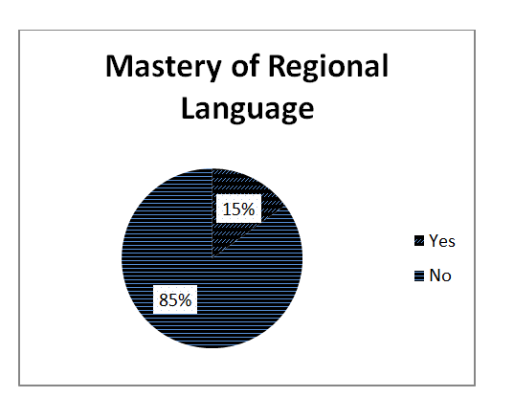 | 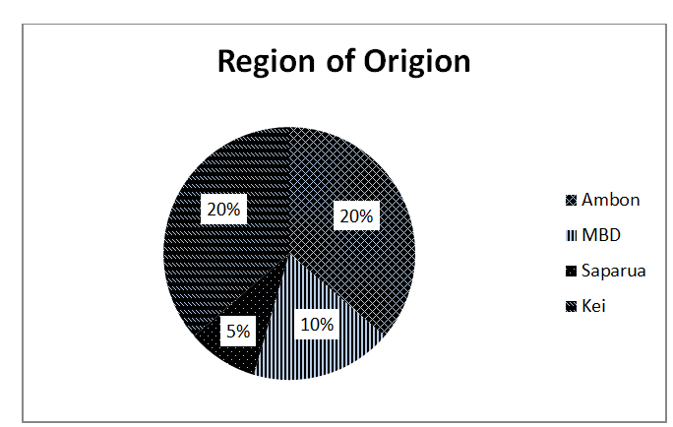
(a) | (b)

Figure 1. Student responses based on their (a) region of origin and (b) mastery of regional languages

Table 1. Internal consistency reliability of biology test
SN | Indicator | Value
1 | Number of Item | 60
2 | Kuder Richardson (KR-20) | 0.620
3 | Cronbach's Alpha Based on Standardized Items | 0.617
4 | Mean Item Difficulty | 0.56
5 | Mean Item Difficulty | 0.4

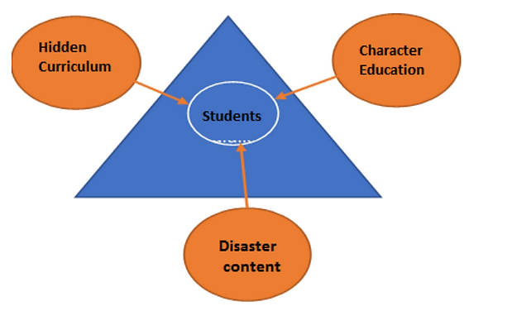

Figure 2. The schema of character education and disaster in hidden curriculum

- RESULTS AND DISCUSSION (10 PT)
In this section, it is explained the results of research and at the same time is given
the comprehensive discussion. Results can be presented in figures, graphs, tables and others that make
the reader understand easily [14], [15]. The discussion can be made in several sub-sections.

3.1. Sub section 1
Equations should be placed at the center of the line and provided consecutively with equation numbers in parentheses flushed to the right margin, as in (1). The use of Microsoft Equation Editor or MathType is preferred.

$E_{v}\text{-}E\text{=}\frac{h}{2.m} (k_{x}^{2}\text{+}k_{y}^{2}$) (1)

All symbols that have been used in the equations should be defined in the following text.

3.2. Sub section 2
Proper citation of other works should be made to avoid plagiarism. When referring to a reference item, please use the reference number as in [16] or [17] for multiple references. The use of ”Ref [18]...” should be employed for any reference citation at the beginning of sentence. For any reference with more than 3 or more authors, only the first author is to be written followed by et al. (e.g. in [19]). Examples of reference items of different categories shown in the References section. Each item in the references section should be typed using 8 pt font size [20]–[25].

3.2.1. Subsub section 1
yy
3.2.2. Subsub section 2
zz

- CONCLUSION (10 PT)
Provide a statement that what is expected, as stated in the "INTRODUCTION" section can ultimately result in "RESULTS AND DISCUSSION" section, so there is compatibility. Moreover, the prospects for the development of research results and the application of further studies can also be added to the next (based on the results and discussion).

ACKNOWLEDGMENTS (if applicable) (10 PT)
This section should acknowledge individuals who provided personal assistance to the work but do not meet the criteria for authorship, detailing their contributions. It is imperative to obtain consent from all individuals listed in the acknowledgments.

FUNDING INFORMATION (mandatory) (10 PT)
This section should describe sources of funding agency that have supported the work. Authors should state how the research described in their article was funded, including grant numbers if applicable. Include the following (or similar) statement if there is no funding involved: Authors state no funding involved.

AUTHOR CONTRIBUTIONS STATEMENT (mandatory) (10 PT)
This journal uses the Contributor Roles Taxonomy (CRediT) to recognize individual author contributions, reduce authorship disputes, and facilitate collaboration. The recommended number of authors is at least two, with one of them designated as the corresponding author. The corresponding author will be responsible for all correspondence related to the paper and must ensure that the other authors are included in the communication regarding submission, revision, and publication processes. We encourage authors to include a statement in the paper that shares and accurately describes each author's contribution. To be eligible for authorship, each individual must have contributed to at least one of the following: conceptualization, methodology, formal analysis, or investigation, as well as at least one aspect of writing (either original draft preparation or writing reviews and editing).

Name of Author | C | M | So | Va | Fo | I | R | D | O | E | Vi | Su | P | Fu
Author 1 name
Author 2 name
Author 3 name
…..
Author x name

C : Conceptualization  M : Methodology  So : Software  Va : Validation  Fo : Formal analysis | I : Investigation  R : Resources  D : Data Curation  O : Writing - Original Draft  E : Writing - Review & Editing | Vi : Visualization  Su : Supervision  P : Project administration  Fu : Funding acquisition

See the examples below:
Name of Author | C | M | So | Va | Fo | I | R | D | O | E | Vi | Su | P | Fu
Mustofa Abi Hamid
Hazita Azman
Julie Sarama

CONFLICT OF INTEREST STATEMENT (mandatory) (10 PT)
To ensure fair and objective decision-making, authors must declare any associations that pose a conflict of interest (financial, personal, or professional) in connection with manuscripts. Non-financial competing interests include a declaration of political, personal, religious, ideological, academic, and intellectual competing interests. The authors declare that they have no known competing financial interests or personal relationships that could have appeared to influence the work reported in this paper. If there are no conflicts of interest, please include the following author's statement: Authors state no conflict of interest.

INFORMED CONSENT (if applicable) (10 PT)
The protection of privacy is a legal right that must not be breached without individual informed consent. In cases where the identification of personal information is necessary for scientific reasons, authors should obtain full documentation of informed consent, including written permission from the patient prior to inclusion in the study. Incorporate the following (or a similar) statement: We have obtained informed consent from all individuals included in this study.

ETHICAL APPROVAL (if applicable) (10 PT)
When papers talk about using people or animals, authors should make it clear that the research followed all national rules and institutional policies, and it was approved by the authors' institutional review board or a similar committee. The Helsinki Declaration's tenets must guide all investigations involving human subjects. Authors must also identify the committee or review board approving the experiments and provide a statement indicating approval of the research. Incorporate the following (or a similar) statement: The research related to human use has been complied with all the relevant national regulations and institutional policies in accordance with the tenets of the Helsinki Declaration and has been approved by the authors' institutional review board or equivalent committee; or: The research related to animal use has been complied with all the relevant national regulations and institutional policies for the care and use of animals.

DATA AVAILABILITY (mandatory) (10 PT)
The data availability statement is a valuable link between a paper’s results and the supporting evidence. It is a brief statement about whether the authors of an article have made the evidence supporting their findings available, and if so, where readers may access it. Data availability statements help to promote transparency and reproducibility in research and to increase the visibility of valuable evidence produced or gathered during the course of research. As part of our commitment to supporting open research, our journal now requires all manuscripts to include a data availability statement in order to be accepted for publication. Examples:
- The data that support the findings of this study are openly available in [repository name] at http://doi.org/[doi], reference number [reference number].
- The data that support the findings of this study will be available in [repository name] [URL / DOI link] following a [6 month] embargo from the date of publication to allow for the commercialization of research findings.
- The data that support the findings of this study are available on request from the corresponding author, [initials, AB]. The data, which contain information that could compromise the privacy of research participants, are not publicly available due to certain restrictions.
- Derived data supporting the findings of this study are available from the corresponding author [initials, AB] on request.
- The data that support the findings of this study are available from [third party]. Restrictions apply to the availability of these data, which were used under license for this study. Data are available [from the authors / at URL] with the permission of [third party].
- The authors confirm that the data supporting the findings of this study are available within the article [and/or its supplementary materials].
- The data that support the findings of this study are available from the corresponding author, [initials, AB], upon reasonable request.
- Data availability is not applicable to this paper as no new data were created or analyzed in this study.

REFERENCES (10 PT)
The main references are international journals and proceedings. All references should be to the most pertinent, up-to-date sources, and the minimum number of references should be 25 (for original research papers) and 50 (for review papers). References are written in IEEE style. You can access a more comprehensive guide at http://ipmuonline.com/guide/refstyle.pdf. Use a tool such as EndNote, Mendeley, or Zotero for reference management and formatting; choose IEEE style. Please use a consistent format for references—see examples (8 pt):

- Journal/Periodicals
Basic Format:
J. K. Author, “Title of paper,” Abbrev. Title of Journal/Periodical, vol. x, no. x, pp. xxx-xxx, Abbrev. Month, year, doi: xxx.
Examples:
- M. M. Chiampi and L. L. Zilberti, “Induction of electric field in human bodies moving near MRI: An efficient BEM computational procedure,” IEEE Trans. Biomed. Eng., vol. 58, pp. 2787–2793, Oct. 2011, doi: 10.1109/TBME.2011.2158315.
- R. Fardel, M. Nagel, F. Nuesch, T. Lippert, and A. Wokaun, “Fabrication of organic light emitting diode pixels by laser-assisted forward transfer,” Appl. Phys. Lett., vol. 91, no. 6, Aug. 2007, Art. no. 061103, doi: 10.1063/1.2759475.

- Conference Proceedings
Basic Format:
J. K. Author, “Title of paper,” in Abbreviated Name of Conf., (location of conference is optional), year, pp. xxx–xxx, doi: xxx.
Examples:
- G. Veruggio, “The EURON roboethics roadmap,” in Proc. Humanoids ’06: 6th IEEE-RAS Int. Conf. Humanoid Robots, 2006, pp. 612–617, doi: 10.1109/ICHR.2006.321337.
- J. Zhao, G. Sun, G. H. Loh, and Y. Xie, “Energy-efficient GPU design with reconfigurable in-package graphics memory,” in Proc. ACM/IEEE Int. Symp. Low Power Electron. Design (ISLPED), Jul. 2012, pp. 403–408, doi: 10.1145/2333660.2333752.

- Book
Basic Format:
J. K. Author, “Title of chapter in the book,” in Title of His Published Book, X. Editor, Ed., xth ed. City of Publisher, State (only U.S.), Country: Abbrev. of Publisher, year, ch. x, sec. x, pp. xxx–xxx.
Examples:
- A. Taflove, Computational Electrodynamics: The Finite-Difference Time-Domain Method in Computational Electrodynamics II, vol. 3, 2nd ed. Norwood, MA, USA: Artech House, 1996.
- R. L. Myer, “Parametric oscillators and nonlinear materials,” in Nonlinear Optics, vol. 4, P. G. Harper and B. S. Wherret, Eds., San Francisco, CA, USA: Academic, 1977, pp. 47–160.

- M. Theses (B.S., M.S.) and Dissertations (Ph.D.)
Basic Format:
J. K. Author, “Title of thesis,” M.S. thesis, Abbrev. Dept., Abbrev. Univ., City of Univ., Abbrev. State, year.
J. K. Author, “Title of dissertation,” Ph.D. dissertation, Abbrev. Dept., Abbrev. Univ., City of Univ., Abbrev. State, year.
Examples:
- J. O. Williams, “Narrow-band analyzer,” Ph.D. dissertation, Dept. Elect. Eng., Harvard Univ., Cambridge, MA, USA, 1993.
- N. Kawasaki, “Parametric study of thermal and chemical nonequilibrium nozzle flow,” M.S. thesis, Dept. Electron. Eng., Osaka Univ., Osaka, Japan, 1993.

*In the reference list, however, list all the authors for up to six authors. Use et al. only if: 1) The names are not given and 2) List of authors more than 6. Example: J. D. Bellamy et al., Computer Telephony Integration, New York: Wiley, 2010.

See the examples:
REFERENCES
[1] P. Delgadoa, C. Vargasb, R. Ackermanc, and L. Salmerón, “Don’t throw away your printed books: A meta-analysis on the effects of reading media on reading comprehension,” Educ. Res. Rev., vol. 25, pp. 23–38, 2018, doi: 10.1016/j.edurev.2018.09.003.
[2] F. Reichert, D. Lange, and L. Chow, “Educational beliefs matter for classroom instruction: A comparative analysis of teachers’ beliefs about the aims of civic education,” Teach. Teach. Educ., vol. 98, pp. 1–13, 2020, doi: 10.1016/j.tate.2020.103248.
[3] J. Roick and T. Ringeisen, “Students’ math performance in higher education: examining the role of self-regulated learning and self-efficacy,” Learn. Individ. Differ., vol. 65, pp. 148–158, 2018.
[4] G. Ocak and A. Yamaç, “Examination of the relationships between fifth graders’ self-regulated learning strategies, motivational beliefs, attitudes, and achievement,” Educ. Sci. Theory Pract., vol. 13, no. 1, pp. 380–387, 2013.
[5] S. Li and J. Zheng, “The relationship between self-efficacy and self-regulated learning in one-to-one computing environment: The mediated role of task values,” Asia-Pacific Educ. Res., vol. 27, no. 6, pp. 455–463, 2018, doi: 10.1007/s40299-018-0405-2.
[6] B. J. Zimmerman and A. R. Moylan, “Self-regulation: where metacognition and motivation intersect,” in D. J. Hacker, J. Dunlosky, and A. C. Graesser, Eds., Handbook of Metacognition in Education, 2009, pp. 299–315.
[7] P. R. Pintrich, D. A. F. Smith, T. Duncan, and W. Mckeachie, A manual for the use of the motivated strategies for learning questionnaire (MSLQ). Ann Arbor, Michigan, 1991.
[8] M. Pressley and C. B. McCormick, Advanced educational psychology for educators, researchers, and policymakers. New York, USA: HarperCollins College Publishers, 1995.
[9] A. Bandura, Prentice-Hall series in social learning theory. Social foundations of thought and action: A social cognitive theory. Prentice-Hall, Inc., 1985.
[10] A. L. Dent and A. C. Koenka, “The relation between self-regulated learning and academic achievement across childhood and adolescence: a meta-analysis,” Educ. Psychol. Rev., vol. 28, no. 3, pp. 425–474, 2015, doi: 10.1007/s10648-015-9320-8.
[11] T. J. Cleary and A. Kitsantas, “Motivation and self-regulated learning influences on middle school mathematics achievement,” School Psych. Rev., vol. 46, no. 1, pp. 88–107, 2017.
[12] P. R. Pintrich, “Chapter 14 - The Role of Goal Orientation in Self-Regulated Learning,” in in M. Boekaerts, P. Pintrich, M. Zeidner, Eds., Handbook of Self-Regulation, San Diego, California: Academic Press, 2000, pp. 451–502.
[13] H. Vonkova and J. Hrabak, “The (in) comparability of ICT knowledge and skill self-assessments among upper secondary school students: The use of the anchoring vignette method,” Comput. Educ., vol. 85, pp. 191–202, 2015, doi: 10.1016/j.compedu.2015.03.003.
[14] F. Baier, A.-T. Decker, T. Voss, T. Kleickmann, U. Klusmann, and M. Kunter, “What makes a good teacher? The relative importance of mathematics teachers’ cognitive ability, personality, knowledge, beliefs, and motivation for instructional quality,” Br. J. Educ. Psychol., vol. 89, no. 4, pp. 767–786, 2019, doi: 10.1111/bjep.12256.
[15] A. M. Flanagan, D. C. Cormier, and O. Bulut, “Achievement may be rooted in teacher expectations: examining the differential influences of ethnicity, years of teaching, and classroom behaviour,” Soc. Psychol. Educ., vol. 23, pp. 1429–1448, 2020, doi: 10.1007/s11218-020-09590-y.
[16] F. M. van der Kleij, “Comparison of teacher and student perceptions of formative assessment feedback practices and association with individual student characteristics,” Teach. Teach. Educ., vol. 85, no. 1, pp. 175–189, 2019.
[17] R. G. Brockett and R. Hiemstra, Self-direction in adult learning: Perspectives on theory, research, and practice. London and New York: Routledge, 2020.
[18] R. Hiemstra and R. G. Brockett, “Reframing the Meaning of Self-Directed Learning: An Updated Modeltt,” in Adult Education Research Conference Proceedings, 2012, pp. 155–161.
[19] S. Geng, K. M. Y. Law, and B. Niu, “Investigating self-directed learning and technology readiness in blending learning environment,” Int. J. Educ. Technol. High. Educ., vol. 16, no. 17, pp. 1–22, 2019, doi: 10.1186/s41239-019-0147-0.
[20] J. R. Fraenkel, N. E. Wallen, and H. H. Hyun, How to design and evaluate research in education. New York, USA: McGraw-Hill, 2012.
[21] M. Honey and D. Marshall, “The impact of on-line muti-choice questions on undergraduate student nurses’ learning,” in Proc. 20th Annu. Conf. Australas. Soc. Comput. Learn. Tertiary Educ. (ASCILITE), 2003, pp. 236–243.
[22] R. A. Krueger and M. A. Casey, Focus groups: A practical guide for applied research. London: Sage Publications, Inc., 2015.
[23] J. W. Creswell and V. L. P. Clark, “Choosing a mixed methods design,” in Designing and Conducting Mixed Methods Research, California: Sage Publications, Inc., 2011, pp. 53–106.
[24] E. H. Mahvelati, “Learners’ perceptions and performance under peer versus teacher corrective feedback conditions,” Stud. Educ. Eval., vol. 70, 2021, doi: 10.1016/j.stueduc.2021.100995.
[25] K. Ismayilova and R. M.Klassen, “Research and teaching self-efficacy of university faculty: Relations with job satisfaction,” Int. J. Educ. Res., vol. 98, pp. 55–66, 2019, doi: 10.1016/j.ijer.2019.08.012.

BIOGRAPHIES OF AUTHORS (10 PT)
In this section, authors are required to provide their professional biography, which should include their academic background, current position, research interests, and any significant contributions to the current study. Additionally, authors should include links to their professional profiles, such as ORCID (mandatory) and, if applicable, Google Scholar, Scopus Author ID, or Web of Science (WoS) ResearcherID. This helps establish the author’s academic identity and enhances the visibility of their research.

Required Information:
- Full name: Include the author's full name as it appears in official records. If preferred, authors may use the format consistent with his/her Scopus profile.
- Email address for each author: Provide the author's professional email address to facilitate correspondence.
- Social media account:
- ORCID iD: This is a mandatory. Each author must include their ORCID iD (https://orcid.org/), which helps link his/her research output to their identity.
- Google Scholar Profile: Include the link to the author's Google Scholar profile. If the author does not have a Google Scholar profile, they may create a new one and include the link.
- Scopus Author ID: If available, include the Scopus Author ID to enhance visibility on Scopus.
- Web of Science (WoS) ResearcherID: Include the Web of Science ResearcherID. If the author does not have a WoS profile, they may create a new one and include the link.
- Brief biography: Provide a concise overview of the author's academic background, research interests, notable publications, and contributions to the current paper. This should be no longer than 150 to 200 words (9 pt).
- Professional achievements: If available, mention any important awards, recognition, or research projects the author has been involved in.
- Photo Submission: Authors must submit a clear, professional headshot (3x4 cm). The photo should be of high quality, well-lit, and not blurry. Avoid using photos that are overly casual or low resolution.

Below is an example of how to format the biography section for each author:

BIOGRAPHIES OF AUTHORS (10 PT)

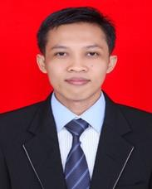 | Mustofa Abi Hamid Mustofa Abi Hamid is an assistant professor in Technical And Vocational Education and Training (TVET). Mustofa Abi Hamid received his master degree in Technical and Vocational Education from Universitas Negeri Padang (UNP) Indonesia and his bachelor degree from Universitas Lampung (UNILA), Bandarlampung, Indonesia. In 2016 he joined the Department of Electrical Engineering Vocational Education in Faculty of Teacher Training and Education of Universitas Sultan Ageng Tirtayasa, Serang Indonesia as assistant professor. He has written several papers in the areas of technical and vocational education and training, evaluation of learning, learning media, ICT for learning. His research interests also include technical and vocational education and training (TVET), Standardization in TVET, Pedagogical Innovations in TVET, Skills and Personal Development, Innovations in Engineering and Education, etc. He can be contacted at email: abi.mustofa@untirta.ac.id.
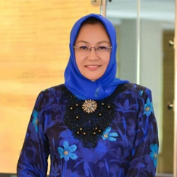 | Hazita Azman is Applied Linguistics and Literacy Studies at the Centre for Language and Linguistics Research, Faculty of Social Sciences and Humanities, UKM. She has researched extensively and has widely published in the areas of language policy, ESL literacy practices, multimodal literacies, literacy assessment, and Environmental Education for Sustainable Development (EESD). She has held administrative posts as Dean of the faculty for five years between 2011-2016, Deputy Dean from 2004-2009 and earlier as Chair of the School from 2000-2003. She is currently Dean of the Faculty of Social Sciences and Humanities (2019-2022). At the national level she serves as a panel member of the English Language Standards and Quality Council (ELSQC) for the Ministry of Education Malaysia since 2016 to current. She can be contacted at email: hazita@ukm.edu.my.
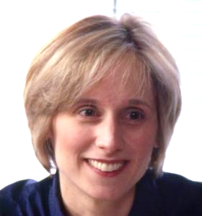 | Julie Sarama is a Distinguished University Professor, the Kennedy Endowed Chair in Innovative Learning Technologies, and co-Executive Director of the Marsico Institute for Early Learning and Literacy at the University of Denver. Julie Sarama received her PhD from the University at Buffalo, State University of New York. She conducts research on young children's development of mathematical concepts and competencies, implementation and scale-up of educational reform, professional development models and their influence on student learning, and implementation and effects of software environments (including those she has created) in mathematics classrooms. These studies have been published in more than 80 refereed articles, 7 books, 60 chapters, and over 100 additional publications. Dr. Sarama has directed over 30 projects funded by the National Science Foundation (NSF), the U.S. Department of Education’s Institute of Education Sciences (IES) the National Institute of Health (NIH), and the Office of Special Education Programs (OSEP). She can be contacted at email: Julie.Sarama@du.edu.

