Explain-to-Learn Microlearning for Metacognitive Regulation in Academic Speaking

Restu Bias Primandhika¹, Nani Solihati², Siti Zulaiha³, Aurelia Sakti Yani⁴
¹⁻³Post-Graduate School, Universitas Muhammadiyah Prof. Dr. Hamka, Jakarta, Indonesia
¹⁻³Indonesian Language Education Study Programme, Faculty of Language Education, Institut Keguruan dan Ilmu Pendidikan Siliwangi, Cimahi, Indonesia

Article Info |  | ABSTRACT
Article history:  Received month dd, yyyy  Revised month dd, yyyy  Accepted month dd, yyyy |  | This study examined whether explain-to-learn microlearning could strengthen metacognitive regulation and academic speaking performance in higher education. Over eight weeks, 80 Indonesian undergraduates completed short multimedia modules, oral explanation tasks, and structured reflection prompts. Using a classroom-based pre-post evaluation informed by design-based research, the study analyzed speaking scores, metacognitive regulation, and learner perceptions. Three findings emerged: 1) metacognitive regulation improved significantly across all three dimensions, with the largest gains in evaluation and planning (partial η² = .59); 2) academic speaking performance increased substantially across all dimensions, with the strongest gains in idea organization and clarity of explanation (d = 1.01); and 3) students rated the design highly for usefulness, cognitive engagement, and instructional clarity. The findings suggest that generative explanation and structured metacognitive reflection may serve as productive mediating activities that make brief instructional input more effective for academic speaking development.
Keywords:
Academic speaking
Explain-to-learn
Higher education
Metacognitive regulation
Microlearning
This is an open access article under the CC BY-SA license.

Corresponding Author:
Nani Solihati
Post-Graduate School, Universitas Muhammadiyah Prof. Dr. Hamka, Jakarta, Indonesia
Jl. Hajjah Tutty Alawiyah Jl. Buncit Raya, RT.2/RW.5, Kalibata, Kec. Pancoran, Kota Jakarta Selatan, Daerah Khusus Ibukota Jakarta 12740
Email: nani_solihati@uhamka.ac.id

- INTRODUCTION
University students are expected to do more than speak fluently. They must explain concepts, organize disciplinary arguments, and make their reasoning clear to listeners who are also learning. This is a cognitively demanding task, and Goh [3] argues that speaking development depends not only on what students produce, but on the internal processes (planning what to say, monitoring whether an explanation is landing, evaluating what fell short) that regulate performance before, during, and after speech. In most university speaking classrooms, however, those processes are left largely implicit. Instruction tends to prioritize observable outcomes: fluency, accuracy, pronunciation. The metacognitive work that supports them rarely receives a dedicated place in the curriculum.
In Indonesia, the stakes are higher than they might first appear. National standards for higher education now require curricula to be organized around graduate learning outcomes that explicitly include effective communication, and they mandate student-centered methods such as discussion, seminar, and project-based learning as pathways to those outcomes [1]. The policy intent is clear. In practice, though, university students frequently struggle with precisely these performances: local studies report persistent weaknesses in scientific presentation, limited oral proficiency, and public speaking anxiety among undergraduates [2]. The demand for communicative competence has moved faster than the instructional infrastructure for building it.

This is not simply a matter of exposure or practice hours. Academic speaking is cognitively heavier than everyday conversation because it requires learners to simultaneously manage content organization, self-monitoring, and audience awareness under real-time pressure. Flavell [4] identified planning, monitoring, and evaluation as foundational regulatory processes in learning; Zimmerman [5] extended that framework to self-regulated performance more broadly. Applied to speaking, these processes matter: Paterson [6] showed that structured metacognitive reflection can drive meaningful speaking improvement, and Zhang et al. [7] found consistent associations among metacognitive strategy use, task demand, and L2 speaking quality. Safari and Fitriati [8] similarly observed that higher-performing speakers are distinguishable from weaker ones partly through how they regulate their own production. The issue is not whether metacognition matters for speaking; the evidence suggests it does. The issue is that metacognitive support in university courses is typically incidental, delayed, or invisible.
Microlearning has attracted attention as one way to make instruction more focused and cognitively manageable. Short, targeted modules can reduce complexity, lower extraneous load, and keep learners engaged across constrained time windows [9], [10], [11], [12]. There is also emerging evidence that microlearning can support speaking development when it is embedded in meaningful communicative activity rather than used as isolated drill [13].
However, brevity alone does not constitute a pedagogy. When short modules function mainly as segmented content delivery, they can improve access and convenience without requiring learners to do anything generative with what they receive: reorganize it, express it aloud, or evaluate whether their explanation actually communicated what they intended. Indeed, excessively segmented instruction may risk conceptual fragmentation if generative integration tasks are absent [10], [12]. The microlearning literature has not yet worked through this problem, particularly not in the context of academic speaking where exactly this kind of elaborative, self-regulated processing matters most.
Explain-to-learn strategies offer a way to close that gap. Fiorella and Mayer [14] describe explanation as a generative learning activity, one that requires learners to select, organize, and integrate information rather than simply retrieve it. Lachner et al. [15] and Bai et al. [16] show that embedding explanation prompts in multimedia learning environments can deepen processing and surface gaps in understanding. Mayer's cognitive theory of multimedia learning [17] adds that brief, well-structured input can reduce extraneous burden and free cognitive resources for exactly this kind of active knowledge construction. > The instructional implication is that microlearning alone may not be sufficient to improve academic speaking. Rather, short instructional input appears most valuable when it initiates a broader generative learning cycle involving learner explanation, retrieval-based oral production, and explicit metacognitive reflection. In this view, microlearning functions as a trigger for active knowledge reconstruction rather than merely a content-delivery format.
Drawing on these theoretical anchors, this study proposes a three-component instructional logic connecting microlearning to academic speaking development: (a) brief multimedia input reduces extraneous cognitive load and focuses attention on a single speaking concept [17]; (b) the subsequent oral explanation task requires generative processing, forcing learners to select, reorganize, and articulate the input in their own words [14], [15], [16]; and (c) structured metacognitive prompts targeting planning, monitoring, and evaluation consolidate regulatory awareness by making the learner's own speaking process an explicit object of reflection [4], [5], [6]. Because planning and evaluation prompts operate before and after speech (where deliberate reflection is most feasible), while monitoring operates during the real-time pressure of speech production (where external scaffolding has less leverage), this logic predicts differential gains: planning and evaluation should be more responsive to the intervention than monitoring. Similarly, the explanation task's emphasis on content reorganization and self-expression predicts stronger gains in idea organization and explanatory clarity than in responsiveness, which depends more heavily on dialogic interaction than on individual rehearsal.
This study tested that logic in a classroom context over eight weeks with undergraduate students at an Indonesian university. Three questions guided the inquiry: 1) to what extent does the intervention influence students' metacognitive regulation in academic speaking; 2) how does it affect academic speaking performance across key dimensions of speaking quality; and 3) how do students perceive the usefulness, cognitive engagement, and clarity of the instructional design?

- METHOD
This study used a classroom-based pre-post evaluation informed by a design-based research orientation. This study used a classroom-based pre-post evaluation [18], [19]. Eighty undergraduate students enrolled in a language education program at a private university in Cimahi, West Java, participated through their intact classes. They had prior exposure to academic speaking coursework but varied in proficiency and metacognitive awareness. Participation followed standard institutional procedures for consent, anonymity, and non-evaluative data use.

2.1. Intervention design
The intervention ran for eight weeks within a web-based microlearning environment delivered asynchronously through Bicaranta (bicaranta.rbpwebdev.my.id), an integrated speaking course platform and LMS. Each weekly session lasted approximately 20–25 minutes and consisted of three sequenced components: (a) a 3-minute multimedia input segment (short video, annotated example, or infographic) introducing a specific academic speaking concept; (b) a 3–5-minute recorded oral explanation task in which students re-explained the material entirely in their own words without relying on presentation slides or visual supports. This requirement was intentionally designed to encourage retrieval, spontaneous idea organization, and independent formulation of explanations rather than reading or reproducing prepared content using /uji video recording feature; and (c) a 5-minute structured metacognitive reflection sequence using written prompts delivered through Bicaranta. Sample reflection prompts included: Planning: "Before your next explanation, what will you organize differently?"; Monitoring: "While recording, at what point did you feel your explanation became unclear?"; Evaluation: "After watching your recording, what was the strongest and weakest part of your explanation?" Across the eight weeks, each session addressed a different academic speaking topic (e.g., organizing an argument, signposting, responding to questions), but the three-component cycle remained constant. The course instructor monitored submissions weekly and provided brief written feedback on selected recordings, though the primary regulatory mechanism was the structured self-reflection rather than external feedback. The design moved through a standard pre-post arc:

Pre-test → Intervention (8 weeks, repeated cycles) → Post-test

Each cycle was structured so that microlearning did not stop at content delivery. Students had to re-explain what they had just encountered in their own spoken words, then reflect explicitly on how well they had communicated it, connecting brief input to generative processing and self-regulated review.

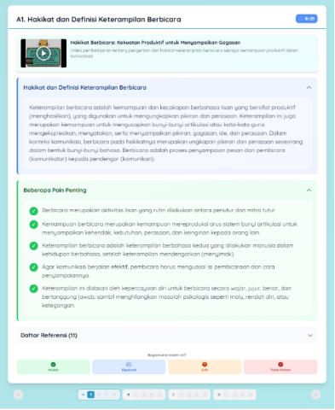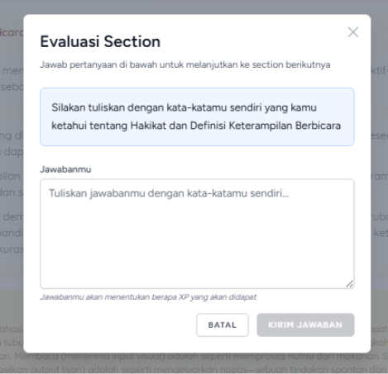
(a)
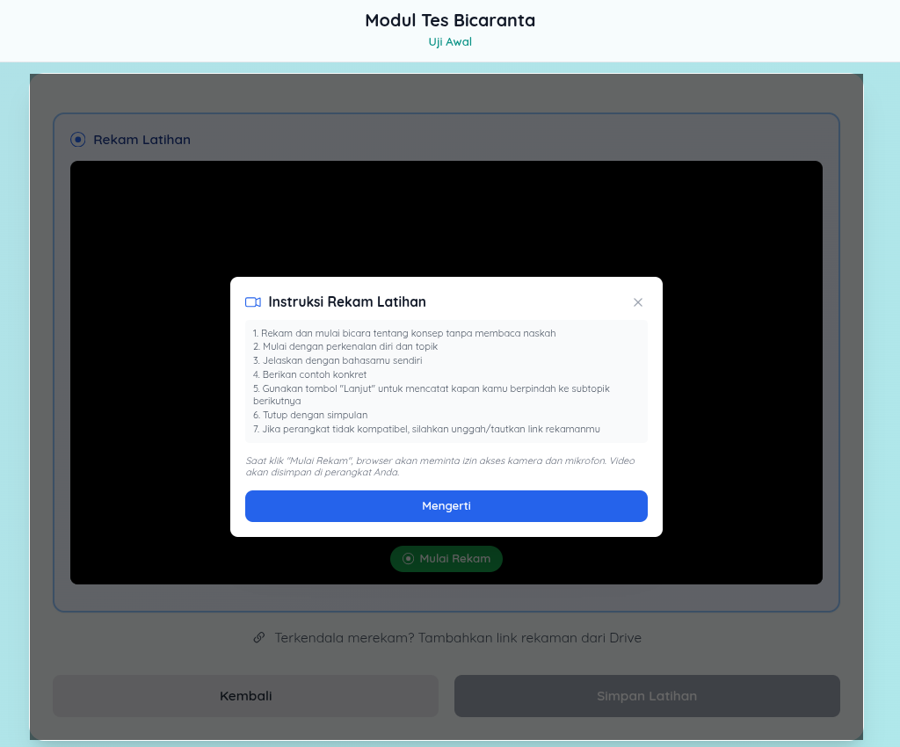

(b)

Figure 1. The preview of Bicaranta’s platform (a) microlearning course page and (b) /uji module containing rules and metacognitive-based session recording

The oral explanation stage also functioned as a retrieval practice activity. Rather than revisiting information passively, students were required to reconstruct key concepts from memory and communicate them coherently to an imagined audience. Prior research suggests that retrieval-based learning activities strengthen knowledge organization and transfer more effectively than repeated exposure alone. Accordingly, the intervention was designed not only to provide content but also to require active reconstruction of that content through speech.

2.2. Instruments
2.2.1. Speaking performance rubric
Speaking was assessed through task-based oral presentations scored on four dimensions: idea organization, clarity of explanation, strategic delivery, and responsiveness. Two independent raters used a five-point rubric adapted from previous academic speaking assessment frameworks [3], [6]. Descriptors ranged from 1 (ideas presented without discernible structure; explanation is unclear or incoherent) to 5 (ideas are logically sequenced with effective signposting; explanation is precise, audience-appropriate, and well-supported). The rubric was calibrated through two rater training sessions using anchor samples prior to scoring. Raters scored all recordings independently and were blinded to pre-post status (recordings were randomized across time points before distribution). Inter-rater reliability reached ICC = .86 (two-way mixed, absolute agreement), indicating good agreement. Discrepancies exceeding one point on any dimension were resolved through discussion.

2.2.2. Metacognitive regulation questionnaire
A 15-item instrument covering planning (5 items), monitoring (5 items), and evaluation (5 items) was used. Sample items included: "Before speaking, I think about how to organize my main ideas" (planning); "While speaking, I notice when my explanation becomes unclear" (monitoring); "After speaking, I review what I could improve next time" (evaluation). Items were rated on a four-point Likert scale (1 = never to 4 = always). The instrument was adapted from established metacognitive regulation scales and reviewed by two subject-matter experts for content validity. It was piloted with 25 students from a non-participating cohort, leading to minor wording revisions. The final instrument demonstrated acceptable internal consistency (Cronbach's α = .87 overall; planning α = .81, monitoring α = .79, evaluation α = .84).

2.1.3. Perception survey
Learner perceptions were gathered via an eight-item survey on usefulness, cognitive engagement, and instructional clarity (four-point Likert scale), supplemented by open-ended responses.

- RESULTS AND DISCUSSION
Three findings emerged from the pre-post analysis, one for each of the study's three research questions. The pattern across all three was directionally consistent, but the distribution of gains within each outcome tells a more specific story about how the intervention may have operated.

3.1 Metacognitive regulation gains
All three dimensions of metacognitive regulation (planning, monitoring, and evaluation) improved from pre-test to post-test, with the overall multivariate effect reaching significance at Wilks' Λ = .41, F(3, 76) = 44.62, p < .001, partial η² = .59. The gains were not evenly distributed across the three dimensions, and that unevenness is where the instructional interpretation becomes more specific.

Table 1. The descriptive pattern
Variable | Pre-Test M (SD) | Post-Test M (SD) | Mean Difference
Planning | 3.12 (0.78) | 4.17 (0.62) | 1.05
Monitoring | 3.45 (0.71) | 4.02 (0.68) | 0.57
Evaluation | 3.08 (0.82) | 4.26 (0.59) | 1.18
Overall speaking performance | 2.89 (0.74) | 3.94 (0.65) | 1.05

Planning and evaluation improved substantially (partial η² = .39 and .42, respectively), while monitoring improved more modestly (partial η² = .22). This differential pattern is consistent with the directional expectation outlined in Section 1. Monitoring is difficult to scaffold directly because it requires students to track their own production under the real-time pressure of ongoing speech. Planning and evaluation, by contrast, operate before and after speech, which is precisely where the intervention's explicit prompts were designed to apply force. The result aligns with what Paterson [6] and Zhang et al. [7] observed: that reflection-oriented support tends to produce stronger instructional effects than attempts to improve regulatory control during live speech production.

3.2 Academic speaking improvement
Speaking performance showed a large overall gain from pre-test to post-test (t(79) = 9.87, p < .001, d = 1.01), but the aggregate effect size flattens what is a differentiated pattern across the four speaking dimensions.

Table 2. Result of of Speaking Dimension
Dimension | t(79) | p-value | Cohen’s d [95% CI]
Idea organization | 10.12 | < .001 | 1.15 [0.90, 1.39]
Clarity of explanation | 9.56 | < .001 | 0.98 [0.74, 1.22]
Strategic delivery | 8.43 | < .001 | 0.87 [0.64, 1.10]
Responsiveness | 7.89 | < .001 | 0.82 [0.59, 1.05]
Overall performance | 9.87 | < .001 | 1.01 [0.77, 1.25]

The strongest improvements fell in idea organization (d = 1.15) and clarity of explanation (d = 0.98), the two dimensions most directly tied to what the intervention required students to do, consistent with the directional prediction in Section 1. When learners repeatedly re-express disciplinary content in their own words without the support of presentation slides, they must retrieve, reorganize, and articulate knowledge under conditions that more closely resemble authentic academic communication. This repeated cycle likely strengthened internal representations of content structure, which may explain why gains were particularly pronounced in idea organization and explanatory clarity. That cycle of selection and reformulation maps closely onto what these two dimensions assess. Explanation-centered and video-supported speaking research supports this reading [21], [22], as does technology-mediated work showing that digital speaking tasks tend to improve proficiency when they require meaningful output rather than passive media consumption [23], [24].
The comparatively smaller gain in responsiveness (d = 0.82) points to a genuine boundary of the design. The intervention prioritized individual explanation tasks delivered asynchronously; dialogic exchange, where students would need to adapt their speech in real time to a live listener, was largely absent from the cycle. Review-level evidence consistently shows that microlearning gains depend on how units are embedded in broader activity rather than on brevity alone [9], [10], [12], [25], [26], and monologue-oriented tasks are better suited to organizational control than to spontaneous interaction [27]. This finding also suggests that asynchronous monologic practice, while productive for planning-oriented speaking skills, may be inherently limited in developing the adaptive, real-time communicative competence that responsiveness requires.
Correlation between speaking performance and each metacognitive dimension (planning, r = .68; monitoring, r = .54; evaluation, r = .71; all p < .01) suggests that regulatory improvement and speaking improvement moved together rather than independently. These are associations, not causal evidence, and the design does not support a mediation claim. The pattern is taken up further in the integrated interpretation below.

3.3. Student perceptions of the design
Beyond the performance and regulation data, students were asked how they perceived the design. Perceived usefulness averaged M = 4.23 (SD = 0.71), cognitive engagement M = 4.15 (SD = 0.76), and instructional clarity M = 4.08 (SD = 0.79). The ratings were uniformly high, but the open-ended responses provide more specific insight into what may have driven them.
Open-ended responses were coded following the procedures described in Section 2.3. Three themes emerged from the analysis:

3.3.1 Manageability of short modules
Students consistently described the brief format as reducing the sense of overwhelm associated with longer lecture-based speaking instruction. One participant wrote: "I didn't feel pressured because the video was short. I could focus on one idea before moving on." Another noted: "The short format made it easier to concentrate. When I watch long lectures, I lose focus halfway."

3.3.2 Explanation as a metacognitive trigger
The oral explanation task was frequently described not merely as speaking practice but as a moment of self-confrontation with understanding gaps. A representative response: "When I explained the material aloud, I realized I actually did not fully understand the concept during the video session. Saying it in my own words forced me to think again." Another student commented: "I thought I understood, but when I had to explain it on camera, I found I could not organize my ideas clearly." Interestingly, many students described moments of difficulty during explanation as productive rather than discouraging. Several participants reported discovering gaps in understanding only when they attempted to explain concepts aloud. This pattern is consistent with generative learning perspectives suggesting that explanation activities reveal incomplete understanding and stimulate deeper processing.

3.3.3 Reflection prompts supporting deliberate preparation
Students reported that the structured reflection sequence helped them approach subsequent speaking tasks with more intentionality. One participant stated: "The reflection questions made me think about what I did wrong and what I should do differently next time. Before this, I never thought about how I speak." Another added: "After answering the reflection prompts, I started planning what to say before recording instead of just talking."

What is notable across these themes is their specificity. Students were not describing general satisfaction with a digital platform; they were identifying the structural features of the design in terms that closely match the design's theoretical rationale. That alignment between perceived mechanism and intended mechanism gives the quantitative gains a clearer interpretive grounding.

3.4 Integrated interpretation
Reading the three sets of findings alongside each other sharpens the picture. Metacognitive gains were largest in the dimensions tied to before and after speaking: planning and evaluation. Speaking gains were largest in the dimensions most dependent on knowing what to say and how to frame it: organization and explanatory clarity. These patterns mirror each other structurally, and the correlation between evaluation and speaking performance (r = .71) suggests they were not independent: students who improved most in post-task regulatory review were also those who showed the strongest gains in how they organized and delivered their explanations. The observed gains are consistent with the proposed instructional logic in which the repeated cycle of reorganization, expression, and reflection provides students with progressively clearer internal models of what a well-explained idea sounds like.
That interpretation must be stated within honest limits. The study ran in a single institutional context within one disciplinary program, relied on self-report for metacognitive regulation, and used a one-group pre-post design without a comparison condition. Without a control group, it is not possible to rule out maturation, concurrent course effects, novelty effects from the digital platform, or other influences on performance; the correlational associations do not establish mediation. There is also a risk that some reflection responses may have been superficial rather than genuinely regulatory, a limitation inherent to prompt-based metacognitive scaffolding that this design cannot fully assess. Additionally, the asynchronous monologic mode constrains generalizability to interactive speaking contexts. What the study can defensibly claim is that substantial gains in both metacognitive regulation and academic speaking appeared under conditions where microlearning was coupled with generative explanation and explicit metacognitive scaffolding, and that students described the mechanism in terms consistent with how the design was theorized. That is a meaningful but bounded finding. Whether this design outperforms alternative instructional arrangements, and whether gains hold across different populations, disciplines, and longer timeframes, are questions that require controlled and more sustained investigation.

- CONCLUSION
Substantial pre-post gains were observed across multiple dimensions of metacognitive regulation and academic speaking performance. The more informative finding, however, is the pattern within them. Planning and evaluation improved more than monitoring; idea organization and explanatory clarity improved more than responsiveness. This distribution is not random; it tracks the structure of the intervention. The design applied deliberate pressure to pre-task organization, post-task review, and the specific demands of formulating and expressing a coherent explanation aloud. The dimensions that showed the largest gains were those the intervention was built to target. Because the intervention combined several instructional components, including microlearning, explanation, retrieval-based speaking practice, and metacognitive reflection, the present design cannot isolate the relative contribution of each element. Future studies employing factorial or comparison-group designs may help determine which components are most influential in producing speaking gains.
The practical implication is narrower than a general endorsement of microlearning for speaking. Short content units alone are unlikely to produce this kind of gain. What appears to matter is not merely the brevity of instructional input but the cognitive work that follows it. Learners were required to retrieve, reorganize, explain, and evaluate knowledge repeatedly across eight weeks. Under these conditions, microlearning functioned less as a delivery mechanism and more as the entry point to a structured cycle of generative speaking practice and metacognitive regulation; whether they must reorganize it, express it in their own spoken words, and then evaluate how well their explanation worked. Under those conditions, microlearning may stop functioning as a delivery format and begin operating as the first step in a generative cycle. That is the design proposition this study advances, and it is a testable one.
The single-context, no-control design limits how far that proposition can currently travel. Replication in more varied settings, with longer durations, more interactive speaking tasks, and a comparison condition, is the clear next step, one that would allow stronger statements about relative effectiveness rather than pre-post change alone. For now, the evidence provides university speaking instructors with a structured and theoretically grounded model: one that takes the communicative competences that Indonesian national curriculum standards now formally require [1] and offers a concrete instructional path for building them.

ACKNOWLEDGMENTS
The authors would like to thank IKIP Siliwangi, particularly the Lembaga Penelitian dan Pengabdian kepada Masyarakat (LPPM), for their institutional cooperation and academic support during the data collection process. The authors also sincerely thank the lecturer participants and student respondents for their valuable time, experiences, and perspectives, which contributed significantly to the completion of this study.

FUNDING INFORMATION
This research was funded by the Anggaran Pendapatan dan Belanja Negara (APBN) through the Pusat Pembiayaan dan Asesmen Pendidikan Tinggi (PPAPT) under the 2025 Domestic Doctoral Study Completion Scholarship Programme (Beasiswa Program Doktor Penyelesaian Studi di Dalam Negeri Tahun 2025).

AUTHOR CONTRIBUTIONS STATEMENT
Restu Bias Primandhika contributed to conceptualization, methodology, formal analysis, investigation, data curation, writing the original draft, visualization, project administration, and funding acquisition. Nani Solihati contributed to conceptualization, methodology, validation, writing review and editing, supervision, and project administration. Siti Zulaiha contributed to conceptualization, methodology, validation, writing review and editing, supervision, and project administration. While Aurelia Sakti Yani contributed to data collection, curation, and project administration.

Name of Author | C | M | So | Va | Fo | I | R | D | O | E | Vi | Su | P | Fu
Restu Bias Primandhika
Nani Solihati
Siti Zulaiha
Aurelia Sakti Yani

C : Conceptualization  M : Methodology  So : Software  Va : Validation  Fo : Formal analysis | I : Investigation  R : Resources  D : Data Curation  O : Writing - Original Draft  E : Writing - Review & Editing | Vi : Visualization  Su : Supervision  P : Project administration  Fu : Funding acquisition

CONFLICT OF INTEREST STATEMENT
The authors state that they have no conflict of interest.

INFORMED CONSENT
All student participants were provided with a written informed consent form prior to their involvement in the study. By signing the form, they confirmed their voluntary participation and acknowledged that their learning activities would be observed and documented as part of the research process.

ETHICAL APPROVAL
This study involved university students and was conducted in accordance with relevant institutional guidelines for educational research, including voluntary participation, anonymity, confidentiality, and non-evaluative participation. No separate ethics approval number was reported in the study records used for this manuscript.

DATA AVAILABILITY
The data that support the findings of this study are available from the corresponding author upon reasonable request. The data are not publicly available because they contain information that could compromise the privacy of research participants.

REFERENCES
[1] Menteri Pendidikan dan Kebudayaan Republik Indonesia, Peraturan Menteri Pendidikan dan Kebudayaan Republik Indonesia Nomor 3 Tahun 2020 tentang Standar Nasional Pendidikan Tinggi, 2020. [Online]. Available: https://peraturan.bpk.go.id/Details/163703/permendikbud-no-3-tahun-2020
[2] A. Gunawan, M. Yamin, and M. M. Hidayatullah, "Analisis kemampuan berbicara dalam presentasi ilmiah mahasiswa Program Studi Pendidikan Teknologi Informasi STKIP Taman Siswa Bima," 2023. [Online]. Available: https://download.garuda.kemdikbud.go.id/article.php?article=3454585&val=30103&title=Analisis%20Kemampuan%20Berbicara%20dalam%20Presentasi%20Ilmiah%20Mahasiswa%20Program%20Studi%20Pendidikan%20Teknologi%20Informasi%20STKIP%20Taman%20Siswa%20Bima
[3] C. C. M. Goh, "Research into practice: Scaffolding learning processes to improve speaking performance," Language Teaching, vol. 50, no. 2, pp. 247-260, 2017, doi: 10.1017/S0261444816000483.
[4] J. H. Flavell, "Metacognition and cognitive monitoring: A new area of cognitive-developmental inquiry," American Psychologist, vol. 34, no. 10, pp. 906-911, 1979, doi: 10.1037/0003-066X.34.10.906.
[5] B. J. Zimmerman, "Becoming a self-regulated learner: An overview," Theory Into Practice, vol. 41, no. 2, pp. 64-70, 2002, doi: 10.1207/s15430421tip4102_2.
[6] R. Paterson, "Prompting metacognitive reflection to facilitate speaking improvements in learners of English as a foreign language," English Teaching & Learning, vol. 46, no. 2, pp. 157-177, 2022, doi: 10.1007/s42321-021-00086-2.
[7] W. Zhang, M. Zhao, and Y. Zhu, "Understanding individual differences in metacognitive strategy use, task demand, and performance in integrated L2 speaking assessment tasks," Frontiers in Psychology, vol. 13, art. 876208, 2022, doi: 10.3389/fpsyg.2022.876208.
[8] M. Safari and S. Fitriati, "Learning strategies used by learners with different speaking performance for developing speaking ability," English Education Journal, vol. 6, no. 2, pp. 87-100, 2017. [Online]. Available: https://journal.unnes.ac.id/sju/index.php/eej/article/view/13060
[9] K. Leong, A. Sung, D. Au, and C. Blanchard, "A review of the trend of microlearning," Journal of Work-Applied Management, vol. 13, no. 1, pp. 88-102, 2020, doi: 10.1108/JWAM-10-2020-0044.
[10] A.-d. Taylor and W. Hung, "The effects of microlearning: A scoping review," Educational Technology Research and Development, vol. 70, no. 2, pp. 363-395, 2022, doi: 10.1007/s11423-022-10084-1.
[11] Y. M. Lee, "Mobile microlearning: A systematic literature review and its implications," Interactive Learning Environments, vol. 31, no. 7, pp. 4636-4651, 2023, doi: 10.1080/10494820.2021.1977964.
[12] N. F. Alias and R. A. Razak, "Exploring the pedagogical aspects of microlearning in educational settings: A systematic literature review," Malaysian Journal of Learning and Instruction, vol. 20, no. 2, pp. 267-294, 2023, doi: 10.32890/mjli2023.20.2.3.
[13] P. Prasittichok and P. N. Smithsarakarn, "The effects of microlearning on EFL students' English speaking: A systematic review and meta-analysis," International Journal of Learning, Teaching and Educational Research, vol. 23, no. 4, 2024. [Online]. Available: https://www.ijlter.org/index.php/ijlter/article/view/10006
[14] L. Fiorella and R. E. Mayer, Learning as a Generative Activity: Eight Learning Strategies that Promote Understanding. Cambridge, U.K.: Cambridge Univ. Press, 2016, doi: 10.1017/CBO9781107707085.
[15] A. Lachner, M. Weinhuber, V. Hoogerheide, and A. Renkl, "Benefits of writing an explanation during pauses in multimedia lessons," Educational Psychology Review, vol. 33, pp. 1859-1885, 2021, doi: 10.1007/s10648-021-09594-w.
[16] C. Bai, J. Yang, and Y. Tang, "Embedding self-explanation prompts to support learning via instructional video," Instructional Science, vol. 50, no. 5, pp. 681-701, 2022. [Online]. Available: https://eric.ed.gov/?id=EJ1350050
[17] R. E. Mayer, Ed., The Cambridge Handbook of Multimedia Learning, 2nd ed. Cambridge, U.K.: Cambridge Univ. Press, 2014, doi: 10.1017/CBO9781139547369.
[18] Design-Based Research Collective, "Design-based research: An emerging paradigm for educational inquiry," Educational Researcher, vol. 32, no. 1, pp. 5-8, 2003, doi: 10.3102/0013189X032001005.
[19] S. McKenney and T. C. Reeves, Conducting Educational Design Research, 2nd ed. New York, NY, USA: Routledge, 2019, doi: 10.4324/9781315105642.
[20] V. Braun and V. Clarke, "Using thematic analysis in psychology," Qualitative Research in Psychology, vol. 3, no. 2, pp. 77-101, 2006, doi: 10.1191/1478088706qp063oa.
[21] S. Adipat, "An artificial intelligence-enhanced phenomenon-based learning approach for interdisciplinary understanding and speaking skills," International Journal of Instruction, vol. 16, no. 3, pp. 531-550, 2023, doi: 10.29333/iji.2023.16329a.
[22] S. Menggo, A. Basir, and Y. S. Halum, "Video-based tasks in strengthening speaking skills of EFL college students," Indonesian Journal of EFL and Linguistics, vol. 7, no. 2, pp. 279-297, 2022, doi: 10.21462/ijefl.v7i2.510.
[23] S. Y. Gao, Y. Y. Tsai, J. H. Huang, Y. X. Ma, and T. L. Wu, "TikTok for developing learning motivation and oral proficiency in MICE learners," Journal of Hospitality, Leisure, Sport & Tourism Education, vol. 32, art. 100415, 2023, doi: 10.1016/j.jhlste.2022.100415.
[24] W. Hanafiah, M. Aswad, H. Sahib, A. H. Yassi, and M. S. Mousavi, "The impact of CALL on vocabulary learning, speaking skill, and foreign language speaking anxiety: The case study of Indonesian EFL learners," Education Research International, vol. 2022, art. 5500077, 2022, doi: 10.1155/2022/5500077.
[25] M. J. Dolasinski and J. Reynolds, "Microlearning: A new learning model," Journal of Hospitality & Tourism Research, vol. 44, no. 3, pp. 551-561, 2020, doi: 10.1177/1096348020901579.
[26] A. D. Samala, L. Bojic, D. Bekiroğlu, R. Watrianthos, and Y. Hendriyani, "Microlearning: Transforming education with bite-sized learning on the go-insights and applications," International Journal of Interactive Mobile Technologies, vol. 17, no. 21, pp. 4-24, 2023, doi: 10.3991/ijim.v17i21.42951.
[27] I. Karpovich, O. Sheredekina, T. Krepkaia, and L. Voronova, "The use of monologue speaking tasks to improve first-year students' English-speaking skills," Education Sciences, vol. 11, no. 6, art. 298, 2021, doi: 10.3390/educsci11060298.
BIOGRAPHIES OF AUTHORS

 | Restu Bias Primandhika  is a lecturer expertised in Language Learning, Linguistics and Digital Learning Media. He received his master's degree in Indonesian Language Education of IKIP Siliwangi and is a doctoral students in Universitas Muhammadiyah Prof. Dr. Hamka. In 2018 he joined the Faculty of Language Education of IKIP Siliwangi as lecturer. He has written several papers in the areas of the impact of learning technology on cognitive abilities: exploring digital media preferences of Indonesian language education students, AI’s impact on students’ oral presentation skills: Indonesian lecturers’ pedagogical responses, experiment on a transformer model Indonesian-to-sundanese neural machine translation with Sundanese speech level evaluation. His research interests also include digital learning media, Indonesian language education, learning technology, pedagogical innovations, artificial intelligence in education, machine translation, etc. He can be contacted at email: restubiasprimandhika@uhamka.ac.id.
 | Nani Solihati  is a professor in Indonesian Language and Literature Education at the Post-Graduate School, Universitas Muhammadiyah Prof. DR. Hamka (UHAMKA). She has researched extensively and has widely published in the areas of critical thinking tasks in language textbooks, literary psychology, gender inequality in literature, and character education through traditional games. She can be contacted at email: nani_solihati@uhamka.ac.id.
 | Siti Zulaiha  is an Associate Professor, the Head of the Master’s Degree Program in English Education, and a senior lecturer at the Graduate School of Universitas Muhammadiyah Prof. DR. HAMKA (UHAMKA). She conducts research on primary school foreign language learning, teaching, and assessment, implementation of next-generation assessment models, English curriculum development, and the perceptions and pedagogical challenges faced by EFL teachers in language classrooms. These studies have been published in various refereed articles, book chapters, and academic publications, including insights on language assessment and English linguistics.  She can be contacted at email: siti.zulaiha@uhamka.ac.id.
 | Aurelia Sakti Yani is a lecturer in Indonesian Language and Literature Education. Aurelia Sakti Yani received both her master's degree (S2) and bachelor's degree (S1) in Indonesian Language and Literature Education from IKIP Siliwangi (formerly STKIP Siliwangi), Cimahi, Indonesia. She joined the Faculty of Language Education at IKIP Siliwangi, Cimahi, Indonesia as a lecturer. She has written several papers in the areas of educational technology optimization, psychological aspects of education, digital literacy, and digital netiquette. Her research interests also include speculative fiction analysis in educational technology, youth delinquency in educational psychology, anti-human trafficking awareness, and community empowerment. She can be contacted at email: saktiyani@ikipsiliwangi.ac.id.

