International Journal of Language Education
Metacognitive regulation and academic speaking performance in explain-to-learn microlearning
Restu Bias Primandhika
Universitas Muhammadiyah Prof. Dr. Hamka, Indonesia
restubiasprimandhika@uhamka.ac.id
Nani Solihati
Universitas Muhammadiyah Prof. Dr. Hamka, Indonesia
nani_solihati@uhamka.ac.id
Siti Zulaiha
Universitas Muhammadiyah Prof. Dr. Hamka, Indonesia
siti.zulaiha@uhamka.ac.id
Aurelia Sakti Yani
Institut Keguruan dan Ilmu Pendidikan Siliwangi, Indonesia
saktiyani@ikipsiliwangi.ac.id
Corresponding author: Nani Solihati (nani_solihati@uhamka.ac.id)
Abstract
This study examined explain-to-learn microlearning in relation to metacognitive regulation and academic speaking performance in higher education. After data cleaning, 79 Indonesian undergraduates contributed valid questionnaire data across an eight-week classroom implementation; matched pre-post speaking scores were available for 35 students. The study used a 15-item four-point metacognitive regulation questionnaire, a five-dimension speaking rubric, and a 12-item four-point learner-perception survey. Post-intervention metacognitive regulation was high for planning (M = 3.88, SD = 0.17), monitoring (M = 3.83, SD = 0.19), and evaluation (M = 3.92, SD = 0.15), although no matched metacognitive pre-test was available for estimating change. Among matched speaking cases, overall performance increased from M = 3.53 (SD = 0.20) to M = 4.04 (SD = 0.26), t(34) = 10.03, p < .001, d = 1.70. Significant gains occurred in language use, clarity of explanation (articulation), idea organization (structure), and communicative impact, whereas audience adaptation did not change significantly. Closed-ended perception ratings were highest for usefulness (M = 2.97, SD = 0.43), followed by instructional clarity (M = 2.60, SD = 0.27) and cognitive engagement (M = 2.23, SD = 0.31) on the four-point scale. The findings support the potential of explanation-centered microlearning for selected dimensions of academic speaking, while the available data do not support a pre-post claim for metacognitive regulation.
Keywords: Academic speaking; explain-to-learn; higher education; metacognitive regulation; microlearning
Introduction
University students must explain concepts, organize disciplinary arguments, and make their reasoning clear to listeners. Goh (2017) argues that speaking development depends on both oral production and the processes that regulate performance before, during, and after speech, including planning, monitoring, and evaluation. Speaking instruction therefore needs to address how students prepare, assess the clarity of their explanations, and review their performance alongside fluency, accuracy, and pronunciation.
In Indonesia, the 2020 national standards for higher education identified communication-related learning outcomes and student-centered instructional approaches (Menteri Pendidikan dan Kebudayaan Republik Indonesia, 2020). Research on Indonesian undergraduates has also examined variation in pronunciation, grammar, vocabulary, fluency, and comprehension during scientific presentations (Purnamasari, 2022). These demands provide a context for examining instructional support for academic speaking and the regulatory processes involved.
Literature review
Metacognitive regulation in academic speaking
Academic speaking requires learners to manage content organization, self-monitoring, and audience awareness under real-time pressure. Flavell (1979) described metacognition and cognitive monitoring, while Zimmerman (2002) connected regulatory processes to self-regulated learning. In speaking research, Paterson (2022) examined structured metacognitive reflection as a means of supporting performance, and Zhang et al. (2022) investigated relationships among metacognitive strategy use, task demand, and L2 speaking performance. Safari and Fitriati (2016) also identified differences in learning strategy use among learners with different speaking performance. These studies provide a rationale for making planning, monitoring, and evaluation explicit within speaking instruction.
Microlearning and explanation-based learning
Microlearning has attracted attention as one way to make instruction more focused and cognitively manageable. Short, targeted modules can reduce complexity, lower extraneous load, and keep learners engaged across constrained time windows (Alias & Abdul Razak, 2023; Lee, 2023; Leong et al., 2021; Taylor & Hung, 2022). There is also emerging evidence that microlearning can support speaking development when it is embedded in meaningful communicative activity rather than used as isolated drill (Prasittichok & Smithsarakarn, 2024).
The brevity of a microlearning unit does not specify what learners do with its content. Short modules can improve access while offering limited opportunity to reorganize information, explain it aloud, or evaluate whether an explanation communicates its intended meaning. Reviews of microlearning emphasize the importance of pedagogical design and the activities surrounding each unit (Alias & Abdul Razak, 2023; Taylor & Hung, 2022). For academic speaking, this raises the question of how brief input can be connected to oral production and structured reflection.
Explain-to-learn activities offer one way to connect brief input with generative processing. Fiorella and Mayer (2015) describe explanation as an activity that requires learners to select, organize, and integrate information. Lawson and Mayer (2021) found benefits from writing explanations during pauses in multimedia lessons, while Bai et al. (2022) examined self-explanation prompts in instructional video learning. These findings support the design rationale for explanation tasks, although they do not directly establish effects on academic speaking. Mayer's (2014) multimedia learning framework further informs the use of brief, structured input to support active processing.
Instructional rationale and research questions
Drawing on these theoretical foundations, the study used a three-component instructional sequence: (a) brief multimedia input to focus attention on a specific speaking concept (Mayer, 2014); (b) oral explanation requiring learners to select, reorganize, and articulate the input in their own words (Bai et al., 2022; Fiorella & Mayer, 2015; Lawson & Mayer, 2021); and (c) structured prompts that make planning, monitoring, and evaluation explicit objects of reflection (Flavell, 1979; Paterson, 2022; Zimmerman, 2002). Because the explanation task emphasizes retrieval, organization, and oral reformulation, improvement was expected to be more visible in dimensions practiced through individual explanation than in audience adaptation, which requires responsiveness to listeners.
This study examined that instructional logic in a classroom context over eight weeks with undergraduate students at an Indonesian university. Three questions guided the inquiry: 1) what post-intervention profile of metacognitive regulation is observed across planning, monitoring, and evaluation; 2) how does academic speaking performance change from pre-test to post-test across the assessed speaking dimensions; and 3) how do students perceive the usefulness, cognitive engagement, and clarity of the instructional design?
Research method
Design and participants
This study used a classroom-based pre-post evaluation informed by a design-based research orientation (The Design-Based Research Collective, 2003; McKenney & Reeves, 2019). During data cleaning, one non-participant test entry used for system checking was removed, leaving 79 undergraduate students enrolled in a language education program at a private university in Cimahi, West Java, in the valid participant pool. They participated through their intact classes and had prior exposure to academic speaking coursework but varied in proficiency and metacognitive awareness. Outcome availability differed across measures: valid metacognitive-regulation and learner-perception records were available for 79 students, speaking pre-test records were available for 77 students, and 35 students had complete matched pre-post speaking scores. Inferential analyses of speaking change therefore used the 35 matched cases.
All student participants were provided with a written informed consent form prior to their involvement in the study. By signing the form, they confirmed their voluntary participation and acknowledged that their learning activities would be observed and documented as part of the research process. This study involved university students and was conducted in accordance with relevant institutional guidelines for educational research, including voluntary participation, anonymity, confidentiality, and non-evaluative participation. No separate ethics approval number was documented in the study records.
Intervention design
The intervention ran for eight weeks within a web-based microlearning environment delivered asynchronously through Bicaranta (bicaranta.rbpwebdev.my.id), an integrated speaking course platform and LMS. Each weekly session lasted approximately 20–25 minutes and consisted of three sequenced components: (a) a 3-minute multimedia input segment (short video, annotated example, or infographic) introducing a specific academic speaking concept; (b) a 3–5-minute recorded oral explanation task in which students re-explained the material entirely in their own words without relying on presentation slides or visual supports. Students used the platform’s video-recording feature to retrieve, organize, and explain content independently; and (c) a 5-minute structured metacognitive reflection sequence using written prompts delivered through Bicaranta.
Sample reflection prompts included: Planning: "Before your next explanation, what will you organize differently?"; Monitoring: "While recording, at what point did you feel your explanation became unclear?"; Evaluation: "After watching your recording, what was the strongest and weakest part of your explanation?" Across the eight weeks, each session addressed a different academic speaking topic (e.g., organizing an argument, signposting, responding to questions), but the three-component cycle remained constant. The course instructor monitored submissions weekly and provided brief written feedback on selected recordings, though the primary regulatory mechanism was the structured self-reflection rather than external feedback. The design moved through a standard pre-post arc:
Pre-test → Intervention (8 weeks, repeated cycles) → Post-test
Each cycle was structured so that microlearning did not stop at content delivery. Students had to re-explain what they had just encountered in their own spoken words, then reflect explicitly on how well they had communicated it, connecting brief input to generative processing and self-regulated review.
The oral explanation stage also incorporated retrieval practice. Students reconstructed key concepts from memory and communicated them to an imagined audience. The task was designed to combine recall, organization, and oral reformulation, consistent with the generative learning strategies described by Fiorella and Mayer (2015).
Figure 1
Bicaranta microlearning and recording interfaces
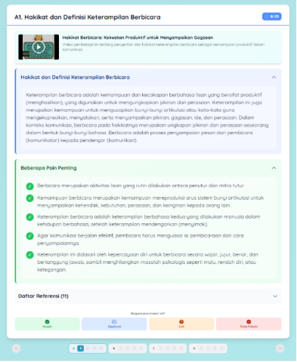 | 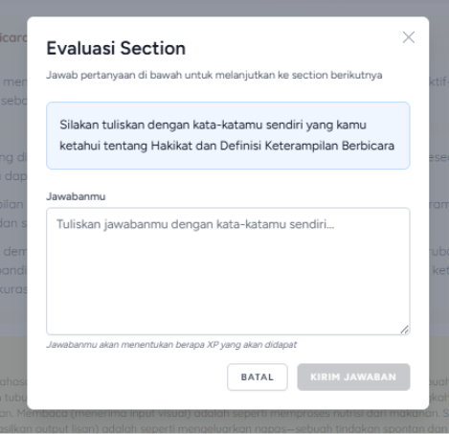
(a) Microlearning content and section evaluation
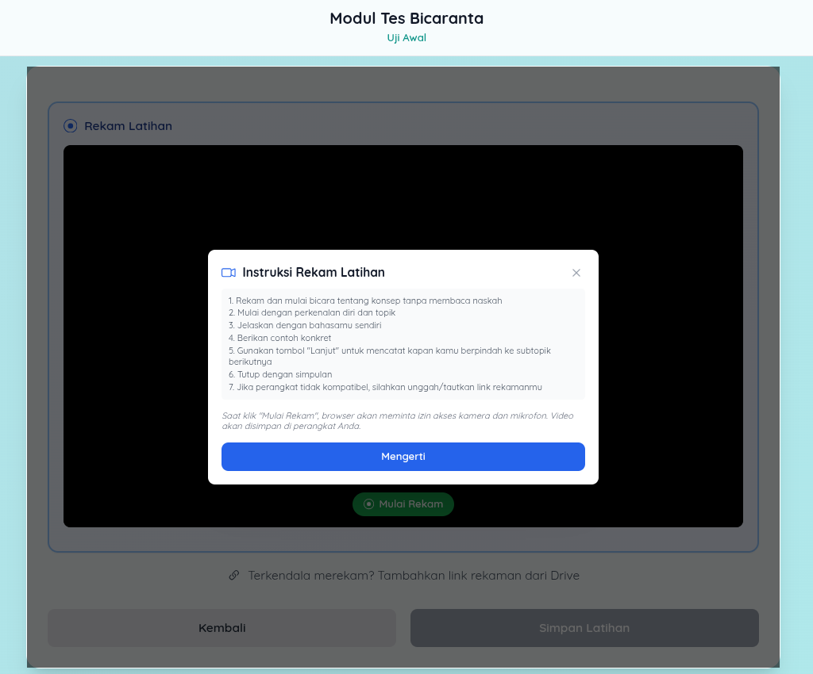 | 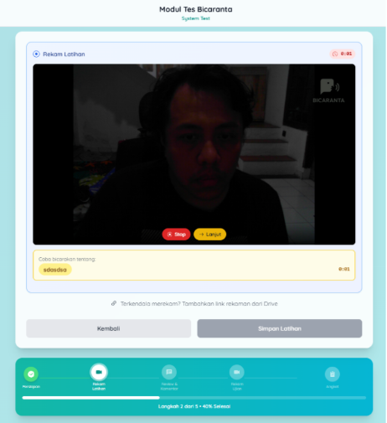
(b) Recording instructions and speaking session
Instruments
Speaking performance rubric
Speaking was assessed through task-based oral presentations scored on five dimensions represented in the assessment data: language use, clarity of explanation (articulation), idea organization (structure), audience adaptation, and communicative impact. Each dimension comprised three rubric criteria scored on a five-point scale, and dimension scores were expressed on the corresponding 1-5 scale for analysis. Two independent raters used the rubric adapted from previous academic speaking assessment frameworks (Goh, 2017; Paterson, 2022). The rubric was calibrated through two rater training sessions using anchor samples prior to scoring. Raters scored recordings independently and were blinded to pre-post status. Inter-rater reliability reached ICC = .86 (two-way mixed, absolute agreement), indicating good agreement. Discrepancies exceeding one point on any criterion were resolved through discussion.
Metacognitive regulation questionnaire
A 15-item instrument covering planning (5 items), monitoring (5 items), and evaluation (5 items) was used. Sample items included: "Before speaking, I think about how to organize my main ideas" (planning); "While speaking, I notice when my explanation becomes unclear" (monitoring); "After speaking, I review what I could improve next time" (evaluation). Items were rated on a four-point Likert scale (1 = never to 4 = always), and negatively keyed items were reverse-scored before dimension means were calculated. The instrument was adapted from established metacognitive regulation scales and reviewed by two subject-matter experts for content validity. It was piloted with 25 students from a non-participating cohort, leading to minor wording revisions. The final instrument demonstrated acceptable internal consistency in the pilot (Cronbach's α = .87 overall; planning α = .81, monitoring α = .79, evaluation α = .84).
Perception survey
Learner perceptions were gathered via a 12-item survey using a four-point Likert scale. For descriptive analysis, items P1-P4, P5-P8, and P9-P12 were treated as the three intended blocks representing usefulness, cognitive engagement, and instructional clarity, respectively, supplemented by open-ended responses.
Data analysis
Quantitative data analysis used descriptive and inferential statistics. Means and standard deviations were calculated for metacognitive regulation, academic speaking, and learner perceptions. Because the metacognitive-regulation dataset comprised post-intervention responses without matched pre-test responses, planning, monitoring, and evaluation were analyzed descriptively rather than as pre-post gains. Speaking change was analyzed only for students with matched pre-test and post-test scores (n = 35) using paired-samples t-tests for the five speaking dimensions and overall performance. Cohen's d for paired samples was calculated as the mean change divided by the standard deviation of the change scores. Pearson correlations examined associations between post-test speaking performance and post-intervention planning, monitoring, and evaluation among the matched cases. Learner-perception means were calculated from the three four-item survey blocks on their original 1-4 scale. Statistical significance was set at p < .05.
Open-ended survey responses were coded using thematic analysis following Braun and Clarke (2006). The analysis focused on recurring patterns in students' perceptions and yielded three themes: manageability of short modules, explanation as a metacognitive trigger, and reflection prompts supporting deliberate preparation.
The data that support the findings of this study are available from the corresponding author upon reasonable request. The data are not publicly available because they contain information that could compromise the privacy of research participants.
Results
The analysis addressed post-intervention metacognitive regulation, matched pre-post academic speaking performance, and learner perceptions. Metacognitive scores were analyzed descriptively because matched pre-test responses were unavailable.
Post-intervention metacognitive regulation
After exclusion of the non-participant test entry, 79 valid questionnaire responses remained. All three metacognitive dimensions fell within the logical 1.00-4.00 range of the four-point scale. Evaluation had the highest mean (M = 3.92, SD = 0.15), followed by planning (M = 3.88, SD = 0.17) and monitoring (M = 3.83, SD = 0.19). The overall metacognitive-regulation mean was 3.88 (SD = 0.11). These values indicate a high post-intervention self-reported regulation profile, but they should not be interpreted as gains because the metacognitive dataset comprised post-intervention responses only.
Table 1. Post-intervention metacognitive regulation (n = 79)
Dimension | M | SD | Observed range
Planning | 3.88 | 0.17 | 3.40-4.00
Monitoring | 3.83 | 0.19 | 3.40-4.00
Evaluation | 3.92 | 0.15 | 3.20-4.00
Overall regulation | 3.88 | 0.11 | 3.53-4.00
Note. Scores were measured on a four-point scale. M = mean; SD = standard deviation.
Academic speaking performance
Complete matched pre-test and post-test speaking scores were available for 35 students. Overall performance increased from M = 3.53 (SD = 0.20) to M = 4.04 (SD = 0.26), t(34) = 10.03, p < .001, d = 1.70. The dimension-level results show that this overall gain was not uniform across all aspects of speaking.
Table 2. Pre-post academic speaking performance among matched cases (n = 35)
Dimension | Pre-test M (SD) | Post-test M (SD) | Paired test
Language use | 3.34 (0.35) | 4.09 (0.54) | t(34) = 6.84, p < .001, d = 1.16
Clarity of explanation (articulation) | 3.72 (0.33) | 4.21 (0.59) | t(34) = 3.85, p < .001, d = 0.65
Idea organization (structure) | 3.39 (0.41) | 4.10 (0.53) | t(34) = 5.44, p < .001, d = 0.92
Audience adaptation | 3.69 (0.34) | 3.64 (0.65) | t(34) = -0.40, p = .694, d = -0.07
Communicative impact | 3.50 (0.39) | 4.16 (0.50) | t(34) = 5.99, p < .001, d = 1.01
Overall performance | 3.53 (0.20) | 4.04 (0.26) | t(34) = 10.03, p < .001, d = 1.70
Note. Scores were measured on a five-point scale. Paired tests used 35 matched cases. Cohen’s d was calculated as mean change divided by the standard deviation of change scores.
Audience adaptation changed from M = 3.69 to M = 3.64, t(34) = -0.40, p = .694, d = -0.07. This change was not statistically significant.
Associations between regulation and speaking performance
Post-test speaking performance was not significantly correlated with the three metacognitive dimensions among the 35 matched speaking cases (planning, r = .07, p = .674; monitoring, r = -.15, p = .401; evaluation, r = -.19, p = .278).
Student perceptions
Beyond performance and regulation, students completed the 12-item perception survey on the same four-point response scale. Using the three four-item blocks retained in the dataset, perceived usefulness averaged M = 2.97 (SD = 0.43), cognitive engagement M = 2.23 (SD = 0.31), and instructional clarity M = 2.60 (SD = 0.27). These ratings are better characterized as mixed or moderate than uniformly high: usefulness received the strongest closed-ended rating, whereas cognitive engagement was lower. The open-ended responses provide additional context for how students interpreted particular features of the design.
Open-ended responses were coded using the thematic analysis procedures described in the Data analysis subsection. Three themes emerged.
Manageability of short modules
Students consistently described the brief format as reducing the sense of overwhelm associated with longer lecture-based speaking instruction. One participant wrote: "I didn't feel pressured because the video was short. I could focus on one idea before moving on." Another noted: "The short format made it easier to concentrate. When I watch long lectures, I lose focus halfway."
Explanation as a metacognitive trigger
The oral explanation task was frequently described not merely as speaking practice but as a moment of self-confrontation with understanding gaps. A representative response: "When I explained the material aloud, I realized I actually did not fully understand the concept during the video session. Saying it in my own words forced me to think again." Another student commented: "I thought I understood, but when I had to explain it on camera, I found I could not organize my ideas clearly." Interestingly, many students described moments of difficulty during explanation as productive rather than discouraging. Several participants reported discovering gaps in understanding only when they attempted to explain concepts aloud. This pattern is consistent with generative learning perspectives suggesting that explanation activities reveal incomplete understanding and stimulate deeper processing.
Reflection prompts supporting deliberate preparation
Students reported that the structured reflection sequence helped them approach subsequent speaking tasks with more intentionality. One participant stated: "The reflection questions made me think about what I did wrong and what I should do differently next time. Before this, I never thought about how I speak." Another added: "After answering the reflection prompts, I started planning what to say before recording instead of just talking."
Discussion
Post-intervention regulation
The three dimensions were closely clustered near the upper end of the scale, with evaluation marginally higher than planning and monitoring. This pattern is compatible with an intervention that repeatedly prompted students to plan, monitor, and review their speaking, particularly through post-task reflection (Paterson, 2022; Zhang et al., 2022). However, the restricted upper-end distribution also limits how strongly differences among the dimensions can be interpreted. Most importantly, the present dataset supports a descriptive statement about post-intervention regulation, not a statistical claim that metacognitive regulation increased over time.
Differences across speaking dimensions
The largest standardized gain was observed for language use (d = 1.16), followed by communicative impact (d = 1.01) and idea organization (structure) (d = 0.92). Clarity of explanation (articulation) also improved significantly (d = 0.65). These dimensions are consistent with the kinds of performance repeatedly practiced in the explain-to-learn cycle: retrieving content, reformulating it in one's own words, organizing it into a coherent sequence, and delivering it audibly to an intended listener. Explanation-centered and video-supported speaking research likewise suggests that meaningful oral production can support speaking development when learners must actively reconstruct rather than passively revisit content (Adipat, 2023; Gao et al., 2023; Hanafiah et al., 2022; Menggo et al., 2022).
The intervention prioritized asynchronous individual explanation rather than live dialogic exchange, so students had relatively limited opportunity to adapt language, examples, or formality in response to an interlocutor. Review-level evidence similarly emphasizes that microlearning outcomes depend on the activity surrounding the short unit (Alias & Abdul Razak, 2023; Dolasinski & Reynolds, 2020; Leong et al., 2021; Samala et al., 2023; Taylor & Hung, 2022), and research on monologue tasks provides a relevant context for considering the opportunities and limits of individually organized oral production (Karpovich et al., 2021).
Learner perceptions and integrated interpretation
Students' comments identified specific features of the design, including the short modules, oral explanation tasks, and reflection prompts. The closed-ended ratings were more moderate, particularly for cognitive engagement. The qualitative comments therefore provide context for how students experienced the design, but do not establish that all students rated every aspect highly.
The findings indicate high post-intervention self-reported metacognitive regulation alongside improvement in several academic speaking dimensions among the 35 matched cases. The absence of a metacognitive pre-test prevents an inference of change in regulation, and the nonsignificant correlations do not establish an association between end-point regulation and speaking performance. The restricted range of metacognitive scores may have reduced observable covariance, but the available data do not establish a mediating role for regulation. The explain-to-learn cycle thus coincided with improvement in several individually practiced speaking dimensions while students reported high post-intervention regulation.
Limitations
That interpretation must remain within several limits. The study was conducted in a single institutional context within one disciplinary program and relied on self-report for metacognitive regulation. The metacognitive dataset did not include a matched pre-test, so change in planning, monitoring, and evaluation cannot be estimated. Speaking pre-test data were available for 77 students, but only 35 had complete matched post-test speaking scores, creating a substantial complete-case limitation and possible selection bias. The classroom-based design was not randomized, and the available outcome records do not permit strong causal attribution of the observed speaking changes to the intervention alone. In addition, the asynchronous monologic mode constrains generalizability to interactive speaking contexts. These limitations make the present findings useful as evidence of a promising instructional pattern rather than as a definitive test of comparative effectiveness.
Conclusion
Post-intervention metacognitive regulation was high across planning, monitoring, and evaluation on the four-point questionnaire, but improvement in these dimensions cannot be established without a matched pre-test. Among the 35 students with matched speaking scores, overall academic speaking performance improved, with significant gains in language use, clarity of explanation (articulation), idea organization (structure), and communicative impact. Audience adaptation did not improve significantly. The pattern suggests that the asynchronous explanation-centered design may be more applicable to individually practiced dimensions of speaking than to adaptive interaction.
The instructional implication is that brief input can support a speaking sequence in which learners retrieve, reorganize, explain, and review content. In this study, that sequence was associated with gains in several speaking dimensions, while students rated usefulness more highly than cognitive engagement. Future implementations could retain the explanation and reflection cycle and add interactive tasks that require students to respond to listeners.
Further research should use complete pre-post measurement for both speaking and metacognitive regulation, minimize outcome attrition, and employ a clearly documented comparison condition or randomized design where feasible. Larger matched samples would also permit more stable estimates of associations between regulatory processes and speaking outcomes. Until such evidence is available, the present study is best read as a classroom-based evaluation showing promising but dimension-specific speaking change rather than as proof of broad causal effects across all outcomes.
Funding Information
This research was funded by the Anggaran Pendapatan dan Belanja Negara (APBN) through the Pusat Pembiayaan dan Asesmen Pendidikan Tinggi (PPAPT) under the 2025 Domestic Doctoral Study Completion Scholarship Programme (Beasiswa Program Doktor Penyelesaian Studi di Dalam Negeri Tahun 2025). The authors thank IKIP Siliwangi, particularly the Lembaga Penelitian dan Pengabdian kepada Masyarakat (LPPM), and the participating lecturers and students for their support.
The authors declare that there is no conflict of interest in this work.
References
Adipat, S. (2023). An artificial intelligence-enhanced phenomenon-based learning approach for interdisciplinary understanding and speaking skills. International Journal of Instruction, 16(3), 531–550. https://doi.org/10.29333/iji.2023.16329a
Alias, N. F., & Abdul Razak, R. (2023). Exploring the pedagogical aspects of microlearning in educational settings: A systematic literature review. Malaysian Journal of Learning and Instruction, 20(2), 267–294. https://doi.org/10.32890/mjli2023.20.2.3
Bai, C., Yang, J., & Tang, Y. (2022). Embedding self-explanation prompts to support learning via instructional video. Instructional Science, 50(5), 681–701. https://doi.org/10.1007/s11251-022-09587-4
Braun, V., & Clarke, V. (2006). Using thematic analysis in psychology. Qualitative Research in Psychology, 3(2), 77–101. https://doi.org/10.1191/1478088706qp063oa
The Design-Based Research Collective. (2003). Design-based research: An emerging paradigm for educational inquiry. Educational Researcher, 32(1), 5–8. https://doi.org/10.3102/0013189X032001005
Dolasinski, M. J., & Reynolds, J. (2020). Microlearning: A new learning model. Journal of Hospitality & Tourism Research, 44(3), 551–561. https://doi.org/10.1177/1096348020901579
Fiorella, L., & Mayer, R. E. (2015). Learning as a generative activity: Eight learning strategies that promote understanding. Cambridge University Press. https://doi.org/10.1017/CBO9781107707085
Flavell, J. H. (1979). Metacognition and cognitive monitoring: A new area of cognitive-developmental inquiry. American Psychologist, 34(10), 906–911. https://doi.org/10.1037/0003-066X.34.10.906
Gao, S.-Y., Tsai, Y.-Y., Huang, J.-H., Ma, Y.-X., & Wu, T.-L. (2023). TikTok for developing learning motivation and oral proficiency in MICE learners. Journal of Hospitality, Leisure, Sport & Tourism Education, 32, Article 100415. https://doi.org/10.1016/j.jhlste.2022.100415
Goh, C. C. M. (2017). Research into practice: Scaffolding learning processes to improve speaking performance. Language Teaching, 50(2), 247–260. https://doi.org/10.1017/S0261444816000483
Hanafiah, W., Aswad, M., Sahib, H., Yassi, A. H., & Mousavi, M. S. (2022). The impact of CALL on vocabulary learning, speaking skill, and foreign language speaking anxiety: The case study of Indonesian EFL learners. Education Research International, 2022, Article 5500077. https://doi.org/10.1155/2022/5500077
Karpovich, I., Sheredekina, O., Krepkaia, T., & Voronova, L. (2021). The use of monologue speaking tasks to improve first-year students’ English-speaking skills. Education Sciences, 11(6), Article 298. https://doi.org/10.3390/educsci11060298
Lawson, A. P., & Mayer, R. E. (2021). Benefits of writing an explanation during pauses in multimedia lessons. Educational Psychology Review, 33(4), 1859–1885. https://doi.org/10.1007/s10648-021-09594-w
Lee, Y.-M. (2023). Mobile microlearning: A systematic literature review and its implications. Interactive Learning Environments, 31(7), 4636–4651. https://doi.org/10.1080/10494820.2021.1977964
Leong, K., Sung, A., Au, D., & Blanchard, C. (2021). A review of the trend of microlearning. Journal of Work-Applied Management, 13(1), 88–102. https://doi.org/10.1108/JWAM-10-2020-0044
Mayer, R. E. (Ed.). (2014). The Cambridge handbook of multimedia learning (2nd ed.). Cambridge University Press. https://doi.org/10.1017/CBO9781139547369
McKenney, S., & Reeves, T. C. (2019). Conducting educational design research (2nd ed.). Routledge. https://doi.org/10.4324/9781315105642
Menggo, S., Basir, A., & Halum, Y. S. (2022). Video-based tasks in strengthening speaking skills of EFL college students. Indonesian Journal of EFL and Linguistics, 7(2), 279–297. https://doi.org/10.21462/ijefl.v7i2.510
Menteri Pendidikan dan Kebudayaan Republik Indonesia. (2020). Peraturan Menteri Pendidikan dan Kebudayaan Republik Indonesia Nomor 3 Tahun 2020 tentang Standar Nasional Pendidikan Tinggi. https://peraturan.bpk.go.id/Details/163703/permendikbud-no-3-tahun-2020
Paterson, R. (2022). Prompting metacognitive reflection to facilitate speaking improvements in learners of English as a foreign language. English Teaching & Learning, 46(2), 157–177. https://doi.org/10.1007/s42321-021-00086-2
Prasittichok, P., & Smithsarakarn, P. N. (2024). The effects of microlearning on EFL students’ English speaking: A systematic review and meta-analysis. International Journal of Learning, Teaching and Educational Research, 23(4), 525–546. https://doi.org/10.26803/ijlter.23.4.27
Purnamasari, R. (2022). Analisis kemampuan berbicara dalam presentasi ilmiah mahasiswa Program Studi Pendidikan Teknologi Informasi STKIP Taman Siswa Bima. Sintaks: Jurnal Bahasa & Sastra Indonesia, 2(2), 180–186. https://doi.org/10.57251/sin.v2i2.525
Safari, M. U. K., & Fitriati, S. W. (2016). Learning strategies used by learners with different speaking performance for developing speaking ability. English Education Journal, 6(2), 87–100. https://journal.unnes.ac.id/sju/eej/article/view/13060
Samala, A. D., Bojic, L., Bekiroğlu, D., Watrianthos, R., & Hendriyani, Y. (2023). Microlearning: Transforming education with bite-sized learning on the go—Insights and applications. International Journal of Interactive Mobile Technologies, 17(21), 4–24. https://doi.org/10.3991/ijim.v17i21.42951
Taylor, A.-d., & Hung, W. (2022). The effects of microlearning: A scoping review. Educational Technology Research and Development, 70(2), 363–395. https://doi.org/10.1007/s11423-022-10084-1
Zhang, W., Zhao, M., & Zhu, Y. (2022). Understanding individual differences in metacognitive strategy use, task demand, and performance in integrated L2 speaking assessment tasks. Frontiers in Psychology, 13, Article 876208. https://doi.org/10.3389/fpsyg.2022.876208
Zimmerman, B. J. (2002). Becoming a self-regulated learner: An overview. Theory Into Practice, 41(2), 64–70. https://doi.org/10.1207/s15430421tip4102_2

