Explain-to-Learn Microlearning for Metacognitive Regulation in Academic Speaking

Restu Bias Primandhika¹, Nani Solihati², Siti Zulaiha³, Aurelia Sakti Yani⁴
¹⁻³Post-Graduate School, Universitas Muhammadiyah Prof. Dr. Hamka, Jakarta, Indonesia
¹⁻³Indonesian Language Education Study Programme, Faculty of Language Education, Institut Keguruan dan Ilmu Pendidikan Siliwangi, Cimahi, Indonesia

Article Info |  | ABSTRACT
Article history:  Received month dd, yyyy  Revised month dd, yyyy  Accepted month dd, yyyy |  | This study examined explain-to-learn microlearning in relation to metacognitive regulation and academic speaking performance in higher education. After data cleaning, 79 Indonesian undergraduates contributed valid questionnaire data across an eight-week classroom implementation; matched pre-post speaking scores were available for 35 students. The study used a 15-item four-point metacognitive regulation questionnaire, a five-dimension speaking rubric, and a 12-item four-point learner-perception survey. Post-intervention metacognitive regulation was high for planning (M = 3.88, SD = 0.17), monitoring (M = 3.83, SD = 0.19), and evaluation (M = 3.92, SD = 0.15), although no matched metacognitive pre-test was available for estimating change. Among matched speaking cases, overall performance increased from M = 3.53 (SD = 0.20) to M = 4.04 (SD = 0.26), t(34) = 10.03, p < .001, d = 1.70. Significant gains occurred in language use, clarity of explanation (articulation), idea organization (structure), and communicative impact, whereas audience adaptation did not change significantly. Closed-ended perception ratings were highest for usefulness (M = 2.97, SD = 0.43), followed by instructional clarity (M = 2.60, SD = 0.27) and cognitive engagement (M = 2.23, SD = 0.31) on the four-point scale. The findings support the potential of explanation-centered microlearning for selected dimensions of academic speaking, while the available data do not support a pre-post claim for metacognitive regulation.
Keywords:
Academic speaking
Explain-to-learn
Higher education
Metacognitive regulation
Microlearning
This is an open access article under the CC BY-SA license.

Corresponding Author:
Nani Solihati
Post-Graduate School, Universitas Muhammadiyah Prof. Dr. Hamka, Jakarta, Indonesia
Jl. Hajjah Tutty Alawiyah Jl. Buncit Raya, RT.2/RW.5, Kalibata, Kec. Pancoran, Kota Jakarta Selatan, Daerah Khusus Ibukota Jakarta 12740
Email: nani_solihati@uhamka.ac.id

- INTRODUCTION
University students are expected to do more than speak fluently. They must explain concepts, organize disciplinary arguments, and make their reasoning clear to listeners who are also learning. This is a cognitively demanding task, and Goh [3] argues that speaking development depends not only on what students produce, but on the internal processes (planning what to say, monitoring whether an explanation is landing, evaluating what fell short) that regulate performance before, during, and after speech. In most university speaking classrooms, however, those processes are left largely implicit. Instruction tends to prioritize observable outcomes: fluency, accuracy, pronunciation. The metacognitive work that supports them rarely receives a dedicated place in the curriculum.
In Indonesia, the stakes are higher than they might first appear. National standards for higher education now require curricula to be organized around graduate learning outcomes that explicitly include effective communication, and they mandate student-centered methods such as discussion, seminar, and project-based learning as pathways to those outcomes [1]. The policy intent is clear. In practice, though, university students frequently struggle with precisely these performances: local studies report persistent weaknesses in scientific presentation, limited oral proficiency, and public speaking anxiety among undergraduates [2]. The demand for communicative competence has moved faster than the instructional infrastructure for building it.

This is not simply a matter of exposure or practice hours. Academic speaking is cognitively heavier than everyday conversation because it requires learners to simultaneously manage content organization, self-monitoring, and audience awareness under real-time pressure. Flavell [4] identified planning, monitoring, and evaluation as foundational regulatory processes in learning; Zimmerman [5] extended that framework to self-regulated performance more broadly. Applied to speaking, these processes matter: Paterson [6] showed that structured metacognitive reflection can drive meaningful speaking improvement, and Zhang et al. [7] found consistent associations among metacognitive strategy use, task demand, and L2 speaking quality. Safari and Fitriati [8] similarly observed that higher-performing speakers are distinguishable from weaker ones partly through how they regulate their own production. The issue is not whether metacognition matters for speaking; the evidence suggests it does. The issue is that metacognitive support in university courses is typically incidental, delayed, or invisible.
Microlearning has attracted attention as one way to make instruction more focused and cognitively manageable. Short, targeted modules can reduce complexity, lower extraneous load, and keep learners engaged across constrained time windows [9], [10], [11], [12]. There is also emerging evidence that microlearning can support speaking development when it is embedded in meaningful communicative activity rather than used as isolated drill [13].
However, brevity alone does not constitute a pedagogy. When short modules function mainly as segmented content delivery, they can improve access and convenience without requiring learners to do anything generative with what they receive: reorganize it, express it aloud, or evaluate whether their explanation actually communicated what they intended. Indeed, excessively segmented instruction may risk conceptual fragmentation if generative integration tasks are absent [10], [12]. The microlearning literature has not yet worked through this problem, particularly not in the context of academic speaking where exactly this kind of elaborative, self-regulated processing matters most.
Explain-to-learn strategies offer a way to close that gap. Fiorella and Mayer [14] describe explanation as a generative learning activity, one that requires learners to select, organize, and integrate information rather than simply retrieve it. Lachner et al. [15] and Bai et al. [16] show that embedding explanation prompts in multimedia learning environments can deepen processing and surface gaps in understanding. Mayer's cognitive theory of multimedia learning [17] adds that brief, well-structured input can reduce extraneous burden and free cognitive resources for exactly this kind of active knowledge construction. > The instructional implication is that microlearning alone may not be sufficient to improve academic speaking. Rather, short instructional input appears most valuable when it initiates a broader generative learning cycle involving learner explanation, retrieval-based oral production, and explicit metacognitive reflection. In this view, microlearning functions as a trigger for active knowledge reconstruction rather than merely a content-delivery format.
Drawing on these theoretical anchors, this study proposes a three-component instructional logic connecting microlearning to academic speaking development: (a) brief multimedia input reduces extraneous cognitive load and focuses attention on a single speaking concept [17]; (b) the subsequent oral explanation task requires generative processing, forcing learners to select, reorganize, and articulate the input in their own words [14], [15], [16]; and (c) structured metacognitive prompts targeting planning, monitoring, and evaluation make the learner's own speaking process an explicit object of reflection [4], [5], [6]. Because the explanation task emphasizes retrieval, organization, and oral reformulation, improvement was expected to be more visible in dimensions directly practiced through individual explanation than in audience-adaptive performance, which depends more heavily on live dialogic interaction.
This study examined that instructional logic in a classroom context over eight weeks with undergraduate students at an Indonesian university. Three questions guided the inquiry: 1) what post-intervention profile of metacognitive regulation is observed across planning, monitoring, and evaluation; 2) how does academic speaking performance change from pre-test to post-test across the assessed speaking dimensions; and 3) how do students perceive the usefulness, cognitive engagement, and clarity of the instructional design?

- METHOD
This study used a classroom-based pre-post evaluation informed by a design-based research orientation [18], [19]. During data cleaning, one non-participant test entry used for system checking was removed, leaving 79 undergraduate students enrolled in a language education program at a private university in Cimahi, West Java, in the valid participant pool. They participated through their intact classes and had prior exposure to academic speaking coursework but varied in proficiency and metacognitive awareness. Outcome availability differed across measures: valid metacognitive-regulation and learner-perception records were available for 79 students, speaking pre-test records were available for 77 students, and 35 students had complete matched pre-post speaking scores. Inferential analyses of speaking change therefore used the 35 matched cases. Participation followed standard institutional procedures for consent, anonymity, and non-evaluative data use.

2.1. Intervention design
The intervention ran for eight weeks within a web-based microlearning environment delivered asynchronously through Bicaranta (bicaranta.rbpwebdev.my.id), an integrated speaking course platform and LMS. Each weekly session lasted approximately 20–25 minutes and consisted of three sequenced components: (a) a 3-minute multimedia input segment (short video, annotated example, or infographic) introducing a specific academic speaking concept; (b) a 3–5-minute recorded oral explanation task in which students re-explained the material entirely in their own words without relying on presentation slides or visual supports. This requirement was intentionally designed to encourage retrieval, spontaneous idea organization, and independent formulation of explanations rather than reading or reproducing prepared content using /uji video recording feature; and (c) a 5-minute structured metacognitive reflection sequence using written prompts delivered through Bicaranta. Sample reflection prompts included: Planning: "Before your next explanation, what will you organize differently?"; Monitoring: "While recording, at what point did you feel your explanation became unclear?"; Evaluation: "After watching your recording, what was the strongest and weakest part of your explanation?" Across the eight weeks, each session addressed a different academic speaking topic (e.g., organizing an argument, signposting, responding to questions), but the three-component cycle remained constant. The course instructor monitored submissions weekly and provided brief written feedback on selected recordings, though the primary regulatory mechanism was the structured self-reflection rather than external feedback. The design moved through a standard pre-post arc:

Pre-test → Intervention (8 weeks, repeated cycles) → Post-test

Each cycle was structured so that microlearning did not stop at content delivery. Students had to re-explain what they had just encountered in their own spoken words, then reflect explicitly on how well they had communicated it, connecting brief input to generative processing and self-regulated review.

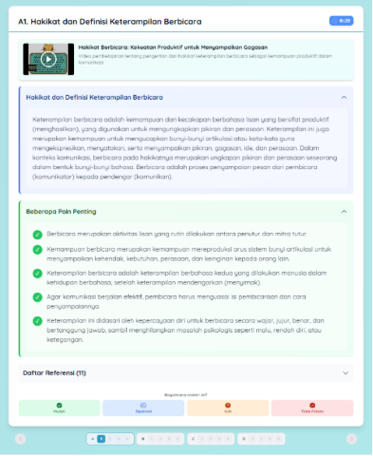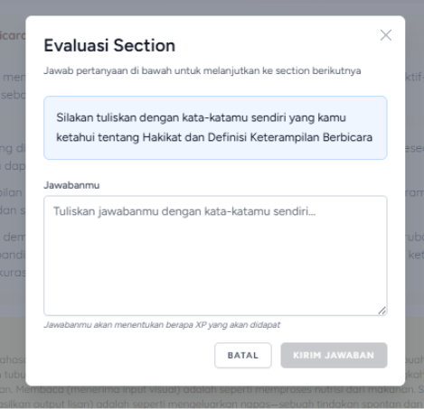
(a)
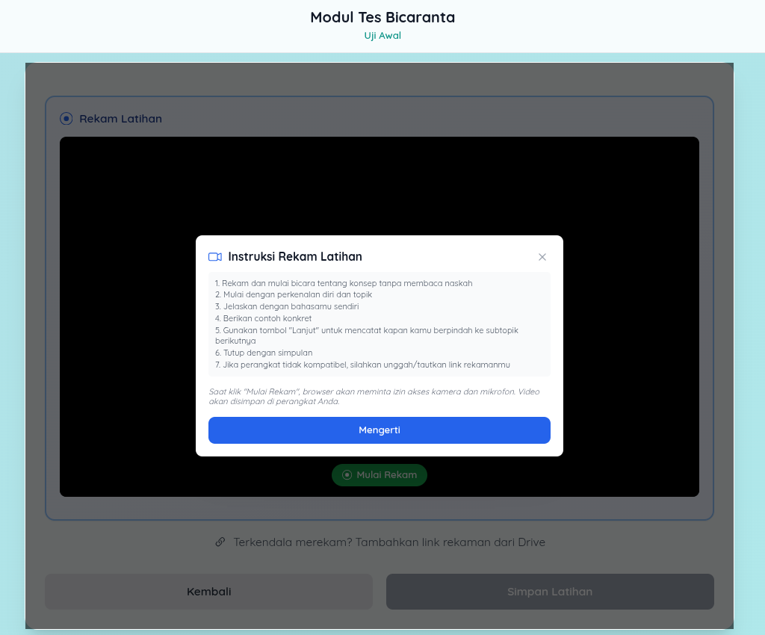
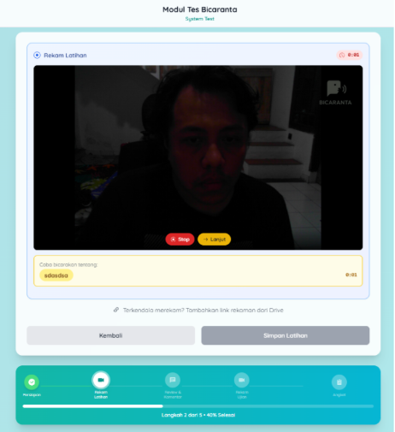
(b)

Figure 1. The preview of Bicaranta’s platform (a) microlearning course page and (b) /uji module containing rules and metacognitive-based session recording

The oral explanation stage also functioned as a retrieval practice activity. Rather than revisiting information passively, students were required to reconstruct key concepts from memory and communicate them coherently to an imagined audience. Prior research suggests that retrieval-based learning activities strengthen knowledge organization and transfer more effectively than repeated exposure alone. Accordingly, the intervention was designed not only to provide content but also to require active reconstruction of that content through speech.

2.2. Instruments
2.2.1. Speaking performance rubric
Speaking was assessed through task-based oral presentations scored on five dimensions represented in the assessment data: language use, clarity of explanation (articulation), idea organization (structure), audience adaptation, and communicative impact. Each dimension comprised three rubric criteria scored on a five-point scale, and dimension scores were expressed on the corresponding 1-5 scale for analysis. Two independent raters used the rubric adapted from previous academic speaking assessment frameworks [3], [6]. The rubric was calibrated through two rater training sessions using anchor samples prior to scoring. Raters scored recordings independently and were blinded to pre-post status. Inter-rater reliability reached ICC = .86 (two-way mixed, absolute agreement), indicating good agreement. Discrepancies exceeding one point on any criterion were resolved through discussion.

2.2.2. Metacognitive regulation questionnaire
A 15-item instrument covering planning (5 items), monitoring (5 items), and evaluation (5 items) was used. Sample items included: "Before speaking, I think about how to organize my main ideas" (planning); "While speaking, I notice when my explanation becomes unclear" (monitoring); "After speaking, I review what I could improve next time" (evaluation). Items were rated on a four-point Likert scale (1 = never to 4 = always), and negatively keyed items were reverse-scored before dimension means were calculated. The instrument was adapted from established metacognitive regulation scales and reviewed by two subject-matter experts for content validity. It was piloted with 25 students from a non-participating cohort, leading to minor wording revisions. The final instrument demonstrated acceptable internal consistency in the pilot (Cronbach's α = .87 overall; planning α = .81, monitoring α = .79, evaluation α = .84).

2.2.3. Perception survey
Learner perceptions were gathered via a 12-item survey using a four-point Likert scale. For descriptive analysis, items P1-P4, P5-P8, and P9-P12 were treated as the three intended blocks representing usefulness, cognitive engagement, and instructional clarity, respectively, supplemented by open-ended responses.
2.3. Data Analysis
Quantitative data analysis used descriptive and inferential statistics. Means and standard deviations were calculated for metacognitive regulation, academic speaking, and learner perceptions. Because the metacognitive-regulation dataset comprised post-intervention responses without matched pre-test responses, planning, monitoring, and evaluation were analyzed descriptively rather than as pre-post gains. Speaking change was analyzed only for students with matched pre-test and post-test scores (n = 35) using paired-samples t-tests for the five speaking dimensions and overall performance. Cohen's d for paired samples was calculated as the mean change divided by the standard deviation of the change scores. Pearson correlations examined associations between post-test speaking performance and post-intervention planning, monitoring, and evaluation among the matched cases. Learner-perception means were calculated from the three four-item survey blocks on their original 1-4 scale. Statistical significance was set at p < .05.
Open-ended survey responses were coded using thematic analysis following Braun and Clarke [20]. The analysis focused on recurring patterns in students' perceptions and yielded three themes: manageability of short modules, explanation as a metacognitive trigger, and reflection prompts supporting deliberate preparation.
- RESULTS AND DISCUSSION
Three findings emerged from the recalculated analysis. First, metacognitive-regulation scores were high at the post-intervention measurement, but the absence of a metacognitive pre-test prevents an inference of pre-post improvement. Second, matched speaking scores showed substantial overall improvement, with a differentiated pattern across the five assessed dimensions. Third, the closed-ended perception ratings were mixed rather than uniformly high, while the open-ended responses continued to identify specific features of the instructional design.

3.1 Post-intervention metacognitive regulation
After exclusion of the non-participant test entry, 79 valid questionnaire responses remained. All three metacognitive dimensions fell within the logical 1.00-4.00 range of the four-point scale. Evaluation had the highest mean (M = 3.92, SD = 0.15), followed by planning (M = 3.88, SD = 0.17) and monitoring (M = 3.83, SD = 0.19). The overall metacognitive-regulation mean was 3.88 (SD = 0.11). These values indicate a high post-intervention self-reported regulation profile, but they should not be interpreted as gains because the metacognitive dataset comprised post-intervention responses only.

Table 1. Post-intervention metacognitive regulation (n = 79)
Dimension | M | SD | Observed range
Planning | 3.88 | 0.17 | 3.40-4.00
Monitoring | 3.83 | 0.19 | 3.40-4.00
Evaluation | 3.92 | 0.15 | 3.20-4.00
Overall regulation | 3.88 | 0.11 | 3.53-4.00

The three dimensions were closely clustered near the upper end of the scale, with evaluation marginally higher than planning and monitoring. This pattern is compatible with an intervention that repeatedly prompted students to plan, monitor, and review their speaking, particularly through post-task reflection [6], [7]. However, the restricted upper-end distribution also limits how strongly differences among the dimensions can be interpreted. Most importantly, the present dataset supports a descriptive statement about post-intervention regulation, not a statistical claim that metacognitive regulation increased over time.

3.2 Academic speaking change
Complete matched pre-test and post-test speaking scores were available for 35 students. Overall performance increased from M = 3.53 (SD = 0.20) to M = 4.04 (SD = 0.26), t(34) = 10.03, p < .001, d = 1.70. The dimension-level results show that this overall gain was not uniform across all aspects of speaking.

Table 2. Pre-post academic speaking performance among matched cases (n = 35)
Dimension | Pre-test M (SD) | Post-test M (SD) | Paired test
Language use | 3.34 (0.35) | 4.09 (0.54) | t(34) = 6.84, p < .001, d = 1.16
Clarity of explanation (articulation) | 3.72 (0.33) | 4.21 (0.59) | t(34) = 3.85, p < .001, d = 0.65
Idea organization (structure) | 3.39 (0.41) | 4.10 (0.53) | t(34) = 5.44, p < .001, d = 0.92
Audience adaptation | 3.69 (0.34) | 3.64 (0.65) | t(34) = -0.40, p = .694, d = -0.07
Communicative impact | 3.50 (0.39) | 4.16 (0.50) | t(34) = 5.99, p < .001, d = 1.01
Overall performance | 3.53 (0.20) | 4.04 (0.26) | t(34) = 10.03, p < .001, d = 1.70

The largest standardized gain was observed for language use (d = 1.16), followed by communicative impact (d = 1.01) and idea organization (structure) (d = 0.92). Clarity of explanation (articulation) also improved significantly (d = 0.65). These dimensions are consistent with the kinds of performance repeatedly practiced in the explain-to-learn cycle: retrieving content, reformulating it in one's own words, organizing it into a coherent sequence, and delivering it audibly to an intended listener. Explanation-centered and video-supported speaking research likewise suggests that meaningful oral production can support speaking development when learners must actively reconstruct rather than passively revisit content [21]-[24].
Audience adaptation was the exception. Its mean changed only from 3.69 to 3.64, t(34) = -0.40, p = .694, d = -0.07. This null result marks an important boundary of the design. The intervention prioritized asynchronous individual explanation rather than live dialogic exchange, so students had relatively limited opportunity to adapt language, examples, or formality in response to an interlocutor. Review-level evidence similarly emphasizes that microlearning outcomes depend on the activity surrounding the short unit [9], [10], [12], [25], [26], while monologue-oriented tasks are less suited to adaptive interaction [27].
Post-test speaking performance was not significantly correlated with the three metacognitive dimensions among the 35 matched speaking cases (planning, r = .07, p = .674; monitoring, r = -.15, p = .401; evaluation, r = -.19, p = .278). Thus, the recalculated data do not support the earlier claim that stronger self-reported regulation was associated with stronger speaking performance. The restricted range of the metacognitive scores may have reduced observable covariance, but the present data do not permit a mediation or coupling claim.

3.3. Student perceptions of the design
Beyond performance and regulation, students completed the 12-item perception survey on the same four-point response scale. Using the three four-item blocks retained in the dataset, perceived usefulness averaged M = 2.97 (SD = 0.43), cognitive engagement M = 2.23 (SD = 0.31), and instructional clarity M = 2.60 (SD = 0.27). These ratings are better characterized as mixed or moderate than uniformly high: usefulness received the strongest closed-ended rating, whereas cognitive engagement was lower. The open-ended responses provide additional context for how students interpreted particular features of the design.
Open-ended responses were coded following the procedures described in Section 2.3. Three themes emerged from the analysis:

3.3.1 Manageability of short modules
Students consistently described the brief format as reducing the sense of overwhelm associated with longer lecture-based speaking instruction. One participant wrote: "I didn't feel pressured because the video was short. I could focus on one idea before moving on." Another noted: "The short format made it easier to concentrate. When I watch long lectures, I lose focus halfway."

3.3.2 Explanation as a metacognitive trigger
The oral explanation task was frequently described not merely as speaking practice but as a moment of self-confrontation with understanding gaps. A representative response: "When I explained the material aloud, I realized I actually did not fully understand the concept during the video session. Saying it in my own words forced me to think again." Another student commented: "I thought I understood, but when I had to explain it on camera, I found I could not organize my ideas clearly." Interestingly, many students described moments of difficulty during explanation as productive rather than discouraging. Several participants reported discovering gaps in understanding only when they attempted to explain concepts aloud. This pattern is consistent with generative learning perspectives suggesting that explanation activities reveal incomplete understanding and stimulate deeper processing.

3.3.3 Reflection prompts supporting deliberate preparation
Students reported that the structured reflection sequence helped them approach subsequent speaking tasks with more intentionality. One participant stated: "The reflection questions made me think about what I did wrong and what I should do differently next time. Before this, I never thought about how I speak." Another added: "After answering the reflection prompts, I started planning what to say before recording instead of just talking."
Across the qualitative themes, students identified concrete structural features of the design rather than offering only general satisfaction statements. At the same time, the recalculated closed-ended survey means were more moderate than the original manuscript reported. The qualitative comments therefore add mechanism-focused context, but they should not be treated as evidence that all students rated every aspect of the design highly.

3.4 Integrated interpretation
Reading the recalculated findings together produces a more bounded picture than the original analysis. Metacognitive regulation was high at the post-intervention measurement, especially for evaluation, but the available data contain no matched metacognitive pre-test and therefore cannot establish improvement. Academic speaking, by contrast, showed a large overall pre-post gain among the 35 matched cases, with significant improvement in language use, clarity of explanation (articulation), idea organization (structure), and communicative impact, but not audience adaptation. The absence of significant correlations between post-test speaking and self-reported metacognitive regulation means that the two outcomes cannot be claimed to have moved together. The strongest defensible interpretation is therefore that the explain-to-learn cycle coincided with improvement in several individually practiced speaking dimensions while students simultaneously reported high end-point metacognitive regulation.
That interpretation must remain within several limits. The study was conducted in a single institutional context within one disciplinary program and relied on self-report for metacognitive regulation. The metacognitive dataset did not include a matched pre-test, so change in planning, monitoring, and evaluation cannot be estimated. Speaking pre-test data were available for 77 students, but only 35 had complete matched post-test speaking scores, creating a substantial complete-case limitation and possible selection bias. The classroom-based design was not randomized, and the available outcome records do not permit strong causal attribution of the observed speaking changes to the intervention alone. In addition, the asynchronous monologic mode constrains generalizability to interactive speaking contexts. These limitations make the present findings useful as evidence of a promising instructional pattern rather than as a definitive test of comparative effectiveness.

- CONCLUSION
The recalculated evidence supports a narrower conclusion than the original manuscript. Post-intervention metacognitive regulation was high across planning, monitoring, and evaluation on the four-point questionnaire, but the absence of a matched metacognitive pre-test means that improvement in these dimensions cannot be claimed. Among the 35 students with matched speaking scores, overall academic speaking performance improved substantially, with significant gains in language use, clarity of explanation (articulation), idea organization (structure), and communicative impact. Audience adaptation did not improve significantly, indicating that an asynchronous explanation-centered design may be better suited to individually rehearsed speaking dimensions than to adaptive interaction.
The practical implication is therefore not a general claim that short instructional units automatically improve speaking or metacognition. The more defensible proposition is that brief input can become instructionally productive when learners must retrieve, reorganize, explain, and review what they have learned. In the present data, that cycle was associated with clear gains in several speaking dimensions, while the perception survey showed stronger ratings for usefulness than for cognitive engagement. Future implementations should preserve the generative explanation and reflection cycle while adding more interactive tasks specifically designed to strengthen audience adaptation.
Further research should use complete pre-post measurement for both speaking and metacognitive regulation, minimize outcome attrition, and employ a clearly documented comparison condition or randomized design where feasible. Larger matched samples would also permit more stable estimates of associations between regulatory processes and speaking outcomes. Until such evidence is available, the present study is best read as a classroom-based evaluation showing promising but dimension-specific speaking change rather than as proof of broad causal effects across all outcomes.

ACKNOWLEDGMENTS
The authors would like to thank IKIP Siliwangi, particularly the Lembaga Penelitian dan Pengabdian kepada Masyarakat (LPPM), for their institutional cooperation and academic support during the data collection process. The authors also sincerely thank the lecturer participants and student respondents for their valuable time, experiences, and perspectives, which contributed significantly to the completion of this study.

FUNDING INFORMATION
This research was funded by the Anggaran Pendapatan dan Belanja Negara (APBN) through the Pusat Pembiayaan dan Asesmen Pendidikan Tinggi (PPAPT) under the 2025 Domestic Doctoral Study Completion Scholarship Programme (Beasiswa Program Doktor Penyelesaian Studi di Dalam Negeri Tahun 2025).

AUTHOR CONTRIBUTIONS STATEMENT
Author contributions: Conceptualization, R.B.P., N.S., and S.Z.; Methodology, R.B.P. and N.S.; Software, R.B.P., S.Z., and A.S.Y.; Validation, R.B.P., N.S., and S.Z.; Formal analysis, R.B.P. and A.S.Y.; Investigation, R.B.P., N.S., and A.S.Y.; Resources, S.Z.; Data curation, R.B.P., S.Z., and A.S.Y.; Writing - original draft, R.B.P.; Writing - review and editing, N.S. and S.Z.; Visualization, R.B.P., N.S., and S.Z.; Supervision, N.S.; Project administration, R.B.P., S.Z., and A.S.Y.; Funding acquisition, R.B.P.

Name of Author | C | M | So | Va | Fo | I | R | D | O | E | Vi | Su | P | Fu
Restu Bias Primandhika
Nani Solihati
Siti Zulaiha
Aurelia Sakti Yani

C : Conceptualization  M : Methodology  So : Software  Va : Validation  Fo : Formal analysis | I : Investigation  R : Resources  D : Data Curation  O : Writing - Original Draft  E : Writing - Review & Editing | Vi : Visualization  Su : Supervision  P : Project administration  Fu : Funding acquisition

CONFLICT OF INTEREST STATEMENT
The authors state that they have no conflict of interest.

INFORMED CONSENT
All student participants were provided with a written informed consent form prior to their involvement in the study. By signing the form, they confirmed their voluntary participation and acknowledged that their learning activities would be observed and documented as part of the research process.

ETHICAL APPROVAL
This study involved university students and was conducted in accordance with relevant institutional guidelines for educational research, including voluntary participation, anonymity, confidentiality, and non-evaluative participation. No separate ethics approval number was reported in the study records used for this manuscript.

DATA AVAILABILITY
The data that support the findings of this study are available from the corresponding author upon reasonable request. The data are not publicly available because they contain information that could compromise the privacy of research participants.

REFERENCES
[1] Menteri Pendidikan dan Kebudayaan Republik Indonesia, Peraturan Menteri Pendidikan dan Kebudayaan Republik Indonesia Nomor 3 Tahun 2020 tentang Standar Nasional Pendidikan Tinggi, 2020. [Online]. Available: https://peraturan.bpk.go.id/Details/163703/permendikbud-no-3-tahun-2020
[2] A. Gunawan, M. Yamin, and M. M. Hidayatullah, "Analisis kemampuan berbicara dalam presentasi ilmiah mahasiswa Program Studi Pendidikan Teknologi Informasi STKIP Taman Siswa Bima," 2023. [Online]. Available: https://download.garuda.kemdikbud.go.id/article.php?article=3454585&val=30103&title=Analisis%20Kemampuan%20Berbicara%20dalam%20Presentasi%20Ilmiah%20Mahasiswa%20Program%20Studi%20Pendidikan%20Teknologi%20Informasi%20STKIP%20Taman%20Siswa%20Bima
[3] C. C. M. Goh, "Research into practice: Scaffolding learning processes to improve speaking performance," Language Teaching, vol. 50, no. 2, pp. 247-260, 2017, doi: 10.1017/S0261444816000483.
[4] J. H. Flavell, "Metacognition and cognitive monitoring: A new area of cognitive-developmental inquiry," American Psychologist, vol. 34, no. 10, pp. 906-911, 1979, doi: 10.1037/0003-066X.34.10.906.
[5] B. J. Zimmerman, "Becoming a self-regulated learner: An overview," Theory Into Practice, vol. 41, no. 2, pp. 64-70, 2002, doi: 10.1207/s15430421tip4102_2.
[6] R. Paterson, "Prompting metacognitive reflection to facilitate speaking improvements in learners of English as a foreign language," English Teaching & Learning, vol. 46, no. 2, pp. 157-177, 2022, doi: 10.1007/s42321-021-00086-2.
[7] W. Zhang, M. Zhao, and Y. Zhu, "Understanding individual differences in metacognitive strategy use, task demand, and performance in integrated L2 speaking assessment tasks," Frontiers in Psychology, vol. 13, art. 876208, 2022, doi: 10.3389/fpsyg.2022.876208.
[8] M. Safari and S. Fitriati, "Learning strategies used by learners with different speaking performance for developing speaking ability," English Education Journal, vol. 6, no. 2, pp. 87-100, 2017. [Online]. Available: https://journal.unnes.ac.id/sju/index.php/eej/article/view/13060
[9] K. Leong, A. Sung, D. Au, and C. Blanchard, "A review of the trend of microlearning," Journal of Work-Applied Management, vol. 13, no. 1, pp. 88-102, 2020, doi: 10.1108/JWAM-10-2020-0044.
[10] A.-d. Taylor and W. Hung, "The effects of microlearning: A scoping review," Educational Technology Research and Development, vol. 70, no. 2, pp. 363-395, 2022, doi: 10.1007/s11423-022-10084-1.
[11] Y. M. Lee, "Mobile microlearning: A systematic literature review and its implications," Interactive Learning Environments, vol. 31, no. 7, pp. 4636-4651, 2023, doi: 10.1080/10494820.2021.1977964.
[12] N. F. Alias and R. A. Razak, "Exploring the pedagogical aspects of microlearning in educational settings: A systematic literature review," Malaysian Journal of Learning and Instruction, vol. 20, no. 2, pp. 267-294, 2023, doi: 10.32890/mjli2023.20.2.3.
[13] P. Prasittichok and P. N. Smithsarakarn, "The effects of microlearning on EFL students' English speaking: A systematic review and meta-analysis," International Journal of Learning, Teaching and Educational Research, vol. 23, no. 4, 2024. [Online]. Available: https://www.ijlter.org/index.php/ijlter/article/view/10006
[14] L. Fiorella and R. E. Mayer, Learning as a Generative Activity: Eight Learning Strategies that Promote Understanding. Cambridge, U.K.: Cambridge Univ. Press, 2016, doi: 10.1017/CBO9781107707085.
[15] A. Lachner, M. Weinhuber, V. Hoogerheide, and A. Renkl, "Benefits of writing an explanation during pauses in multimedia lessons," Educational Psychology Review, vol. 33, pp. 1859-1885, 2021, doi: 10.1007/s10648-021-09594-w.
[16] C. Bai, J. Yang, and Y. Tang, "Embedding self-explanation prompts to support learning via instructional video," Instructional Science, vol. 50, no. 5, pp. 681-701, 2022. [Online]. Available: https://eric.ed.gov/?id=EJ1350050
[17] R. E. Mayer, Ed., The Cambridge Handbook of Multimedia Learning, 2nd ed. Cambridge, U.K.: Cambridge Univ. Press, 2014, doi: 10.1017/CBO9781139547369.
[18] Design-Based Research Collective, "Design-based research: An emerging paradigm for educational inquiry," Educational Researcher, vol. 32, no. 1, pp. 5-8, 2003, doi: 10.3102/0013189X032001005.
[19] S. McKenney and T. C. Reeves, Conducting Educational Design Research, 2nd ed. New York, NY, USA: Routledge, 2019, doi: 10.4324/9781315105642.
[20] V. Braun and V. Clarke, "Using thematic analysis in psychology," Qualitative Research in Psychology, vol. 3, no. 2, pp. 77-101, 2006, doi: 10.1191/1478088706qp063oa.
[21] S. Adipat, "An artificial intelligence-enhanced phenomenon-based learning approach for interdisciplinary understanding and speaking skills," International Journal of Instruction, vol. 16, no. 3, pp. 531-550, 2023, doi: 10.29333/iji.2023.16329a.
[22] S. Menggo, A. Basir, and Y. S. Halum, "Video-based tasks in strengthening speaking skills of EFL college students," Indonesian Journal of EFL and Linguistics, vol. 7, no. 2, pp. 279-297, 2022, doi: 10.21462/ijefl.v7i2.510.
[23] S. Y. Gao, Y. Y. Tsai, J. H. Huang, Y. X. Ma, and T. L. Wu, "TikTok for developing learning motivation and oral proficiency in MICE learners," Journal of Hospitality, Leisure, Sport & Tourism Education, vol. 32, art. 100415, 2023, doi: 10.1016/j.jhlste.2022.100415.
[24] W. Hanafiah, M. Aswad, H. Sahib, A. H. Yassi, and M. S. Mousavi, "The impact of CALL on vocabulary learning, speaking skill, and foreign language speaking anxiety: The case study of Indonesian EFL learners," Education Research International, vol. 2022, art. 5500077, 2022, doi: 10.1155/2022/5500077.
[25] M. J. Dolasinski and J. Reynolds, "Microlearning: A new learning model," Journal of Hospitality & Tourism Research, vol. 44, no. 3, pp. 551-561, 2020, doi: 10.1177/1096348020901579.
[26] A. D. Samala, L. Bojic, D. Bekiroğlu, R. Watrianthos, and Y. Hendriyani, "Microlearning: Transforming education with bite-sized learning on the go-insights and applications," International Journal of Interactive Mobile Technologies, vol. 17, no. 21, pp. 4-24, 2023, doi: 10.3991/ijim.v17i21.42951.
[27] I. Karpovich, O. Sheredekina, T. Krepkaia, and L. Voronova, "The use of monologue speaking tasks to improve first-year students' English-speaking skills," Education Sciences, vol. 11, no. 6, art. 298, 2021, doi: 10.3390/educsci11060298.
BIOGRAPHIES OF AUTHORS

 | Restu Bias Primandhika is a lecturer expertised in Language Learning, Linguistics and Digital Learning Media. He received his master's degree in Indonesian Language Education of IKIP Siliwangi and is a doctoral students in Universitas Muhammadiyah Prof. Dr. Hamka. In 2018 he joined the Faculty of Language Education of IKIP Siliwangi as lecturer. He has written several papers in the areas of the impact of learning technology on cognitive abilities: exploring digital media preferences of Indonesian language education students, AI’s impact on students’ oral presentation skills: Indonesian lecturers’ pedagogical responses, experiment on a transformer model Indonesian-to-sundanese neural machine translation with Sundanese speech level evaluation. His research interests also include digital learning media, Indonesian language education, learning technology, pedagogical innovations, artificial intelligence in education, machine translation, etc. He can be contacted at email: restubiasprimandhika@uhamka.ac.id.
 | Nani Solihati is a professor in Indonesian Language and Literature Education at the Post-Graduate School, Universitas Muhammadiyah Prof. DR. Hamka (UHAMKA). She has researched extensively and has widely published in the areas of critical thinking tasks in language textbooks, literary psychology, gender inequality in literature, and character education through traditional games. She can be contacted at email: nani_solihati@uhamka.ac.id.
 | Siti Zulaiha is an Associate Professor, the Head of the Master’s Degree Program in English Education, and a senior lecturer at the Graduate School of Universitas Muhammadiyah Prof. DR. HAMKA (UHAMKA). She conducts research on primary school foreign language learning, teaching, and assessment, implementation of next-generation assessment models, English curriculum development, and the perceptions and pedagogical challenges faced by EFL teachers in language classrooms. These studies have been published in various refereed articles, book chapters, and academic publications, including insights on language assessment and English linguistics.  She can be contacted at email: siti.zulaiha@uhamka.ac.id.
 | Aurelia Sakti Yani is a lecturer in Indonesian Language and Literature Education. Aurelia Sakti Yani received both her master's degree (S2) and bachelor's degree (S1) in Indonesian Language and Literature Education from IKIP Siliwangi (formerly STKIP Siliwangi), Cimahi, Indonesia. She joined the Faculty of Language Education at IKIP Siliwangi, Cimahi, Indonesia as a lecturer. She has written several papers in the areas of educational technology optimization, psychological aspects of education, digital literacy, and digital netiquette. Her research interests also include speculative fiction analysis in educational technology, youth delinquency in educational psychology, anti-human trafficking awareness, and community empowerment. She can be contacted at email: saktiyani@ikipsiliwangi.ac.id.

