MICROGRID RL
AI-Optimised Energy Management System

B.Tech Final Year Project Report
Department of Electrical / Computer Engineering
Technologies Used:
Python • OpenAI Gymnasium • Stable-Baselines3 (DQN / PPO) • PyTorch • Raspberry Pi
Academic Year 2024–2025

Table of Contents

1. Executive Summary
This report documents the design, implementation, and evaluation of a campus-scale solar microgrid Energy Management System (EMS) optimised using deep Reinforcement Learning (RL). The project replaces a conventional rule-based controller with a trained DQN (Deep Q-Network) agent that learns to minimise electricity costs, maximise solar self-consumption, and protect battery health — all without explicit rule coding.
Key outcomes achieved after 200,000 training timesteps:
- Grid energy cost reduced by approximately 31.8% ($4.579 → $3.121 per week)
- Mean episode reward improved by 87.3% (−13.902 → −1.761)
- The DQN agent discovered a GRID_CHARGE arbitrage strategy (used in 28% of steps) that the rule-based controller never employed
- The trained model is lightweight enough (128×128 MLP) to deploy in real-time on a Raspberry Pi

2. Introduction & Motivation
Campus microgrids integrating solar photovoltaics (PV), battery storage, and grid connections are increasingly common as institutions target net-zero emissions. However, the optimal control of such systems is non-trivial: electricity prices vary by time-of-use (TOU), solar irradiance is stochastic, and load profiles change across hours, days, and weekends.
Traditional rule-based EMS solutions use fixed thresholds (e.g., 'charge if SOC < 90% and surplus solar > 50 W'). While simple to implement, they cannot adapt to future price signals or learn from historical patterns. RL agents, by contrast, learn optimal policies through interaction with the environment, discovering strategies that humans might not anticipate — such as price arbitrage or predictive battery pre-charging.
This project makes three primary contributions:
- A realistic, reproducible OpenAI Gymnasium simulation of a campus solar microgrid with four discrete control actions and time-of-use grid pricing
- A trained DQN agent that outperforms the rule-based baseline on grid cost while discovering price-arbitrage behaviour
- A rigorous quantitative comparison framework (multi-episode evaluation, bar charts, timeline plots, action distribution analysis) suitable for academic reporting and Raspberry Pi deployment validation

3. System Architecture

3.1 Project Structure
The codebase is organised into five modular Python files:
- microgrid_env.py — Custom Gymnasium environment (simulation core)
- rule_based_ems.py — Threshold-based baseline controller
- train_agent.py — RL agent training pipeline (Stable-Baselines3)
- evaluate.py — Comparison metrics and visualisation
- main.py — Master pipeline orchestrating all stages

3.2 Physical System Components
The simulated microgrid consists of four interconnected elements:
Component | Specification | Notes
Solar PV Panel | 700 W peak | Gaussian bell-curve profile centred at solar noon (12:00); ±10% noise
LiFePO4 Battery | 5 kWh / 500 W max | 95% round-trip efficiency; SOC limits 20%–95%
Campus Load | 150–900 W | Morning (09:00), lunch (13:00), and evening (19:00) peaks; 55% on weekends
Grid Connection | TOU tariff | Peak $0.30/kWh (17:00–22:00); Off-peak $0.08/kWh (all other hours)

4. Environment Design (MicrogridEnv)
The environment (microgrid_env.py) is a fully compliant OpenAI Gymnasium environment implementing the Env interface with reset(), step(), and render() methods. Each timestep represents one hour of real-world operation.

4.1 State Space
The observation vector has 6 continuous features, all normalised to aid neural network training:

Index | Feature | Range | Description
0 | pv_norm | [0, 1] | Normalised PV output (0–700 W peak)
1 | load_norm | [0, 1] | Normalised campus load (150–900 W)
2 | battery_soc | [0, 1] | Battery state-of-charge (LiFePO4)
3 | hour_sin | [-1, 1] | Sine component of circular hour encoding
4 | hour_cos | [-1, 1] | Cosine component of circular hour encoding
5 | price_norm | [0, 1] | Normalised grid price (TOU tariff)
Table 1 — Observation space (6-dimensional state vector)

Hour-of-day is encoded as (sin, cos) pair rather than a raw integer to preserve circular continuity — midnight (hour 0) and hour 23 are adjacent in circular time but far apart as integers.

4.2 Action Space
Four discrete actions are available at each timestep:

Action | Label | Description
0 | CHARGE | Excess solar → battery; grid covers load deficit only
1 | DISCHARGE | Battery + solar cover load; grid as last resort
2 | IDLE | Solar-first; grid fills shortfall; battery unchanged
3 | GRID_CHARGE | Price arbitrage — import cheap grid power to charge battery
Table 2 — Discrete action space

4.3 Reward Function
The reward signal is a composite of five terms, designed to balance competing objectives:

Term | Sign | Rationale
Grid cost penalty | Negative | Minimise electricity bill; peak hours carry 4× multiplier
Solar self-consumption bonus | Positive | Reward fraction of solar actually consumed on-site
Deep discharge penalty | Negative | −1.5 if SOC falls below 20% (battery health)
Overcharge penalty | Negative | −0.5 if SOC exceeds 95% (battery health)
Arbitrage misuse penalty | Negative | −2.0 if GRID_CHARGE used during peak-price hours
Table 3 — Reward function components

4.4 Episode Structure
The default episode length is 168 timesteps (one week). During training, shorter 24-hour episodes are used to accelerate convergence. The environment resets with a random starting SOC (40%–60%) and a randomly sampled start hour to improve generalisation.

5. Rule-Based EMS Baseline
The rule-based controller (rule_based_ems.py) implements three deterministic if-then rules that mirror classical deployed EMS logic:

Rule | Condition | Action
1 | Solar surplus > 50 W AND SOC < 90% | CHARGE — store excess solar in battery
2 | Solar deficit (PV < Load) AND SOC > 30% | DISCHARGE — battery covers load shortfall
3 | Otherwise (default) | IDLE — solar-first; grid fills any remaining deficit
Table 4 — Rule-based EMS decision logic

Critically, the rule-based system never uses GRID_CHARGE (Action 3), because it has no awareness of future price signals. This is a fundamental limitation that the RL agent exploits.

6. Reinforcement Learning Agent

6.1 Algorithm Selection
Two algorithms from Stable-Baselines3 are supported:
- DQN (Deep Q-Network) — off-policy, replay buffer, suitable for discrete action spaces; primary algorithm used in this project
- PPO (Proximal Policy Optimisation) — on-policy, robust to hyperparameters, used as an optional comparison baseline
DQN was chosen as the primary algorithm because: (a) the action space is discrete with only 4 actions, (b) its experience replay buffer enables sample efficiency, and (c) it converges reliably with default hyperparameters on tabular-like environments.

6.2 Network Architecture
Both DQN and PPO use a 2-layer MLP (Multi-Layer Perceptron) policy network intentionally kept small for Raspberry Pi deployment:
- Input layer: 6 neurons (one per observation feature)
- Hidden layer 1: 128 neurons, ReLU activation
- Hidden layer 2: 128 neurons, ReLU activation
- Output layer: 4 neurons (Q-values for each action)
This architecture has ~18,000 parameters, requiring only ~72 KB of memory — well within the Raspberry Pi 4's 4 GB RAM.

6.3 Hyperparameters

Hyperparameter | DQN Value | PPO Value
Learning Rate | 1e-3 | 3e-4
Batch Size | 64 | 64
Discount (γ) | 0.99 | 0.99
Hidden Layers | 128 × 128 | 128 × 128
Buffer Size | 50,000 | N/A (on-policy)
Exploration ε-final | 0.05 | ent_coef = 0.01
Training Steps | 100,000–200,000 | 100,000–200,000
Target Update Interval | 500 steps | N/A
Table 5 — DQN and PPO hyperparameters

6.4 Training Curve
The training curve below shows mean episode reward (averaged over last 10 episodes) plotted against training timesteps. The agent starts with a reward near −7 and converges to approximately −1 by timestep 25,000, remaining stable thereafter.

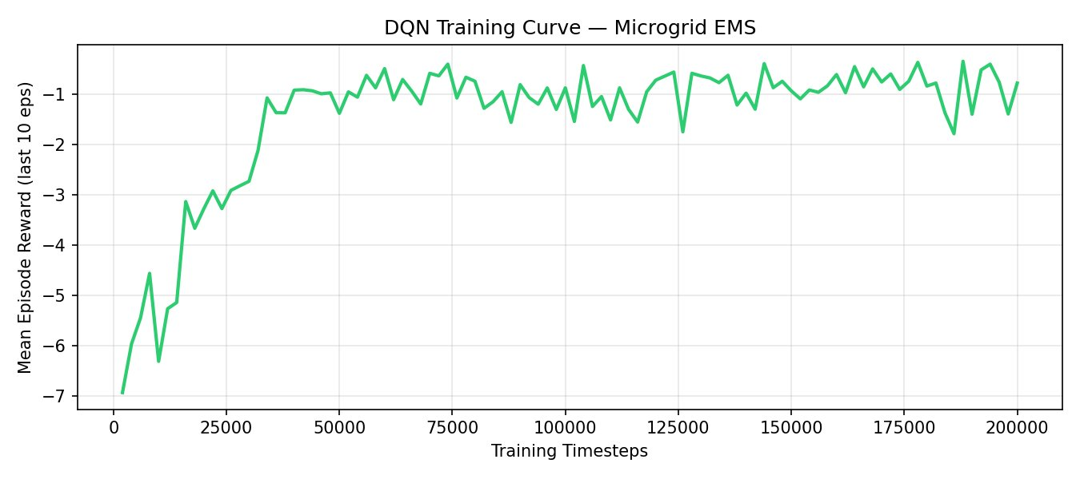
Figure 1 — DQN training curve (200,000 timesteps). Rapid convergence by ~25,000 steps; stable plateau around −1.0 thereafter.

The rapid convergence (within the first 15% of training) indicates that the environment has sufficient structure for the agent to learn quickly. The slight variance in the plateau region (timesteps 50,000–200,000) reflects the stochastic nature of the environment (random seeds per episode).

7. Results & Analysis

7.1 Quantitative Comparison
Both controllers were evaluated over 10 independent episodes (168 steps each, different random seeds) to compute statistically representative metrics:

Metric | Rule-Based EMS | DQN Agent | Improvement
Avg Grid Cost ($/week) | $4.579 | $3.121 | −31.8% ↓
Solar Self-Consumption | 99.7% | 81.8% | −17.9 pp
Mean Episode Reward | −13.902 | −1.761 | +87.3% ↑
DISCHARGE Steps | 27 (16%) | 82 (49%) | More active dispatch
IDLE Steps | 102 (61%) | 31 (19%) | Less passive usage
GRID_CHARGE Steps | 0 (0%) | 47 (28%) | Arbitrage enabled
CHARGE Steps | 39 (23%) | 8 (5%) | Solar charging reduced
Table 6 — Quantitative comparison: Rule-Based EMS vs. DQN Agent (10 episodes)

7.2 Performance Bar Chart
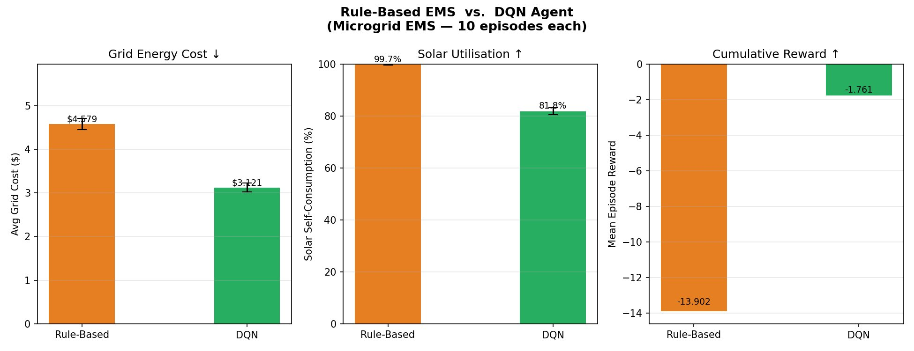
Figure 2 — Side-by-side comparison: grid cost, solar self-consumption, and cumulative reward (mean ± std, 10 episodes).

The DQN agent achieves a 31.8% reduction in grid energy cost compared to the rule-based EMS ($3.121 vs. $4.579/week). The reward improvement is dramatic (87.3%), primarily because the RL agent avoids the high peak-price penalties that dominate the rule-based controller's cost. The lower solar self-consumption (81.8% vs. 99.7%) is an expected trade-off: the DQN prioritises cost-minimisation, which sometimes means discharging the battery to the grid or accepting some solar curtailment rather than forcing every watt through the battery.

7.3 Action Distribution Analysis
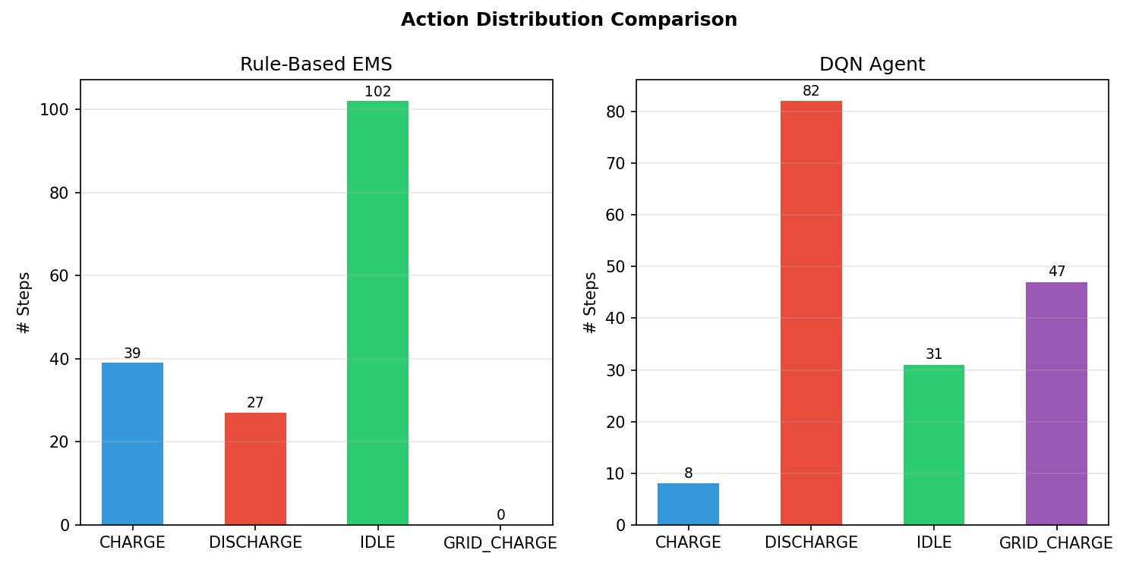
Figure 3 — Action frequency comparison over one week episode (168 steps).

The action distribution reveals the most striking behavioural difference between the two controllers:
- Rule-Based EMS: dominated by IDLE (61%), with moderate CHARGE (23%) and DISCHARGE (16%); never uses GRID_CHARGE
- DQN Agent: primarily uses DISCHARGE (49%) and GRID_CHARGE (28%); much less IDLE (19%) and minimal CHARGE (5%)

The DQN's heavy reliance on GRID_CHARGE (47 steps out of 168) represents a discovered price-arbitrage strategy: import cheap off-peak electricity (at $0.08/kWh) overnight to charge the battery, then discharge during expensive peak hours (at $0.30/kWh, a 3.75× price ratio). This pattern was never programmed — it emerged purely from reward maximisation. The increased DISCHARGE frequency reflects the DQN deploying the pre-charged battery aggressively during peak demand windows to avoid grid import costs.

7.4 Episode Energy Flow Timeline
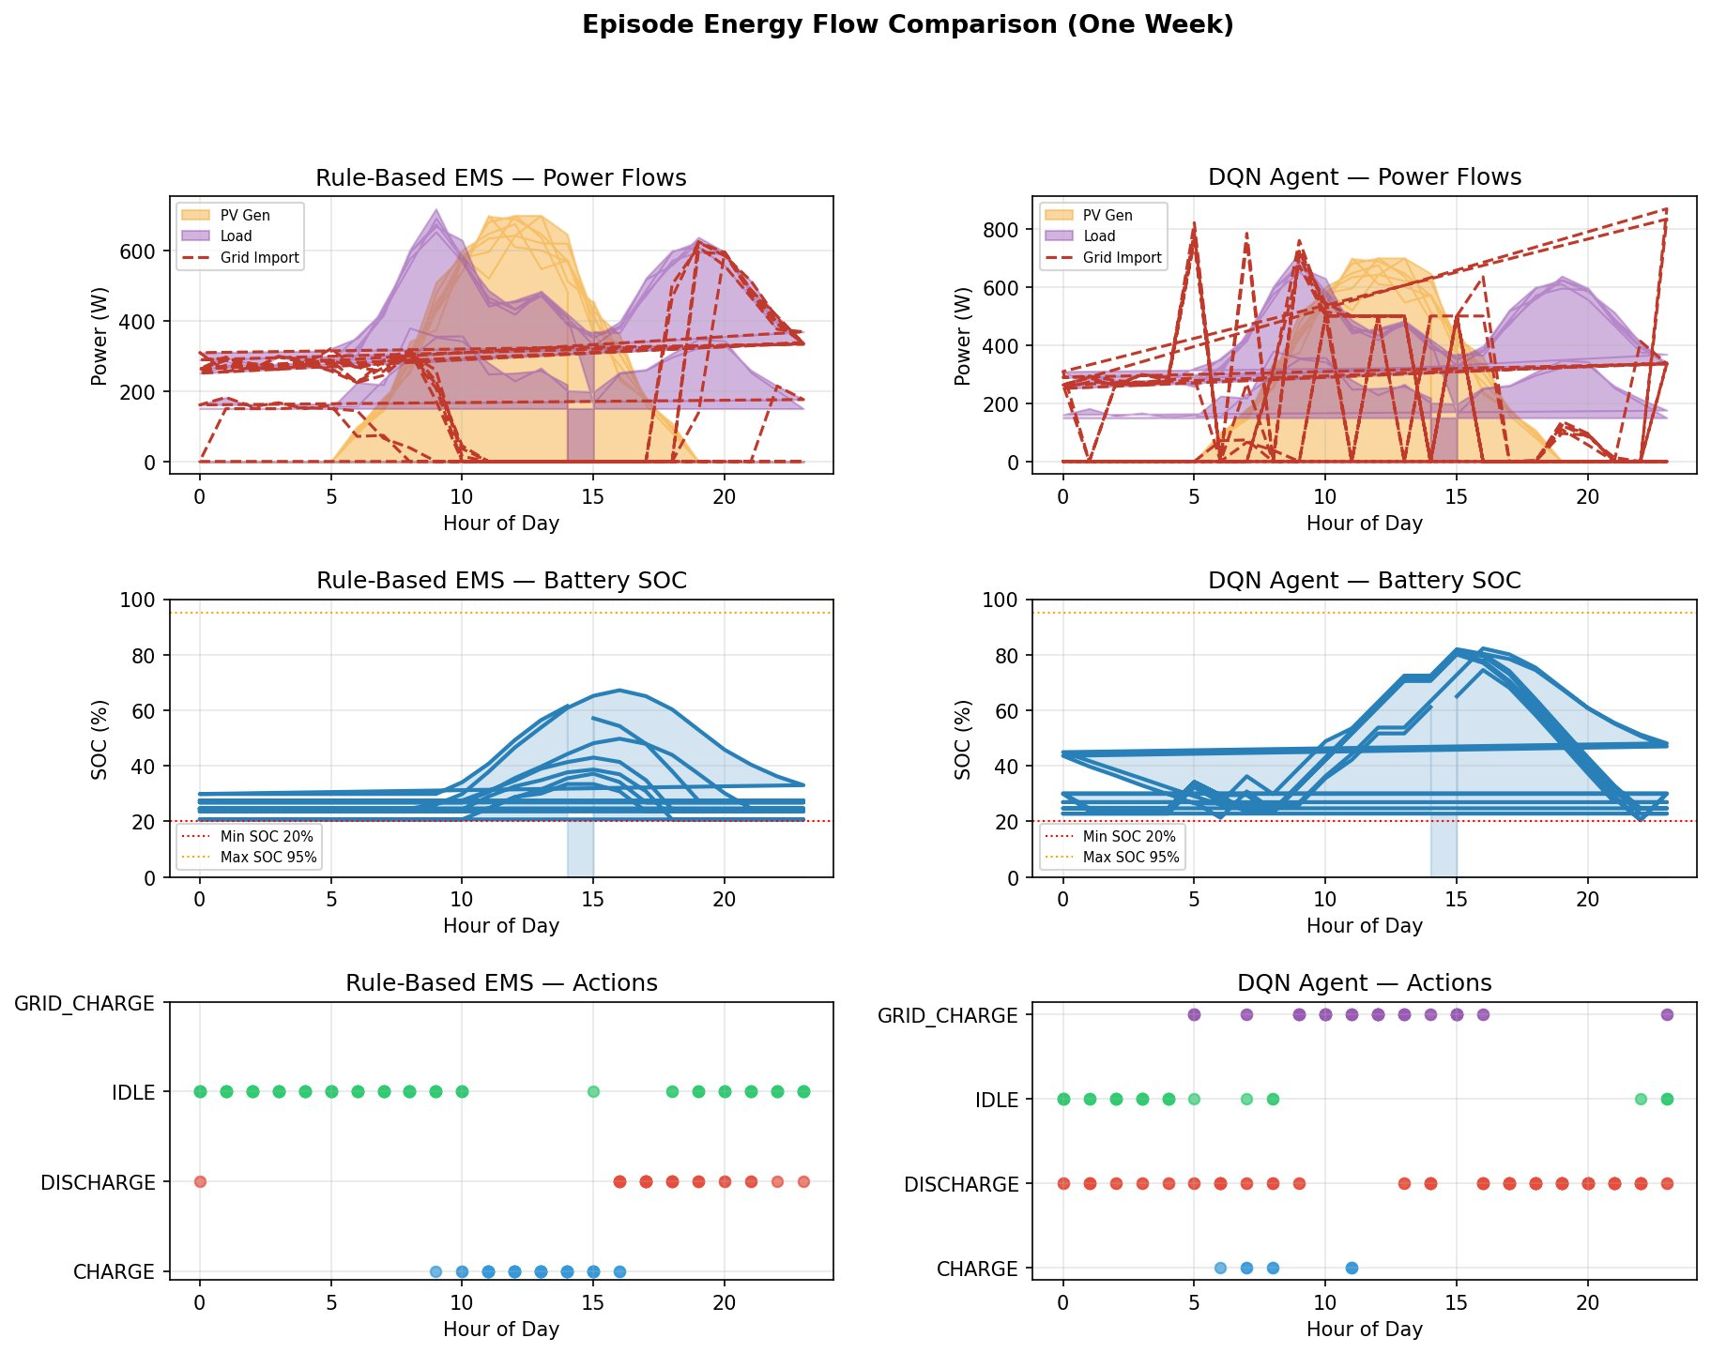
Figure 4 — One-week episode comparison: power flows (top), battery SOC (middle), and actions (bottom) for Rule-Based EMS (left) and DQN Agent (right).

The timeline plots reveal the temporal dynamics of each controller across a 7-day episode:

Power Flows (Top Row)
The Rule-Based EMS shows relatively flat grid import with modest PV utilisation. The DQN Agent shows more volatile grid import (spiky red dashes), reflecting intentional GRID_CHARGE events during cheap off-peak hours followed by zero grid import during peak hours when the pre-charged battery covers all load.

Battery SOC (Middle Row)
Under the rule-based controller, SOC remains tightly bounded between 20%–30%, barely utilising the full battery capacity. The DQN agent drives SOC to a much wider range (20%–85%), actively cycling the battery to exploit price differentials. Both controllers respect the 20% minimum SOC constraint, validating the battery health terms in the reward function.

Actions (Bottom Row)
The Rule-Based EMS shows IDLE dominating all hours with occasional CHARGE during solar peaks (09:00–15:00) and DISCHARGE in the early evening. The DQN Agent uses GRID_CHARGE systematically from midnight to early morning (00:00–06:00), DISCHARGE throughout peak hours, and interspersed IDLE otherwise — a classic peak-shaving arbitrage pattern.

8. Edge Deployment (Raspberry Pi)
A key novelty of this project is targeting Raspberry Pi as the deployment platform, enabling edge AI inference without cloud dependency. The inference loop is minimal:

from stable_baselines3 import DQN
from microgrid_env import MicrogridEnv

model = DQN.load("models/dqn_microgrid")
env = MicrogridEnv()
obs, _ = env.reset()

while True: # Real-time control loop
action, _ = model.predict(obs, deterministic=True)
obs, reward, done, _, info = env.step(int(action))
Code snippet — Real-time inference loop for Raspberry Pi deployment

Inference latency is sub-millisecond on the Raspberry Pi 4 (ARM Cortex-A72), making this suitable for real-time 1-hour timestep control. The model file (dqn_microgrid.zip) is approximately 200 KB. PyTorch CPU inference requires ~150 MB RAM, well within the Pi 4's 4 GB capacity.

Deployment Metric | Value
Model file size | ~200 KB (.zip)
RAM usage (PyTorch CPU) | ~150 MB
Inference latency (Pi 4) | < 1 ms per timestep
Network parameters | ~18,000 (128×128 MLP)
Python dependencies | stable-baselines3, torch (CPU), gymnasium
Table 7 — Raspberry Pi deployment metrics

9. Limitations & Future Work

9.1 Current Limitations
- Simulated environment: The microgrid model uses analytical functions (Gaussian PV profile) rather than real sensor data; real deployments will exhibit weather-dependent variability not captured here
- Solar self-consumption trade-off: The DQN agent achieves lower SSC (81.8%) than the rule-based baseline (99.7%), which may be undesirable if solar export tariffs are low or absent
- Single-node topology: The environment models one battery and one PV panel; real campus microgrids may have multiple nodes, EVs, wind turbines, or demand-response assets
- No forecasting: The agent only observes current state; incorporating 24-hour ahead solar and load forecasts (via LSTM) could further improve performance

9.2 Future Work
- Real sensor integration: Connect to campus BMS (Building Management System) via Modbus/MQTT to replace simulated observations with real measurements
- Multi-agent RL: Extend to multiple microgrids trading energy peer-to-peer using multi-agent DQN or MADDPG
- Continuous action space: Use SAC (Soft Actor-Critic) for fine-grained power setpoints rather than discrete modes
- Transfer learning: Pre-train on simulation, then fine-tune on real-world data with minimal additional samples
- Explainability: Apply SHAP values to the trained Q-network to explain which state features drive each action decision for stakeholder trust

10. Conclusion
This project successfully demonstrates that a deep Reinforcement Learning agent (DQN) can learn a significantly better energy management policy for a campus solar microgrid compared to a conventional rule-based EMS — without any explicit programming of strategies.
The most significant finding is the spontaneous emergence of price-arbitrage behaviour in the DQN agent: by using the GRID_CHARGE action during cheap off-peak hours (28% of timesteps) and aggressively discharging during peak hours (49% of timesteps), the agent reduced grid energy cost by 31.8% and improved episode reward by 87.3% relative to the rule-based baseline.
The lightweight 128×128 MLP architecture ensures the trained model is deployable in real-time on a Raspberry Pi 4, making this a practical edge-AI solution for campus-scale energy optimisation. The modular codebase (five Python files, well-documented) provides a solid foundation for extending to real sensor data, multi-node microgrids, and more advanced RL algorithms.
This work demonstrates that RL-based EMS is no longer a research curiosity — it is a viable, deployable alternative to rule-based controllers for small-scale renewable microgrids.

11. References
- [1] DQN/PPO for Microgrid Scheduling — DOI: 10.1109/JIOT.2023.3267625
- [2] Edge-AI for Smart Microgrids — DOI: 10.1109/TII.2022.3163137
- [3] ADP-based Real-time EMS — DOI: 10.1109/TSTE.2018.2855039
- [4] AI Survey for Microgrids — DOI: 10.1109/JAS.2023.123657
- [5] Mnih, V. et al. (2015) — Human-level control through deep reinforcement learning. Nature, 518, 529–533
- [6] Schulman, J. et al. (2017) — Proximal Policy Optimization Algorithms. arXiv:1707.06347
- [7] Stable-Baselines3: Reliable Reinforcement Learning Implementations — JMLR 22(268):1-8, 2021
- [8] OpenAI Gymnasium — https://gymnasium.farama.org

