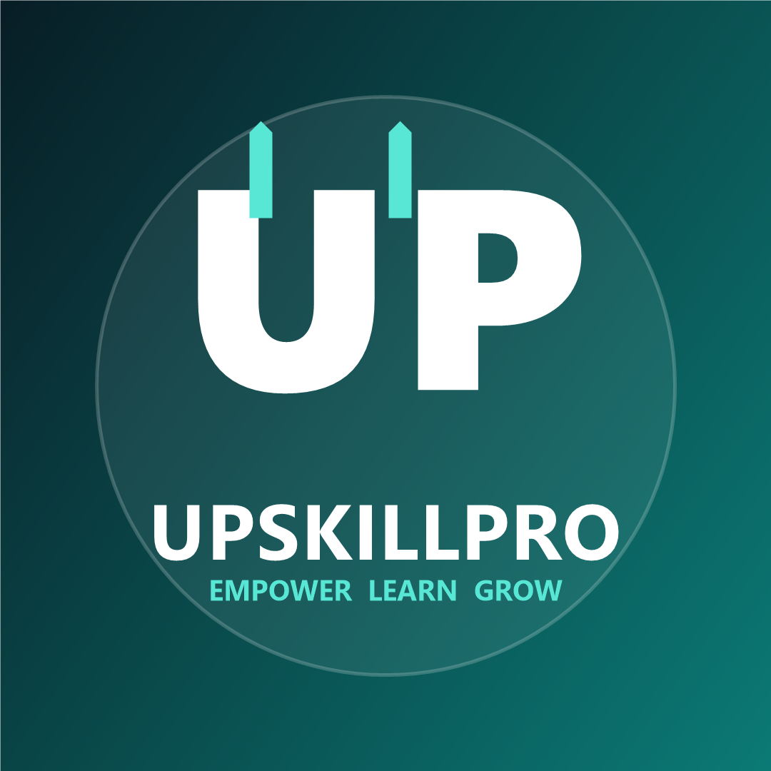
UpskillPro Hospitality Academy
Hospitality Management & Guest Service Excellence Diploma
Trainer Manual - Module 1: Introduction to Hospitality
Level  Diploma | Format  Instructor-led | Audience  Hotel and hospitality teams
Premium commercial training materials for hotels, restaurants, resorts, and hospitality businesses.

Delivery Overview
Use this guide to deliver Module 1 as a practical, discussion-led session. Keep examples grounded in the learner's department and property type.
Stage | Timing | Method | Trainer focus
Welcome and ice breaker | 20 min | Pair discussion | Connect experience to hospitality moments
Hospitality foundations | 45 min | Mini teach + questions | Clarify sector language
Guest journey mapping | 60 min | Group activity | Draw links between departments
Professional behaviour | 45 min | Scenario analysis | Coach tone and ownership
Department teamwork | 50 min | Case study | Expose handover risks
Simulations | 90 min | Role play stations | Observe communication and service recovery
Assessment and review | 45 min | Quiz + action planning | Confirm evidence and next steps

What Is Hospitality?
Key message: Hospitality is the professional practice of making people feel expected, respected, safe, and cared for.

Facilitation Notes
- Ask learners to share a real example from their property.
- Keep discussion focused on observable behaviour, not personality.
- Translate theory into one shift-level habit learners can practise.

Common Misconceptions
Learners may think hospitality is only politeness. Reinforce that it also includes safety, accuracy, commercial awareness, and teamwork.

Extension Activity
Ask advanced learners to redesign one service moment for a luxury guest, business guest, and first-time international guest.

History of Hospitality
Key message: From inns and trade routes to luxury hotel brands, hospitality has always balanced welcome, shelter, food, and trust.

Facilitation Notes
- Ask learners to share a real example from their property.
- Keep discussion focused on observable behaviour, not personality.
- Translate theory into one shift-level habit learners can practise.

Common Misconceptions
Learners may think hospitality is only politeness. Reinforce that it also includes safety, accuracy, commercial awareness, and teamwork.

Extension Activity
Ask advanced learners to redesign one service moment for a luxury guest, business guest, and first-time international guest.

Hospitality Sectors
Key message: Hotels, restaurants, resorts, serviced apartments, events, cruise, contract catering, and destination experiences.

Facilitation Notes
- Ask learners to share a real example from their property.
- Keep discussion focused on observable behaviour, not personality.
- Translate theory into one shift-level habit learners can practise.

Common Misconceptions
Learners may think hospitality is only politeness. Reinforce that it also includes safety, accuracy, commercial awareness, and teamwork.

Extension Activity
Ask advanced learners to redesign one service moment for a luxury guest, business guest, and first-time international guest.

Hotel Classifications
Key message: Classification communicates expected standards, facilities, consistency, and service promise.

Facilitation Notes
- Ask learners to share a real example from their property.
- Keep discussion focused on observable behaviour, not personality.
- Translate theory into one shift-level habit learners can practise.

Common Misconceptions
Learners may think hospitality is only politeness. Reinforce that it also includes safety, accuracy, commercial awareness, and teamwork.

Extension Activity
Ask advanced learners to redesign one service moment for a luxury guest, business guest, and first-time international guest.

Types of Hotels
Key message: Business, boutique, resort, airport, extended-stay, budget, luxury, conference, and lifestyle hotels.

Facilitation Notes
- Ask learners to share a real example from their property.
- Keep discussion focused on observable behaviour, not personality.
- Translate theory into one shift-level habit learners can practise.

Common Misconceptions
Learners may think hospitality is only politeness. Reinforce that it also includes safety, accuracy, commercial awareness, and teamwork.

Extension Activity
Ask advanced learners to redesign one service moment for a luxury guest, business guest, and first-time international guest.

Customer Expectations
Key message: Guests expect accuracy, cleanliness, personal recognition, speed, empathy, and recovery when things go wrong.

Facilitation Notes
- Ask learners to share a real example from their property.
- Keep discussion focused on observable behaviour, not personality.
- Translate theory into one shift-level habit learners can practise.

Common Misconceptions
Learners may think hospitality is only politeness. Reinforce that it also includes safety, accuracy, commercial awareness, and teamwork.

Extension Activity
Ask advanced learners to redesign one service moment for a luxury guest, business guest, and first-time international guest.

The Guest Journey
Key message: Discovery, booking, arrival, stay, service moments, departure, review, and loyalty follow-up.

Facilitation Notes
- Ask learners to share a real example from their property.
- Keep discussion focused on observable behaviour, not personality.
- Translate theory into one shift-level habit learners can practise.

Common Misconceptions
Learners may think hospitality is only politeness. Reinforce that it also includes safety, accuracy, commercial awareness, and teamwork.

Extension Activity
Ask advanced learners to redesign one service moment for a luxury guest, business guest, and first-time international guest.

Professional Behaviour
Key message: Appearance, language, ownership, discretion, punctuality, and calm conduct under pressure.

Facilitation Notes
- Ask learners to share a real example from their property.
- Keep discussion focused on observable behaviour, not personality.
- Translate theory into one shift-level habit learners can practise.

Common Misconceptions
Learners may think hospitality is only politeness. Reinforce that it also includes safety, accuracy, commercial awareness, and teamwork.

Extension Activity
Ask advanced learners to redesign one service moment for a luxury guest, business guest, and first-time international guest.

Hotel Departments
Key message: Front office, housekeeping, food and beverage, concierge, maintenance, security, sales, revenue, and management.

Facilitation Notes
- Ask learners to share a real example from their property.
- Keep discussion focused on observable behaviour, not personality.
- Translate theory into one shift-level habit learners can practise.

Common Misconceptions
Learners may think hospitality is only politeness. Reinforce that it also includes safety, accuracy, commercial awareness, and teamwork.

Extension Activity
Ask advanced learners to redesign one service moment for a luxury guest, business guest, and first-time international guest.

Teamwork
Key message: Strong service relies on handovers, shared standards, escalation habits, and respect between departments.

Facilitation Notes
- Ask learners to share a real example from their property.
- Keep discussion focused on observable behaviour, not personality.
- Translate theory into one shift-level habit learners can practise.

Common Misconceptions
Learners may think hospitality is only politeness. Reinforce that it also includes safety, accuracy, commercial awareness, and teamwork.

Extension Activity
Ask advanced learners to redesign one service moment for a luxury guest, business guest, and first-time international guest.

Answer Guide
1. Which statement best describes hospitality?
Creating a safe, welcoming, professional guest experience.
2. Name four stages of the guest journey.
Booking, arrival, stay, departure, review/loyalty.
3. What does service recovery mean?
Actions taken to restore trust after a service failure.
4. Give two examples of professional behaviour.
Punctuality, calm tone, discretion, ownership, appearance.
5. Why are handovers important?
They protect continuity, accuracy, safety, and guest confidence.
6. What should staff do before promising a solution?
Check facts, authority, availability, and expected time.
7. Name three hotel departments.
Front office, housekeeping, F&B, maintenance, concierge, security, sales.
8. What is one risk of poor teamwork?
Delayed service, repeated questions, guest frustration, safety issues.

Observation Guidance
- Greeting and opening tone
- Questioning and confirmation
- Empathy
- Practical solution
- Closing and follow-up

