专题15. It 句型归纳
1.It is ＋adj.(＋for sb.／sth.) ＋ to do sth.
用于此句型的形容词有：easy， hard， difficult，possible， important， impossible， necessary， good， bad， exciting， interesting， surprising等。如：
It is necessary to change your job.
It was very hard for them to walk such a long way in the snow.
2.It is ＋n.(＋for sb.／sth.) ＋ to do sth.
用于此句型的名词有： pity, shame, pleasure, one’s duty, one’s job, fun, joy, good manners, bad manners等。如： It is a pity for you to have missed such a wonderful play.
It is bad manners for the young to take up the seats for the old.
3.It is ＋adj.＋of sb.＋to do sth.
此句型中的adj.主要描述某人的品德、特征。能用于该句型的形容词有： kind, nice, wise,
silly, polite, impolite, friendly, foolish, clever等。
如： How silly it was of you to give up such a good chance！
It is friendly of the family to try to make me feel at home in their house.
4.It is ＋adj.(＋n.)＋doing sth.
此句型中的形容词和名词常见的有：no／little use, no／much good, useless等。如：
It’s no use crying over spilt milk.
5. It takes sb.＋一段时间＋to do sth. 表示“做某事花费某人多长时间”。如：
It took us half an hour to ride to the town by the sea.
6.It is ＋及物动词的过去分词＋that从句
此句型中常见的及物动词的过去分词有：said, told, known, reported, recorded, thought, believed, considered等。
如：It is reported that the Russian President will visit China next week.
7.It ＋不及物动词＋that从句
此句型中不及物动词常见的有：seem， happen， appear， matter等。如：
It seems that there will be a heavy snow tomorrow.
It happened that I met my good friends in the museum yesterday.
8.强调句型：It is＋被强调部分＋that／who从句
在使用强调句型时要注意，指人时可以用who或that，其它情况一律用that。如：
It was under the bed that my brother hid the ball this morning.
It is Mr Bell who／that often comes and looks after the old man.
9.It is／has been＋一段时间＋since从句。
如： It is ／has been three years since we saw each other last.
10.It is (high) time that sb. did sth.
该句型表示“某人现在该做某事了”，从句常用过去时(虚拟语气)说明现在应该做的事情。如： It’s six o’clock.It is high time that we went home now.
写作(1)
当前出现一种现象，有些大学一年级学生申请休学一年到公司打工，目的是了解社会所需，使以后的学习目标明确；再者因有工作经历，有利于将来找到理想的工作。作为一名高中生，你对此有何感想？请用120—150词叙述一下这种现象，并谈谈你的看法。
注意：休学suspend one’s schooling , 大学一年级学生freshman
(参考范文)Nowadays some freshmen are applying to suspend their schooling for one year . They want to make the best use of the time to find jobs in the companies. Through practice they will get to know the society better , which will certainly helps them study with a clear aim and improve their abilities in the university . On the other hand , it is easier for them to find jobs after graduation because of their experience.
In my opinion, what they do really helps them make up for the failing that they lack social experience and they don’t know what society requires . It is in this way that they are quite sure what they will do in university to meet the society’s need .
As a senior student , I think we should take part in some practical activities besides learning in school in order to know the society better and inspire our studies .

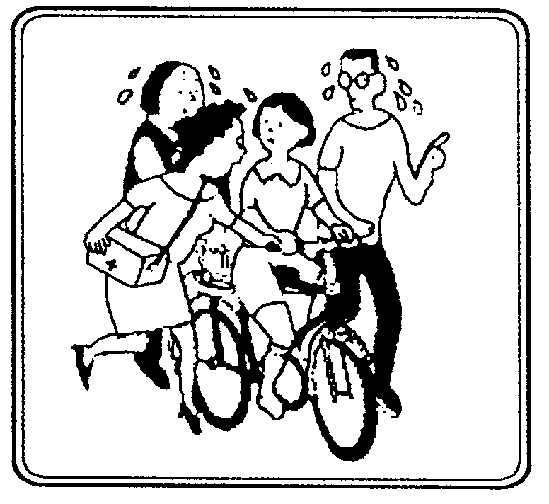
写作(2)
简要描述图片内容，结合生活实际，就图片的主题(A girl is learning how to ride a bike.)谈谈自己的感想。词数：120—150。
(参考范文)There are four people in the picture. A girl is learning how to ride a bike. Her parents and her grandmother, being afraid that she might fall off the bike, are trying hard to support her. The mother is even carrying a first – aid box. But with them around her, the girl finds it very difficult to learn. So she tells them to let her ride it by herself.
In our real life, we can see something like that happening everywhere. Parents love their children too much. They take care of everything for them. They don’t want them to take any risks. However, by doing so, the parents actually hinder their children from growing up strong and healthy. Parents should know that trees can’t grow big and strong in a greenhouse.
写作(3)
下表是对某中学高三一班50个学生健康问题的调查表。请根据表格内容，综述学生当前存在的健康问题，并就中学生如何保持身心健康提出自己的建议。
问题类型 | 学习焦虑 | 逆反心理 | 缺乏交往 | 睡眠不足 | 缺乏锻炼 | 视力不佳
人数 | 35 | 20 | 15 | 40 | 25 | 35
比例 | 70％ | 40％ | 30％ | 80％ | 50％ | 70％
词数要求: 120-150
(参考范文) As is apparently shown in the chart above, many middle school students have problems both physically and mentally, with 70% of students having learning anxieties as well as bad eyesight, and a larger percentage lacking sleep. Coming next is the lack of physical exercise. 40% of the students surveyed won't obey their parents or teachers. Still fewer claimed not to have enough communication with others.
So far as 1 am concerned, we students should balance our physical exercise and studies. Just like a saying goes:" All work but no play makes Jack a dull boy," without a sound body one cannot achieve anything; however, too much attention has been paid only to studies. Therefore, I suggest we be given less homework and more time for out-of--classroom activities to solve all the problems. Only in this way can we lead a healthy life.

写作(4)
随着经济的发展，许多人为城市未来的交通状况而担忧，你对此持何态度？请写一篇120—150词左右的短文，谈谈自己的见解和设想。
(参考范文) Traffic In The City
With the development of economy, traffic is becoming one of the greatest problems of a modern city.
One problem is pollution .The waste gases from the exhaust pipes are great enemies to the air. And there are so many cars and buses in the city that the harm they cause to the environment is considerable. Another problem is crowdedness .City inhabitants are so familiar with traffic jams that they are part of their lives. Time wasted on traffic and people are made impatient by the awful traffic. Worse than that ,traffic accidents are real-life disasters of blood and death .Traffic has become one of the nightmares of people living in cities.
To build highways and bridges only works out part of the problem .Cars and buses should be improved to give less waste gases. Government should encourage citizens to take buses so that there is less traffic on road. People should obey traffic rules and try not to make trouble on road. City area should be expanded so that there is more space for wide roads. Maybe low-pollution high-efficiency means of traffic should be invented .Only after we pay enough attention to the problem will it be possible for us to solve it .

写作(5)
高中学习任务非常繁重，因此同学们对于参加学校活动有着不同的看法，请以Taking Part in School Activities为题，根据下列提示，并结合自己的见闻，用英语写一篇120—150字的短文。
1.部分同学积极参加学校活动，因为……
2.另一部分同学则不愿参加，因为……
3.我认为……
(参考范文) Taking Part in School Activities
Many students are very enthusiastic about school activities; they have their reasons. Firstly, they think that learning from textbooks is not their only task. They believe that they should take every chance to get some practical knowledge. Secondly, they hold that after long hours of study, they can relax themselves by participating school activities.
However, a large group of students take little interest in them and spends most of their time on studies. First, they believe that they should make full use of time to study. Second, they feel that school activities have little to do with their further development.
As far as I’m concerned, I prefer the first view. On one hand, we can learn a great deal from other students we meet in activities. Furthermore, the modern society requires of young students many qualities, so “book-worms” can’t keep up with the times and longer.

写作(6)
在我国不少地方环境污染仍然比较严重。 请你用英语给China Daily写一封信反映这一情况，并以“如何使我们的天空更蓝，山岭更绿，河流更清”为主题，提出建议，保护环境，共筑美好家园。
注意：1.信的开头与结尾已经给出，不计算在总词数内.
2. 字数要求: 120-150.
Dear Editor,
In some places in our country ... (参考范文)
Dear Editor,
In some places in our country the surroundings is worsening with the air filled with heavy smoke, many mountains turning deserted and rivers pulluted. Waste is scattered here and there.
So I strongly suggest that government take effective measures to stop this. First more laws should be passed to protect the surroundings. Factories are forbidden to send out smok eand poisonous gases into the air. Every year more trees should be planted on the mountains. No one is allowed to cut down any trees or pour waste water into the rivers. Anyone who breaks the law should be punished accordingly. Secondly the public should be clear that it is a shame to throw rubbish around. All people should form good habits to protect the surroundings.
Only when the whole society takes actions, will the sky become blue, mountains green and rivers clear. Thus our home will become more beautiful.
Yours truly
Li Hua

写作(7)
假如你是李明，4月2日早晨7点在你上学的路上目击一起车祸，请你以“An Eyewitness Account of a Traffic Accident”为题，根据下图所示，用英语写一份见证书，简要描述你所见到的车祸情况，并对车祸原因进行分析（至少写两点）。
注意：l.词数120左右。短文中已写好的部分，不计入词数。
2.参考词汇：（路）滑的：slippery
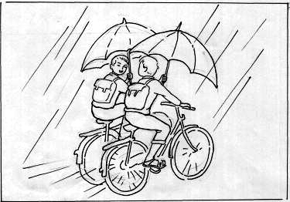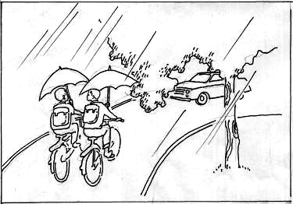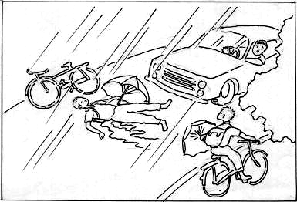
An Eyewitness Account of a Traffic Accident
My name is Li Ming. I saw a traffic accident on my way to school.
(参考范文) An Eyewitness Account of a Traffic Accident
My name is Li Ming. I saw a traffic accident on my way to school. It happened at about 7:00 on the morning of April 2nd. It was raining heavily. Two boys were riding a bike, talking with each other. They were holding an umbrella in one hand, and the handle in the other. As they turned right, a car came out at a high speed turning left on the corner. Both the boys and the driver acted quickly, but it was too late. One of the boys was hit by the car and badly hurt.
In my opinion, there are several reasons for this tragedy. First, the boy was absent- minded. He was talking all the way, dangerously holding an umbrella while riding. Second, the bad weather and the slippery road made it hard for the driver to bring the car to a full stop suddenly. Last, the big tree made the road conditions invisible when they were going to make a turn.

写作(8)
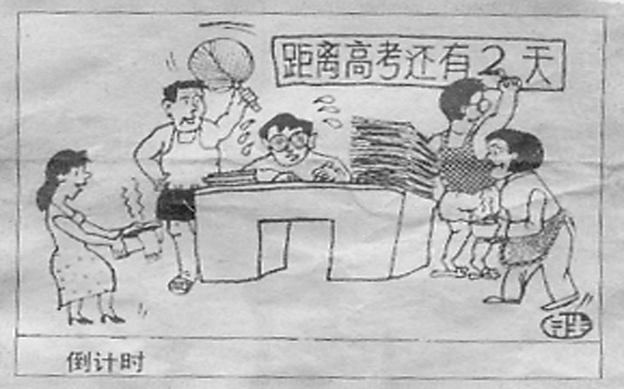
高考是全社会关注的大事，学校和家庭表现尤为突出。家庭成员对考生从学习到生活给予无微不至的"关怀"，结果却给考生带来负面影响。根据图画所描述的内容写一篇文章,并发表自己的观点(夹叙夹议)。词数120左右。
As the College Entrance Examination is drawing near，____________________________________
(参考范文)As the College Entrance Examination is drawing near, the situation is getting worse and worse. From the picture, we can see that Li Ming is "studying hard". There are many books for him to read and many papers for him to do. How poor he is! At the same time, all his family are also busy working for him.
Nowadays, many parents expect too much of their sons or daughters. They hope that their sons or daughters study hard in order to be admitted to an ideal college or a key university. It is for this reason that parents are strict with their children. However, they don’t realize what they have become a heavy burden or a great pressure. It is the hard work or the great pressure that changes their children that much.
So I hope parents provide a proper environment for their children. Only in this way, will they try their best and succeed at last!
本文是夹叙夹议类的文章，主要反映家庭对考生的特别"关注"给他们带来负面影响。在写作过程中，对主题要审准、审清，对发展过程和结果进行叙述。
经典试题展示（三）[语法与词汇 30题]
(1)
21.--- Peter, _____ Mr. Jarvis is waiting for you at ______ main gate.
--- Thanks, I’ll go and meet him immediately.
A.a; a B.a; the C.the; the D.the; a
22. Thousands of fish had been washed up on shore, too far up for them to make ____ back into the water by themselves.
A.them B.themselves C.it D.that
23. The millionaire passed away, leaving his children with a large ________.
A.fortune B.luck C.money D.amount
24. They are still discussing whether I ______ to the meeting yesterday, which I don’t think was necessary at all.
A.came B.should have come
C.would come D.had come
25. She is overweight, but she can’t ____ the temptation to eat more delicious food.
A.forbid B.attach C.allow D.resist
20070124
26. After shaving, it will take me a couple of minutes to _____.
A.have changed B.get changed C.get a change D.get to change
27.___ advice I gave them, they would still do exactly what they wanted to.
A.Whatever B.However C.What D.How
28. Don’t push me! _____ you know the truth right away?
A.Must B.Could C.Might D.Would
29. He finally refused to _____ his plan of traveling the world.
A.give off B.give up C.give to D.give in
30. It was only on the way back home that _____ he was cheated by the girl.
A.he realized B.did he realize C.he was realizing D.realized he
31. Scientist are not sure about the ______ of water on the Mars.
A.occupation B.existence C.demand D.treasure
32. He dressed up and went to the party as if ______.
A.was invited B.had been invited C.invited D.to be invited
33. Before the conference, a new problem came up ______ could speak on behalf of our group.
A.that B.who C.which D.how
34. Thank you very much for the trouble you have taken _____ me with my English.
A.helping B.to help C.help D.helped
35. We are now living in a high-tech age ____ easy things are becoming complicated.
A.where B.that C.when D. why

参考答案：21-25 BCABD 26-30 BAABA 31-35 BCBBC

(2)
21. — Have you seen my notebook?
— Oh, Jane must take it _____; she has the same one as yours.
A. on purpose B. by chance C. by accident D. by mistake
22. — Our plane takes off at 6 o'clock tomorrow morning from Xiaoshan Airport.
— ______ we fail to arrive there in time?
— I have no idea.
A. What if B. As if C. Only if D. Even if
23. The employees have not been paid _____since the new manager took over this company last month.
A. regularly B. normally C. absolutely D. ordinarily
24. _____your advice, I would have caught in the traffic and I wouldn't have been there on time.
A. In spite of B. But for C. Because of D. As for
25. No matter how frequently _____, the work of Beethoven still attract people all over the world.
A. being performed B. performing C. to be performed D. performed
26. — Are the rules you made working?
— Yes, _____ students are late for class.
A. Few B. More C. Some D. None
27. The old woman spoke to the girl again, raising his voice a bit, but still____no answer.
A. received B. receving C. had received D. to receive
28. — Is this the studio you refered to?
— Right, just the one ____ you know I used to work for years.
A. that B. which C. where D. what
29. Leaders of many counties have been trying to____what it is that makes China develop so fast. A. carry out B. figure out C. watch out D. make out
30. We are looking forward with hope to _____from Ms. Smith.
A. hear B. hearing C. heard D. being heard
31. They decided to chase the cow away ____ it did more damage.
A. unless B. until C. before D. although

32. — I hear there was a road accident this morning. — Yes. ____ car hit a tree and ____ driver was killed.
A. A; a B. The; a C. The; the D. A; the
33. I don't know if you noticed their absence or not, but we______.
A. did B. have C. had D. were
34. — Few children are as bright as he is, and also, he works very hard.
— It's no _____he always wins first place in every examination.
A. doubt B. wonder C. problem D. question
35. —What a nice dress!
—Yes.This dress I ______ 500 yuan was made in Shanghai.
A. spent on B. paid for C. bought for D. cost

参考答案：21-25 DAABD 26-30 AACBB 31-35 CDABC

