**JAVA+FlexPaper+swfTools仿文库文档在线阅读**

**一、文档在线阅读思路**

1.用OpenOffice把PPT、Word、Excel、Text转换为pdf  
    2.用SWFTool将生成的pdf转换成swf，然后利用FlexPlayer实现在线预览播放

**二、准备工作**  
    1.安装OpenOffice，官网下载地址：<http://www.openoffice.org/download/index.html>，最新版为3.4.1，我使用的版本为3.3.0：[http://pan.baidu.com/share/link?shareid=1181746637&uk=1913152192#dir/path=%2F%E8%BD%AF%E4%BB%B6%E5%B7%A5%E5%85%B7](http://pan.baidu.com/share/link?shareid=1181746637&uk=1913152192" \l "dir/path=%2F%E8%BD%AF%E4%BB%B6%E5%B7%A5%E5%85%B7)  
    2.启动OpenOffice服务，CMD命令进入OpenOffice安装目录下的program目录，键入如下命令  
        soffice "-accept=socket,host=localhost,port=8100;urp;StarOffice.ServiceManager" -nologo -headless –nofirststartwizard

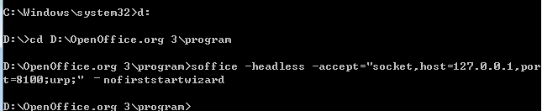

参考资料：<http://blog.csdn.net/hbcui1984/article/details/5109169>  
    3.下载JODConverter：<http://sourceforge.net/projects/jodconverter/files/>，项目中主要使用lib目录下的jar包。  
    4.下载并安装SWFTools：<http://www.swftools.org/download.html>，下载exe文件安装完成即可  
    5.下载FlexPlayer  
    <http://pan.baidu.com/share/link?shareid=1181746637&uk=1913152192#dir/path=%2F%E8%BD%AF%E4%BB%B6%E5%B7%A5%E5%85%B7>  
    官网下载地址：<http://flexpaper.devaldi.com/download/>，版本为2.1.5，与1.5.1有较大差别，未使用最新版。

**三、软件开发**   
    1.新建web项目并引入jar包  
        阅读JODConverter/lib目录下的DEPENDENCIES.txt可知需要添加哪些jar包

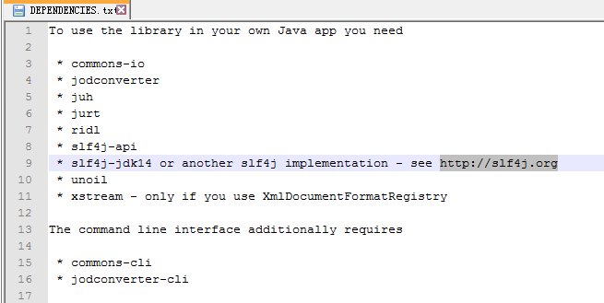

新建OfficeOnline项目，引入相应jar包（使用的是cos进行文档上传,cos.jar需要另外下载），将FlexPaper\_1.5.1\_flash.zip解压后的js目录引入到项目中，FlexPaperViewer.swf也引入进来

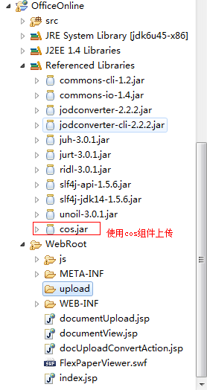

 2.新建DocConverter.java  
        注意：根据SWFTools安装路径不同需要修改pdf2swf()方法中pdf2swf.exe的路径，我安装的路径是在D盘  
                main()测试中根据自己文档路径进行修改测试。

package com.util;

import java.io.BufferedReader;

import java.io.File;

import java.io.IOException;

import java.io.InputStream;

import java.io.InputStreamReader;

import com.artofsolving.jodconverter.DocumentConverter;

import com.artofsolving.jodconverter.openoffice.connection.OpenOfficeConnection;

import com.artofsolving.jodconverter.openoffice.connection.SocketOpenOfficeConnection;

import com.artofsolving.jodconverter.openoffice.converter.OpenOfficeDocumentConverter;

public class DocConverter {

private static final int environment = 1;// 环境1：windows,2:linux(涉及pdf2swf路径问题)

private String fileString;

private String outputPath = "";// 输入路径，如果不设置就输出在默认位置

private String fileName;

private File pdfFile;

private File swfFile;

private File docFile;

public DocConverter(String fileString) {

ini(fileString);

}

/\*

\* 重新设置 file @param fileString

\*/

public void setFile(String fileString) {

ini(fileString);

}

/\*

\* 初始化 @param fileString

\*/

private void ini(String fileString) {

this.fileString = fileString;

fileName = fileString.substring(0, fileString.lastIndexOf("."));

docFile = new File(fileString);

pdfFile = new File(fileName + ".pdf");

swfFile = new File(fileName + ".swf");

}

/\*

\* 转为PDF @param file

\*/

private void doc2pdf() throws Exception {

if (docFile.exists()) {

if (!pdfFile.exists()) {

OpenOfficeConnection connection = new SocketOpenOfficeConnection(8100);

try {

connection.connect();

DocumentConverter converter = new OpenOfficeDocumentConverter(connection);

converter.convert(docFile, pdfFile);

// close the connection

connection.disconnect();

System.out.println("\*\*\*\*pdf转换成功，PDF输出：" + pdfFile.getPath() + "\*\*\*\*");

} catch (java.net.ConnectException e) {

// ToDo Auto-generated catch block

e.printStackTrace();

System.out.println("\*\*\*\*swf转换异常，openoffice服务未启动！\*\*\*\*");

throw e;

} catch (com.artofsolving.jodconverter.openoffice.connection.OpenOfficeException e) {

e.printStackTrace();

System.out.println("\*\*\*\*swf转换器异常，读取转换文件失败\*\*\*\*");

throw e;

} catch (Exception e) {

e.printStackTrace();

throw e;

}

} else {

System.out.println("\*\*\*\*已经转换为pdf，不需要再进行转化\*\*\*\*");

}

} else {

System.out.println("\*\*\*\*swf转换器异常，需要转换的文档不存在，无法转换\*\*\*\*");

}

}

/\*

\* 转换成swf

\*/

private void pdf2swf() throws Exception {

Runtime r = Runtime.getRuntime();

if (!swfFile.exists()) {

if (pdfFile.exists()) {

if (environment == 1)// windows环境处理

{

try {

// 这里根据SWFTools安装路径需要进行相应更改

Process p = r.exec("d:/SWFTools/pdf2swf.exe " + pdfFile.getPath() + " -o " + swfFile.getPath() + " -T 9");

System.out.print(loadStream(p.getInputStream()));

System.err.print(loadStream(p.getErrorStream()));

System.out.print(loadStream(p.getInputStream()));

System.err.println("\*\*\*\*swf转换成功，文件输出：" + swfFile.getPath() + "\*\*\*\*");

if (pdfFile.exists()) {

pdfFile.delete();

}

} catch (Exception e) {

e.printStackTrace();

throw e;

}

} else if (environment == 2)// linux环境处理

{

try {

Process p = r.exec("pdf2swf " + pdfFile.getPath() + " -o " + swfFile.getPath() + " -T 9");

System.out.print(loadStream(p.getInputStream()));

System.err.print(loadStream(p.getErrorStream()));

System.err.println("\*\*\*\*swf转换成功，文件输出：" + swfFile.getPath() + "\*\*\*\*");

if (pdfFile.exists()) {

pdfFile.delete();

}

} catch (Exception e) {

e.printStackTrace();

throw e;

}

}

} else {

System.out.println("\*\*\*\*pdf不存在，无法转换\*\*\*\*");

}

} else {

System.out.println("\*\*\*\*swf已存在不需要转换\*\*\*\*");

}

}

static String loadStream(InputStream in) throws IOException {

int ptr = 0;

//把InputStream字节流 替换为BufferedReader字符流 2013-07-17修改

BufferedReader reader = new BufferedReader(new InputStreamReader(in));

StringBuilder buffer = new StringBuilder();

while ((ptr = reader.read()) != -1) {

buffer.append((char) ptr);

}

return buffer.toString();

}

/\*

\* 转换主方法

\*/

public boolean conver() {

if (swfFile.exists()) {

System.out.println("\*\*\*\*swf转换器开始工作，该文件已经转换为swf\*\*\*\*");

return true;

}

if (environment == 1) {

System.out.println("\*\*\*\*swf转换器开始工作，当前设置运行环境windows\*\*\*\*");

} else {

System.out.println("\*\*\*\*swf转换器开始工作，当前设置运行环境linux\*\*\*\*");

}

try {

doc2pdf();

pdf2swf();

} catch (Exception e) {

// TODO: Auto-generated catch block

e.printStackTrace();

return false;

}

if (swfFile.exists()) {

return true;

} else {

return false;

}

}

/\*

\* 返回文件路径 @param s

\*/

public String getswfPath() {

if (swfFile.exists()) {

String tempString = swfFile.getPath();

tempString = tempString.replaceAll("\\\\", "/");

return tempString;

} else {

return "";

}

}

/\*

\* 设置输出路径

\*/

public void setOutputPath(String outputPath) {

this.outputPath = outputPath;

if (!outputPath.equals("")) {

String realName = fileName.substring(fileName.lastIndexOf("/"), fileName.lastIndexOf("."));

if (outputPath.charAt(outputPath.length()) == '/') {

swfFile = new File(outputPath + realName + ".swf");

} else {

swfFile = new File(outputPath + realName + ".swf");

}

}

}

public static void main(String s[]) {

DocConverter d = new DocConverter("E:/TDDOWNLOAD/test.doc");

d.conver();

}

}

运行结果：

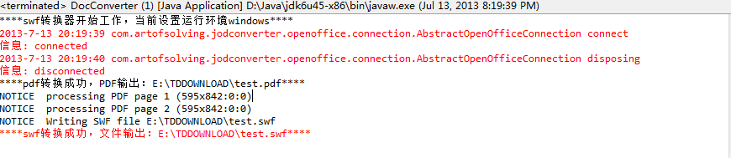

3.新建 documentUpload.jsp

<%@ page language="java" contentType="text/html; charset=UTF-8" pageEncoding="UTF-8"%>

<!DOCTYPE html PUBLIC "-//W3C//DTD HTML 4.01 Transitional//EN" "http://www.w3.org/TR/html4/loose.dtd">

<html>

<head>

<meta http-equiv="Content-Type" content="text/html; charset=UTF-8">

<title>文档在线预览系统</title>

<style>

body {

margin-top: 100px;

background: #fff;

font-family: Verdana, Tahoma;

}

a {

color: #CE4614;

}

#msg-box {

color: #CE4614;

font-size: 0.9em;

text-align: center;

}

#msg-box .logo {

border-bottom: 5px solid #ECE5D9;

margin-bottom: 20px;

padding-bottom: 10px;

}

#msg-box .title {

font-size: 1.4em;

font-weight: bold;

margin: 0 0 30px 0;

}

#msg-box .nav {

margin-top: 20px;

}

</style>

</head>

<body>

<div id="msg-box">

<form name="form1" method="post" enctype="multipart/form-data" action="docUploadConvertAction.jsp">

<div class="title">

请上传要处理的文件，过程可能需要几分钟，请稍候片刻。

</div>

<p>

<input name="file1" type="file">

</p>

<p>

<input type="submit" name="Submit" value="上传">

</p>

</form>

</div>

</body>

</html>

4.新建docUploadConvertAction.jsp

<%@ page language="java" contentType="text/html; charset=UTF-8" pageEncoding="UTF-8"%>

<%@page import="java.io.\*"%>

<%@page import="java.util.Enumeration"%>

<%@page import="com.oreilly.servlet.MultipartRequest"%>

<%@page import="com.oreilly.servlet.multipart.DefaultFileRenamePolicy"%>

<%@page import="com.util.DocConverter"%>

<%

//文件上传采用cos组件上传，可更换为commons-fileupload上传，文件上传后，保存在upload文件夹

//获取文件上传路径

String saveDirectory = application.getRealPath("/") + "upload";

//打印上传路径信息

System.out.println(saveDirectory);

//每个文件最大50m

int maxPostSize = 50 \* 1024 \* 1024;

//采用cos缺省的命名策略，重名后加1,2,3...如果不加dfp重名将覆盖

DefaultFileRenamePolicy dfp = new DefaultFileRenamePolicy();

//response的编码为"UTF-8",同时采用缺省的文件名冲突解决策略,实现上传,如果不加dfp重名将覆盖

MultipartRequest multi = new MultipartRequest(request, saveDirectory, maxPostSize, "UTF-8", dfp);

//MultipartRequest multi = new MultipartRequest(request, saveDirectory, maxPostSize,"UTF-8");

//输出反馈信息

Enumeration files = multi.getFileNames();

while (files.hasMoreElements()) {

System.err.println("ccc");

String name = (String) files.nextElement();

File f = multi.getFile(name);

if (f != null) {

String fileName = multi.getFilesystemName(name);

//获取上传文件的扩展名

String extName = fileName.substring(fileName.lastIndexOf(".") + 1);

//文件全路径

String lastFileName = saveDirectory + "\\" + fileName;

//获取需要转换的文件名,将路径名中的'\'替换为'/'

String converfilename = saveDirectory.replaceAll("\\\\", "/") + "/" + fileName;

System.out.println(converfilename);

//调用转换类DocConverter,并将需要转换的文件传递给该类的构造方法

DocConverter d = new DocConverter(converfilename);

//调用conver方法开始转换，先执行doc2pdf()将office文件转换为pdf;再执行pdf2swf()将pdf转换为swf;

d.conver();

//调用getswfPath()方法，打印转换后的swf文件路径

System.out.println(d.getswfPath());

//生成swf相对路径，以便传递给flexpaper播放器

String swfpath = "upload" + d.getswfPath().substring(d.getswfPath().lastIndexOf("/"));

System.out.println(swfpath);

//将相对路径放入sessio中保存

session.setAttribute("swfpath", swfpath);

out.println("上传的文件:" + lastFileName);

out.println("文件类型" + extName);

out.println("<hr>");

}

}

%>

<!DOCTYPE html PUBLIC "-//W3C//DTD HTML 4.01 Transitional//EN" "http://www.w3.org/TR/html4/loose.dtd">

<html>

<head>

<meta http-equiv="Content-Type" content="text/html; charset=UTF-8">

<title>Insert title here</title>

<style>

body {

margin-top: 100px;

background: #fff;

font-family: Verdana, Tahoma;

}

a {

color: #CE4614;

}

#msg-box {

color: #CE4614;

font-size: 0.9em;

text-align: center;

}

#msg-box .logo {

border-bottom: 5px solid #ECE5D9;

margin-bottom: 20px;

padding-bottom: 10px;

}

#msg-box .title {

font-size: 1.4em;

font-weight: bold;

margin: 0 0 30px 0;

}

#msg-box .nav {

margin-top: 20px;

}

</style>

</head>

<body>

<div>

<form name="viewForm" id="form\_swf" action="documentView.jsp" method="POST">

<input type='submit' value='预览' class='BUTTON SUBMIT' />

</form>

</div>

</body>

</html>

5.新建documentView.jsp

<%@ page language="java" contentType="text/html; charset=UTF-8" pageEncoding="UTF-8"%>

<%

String swfFilePath = session.getAttribute("swfpath").toString();

%>

<!DOCTYPE html PUBLIC "-//W3C//DTD HTML 4.01 Transitional//EN" "http://www.w3.org/TR/html4/loose.dtd">

<html>

<head>

<meta http-equiv="Content-Type" content="text/html; charset=UTF-8">

<script type="text/javascript" src="js/jquery.js"></script>

<script type="text/javascript" src="js/flexpaper\_flash.js"></script>

<script type="text/javascript" src="js/flexpaper\_flash\_debug.js"></script>

<style type="text/css" media="screen">

html,body {

height: 100%;

}

body {

margin: 0;

padding: 0;

overflow: auto;

}

#flashContent {

display: none;

}

</style>

<title>文档在线预览系统</title>

</head>

<body>

<div style="position: absolute; left: 50px; top: 10px;">

<a id="viewerPlaceHolder" style="width: 820px; height: 650px; display: block"></a>

<script type="text/javascript">

var fp = new FlexPaperViewer(

'FlexPaperViewer',

'viewerPlaceHolder', { config : {

SwfFile : escape('<%=swfFilePath%>'),//编码设置

Scale : 0.6,

ZoomTransition : 'easeOut',//变焦过渡

ZoomTime : 0.5,

ZoomInterval : 0.2,//缩放滑块-移动的缩放基础[工具栏]

FitPageOnLoad : true,//自适应页面

FitWidthOnLoad : true,//自适应宽度

FullScreenAsMaxWindow : false,//全屏按钮-新页面全屏[工具栏]

ProgressiveLoading : false,//分割加载

MinZoomSize : 0.2,//最小缩放

MaxZoomSize : 3,//最大缩放

SearchMatchAll : true,

InitViewMode : 'Portrait',//初始显示模式(SinglePage,TwoPage,Portrait)

ViewModeToolsVisible : true,//显示模式工具栏是否显示

ZoomToolsVisible : true,//缩放工具栏是否显示

NavToolsVisible : true,//跳页工具栏

CursorToolsVisible : false,

SearchToolsVisible : true,

PrintPaperAsBitmap:false,

localeChain: 'en\_US'

}});

</script>

</div>

</body>

</html>

 6.部署后访问：http://localhost:8080/OfficeOnline/documentUpload.jsp  
    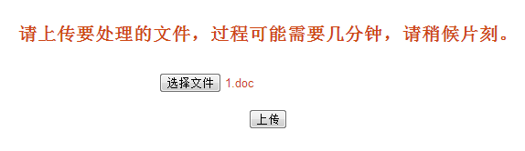

上传成功后预览：



7.若出现swf无法预览，请访问[http://www.macromedia.com/support/documentation/en/flashplayer/help/settings\_manager04a.html#119065](http://www.macromedia.com/support/documentation/en/flashplayer/help/settings_manager04a.html" \l "119065" \t "_blank)将生成swf的文件夹设置为信任文件。  
    8.参考资料：[http://blog.csdn.net/hil2000/article/details/8459940](http://blog.csdn.net/hil2000/article/details/8459940" \t "_blank)  
                        <http://www.cnblogs.com/star-studio/archive/2011/12/09/2281807.html>  
                       文件中文名乱码解决：[http://blog.csdn.net/kunoy/article/details/7903258](http://blog.csdn.net/kunoy/article/details/7903258" \t "_blank)

**四、其他优化**    解决flexpaper搜索文字时不能高亮的问题： <http://my.oschina.net/dianfusoft/blog/125450>   
     flexpaper去简介去水印等：<http://blog.csdn.net/zengraoli/article/details/7827840>