KNOWLEDGE BASE

GLOSSARY

Core SEO Terms

SEO
Search Engine Optimization - The practice of improving your website's visibility in search engine results pages (like Google) to attract more organic (unpaid) traffic.

SERP / Search
Search Engine Results Page - The page displayed by search engines in response to a user's query. This includes organic results, paid ads, featured snippets, and other elements.

Click Through Rate (CTR)
The percentage of people who click on your link after seeing it in search results. Higher CTR signals to Google that your content is relevant to searchers.

AI
Artificial Intelligence - Computer systems that can perform tasks typically requiring human intelligence, such as understanding language and generating content.

AI SEO
The practice of using artificial intelligence tools to enhance and streamline SEO efforts, including content creation, keyword research, and optimization strategies.

Google Business Profile

GBP / GMB
Google Business Profile (formerly Google My Business) - A free tool that allows businesses to manage their online presence across Google, including Search and Maps.

NAP / N-A-P
Name, Address, Phone - The three critical pieces of business information that must be consistent across all online listings to build local SEO authority.

SAB / Service Area Business
A business that serves customers at their location rather than having customers come to them (like plumbers or mobile mechanics). These businesses can hide their address on Google.

Link Building & Authority

Backlink / External Link
A link from another website pointing to your site. These act as "votes of confidence" and are crucial for building domain authority.

Internal Link
Links within your website that connect one page to another. These help users navigate and distribute SEO authority throughout your site.

Anchor Text
The clickable text in a hyperlink. The words used in anchor text help search engines understand what the linked page is about.

Technical SEO

Schema / Schema Markup / Structured Data
Code added to your website that helps search engines better understand your content. It can result in rich snippets and enhanced search results.

Geotag
Location data embedded in images that tells search engines where a photo was taken. Important for local SEO to prove geographic relevance.

Sitemap
An XML file that lists all important pages on your website, helping search engines discover and crawl your content more efficiently. Essential for larger websites or those with complex structures.

Content & Strategy

E-E-A-T
Experience, Expertise, Authoritativeness, Trustworthiness - Google's framework for evaluating content quality. Critical for ranking in competitive niches.

Core 30
A strategic set of 30 essential pages every local business website should have, covering primary services, locations, and key topics to establish topical authority.

YMYL / Your Money Your Life
Google's classification for websites that could impact a person's health, financial stability, safety, or happiness. These sites face stricter quality standards and require exceptional E-E-A-T to rank well.

WHAT IS LOCAL SEO
Local SEO is fundamentally different from traditional SEO, and understanding this difference is crucial for your success. Let's break down what makes local search unique and why it requires a specialized approach.
When Google determines that a search query has local intent, the search results page looks dramatically different.
The Local Search Results Structure:
- Sponsored ads at the top
- Map pack (the main map results with Google Business Profile listings)
- Organic results below the map
🔍 Key Insight: If you see the map results, Google considers it a local search. No map means Google treats it as non-local.
The map pack is where the real action happens in local search. These three Google Business Profile (GBP) listings capture 60-70% of all traffic, clicks, calls, and engagement from that search. Add the 5-10% that goes to ads, and organic results are left fighting for just 20-30% of the total search volume.

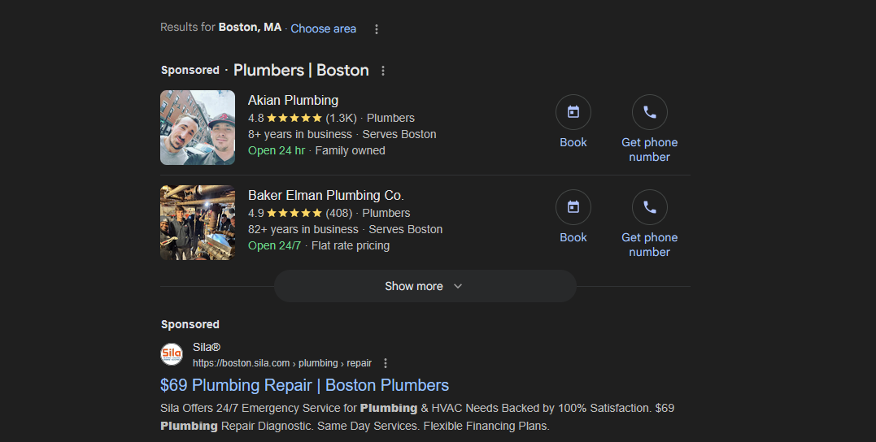
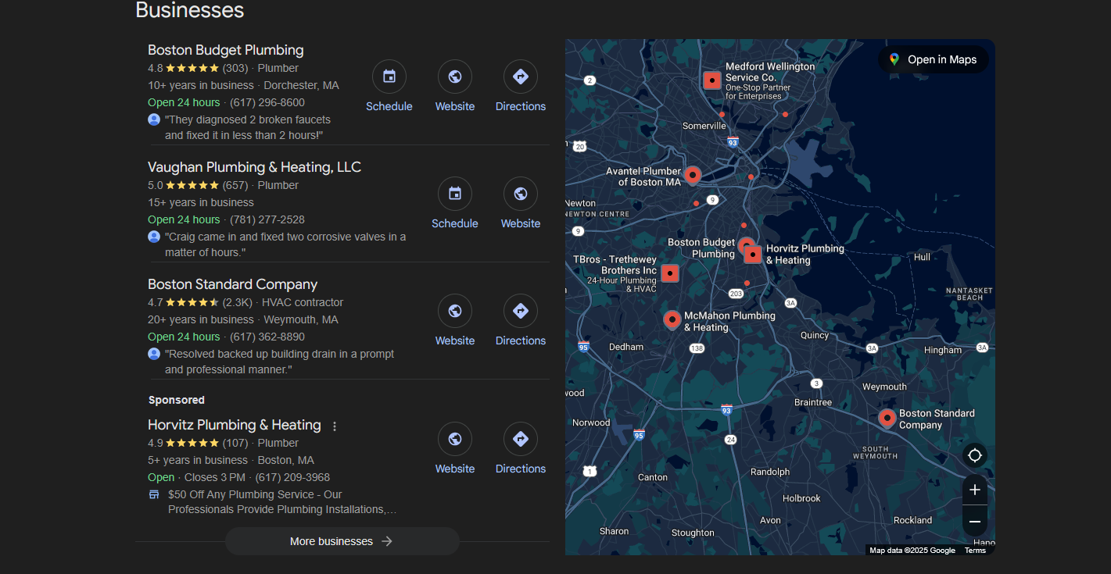
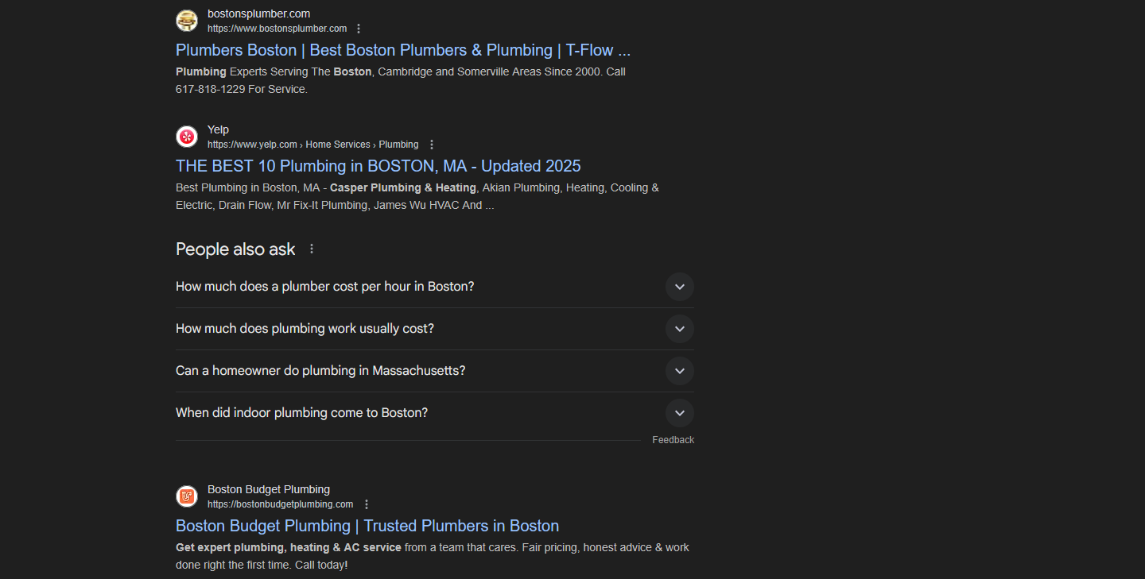
The Distance Factor Challenge
One of the biggest ranking factors in local SEO is something you might not expect: proximity. Google heavily weighs the distance between your GBP address and the searcher's location, even when distance shouldn't logically matter.
For service-based businesses like plumbers, HVAC companies, or roofers, physical proximity to the customer's location isn't really relevant—what matters is your willingness to travel to their area. However, Google's algorithm still prioritizes closer businesses in the map pack.
Geographic Limitations
This creates a significant challenge: it's extremely difficult to rank in a city different from where your GBP address is located. If your business is in a Chicago suburb but you want to rank for "Chicago plumber," you're facing an uphill battle that's nearly impossible without minimal competition.
💡 Pro Tip: Some suburbs allow you to use different city names interchangeably for the same address (the mail still reaches you). If this applies to your situation, consider updating your GBP city to match where you want to rank—but only if Google recognizes it as the same location.
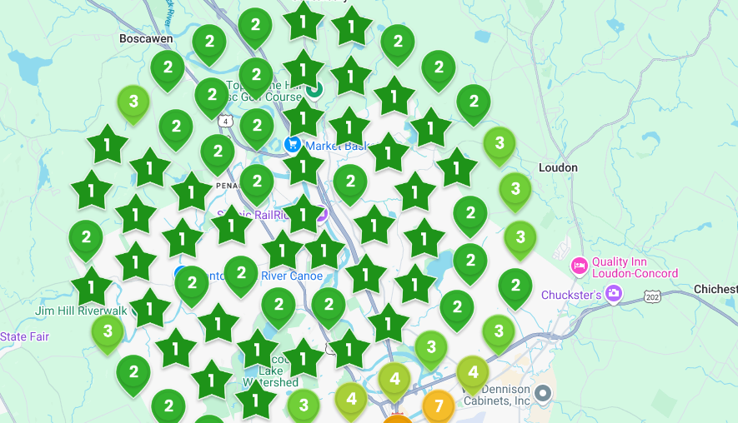
How Local SEO Progress Is Measured
Unlike traditional SEO where you track rankings from a single location, local SEO requires rank tracking based on distance from your GBP location. This is why local SEO tools generate heat maps showing your ranking performance across different geographic areas.
You'll see visualizations with red (poor rankings), yellow (moderate rankings), and green (strong rankings) areas around your business location. The goal is systematically turning those reds and yellows into greens by building enough trust and relevance to overcome the distance penalty.
Controllable Local Ranking Factors
Here are the key ranking factors you can control, listed roughly in order of impact-to-effort ratio:
Quick Wins (High Impact, Low Effort):
- Primary GBP category in your landing page title
- Complete GBP profile (every single field filled out)
- City name in your website landing page title
- Additional GBP categories and services
Medium Effort, High Impact:
- GBP consistency with website categories and services
- Proper website structure and content
- Schema markup implementation
Higher Effort, Still Important:
- Citations and press releases
- Quality backlinks
- Customer reviews
- Social signals
Local SEO is fundamentally different from traditional SEO, and understanding this difference is crucial for your success. Let's break down what makes local search unique and why it requires a specialized approach.
When Google determines that a search query has local intent, the search results page looks dramatically different.
The Local Search Results Structure:
- Sponsored ads at the top
- Map pack (the main map results with Google Business Profile listings)
- Organic results below the map
🔍 Key Insight: If you see the map results, Google considers it a local search. No map means Google treats it as non-local.
The map pack is where the real action happens in local search. These three Google Business Profile (GBP) listings capture 60-70% of all traffic, clicks, calls, and engagement from that search. Add the 5-10% that goes to ads, and organic results are left fighting for just 20-30% of the total search volume.




The Distance Factor Challenge
One of the biggest ranking factors in local SEO is something you might not expect: proximity. Google heavily weighs the distance between your GBP address and the searcher's location, even when distance shouldn't logically matter.
For service-based businesses like plumbers, HVAC companies, or roofers, physical proximity to the customer's location isn't really relevant—what matters is your willingness to travel to their area. However, Google's algorithm still prioritizes closer businesses in the map pack.
Geographic Limitations
This creates a significant challenge: it's extremely difficult to rank in a city different from where your GBP address is located. If your business is in a Chicago suburb but you want to rank for "Chicago plumber," you're facing an uphill battle that's nearly impossible without minimal competition.
💡 Pro Tip: Some suburbs allow you to use different city names interchangeably for the same address (the mail still reaches you). If this applies to your situation, consider updating your GBP city to match where you want to rank—but only if Google recognizes it as the same location.

How Local SEO Progress Is Measured
Unlike traditional SEO where you track rankings from a single location, local SEO requires rank tracking based on distance from your GBP location. This is why local SEO tools generate heat maps showing your ranking performance across different geographic areas.
You'll see visualizations with red (poor rankings), yellow (moderate rankings), and green (strong rankings) areas around your business location. The goal is systematically turning those reds and yellows into greens by building enough trust and relevance to overcome the distance penalty.
Controllable Local Ranking Factors
Here are the key ranking factors you can control, listed roughly in order of impact-to-effort ratio:
Quick Wins (High Impact, Low Effort):
- Primary GBP category in your landing page title
- Complete GBP profile (every single field filled out)
- City name in your website landing page title
- Additional GBP categories and services
Medium Effort, High Impact:
- GBP consistency with website categories and services
- Proper website structure and content
- Schema markup implementation
Higher Effort, Still Important:
- Citations and press releases
- Quality backlinks
- Customer reviews
- Social signals

KEY GOOGLE RANK FACTORS
At its heart, Google is math. This fundamental concept shapes everything about how search rankings work.
Google doesn't employ armies of people to read and evaluate every piece of content on the internet. Instead, it uses sophisticated algorithms to determine which pages best answer searchers' queries. Why? Because Google's primary goal is keeping its users happy—after all, approximately 80% of Alphabet's (Google's parent company) revenue comes from advertising. Happy searchers see more ads, which drives Google's business model.
💡 Key Insight: Google's free search service is funded by ad revenue, so user satisfaction directly impacts their bottom line. This means Google is highly motivated to show you the best possible results for your search.
The Open Book SEO Test
Here's a game-changing perspective: SEO is an open book test. You don't need to guess what Google wants—it shows you exactly what works by displaying the top 10 results for any given search query.
When you search for a keyword you want to rank for, Google reveals:
- What type of content performs best (blog posts, e-commerce pages, service pages, etc.)
- What information searchers expect to find
- How comprehensive the content needs to be
Content Type Matching
If you search for a keyword and see:
- E-commerce category pages → Your blog post won't rank
- Blog posts and articles → Your product page won't rank
This isn't Google playing favorites—it's Google responding to what users engage with most for that particular search.
📚 Related Learning: Understanding search intent is crucial for your content strategy. Check out our lesson on AI Content Prioritization to learn how to identify and match user intent effectively.
How Google's Algorithm Really Works
Forget those "200 ranking factors" articles. Google's algorithm is far more sophisticated—it's a machine learning system that analyzes every infinitesimal detail on your website.
The Machine Learning Approach
Google's algorithm:
- Tests countless variables against user engagement metrics
- Keeps what improves user satisfaction
- Discards what doesn't improve the user experience
Even Google's own search engineers can't explain exactly why one URL ranks above another—the algorithm makes these decisions independently based on patterns it has learned from billions of searches.
Writing for Google's Algorithm
Since Google "reads" with math, not comprehension, you need to write content that its algorithm can understand. This is where LSI (Latent Semantic Indexing) concepts come into play.
LSI keywords aren't synonyms or keywords you're targeting—they're contextually related terms that help Google understand your content's topic.
Examples:
For "attorney/lawyer":
- Courtroom
- Trial
- Settlement
- Judge
- Binding contract
- Legal proceedings
For "Star Wars":
- Luke Skywalker
- Princess Leia
- Darth Vader
- Death Star
- Jedi
- George Lucas
🎯 Pro Tip: Don't stuff keywords! Instead, naturally incorporate related terms that someone knowledgeable about your topic would use. This signals expertise to Google's algorithm.
The Four Pillars of Ranking
1. Content Alignment
Your content's word patterns and structure should align with what's already ranking well. Google compares your content to successful pages to determine relevance.
2. External Links (Quality Signals)
Since Google can't judge writing quality like humans do, it uses external links as quality indicators. When other websites link to your content, it signals to Google that your content provides value.
⏩⏩Related Lesson: Introduction to Backlinking
3. Topical Relevance
Building comprehensive content around your topic area shows Google you have expertise. This isn't just about one page—it's about your entire site's focus.
⏩⏩Related Lesson: Building More Topical Relevance
4. User Engagement (The Final Test)
Once Google ranks you on the first page, the real test begins. This is called the "Google Dance"—your content will move up and down as Google tests how users interact with it.
If users:
- Click and stay → You'll maintain or improve rankings
- Click and bounce → You'll drop in rankings
The Bottom Line
Remember: Google cannot read, but it can measure user satisfaction through engagement metrics. Your goal is to:
- Convince Google's algorithm that your content will satisfy searchers (through proper optimization)
- Earn quality external links to validate your content's value
- Build topical relevance to demonstrate expertise
- Actually satisfy searchers when they visit your page
Success in SEO means aligning what Google's algorithm wants with what real people need. Master this balance, and you'll see sustainable ranking improvements.

HOW SEO AUTHORITY IS PASSED
Understanding how SEO authority flows through links is crucial for effective optimization. Many SEOs misunderstand this fundamental concept, which can lead to poor linking strategies and wasted opportunities.
Link authority (colloquially known as "link juice") represents the trust and quality signals that pass from one page to another through hyperlinks. Despite what Google may claim, links remain a critical ranking factor—especially for pages beyond the first few search results.
💡 Quick Note: While user engagement data influences rankings on pages 1-2, deeper pages (7-9) rely heavily on link authority since few users venture that far into search results.
Types of Links and Their Behavior
Not all links are created equal. Here's how different link types behave:
Link Placement Types
- Editorial links - Links within the main body content
- Navigation bar links - Links in the top navigation menu
- Footer links - Links at the bottom of the page
- Sidebar links - Links in side rails or sidebars
- Author bio links - Links in author biography sections
The Critical Rule
Only editorial links in the main body content pass significant authority. All other link placements, whether follow or nofollow, pass minimal to no authority.
⚠️ Important: Only the first link to any URL on a page passes authority. Since Google typically crawls pages from top to bottom, navigation links are often encountered first—and they don't pass meaningful authority!
How Authority Distribution Works
Let's understand how link authority gets distributed across a page:
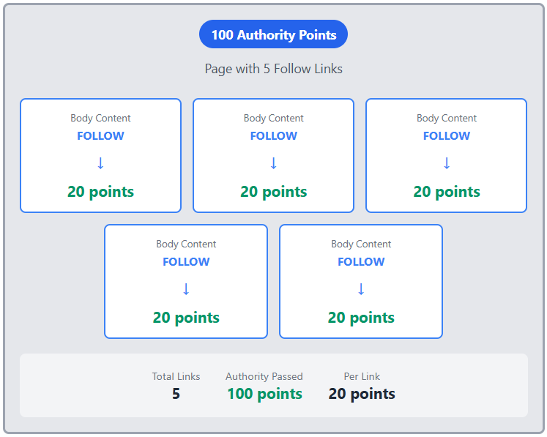
Example 1: Simple Distribution
Imagine a page with 100 authority points and 5 follow links in the body content:
- Each link passes approximately 20 authority points
- Total authority passed: 100 points
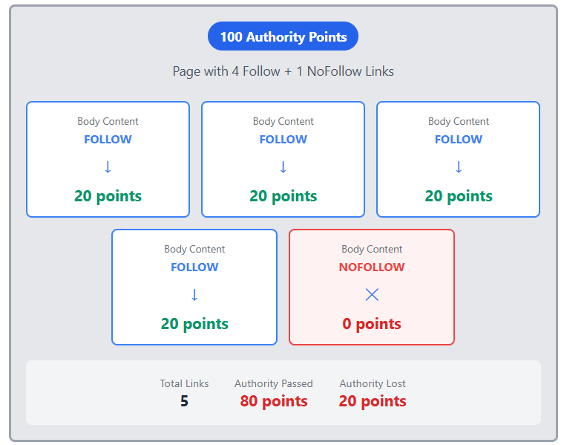
Example 2: Mixed Link Types
Same page with 4 follow links and 1 nofollow link:
- Each follow link still passes 20 authority points
- The nofollow link passes 0 points
- Total authority passed: Only 80 points
- 20 points are lost due to the nofollow link
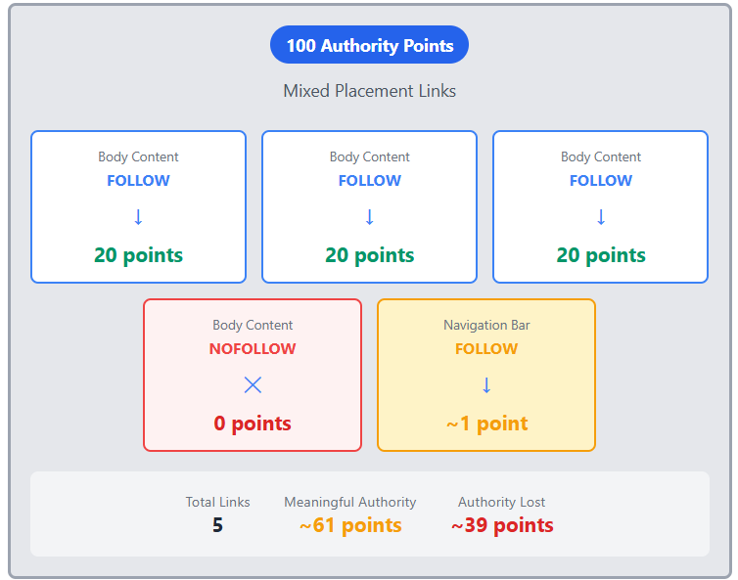
Example 3: Different Placements
Page with mixed link placements:
- 3 body follow links: 20 points each
- 1 body nofollow link: 0 points
- 1 navigation follow link: ~1 point (minimal)
- Total meaningful authority passed: ~61 points
Key Takeaways for Your Strategy
1. Avoid Navigation Links for Target Pages
Since navigation links appear first and pass minimal authority, avoid placing pages you're trying to rank in the main navigation. This prevents you from passing meaningful internal link authority to these pages later in the content.
2. External Links Don't Decrease Your Authority
Linking to other websites (whether follow or nofollow) doesn't reduce your page's authority. In fact, linking to high-authority sites (DR 90+) can actually improve your rankings by establishing topical relevance.
3. Internal Links = External Links
Internal links work exactly like external links for passing authority. Use them strategically to build authority for important pages within your site.
4. Authority Sculpting Penalties
Google penalizes attempts to "sculpt" authority by nofollowing most links. The total number of links on a page determines authority distribution, regardless of follow/nofollow status.

AI OVERVIEW IN SEARCH

Google's AI Overview represents a significant shift in how search results are displayed and consumed. This feature uses artificial intelligence to generate comprehensive answers directly on the search results page, fundamentally changing the SEO landscape.
The AI Overview feature is still evolving, and its impact on SEO continues to develop. While it presents challenges for traditional SEO approaches, understanding how to work around it is crucial for maintaining organic visibility.
When Google's AI Overview appears for a search query, it typically means:
- The query is informational in nature - Questions that can be answered quickly and definitively
- Traffic potential is significantly reduced - Users get their answer without clicking through to websites
- Competition becomes nearly impossible - Only extremely high-authority sites get featured
💡 Key Insight: If your target keyword triggers an AI Overview, consider pivoting to a different keyword unless you're building topical relevance as part of a larger content strategy.
Who Benefits from AI Overview?
Google claims that websites featured in AI Overview cards receive more click-through traffic than before. However, there's a significant catch:
- Featured sites typically have domain ratings in the 90s (like Quora)
- Small to medium websites rarely qualify for these positions
- It creates a "winner-takes-all" scenario where one site captures most available traffic
📚 Related Learning: Review our lesson on Key Google Rank Factors to understand how domain authority affects your ability to compete for these positions.
Checking for AI Overview in Your Keyword Research
Step 1: Test Your Target Keywords
Before committing to a keyword strategy:
- Search your target keyword on Google
- Check if an AI Overview appears
- Note which websites are featured in the overview cards
Step 2: Analyze the Competition
When using tools like Ahrefs:
- Look beyond the keyword difficulty score (which can be unreliable)
- Check the actual domain ratings of ranking sites
- If most competitors have DR 70+, reconsider your target
⚠️ Important Note: Keyword difficulty scores in SEO tools don't account for AI Overview impact. Always manually verify the SERP landscape.
The Mortgage Calculator Effect
A cautionary example of Google's SERP features impact:
- Sites that invested heavily in ranking for "mortgage calculator"
- Google added a calculator directly to the search results
- Click-through rates dropped from 80-90% to approximately 67%
- Sites lost a third of their traffic overnight
This demonstrates how Google's SERP features can dramatically impact even well-established rankings.
Current Limitations in Tracking
As of now, there are significant tracking challenges:
- Google Search Console doesn't track AI Overview clicks
- Third-party SEO tools cannot measure AI Overview performance
- No reliable way to optimize for or measure success with AI Overview features
This creates a blind spot in your analytics where you can't determine if your content is benefiting from AI Overview exposure.
Strategic Recommendations
1. Adapt Your Keyword Strategy
- Avoid purely informational keywords that trigger AI Overview
- Focus on transactional and commercial intent keywords
- Target long-tail keywords with specific user intent
🎯 Pro Tip: Check out our module on Optimizing for ChatGPT to find opportunities for searchers skipping the SERPs entirely and instead asking AI.
2. Build Topical Authority Strategically
If you must target AI Overview keywords:
- Use them as supporting content to build topical relevance
- Don't expect direct traffic from these pages
- Focus on establishing expertise in your niche
3. Monitor SERP Changes
- Regularly check your target keywords for new AI Overview appearances
- Be prepared to pivot your strategy as Google expands this feature
- Focus on keywords where traditional organic results still dominate

WHAT IS E-E-A-T?
Let's talk about E-E-A-T, which stands for Experience, Expertise, Authoritativeness, and Trustworthiness. Understanding Google's search radar guidelines, introduced in late 2022, is going to be a helpful guideline in everything you do. This framework, although not a direct ranking factor, profoundly influences the evaluation of content quality on the web.
❔ Did You Know? The introduction of E-E-A-T predated the Helpful Content updates and the March 2024 Core Update.
Google utilizes these guidelines, embodied in a comprehensive 300-page document, to train human quality raters. These raters assess the quality of search results, ensuring that Google's outputs are beneficial and relevant. Understanding that these guidelines influence algorithmic updates indirectly is key to grasping their importance.
Experience
The addition of 'Experience' to the already previously well-known E-A-T framework emphasizes the value of firsthand involvement.
For content creators, this means your articles, blogs, or webpages should reflect direct, personal experience in the subject matter. This could involve detailing personal anecdotes or providing unique insights that only someone with direct experience could offer.
When crafting content, it is advantageous to integrate an author bio that showcases this firsthand experience. This not only enhances the trustworthiness of the content but also aligns with Google's emphasis on author credibility.
Expertise
'Expertise', the second E in E-E-A-T, is demonstrated through comprehensive knowledge and authoritative discourse on a topic.
Here, you will learn to build topical relevancy and authority through strategic content mapping. By adhering to structured methods of content creation, such as developing topical authority maps and citing credible sources, you position yourself as an expert in your field.
Authoritativeness
To establish 'Authoritativeness', off-site SEO tactics like press releases can be effective. These should link back to your site from high-domain authority sources.
Additionally, engaging actively under your real name in industry-specific forums and on platforms like Reddit can further substantiate your authority.
A claimed Google Knowledge Panel or having published works, such as books, can significantly boost your authoritative standing. These elements contribute to a digital footprint that reinforces your credibility.
Trustworthiness
Lastly, 'Trustworthiness' is paramount. Transparency about who is creating the content is essential. Ensure that your website clearly displays contact information, privacy policies, and the author's identity.
Implementing these practices not only meets Google's standards but also builds a foundation of trust with your audience. Creating a Google Business Profile for non-local businesses and linking it appropriately, along with maintaining active social media profiles, can also boost trustworthiness.

KEYWORD RESEARCH
Keyword research has fundamentally changed. Before ChatGPT and recent Google algorithm updates, we used to spend 4-5 hours meticulously analyzing keywords. Today, with AI assistance and the growing importance of topical authority, our approach is more streamlined and strategic.
🔑 Key Insight: Content creation is now inexpensive, allowing us to target more keywords without extensive deliberation. This shifts our focus from "which keywords should we target?" to "how do we build comprehensive topical authority?"
While keyword research remains important, it's no longer the cornerstone of SEO strategy. Here's what has changed:
- Topical relevance now carries more weight in Google's algorithm
- AI tools help us generate keyword variations quickly
- Content creation costs have dropped dramatically
- We can target broader keyword clusters rather than individual terms
Starting Point: Assessing Current Performance
When evaluating a website, your first step is to analyze their non-branded keyword traffic. Ask yourself:
- How much traffic comes from non-branded searches?
- What's their current domain rating?
- What competitive landscape are they facing?
Note: Branded keywords are easy to rank for—focus your efforts on non-branded opportunities that drive new visitors.
The One URL, One Keyword Rule
This is critical: Each URL gets ONE target keyword.
You cannot effectively optimize a single page for multiple keywords. While this might seem limiting, remember:
- One optimized keyword often ranks for multiple variations
- Similar queries tend to produce similar search results
- Your page will naturally capture related long-tail keywords
Example: Personal Injury Keywords
Consider "personal injury lawyer" vs. "personal injury attorney":
- Google sees these as nearly identical
- Search results are almost the same
- Ranking for one typically means ranking for both
- Add their search volumes together when evaluating opportunity
🧪 Quick Test: Type both variations into Google. If the results are similar, you can count them as one keyword opportunity with combined search volume.
Managing Client Expectations
Clients often suggest keywords that are unrealistic for their current authority level. A common scenario:
- Client has a domain rating of 5
- They want to rank for keywords requiring a domain rating of 80
- They're not prepared to invest millions in link building
Your job is to find achievable targets that can build momentum and gradually increase their authority.
What We're Looking For
- High volume (relative to the client's niche)
- Low competition (appropriate for their domain authority)
- Topical relevance (builds subject matter expertise)
Context Matters
Volume is relative to your client's business:
- High-value B2B: 20-30 clicks/month might be excellent (if each client is worth $50,000+)
- E-commerce: 10,000 clicks/month might be a rounding error
Always evaluate keyword opportunities within the context of your client's business model and revenue per visitor.
The Modern Approach: Quantity Over Perfection
Since AI has made content creation inexpensive, our strategy has evolved:
- Cast a wider net - Target all relevant keywords in your niche
- Build topical clusters - Create comprehensive coverage of related topics
- Let Google decide - Publish more content and see what performs
- Iterate based on data - Improve what works, prune what doesn't
Remember: We used to agonize over keyword selection because content was expensive. Now, we can afford to be more experimental.
Calculating True Search Volume
When evaluating keywords:
- Identify similar queries using Google's search results
- Add search volumes for keywords that will likely rank together
- Calculate weighted average of difficulty scores
- Make decisions based on combined opportunity
This gives you a more accurate picture of the traffic potential for each content piece.

🤖Keyword research prompt🤖

You are a local search engine optimization expert. Give me some keyword ideas for a [local Niche] in [City, State]. Include keywords that target specific neighborhoods in this city and keywords for a variety of services a local [Niche] would want customers for. Keep in mind seasonal trends and local language nuances. Mention local events or landmarks in the keywords.

WHICH AI TOOLS TO USE
Choosing the right AI tool is crucial for efficient SEO work. While several options exist, we'll guide you through our recommended tools and explain when to use each one for maximum effectiveness.
Our Primary Recommendation: Claude
For the majority of SEO tasks covered in this course, Claude by Anthropic is our top recommendation. Claude offers two distinct models, each optimized for different types of work:
Claude's Two Models
🎯 Sonnet 4 - Your Content Writing Powerhouse
- Best for: Writing SEO content, creating page copy, generating articles
- Excels at: Natural language generation, maintaining consistent tone, creating engaging content
- When to use: Any time you need to create written content for your SEO projects
📊 Opus 4 - Your Data Analysis Expert
- Best for: Technical SEO audits, data analysis, complex problem-solving
- Excels at: Processing large amounts of data, identifying patterns, comprehensive site audits
- When to use: Conducting local site technical audits or analyzing SEO performance data
💡 Quick Tip: Remember this simple rule - Sonnet for Stories (content), Opus for Operations (analysis)
Alternative Option: ChatGPT
While Claude is our primary recommendation, ChatGPT remains a valuable tool in certain scenarios. Here's how ChatGPT's models compare:
- O3: Similar capabilities to Claude's Opus for auditing and analysis
- 4.5: Designed for writing tasks (though Sonnet 4 typically outperforms it)
- 4.0: The basic ChatGPT model for general use
When ChatGPT Excels
Despite Claude's advantages, there are three specific areas where ChatGPT offers unique benefits:
1. Image Generation 🎨
- ChatGPT can create images on demand
- Claude currently lacks this capability
- Useful for creating visual content for blogs or social media
2. Local Business Recommendations 📍
- ChatGPT will provide actual business recommendations when asked
- Claude refuses these requests and instead explains how to evaluate businesses
- Essential for competitive research and local SEO analysis
🔗 Related Learning: This capability becomes particularly important in our lesson on "Optimizing for ChatGPT" where we explore how AI makes local recommendations.
3. Voice Functionality 🎙️
- ChatGPT offers robust voice chat features
- Perfect for brainstorming sessions while multitasking
- Can generate written notes from voice conversations
- Ideal for capturing ideas on the go
Our Recommended Setup
For serious SEO professionals, we maintain subscriptions to both services. Here's why:
- Claude Pro for primary content creation and technical audits
- ChatGPT Plus for image generation, local business research, and voice brainstorming
This dual-tool approach ensures you're never limited by a single platform's constraints and can always use the best tool for each specific task.

CREATING AN AUDIENCE AVATAR
An audience avatar is a foundational element of successful AI-powered SEO content creation. This critical step ensures that every piece of content you generate speaks directly to your ideal customer, improving engagement and conversion rates.
When AI understands exactly who it's writing for, it can craft content that resonates on a deeper level. Think of an audience avatar as a detailed profile of your typical customer – their needs, challenges, preferences, and behaviors. This profile becomes the lens through which all your content is created.
📌 Key Insight: AI tools like Claude produce significantly better content when they have a clear understanding of the target audience. Without this context, content tends to be generic and less effective at connecting with readers.
The Avatar Generation Process
Creating an audience avatar with Claude is straightforward when you follow this systematic approach:
Required Information
To generate an accurate avatar, you'll need to provide Claude with:
Services from the Google Business Profile (GBP)
Primary category from the GBP
Secondary categories from the GBP
City name where the business operates
Setup and Execution
Set up a Claude project with avatar generation instructions (template provided below this lesson)
Input the business details mentioned above
Let Claude generate a comprehensive audience avatar sheet
Review and refine the avatar to ensure accuracy
💡 Pro Tip: If you've already set up your Claude project as outlined in Using Custom Projects in Claude, you'll have the avatar generation instructions preloaded and ready to use.
- Does the avatar accurately represent your typical customer?
- Are the demographics aligned with your actual client base?
- Do the pain points and needs match what you see in real interactions?
- Is the language style and communication preference accurate?
Make adjustments as needed to ensure the avatar truly represents your target audience. This isn't a "set it and forget it" exercise – your avatar should evolve as you learn more about your customers.
Implementation Across Your SEO Strategy
Your audience avatar becomes a powerful tool that you'll use repeatedly throughout your SEO campaign:
Content Creation
Feed the avatar back to Claude or ChatGPT whenever you're:
- Writing service pages (Generating Service & Category Pages)
- Creating blog content (Generating Supporting Content)
- Crafting GBP posts (Endless GBP Posts)
- Developing landing pages (Generating a GBP Landing Page)
Consistency is Key
By consistently referencing your audience avatar, you ensure that all content maintains:
- A unified voice and tone
- Relevant messaging that addresses real customer needs
- Appropriate technical level and language complexity
- Focus on the problems your audience actually faces
With your audience avatar complete, you're ready to begin creating targeted content that speaks directly to your ideal customers. This avatar will be referenced throughout the remaining lessons as we build out your comprehensive SEO strategy.

🤖 Prompt: Audience Avatar 🤖
You are an expert SEO marketer who helps rank client websites higher. The goal is to determine an audience avatar for your clients' websites.
The client offers the below services:
[PASTE SERVICES FROM GBP]
I need to create a comprehensive customer avatar for the person searching for [NICHE].
Be very specific about the details you provide in your response. I want to really understand their deepest desires, their biggest challenges, and what makes them tick. Your response should include the following: What goals are they working towards and how can my content help them get there faster?
In your response, answer questions like: • Service 1 • Service 2 • Service 3 • demographics • psychographics • challenges and pain points • goals and aspirations • technological proficiencies • opportunities • What are the problems that keep them up at night? • What are they struggling with that I can help them solve?
I'm going to give you the city this client website is in. With that information, please generate the customer avatar.
[CITY]

THE 3 PHASES OF LOCAL SEO
Local SEO success follows a strategic three-phase approach that builds your website's authority systematically. Most businesses achieve excellent rankings before completing all three phases, making this a highly efficient methodology.
Your local SEO consists of:
- Phase 1: Core 30 - Building foundational pages
- Phase 2: Topical Relevance - Establishing expertise
- Phase 3: Geographic Relevance - Expanding your reach
The beauty of this system? Many businesses rank in the top 3 positions across their service area just by completing Phase 1. You'll monitor your progress using rank maps, moving to the next phase only if needed.
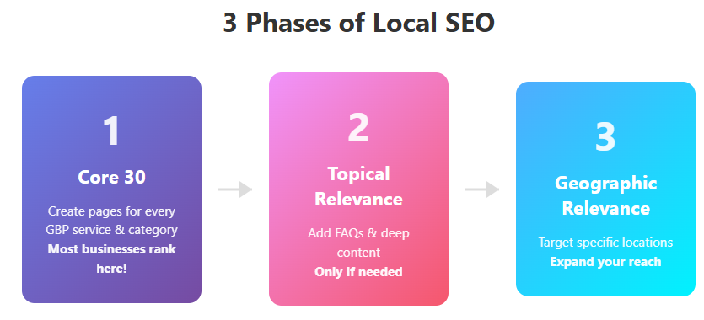
Phase 1: The Core 30 Foundation
The Core 30 forms the backbone of your local SEO strategy. This phase involves creating dedicated pages for every category and service listed on your Google Business Profile (GBP).
What Makes Up the Core 30?
- One URL per GBP category (e.g., "Plumber Houston")
- One URL per GBP service (e.g., "Water Heater Replacement Houston")
- Essential pages: About Us, Contact Us
- Total: Approximately 30 pages for most local businesses
Key Implementation Rules
Each Core 30 page requires:
- Target keyword formula: [Service/Category] + [City Name]
- External backlink: Every URL needs at least one quality external link
- Strategic internal linking: Proper structure connecting related pages

Monitoring Progress
Set up rank tracking immediately and watch your local rank map as you build. When you see your map turning green (positions 1-3), you're achieving success. Many clients rank well before completing all 30 pages!
Phase 2: Building Topical Relevance
If your rank map shows limited green areas after Core 30 completion, you need more topical relevance. This phase helps Google trust your expertise in your service area.
When Do You Need Phase 2?
Look at your rank map:
- Less than 1/3 green: You need topical relevance
- No top 3 rankings near your location: Definite sign to proceed with Phase 2
- Common scenarios: Personal injury attorneys, competitive markets like Houston
How to Build Topical Relevance
- Add FAQ sections to existing pages
- Answer semantically relevant questions (50-100 words each)
- Create long-form content (500+ words) for deeper answers
- Link strategically between short answers and detailed pages
💡 Pro Tip: Don't use exact "People Also Ask" questions anymore. Instead, have AI rewrite them semantically to avoid duplicate content issues while maintaining relevance.
Example Rank Map - Needs Topical Relevance
When you see no green (1-3 rankings) even at your business location, Google doesn't yet trust your expertise. This calls for topical relevance building.
Phase 3: Expanding Geographic Relevance
Most engagements jump directly from Core 30 to geographic relevance, skipping Phase 2. This phase extends your ranking radius to cover your entire service area.
When to Implement Phase 3
Your rank map shows:
- Strong rankings (1-3) near your location
- Positions 4-6 in outer areas
- Clear geographic boundaries where rankings drop
Geographic Content Strategy
- Identify target areas: Find positions 4, 5, or 6 on your rank map
- Research landmarks: Locate neighborhoods, parks, intersections near those positions
- Create location-specific content: [Primary Service] + [Geographic Landmark]
  - Example: "Water Heater Replacement River Oaks"
  - Example: "Plumber Near I-10 and 610 Interchange"
🤖 AI Assistance: Use the AI prompts covered in later lessons to help identify geographical landmarks and create location-specific content
Example Rank Map - Ready for Geographic Relevance
When you see lots of 1s, 2s, and 3s near your location but 4s, 5s, and 6s farther out, Google trusts your expertise but needs confirmation you serve those distant areas.
Strategic Implementation Tips
- Always start with Core 30 - This alone often achieves your goals
- Skip to geographic relevance if you have good center rankings but poor outer coverage
- Add topical relevance only when lacking authority everywhere
Link Building Reminder
Every new URL across all phases requires at least one external link. This remains constant whether you're building Core 30 pages, topical relevance content, or geographic pages.

LOCAL LINK OVERVIEW
In local SEO, not all links are created equal. Understanding the strategic purpose behind different link types will help you build a more effective and sustainable SEO campaign for your local business clients.
When building links for local SEO, we categorize them into two distinct types, each serving a specific purpose in your overall strategy.
Type 1: Content Validation Links
The primary purpose of these links is simple but crucial: they signal to Google that your content isn't AI-generated slop.
With the proliferation of AI content generation tools, it's now possible to produce thousands of articles daily through WordPress plugins connected directly to AI APIs. While this worked temporarily, Google's Helpful Content Update largely eliminated the effectiveness of mass-produced, low-quality content.
⏩⏩Related Lessons:
Searching for Link Opportunities
Local Authority Building
Key Points:
- You need approximately one link per URL that you create or significantly modify
- These links don't necessarily build ranking authority
- They primarily serve to get your content indexed and trusted by Google
- Without these links, Google may dismiss your content as low-quality AI spam
📌 Remember: Google has its own AI content generator at the top of search results. They don't want everyone else's AI-generated content cluttering up their index without proper validation.
Type 2: Trust & Authority Links
These are the powerhouse links that actually move the needle for rankings. Unlike validation links, these hyperlocal, highly specific links build genuine trust with both Google and ChatGPT.
Characteristics:
- Much more powerful than validation links
- Almost never free (typically require sponsorships or donations)
- You usually only need 2-4 of these for most local businesses
- Highly competitive niches (like plastic surgeons in major cities) may require 20+
Implementation Strategy for Validation Links
Primary Source: PBN Links
For validation links, we primarily use Private Blog Network (PBN) links because they're:
- Cost-effective for accomplishing the validation goal
- Quick to implement
- Sufficient for signaling content quality to Google
⚠️ Important Note: These PBN links are NOT used for ranking purposes. They exist solely to validate that your content is legitimate and worth indexing.
Link Diversity Schedule
To maintain a natural link profile, implement this diversification schedule:
At engagement start and every 3-4 months:
- Press releases
- Social media signals
- Blog comments
Every 4-5 months:
- Blog outreach links (higher quality, more expensive)
💡 Pro Tip: In less competitive markets (like a plumber in Fort Wayne, Indiana), you may not need any of these diversification tactics. Always scale your efforts to match the competition level.
Acquiring Trust & Authority Links
The most effective local trust links come from community involvement and sponsorships:
Prime Opportunities:
- Chamber of Commerce membership
- Youth sports league sponsorships
- Local festival sponsorships
- Local nonprofit donations
How It Works:
- Identify local organizations that need funding
- Provide a sponsorship (usually a few hundred dollars)
- They create a sponsors page thanking you with a link to your homepage
- You receive a plaque or certificate for display in your client's location
- Everyone wins: they get funding, you get a powerful local link
🎯 Related Lesson: Check out Searching for Link Opportunities for specific prompts to find these sponsorship opportunities in your area.
Scaling Your Link Building Efforts
The number and type of links you need depends entirely on your competitive landscape:
Low Competition Markets:
- May need zero diversification links
- 1-2 local authority links maximum
- Focus on content quality over quantity
High Competition Markets:
- Full diversification schedule implementation
- 10-20+ local authority links
- Higher budget allocation for link acquisition

DUE DILIGENCE EXPLANATION

In local SEO, understanding competition levels is crucial for developing effective strategies and setting realistic expectations with clients. This lesson will teach you how to quickly assess whether a local market is low, medium, or high competition.
Competition in local SEO is determined by two primary factors:
- The Service Type - Some services are inherently more competitive (e.g., personal injury lawyers vs. house painters)
- The Population of the Area - Larger cities typically mean more competition
💡 Note: A personal injury lawyer in a small town can be more competitive than a plumber in a large city. Always consider both factors together.
What to Look For: Key Competition Indicators
1. Review Count in the Map Pack
The number of reviews is your first visual indicator of competition:
- High Competition: 200+ reviews (often 500-6,000+)
- Medium Competition: 15-100 reviews
- Low Competition: Under 15 reviews
⚠️ Important: While reviews aren't a major ranking signal, they massively impact click-through rates. If competitors have 900 reviews and you have 4, even ranking won't bring calls.
2. Organic Rankings of Map Pack Businesses
This is your most reliable competition indicator:
- High Competition: Map pack businesses also rank on page 1 of organic results
- Medium Competition: Map pack businesses rank on pages 2-4 of organic results
- Low Competition: Map pack businesses don't rank organically at all
3. Website Presence
Check if the top 3 map pack businesses have websites:
- High Competition: All have well-optimized websites
- Medium Competition: All have websites, but not all are optimized
- Low Competition: 1-2 businesses don't even have websites
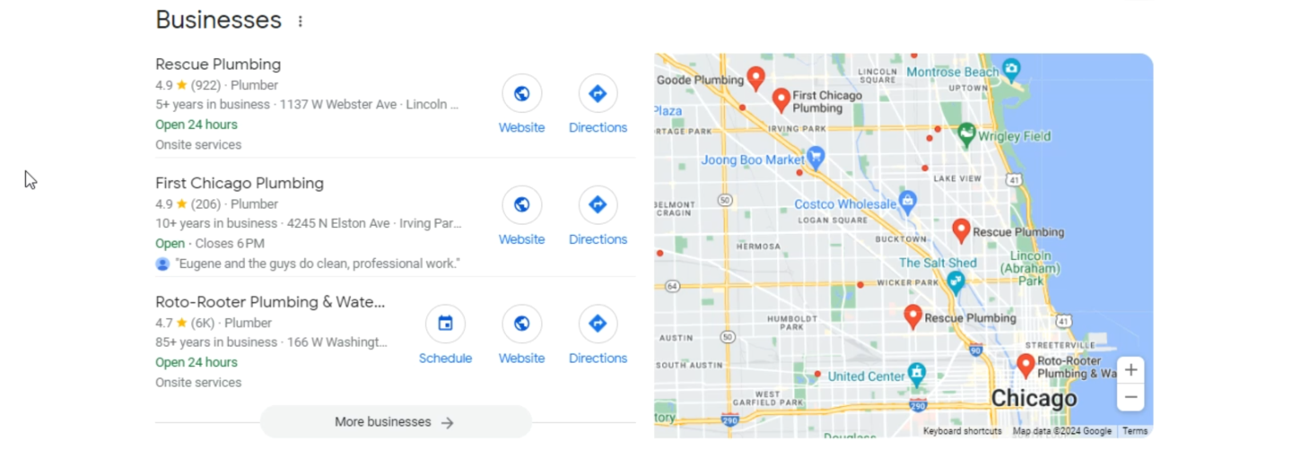
Real-World Examples
High Competition: Plumber in Chicago
- Reviews: 900, 200, 6,000+
- Organic Rankings: Top map businesses also dominate page 1 organic results
- National franchises present (e.g., Roto-Rooter)
Medium Competition: Plumber in Biloxi
- Reviews: 13, 43, 2,700 (outlier)
- Organic Rankings: Map businesses found on pages 2-5
- All have websites but varying optimization levels
Low Competition: Plumber in Soshur/Long Beach, MS
- Reviews: 7, 12, 1,277
- Organic Rankings: Only one business appears organically
- Two of three businesses don't have websites
The Geographic Ranking Challenge
Here's a critical insight: Even a business with 2,700 reviews struggles to rank in nearby cities where they don't have a physical address.
🗺️ Case Study: Ball Plumbing has 2,700 reviews and ranks in Biloxi but can't crack the top 3 in nearby Long Beach, where businesses with 7-12 reviews and no websites dominate.
This demonstrates why "Geographical Relevance" (covered in another lesson) is so crucial - you can't simply overpower local competition from another city, no matter how strong your SEO.
What This Means for Your Strategy
- Low Competition: Focus on basic optimization, can achieve results quickly
- Medium Competition: Need solid Core 30 content and consistent link building
- High Competition: Requires comprehensive strategy, significant content, and patience

SCHEMA EXPLANATION
Schema markup is one of the quickest wins in SEO—it's incredibly fast to implement and helps search engines understand your content better. Despite being easy to overlook, there's no reason why every single URL on your domain shouldn't have schema markup.

🤖 Schema Prompt 1 🤖
What information do you need from me to create [schema type] schema?

🤖 Follow-up Prompt 🤖
Here is the information you need to create [schema type]. Please write it for me.
What is Schema?
Schema is a structured data markup language that helps Google and other search engines understand what your content is about. Think of it as providing clear labels and context for your website's information, removing any guesswork for search engines.
Types of Schema Markup
Let's break down the main types of schema you'll be implementing:
1. Organization Schema
- Where to use: Every single URL on your domain (in the header)
- Purpose: Provides consistent business information across your entire website
- Why it matters: Ensures search engines understand your business identity throughout your site
2. Local Business Schema
- Where to use: Only on the URL your Google Business Profile points to
- Purpose: Confirms your landing page matches your GBP information exactly
- Why it matters: Strengthens local SEO signals by linking your website to your GBP
💡 Note on Location Types: If you have multiple locations, each location page should have schema matching its specific Google Business Profile. For single locations, this typically goes on your homepage.
3. Product Schema
- Where to use: Individual product pages (mainly e-commerce)
- Purpose: Provides detailed product information including price, availability, and specifications
- Why it matters: While Google can guess product details, schema ensures accuracy
4. Article Schema
- Where to use: Every blog post and article
- Purpose: Helps your content appear better in search results
- Why it matters: Can improve click-through rates by enhancing how your content displays
5. FAQ Schema
- Where to use: Any page with frequently asked questions
- Purpose: Allows Google to display Q&As directly in search results
- Why it matters: More SERP real estate = more clicks
📌 Pro Tip: Following our content structure guidelines means many of your pages should include FAQs, making this schema type especially valuable.
6. Review Schema
- Where to use: Every page containing customer reviews
- Purpose: Can display review ratings in search results
- Why it matters: Star ratings in SERPs can significantly boost click-through rates (though this is becoming harder to achieve)
7. Breadcrumb Schema
- Where to use: Pages with hierarchical structure (especially target URLs and supporting content)
- Purpose: Helps Google understand your site structure and content silos
- Why it matters: Reinforces the topical relevance you're building with your content strategy

Local business schema
Local business schema is a critical piece of markup language that communicates directly with Google, identifying your website as a local business and providing all the essential information search engines need to understand your business better.
Schema markup is structured data that helps search engines understand the content and context of your website. For local businesses, this specialized markup ensures Google recognizes you as a local entity and can properly display your business information in search results.
💡 Key Insight: Schema markup acts as a translator between your website and search engines, making your business information crystal clear to Google's algorithms.
Creating Schema with AI
The fastest way to generate local business schema is using ChatGPT or Claude. Here's the simple process:
- Ask the AI what information it needs to write local business schema
- Provide all the requested information (detailed below)
- Request the schema markup by saying: "Please write local business schema for me"
- Validate the output using Google's Structured Data Testing Tool
⚠️ Important: Always verify AI-generated schema, as AI tools can occasionally make formatting errors or include outdated markup standards.
Where to Place Your Schema
Schema placement is straightforward but crucial:
- Single location businesses: Place schema only on your GBP landing page (the page your Google Business Profile links to)
- Multi-location businesses: Each location needs its own landing page with location-specific schema
❌ Common Mistake: Don't add schema to every page on your website—only the designated landing page(s) need this markup.
⏩⏩ Related: Learn how to create effective landing pages in Generating a GBP Landing Page and understand site structures in How to Structure the Core 30.
Essential Schema Information
Every piece of information in your schema must exactly match what appears on your Google Business Profile:
- Business Name: Must match GBP name exactly
- Business Type: Use your primary GBP category (🔗 See "GBP Categories" for optimization tips)
- Description: Copy your GBP description verbatim (🔗 Learn to craft effective descriptions in "GBP Description")
- Address: Match the GBP address format precisely
- Phone Number: Use the exact number from your GBP
- Email Address: Must match GBP contact email
- Website URL: The landing page URL
- Coordinates: Latitude and longitude of your business location
📍 Pro Tip: To find coordinates, right-click any location in Google Maps to instantly see latitude and longitude.
- Opening Hours: Mirror your GBP hours exactly (🔗 Don't forget "Upcoming Holiday Hours")
- Service Area: Match your GBP service area settings
- Social Media Profiles: Include all profiles listed on GBP
- Business Logo URL: Right-click your logo on your website → "Copy image address"
- Additional Images: Optional but recommended; can include storefront or service photos
- Payment Methods: List accepted payment types
- Price Range: Use dollar signs ($, $$) to indicate pricing tier

🤖 Claude Prompt 1 🤖
What information do you need to create local business schema?

🤖 Claude Prompt 2 🤖
[Give requested information]
With this data, please write local business schema.

THE CORE 30 CONTENT STRATEGY
Before diving into the Core 30 concept, it's crucial to understand a fundamental principle of local SEO that sets it apart from traditional SEO strategies. In local SEO, every single piece of content on your website exists for one primary purpose—to rank your Google Business Profile (GBP) higher.
This represents a significant shift in mindset from traditional SEO. While conventional SEO often focuses on ranking individual pages for specific keywords, local SEO takes a holistic approach. Every URL, every article, every page on your site works together as part of a larger ecosystem designed to establish your business as the go-to authority in your local area.
💡 Key Insight: In local SEO, we're not trying to rank individual articles or pages. Everything we create is designed to build topical or geographical relevance that elevates your GBP in local search results. This unified approach is what makes local SEO both powerful and efficient.
The Power of Topical Relevance
Building a successful local SEO presence follows a specific hierarchy that cannot be shortcuts. You must establish topical relevance before geographical relevance—this is non-negotiable. Think of it as building a house: you need a solid foundation before you can add walls and a roof.
Why Topical Relevance Comes First
Consider this practical example: You can't establish yourself as "Chicago's best plumber" if Google doesn't first understand that you're a plumber. Without strong topical signals, any geographical signals you send become meaningless. It's like trying to be famous for something you haven't proven you can do.
The most effective way to build this topical relevance is through strategic content creation that mirrors your business's actual services and expertise. This is where the Core 30 strategy becomes not just useful, but essential to your local SEO success.
📚 Related Learning: To understand how Google evaluates topical relevance and authority, review the lesson How SEO Authority is Passed

What Exactly is the Core 30?
The Core 30 is a strategic content framework that creates perfect alignment between your website structure and your Google Business Profile. It's called the "Core" 30 because these pages form the absolute foundation of your local SEO presence—without them, other efforts will yield limited results.
Core Components Breakdown
1. Category Pages (3-5 pages)
- One comprehensive page for each primary category in your GBP
- These are your broadest service offerings (e.g., "Plumbing Services," "HVAC Services")
- Each page should contain 1,500-2,500 words of in-depth content
- Focus on explaining what the category encompasses and why it matters
2. Service Pages (20-30 pages)
- One detailed page for each specific service listed in your GBP
- These drill down into specific offerings (e.g., "Water Heater Repair," "Drain Cleaning")
- Each page should contain 1,000-2,000 words of targeted content
- Include specific information about processes, benefits, and common customer questions
3. Essential Business Pages
- About Us: Establishes your business story, credentials, and local connection
- Contact Us: Provides clear pathways for customer engagement
- Additional pages as needed (e.g., service areas, testimonials)
This typically totals around 30-40 pages—hence the name "Core 30" (because, let's be honest, "Core 40" doesn't have the same ring to it!).
🎯 Strategic Note: The exact number isn't as important as the concept. Whether you end up with 28 or 35 pages, what matters is that you have comprehensive coverage of every service and category in your GBP.
Why the Core 30 Works So Effectively
The Core 30 strategy succeeds because it leverages multiple SEO principles simultaneously:
1. Content Volume and Depth
When properly executed, the Core 30 creates tens of thousands of words of topically relevant content. This massive content foundation sends strong signals to Google about your expertise and comprehensive service offerings. It's not just about quantity—it's about creating a complete topical map of your business.
2. Perfect Structural Alignment
Your website structure becomes a mirror image of your GBP structure. This alignment makes it incredibly easy for Google to understand:
- What services you offer
- How those services relate to each other
- Which services are most important to your business
- How comprehensive your expertise is in each area
3. Internal Linking Opportunities
With 30+ interconnected pages, you create natural opportunities for internal linking that:
- Distributes authority throughout your site
- Helps users navigate between related services
- Reinforces topical relationships
- Keeps visitors engaged longer
4. User Experience Benefits
Visitors can easily find detailed information about any service they're interested in, improving:
- Time on site metrics
- Conversion rates
- Customer confidence
- Overall user satisfaction
📚 Related Learning: To maximize the impact of your Core 30, review Internal Anchor Text Guidelines
Monitoring Your Progress: The Data-Driven Approach
Building the Core 30 isn't a "set it and forget it" strategy. Success requires careful monitoring and adjustment based on real performance data.
Setting Up Your Tracking System
- Implement Rank Tracking
  - Use professional rank tracking tools to monitor local visibility
  - Track rankings for your primary service + location combinations
  - Monitor both GBP rankings and organic website rankings
  - Set up alerts for significant ranking changes
- Automate Rank Maps
  - Schedule weekly or bi-weekly rank map reports
  - These visual representations show your visibility radius
  - Watch how your coverage area expands as you publish content
  - Identify gaps in coverage that need attention
- Track Publishing Impact
  - Document when each Core 30 page goes live
  - Note ranking changes 2-4 weeks after publishing
  - Identify which pages create the biggest impact
  - Use this data to prioritize remaining content
⚡ Success Note: Here's an exciting reality—the Core 30 strategy is so powerful that over 80% of local businesses achieve their ranking goals before even completing all 30 pages! Many businesses see significant improvements after publishing just 10-15 pages, especially if they start with their most important categories and services.
Critical Success Factor: Link Building
While creating the Core 30 content is crucial, remember that content alone isn't enough in competitive markets. The two-pronged approach of content + links is what creates unstoppable local SEO momentum.
Why Links Matter for the Core 30
- Authority Distribution: Links pass authority to your Core 30 pages, making them more likely to influence your GBP rankings
- Crawl Priority: Linked pages get crawled and indexed faster
- Trust Signals: Quality links indicate that other websites vouch for your content
- Competitive Edge: In competitive markets, links often make the difference between ranking #3 and ranking #1
Link Building Best Practices for Core 30
- Prioritize Your Most Important Pages
  - Start with category pages (they're broader and easier to link to)
  - Focus on your highest-revenue services
  - Build links gradually and naturally
- Diversify Your Link Sources
  - Local business directories
  - Industry-specific directories
  - Local news and blog mentions
  - Partner and vendor websites
  - Community organization sites
- Monitor Link Impact
  - Track which pages have links
  - Measure ranking improvements after link acquisition
  - Adjust strategy based on results
🔗 Next Steps: Learn more about effective link building strategies in the module Starting Off-Site AI SEO, particularly the lessons on Introduction to Backlinking and Local Authority Building.
Common Pitfalls to Avoid
Understanding what not to do is just as important as knowing what to do:
1. Publishing Without Optimization
Don't just create content for the sake of hitting a number. Each page should be:
- Fully optimized for its target service/category
- Written with user intent in mind
- Properly formatted with headers, bullets, and images
- Mobile-friendly and fast-loading
2. Ignoring Content Quality
AI can help create content quickly, but don't sacrifice quality for speed:
- Always edit AI-generated content
- Add local examples and case studies
- Include unique insights from your business experience
- Ensure accuracy and helpfulness
3. Forgetting the User
While the Core 30 is designed to rank your GBP, remember that real people will read these pages:
- Write in a conversational, approachable tone
- Answer common customer questions
- Include clear calls-to-action
- Make it easy to contact you
🎨 Content Tip: Review Human Editing of AI Articles in the Creating AI Content module to ensure your Core 30 pages resonate with real customers.
Putting It All Together: Your Action Plan
Audit Your Current State
Quality matters more than quantity. Thirty mediocre pages won't outperform fifteen excellent ones that truly serve your customers' needs. The good news is that 80% of businesses achieve their ranking goals before completing all 30 pages—the strategy is that powerful when executed properly.
- List all categories in your GBP
- List all services in your GBP
- Identify which pages already exist on your website
- Create a gap analysis
Prioritize Your Content Creation
Remember that topical relevance must come first—you simply cannot build geographical relevance without establishing what your business does. Monitor your progress continuously with rank tracking tools to guide your efforts and ensure you're moving in the right direction. The combination of quality content and strategic link building creates the momentum you need for lasting success.
- Start with missing category pages
- Move to your most profitable services
- Fill in remaining service pages
- Add any missing essential pages
Create a Publishing Schedule
The Core 30 represents the foundation of local SEO success. Without it, other efforts will have limited impact because you lack the topical relevance necessary to compete effectively. Creating perfect alignment between your website structure and GBP sends powerful relevance signals that Google cannot ignore.
- Aim for 2-3 new pages per week
- Allow time for proper optimization
- Build in link acquisition for each page
- Monitor results continuously
Measure and Adjust
Remember that topical relevance must come first—you simply cannot build geographical relevance without establishing what your business does. Monitor your progress continuously with rank tracking tools to guide your efforts and ensure you're moving in the right direction. The combination of quality content and strategic link building creates the momentum you need for lasting success.
- Track ranking improvements weekly
- Identify which pages drive the most impact
- Adjust your strategy based on data
- Celebrate wins along the way
The Core 30 is your foundational website structure for local SEO success. This lesson breaks down exactly how to organize your site's content hierarchy to maximize local search visibility.
The Core 30 represents the essential pages every local business website needs to establish topical authority and geographic relevance. Think of it as your site's backbone—without it, you're missing critical ranking opportunities.
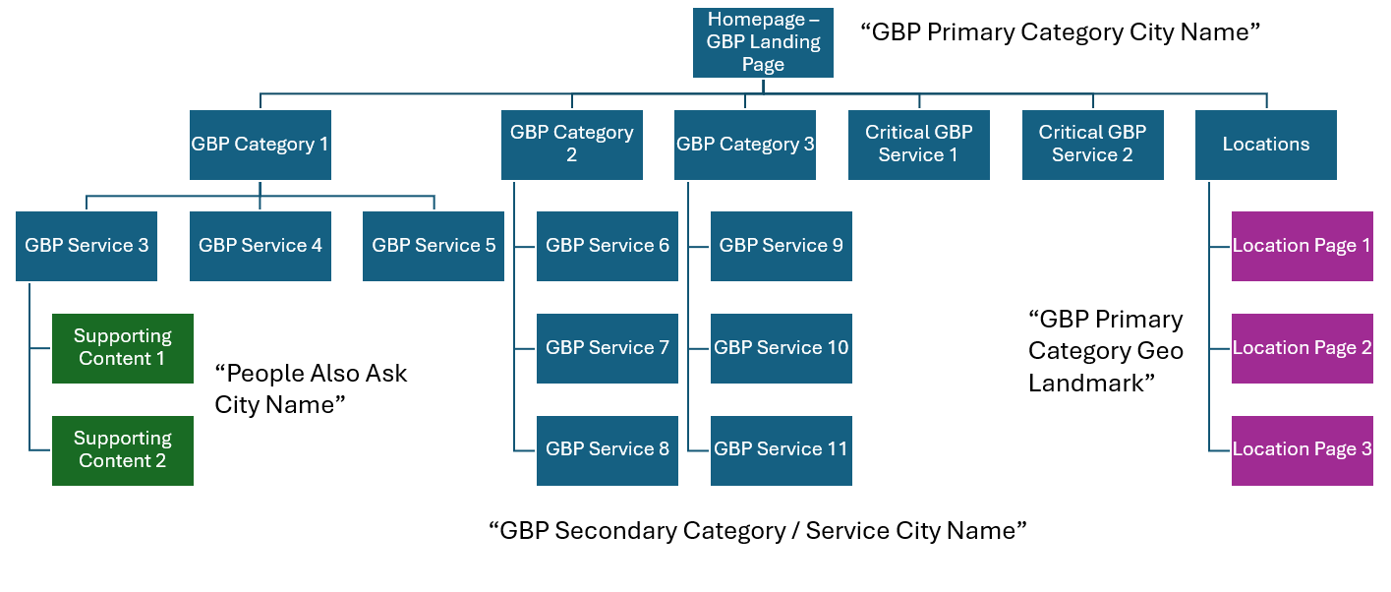
Homepage vs. GBP Landing Page
Your approach here depends on your business structure:
Single Location Businesses:
- Homepage = GBP Landing Page
- Target keyword: [GBP Primary Category] + [City Name]
- Example: "Plumber Houston" or "Plumber Chicago"
Multi-Location Businesses:
- Homepage remains separate
- Create individual GBP landing pages for each location
- Each landing page targets its specific location
💡 Pro Tip: Your title tag and H1 should include your exact match target keyword, but you can add additional words for context. Example: "Find Out Why We're the Best Plumber in Chicago 2025"
The Core 30 Structure Breakdown
1. GBP Landing Page (Homepage for Single Locations)
Your GBP landing page serves as the hub for all your services and categories. Structure it with:
- Target Keyword: [Primary Category] + [City Name]
- Subheadings: One for each GBP category (up to 10 total)
- Content Blocks: 50-100 words under each subheading
- Internal Links: Link from each block to its dedicated category/service page
2. Category Pages
Create one URL for each GBP category:
- Primary Category: Gets its own dedicated page
- Secondary Categories: Up to 9 additional category pages
- Target Keywords: [Category Name] + [City Name]
⏩⏩ Related Lesson: Review GBP Categories to understand how to select and optimize your Google Business Profile categories effectively.
3. Service Pages
Build individual pages for each service you offer:
- Minimum Recommendation: 11+ service pages
- Target Keywords: [Service Name] + [City Name]
- Example: "Water Heater Replacement Houston"
Special High-Priority Services
For critical, high-margin services (limit to 2-3):
- Link directly from the homepage
- Track rankings separately in your rank tracking tool
- Common examples for plumbers:
  - Water heater replacement
  - Main drain line replacement
4. Locations Page
A standard locations page listing all your service areas or business locations.
Beyond the Core 30: Building Relevance
Once your Core 30 is complete, evaluate your rank map to determine next steps:
If your geographic coverage is weak, add supporting content (colored green in the diagram.)
- Source: People Also Ask questions
- Structure: [PAA Question] + [City Name]
- Example: "How Much Money Does a Plumber Make in Houston?"
- Linking: Connect these pages to relevant service pages
When topical relevance is strong but you need broader geographic coverage (purple in diagram):
- Target Keywords: [Primary Category/Service] + [Geographic Landmark]
- Examples:
  - "Plumber River Oaks" (neighborhood)
  - "Plumber I-10 and 610 Interchange" (major landmark)
- Purpose: Expand your visibility across the service area
⏩⏩ Related Lesson: Check out Building More Geographical Relevance for detailed strategies on geographic expansion.
Multi-Location Considerations
For businesses with multiple locations, the Core 30 multiplies:
- 3 Locations = Core 90: Build complete structures for each location
- Prioritize Based on Rank Maps: You might not need to complete all 30 pages for every location
- Watch for Patterns: Location 2 might achieve good topical relevance before Location 3 finishes its Core 30
⚡ Efficiency Tip: Use your rank tracking data to guide content priorities. Don't build unnecessary pages if your topical relevance is already strong.

PROPERTY AUDIT QUICK WINS

When you're looking to improve your website's performance, one of the most effective strategies is to enhance content that's already gaining traction. Google Search Console provides powerful filtering capabilities that help you identify quick wins—pages and queries where small improvements can yield significant traffic gains.
The key principle here is simple: it's much easier to improve rankings for keywords you're already ranking for than to rank for entirely new keywords. By focusing on existing rankings, especially those on the cusp of better visibility, you can achieve faster results with less effort.
Using Custom Regex Filters in Search Console
Google Search Console's custom regex (regular expression) feature allows you to filter queries in sophisticated ways. This helps you identify specific types of keywords that represent different opportunities for improvement.
Setting Up Custom Filters
To access this feature:
- Navigate to your Search Console property
- Go to the Performance report
- Click on "Query" filter
- Select "Custom (regex)" from the dropdown
Note: Search Console displays a maximum of 1,000 queries, so if you have a high-traffic site, your filters may return the maximum results.
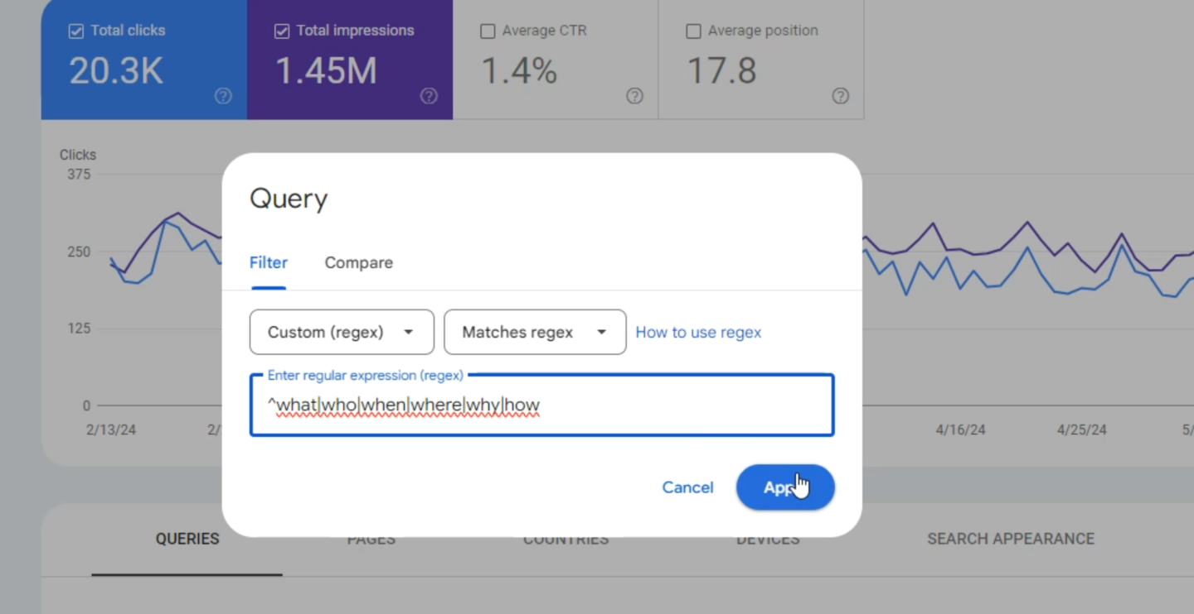
Three Powerful Regex Filters
1. Question-Based Queries
Regex pattern: what|who|when|where|why|how
This filter identifies all queries containing question words. These queries are particularly valuable because:
- They indicate informational search intent
- Users are actively seeking detailed answers
- They often have featured snippet opportunities
ℹ️ Example: If you find a question query getting 54 clicks from position 5, improving that content could significantly increase traffic.
To identify which page ranks for a specific query:
- Click on the query to add it as a filter
- Navigate to the "Pages" tab
- Review which pages are ranking and their combined performance
2. Long-Tail Keywords
Regex pattern: ^(\w+\s){5,}\w+$
This complex-looking pattern identifies queries with more than five words. Long-tail keywords are valuable because:
- They typically have lower competition
- They often indicate higher user intent
- Small ranking improvements can have proportionally larger impacts
These longer queries may have lower search volume individually, but collectively they can drive substantial, highly targeted traffic.
3. Buyer Intent Keywords (E-commerce Focus)
Regex pattern: price|advice|buy|order|promotions|best
For e-commerce sites, this filter reveals queries that indicate purchasing intent. These are your money keywords—the queries most likely to convert into sales.
Strategic insight: A query like "best truck seat covers" ranking at position 18 (top of page 2) represents a critical opportunity. Moving from position 11 (first position on page 2—the "first loser" in SEO) to position 8 or 9 can increase clicks from 13 to potentially 50-60 clicks.
Implementing Your Findings
Once you've identified target queries using these filters:
- Prioritize by opportunity: Focus on queries ranking between positions 4-20, where improvements are most impactful
- Analyze the content: Visit the ranking pages and assess what improvements would help them better serve the search intent
- Enhance strategically: Add more comprehensive information, improve structure, update data, or address gaps in the content
ℹ️ Quick Win Strategy: Pages ranking at position 11 (top of page 2) should be your highest priority. Moving these to the bottom of page 1 often results in 3-5x traffic increases.
Additional Regex Patterns to Consider
While the lesson covers three main patterns, you might also find value in:
- Location-based queries: near me|in [city]|nearby
- Comparison queries: vs|versus|compare|difference
- Year-specific queries: 2024|2025 (update annually)
Remember, the data in Search Console represents real user behavior—these are queries people are actually using to find your site. By improving your performance for these existing queries, you're building on a foundation that's already proven to work.
ℹ️ Pro Tip: Export your filtered data regularly to track improvements over time. This helps you measure the impact of your optimizations and build a case for continued SEO investment.

PROPERTY AUDIT PART 1
When optimizing an existing property, one of your first tasks is understanding what content we already have and what's missing. This lesson will show you how to perform a comprehensive content audit that aligns with the Core 30 structure we've been building throughout this course.
This audit process helps you:
- Identify existing content that fits the Core 30 framework
- Discover content gaps that need to be filled
- Create a clear action plan for content development
- Ensure proper site structure for local SEO success
Prerequisites
Before starting your content audit, you'll need:
- Screaming Frog SEO Spider (free for sites under 500 URLs) - CAN BE REPLACED BY N8N
- Access to ChatGPT o1 (or Claude as an alternative)
- The property’s Google Business Profile information
- Basic text editor or Word processor
💡 Note: While ChatGPT o1 performs better for this analysis task, Claude can handle it effectively if you don't have a ChatGPT subscription.
Step-by-Step Audit Process
Step 1: Gather Homepage Content
Start by collecting the client's homepage content:
- Navigate to the client's website
- Select all content (Ctrl+A or Cmd+A)
- Copy the content (Ctrl+C or Cmd+C)
- Paste into a Word document or text file
- Save this for later use
Step 2: Collect Service Information
Next, gather the services from the client's Google Business Profile:
- Access the client's GBP
- Click on "Services"
- Copy all listed services
- Keep this list handy for the prompt
Step 3: Run Screaming Frog Analysis
Now it's time to crawl the website:
- Open Screaming Frog SEO Spider
- Enter the main domain (e.g., example.com)
- Click "Start" to begin crawling
- Wait for the crawl to complete
Once finished, export two critical files:
Export 1: Internal URLs
- Navigate to the "Internal" tab
- Click "Export"
- Select "Internal - All (CSV)"
- Save the file
Export 2: Links Data
- Navigate to the "Links" tab
- Click "Export"
- Select "All Links (CSV)"
- Save the file
Step 4: Prepare Your AI Prompt
Use the provided prompt template (available in this lesson) and customize it with:
- The client's secondary services/categories
- The complete list of services from their GBP
Step 5: Run the Analysis
- Open ChatGPT o1 (or Claude)
- Paste your customized prompt
- Upload the three files:
  - Homepage content document
  - Internal URLs CSV
  - Links CSV
Step 6: Handle Common Issues
It's common for ChatGPT to initially claim it can't read the CSV files. If this happens, don't panic - this is normal. Respond with this:
I gave you the CSV files necessary. Please use them in the analysis. I can give them to you again if necessary.
Then, the AI will typically then process the files correctly using Python
⚠️ Important: This extra step is almost always necessary with ChatGPT o1. Be patient and persistent.
Understanding the Output
Your content audit will reveal several key insights:
Missing Category Pages
The analysis will identify which service category pages are absent, such as:
- Drainage service category page
- Gas service category page
- Heating contractor category page
Homepage Gaps
The audit will show:
- Which services aren't linked from the homepage
- Which services aren't mentioned in homepage content
- Internal linking opportunities being missed
Service Page Analysis
For each GBP service, you'll learn:
- Which service pages exist
- Which are missing
- Which need improvement
Action Items
The analysis concludes with:
- Summary of all content gaps
- Priority order for content creation
- Specific next steps for implementation
🎯 Pro Tip: This level of detailed analysis is typically reserved for clients or near-clients. For initial prospects, consider a simpler content review to save time.
Next Steps
After completing your Core 30 Content Audit:
- Create Missing Category Pages: Start with the high-priority category pages identified in the audit
- Update Homepage Content: Add mentions of missing services and improve internal linking
- Build Service Pages: Develop individual pages for each missing service
- Review Site Structure: Ensure your content aligns with the Core 30 framework
⏩⏩ Related Lessons
How to Structure the Core 30 - Review the ideal site structure
AI-Writing Content - Learn how to efficiently create the missing pages
Internal Anchor Text Guidelines - Optimize your internal linking

🤖 Prompt: Core 30 Content Audit 🤖
- Data Inputs
  - Screaming Frog Files:
    - links_all.csv
    - internal_all.csv
  - Homepage Content: [Paste the homepage copy here or provide a reference]
  - GBP Categories (primary + secondary):
    - Primary: Plumber
    - Secondary: Drainage Service, Gas Installation Service, Heating Contractor
  - Services:
    - [List each service…]
  - City Name: [e.g., Anytown]
- Analysis Goals
  - For each secondary GBP category, confirm there is a dedicated URL whose title tag and H1 tag includes the keyword phrase in the format "GBP Category" + "City Name" plus additional context (e.g., "Plumbing Services Anytown | Expert Installation & Repair").
  - Check that the homepage:
    - Mentions each of the secondary categories in the copy.
    - Has an internal link to each secondary category page.
  - For each service, ensure there is a dedicated URL whose title tag exactly includes "Service City Name" plus additional words (e.g., "Drain Cleaning Anytown | Quick & Reliable Service").
  - Assign each service to the most relevant GBP secondary category and make sure there is a link from that category’s page to the specific service page.
- What to Output
  - Provide a list of missing pages or title tag gaps (i.e., any GBP category or service that does not have its corresponding dedicated URL with the right format).
  - Identify if the homepage is missing mentions or internal links to any secondary categories.
  - Show any services that do not have a dedicated page or the required exact-match title tag.
  - Highlight if any category pages are missing links to the relevant service pages.
  - Summarize all gaps in a clear, bulleted list so it’s easy to see where the website does not match the intended structure.

PROPERTY AUDIT PART 2
After completing your Core 30 content and building external links to those pages, you might find your rank map still showing room for improvement. This is a clear signal that you need to build more topical relevance for your target keywords.
Topical relevance means creating content that comprehensively covers your subject matter. Google rewards websites that demonstrate deep expertise in their topic areas. The most effective way to build this relevance is by answering the questions Google already knows people are asking.
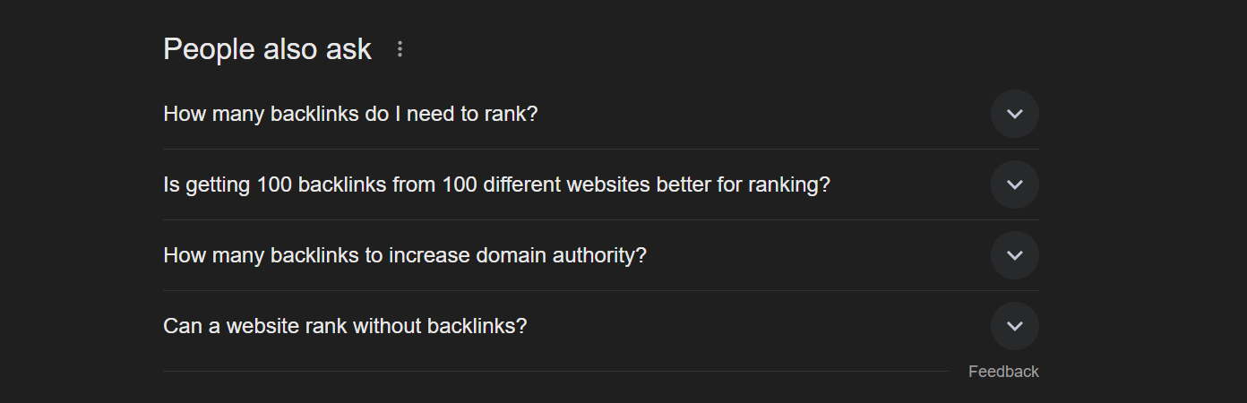
Finding Your Questions
To identify the most relevant questions for your topic:
- Search without geographic modifiers - If you're ranking a plumber in Houston, search just "plumber"
- Locate the People Also Ask section - It typically appears in the middle of search results
- Trigger more questions - If PAA doesn't appear, add "how" or "what" to your search
- Expand your question list - Click to open and close questions repeatedly to reveal dozens more
💡 Pro Tip: Opening and closing PAA questions multiple times can reveal 20-30+ related questions that Google considers highly relevant to your topic.
Creating Content from PAA Questions
The strategy has evolved since summer 2023. Here's the current best practice:
Step 1: Rewrite Questions Semantically
Instead of using PAA questions as exact-match H2 headings, use AI to rewrite them in a semantically relevant way while adding your city name.
Example:
- Original PAA: "How much does a plumber make?"
- Rewritten H2: "How Much Money Does a Plumber Make in Houston?"
Step 2: Answer Immediately and Succinctly
The first sentence after your H2 should deliver a direct answer:
H2: How Much Money Does a Plumber Make in Houston?

A plumber in Houston makes between $75,000 and $120,000 per year on average...
Notice how we repeat key elements from the question in our answer. This helps Google's algorithm clearly understand that we're providing a direct answer to the specific question.
Step 3: Create Supporting Long-Form Content
After your initial 50-75 word answer paragraph, link to a comprehensive 1,500-word article that fully explores the topic. This article should:
- Be specific to your location (Houston in our example)
- Cover various aspects (experience levels, license types, specializations)
- Include a contextual editorial link back to the original FAQ page
- Have its own external backlink
Implementation Schedule
Monthly Content Production
- Target 3-5 supporting articles per month per topic
- Alternate between topics each month
- Allow time for ranking improvements between content batches
Example Schedule:
- Month 1: 3-5 articles about "plumber"
- Month 2: 3-5 articles about "water heater replacement"
- Month 3: Return to "plumber" articles
- Continue alternating...

Why Alternate Topics?
Ranking improvements take time to manifest. By alternating between topics monthly, you:
- Avoid over-producing content for topics that may already have sufficient relevance
- Give Google time to process and rank your new content
- Can measure the impact of your efforts before investing more resources
⚡ Quick Check: After implementing topical relevance content, monitor your rank map. When you see significant improvement across your target keywords, it's time to shift focus to Building More Geographical Relevance.

🤖 PAA Question Rewording Prompt 🤖
I will provide you with a list of "People Also Ask" (PAA) questions related to a specific target keyword. Your task is to reword each question in a semantically relevant way that:
- Maintains the same search intent and core meaning
- Uses natural, conversational language that feels authentic
- Incorporates synonyms, related terms, or alternative phrasings
- Remains highly relevant to the target keyword for search algorithms
- Avoids the exact PAA phrasing that has been widely scraped
Guidelines for rewording:
- Change question structure (e.g., "How to..." → "What's the best way to..." or "Steps to...")
- Use synonyms for key terms where appropriate
- Vary question formats (Why/How/What/When/Where)
- Keep the same level of specificity
- Ensure the reworded version would logically appear in search results for the same queries
Format your response as:
- Original PAA: [original question]
- Reworded: [your semantically relevant alternative]
Target keyword: [INSERT]
PAA questions to reword: [INSERT LIST]

CONTENT PLANNING: TOPICAL RELEVANCE PART 1
In the modern Google algorithm, topical relevance is more important than keyword research. While keywords remain relevant, topical relevance is how you establish your website as the comprehensive authority on your target subject.
Topical relevance means covering all aspects of a topic area. Google analyzes the breadth and depth of your content to determine if you're truly an expert in your field.
🔑 Key Insight: You're building topical clusters that signal to Google your site is the go-to resource for everything related to your niche.
Using AI for Topic Generation
When requesting topics from AI, specify that they should be "semantically relevant according to Google's algorithm" - not just what the AI considers relevant.
This distinction matters because Google's algorithm has specific semantic understanding that differs from general AI associations.
Implementation Process
⚠️ Always use the most current AI model available, and verify you have the correct model selected before proceeding.
- Select the newest AI model available
- Use the provided prompt in this module (don't modify the semantic relevance specification)
- Generate 25 related topics for your target subject
- Review results for Google algorithm alignment
Next Steps
Use your 25 topically relevant subjects to plan content creation, identify gaps, build topic clusters, and establish semantic authority.

🤖Content planning for Topical Relevance Prompt🤖
Replace “graphic design” with your niche.
You are an SEO and language expert with a history in understanding how Google’s algorithm interprets language. I want to improve my website’s topical relevance within the “graphic design” niche. My goal is to create content that aligns closely with topics Google’s algorithm considers semantically related, thereby improving my site’s visibility and authority. To achieve this, I need your help with the following tasks:
- Generate a list of topics: Please create a list of 25 topics related to “graphic design.” These topics should be carefully chosen to ensure they are viewed as closely related by Google’s algorithm, improving the topical relevance of my website for “graphic design.” Consider emerging trends, foundational principles, and specialized areas.
- Evaluate the main category: Based on your understanding of current SEO trends and Google’s algorithm preference, suggest any modifications to the main category of “graphic design” if you see a more focused or altered categorization could better serve my goal of increasing topical relevance and search visibility.
- Clarifying questions: Should you need further clarification on the scope of this category or if specific aspects of my request are unclear, please list any questions that would help you better tailor your response to my needs. This could include seeking more information about my target audience, the current content mix on my website, or particular areas of this topic I wish to emphasize.
The ultimate aim is to identify a cohesive set of topics that will guide our content creation efforts, making the website a comprehensive resource that is highly regarded by both users and Google’s search algorithm.

CONTENT PLANNING: TOPICAL RELEVANCE PART 2
How to leverage AI to generate multiple keyword variations for your content topics? This technique helps you build comprehensive topical authority by creating semantically relevant content that Google recognizes as authoritative within your niche.
When you're building content at scale, keyword variations are essential. By creating multiple angles and approaches to the same topic, you:
- Increase topical coverage across your domain
- Build semantic relevance that search engines recognize
- Create more opportunities to rank for related searches
- Establish domain authority in your chosen niche
The Process: From Topics to Keywords
Step 1: Start with Your Core Topics
Using the 25 relevant topics you identified in the previous lesson (see: Generate Topical Relevance), you'll now expand each one into multiple keyword variations.
Step 2: Generate Variations Using AI
For each of your 25 topics, you'll use Claude to generate:
- 15 keyword variations
- SEO-optimized titles
- Content headings
- Basic content outlines
ℹ️ Example: If your topic is "Introduction to Graphic Design," the AI will generate 15 different keyword approaches to this topic, each with its own unique angle and search intent.
Step 3: Scale Your Content Strategy
Here's the math that makes this powerful:
- 25 core topics × 15 variations each = 375 unique article ideas
- Each article targets a specific keyword variation
- All articles remain semantically connected to your main niche
Domain Rating Considerations
Before implementing this strategy, consider your domain's current authority:
- Higher DR sites can target more competitive variations
- Newer sites should focus on long-tail, less competitive variations
- Adjust your keyword difficulty targets based on your site's strength
❗ Important: The examples in this lesson use graphic design as a niche. You must adapt all prompts and strategies to your specific industry or topic area.
The Content Creation Pipeline
Once you have your 375 article ideas complete with:
- Target keywords
- SEO-optimized titles
- Content headings
- Basic outlines
You'll move to the next phase: using AI to write all 375 articles. This systematic approach allows you to build authority much faster than traditional content creation methods.

🤖Keyword variations for topical relevance prompt🤖
You are an SEO expert, specifically on growing traffic from Google search by focusing on improving topical relevance. I'm working to boost my website's visibility and authority in the "graphic design" niche on Google. My objective is to craft a series of articles that will not only resonate with various user intents but also enhance the website's topical relevance in the eyes of Google's algorithm. To achieve this, I need:
- 15 keyword variations on the theme "Fundamentals of Graphic Design," each tailored to different facets of user search intent. These variations should explore different aspects, challenges, and interests within the field of graphic design, catering to a wide audience range from beginners to professionals.
- For each keyword variation, please suggest an SEO-optimized title tag designed to maximize click-through rates. The title should be compelling, incorporating the keyword effectively while enticing the potential reader with the promise of valuable insights or solutions.
- Additionally, provide three article heading suggestions for each keyword. These headings should outline a clear, structured approach to the topic, aiming to cover various angles that address specific questions, problems, or interests related to the main keyword. The goal is to create content that is both informative and engaging, encouraging deeper exploration and interaction.
This content strategy aims not only to improve the site’s ranking for a broad spectrum of related searches but also to establish the site as a comprehensive resource in the graphic design domain. Any suggestions for improving the main category or additional questions to better understand this request are welcome.
By applying this method to all your topics, you could theoretically end up with hundreds of article ideas—375, to be exact, in this scenario. Each article will be geared towards enhancing the SEO authority of your domain in the space of your choice.

CONTENT PLANNING: GEOGRAPHICAL RELEVANCE PART 1
Welcome to Phase 3 of the Local SEO process! After establishing strong topical relevance in Phase 2, it's time to focus on overcoming proximity challenges and expanding your reach across your service area.
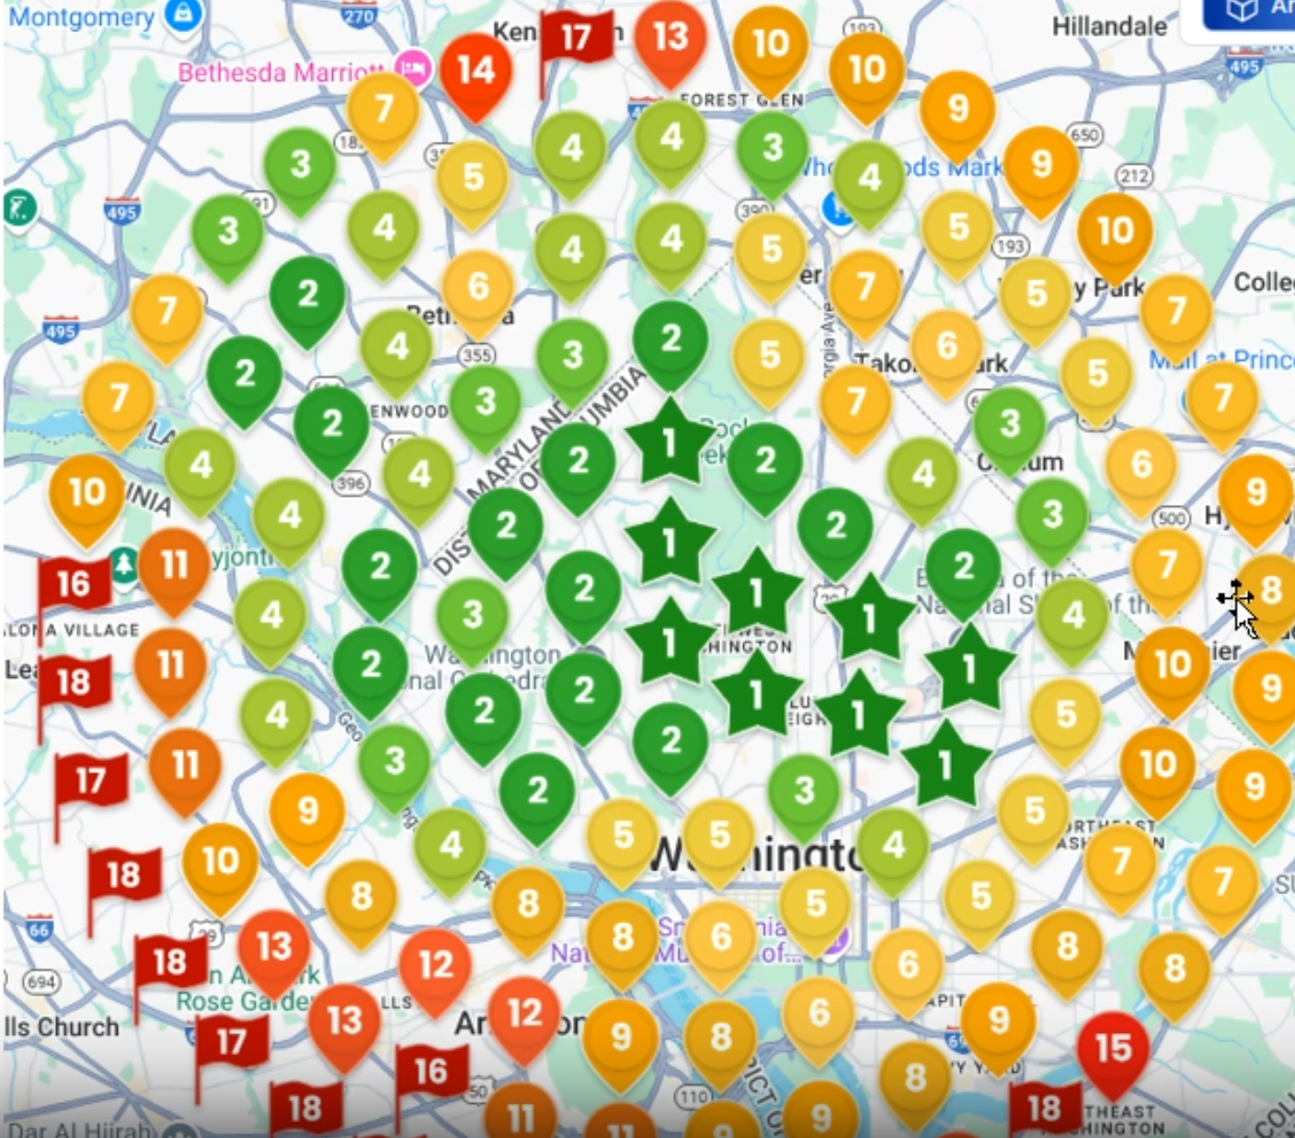
When to Start Building Geographical Relevance
Before diving into geographical content creation, you need to ensure your foundation is solid. Here's how to know you're ready:
- Check your rank map: Roughly one-third of your tracked locations should be ranking well (positions 1-3)
- Pattern recognition: You'll notice rankings are strongest near your business location and drop off with distance
- Goal clarity: Remember, proximity is a major ranking factor we're working to overcome
💡 Quick Tip: Don't rush into Phase 3! Ensure your topical relevance (Phase 2) is well-established first. Check out the lesson on Building More Topical Relevance if you need a refresher.
The Strategic Approach to Geographic Content
Step 1: Identify Target Opportunities
Look for ranking positions that are almost there:
- Primary targets: Positions 4-5
- Secondary targets: Position 6
- Why these positions?: A 1-2 position improvement here means breaking into the coveted top 3!
Step 2: Find Geographic Landmarks
Once you've identified a position 4-6 ranking location:
- Zoom in on your rank tracking tool
- Cross-reference with Google Maps
- Identify nearby landmarks such as:
  - Neighborhood names
  - Parks or recreational areas
  - Lakes or natural features
  - Monuments or historical sites
  - Major intersections
  - Highway interchanges
  - Shopping centers
  - Schools or universities
📍 Example: If you find a position 5 ranking near a major highway interchange, that interchange becomes your geographic landmark for content creation.
Step 3: Create Targeted Geographic Content
Your content formula is simple but powerful:
[Service/Category] + near + [Geographic Landmark] + in + [City]
For example:
- "Water Heater Replacement near the I-10 and 610 Interchange in Houston"
- "Emergency Plumbing near Memorial Park in Houston"
- "Drain Cleaning near Rice University in Houston"
Content Structure for Geographic Pages
Focus your content on one of these angles...
- Project Experience
  - Describe specific jobs completed near the landmark
  - Include challenges unique to that area
  - Mention repeat customers or referrals from the neighborhood
- Area-Specific Considerations
  - What makes servicing this area different?
  - Traffic patterns or access challenges
  - Local regulations or requirements
  - Typical home styles or plumbing systems in the area
- Landmark Significance
  - Interesting facts about the landmark
  - How it affects your service delivery
  - Why residents near this landmark choose your services
🎯 The I-10 and 610 interchange example is perfect because it's one of the widest interstates in the US. You could discuss traffic challenges, timing considerations, and how your team navigates these obstacles to provide timely service.
Creating Your Locations Hub Page
Every local SEO strategy needs a central locations page that:
Structure:
- Navigation placement: Link from your main navigation with simple "Locations" text
- Overview content: Write 200-300 words about your overall service area
- Hub functionality: Link to all individual geographic content pages
- Bidirectional linking: Each geographic page should link back to the main locations page
Content for the Hub Page:
- General discussion of your service across the entire city
- What makes your city unique from your service perspective
- Your commitment to serving all neighborhoods
- Years of experience in the area
⏩⏩ Related Lesson: If you haven't created your locations page as part of the Core 30, review How to Structure the Core 30 for guidance.
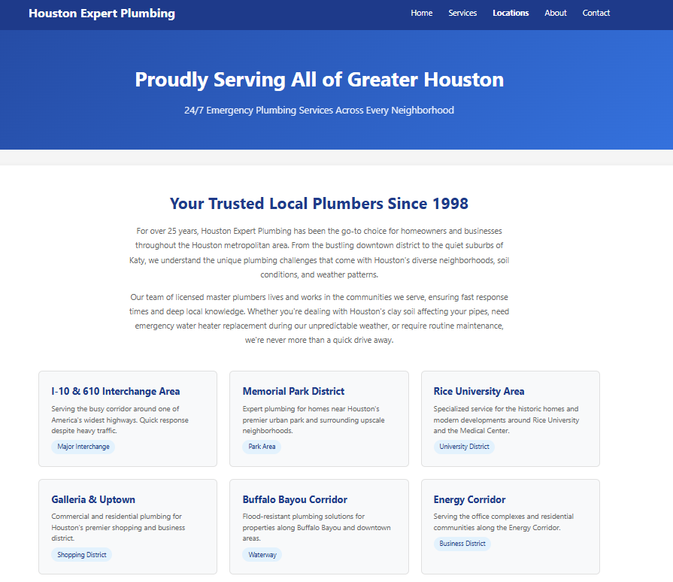
Essential Elements for Each Geographic Page
1. Driving Directions
Always include turn-by-turn directions from the landmark to your Google Business Profile location. This:
- Reinforces the geographic connection
- Provides genuine utility to visitors
- Strengthens local relevance signals
2. External Link Requirement
Every geographic relevance page needs at least one external backlink to be effective. This could come from:
- Local directories
- Neighborhood associations
- Community blogs
- Local news sites
⚠️ Important: Don't skip the external linking step! Review Introduction to Backlinking and Searching for Link Opportunities for strategies.
Scaling Your Geographic Strategy
Example: Chicago Neighborhoods
Chicago provides an excellent model with its distinct neighborhood structure:
- Created dozens of neighborhood-specific pages
- Each linked from a central locations page
- Targeted local search terms for each area
Adapting to Your Market
Not every city has Chicago's neighborhood structure, but every area has landmarks:
- Suburban areas: Shopping centers, schools, major intersections
- Rural areas: County landmarks, highways, natural features
- Dense urban areas: Districts, subway stops, cultural landmarks
Measuring Success
Track your progress by monitoring:
- Movement of positions 4-6 into the top 3
- Overall map coverage improvement
- Expansion of your "green zone" on rank tracking maps
- Increase in calls/leads from previously weak areas

CONTENT PLANNING: GEOGRAPHICAL RELEVANCE PART 2
After establishing your Core 30 content structure, the next challenge is determining which specific geographic areas and keywords to target first. Rather than guessing or randomly selecting neighborhoods, we'll use AI to analyze ranking data and prioritize content creation based on actual opportunity.
When working with local SEO, you'll often face hundreds or thousands of potential keyword-location combinations. For example, a plumbing company in a major metropolitan area might have:
- 50+ services to target
- 20+ neighborhoods or suburbs
- Multiple keyword variations for each service
This creates an overwhelming matrix of content possibilities. AI helps us cut through this complexity by analyzing ranking data and identifying the highest-impact opportunities first.
Working with Leadsnap Data
Step 1: Export Your Ranking Data
Start by accessing your Local Dominator dashboard and downloading the CSV export of your rank tracking data. This file contains comprehensive ranking information across all tracked keywords and locations.
📌 Note: The exported CSV typically contains 1,000+ rows of data, including rankings for your client and all tracked competitors. This is too large to process directly in Claude, so we'll need to filter it first.
Step 2: Filter for Your Client's Data
- Open the CSV in your spreadsheet application
- Select the header row
- Apply a filter to the entire dataset
- In the "Business" column, unselect all options
- Select only your client's business name
Step 3: Prepare Data for Claude
Here's the crucial step that ensures Claude can process your data effectively:
- Click on the column header to select the entire filtered view
- Navigate to Home → Find & Select → Go to Special
- Choose Visible Cells Only
- Copy the selected data
⚠️ Important: If you skip the "Visible Cells Only" step, you'll copy hidden rows and Claude will likely return an error about too much data.
Using Claude for Prioritization
Once you've prepared your filtered data, paste it into Claude along with our prioritization prompt. Claude will analyze:
Geographic Factors
- Population density of different neighborhoods
- Business concentration in each area
- Competition levels across locations
- Current ranking positions by geography
Keyword Opportunities
- Ranking gaps where you're close to page one
- Search volume estimates based on service type
- Competition difficulty for specific terms
- Quick win opportunities (rankings 4-10)
- Highly profitable areas (current rankings lower, but demographics show high value ranking in this location)
💡 Related Lesson: Review Identifying Low Competition for additional strategies on finding untapped keyword opportunities that complement this AI-driven approach.

🤖 Content Prioritization Prompt 🤖
Please analyze the following rank data to identify content opportunities:
Rank map target keyword: [INSERT HERE]
The goal is to improve geographic relevance for specific locations for the target keyword above.
Data Format: CSV with columns:
· Scan Date
· Latitude/Longitude
Analysis Requirements
1. Geographic Coverage Assessment
· Identify areas with weak ranking performance
· Map rank patterns across coordinates
· Note rank variations by neighborhood
2. Competitor Analysis
· Identify neighborhoods with consistent rank drops
· Note patterns in competitive areas
· Highlight geographic gaps
3. Keyword Opportunity Analysis
· List neighborhoods with ranking potential
· Suggest location-specific keyword variations
· Prioritize by ranking difficulty/opportunity
4. Content Recommendations
· Propose neighborhood-focused content topics
· Include geographic modifiers
· Target specific service areas with poor visibility
Expected Output
1. Priority neighborhood list ranked by opportunity. Priority should be given to areas that are already close to the top 3 unless there is a compelling reason otherwise. Make this reason clear.
2. Specific keyword targets for each neighborhood. At least 3 exact target keywords for each area that needs rank improvement relevant to that area and the target keyword. The target keyword for the overall rank map is given above and keep that in mind
3. Content topic suggestions with geographic focus. Find geographic landmarks or similar to focus the content on. For example, "plumber near wrigley field chicago"
4. Ranking improvement potential estimates
Output Format
Which neighborhoods were selected to target and why. Rank each neighborhood on a scale of 1-10 for prioritization in terms of ease of ranking and traffic potential.
1. Neighborhood name
1. Target keyword 1
2. Target keyword 2
3. Target keyword 3
2. Neighborhood two name
1. Target keyword 1
2. Target keyword 2
3. Target keyword 3
3. And so on in this format

Understanding Claude's Output
Claude will provide a prioritized list that typically includes:
- Immediate Opportunities: Keywords where you're ranking 11-20 (just off page one)
- High-Population Targets: Neighborhoods with the most potential customers
- Low-Competition Wins: Areas where competitors haven't established strong presence
- Strategic Expansions: Logical next steps based on your current strengths
Sample Priority Structure
Priority 1: Downtown Plano - "emergency plumber"
- Current Rank: 14
- Population: High density
- Competition: Moderate
- Recommendation: Create dedicated neighborhood page

Priority 2: West Plano - "water heater repair"
- Current Rank: 18
- Population: Growing area
- Competition: Low
- Recommendation: Develop service-specific content

Implementing Your Priority Plan
Content Creation Workflow
- Start with Priority 1 items - These offer the fastest potential returns
- Batch similar content - Group neighborhood pages or service pages together
- Track progress weekly - Monitor ranking improvements as you publish
- Adjust priorities - Re-run the analysis monthly as rankings shift
📝 Pro Tip: Claude has extensive data on neighborhoods, demographics, and local characteristics. Don't hesitate to ask follow-up questions about specific areas to enhance your content strategy.
Maximizing Efficiency
Time-Saving Strategies
- Template development: Create templates for neighborhood and service pages based on top priorities
- Batch processing: Generate multiple pieces of content in one Claude session
- Strategic scheduling: Plan content rollout based on seasonal demand patterns
💡 Related Lesson: Check out Generating Supporting Content for specific techniques on efficiently creating the prioritized pages identified through this process.
Common Pitfalls to Avoid
- Over-prioritizing based on population alone - High population doesn't always mean high conversion
- Ignoring seasonal factors - Some services have peak seasons that affect priority
- Neglecting current strengths - Sometimes expanding where you already rank well yields faster results
- Analysis paralysis - Don't spend weeks analyzing; start creating content and adjust as you go
Measuring Success
Track these metrics to validate your prioritization strategy:
- Ranking improvements in targeted keywords/locations
- Traffic increases to new geographic pages
- Lead quality from different neighborhoods
- Conversion rates by location
🎯 Next Steps: Once you've identified your priorities, move on to creating optimized content. The Generating Service & Category Pages lesson will show you exactly how to create high-performing pages for your prioritized targets.

CONTENT AUDIT : OVERVIEW
This lesson demonstrates how to systematically improve existing content that's performing well but could rank higher. Using Google Search Console data combined with AI, you can identify pages ranking on the second page (positions 11-20) and optimize them to reach the first page with strategic content additions.
When a page ranks in positions 11-12 for a query but doesn't contain the exact match keyword, simply adding that keyword can improve rankings by several positions. This small improvement is often enough to move content from page 2 to page 1—a massive traffic boost.
The 6-Step Process
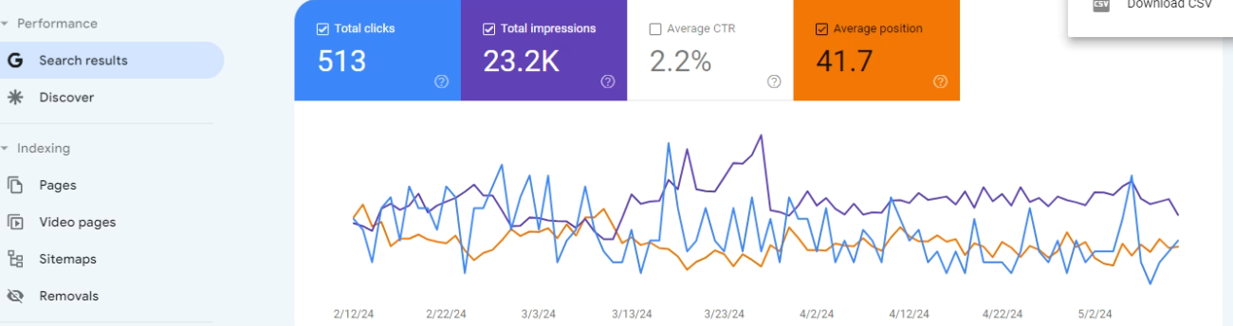
Step 1: Identify Target Pages in Search Console
- Navigate to Performance > Pages in Google Search Console
- Look for pages that are performing moderately well but have room for improvement
- Select a page that shows potential (avoid pages with mixed rankings—some on page 1, others on page 10+)
- Click on the URL to filter your data to that specific page
Step 2: Analyze Page Performance
- Switch to the Queries tab to see all search terms for your selected page
- Look for queries where you're ranking on the second page (positions 11-20)
- Focus on commercial keywords
- Export the data as a CSV file for AI analysis
Step 3: AI Content Analysis and Rewrite
- Upload the CSV file to your AI tool (ChatGPT or Claude)
- Copy the existing page content
- Use the provided prompt to have AI analyze the CSV data and rewrite the content to include exact match keywords
Step 4: Identify Primary Target Keyword
- Ask your AI tool to identify the most important keyword the page currently ranks for
- This becomes your primary optimization target
- While you could verify this with tools like Ahrefs, the AI analysis is typically accurate for this purpose
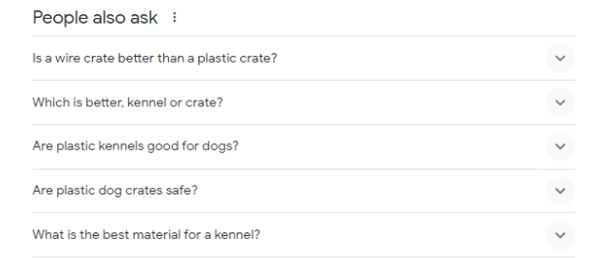
Step 5: Generate FAQ Content Using "People Also Ask"
- Search Google for your primary target keyword
- Expand the "People Also Ask" section by clicking through multiple questions
- Copy all the questions and feed them to your AI tool
- Request an FAQ section that:
  - Separates questions directly answered by existing content from those that aren't
  - Focuses first on questions that can be answered using only your existing content (reduces hallucination risk)
  - Provides comprehensive answers to establish topical authority
⚠️ Important: Always fact-check AI-generated content, especially when the AI draws from external sources rather than your provided content.
Step 6: Plan Supporting Content Articles
- Ask your AI tool which FAQ questions would work well as standalone articles
- Request target keywords, title tags, and article outlines for each suggested piece
- Use these as supporting content that can link back to your main page
- This creates a content hub that reinforces your topical authority

CONTENT AUDIT: HOMEPAGE

🤖AI Homepage Rewrite Prompt🤖

You are a local SEO expert and have years of experience in writing content that is semantically relevant to target keywords. The content you write sounds human written, includes experiences, advice, and opinions. You don’t use cliches or exaggerated language. You are very familiar with how Google’s algorithm interprets written content and how it knows what keyword to rank specific content for. I’m giving you homepage content for a local business.
Their primary GBP service is [Primary Category]. The secondary GBP categories are:
[secondary categories]

The services they offer on the GBP are:
[GBP services]

Begin re-writing this provided homepage content in an SEO-optimized article, using a tone and style that will appeal to customers interested in the service offered by this business. Include local neighborhoods, language style, events, and places for the area of [city, province]. Write in first person as an expert in the field.

Start with the introduction section. Incorporate a compelling hook that uses personal anecdotes or stories to enhance emotional resonance with the reader. As you re-write the content, ensure it remains concise and directly addresses the reader's questions.

Use storytelling techniques and adhere to Google’s quality guidelines to keep the content engaging. Employ metaphors and vivid descriptions where appropriate to enrich the narrative, and ensure the tone aligns with our previous analysis of our customers' preferred writing style.

Make sure you include the target keyword of [primary category city] as a heading in this first section. In later sections, make sure you include an H2 tag for each secondary category provided above and mention each of the services provided under the H2 tag that is most relevant to that particular service.

Please re-write one section at a time. After completing the introduction, wait for my feedback before proceeding to the next section. This process will ensure each part of the article meets our standards and resonates well with our target audience.

CONTENT AUDIT: SUPPORTING PAGES

🤖AI Supporting Pages Rewrite Prompt🤖

You are a local SEO expert and have years of experience in writing content that is semantically relevant to target keywords. The content you write sounds human written, includes experiences, advice, and opinions. You don’t use cliches or exaggerated language. You are very familiar with how Google’s algorithm interprets written content and how it knows what keyword to rank specific content for. I’m giving you homepage content for a local business.
Their primary GBP service is [Primary Category]. The secondary GBP categories are:
[secondary categories]

The services they offer on the GBP are:
[GBP services]

Begin re-writing this provided homepage content in an SEO-optimized article, using a tone and style that will appeal to customers interested in the service offered by this business. Include local neighborhoods, language style, events, and places for the area of [city, state]. Write in first person as an expert in the field.

Start with the introduction section. Incorporate a compelling hook that uses personal anecdotes or stories to enhance emotional resonance with the reader. As you re-write the content, ensure it remains concise and directly addresses the reader's questions.

Use storytelling techniques and adhere to Google’s quality guidelines to keep the content engaging. Employ metaphors and vivid descriptions where appropriate to enrich the narrative, and ensure the tone aligns with our previous analysis of our customers' preferred writing style.

Make sure you include the target keyword of [primary category city] as a heading in this first section. In later sections, make sure you include an H2 tag for each secondary category provided above and mention each of the services provided under the H2 tag that is most relevant to that particular service.

Please re-write one section at a time. After completing the introduction, wait for my feedback before proceeding to the next section. This process will ensure each part of the article meets our standards and resonates well with our target audience.

E-E-A-T WITH “ABOUT US” PAGE
Your About page is critical for establishing E-E-A-T with Google. The days of using AI-generated personas with fake backstories are over—Google now requires proof that real people create your content.
The Six Essential Elements
1. Contact Information
Be transparent and accessible. Include multiple ways to reach you—email, phone, contact form, and physical address if applicable. Google values businesses that don't hide behind anonymity.
2. Personal Story
Share your genuine journey and expertise. Make it authentic with real experiences, verifiable through other online sources, and directly relevant to why you're qualified to serve your audience.
📌 Related Learning: Review What is E-E-A-T? to understand why author credibility matters for SEO.
3. Author Bio Box
Create a professional author section with your headshot, credentials, and brief professional summary. Use this same format across all content pages to reinforce your authorship.
4. Social Media Integration
Link to your active social profiles—LinkedIn, Facebook, X (Twitter), Instagram, and any industry-specific platforms. These profiles should use photos of the same person (but not identical images), maintain reasonable activity, and have complete information.
⚠️ Important: Inactive or incomplete social profiles can hurt more than help. Only link to profiles you actively maintain.
5. Multimedia Proof
Video is your best option—record a brief introduction discussing your expertise and mission. If video isn't possible, use multiple photographs from different angles and contexts. A single headshot everywhere screams "fake" to Google's algorithms.
6. Google Business Profile
Even non-local businesses benefit from a Google Business Profile. Local businesses should link their GBP to their homepage, while non-local businesses should link to their About page. This additional verification signal strengthens your legitimacy.
🔗 Next Steps: Learn more in our Google Business Profile module about optimizing your GBP for maximum impact.
Why This Matters Now
Five years ago, fake personas worked. Today, Google's algorithms detect and devalue sites lacking authentic human authorship. Your About page serves as the primary verification point—it's not just for Google, but often one of your most visited pages.
Remember to write genuinely, highlight specific achievements, and maintain consistency across all platforms. Your About page builds trust with both search engines and human visitors, making it worth the investment to get right.
🎯 Action Item: After creating your About page, use it as the foundation for consistent author information across all platforms.

PROPERTY TECHNICAL AUDIT
A technical audit is a comprehensive analysis of a website's technical health and SEO performance.
When to Perform Technical Audits
Here's when you should consider one:
- Website size: More than 500 URLs (requires Screaming Frog license)
- Competition level: Operating in highly competitive niches
- Budget: Client has resources to implement comprehensive fixes
💡 Note: The example in this lesson features a plastic surgeon in Houston with 1,400 URLs—a perfect candidate for technical auditing due to both website size and competitive market.
Setting Up Screaming Frog
Before running your audit, you'll need to configure Screaming Frog properly:
1. Configure PageSpeed Insights API
- Navigate to Configuration → API Access → PageSpeed Insights
- Click the provided link to obtain a free API key
- Enter your API key in the designated field
⚠️ Important: Without the API key, your PageSpeed data will be blank, missing crucial performance insights.
2. Running the Crawl
- Enter the client's homepage URL
- Click Start to begin crawling
- Note: Crawls with PageSpeed API enabled take longer but provide essential performance data
Exporting Required Data
Once your crawl is complete, you'll need to export specific datasets for AI analysis. Export the following files:
From Screaming Frog:
- internal_all.csv - All internal URLs
- page_titles_all.csv - Title tag analysis
- meta_description_all.csv - Meta description analysis
- response_codes_all.csv - HTTP status codes
- images_all.csv - All image files
- canonicals_all.csv - Canonical tag analysis
- structured_data_all.csv - Schema markup data
- pagespeed_all.csv - Core Web Vitals data
- links_all.csv - Internal linking data
- directives_all.csv - Robots meta directives
From Google Search Console:
- performance_export.csv - Search performance data
- coverage_issues.csv - Indexation issues
- mobile_usability.csv - Mobile issues

🤖Technical Audit Prompt🤖
You are an expert Local SEO Consultant specializing in helping local service businesses dominate their geographic markets. You have 10+ years of experience improving local search visibility, Google Business Profile rankings, and driving qualified local leads through technical optimization. I want you to generate a comprehensive technical SEO audit report for a local service business. Analyze the provided data files and create a detailed report focused on local search performance and technical issues impacting local rankings.
Context:
- Business Type: [Insert: HVAC/Plumbing/Law Firm/Dental/Restaurant/etc.]
- Service Area: [Insert: City/Metro Area or Radius]
- Primary Competitors: [Insert top 3 business names currently ranking]
Data Files Provided:
The following Screaming Frog CSV exports:
- internal_all.csv - All internal URLs
- page_titles_all.csv - Title tag analysis
- meta_description_all.csv - Meta description analysis
- response_codes_all.csv - HTTP status codes
- images_all.csv - All image files
- canonicals_all.csv - Canonical tag analysis
- structured_data_all.csv - Schema markup data
- pagespeed_all.csv - Core Web Vitals data
- links_all.csv - Internal linking data
- directives_all.csv - Robots meta directives
From Google Search Console:
- performance_export.csv - Search performance data
- coverage_issues.csv - Indexation issues
- mobile_usability.csv - Mobile issues
Scoring Methodology:
Calculate the Local SEO Health Score (0-100) using:
- Technical Health: 30% (site speed, mobile, crawlability)
- Local Optimization: 30% (local schema, NAP consistency, local content)
- Content Quality: 20% (service pages, local area pages)
- User Experience: 20% (Core Web Vitals, mobile usability)
Critical Local SEO Factors to Analyze:
- Local Schema Implementation
  - LocalBusiness schema completeness
  - Service area markup
  - Review/aggregate rating markup
  - Opening hours specification
  - NAP consistency in schema
- Location Page Optimization
  - Title tags with location modifiers
  - Local content depth (minimum 500 words)
  - Unique content per location
  - Local image optimization
  - Internal linking to location pages
- Technical Local Factors
  - Mobile page speed (critical for local searches)
  - Click-to-call functionality
  - Local business citations in content
  - Proximity-based URL structure
  - HTTPS implementation
- Content Localization
  - Service area pages
  - City/neighborhood pages
  - Local keyword optimization
  - Geo-modified keywords in titles/headers
  - Local case studies/testimonials
Report Structure:
- Executive Summary (1 page)
  - Local SEO Health Score
  - Top 5 issues impacting local visibility
  - Quick wins for immediate impact
  - Competitive gaps identified
- Priority Issues by Impact:
🚨 Critical Issues (Fix immediately)
  - Issues directly harming local rankings
  - Mobile usability problems
  - Site speed issues affecting conversions
  - Missing local schema markup
- ⚠️ Important Issues (Fix within 30 days)
  - Local content opportunities
  - Technical improvements
  - Schema enhancements
- 💡 Opportunities (Ongoing improvements)
  - Content expansion
  - Additional local optimizations
- Detailed Analysis Sections:
A. Technical Foundation
  - Mobile-first readiness
  - Page speed by location/service page
  - HTTPS implementation
  - XML sitemap optimization
  - Robots.txt configuration
  - Core Web Vitals performance
- B. Local SEO Elements
  - NAP consistency analysis
  - Local schema implementation
  - Location page structure
  - Service area coverage
  - Local internal linking
  - Click-to-call implementation
- C. Content Optimization
  - Service page optimization
  - Location page quality
  - Title tags (with local modifiers)
  - Meta descriptions (local CTR focus)
  - Header structure and local keywords
  - Image optimization and local alt text
- D. User Experience
  - Mobile usability scores
  - Contact form accessibility
  - Phone number visibility
  - Directions/map integration
  - Page load speed by template
- For Each Issue Provide:
  - Issue description with severity level
  - Number of affected pages
  - Current state vs best practice
  - Impact on local rankings/conversions
  - Step-by-step fix instructions
  - Code examples where applicable
- Code Templates & Examples:
  - LocalBusiness schema template
  - Service area markup
  - FAQ schema for service pages
  - .htaccess speed optimizations
  - Image compression scripts
Local-Specific Analysis Requirements:
- Competitor Benchmarking
  - Compare against top 3 local competitors
  - Identify content gaps
  - Technical advantages/disadvantages
- Local Search Factors
  - Proximity optimization
  - Local link opportunities
  - Citation consistency
  - Review schema implementation
Success Metrics:
- Local pack rankings improvement
- Organic calls/form fills increase
- Mobile conversion rate improvement
- Local page visibility increase
- Technical score improvement
Deliverables:
- Main audit report (markdown format)
- Executive summary (concise overview)
- Technical checklist (prioritized fixes)
- Code snippets (ready to implement)
Please analyze all provided data and create a comprehensive local SEO audit that prioritizes fixes based on their impact on local search visibility. Focus on actionable recommendations that can be implemented with limited technical resources.

PROPERTY CTR AUDIT
Click Through Rate (CTR) represents the percentage of users who click on your website link after seeing it in search results. This metric is one of the most straightforward yet powerful ways to increase your website traffic without extensive SEO overhauls.
Improving your CTR from 2% to 3% can represent a 50% increase in traffic to your site—a significant boost from what seems like a small percentage change. This improvement typically comes from optimizing your title tags and meta descriptions to be more compelling to searchers.
The CTR Analysis Process
Step 1: Export Your Search Console Data
- Navigate to Google Search Console
- Click on Performance in the left sidebar
- Select Export and choose CSV format
- You'll receive two key files:
  - Queries: Shows what people searched for to find your site
  - Pages: Shows which URLs appeared in search results
Step 2: Prepare Your Data with Screaming Frog
For comprehensive analysis, you can use Screaming Frog to crawl your site. The free version allows crawling up to 500 URLs.
- Extracts current title tags and meta descriptions
- Helps identify non-indexable pages to exclude from analysis
💡 Tip: Focus only on indexable HTML pages in your analysis. Filter out PDFs, images, and other non-HTML content types to streamline your work.
Step 3: Analyze with Claude
Upload both CSV files to Claude along with the analysis prompt. Claude will:
- Match queries to specific URLs based on performance data
- Identify your likely primary keywords for each page
- Calculate domain-wide and page-specific CTR metrics
- Highlight optimization opportunities
Step 4: Implement High-Priority Changes
Focus on pages with:
- High impressions but low CTR: These represent your biggest opportunities
- Rankings in positions 4-10: Small improvements here can push you to the first page
- Misaligned titles/descriptions: Where the current metadata doesn't match user intent
What Claude's Analysis Provides
Overall Domain Performance
- Average CTR across all queries and pages
- Top-performing queries and their metrics
- Query distribution by search position
URL-Specific Insights
- Top 10 and bottom 10 URLs by CTR
- Pages with optimization potential
- Inferred primary keywords for each URL
Actionable Recommendations
- Specific title tag and meta description rewrites
- Priority pages for immediate optimization
- Strategies for addressing keyword cannibalization
⏩⏩ Related Lessons:
Generating Metadata - For creating optimized title tags and descriptions at scale
Search Console for Existing Content - Deep dive into Search Console data analysis
Best Practices for CTR Optimization
When rewriting title tags and meta descriptions based on Claude's analysis:
- Include the primary keyword naturally in both title and description
- Match search intent - ensure your message aligns with what users want
- Stay within limits:
  - Title tags: 50-60 characters
  - Meta descriptions: 150-160 characters
⚠️ Important: While Claude provides excellent recommendations, always review suggestions before implementing. Ensure they align with your brand voice and accurately represent your content.
CTR optimization is an ongoing process. As search trends and user behavior evolve, regularly revisiting your title tags and meta descriptions ensures you're always putting your best foot forward in search results.

🤖CTR AUDIT PROMPT🤖
Analyze the provided Google Search Console data for our domain, using two separate datasets:

Query-level data (query, clicks, impressions, CTR, position) for the entire domain
URL-level data (URL, clicks, impressions, CTR, position)

Perform a comprehensive click-through rate (CTR) analysis, aiming to identify the most likely primary keyword for each URL. Include the following elements:

Overall domain performance:
Calculate the average CTR across all queries and pages.
Identify top-performing queries and their metrics.
Analyze the distribution of queries by position.

URL performance:
List the top 10 and bottom 10 URLs by CTR.
Identify URLs with high impressions but low CTR as optimization opportunities.

Primary keyword inference:
For each URL, attempt to infer the most likely primary keyword by comparing URL performance metrics with query-level data.
Consider factors such as similar click and impression volumes, CTR, and position.

CTR trends:
Analyze CTR trends over time for both queries and URLs, noting significant changes or patterns.
Position analysis:
Break down average CTR by search result position ranges (e.g., 1-3, 4-10, 11-20) for both queries and URLs.
Identify positions where CTR performance differs notably from expected averages.
Optimization opportunities:
Highlight URLs and queries with potential for CTR improvement based on current performance and position.
Suggest content or metadata optimizations that could improve CTR for specific URL-query pairs.
Keyword cannibalization detection:
Identify potential keyword cannibalization issues by looking for similar high-volume queries that might map to multiple URLs.
Recommendations:
Provide actionable recommendations to improve overall domain CTR and specific URL performance.
Suggest strategies for better aligning URLs with their inferred primary keywords.
Present the findings using tables, charts, and concise bullet points. Include a brief executive summary highlighting key insights and top recommendations.
Note: Due to the separate nature of the query and URL datasets, some analyses will be based on inferences and may have limitations. Highlight any areas where additional data could provide more precise insights.

PROPERTY CONTENT WITH EXISTING AUTHORITY AUDIT
⚠️ Complete the Click Through Rate (CTR) Analysis first and export your internal_all file from Screaming Frog.
Google recognizes domains as authorities on specific topics. When you publish new content within your established expertise areas, it inherits your existing authority and ranks faster – no waiting months for aging or heavy backlink investment.
Example: If Google trusts you on "vintage car restoration," new content about "classic car paint techniques" will rank quickly. This is topical relevance in action.
Find Content Opportunities with ChatGPT
- Export your existing content data: URLs, title tags, meta descriptions. This is in your internal_all file from Screaming Frog.
- Upload to ChatGPT with this prompt:
- Review suggestions for topics that relate to your best content and fill obvious gaps
The "Almost Winners" Strategy
Maximize what you already have before creating something new. This approach delivers the fastest results.
Focus on pages ranking in positions 11-30 (pages 2-3).
These pages are golden because Google already trusts them, and small improvements to these pages can 10x traffic. Plus, they're proven to already have some relevance.
Step 1: Find Your Targets
Using Ahrefs, Semrush, or Search Console:
- Filter for positions 11-30
- Sort by search volume
- Look for reasonable difficulty scores
Step 2: Evaluate Each Opportunity
Check:
- Current traffic (low = safer to optimize)
- Keyword difficulty (lower = easier wins)
- Search volume (higher = more potential)
- Intent alignment (can your page satisfy searchers?)
Step 3: Optimization Plan
- Expand content depth with AI
- Optimize for target keywords (use Page Optimizer Pro)
- Match top 3 competitors' approach
- Build 1-2 quality backlinks
Quick Implementation
Create a simple spreadsheet:
- Target URL
- Current position
- Target keyword
- Current vs. potential traffic
- Priority level
This becomes your roadmap for quick wins in the first 60 days.
❌❌❌ Don't:
- Over-optimize pages already getting traffic
- Ignore search intent
- Manually request re-crawls
- Sacrifice readability for keywords
✅✅✅ Do:
- Focus on truly underperforming pages
- Always improve content quality
- Let backlinks trigger natural re-crawls

🤖Property content with authority audit prompt🤖
You're an expert search engine optimizer, especially in the field of content marketing and semantic SEO. My goal is to publish additional content for my domain that I already have some topical relevance and authority for. I’m giving you a file with URLs, title tags, and meta descriptions. Using this information, please recommend additional articles that will be topically relevant to articles I already have. It’s important to note that I only care about additional articles that Google’s algorithm will likely see as topically relevant. Additionally, the goal for the site is to improve traffic to a local service website, meaning we want searchers who may be likely to purchase services we offer.

Please give me at least 15 ideas, and for each one provide the overall topic, target keyword, and an example title tag.

GBP OVERVIEW
First, let's clear up any confusion about terminology. Google Business Profiles (GBPs) were called Google My Business listings (GMBs) for about a decade. You'll still hear many people refer to them as GMBs — they're exactly the same thing. Google simply rebranded them to Google Business Profiles a few years ago.
Why GBPs Matter for Local SEO
When someone performs a local search that triggers map results, the traffic distribution is eye-opening:
- 60-70% of clicks go to one of the three GBPs in the map pack
- 5-10% go to paid ads
- 20-25% (best case) go to organic results below the map
This means that even if you rank #1 organically, you're only competing for a quarter of the total search traffic at most. The map results don't show business websites — they show Google Business Profiles. Without a GBP, you simply can't appear in this prime real estate.
💡 Key Insight: In local SEO, we're not trying to rank websites or URLs higher — we're trying to rank GBPs higher.
The Three Core Ranking Factors
1. Trust
"Trust" is SEO code for links from third-party websites. The more trustworthy and relevant these linking websites are, the better. To build trust through local links:
- Join the Chamber of Commerce
- Sponsor local youth sports teams
- Support local nonprofit organizations
- Partner with community events (festivals, fundraisers, etc.)
The goal is to connect with anything hyper-local that has a powerful website in exchange for a link.
2. Relevance
We build relevance through content, specifically:
- Geographic relevance (content about your local area)
- Topical relevance (content about your services/industry)
Note that links to this relevance-building content serve a different purpose than trust-building links. These links help get your content indexed and recognized as quality content (not AI slop), but they're not the same powerful trust signals.
⏩⏩ Related Lessons
Building More Topical Relevance
Building More Geographical Relevance
3. Proximity
The closer a searcher is to your GBP address, the easier it is to rank. This is why rank maps often show positions 1-3 near the business center, with rankings dropping off as distance increases.
However, proximity can be overcome! With enough trust and relevance, you can outrank competitors who are physically closer to the searcher. This is essentially what we're doing in a local SEO engagement — building trust and relevance to expand your ranking radius.
The Second Page Reality
Here's a favorite SEO joke: Where's the best place to hide a dead body? The second page of Google search results.
For local search with GBPs:
- Positions 1-3 appear in the map pack
- Position 4 is essentially the first result on the "second page"
- Being ranked #4 gets you roughly the same traffic as being ranked #80
⚠️ Critical Point: If you can't do enough SEO to get into the top 3, save your money and don't do any at all. There's no benefit from moving from position 80 to position 5 — you'll get the same amount of traffic.
Types of Google Business Profiles
1. Single Location Business
- One GBP, one website
- GBP landing page (the website URL in the GBP) should point to the homepage
- Homepage is the most powerful URL on the domain, so it ranks faster
2. Multi-Location Business
- One website, multiple GBPs
- Each GBP needs its own independent landing page
- Why? Each landing page must be optimized for its specific location:
  - Local business schema
  - Embedded GBP
  - Embedded reviews
  - City-specific content optimization
You can't optimize one landing page for multiple GBPs effectively.
🔍 Pro Tip: If you inherit a multi-location client with all GBPs pointing to the homepage, run rank maps first! Only create new landing pages for locations that aren't ranking well. "Don't touch it if it's ranking" is a rule to live by in SEO.
3. Service Area Business (SAB)
Service area businesses require 30-50% more effort to rank compared to businesses with visible addresses. In practical terms:
- Visible address business: $3,000/month engagement
- Service area business: $4,000-5,000/month for the same results
It's often less expensive to get office space and maintain a visible address than to invest in the additional SEO work required for an SAB.
⚠️ Critical: Before taking on an SAB client, ensure both you and the client fully understand these downsides. The additional cost and effort required for SAB SEO can make it an unwise investment compared to simply establishing a physical presence.

GBP VERIFICATION

Get Ready for the Video
- At your computer, open the backend of your website to show edit access.
- Have your printed document with business name next to the mouse / keyboard
- Have your business card and driver’s license on passenger seat of truck / van / car
- Have your car magnet on the side of the truck covering any existing logos
- Have your garage door / truck / van / car trunk open showing work tools (if possible)
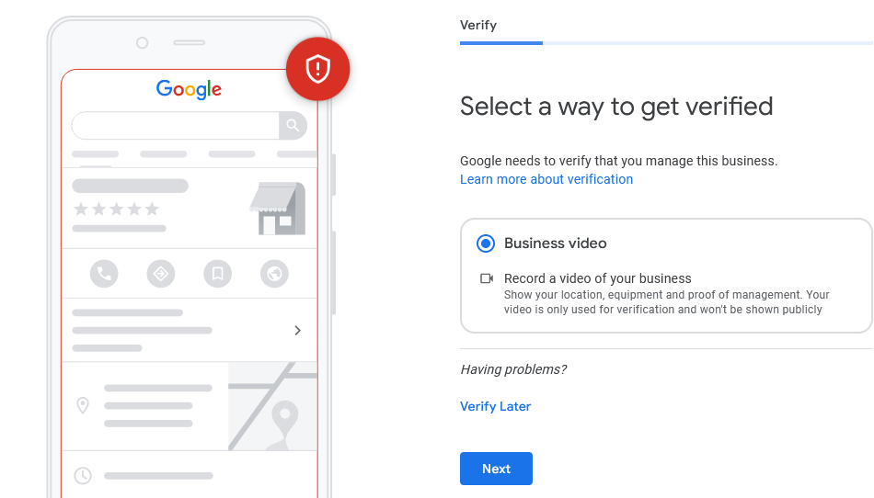

Start Recording Your Video Outside
- Start at truck / van with magnet on side
- Hold up key fob showing it and the truck / van
- Hit lock and unlock so truck / van headlights blink, honks, etc to show you control vehicle
- Open the passenger door and show business card and driver’s license with matching name
- Show tools in the back of the truck / van / car or show tools in garage
- Close passenger door to truck / van / car and lock the door
- Show a street sign if near a corner or intersection (if possible). Show left and right neighbors
- Walk to house / office
- Show house numbers
- Demonstrate door is locked by trying to open it
- Unlock and open door
- Walk inside
- Show the website edit access on computer screen
- Switch to other window / tab showing the website
- End video

GBP DESCRIPTION

🤖 GBP Description Claude Prompt 1 🤖
You are an expert in local SEO and improving GBP rank position. Please write a Google Business Profile description for a [NICHE] in [CITY, STATE] targeting 750 characters in length. They have been in business for [XYZ] years and their unique selling proposition is [XYZ]

🤖 GBP Description Claude Prompt 2: 🤖
Rewrite with the 750 character limit in mind. Do not exceed 750 characters

🤖 GBP Description Claude Prompt 3: 🤖
Give me some great examples of unique selling propositions for a [NICHE] located in [CITY, STATE]

GBP SERVICES
Your Google Business Profile (GBP) services section is a crucial component that helps potential customers understand exactly what you offer. This section appears prominently on your GBP listing and directly influences how Google matches your business with relevant searches.
Services in your GBP accomplish three key objectives:
- Search Visibility - Each service you list becomes a potential keyword match for customer searches
- Customer Clarity - Visitors immediately understand your offerings without clicking through to your website
- Category Enhancement - Services work hand-in-hand with your GBP categories to strengthen your local relevance
Strategic Service Selection
When adding services to your GBP, you're not just listing what you do—you're strategically positioning your business for maximum visibility. The services you choose will directly inform your category selection process, creating a cohesive profile that Google's algorithm can easily understand and rank.
💡 Pro Tip: Don't limit yourself to exactly 20 services. Ask for more if needed—comprehensive service listings help capture more search variations. In our example, asking for 20 services resulted in 46 relevant options!

🤖 GBP Services Prompt 🤖
You are a local SEO expert. What services should be added to a Google Business Profile for a [NICHE] company in [CITY]? Please be specific and list at least 20 services but feel free to list additional ones. Each service should be specific offerings and not broad categories. Also, include variations of services that might have different names but are commonly searched for by my target customers.

Quality Control: The Critical Step
Before adding any AI-generated services to your GBP, you must verify each one with your client. This verification process is non-negotiable for maintaining trust and avoiding customer disappointment.
⚠️ Cautionary Tale: We once added "solar water heater installation" to a plumber's service list without verification. The plumber received a call from a customer specifically requesting this service—which they didn't actually offer. This created an awkward situation and potentially lost business.
Your carefully curated service list serves a dual purpose. Not only does it enhance your GBP's visibility, but it also provides the foundation for selecting additional categories in the next phase of optimization.
⏩⏩ Related Lesson: After completing your services, you'll use this information in the GBP Categories lesson to expand your category selections strategically.

GBP CATEGORIES
One of the most common oversights we encounter is an underutilized Google Business Profile (GBP) category setup. Most businesses select their primary category and stop there—leaving significant ranking opportunities on the table.
Google offers over 1,000 different business categories, each providing a unique opportunity to appear in relevant local searches. By strategically selecting multiple categories, you expand your client's visibility across various search terms their potential customers might use.

🤖 GBP Categories Prompt 🤖
You are a local seo expert. What additional categories should a local business [niche] use for their Google Business Profile? I've given you a list of all current GBP categories. Please choose 3 or 4 additional relevant categories from this list. Here are the services they're currently using:
[Services]

Why Multiple Categories Matter
Think of GBP categories as different doors into your client's business. Each category represents a different way customers might search for their services. When you only use one category, you're essentially keeping all but one door locked.
💡 Key Insight: While it's easier to rank for broader categories, using multiple specific categories helps you capture more targeted, high-intent searches.
The Smart Approach to Category Selection
Instead of manually reviewing Google's thousand-plus categories, we'll use AI to streamline the process:
Step 1: Gather Your Information
Collect the following details about your client:
- Business type and primary service
- Location
- Complete list of services offered
Step 2: Use AI for Category Recommendations
Here's the efficient method we use:
- Input your client's business description (e.g., "HVAC service installation company in Houston")
- Add their complete service list
- Use ChatGPT to generate relevant GBP category suggestions
This approach transforms what could be hours of research into a quick, targeted list of appropriate categories.
Step 3: Review and Select Categories
From the AI-generated list:
- Start at the top and work your way down
- Verify each category against actual services provided
- Select categories that accurately represent your client's offerings
📌 Important Rule: Choose 5 secondary categories plus your primary category (6 total)
Best Practices for Category Selection
When reviewing potential categories, ask yourself:
- Does the client actually provide this service?
- Is this how customers would search for the business?
- Does this category complement the primary category?
⚠️ Warning: Never select categories for services your client doesn't actually provide. This can harm their credibility and potentially lead to GBP suspension.

GBP CATEGORIES EDGE CASES (RE-THEMING)
For most local businesses, finding the right Google Business Profile (GBP) category is straightforward. If you're a plumber targeting "plumber Houston," there's a GBP category for that. If you're a roofer targeting "roofer Houston," there's a category for that too.
But what happens when your target keyword doesn't have an exact GBP category match?
This lesson covers a powerful technique called "re-theming" that allows you to rank for keywords that don't perfectly align with available GBP categories.
Understanding the Challenge
Let's use a real example: car accident lawyer Houston
This is a high-value keyword, but here's the problem – there's no GBP category specifically for "car accident lawyer." The closest options are:
- Civil Law Attorney (secondary category)
- Personal Injury Attorney (usually primary category)
So how do you signal to Google that you want to rank for "car accident lawyer" when you're forced to choose a different category? That's where re-theming comes in.
The Re-Theming Strategy
Re-theming creates a bridge between your chosen GBP category and your target keyword. Here's the step-by-step process:
1. Create a Category-Matched URL
Build a URL that exactly matches your secondary GBP category:
yourdomain.com/civil-law-attorney

This shows Google that your website structure aligns with your GBP categories – a crucial consistency signal.
💡 Best Practice: Always create URLs that match your secondary GBP categories, even when they're not your primary target keywords. This strengthens the connection between your website and your GBP listing.
2. Optimize the Title Tag for Your Target
Use your actual target keyword in the title tag:
Car Accident Lawyer Houston | Get Legal Help Today
3. Use the GBP Category in Your H1
This is one of the rare times where your H1 should differ from your title tag. Use the exact GBP category match:
<h1>Civil Law Attorney Houston</h1>
This critical step tells Google: "Yes, we understand we chose this GBP category, and our content reflects that choice."
4. Focus Content on Your Target Keyword
After establishing the category connection with your URL and H1, the rest of your content should focus on your actual target:
- H2 headings about car accidents
- H3 headings with keyword variations and modifiers
- Body content optimized for "car accident lawyer Houston" and related terms
You won't need to mention "civil law attorney" again after the H1 – you've already made the connection clear to Google.
Common Re-Theming Scenarios
Here are other situations where re-theming might be necessary:
Estate Planning Services: When targeting "estate planning lawyer" but the closest GBP category is "Elder Law Attorney," you'd create the URL /elder-law-attorney while focusing your content on estate planning services.
DUI Defense: For "DUI attorney" targets with only "Criminal Lawyer" as a category option, use /criminal-lawyer as your URL but optimize all content for DUI defense.
Divorce Services: When pursuing "divorce lawyer" rankings with "Family Law Attorney" as your category, structure it as /family-law-attorney with divorce-focused content throughout.
⚠️ Important Note: Only use re-theming when there's a genuine semantic relationship between your target keyword and the GBP category. The category should logically encompass your target service.
Implementation Tips
When re-theming a GBP category, remember to identify the closest relevant GBP category first. This should be a category that genuinely relates to your service – don't force connections that don't make sense. Create an exact-match URL for that category, use your target keyword in the title tag, and place the GBP category as your H1. Then focus all other content elements on your target keyword while ensuring the relationship between category and target remains logical.
🔗 Next Steps: After implementing re-theming, review the "Local Business Schema" lesson to add structured data that reinforces your category choices while highlighting your specific services.

WARNING FOR GBP CHANGES
When optimizing a Google Business Profile, it's crucial to understand that changes can sometimes create more problems than they solve. This lesson covers the potential risks of GBP modifications and how to approach changes strategically.
Every time you modify a Google Business Profile, you're potentially triggering Google's verification systems. Think of it like renovating a house while someone's living in it—you need to be careful not to disrupt the foundation while making improvements.
High-Risk Changes
The following modifications carry the highest risk of triggering re-verification or suspension:
Business Name Changes
Changing the GBP business name almost always triggers re-verification. Google treats name changes seriously because they could indicate a completely different business trying to take over an existing profile.
Address Modifications
- Changing the address of an existing business
- Adding a visible address to a service area business
- Both scenarios frequently require re-verification
Category Additions Adding new categories, especially in YMYL (Your Money Your Life) industries like medical, legal, or financial services, often triggers a soft suspension that may escalate to full re-verification.
Perhaps the most impactful change you can make—for better or worse—is modifying the GBP landing page URL.
When NOT to Change the Landing Page
If your rank tracking shows positions better than 20+ anywhere on the map, changing the landing page URL will likely hurt rankings in the short term. This is true even if the current setup isn't "optimal" according to best practices.
🚨 Real-World Example: We inherited a client with 8 locations, all pointing to the homepage instead of individual landing pages. Our rank analysis showed:
- 4 locations: Top 3 rankings everywhere
- 2 locations: Average ranking 10-11
- 2 locations: 20+ average ranking
We only changed the landing pages for the two poorest performers, leaving the successful ones untouched despite being "incorrect" from a technical standpoint.
The Ranking Impact
Remember: If it's working, don't fix it—at least not immediately. Success in local SEO sometimes means accepting imperfect setups that are producing results.
📊 Related Material: We use localfalcon for local rank tracking
Best Practices for Making Changes
You have two strategic options when making GBP changes:
- Gradual Approach: Add one category every few weeks to a month
- All-at-Once Approach: Make all changes simultaneously but be prepared for verification requirements
Before Making Any Changes
Ask yourself these critical questions:
- Am I prepared for a potential suspension?
- Can I handle a re-verification process?
- What if rankings drop to 20+ across the board?
- Is the current performance worth risking?
📝 Note: If a GBP is already ranking 20+ everywhere, you have little to lose. But if you're seeing 10+ average rankings, proceed with extreme caution.
The Risk-Reward Calculation
The importance of the field you're changing correlates directly with the risk level:
- Highest Risk: Business name, address
- Medium Risk: Categories (especially primary), hours
- Lower Risk: Description, services, posts
🎯 Key Takeaway: GBP changes are not to be made lightly. The "correct" setup according to best practices isn't always the right move if the current configuration is producing results. Always monitor rankings carefully and be prepared for worst-case scenarios before making modifications.

GBP HOLIDAY HOURS MAINTENANCE + AUTOMATED CALLS
Keeping your Google Business Profile (GBP) holiday hours updated is a small but critical task that signals to Google that your business is actively managed and cares about customer experience.
Google uses special hours as one of its signals to determine if a business is actively maintaining their GBP. An up-to-date profile with accurate holiday hours shows:
- Your business is legitimate and operational
- You care about customer experience
- Your GBP is actively managed (not abandoned)
This seemingly minor detail contributes to your overall local SEO authority and can impact your visibility in local search results. Just like maintaining your GBP Services and other profile elements, holiday hours are part of demonstrating consistent, professional management.
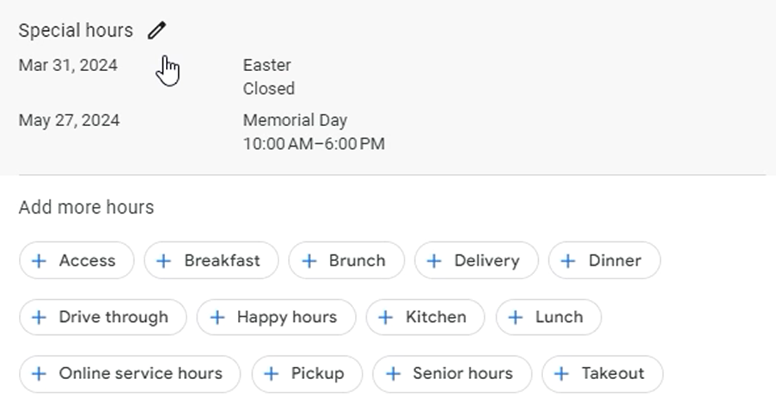
How to Update Holiday Hours
Step-by-Step Process
- Access Your GBP Dashboard
  - Log into your Google Business Profile (must be verified first)
  - Click "Edit profile"
  - Scroll down to "Hours"
- Find Special Hours
  - Look for the "Special hours" section
  - Click the pencil icon to edit
- Add Holiday Hours
  - Select the holiday date
  - Set your hours (or mark as closed)
  - Save your changes
⚠️ Important Limitation
Google only allows you to set special hours 2-3 months in advance. You cannot set Christmas hours in July or Thanksgiving hours in August. This limitation requires a proactive management approach.
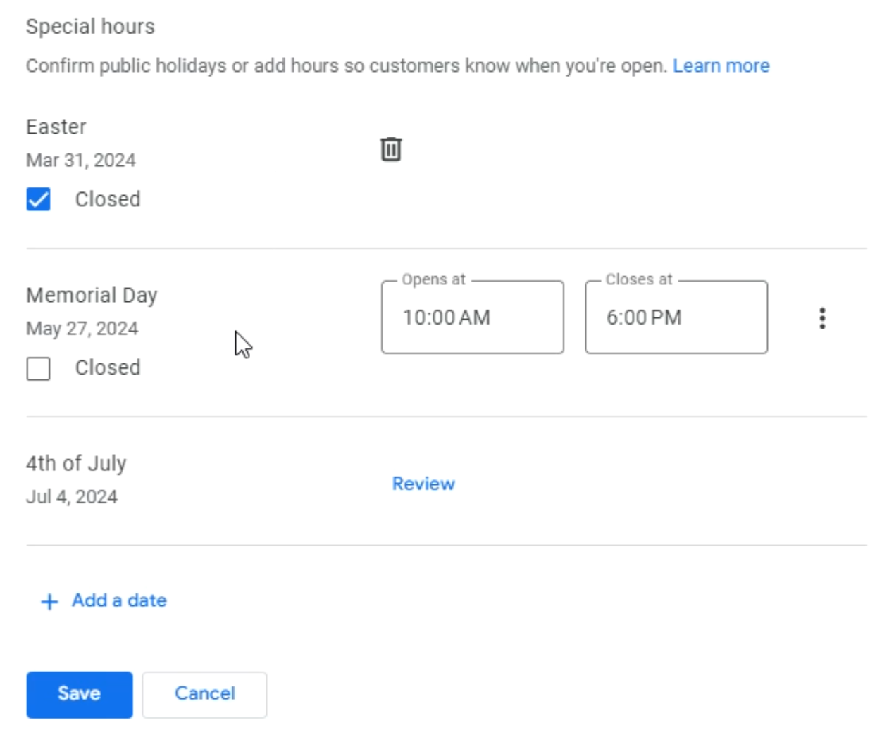
Creating a Management System
Since Google restricts how far in advance you can set holiday hours, you need a systematic approach to keep them updated throughout the year. This type of proactive management is exactly what helps reduce client churn by demonstrating ongoing value and attention to detail.
📅 Recommended Schedule
Set a recurring calendar reminder for the 1st of every other month to:
- Review upcoming holidays
- Update all client GBPs with special hours
- Verify previously entered hours are still accurate
Common Holidays to Track
- New Year's Day
- Martin Luther King Jr. Day
- Presidents' Day
- Memorial Day
- Independence Day (4th of July)
- Labor Day
- Columbus Day
- Veterans Day
- Thanksgiving
- Christmas Eve
- Christmas Day
- New Year's Eve
💡 Pro Tip: Some businesses may also need to account for religious holidays, local events, or industry-specific closures. Know your client's schedule!
Small details like holiday hours might seem insignificant, but they're part of the larger picture of maintaining an optimized, trustworthy online presence for local businesses.
Google Business Profile includes a feature for automated calls that's designed to keep your business information current. However, this feature has been known to cause issues—including potential suspensions of your GBP.
We've experienced firsthand that GBPs can get suspended due to automated calls. To protect your profile and maintain control over your business information, it's best to turn this feature off completely.
How to Turn Off Automated Calls
Follow these simple steps to disable automated calls:
- Access Business Profile Settings
  - Navigate to your Google Business Profile
  - Click the three dots menu (⋮)
  - Select "Business hours"
- Navigate to Advanced Settings
  - Look for and click on "Advanced settings"
- Disable Automated Calls
  - Find "Automated calls to keep your business profile up to date"
  - Toggle the switch to turn it OFF
That's it! This quick adjustment helps ensure your GBP stays active and under your control.

GBP OPTIMIZATION
When optimizing a Google Business Profile, completeness matters. Every empty field is a missed opportunity to provide valuable information to potential customers and strengthen your local SEO presence. This lesson covers the essential practice of ensuring every available field in your GBP is properly filled out.
⚠️ It's much easier and faster to rank GBPs with addresses listed, so if possible, try to list the business' address, even if the client does not have a physical location yet.
A fully completed Google Business Profile serves multiple purposes:
- Provides comprehensive information to potential customers
- Signals to Google that the business is active and legitimate
- Improves visibility in local search results
- Increases trust and credibility with users
Key Areas to Complete
Social Profiles
One of the most commonly overlooked sections is social media profiles. An incomplete social profile section sends the wrong signal about your business's online presence.
What to include:
- Facebook page URL
- Twitter/X profile
- LinkedIn company page
- Instagram profile
- YouTube channel (if applicable)
- Any other relevant social platforms
💡 Pro Tip: Even if a business isn't highly active on all platforms, having the profiles linked shows legitimacy and provides multiple ways for customers to connect.
Operating Hours
Beyond basic hours, ensure you've addressed:
- Regular business hours for each day of the week
- Special hours for holidays and events
- More hours section if the business has different hours for specific services
⏩⏩ Related Lesson: See our lesson on Upcoming Holiday Hours for detailed guidance on managing seasonal schedule changes.
Additional Information Fields
Work through every available option in the edit profile section:
Accessibility Features
- Wheelchair accessible entrance
- Wheelchair accessible parking
- Wheelchair accessible restroom
- Other accessibility accommodations
Service Options
- Online appointments
- On-site services
- Delivery options
- Curbside pickup
Amenities
- Wi-Fi availability
- Parking options
- Payment methods accepted
- Health and safety measures
The Systematic Approach
To ensure nothing is missed, follow this process:
- Access the edit profile section of your Google Business Profile
- Review each category systematically from top to bottom
- Fill in every applicable field - if it applies to the business, it should be completed
- Double-check for completeness before saving
⚠️ Important: Don't skip fields just because they seem minor. Google uses all available data to understand and rank your business.
Common Mistakes to Avoid
- Leaving fields blank when the information is available
- Assuming some fields don't matter - they all contribute to your profile's completeness
- Forgetting to update when business details change
- Not exploring all available options in each section
Be Thorough
Take the time to explore every section and subsection. New fields and options are occasionally added by Google, so periodic reviews are beneficial.
Be Accurate
Ensure all information is current and correct. Inaccurate information can harm your credibility and confuse potential customers.
Be Consistent
Information across all fields should align with what's on your website and other online profiles.
📊 Quick Check: After completing all fields, your GBP should show 100% profile completion in the dashboard.

GBP + WEBSITE IMAGE GEOTAGGING
Geotagging adds geographical location data to your images' metadata, helping search engines understand where your business operates.
- We currently use the GeoTag app on Mac.
Does It Work?
While some SEOs debate its effectiveness, we've seen clients experience overnight ranking improvements after uploading geotagged images.
💡 Our Philosophy: If it takes less than 30 minutes, just do it. The potential upside outweighs the minimal time investment.
The Google Business Profile Question
Yes, Google strips metadata from images uploaded to GBP. However, this doesn't mean Google ignores the data during upload. They could process the location information before removing it.
Quick Process
- Upload images to GeoTag
- Enter the business location
- Click "Geotag"
- Upload to your website and GBP

GBP POSTS
🤖 Basic Prompt 🤖
Create 52 engaging Google Business Profile posts for [BUSINESS NAME], a [BUSINESS TYPE] located in [CITY/REGION]. Each post should be between 150-300 characters, include a clear call-to-action, and be designed to increase engagement, visibility, and conversions.
Do not include email address, phone number, or website url in the GBP posts.
- Business name: [INSERT]
- Business type/industry: [INSERT]
- Location: [INSERT]
- Primary services/products: [LIST 3-5 MAIN OFFERINGS]
- Unique selling propositions: [LIST 2-3 THINGS THAT MAKE YOUR BUSINESS SPECIAL]
- Target audience: [Ideal Audience, Audience Avatar]
- Business hours: [INSERT]
- Website URL: [INSERT]
- Contact information: [PHONE, EMAIL]
- Promotional Posts (13 posts)
  - Special offers and discounts
  - New products/services
  - Limited-time promotions
  - Loyalty programs
- Educational Posts (13 posts)
  - Industry tips and advice
  - How-to content related to your products/services
  - Frequently asked questions
  - Myth-busting about your industry
- Engagement Posts (13 posts)
  - Customer testimonials and success stories
  - Behind-the-scenes content
  - Team spotlights
  - Community involvement
- Seasonal/Event Posts (13 posts)
  - Holiday-related content
  - Local events participation
  - Industry-specific seasonal trends
  - Business milestones and anniversaries
- For each post, include:
  - An attention-grabbing headline (when applicable)
  - Concise, value-driven body text (150-300 characters)
  - A clear call-to-action
  - A recommendation for the type of image to include
  - Relevant hashtags (2-3 maximum)
- Calls-to-Action: Vary between "Call now," "Book online," "Learn more," "Visit our website," "Stop by today," etc.
- Time Sensitivity: Include phrases like "Limited time," "This week only," "While supplies last" for promotional posts
- Keywords: Incorporate location-specific and industry-specific keywords naturally
- Formatting: Use emoji sparingly but strategically to draw attention to key points
- January-March: Focus on new year goals, winter services/products, early spring preparation
- April-June: Highlight spring offerings, Mother's/Father's Day, graduation season, summer preparation
- July-September: Emphasize summer services, back-to-school transitions, early fall offerings
- October-December: Feature fall services, holiday preparation, end-of-year promotions, gift ideas
Example Post Format
[POST CATEGORY: Promotional]
Image: [Product collection with sale graphic overlay]
Headline: Summer Special: 20% Off All [Product Category]!
Body: Beat the heat with our biggest discount of the season! All [specific products] are 20% off through June. Perfect for [specific benefit to customer].
CTA: Shop online or visit our store today before this deal melts away!

CONTENT : BLOG POST OUTLINE
Creating a well-structured outline is the foundation of compelling AI-generated content. In this lesson, you'll learn how to use Claude's custom projects feature to create blog outlines that engage readers and improve your SEO performance.
Before you ask Claude to write any content, you need to establish the structure of your article. This structure serves as the blueprint that guides Claude in creating content that not only ranks well but also keeps readers engaged from start to finish.
💡 Remember: Better engagement metrics = higher rankings on search engine results pages
The Recommended Blog Structure
Here's the proven structure we use for creating high-performing blog articles:
1. The Hook
Start with something compelling and engaging that immediately captures attention. This opening needs to make readers want to continue reading your article.
2. The Sneak Peek
Give readers a preview of what they'll learn in the article. This sets expectations and helps readers decide if your content addresses their needs.
3. The Story
People connect with stories. Including a relevant narrative helps maintain attention and makes your content more memorable. Claude will provide you with seven different storytelling approaches to choose from.
4. Main Points
This is where you deliver the core value of your article—the information your readers came to find.
5. Call to Action (CTA)
End with a clear next step for your readers, whether that's contacting your business, reading another article, or taking another desired action.
📝 Note: This structure isn't set in stone. Feel free to adapt it based on your needs or your clients' preferences. The key is having a clear structure before you start writing.
Working with Claude: Step-by-Step Process
When creating an outline with Claude, you'll follow an interactive process that allows you to maintain control while leveraging AI's creative capabilities.
Step 1: Provide Basic Information
Start by giving Claude:
- Your target keyword (e.g., "roofer")
- Your target city (e.g., "San Antonio")
Step 2: Choose Your Hook
Claude will present you with five different hook options. Review them and select the one that best resonates with your target audience.
Step 3: Define the Sneak Peek Questions
You have two options:
- Provide Claude with three specific questions you want to address
- Let Claude suggest three questions based on common search intent
💡 Pro Tip: If you're unsure what questions to address, let Claude make suggestions—it's trained on common search patterns and user intent.
Step 4: Select Your Story Approach
Claude will provide seven different storytelling methods, such as:
- Personal anecdotes
- Client success stories
- Metaphors
- Historical examples
- Problem/solution narratives
Choose the approach that best fits your brand voice and audience.
Step 5: Review and Copy the Complete Outline
Once you've made all your selections, Claude will generate the complete outline in one place. Copy this outline—you'll need it for the content writing phase.
Customizing Your Outline Structure
The beauty of using Claude with custom instructions is that you can create any structure that works for your specific needs.
How to Modify the Structure
- Start with your ideal article example: If you have existing content that performs well, use it as a template
- Ask Claude for help: Copy your current custom instructions and ask Claude to help you modify them
- Be specific about changes: Want to add an FAQ section? Include local business information? Just tell Claude exactly what you want
Example Custom Structure Request:
"I want to modify this outline structure to include:
- An FAQ section at the end
- More emphasis on local relevance
- A section for customer testimonials"

Claude will then provide you with updated custom instructions that reflect your desired structure.
✅✅✅ Do:
- Always review and approve each section before moving forward
- Keep your target audience (from your Audience Avatar) in mind when making selections
- Save successful outlines as templates for similar content
- Experiment with different structures for different content types
❌❌❌ Don't:
- Rush through the selections—each choice impacts the final content quality
- Use the same hook or story approach for every article
- Forget to copy the final outline before moving to the content creation phase

🤖 Blog Post Outline Prompt 🤖
You will be acting as a world-class educational SEO blog writer and expert in the local city and business in the attached customer avator. Your task is to write a detailed script outline for a blog post. This post will primarily target the customer avatar
Please write the outline, 1 section at a time. After each section, ask for my feedback and approval before moving on to the next one. I will provide my input, and once I’m satisfied with each section, you can proceed to write the next one. If you need any additional information or clarification to write the outline effectively, please ask.
Article Structure
1. Title & Meta Elements
SEO Title Tag (55-60 characters)
Meta Description (150-160 characters)
URL Structure
H1 Tag (incorporating primary keyword)
2. Introduction Block (150-200 words)
Hook Options:
Question-based hook
Statistical hook with citation
Story-based hook
Problem-solution hook
Future-pacing hook
Keyword incorporation
Clear value proposition
Topic relevance signals
Article roadmap/preview
3. Featured Snippet Target (100-150 words)
First, ask me specifically which query / question to target for the featured snippet here. Provide some suggestions. Ask me to give you the current featured snippet for this question. Also, ask if I would like to skip this section.
Direct answer to main search query
Structured for featured snippet optimization
Bulleted or numbered list
Clear, concise definitions
Schema markup recommendations
4. Main Content Sections
H2 Sections (incorporate secondary keywords)
Supporting H3 subsections
Key points and evidence
Expert quotes/citations
Statistics and data
Visual content recommendations
Internal linking opportunities
External authority links
5. User Experience Elements
Content breaks (every 300 words)
Transition sentences
Bullet points and lists
Table of contents
Custom graphics/images
Interactive elements
6. Trust Building Elements
Expert credentials
Case studies
Social proof
Data visualization
Authority citations
7. Call-to-Action Framework
Primary CTA
Secondary CTAs
Lead magnet opportunity
Contact information
Next steps
8. Technical SEO Elements
Word count target (based on SERP analysis)
Keyword density guidelines
Image alt text
Schema markup
Mobile optimization notes
Content Guidelines
Natural keyword placement
E-A-T signals
Reading level optimization
Content freshness signals
User intent alignment
Semantic relevance
Quality Control Checklist
Keyword optimization
Content depth
Technical SEO elements
User experience
Mobile responsiveness
Loading speed considerations
Remember, for this blog post our goal is to write it for both readers and optimized for Google’s algorithm so we can rank it.
I will give you the target keyword and the title tag.

CONTENT: BLOG POST WRITING
Now that you've created your outline, it's time for the final step: getting Claude to write the actual content. This lesson will walk you through the process of generating high-quality, human-like content that ranks well and passes AI detection tests.
Before Claude starts writing, you need to provide two essential components:
1. Your Audience Avatar
Use the same avatar you created in the Creating an Audience Avatar lesson. This ensures your content speaks directly to your target audience and maintains consistency across all your materials.
2. Writing Samples
Writing samples are crucial for teaching Claude the style and structure that performs well in search results. Here's how to choose them:
- If you have other ranking clients: Use content from those successful campaigns
- If you're just starting: Find high-ranking content in any niche through Google searches
- Format: Copy the content into a Word document or similar format
- Why this works: Google rewards content similar to what's already ranking well
💡 Pro Tip: Your writing samples don't need to be from the same industry. Focus on finding content that ranks well and engages readers, regardless of the niche.

🤖 Blog Post Writing Prompt 🤖
You will be acting as a world-class educational blog article writer and expert for a local business website with the service and city in the customer avatar attached in project knowledge. Your task is to write a detailed blog post for the post I’m going to give you an outline for.
The post you provide should be specifically based on the outline I’ll provide to you.
I will provide you with my detailed outline, and I have given you a document called Blog Posts that I’d like you to analyze for tone of voice and speaking cadence, so you can replicate the speaking style as closely as possible in writing the final script. The Blog Posts are blog posts of earlier writing. The new blog post must sound natural enough for spoken dialogue, not adhering to grammar rules that only apply to written communications. Include every single idea that’s in the outline in the final script. Leave nothing out.
Only include content that’s already in the outline.
In addition to the outline, I will give you the target keyword. Please make sure to use the exact match target keyword in the blog post.
Outline, target keyword, and target length will be given in the prompt.
Start with an H1 tag that has exact match target keyword
Then structure the blog with a headings, bullet points, tables, and more as is appropriate.
Make sure to write with grammatical errors.
Start with the introduction section. Incorporate a compelling hook that uses personal anecdotes or stories to enhance emotional resonance with the reader. As you develop the content, ensure it remains concise and directly addresses the reader's questions.
Use storytelling techniques and adhere to Google’s quality guidelines to keep the content engaging. Employ metaphors and vivid descriptions where appropriate to enrich the narrative, and ensure the tone aligns with our previous analysis of our customers' preferred writing style.
Please write one section at a time. After completing the introduction, wait for my feedback before proceeding to the next section. This process will ensure each part of the article meets our standards and resonates well with our target audience.
Do not use any of the following words: embark, look no further, navigating, picture this, top-notch, unleash, unlock, unveil, we've got you covered, transition, transitioning, crucial, delve, daunting, deep dive, dive in, realm, ensure, in conclusion, in summary, optimal, assessing, firstly, strive, striving, furthermore, moreover, comprehensive, we know, we understand, testament, captivating, eager, refreshing, edge of my seat, breath of fresh air, breath of fresh, to consider, it is important to consider, there are a few considerations, it's essential to, vital, it's important to note, it should be noted, to sum up, secondly, lastly, in terms of, with regard to, it's worth mentioning, it's interesting to note, significantly, notably, essentially, as such, therefore, thus, interestingly, in essence, noteworthy, bear in mind, it's crucial to note, one might argue, it's widely acknowledged, predominantly, from this perspective, in this context, this demonstrates, arguably, it's common knowledge, undoubtedly, this raises the question, in a nutshell, unveiled
—
Claude will write your content one section at a time. This approach offers a significant advantage:
- Real-time adjustments: If you don't like the style or tone, you can provide feedback immediately
- Consistency: Claude will apply your feedback to all subsequent sections
- Quality control: You can ensure each section meets your standards before moving forward
📝 Note: After each section, simply type "keep going" if you're satisfied, or provide specific feedback for adjustments. For example, if the tone is too casual or formal, mention it right away.
Finalizing Your Content
Once all sections are complete, type these prompts into Claude...

🤖 Follow-up Prompt 1🤖
Please provide the entire article in one piece that I can copy.

🤖 Follow-up Prompt 2🤖
Please check the outline and confirm everything is included.
This systematic approach transforms AI from a simple writing tool into a sophisticated content creation system that produces material indistinguishable from human writing while maintaining SEO best practices.
Passing the AI Detector Test
If you need to pass AI detector test, use the below prompts to rewrite it:

🤖 AI detector test follow-up Prompt🤖
Rewrite to include more grammatical errors
Rewrite to not be in the first person
Rewrite to increase the formality
Rewrite to target a reading level of grade 5
Rewrite and add additional human perspective, human experience, advice, opinion, and uniqueness.
Rewrite using bullet lists, call outs, and tables where possible
Rewrite using more local language for [location]
Rewrite and add suggested links to external trusted websites
Rewrite using additional first hand experience with this service
Continue writing in the same style with the outline you previously developed

CONTENT: HOMEPAGE

⚠️ Be sure to modify the bolded and bracketed sections to be relevant to your client information or niche.

🤖 Prompt: Rewriting Existing Homepage🤖
You are a local SEO expert and have years of experience in writing content that is semantically relevant to target keywords. The content you write sounds human written, includes experiences, advice, and opinions. You don’t use cliches or exaggerated language. You are very familiar with how Google’s algorithm interprets written content and how it knows what keyword to rank specific content for. I’m giving you homepage content for a local business. Their primary GBP service is [Primary Category]. The secondary GBP categories are:
[secondary categories]
The services they offer on the GBP are:
[GBP services]
Begin re-writing this provided homepage content in an SEO-optimized article, using a tone and style that will appeal to customers interested in the service offered by this business. Include local neighborhoods, language style, events, and places for the area of [city, state]. Write in first person as an expert in the field.
Start with the introduction section. Incorporate a compelling hook that uses personal anecdotes or stories to enhance emotional resonance with the reader. As you re-write the content, ensure it remains concise and directly addresses the reader's questions.
Use storytelling techniques and adhere to Google’s quality guidelines to keep the content engaging. Employ metaphors and vivid descriptions where appropriate to enrich the narrative, and ensure the tone aligns with our previous analysis of our customers' preferred writing style.
Make sure you include the target keyword of [primary category city] as a heading in this first section. In later sections, make sure you include an H2 tag for each secondary category provided above and mention each of the services provided under the H2 tag that is most relevant to that particular service.
Please re-write one section at a time. After completing the introduction, wait for my feedback before proceeding to the next section. This process will ensure each part of the article meets our standards and resonates well with our target audience.

CONTENT: SERVICE PAGES

🤖 Prompt : Rewriting Existing Service Page🤖
You are a local SEO expert with years of experience in writing high-converting service pages and compelling meta information that drives clicks from search results. You understand both technical SEO requirements and persuasive copywriting principles that motivate local customers to take action.
I'm giving you information about a service/category page for a local business.
I want content for a new page focused on a GBP category or GBP service, following the structure below.
Required inputs:
- Business Name: [Name]
- Primary GBP Category: [Primary Category]
- Target service/category for this page: [Specific service/category]
- Business location: [city, state]
- Related GBP services for this page (if a category page): [List relevant services]
- Unique Selling Points: [List USPs]
- Special Offer (Optional): [Current offer]
Please provide the following elements in order:
- Title Tag Options (10 variations):
- Include exact target service/category for this page and the city name
- Maximum 60 characters
- Include location and offer when possible
- Use brackets, parentheses, or numbers for enhanced CTR
- For each title provide:
  - SEO Score (1-10)
  - Engagement Score (1-10)
  - Overall Score (1-10)
  - Character count
- Meta Description Options (10 variations):
- 150-160 characters including spaces
- Include exact match category / service and variations
- Mention city name
- Include offer if given
- Use brackets or parentheses strategically
- Avoid exclamation points or emojis
- Focus on driving clicks
- Include character count for each option
- For each meta description provide:
  - SEO Score (1-10)
  - Engagement Score (1-10)
  - Overall Score (1-10)
- Page Content (write section by section):
Introduction Section (200-250 words):
- Write in first person as a local service expert
- Include a brief personal anecdote or customer story relevant to [city]
- Naturally incorporate local landmarks, neighborhoods, or events
- Address the main customer pain point this service solves
- Include primary keyword [service / category + city]
Service Details (H2 sections):
- Break down the main service components
- Include relevant local considerations
- Address common customer questions
- Incorporate local trust signals
- Mention any service guarantees or unique offerings
Trust Building Elements:
- Local experience examples
- Area-specific expertise
- Community involvement
- Local awards or recognition
- Customer success stories from the area
Call-to-Action:
- Location-specific offer or value proposition
- Clear next steps
- Service area coverage
- Contact information
Guidelines for all content:
- Focus on single service/category
- Location-specific
- Conversion-oriented
- Naturally optimized for local search
- Professional but approachable tone
- 800-1000 words total
- Include relevant schema markup recommendations
Please write one section of this content at a time and ask for feedback in each.

CONTENT: SUPPORTING PAGES
Supporting content exists not as standalone material but as a means to boost another URL's rank. Instead of merely increasing the number of backlinks to a target URL—a method with diminishing returns—supporting content enhances the content ecosystem around the target URL. This is critical because Google favors URLs that engage users, rewarding similar content that satisfies searcher intent.
Writing Supporting Content
Creating high-quality supporting content involves identifying topics that add depth and detailed answers to common questions within your niche. This can be achieved through AI-generated FAQs, which we will explore in a subsequent module. These FAQs help in pinpointing relevant questions and providing detailed answers, which are then expanded into full articles.
Practical Application
To put this into practice, consider generating between one to ten supporting articles each month based on competitive need, with three being a typical number due to cost-effectiveness and sufficient impact.
Each piece of supporting content should link to your target URL and vice versa. This interlinking helps in building a robust content structure that Google recognizes as thematically cohesive.
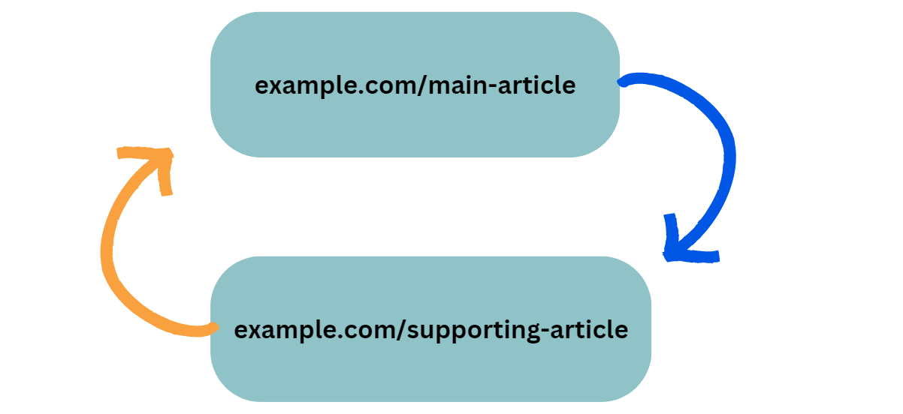
As you continue to add content monthly, you maintain this interconnected structure, ensuring that each new piece integrates seamlessly, further strengthening the topical silo around your main target.
The Impact of Supporting Content
This methodology, revolving around the creation and strategic use of supporting content, constitutes approximately 80% of the ongoing SEO efforts. If a target URL does not rank or attract traffic, the solution often involves publishing more supporting content.
Conversely, if a target URL performs well, the strategy shifts to developing new supporting content for other URLs.

CONTENT: HIDDEN CONTENT
When building websites, you'll often encounter requests to hide content behind accordions, mouseovers, or collapsible blocks. While these design elements might seem appealing from an aesthetic perspective, they can significantly (and negatively) impact your SEO performance.
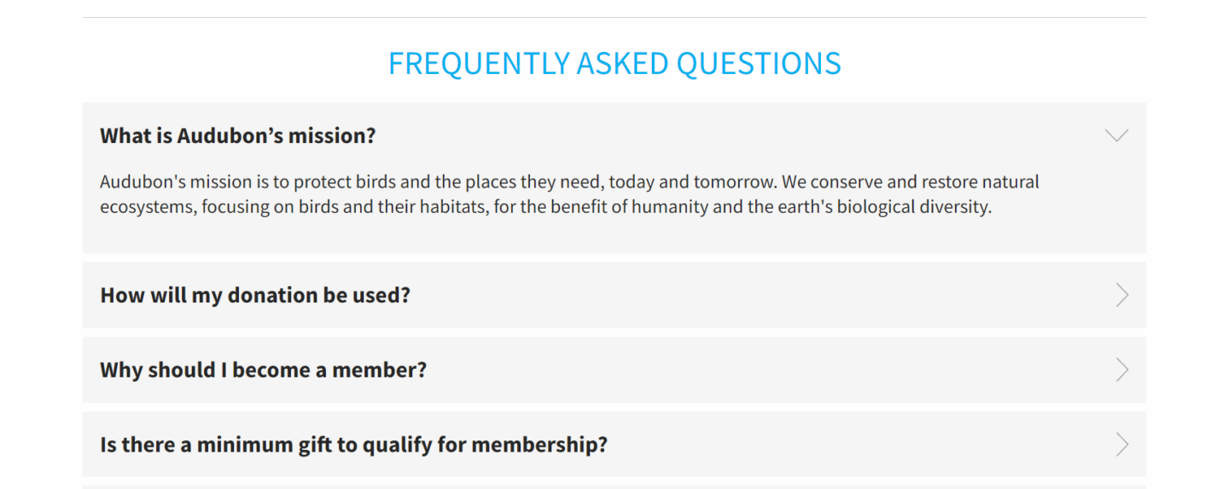

What Is Hidden Content?
Hidden content refers to any text, images, or other elements that require user interaction to become visible. Common examples include:
- Accordion menus (expandable/collapsible sections)
- Tab interfaces
- Mouseover reveals
- "Read more" expandable blocks
- Content that appears on click
How Google Crawls Hidden Content
Google renders websites using the most recent version of Chrome. Here's the crucial detail: Google's crawler can follow links, but it cannot click or hover.
This means if your content requires any user interaction to become visible, Google's ability to properly index and rank that content is compromised.
The Technical Reality
While Google can technically see hidden content (you can verify this by searching for exact-match phrases in quotes), it doesn't treat hidden content equally to visible content.
💡 Real-World Test: In controlled experiments where identical websites were compared—some with hidden content and others with fully visible content—the sites with visible content consistently ranked higher when searching for the exact phrases contained within.
Best Practices for Content Visibility
The most straightforward approach is the most effective: don't hide content. Display all your important information directly on the page without requiring user interaction. You'll get:
- Better Rankings: Visible content ranks better and faster than hidden content
- User Expectations: Users are accustomed to seeing content displayed openly on well-ranking websites
- Crawl Efficiency: Google can process your content more effectively when it's immediately accessible
📝 Related Lesson: This principle ties directly into our lesson on Google Rank Factors, where content accessibility is a key ranking signal.

CONTENT: INTERNAL ANCHOR TEXT GUIDELINES
Internal linking is a powerful yet often overlooked aspect of SEO. When you link from one page on your website to another, the text you use for that link—called anchor text—plays a crucial role in how search engines understand and rank your content.
What is Internal Anchor Text?
Internal anchor text refers to the clickable text that connects one page of your website to another page within the same domain. Unlike external links that point to other websites, internal links help establish the structure and hierarchy of your site while passing SEO authority between your pages.
The 6 Golden Rules of Internal Anchor Text
1. Never Repeat Anchor Text
Every piece of anchor text on your site should be unique. Using the same anchor text multiple times dilutes its effectiveness and can appear manipulative to search engines.
2. Incorporate Keywords Naturally
While it's important to include relevant keywords in your anchor text, they must flow naturally within the content. Avoid keyword stuffing at all costs—it looks spammy and can harm your rankings.
3. Describe the Destination Page
Your anchor text should accurately describe what users will find when they click the link. Think of it as a preview of the destination content, not a description of the current page.
4. Keep It Descriptive Yet Concise
Strike a balance between being descriptive and being brief. Your anchor text should give users and search engines clear context without being overly wordy.
5. Place Links in Body Content
Internal links belong in the main body text of your content. Avoid placing them in:
- Headers or headings
- Footers
- Navigation bars
- Sidebars
6. Avoid Using Your Brand Name
Generally, skip using your brand name as internal anchor text. Save your brand for external link building efforts where brand mentions add credibility.
Examples: Good vs. Bad Anchor Text
Let's examine some real examples using "motorized pergola" as our target keyword to illustrate these principles in action.
✅ Good Internal Anchor Text Examples
- "Learn more about choosing the right materials for pergolas"
  - Descriptive and natural
  - Incorporates the keyword "pergola" without stuffing
  - Clearly indicates what the linked page contains
- "Pergola material options"
  - Concise and to the point
  - Relevant keyword usage
  - Sets clear expectations
- "Benefits of motorized pergolas"
  - Directly describes the destination content
  - Natural keyword integration
  - Helps both users and search engines understand the linked page
- "Installation tips for motorized pergolas"
  - Specific and actionable
  - Would clearly link to installation-related content
  - Maintains natural language flow
❌ Bad Internal Anchor Text Examples
- "Click here"
  - Too generic
  - Provides no context about the destination
  - Wastes an opportunity for keyword relevance
- "Here's a detailed guide on the various material options you can choose for building pergolas"
  - Way too long
  - Reads more like a sentence than anchor text
  - Disrupts content flow
- Using "motorized pergola" 15 times
  - Over-optimization red flag
  - Appears manipulative to search engines
  - Can trigger ranking penalties
- "Installation tips for motorized pergolas" → linking to general home improvement
  - Misleading anchor text
  - Creates poor user experience
  - Damages site credibility
The best advice for internal anchor text? Don't overthink it. Write naturally and focus on creating a good user experience. If your anchor text helps users understand where they're going and why they should click, you're on the right track.
📌 Remember: Good internal anchor text is like a helpful signpost—it guides visitors through your site while helping search engines understand your content structure.
Related Lessons
As you implement these internal anchor text guidelines, you'll want to ensure they work harmoniously with your overall linking strategy. Check out our lesson on External Anchor Text Guidelines to understand how your internal and external linking approaches should differ. Additionally, review How SEO Authority is Passed to better understand why anchor text matters so much for your site's ranking potential.

CONTENT: OUTBOUND AUTHORITY LINKS
What Are Outbound Authority Links?
Outbound authority links are strategic links from your website's content to other high-trust, non-competitive websites. These external links point to domains that Google recognizes as authoritative and trustworthy sources of information.
Think of these links as references in an academic paper—they show Google that your content is well-researched and connected to reputable sources in your industry.
Why Outbound Authority Links Matter
1. Improved Rankings
Research shows a strong correlation between the use of outbound authority links and better ranking positions. When you link to trusted sources, you're signaling to Google that your content exists within a network of quality information.
2. AI Detection Benefits
Here's an interesting advantage: AI-generated content typically doesn't include strategic outbound links. By adding these authority links to your content, you're more likely to pass AI detection tests, making your content appear more human-written and authentic.
💡 Quick Tip: This is especially important as Google becomes more sophisticated at detecting AI-generated content. Adding authority links is one way to ensure your AI-assisted content maintains a human touch.
How to Find and Use Authority Links
The Site Search Method
The most effective way to find relevant authority links is using Google's site search operator. Here's the step-by-step process:
- Choose an authority domain from a diverse list (avoid using the same domain repeatedly)
- Use the site search operator: site:domain.com [your topic]
- Select the most relevant result for your content
Example in Action
Let's say you're writing content for a local plumber:
- Basic search: site:britannica.com plumber
- For water heater content: site:britannica.com water heater replacement
- For drain services: site:britannica.com main drain line replacement
The key is matching the authority link to your specific content topic. If you're writing an FAQ section about water heater replacement, find an authority page specifically about that topic.
Best Practices for Authority Linking
1. Diversify Your Sources
Don't default to Wikipedia for every article. While Wikipedia is an excellent authority source, using it exclusively looks unnatural. Rotate through different high-authority domains to create a more organic linking pattern.
2. Match Content Relevance
Always ensure the page you're linking to is directly relevant to your content. The more specific the match, the more value the link provides to both users and search engines.
3. Natural Integration
Weave authority links naturally into your content. They should enhance the reader's experience by providing additional context or supporting information.
📚 Related Learning: This technique works hand-in-hand with what you'll learn in Internal Anchor Text Guidelines for creating a comprehensive linking strategy.
100 Authority Domains Resource
Having a curated list of 100+ authority domains gives you plenty of options for diversifying your outbound links. You should have 1 link in your content per 1,000 words. These domains should be:
- Non-competitive to your niche
- Highly trusted by Google
- Relevant to your industry or topic
- Regularly updated with quality content
⚡ Pro Tip: Create a spreadsheet tracking which authority domains you've used for each client or project. This helps maintain diversity and prevents overuse of any single source.

METADATA: SEO TITLES AND DESCRIPTIONS

When generating metadata, be sure to double check it for accuracy and character count.

🤖 Prompt: Generating a Meta Description 🤖
You are an expect in writing meta descriptions that drive clicks from the Search Engine Results Page. I need a meta description for SEO purposes. The goal of the meta description is to get Google searchers to click on the search result. The meta description should be engaging and include important keywords related to the business. The character count must be between 150 and 160 characters, including spaces. I would like 10 ideas.
The target keyword should be included in exact match, as well as similar keywords. The city must be called out. The offer should also be mentioned. Avoid punctuation like exclamation points or emojis. Try to use brackets, parenthesis, and numbers. Here are the details:
Business Name: [insert exact]
Location: [insert city, state]
Type of Business: [insert primary category]
Unique Selling Points (USPs): [insert]
Offer: [insert]
Target Audience: [insert]
Target Keyword: [insert exact]

🤖 Prompt: Generating a Title Tag 🤖
I want you to help me create compelling [Page type] title that are optimized for a specific keyword phrase. I will provide you with the target SEO keyword phrase, and your task is to generate 10 unique, enticing titles that incorporate this phrase. Each title should:
Include the exact keyword phrase or a very close variation to maintain SEO relevance
Be concise and attention-grabbing, with a character count between 50 and 60 characters per title.
After generating the titles, assign each one a score from 1 to 10 based on two factors: One - How likely the title is to rank well for the target keyword phrase (SEO Score) and Two - How likely viewers are to click on the title due to its engaging and compelling nature (Engagement Score)
Additionally, provide an overall score that combines both the SEO score and engagement score, giving equal weight to each. The overall score should also be on a scale from 1 to 10.
Please format your response as follows:
[Title] - SEO Score: [X]/10, Engagement Score: [Y]/10, Overall Score: [Z]/10
Please generate these for the list of keywords I’m going to give you.

CONTENT REVIEW: COMPETITIVE COMPARISON

**We can replace with internal AI agent that can analyze competitor’s pages
Page Optimizer Pro is a great tool to enhance your website's SEO through strategic keyword optimization. Our focus will be on effectively integrating both primary and LSI (Latent Semantic Indexing) keywords to meet Google's algorithms' expectations, ensuring your content is both discoverable and relevant.
Page Optimizer Pro's Functionality
Page Optimizer Pro analyzes your content against your competitors', focusing on the usage of keywords and LSI keywords. This analysis helps provide specific recommendations on how to adjust your content to improve its SEO ranking. The goal here is to ensure that Google not only understands but also values the content in the context of what is already performing well in your niche.
⚠️ Don't have this tool? Use this referral link to get Page Optimizer Pro.
Page Optimizer Pro is $34/month for the most basic plan. This plan will allow you to urn 20 reports each month. As you get more clients, you'll upgrade from the basic plan to be able to run the number of reports you need.
Implementing Recommendations
After setting up your project and defining your main keyword—alongside any secondary keywords if applicable—the tool processes your input and outputs a score indicating the current optimization level of your content. For example, a score of 25% suggests significant room for improvement.
The tool will offer detailed guidance on where and how to use critical terms effectively. This includes suggestions for your title tags, subheadings, and the main body of your content. If the tool indicates an overuse of a particular term, it will advise on reducing its frequency to avoid keyword stuffing, which can negatively impact SEO.
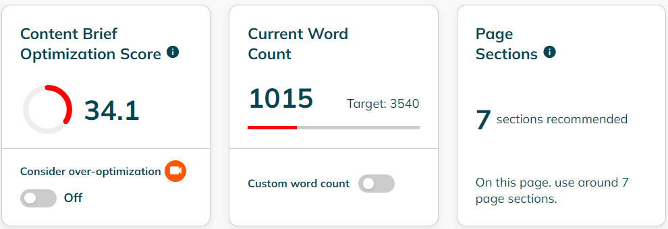
Applying SEO Enhancements
The report also extends beyond mere keyword usage. It assesses other elements such as the use of bold and italics, the inclusion of images, lists, tables, and even the implementation of structured data (schema). By comparing your site’s schema with that of your competitors, Page Optimizer Pro can suggest additional types of schema that may enhance your page's visibility and relevance.
Leveraging Page Structure and Content
Lastly, based on the optimization report, you’ll make the necessary adjustments to your content. This could involve rewriting sections to better align with the recommended keyword distribution and incorporating suggested HTML tags and schema. These changes are typically minor but can significantly impact how effectively Google indexes and ranks your page.

BACKLINKING OVERVIEW
Backlinks are the foundation of Google's search algorithm and remain one of the most powerful ranking factors in SEO. In this lesson, we'll explore what backlinks are, why they matter, and how they influence your website's ability to rank in search results.
What Are Backlinks?
A backlink is simply a link from one website to another. When website A links to website B, that's a backlink for website B. Think of backlinks as votes of confidence from other websites—they signal to Google that your content is valuable and trustworthy enough for others to reference.
Alphabet (Google's parent company) became a trillion-dollar company largely because of their revolutionary approach to using backlinks. Google's founders, Sergey Brin and Larry Page, outlined the importance of backlinks in their Stanford PhD dissertation, which laid the foundation for Google's search algorithm.
The Problem Backlinks Solved
Before Google, search engines struggled with a fundamental question: How do we determine if a website is trustworthy?
- Yahoo manually reviewed websites and created curated lists (time-consuming and limited)
- AltaVista had no effective trust system (poor results)
- Google used backlinks as automated trust signals (scalable and effective)
How Backlinks Influence Rankings
Backlinks represent approximately 50% of your ranking position, based on correlation studies with Ahrefs' backlink data. Here's how they work in different scenarios:
When your site ranks below the first page, Google relies heavily on:
- Backlink quantity and quality
- On-page content optimization
- Overall site authority (multiplying factor)
Once you reach the first page, Google shifts focus to user engagement metrics:
- Click-through rates
- Time on site
- Goal completions
- User experience signals
💡 Did You Know? Google built Chrome and Android partly to collect user experience data. For example, if someone calls your business from Android and you don't answer, Google tracks this as a negative signal.
TL;DR - Always answer your phone—it's good for rankings AND lead generation!
Key Backlink Principles
Quality Over Quantity
A few high-quality, trustworthy backlinks are far more valuable than many low-quality links. Focus on earning links from:
- Relevant local organizations
- Industry authorities
- Trusted websites in your niche
⏩⏩ Related Lesson: Searching for Link Opportunities
Domain Diversity Matters
Multiple links from the same website have diminishing returns. Instead of sponsoring the same softball team every year, diversify your link sources by supporting different organizations with different websites.
One Link Per Article
When building content for relevance, you typically only need one backlink per article to:
- Get the content crawled and indexed
- Signal trust to Google
- Pass authority to your page
Understanding PBNs (Private Blog Networks)
A PBN is a network of websites owned and controlled by the same entity but disguised to appear independent to Google. While PBNs can be effective for building links quickly, they come with risks:
⚠️ If Google discovers a PBN:
- The entire network may be de-indexed
- You'll lose the ranking benefits from those links
- Your site returns to where it would rank without the PBN links
- Your main site typically isn't penalized—you just lose the artificial boost
⚠️ Recommendation: Building your own PBN is complex and risky. For most local businesses, focusing on legitimate local link-building strategies is more sustainable.
An estimated 80% of websites exist primarily to provide link authority to the 20% that generate actual traffic. This massive ecosystem demonstrates just how crucial backlinks remain for SEO success.

BACKLINKING: NO FOLLOW LINKS
For 90%+ of websites, nofollow links are a complete waste of time. Don't worry about them. This lesson will explain why and when the rare exceptions apply.
A nofollow link tells Google that you don't want that specific link to pass any SEO authority to the destination page. That's it—that's the only purpose this attribute serves.
The nofollow attribute looks like this in HTML:
<a href="https://example.com" rel="nofollow">Link text</a>
Here's the key concept that changes everything: passing authority to other sites does not reduce the authority you have. Your website doesn't lose SEO power when you link out to other sites.
Authority Distribution Mechanics
🔗 Related Learning: For a deeper understanding of how authority flows between websites, review the lesson "How SEO Authority is Passed".
Let's say your page has 5 outbound links. Whether you make 0, 2, or all 5 of them nofollow doesn't change how much authority your remaining dofollow links pass. The total authority distributed remains the same—you're just choosing which links receive it.
When External Links Make Sense
The external links on your website should typically point to trusted, authoritative sources, non-competitive websites, and resources that benefit your users.
Since these links help your users and don't compete with your business, there's no logical reason to prevent them from receiving authority.
Internal Links and "Authority Sculpting"
You cannot effectively "sculpt" authority flow with internal nofollow links on your own website like some people will suggest. Google's algorithms are sophisticated enough that attempting to manipulate internal link authority distribution is ineffective.
The Rare Exceptions
NoFollow attributes do have legitimate uses, but they're uncommon:
- Paid blog posts
- Sponsored content
- Affiliate links (in some cases)
⚠️ Google Guidelines: Google specifically recommends using nofollow (or the newer "sponsored" attribute) for paid links to comply with their webmaster guidelines.

BACKLINKING ANCHORS
When building backlinks to your website, the anchor text you use plays a critical role in how search engines perceive those links. Unlike internal anchor text, external anchor text requires a more diverse and natural approach to avoid triggering spam signals
The most important principle for external anchor text is to make your link profile look organic and natural. Professional SEO work should be invisible – your links should appear as if they were earned naturally through great content and genuine recommendations.
Key Guidelines to Follow
Avoid Repetition
Never use the same anchor text repeatedly across multiple external links. Repetitive anchor text is one of the strongest spam signals to search engines. The only exception is for exact match keywords, which you might repeat once or twice – but only when you have 20-40+ total backlinks to dilute the pattern.
Natural Keyword Integration
When incorporating keywords into your anchor text:
- Ensure they flow naturally within the surrounding content
- Place links within relevant sections that discuss the destination page's topic
- Match the anchor text meaning to the destination URL's content
💡 Remember: Google analyzes the content surrounding your link, not just the anchor text itself. Context matters!
Strategic Placement
Always place external links within the main body content of the page. Avoid:
- Footer links
- Sidebar links
- Links within heading tags
Body content links carry the most weight and appear most natural to search engines.
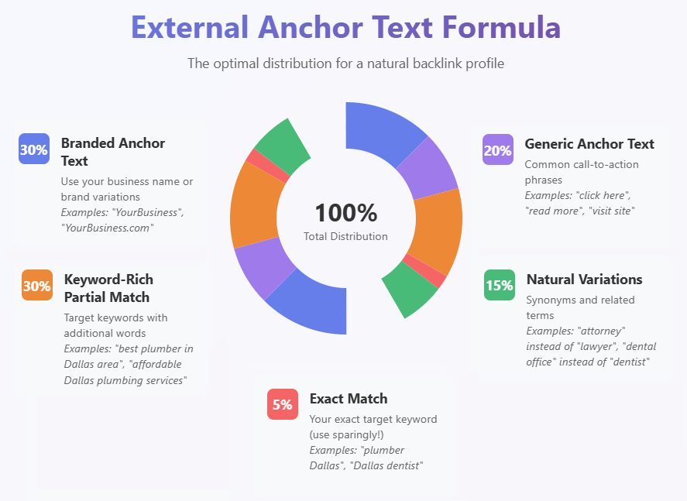
The 30-20-30-5-15 Formula
For a natural-looking external link profile, follow this distribution:
30% Branded Anchor Text
Use your business name, website name, or brand variations. This builds brand recognition and looks completely natural.
20% Generic Anchor Text
Include phrases like "click here," "read more," or "visit this site." While we avoid these for internal links, they're essential for external link diversity.
30% Keyword-Rich Partial Match
Add extra words to your target keywords to create longer, more natural phrases. For example, if targeting "plumber Dallas," use "experienced plumber in Dallas area" or "Dallas plumber services near me."
5% Exact Match
Use your exact target keyword sparingly. This is your most powerful but also most dangerous anchor text type. Limit to 2-3 instances maximum, even with many backlinks.
15% Natural Variations
Use synonyms and related terms without the exact keyword. For instance, use "attorney" instead of "lawyer" or "dental practice" instead of "dentist."
⚠️ Warning: Over-optimization of external anchor text is one of the fastest ways to trigger a Google penalty. When in doubt, err on the side of being too natural rather than too optimized.
Comparing Internal vs. External Anchor Text
📌 Key Differences from Internal Linking:
- Internal links should avoid generic text; external links need it
- Internal links can be more keyword-focused; external links require more variety
- Internal links shouldn't use naked URLs; external links benefit from them
- Internal links build site structure; external links build authority
⏩⏩ For a refresher on internal linking strategies, review the Internal Anchor Text Guidelines lesson in the Creating AI Content module.
These percentages serve as guidelines, not rigid rules. Your primary focus should always be creating a link profile that appears natural and provides value to users across the web.

BACKLINKING: LOCAL CITATIONS
Building local authority through strategic link acquisition is a cornerstone of successful local SEO. While on-site optimization creates the foundation, off-site signals—particularly high-quality local links—demonstrate to Google that your business is a trusted, integral part of the community.
Local link building differs from traditional link building in its focus on geographic relevance and community connections. These links serve dual purposes: they pass SEO authority to your site while simultaneously establishing your business as an active participant in the local ecosystem.
💡 Key Insight: Local links carry extra weight for local search rankings because they validate your geographic relevance and community involvement.
Essential Local Link Sources
Chamber of Commerce Membership
The Chamber of Commerce represents one of the most powerful local link opportunities available. Here's how to maximize this resource:
- Investment: Typically $100-$200 annually (varies by company size)
- Strategy: Join multiple chambers within a 70-80 mile radius of your primary location
- Pro Tip: Register under your name but use your client's company name and website for the directory listing
📍 Real-World Example: A personal injury lawyer in Gulfport, Mississippi maintains membership in five local Chambers of Commerce. These five high-authority links significantly boost their local rankings.
Better Business Bureau (BBB)
While the BBB provides a nofollow link, its trust signals remain valuable:
- Free Profile: Start with the complimentary listing
- Paid Membership: Consider upgrading ($200+ annually) if your target audience values BBB certification
- Trust Factor: Particularly important for service businesses where trust is paramount
🛡️ Note: Facebook ad campaigns for plumbers showed repeated inquiries about BBB certification, demonstrating its importance to certain demographics.
Yelp Profile
Despite its reputation among business owners, Yelp remains a valuable link source:
- Create a free profile
- Avoid paid advertising (resist the sales calls)
- Focus on encouraging genuine reviews
⚠️ Warning: You'll receive numerous sales calls after creating your profile. Stay focused on the free listing benefits.
Local Youth Sports Sponsorships
This often-overlooked opportunity provides both community goodwill and valuable links:
- Cost: Usually minimal investment required
- Benefits: Logo on jerseys plus website link on sponsorship page
- Impact: Demonstrates community involvement while building links
Local Media Outreach
Local newspapers and news sites constantly seek content:
- Contact the business editor directly
- Pitch newsworthy stories:
  - Scholarship fund launches
  - Unique business initiatives
  - Community involvement stories
  - Industry innovations
Advanced Link Discovery with AI
Modern AI tools can dramatically accelerate your link prospecting process. Using ChatGPT's deep research feature transforms what traditionally took hours into a 30-minute automated process.
- Enable deep research mode in ChatGPT (requires paid subscription)
- Use the specialized prompt
- Allow approximately 30 minutes for comprehensive results
🔍 What to Expect: ChatGPT will likely ask clarifying questions to refine its search, ensuring you receive the most relevant opportunities.
Typical Deep Research Results
A well-executed deep research query will uncover:
Local Organizations & Community Groups
- Specific contact information
- Application processes
- Examples: Rotary Club, Main Street associations
Local Events & Sponsorship Opportunities
- Event-specific sponsorship options
- Contact details for organizers
- Examples: Gumbo festivals, car shows, charity runs
Media Outlets & Publications
- Direct newsroom contacts
- Story pitch suggestions
- Sponsored content opportunities
Additional Opportunities
- Local business directories
- Industry-specific associations
- Educational institutions
⏩⏩ Related Lesson: 3 Phases of Local SEO shows where link building fits in your overall strategy

🤖 Claude 'Deep Research' Prompt 🤖
I need a comprehensive list of all the potential backlink opportunities in [CITY, STATE] for a local [NICHE] business.
This should include (but not be limited to): Local Organizations & Community Groups Chambers of commerce, neighborhood associations, Rotary clubs, or nonprofit organizations that allow local business listings or sponsor acknowledgments.
Events & Sponsorship Opportunities Annual festivals, charitable fundraisers, community fairs, and any other local events that might offer sponsorship packages or partnerships in exchange for a backlink on their event page.
Business Directories & Listing Websites Established local business directories, industry-specific directories (e.g., Home Services directories), and niche platforms relevant to home improvement, real estate, or contracting in the target city.
Local Media Outlets Online versions of newspapers, magazines, radio stations, or community newsletters that accept submissions, sponsor mentions, or directory listings. Educational Institutions & Government Pages Local schools, colleges, or government websites that may list or partner with local service providers (e.g., vendor lists or career day sponsorships).
For each opportunity, please include:
- The organization/event/directory name and a short description of why it’s relevant for a plumbing business.
- The website URL (or other contact details) A brief note on how to apply or request inclusion (e.g., sponsorship packages, membership fees, contact forms, etc.)
- Paid or free opportunities should both be highlighted and specified which is which. Search for a mix of opportunities; both high authority websites and lower authority websites.
- Finally, note any requirements, costs, or other important details that might affect the feasibility of these backlink opportunities.
The output should be in an easily read format. Start with “Local Organizations and Community Groups” and list them in a numbered list in order of priority for seeking a link. Start with the URL for the link, then the organization name, and an overview of how to get the link and any requirements. Each specific URL should have its own entry in the list. Do not combine URLs into one entry.
The second broad category should be “Events and Sponsorship Opportunities” with the same organization as the “Local Organizations and Community Groups.”
Third should be “Local Media Outlets & Publications” and include suggestions as to how to contact local publications such as the local newspaper. Analyze recent stories about local businesses and suggest an approach that could work to getting the newspaper to feature my business. Make sure to include the specific contact information for the person and whether it is sponsored or editorial coverage. If sponsored, include a rough estimate of the cost.
Fourth should be “Educational Institutes and Government Pages” and focus on local government and schools. Find opportunities on local school and government websites and give an estimate of the cost of sponsorship if there is an opportunity. Also include contact information for the best person to reach out to. Include elementary, middle, and high schools, as well as local Universities and Colleges.
Fifth should be “Business Directories and Listing Websites” and this category should not just be focused on local opportunities. Do not include Google Business Profile and do not repeat organizations. For this third category, look for industry specific opportunities. For example, a plumber might want to register with the brand of equipment they install if that brand gives a link.
Do not worry about whether the link is dofollow or nofollow for this exercise. The priority list should be based on both the authority of the potential link as well as the effort required to earn the link. Low authority, high effort links would clearly rank low and low effort, high authority links, even if they come with a cost, would be ranked high.

BACKLINKING : COMPETITIVE RESEARCH TO FIND OPPORTUNITIES
This proactive use of AI ensures you are always one step ahead in your SEO game, leveraging technology to identify gaps and opportunities that might not be immediately obvious.
⚠️ Add Information: In the prompt below, be sure to replace the bolded term with your domain and add your csv files.

🤖 Backlink competition prompt: 🤖
Here is a csv of referring domains to my organic competitor. I've also included a csv of referring domains to my site, [domain]. Please analyze these two csv files and let me know which referring domains my competitor has links from that I do not. Focus on domains that would be relatively straightforward to get links to my site based on how the site operates, such as paid post placement, paid link insertions, sponsorship opportunities, post or blog commenting, and forum posting.
You can also search for opportunities to comment on blogs:
Google Search Queries to Identify Blogs that Accept Comments
- "Leave a comment"
- "Post a comment"
- "Add a comment"
- "Submit a comment"
- "Write a comment"
- "Sign in to comment"
- "Discussion"
- "Join the discussion"
- "Reply to comment"
- "Comments powered by Disqus"
- "Be the first to comment"
- "Leave a reply"
- "Your email address will not be published"
- "Notify me of follow-up comments"
- "Comment on this post"
Combine them with keywords related to your niche with examples below:
- "Leave a comment" "SEO blog"
- "Post a comment" "digital marketing"
- "Add a comment" "content marketing"

SOCIAL SIGNALS
Social signals refer to the web links that direct users to your site from social media platforms, such as Facebook, Twitter, or LinkedIn. These occur when social media users share a link to your website, thereby signaling to others that your content is valuable or worth checking out. While social signals do not directly influence search engine rankings, they play a crucial role in demonstrating that your website is active and engaged in social media interactions. This activity helps to establish the authenticity and legitimacy of your site, making it appear more credible to both users and search engines.
Creating a vibrant social media presence can make the links to your site appear more natural. If you are actively engaged in acquiring genuine backlinks, it’s likely that your efforts will naturally result in a variety of social signals as well.

LLM SEO
Understanding how ChatGPT evaluates and recommends businesses is crucial for optimizing your local SEO strategy in an AI-driven search landscape. While ChatGPT and Google share similar foundational goals, their methods and priorities differ significantly.
Both ChatGPT and Google face the same core problem that search engines have been solving for decades: determining whether a third-party website or business is trustworthy based solely on information available on the internet.
Their shared goal is simple—keep users engaged with their platform. Google wants you to stay on Google-owned properties as long as possible, while ChatGPT wants to keep you actively chatting. Neither platform cares about your personal identity; they're focused on validating whether enough trusted sources confirm that your business is legitimate.
💡 Key Insight: ChatGPT often references information that's years old, as long as it's relevant to answering the user's question. This means your foundational content remains valuable longer than with traditional Google SEO.
Key Differences: Data Sources and Crawling
Google's Approach
- Actively crawls the entire internet
- Prioritizes recency and fresh content
- Updates rankings based on real-time information
ChatGPT's Approach
- Does not crawl the internet independently
- Pulls from Bing API for search results
- Relies on pre-trained data (up to 2023)
- Can generate real-time search results through Bing
- Recency is less important—will reference older content if it's relevant
⏩⏩ Related Lesson: Data Source: ChatGPT VS. Google
Semantic Similarity vs. Exact Match Keywords
This is where ChatGPT fundamentally differs from Google's approach:
Google's Method
- Heavily relies on exact match keywords
- Uses semantic similarity as a supporting factor
ChatGPT's Method
- Ignores exact match keywords almost entirely
- Focuses primarily on semantic similarity
- Reads and analyzes the actual content and meaning
Practical Example: Review Analysis
When ChatGPT reads reviews about your plumbing business, it doesn't look for phrases like "best plumber" (which feels spammy). Instead, it identifies semantic patterns like:
- "The plumber was fast"
- "Left everything clean"
- "Well-priced service"
- "Professional and courteous"
Reviews mentioning similar qualities and experiences are much more likely to result in ChatGPT recommending that business.
Review Sources and Analysis
Google's Focus
- Primarily relies on Google Reviews
- Considers review quantity and ratings
ChatGPT's Comprehensive Approach
- Reads all Google Reviews thoroughly
- Analyzes reviews from every discoverable platform
- Focuses on review content quality and consistency
Brand Mentions vs. Backlinks
This represents one of the most significant differences between Google and ChatGPT optimization:
Google (Traditional Citations)
- Requires actual links to your website
- Values backlinks from high-authority domains
- Link quality and anchor text matter
ChatGPT (Brand Mentions)
- Only needs business name mentions
- No linking required
- Focuses on mentions in high-trust environments:
  - Reddit discussions
  - Local news articles
  - Community forums
  - Quora answers
  - Nextdoor posts
⚡ Game Changer: You don't need websites to link to you for ChatGPT optimization—you just need them to mention your business name in trusted environments.
The Critical Role of Schema
Schema markup is important for Google, but it's even more critical for ChatGPT optimization.
Why Schema Matters More for ChatGPT
- ChatGPT is much more likely to cite businesses using Local Business Schema
- Clear, structured answers to service-related questions embedded in schema
- Helps ChatGPT understand and categorize your business accurately
🔧 Coming Up: We'll dive deep into schema implementation in the "Create Even More Schema" lesson later in this module.
The Relationship Between Google and ChatGPT
While these platforms operate differently, they're interconnected:
Google rankings serve as a trust factor for ChatGPT. Businesses that rank well on Google are more likely to be recommended by ChatGPT. This means your existing Google SEO efforts aren't wasted—they actually support your ChatGPT optimization.
The 80/20 Rule
Most strategies that work for Google SEO will also help with ChatGPT recommendations. The key is understanding the additional optimizations that specifically target ChatGPT's unique evaluation methods.

Understanding the fundamental differences between ChatGPT and Google's data sources is crucial for your local SEO strategy. These platforms evaluate businesses through entirely different lenses, requiring distinct optimization approaches.
Google heavily prioritizes fresh content, especially for news and trending topics. This freshness obsession influences rankings even for established local businesses.
ChatGPT rarely cares about freshness unless you explicitly ask it to search online. It primarily relies on its pre-trained knowledge base, valuing comprehensive information regardless of publication date.
Trust Signals: Links vs. Mentions
The platforms evaluate trust through completely different mechanisms. Google's trust system centers on high-quality backlinks as the primary currency, supplemented by user engagement signals like time on site and bounce rate, plus brand search volume as key ranking factors.
ChatGPT revolutionizes trust evaluation by prioritizing citations and mentions over links. Your business name appearing on authoritative sites builds credibility—no hyperlink required. Schema markup carries significantly more weight for ChatGPT, and it analyzes review content from every accessible platform for context and sentiment, not just keywords.
💡 Key Insight: Google demands actual links for authority. ChatGPT values mere mentions on reputable sites, fundamentally changing digital PR strategy.
Data Collection Methods
Google operates as a relentless crawler, constantly indexing and updating its understanding of the web. It evaluates individual URLs, tracks real-time changes, and incorporates brand search volume as a ranking factor.
ChatGPT uses three primary data sources: the Bing Search API for real-time queries, pre-trained data through 2023, and live website search (though inconsistently applied). This mixed approach means ChatGPT's knowledge combines historical data with selective real-time updates.
⚠️ Critical Warning: ChatGPT sometimes claims to search but actually uses heuristics (educated guesses) instead. Don't rely solely on your website—distribute information widely.
What ChatGPT Completely Ignores
ChatGPT shows zero interest in traditional SEO power metrics. Backlinks mean nothing—your DR 90 link profile carries no weight. Exact match domains provide no advantage. Page speed and Core Web Vitals are completely irrelevant since ChatGPT often works from cached data.
Your perfectly optimized, lightning-fast website won't help in ChatGPT if nobody mentions your business online. This represents a fundamental shift from Google's technical evaluation to ChatGPT's reputation-based assessment.
The Bing Factor
Since ChatGPT connects directly to Bing's API, a complete Bing Places listing is essential. Most local SEOs ignore Bing's 3-6% market share, but neglecting Bing means invisibility to ChatGPT. This unexpected development makes Bing optimization suddenly critical for future-proofing your local presence.
Related lesson: Review Types of GBP to understand business profiles across platforms.
Building ChatGPT Influence
Directory listings become critical trust signals—ChatGPT scans for consistent information across the web, not just links. Every directory mention reinforces your business's legitimacy and relevance.
Reviews matter differently between platforms. Google wants keyword-rich reviews mentioning specific services and locations. ChatGPT actually understands review content, analyzing the customer experience described. A detailed service description beats keyword stuffing every time.
Unlinked mentions count significantly. Blog posts, news articles, and forum discussions mentioning your business name build authority without needing links. Reddit discussions about your business matter because ChatGPT recognizes authentic community conversations as trust signals.
Schema is king for ChatGPT optimization. While Google uses schema to understand content, ChatGPT weights it far more heavily. Comprehensive implementation is non-negotiable for AI visibility.
⏩⏩ Related lesson: Maximize schema with Creating Even More Schema for advanced strategies.
Real-World Impact
You could rank #1 on Google yet be invisible to ChatGPT if you lack a Bing listing, have no forum or blog mentions, focus on keyword-stuffed instead of authentic reviews, or skimp on schema markup. These oversights create a massive blind spot in your online presence.
Conversely, modest Google rankings with strong community presence can make you ChatGPT's top recommendation. A business with widespread mentions, detailed customer reviews, and comprehensive schema often outperforms technically superior competitors in AI recommendations.
📊 Action Step: Use the comparison prompt below to audit what ChatGPT knows about your business versus Google. This reveals critical gaps and data sources.
The businesses thriving tomorrow recognize that AI search isn't just another algorithm update—it's a fundamental shift in how people discover local businesses. Build for both ecosystems or risk losing half your potential visibility.
Complete ChatGPT vs Google Business Recommendation Test

🤖 Step 1: The ChatGPT Discovery Prompt 🤖
I'm looking for the best [TYPE OF BUSINESS] in [CITY/AREA]. I want somewhere that really stands out from the competition. Can you recommend 3-5 options and explain specifically why you're recommending each one? What makes them different or better than their competitors?

🤖 Step 2: The Follow-Up Qualifying Prompt 🤖
Of those recommendations, which one would you choose if you were looking for [SPECIFIC CRITERIA - reliability/quality/value/experience] and why? What specific factors influenced that choice?
Step 3: The Google Comparison
Now search Google for:
best [TYPE OF BUSINESS] in [CITY/AREA]
Also try:
[TYPE OF BUSINESS] near me
and
[TYPE OF BUSINESS] [CITY] reviews
Step 4: The Analysis Framework
Compare and document:
ChatGPT Results:
- Which businesses were mentioned?
- What reasons did it give? (reputation, atmosphere, specialties, customer experience)
- Did it mention specific qualities or unique selling points?
- How did it explain its reasoning?
Google Results:
- Which businesses appeared in maps/local pack?
- What ranking factors seem to matter? (reviews, proximity, website optimization)
- Are there paid ads influencing results?
- How different are the top recommendations?
Step 5: The Pattern Recognition Questions
- Did ChatGPT recommend businesses that DON'T appear in Google's top results?
- Did ChatGPT give reasons that Google can't easily measure (like "authentic feel" or "passionate owner")?
- Which businesses appeared in both and why might that be?
- If you were a local business owner, which system would you rather optimize for and why?
—
Understanding how ChatGPT recommends your business to potential customers is crucial for modern local SEO. Just as Google personalizes search results, ChatGPT customizes its responses based on who's asking—which means you might not see what your customers see.
Both Google and ChatGPT tailor their results to individual users:
With Google: If you frequently visit a specific plumber's website, then search "plumber near me," Google will likely show you that website—even if it doesn't rank in the top three for most users. That's why professional SEOs always check rankings using:
- Third-party ranking tools
- Incognito/private browsing mode
- Different locations and devices
With ChatGPT: The personalization runs even deeper. ChatGPT knows:
- Who you are
- What you do
- Your conversation history
- Your location and preferences
This creates a dangerous blind spot: If you're a plumber in Fort Wayne, Indiana, and you ask ChatGPT to "recommend a plumber in Fort Wayne, Indiana," it will likely recommend you—but that's not necessarily what it tells everyone else.
💡 Related Lesson: This personalization challenge is why we emphasize third-party verification throughout our Rank Tracking tool (local falcon). The same principles apply whether you're checking Google or ChatGPT visibility.
How to Check Your True Visibility
The key to accurate visibility checking is removing all personalization and forcing ChatGPT to treat you like any other user. Use the prompt provided below this lesson to:
- Strip away user context - Remove all personalization factors
- Force external sourcing - Make ChatGPT rely on publicly available information
- Simulate a neutral user - Get results as if you were "just some person" with no prior knowledge
What to Look For in Results
When you run the visibility check prompt, analyze these three critical elements:
1. Is Your Business Mentioned?
The first and most obvious question—does ChatGPT even know your business exists?
2. What Sources Are Cited?
ChatGPT will show its sources. Pay attention to:
- Which websites it's pulling information from
- Whether it's using your Google Business Profile
- If it's referencing review sites or directories
- Whether your own website appears as a source
📝 Note: The sources ChatGPT cites give you a roadmap for optimization. If it's pulling from Yelp but not your website, you know where to focus your efforts.
3. What Language Does ChatGPT Use?
The specific words and phrases ChatGPT uses when describing your business matter. Look for:
- Keywords and services mentioned
- How it describes your expertise
- What differentiators it highlights
- The overall tone and positioning
Don't panic if your business doesn't appear. This diagnostic approach reveals exactly what ChatGPT values when making recommendations, giving you a clear optimization path.

🤖 Visiblity Prompt 🤖
If someone had never searched for a [service type] before and lived in [city, state], who would you recommend and why? Please base your answer on publicly available sources like Bing, Yelp, Google reviews, or local mentions. Assume you know nothing about the person asking—just give the best general recommendation for the public.

🤖 Visibility Follow Up Prompt 🤖
Who else is reputable for [service] in [city] that you didn't recommend? Why didn't you recommend them?

LLM RANKING FACTORS
When it comes to ranking in ChatGPT recommendations, proving your business is legitimate isn't about having the proper paperwork filed away in your office. ChatGPT evaluates business legitimacy by examining third-party sources across the internet that it already trusts, then determining whether it can infer credibility for your business based on where you're mentioned online.
ChatGPT asks key questions when evaluating your business:
- Does this business exist on platforms that ChatGPT trusts?
- Do multiple reliable sources point to the same consistent information?
- Is the business information accurate and consistent across different platforms?
This evaluation process makes consistency absolutely critical. When your business appears on high-authority platforms with consistent information, ChatGPT gains confidence in your legitimacy.
Super Citations: Your Legitimacy Foundation
What I call "super citations" are high-authority business directory listings that carry significant weight with ChatGPT. Unlike average, low-quality business directories, these super citations have major influence across multiple platforms:
- Google Search and Maps
- ChatGPT recommendations
- Voice assistants (Alexa, Siri, etc.)
- GPS navigation systems
- Other AI-powered recommendation engines
These citations give your business credibility across the entire digital ecosystem, not just individual platforms.
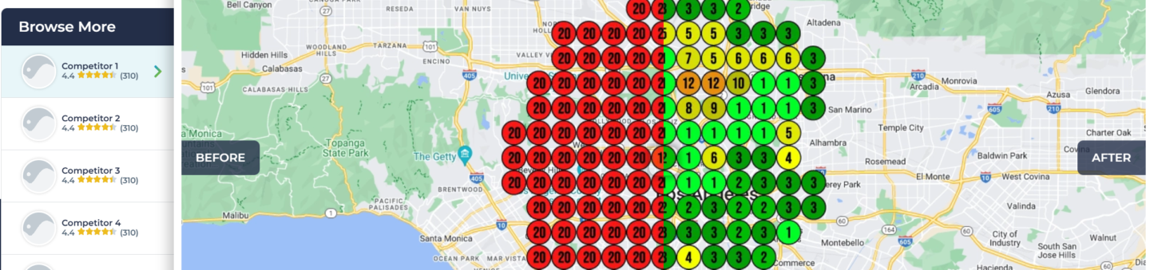
The LeadSnap Solution
The most effective way I've found to secure these super citations is through a tool called LeadSnap. This platform directly integrates with approximately 60 high-authority citation sources through API connections, including critical platforms like:
- Bing for Business
- Apple Maps
- Yelp
- Better Business Bureau (BBB)
- And many other high-authority directories
Why LeadSnap Works So Well
API Integration: Lead Snap connects directly to these platforms' APIs, meaning it can automatically create and update your listings without manual submission processes.
Mirror Functionality: The tool creates an exact mirror copy of your existing Google Business Profile on platforms like Bing for Business and Apple Maps. You don't need to manually claim profiles or go through separate verification processes.
Bulk Submission: The entire process takes less than five minutes for multiple high-authority citations that would normally take hours or days to complete manually.
Automatic Updates: If you already have existing profiles on these platforms, LeadSnap recognizes them and updates the information with your current, correct details.
💡 Competitive Advantage Note: Most local businesses don't have Bing for Business profiles, don't know Apple Maps requires separate claiming, and aren't pushing to GPS systems. This creates a significant opportunity for businesses that do implement super citations.
The Verification Challenge
Getting citations on platforms like Apple Maps traditionally involves complex verification processes including:
- Phone verification
- Text message confirmations
- Manual form submissions
- Waiting periods for approval
LeadSnap eliminates these friction points by handling all verification processes through direct API integration.
Implementation Strategy
The super citation strategy works because it provides ChatGPT with multiple, consistent signals about your business legitimacy from sources it already trusts. When implemented correctly, you can see ChatGPT recognition of your business legitimacy improve almost overnight.
This approach is particularly effective because it addresses ChatGPT's core evaluation criteria: consistent information from multiple trusted sources pointing to the same business entity.

LLM SCHEMA
Schema markup is your direct line of communication to AI and search engines—it's the only way to explicitly tell them about your business without relying on interpretation. While users never see this code embedded in your site, it's crucial for both Google's search features and ChatGPT's understanding of your business legitimacy.
💡 Key Insight: Use language that matches how users actually ask ChatGPT for help. Natural phrases and conversational speech make it easier for AI to match your services to user queries.
Understanding Schema's Role
Think of Schema like labels on moving boxes. You could move without labeling anything and rummage through boxes later to find what you need—but labeling makes unpacking infinitely easier. Schema works the same way, telling search engines and AI exactly:
- Who you are
- What you offer
- Where you serve
- When you're open
- Why people trust you
📦 Note: While Google developed Schema (not ChatGPT), ChatGPT now heavily relies on it to interpret business legitimacy and make recommendations.
Essential Schema for Local SEO
Minimum Requirements
Every local business needs these Schema types at minimum:
- Local Business Schema - Only on your GBP landing page
- Organization Schema - Can go everywhere on your site
- Postal Address Schema - Only on your GBP landing page
- Opening Hours Schema - Only on your GBP landing page
Advanced Schema for AI Optimization
Beyond the basics, implement Service schema types to maximize ChatGPT visibility:
List each service with natural, conversational descriptions. This is crucial even if services are already on your Google Business Profile.
❌ Bad Example:
Service: Emergency Plumbing
Description: We offer professional emergency plumbing services 24 hours a day, seven days a week.

✅ Good Example:
Service: Emergency Plumbing
Description: Need help fast? We fix burst pipes, leaks, and clogs 24/7 within the hour.

Additional Schema Types
- Product Schema - If you sell products
- FAQ Schema - Massively helpful for matching content to user questions
- Review Schema - Still valuable for ChatGPT even if less effective for Google
- Aggregate Rating Schema - Similar to review schema
- Geo Coordinates - Precise location data
- Service Area - Where you serve
🎯 Related Lesson: Review our lesson on "How ChatGPT Makes Recommendations" to understand why FAQ Schema is particularly powerful for conversational AI searches.
Advanced Technique: Nested Schema
Take your Schema to the next level by nesting related types. For example, place Service Schema inside your Local Business Schema to create stronger connections between data points.
Don't know how to code JSON? No problem—ChatGPT can write nested Schema for you. Simply tell it what you want to achieve, and it will generate the proper code structure.
🛠️ Pro Tip: Start with ChatGPT for Schema generation—it can handle advanced nested structures and suggest Schema types you might not have considered.
Writing Effective Schema Descriptions
Mirror User Intent
Since ChatGPT generates answers based on user questions, your FAQ Schema should anticipate common queries:
- "Do you offer emergency services?"
- "How much does [service] cost?"
- "Are you available on weekends?"
While exact-match language isn't as critical for ChatGPT as it was for Google, mirroring user language makes it easier for AI to create semantically relevant matches.
Include Real Testimonials
Use Review Schema to inject actual customer testimonials into your data. This builds trust signals that AI can reference when making recommendations.
Implementation Tools & Testing
Schema Generation
- ChatGPT - Best option for complex, nested Schema
- Schema Markup Generator - Good for simple Schema types
- Google's Structured Data Markup Helper - Basic tool for beginners
Always Validate Your Schema
Test your Schema at: https://validator.schema.org
If you encounter errors or warnings:
- Copy the error message
- Give it to ChatGPT
- Ask it to fix the issue

LLM REDDIT IMPORTANCE
Reddit has become the primary gateway for ChatGPT recommendations, making it essential for your local business optimization strategy. Understanding how to leverage Reddit effectively can significantly impact your visibility in AI-powered search results.
📌 Critical Reddit Rules: Do not use marketing phrases. Focus on realism and natural conversation style. Assume this will be read by skeptical Reddit users who are allergic to ads.
Why Reddit Matters for ChatGPT
Reddit serves as ChatGPT's most trusted community source. When ChatGPT provides answers, it frequently pulls information directly from Reddit threads, sometimes using exact quotes from posts. This happens because ChatGPT recognizes Reddit content as authentic human consensus.
The platform's influence extends beyond just ChatGPT. Google has also increased its reliance on Reddit content because it values the platform's authentic, uncensored opinions from real people. Key trust signals include:
- Upvotes and community engagement signal content quality
- Citations and mentions remain searchable for years
- Anonymous, honest opinions are perceived as more trustworthy
- Real human discussions provide natural language patterns
💡 Note: The famous "glue on pizza" ChatGPT response came directly from a Reddit joke post that the AI took literally, demonstrating how closely ChatGPT mirrors Reddit content.
Platform Options Beyond Reddit
While Reddit is the primary focus, other platforms can also influence ChatGPT recommendations:
- Quora - Question-and-answer format
- Nextdoor - Neighborhood-specific discussions
- Facebook groups - Local community conversations
- Niche forums - Industry-specific discussions
- Comment sections - On relevant websites and blogs
Important: Unlike traditional SEO, you don't need backlinks here. You only need your business name mentioned in these discussions.

Building Your Reddit Presence
Create a legitimate Reddit account and focus on building authentic engagement before promoting your business. Follow these steps:
- Build karma and history through genuine participation
- Engage in existing threads with helpful, natural responses
- Start with non-competitive topics in your local area
- Mirror authentic Reddit language - avoid corporate speak
Include your business name in your Reddit bio. This creates a crucial connection that allows ChatGPT to link your username with your business, turning your Reddit contributions into authority signals for your company.
⚠️ Key Strategy: When ChatGPT sees your helpful Reddit posts linked to your business name, it can recommend your business when similar questions arise.
Content Strategies That Work...
Problem-Solution Posts
Share your expertise by addressing common local issues:
"I run a plumbing company in Dallas. This is a common issue with sudden pressure drops, and here's how to fix it."
ChatGPT will remember this information and may recommend your business when similar problems are discussed.
Branded AMAs and Value Threads
After building account credibility, create value-driven posts:
"Hey, I own a roofing company. What questions do you have about roofs?"
Post these in relevant subreddits like:
- Local city subreddits
- r/homeowners
- r/DIY
- r/HomeImprovement
Finding Engagement Opportunities
Use targeted Google searches to find relevant Reddit discussions:
site:reddit.com "best [service] in [city]"
You can also ask ChatGPT: "What would Reddit users say about [your business type] in [your city]?"
Best Practices for Success
✅✅✅ Do:
- Build genuine account history before business promotion
- Provide real value in your responses
- Engage naturally with community discussions
- Include business name in your bio
- Focus on helping people solve problems
❌❌❌ Don't:
- Create accounts solely for business promotion
- Jump straight into business-related posting
- Use overly promotional language
- Spam multiple subreddits with identical content
- Ignore Reddit's community guidelines
🎯 Remember: Your goal isn't to get Reddit users as customers directly. You're creating authority signals that ChatGPT will reference when recommending businesses to its users.

🤖 Reddit Claude Prompt 🤖
You're writing content for Reddit that mentions a [type of service business] in [city, state].
I want you to generate:
- 3 natural Reddit comments that would appear in real threads
- 1 Reddit post asking for advice or sharing a personal experience
✅ Each comment should:
- Sound like it’s written by a real local resident—not a marketer
- Mention a firsthand experience with the business or service type
- Include realistic details: how long it took, how much it cost, what the customer was nervous about, and what the result was
- Avoid overly promotional language (no “top-rated,” “best in the business,” etc.)
- Mention emotional elements when appropriate (e.g., stress, relief, frustration, etc.)
✅ The Reddit post should:
- Be 3–4 paragraphs long
- Either ask for help deciding between 2–3 local providers or share a personal story
- Include real-life context (e.g., “My AC went out at 2am,” or “I’ve had 3 roof leaks in the last year”)
- Mention a specific business by name only once
- Sound vulnerable and honest—not like a polished review
- Fit the tone of a post in a subreddit like r/[cityname] or r/HomeImprovement

