

Education
🎓 B.E. in Electronics & Communication Engineering
Knowledge Institute of Technology, Tamil Nadu – 2015 | 64%
🎓Diploma in Electronics & Communication Engineering
Kavery Polytechnic College,
Tamil Nadu – 2012 | 87%

Key Skills

- 365 admin service: Entra ID (Azure AD), Exchange Online, Intune, SharePoint, Teams, and Microsoft Security & Compliance
- Scripting: Power shell
- Report: Power BI
- Networking: Juniper APs, Firewalls-Sophos, FortiGate
- VLANs, MAC Binding, Switches
- Device: Windows, MAC, IPAD, Android& Linux
- Security: Microsoft Defender, BitLocker, Symantec, CrowdStrike, Kaspersky
- Migration Expertise: G-Suite to O365, IMAP, Tenant-to-Tenant
- Reporting & Analytics: Power BI & MS List, Basic in fabrics
- ERP Billing: SAP BYD, S4 Hana
- Knowledge In ITGC IT audit

Professional Summary
IT Infrastructure Specialist with over 8+ years of progressive experience in IT operations, including 5+ years specializing in Microsoft 365 administration and support. Skilled in managing Entra ID (Azure AD), Exchange Online, Intune, SharePoint, Teams, and the Microsoft Security & Compliance Center for monitoring, investigation, and incident response.
Proficient in PowerShell automation & Power BI reporting to streamline IT processes and strengthen data security policies. Additionally experienced in SAP-ERP–based IT billing, vendor coordination, network operations, and device lifecycle management, ensuring efficient and compliant IT service delivery

Work Experience
iBUS Networks & Infrastructure Pvt Ltd 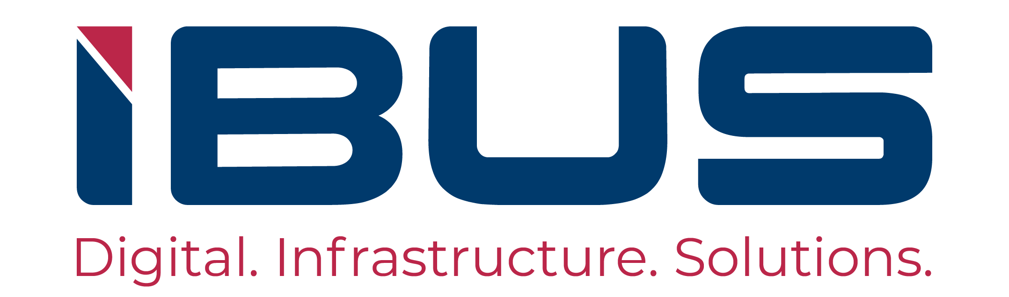
Senior Executive – 365 admin Support
📍 Bengaluru, India (On-site) | 🗓 Nov 2022 – Present
Industry: Digital Infratech platform delivering end-to-end Wi-Fi and connectivity solutions.
Support: 365 admin Support & IT operations Collaborated with Pan INDIA IT Team
Ticketing Tool: Infraon
Key operations
🔧 Microsoft 365 Admin & Entra Center
- Administered user, group, and license management within Microsoft 365.
- Enabled and maintained Litigation Hold and Self-Service Password Reset (SSPR).
- Managed MFA, app password policies, and Conditional Access for users, groups, and guest accounts.
- Configured and maintained domain records in GoDaddy and M365 (TXT, MX, SPF, DKIM, DMARC) and handled domain renewals.
- Monitored tenant health and account usage, assigned admin roles, and modified MFA settings.
- Implemented SSO integrations for third-party applications using SAML and SMTP, restricted access via security groups
📧 Exchange Online
- Managed user mailboxes, shared mailboxes, distribution groups, and mail-enabled security groups.
- Configured retention policies, litigation holds, archive mailboxes, and message size limits.
- Managed calendar sharing, mailbox delegation, and permissions using PowerShell.
- Monitored mail flow, performed message tracing, Application SMTP authentication, and enforced group restrictions.
- Created transport rules and connectors to secure and control external mail flow.

📱 Microsoft Intune
- Managed MDM/MAM policies across Windows, macOS, Android, and iOS/iPadOS for secure corporate access. Troubleshooting + support -compliant and non-compliant devices in Intune.
- Enforce organization application &Device policy over Intune company portal & Onboarded laptops and desktops using Windows Autopilot
- Managed Conditional Access, Compliance, and Configuration Profiles to enforce device policy
- Managing USB block list, Filtering group &URL block policies (Edge, Chrome),
- Implemented silent BitLocker encryption and managed recovery keys.
📂 SharePoint &Teams
- Managed active/deleted SharePoint sites, user profiles, and access permissions based on requests.
- Assigned Exchange Online plans according to user or departmental requirements.
- Controlled external sharing, enforced storage limits, and implemented retention policies.
- Provided migration activity support and continuous monitoring for data integrity and performance
- Provided Microsoft Teams support, including Poly X50/X30 device integration, updates management, webinars, events, guest access configuration, and administration of meeting policies.

Contact
📞 +91 8015224482
✉️ Boopathi.r2040@gmail.com
📍Bengaluru, Karnataka, India
🔗 LinkedIn

Boopathi. R
Microsoft 365 administrator

PERSONAL DETAILS

Date of Birth: June 2, 1993
Languages: English, Tamil, Kannada, Hindi

DECLARATION
I hereby declared the above-given information is true to the best of my knowledge.
Signature & Date:
Boopathi. R
11-10-2025

🔐 Security & Compliance
- Utilized Microsoft Purview for eDiscovery, DLP, audit logs, sensitivity labels, and alert monitoring; created and managed data lifecycle and retention tags/policies to ensure regulatory compliance.
- Implemented and maintained security policies and rules including Anti-Phishing, Anti-Spam, Anti-Malware, Safe Attachments, and Safe Links.
- Administered Microsoft Defender for device protection, incident response, and threat detection.
🔄 Migration Projects
- Migrated 850 users from G-Suite to Microsoft 365
- Migrated 200 users from IMAP (Yahoo) to Microsoft 365
- Integrated 600 Zoho Mail users with Microsoft 365 SSO
- provisioning accounts and ensuring user profile sign in, Data, application setup also devices migrated.
OCS Group India Pvt Ltd 
Senior Executive – 365 admin Support
📍 Bengaluru, India (On-site) | 🗓 Dec 2021 – Oct 2022
Industry: UK-based facility management services provider
Support: Pan India 365 admin Support & IT operations Collaborated UK & INDIA Helpdesk engineers
Ticketing tool: ServiceNow
Key operations
- Managed and supported Entra ID (Azure AD), Exchange Online, Intune, Symantec Antivirus, and the Microsoft Security & Compliance Center.
- Created and managed Microsoft Teams meeting policies tailored for specific events and organizational requirements.
- Prepared and maintained IT incident and service reports across 16 branch offices, collaborating with three engineers to ensure SLA compliance and accurate call reports through ServiceNow.
- Supported Hybrid AD–Azure environments using PowerShell scripting for synchronization and automation processes.
- Resolved device compliance issues in Intune and managed endpoint protection incidents.
- Oversaw vendor coordination, IT asset tracking, and billing operations across multiple locations in India.
- Managed Windows/macOS provisioning and collaborated with the UK application team for ERP (Oracle) upgrades and Power BI dashboard improvements.
- Coordinated with hardware and software vendors for procurement activities, ensuring timely support and uninterrupted service delivery.
VSERV Infosystems Pvt Ltd 
Senior Desktop Support Engineer (L2)
📍 Bengaluru, India (On-site) | 🗓 Feb 2021 – Dec 2021
Industry: IT Infrastructure Management Services
Support: Honda Motorcycle and Scooter Karnataka plant on site client IT operations
Ticketing tool: IT Sahayak,
Key operations
- Provided hardware, networking, and application setup support for on-site users.
- Handled Azure AD operations including password resets and security group management.
- Administered Windows Server 2012, managed Hybrid AD profiles, and maintained group.
- Configured network switches (VLAN setup, MAC binding) and resolved end-user network connectivity issues.
- Troubleshot client applications such as Outlook, Teams, OneDrive, SharePoint, and Excel, ensuring smooth user operations.
- Provided support for MS Office, Symantec Endpoint Protection, CrowdStrike, Digital Guardian, and Oracle applications
Fourth Dimension Technologies Pvt Ltd 
Senior Desktop Support Engineer
📍 Chennai, India (On-site) | 🗓 May 2018 – Feb 2021
Industry: IT Infrastructure Management Services
Support: CAMS – Mutual fund transfer agency on site client IT operations.
Ticketing tool: ManageEngine
Key Responsibilities:
- Supported over 4,500 end users across desktops and laptops, ensuring minimal downtime.
- Performed OS imaging (GHOST, Terabyte), system configuration, and software troubleshooting.
- Resolved Outlook PST/OST issues and managed USB/network printers, scanners, and antivirus.
- Implemented BitLocker encryption and securely managed encryption keys.
- Provided remote IT support and assisted in migrating 350 laptops and desktops from on-premises domain to CAMS domain, resolving Finance application and digital signature issues.
- Delivered support for MS Outlook, Teams, Webex, Poly VC devices, Pulse Secure, and VPN connectivity.

Certifications
- CCNA – Sansbound Networking School, Chennai
- MCSE – Sansbound Networking School, Chennai
- Microsoft Certified: Azure Administrator Associate
(AZ-104) – Udemy
- Microsoft 365 Security Administration
(MS-500) – Udemy

ACHIVEMENT
- Won “iBUS IXCEL 2023” Award for optimizing Microsoft 365 licensing by converting shared mailboxes, resulting in saving 104 licenses.
- Second Prize in a College Project Expo for innovative project
- Nominated for “iBUS IXCEL 2025” in recognition of consistent performance and contribution to IT operations

