REVANTH KUMAR .P
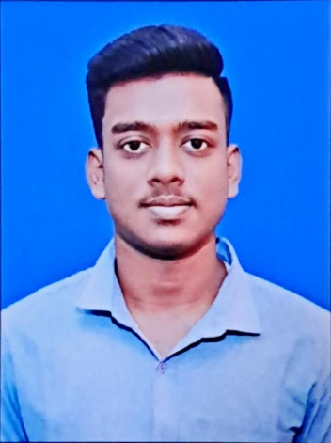
IT Technician and Martial Artist

E 9360529229  revanthkumartcp2005@gmail.com  MANGADU

SUMMARY

I am an enthusiastic professional with experience in hardware and software services, complemented by skills in networking, troubleshooting, and technical support. With a strong foundation in IT through education and practical exposure, I strive to enhance productivity and solve technical challenges effectively. My passion for martial arts and typing reflects my commitment to personal development.

EXPERIENCE

Sales and Services Associate

ARS HARDWARE SOFTWARE SALES AND SERVICES
01/06/2022 -01/12/2023 - MANGADU
Hardware and Software Sales and Services.
- Experienced in hardware and software sales and services for about 2 years.
- Handled technical issues in the system and recovery.

Hardware and Networking Technician

RBS SECURITY HARDWARES AND NETWORKING
01/01/2024 – 31/01/2025 POONAMALEE
• Experienced in networking, OS installation, router configuration, burglar alarm, CCTV, and biometric systems.

EDUCATION

10th

MADANLAL KHEMANI VIVEKANANDA VIDYALAYA
2020 - GUMMIDIPOONDI
12th

ST.MARY'S MATRICULATION HIGHER SECONDARY SCHOOL
2022 - GUMMIDIPOONDI
B.com (Corporate Secretaryship)

CHENNAI NATIONAL ARTS AND SCIENCE COLLEGE
2025 - AVADI

LANGUAGES
Tamil
Native
English
Proficient
Telugu
Advanced

KEY ACHIEVEMENTS

 Martial Arts Achievements
Achieved a black belt in Karate and participated in state-level Silambam.

k Typewriting Proficiency
Completed a Typewriting class with a second-class certificate.

SKILLS
CCTV
Networking
Playing shuttle cock

PROJECTS

Martial Arts and Typewriting Projects
2024 - MANGADU
Personal development projects focused on martial arts and typing skills.
- Participated in Karate competitions and trained extensively.
- Involved in Silambam training and performances.
- Developed typing skills through a Typewriting course.

PASSIONS

& Martial Arts and Music
Active participation in martial arts, particularly Karate and Silambam, and skilled in rhythmic pad performance.

