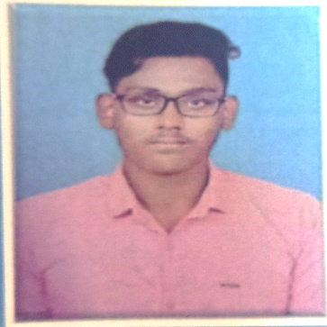
RAFFEL RAJASIRPI.R
CONTACT : 6381307913
E – mail : randyraffel@gmail.com
CAREER OBJECTIVE
- Dedicated and technically skilled Electronics and Communication Diploma holder with hands-on experience in CCTV installation,maintenance and basic network configurations. CCNA and CCNP certified with a strong foundation in Seeking a position as a CCTV Technician/Network Support Engineer where I can apply my technical knowledge and continue growing in the field of network infrastructure and surveillance systems.
EDUCATIONAL QUALIFICATION
- Diploma in ECE
Ka.So.Ka Polytechnic College
Percentage : 77%
CERTIFICATIONS
- CCNA/CCNP– Completed in
- CCTV Installations & Maintenance
TECHNICAL SKILLS
- Installation and configuration of CCTV cameras ( Analog & IP ),NVR/DVR Setups
- Networking : Advanced skills in routing, switching,VLANs,subnetting,IP addressing and security protocols,Network security (ACLs,Firewalls )
- Software & Tools : CCTV syatem monitoring software, Cisco Packet Tracer,Wireshark Multimeters Network analyzers and Hand tools for installations
- Protocols : DNS,SNMP,TCP/IP,etc
WORK EXPERIENCE
- Installed and configured CCTV systems ( analog and IP cameras,DVRs,NVRs) for residential and commercial clients.
- Provided maintenance and troubleshooting for CCTV setups, ensuring minimal downtime.
- Assisted in setting up and configuring network devices ( routers,switches,access points )
PERSONAL ATTRIBUTES
- Able to assess complex network and CCTV issues and provide quick and effective solutions
- Collaborates effecti vely with other technician,engineers and clients to deliver superior service
- Quick learner with a passion for staying updated with new technologies
- Excellent communication and customer service ability
- Able to work under pressure and can deliver effective solutions

DECLARATION :
I declare that the information presented in this resume is true and accurate of the best of my knoeledge. I assure you that my skills,experience and qualification meet thr requirements of the job and I am commited to making a positive contribution to your organizarion.

Place : Ariyalur

