SOMA Codex
Book 0 — Overview, Reading Map & the Operational-Definitions Convention
Start here. This book orients the whole Codex, states the recursion rule once as canon, and fixes the language conventions that bind every other book.

1. What this is
The SOMA Codex is a design bible for a new agent runtime conceived as a single living organism. Not a platform that hosts agents — an organism whose parts are its cells, tissues, and organs. It is named SOMA (Greek, "the living body"); its largest scale — the aware whole, if awareness ever arises — is CHORUS, because the mind, if there is one, is the chorus and never the soloist.
The Codex is both a theory (why an organism, why governance, why the open questions stay open) and a buildable specification (crates, contracts, invariants, algorithms). It is written so a human or an AI coding tool can build from it, and so the design and its reasoning are not lost.
The one-organism thesis. Cognition is a property of a governed, integrated, persistent, specialized whole over time — not of any single component. So we do not build a smarter component; we build a well-governed body and let capability emerge in the whole. Governance is not a safety layer bolted on; it is the physics that turns emergence into capability instead of noise.

2. The reading map
Book | Question it answers | Read it for
0 — Overview | What is this and how do I read it? | orientation; the recursion rule; the language conventions (this book)
I — Theory | Why an organism, why governance, what stays open? | the philosophy made rigorous; the two gaps; the honest stance
II — Anatomy | What is it made of? | the holarchy, the membrane, the eight systems — the contract for all other books
III — Physiology | How does each part compute? | the ~30 load-bearing theorems with algorithms; the determinism boundary
IV — Engineering | How is it built? | Rust crate map, the one ceremony, contracts, the MUST invariants, threat model
V — Runtime | How does it live? | the cognitive cycle, development, evolution, failure/recovery, a worked trajectory
Appendices | Reference | full theorem catalog (A), glossary (B), cross-reference (C), open questions (D), lineage (E)
Suggested paths: to understand the idea — 0 → I → II. To build it — 0 → II → IV → III → V. To evaluate it — I §2 & §14 → III §11 → Appendix D.

3. The holarchy, in one picture
SOMA is a holarchy: a hierarchy of holons, where each holon is at once a complete whole and a part of a larger whole. A cell is made of primitive operations and is part of a workflow; a workflow is part of an organ; organs form systems; systems form the organism; organisms form an ecosystem.
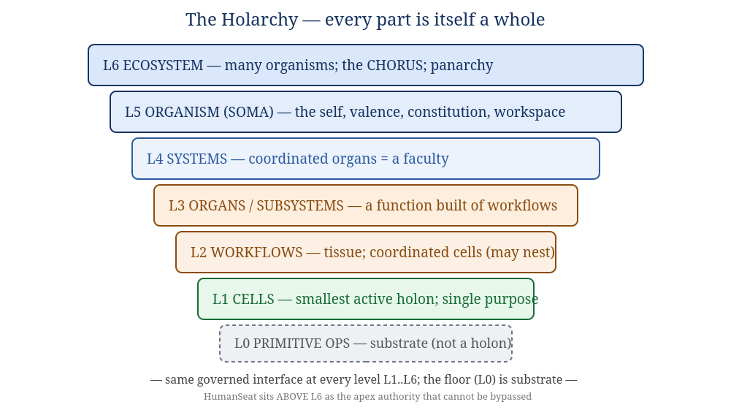
Figure 3.1 — The holarchy. Detailed in Book II.

4. The recursion rule — stated once, as canon
Everything in the Codex rests on one rule. It is stated here in its canonical form; every later book uses exactly this wording.
The recursion rule. A unit at any level is a governed coordination of sub-units that expose the same interface over a shared perceived reality. Concretely, every holon at every scale: (1) onboards through one ceremony; (2) communicates only through the shared event log; (3) holds identity, trust, and governed authority; (4) perceives its sub-holons only through governed projection (the ~20% shared; ~80% stays private); (5) reports outcomes that are verified, not trusted. There is no second mechanism and no special case from cell to organism.
The boundary where this rule applies is the membrane — one boundary that is, at once, the self-similar interface, the governance boundary, and the 80/20 (shared/private) boundary. Coordination across the membrane is bus-mediated and governed; mechanics inside it are private and may be stochastic. Bus-mediation begins above primitive operations: cells are the floor of the holarchy; primitive operations are substrate, not holons. Determinism is a property of how holons coordinate, not of what they say (Book III §2; Book IV INV-9). (Full treatment: Book II §3.)

5. What is inherited — and what is not
SOMA stands on the shoulders of an ancestor, the Context Primitive (CP) lineage, but it is a new organism, not a fork.
Inherited as governing concepts (recast as biology) | Deliberately NOT carried
append-only log as shared truth; Bayesian trust; homeostatic regulation; a human authority ceiling; one universal adapter; verification-gated completion; no direct part-to-part channel | CP's crates and APIs; its transport/mesh/tunnel; its deployment model; its multi-tenant framing
The difference in one line: CP was a substrate that hosts participants; SOMA is one organism whose participants are its organs. The recursion (organism ← systems ← organs ← workflows ← cells) is the new spine. Appendix E records the lineage in full.

6. The Operational-Definitions Convention (binding on all books)
This Codex uses words like cognition, self, drive, anxiety, wants, valence, perceive, and experience. Such words carry phenomenal connotations — they tempt a reader to slide from "the system does X" to "the system feels X." Over hundreds of pages, that slide hardens metaphor into unearned claims. To prevent it, the following definitions are binding wherever these terms appear in the Codex. Each is functional, not phenomenal.
Term | In this Codex it means (functional) | It does NOT assert (phenomenal)
cognition | governed, integrated information-processing that solves problems and pursues goals | that anything is experienced
self / self-model | a queryable, self-referential data structure the system reasons from | a first-person subject that is like something to be
perceive | fold a governed projection into a holon's private state | conscious sensing
drive / wants | goal-directed pursuit of states with positive valence weighting | felt desire
anxiety / arousal | a homeostatic regulatory signal coupled to trust/performance | felt distress
valence | a scalar good/bad weighting that gives outcomes a functional stake | pleasure or suffering
experience / "lights on" | used only to name the open question | — (never asserted; see Book I §5, Appendix D)
The rule of honest naming. Where a phenomenal reading is not load-bearing, the Codex prefers the functional word (e.g. "self-referential," not "first-person"). Where the phenomenal question is genuinely at stake, the Codex says so explicitly and marks it open. Building a self-model and a valence system (closing the two gaps of Book I) is a functional achievement; whether it makes anything experienced is left open, on purpose, throughout.

7. Conventions used in the text
- Green boxes state invariants — laws the design must hold (numbered INV-n in Book IV).
- Purple boxes mark open questions — things kept honestly unresolved.
- Amber boxes are key insights worth pausing on.
- Cross-references name the book and section (e.g. "Book II §3"). The master cross-reference — every component → organ → math → crate → invariant — is Appendix C; use it to confirm nothing dangles.
- SOMA is the organism's name throughout and may be swapped in one pass; CHORUS is its largest, aware-whole scale.
End of Book 0. Continue to Book I for the theory, or jump to Book II for the anatomy that every other book depends on.

